Accountability Report Transmittal Form

Agency Name: South Carolina Vocational Rehabilitation Department

Date of Submission: September 15, 2004

Agency Director: Larry C. Bryant

Agency Contact Person: Mark G. Wade
Contact Person’s
Telephone Number: (803) 896-6834
I. Executive Summary
The mission of the South Carolina Vocational Rehabilitation Department (SCVRD) is to enable eligible South Carolinians with disabilities to prepare for, achieve and maintain competitive employment.
Investing in South Carolinians with disabilities offers a high-yield return. The public vocational rehabilitation program converts people reliant on government assistance into self-sufficient citizens who have jobs, purchase goods and services, save for the future, and pay taxes that quickly reimburse the funds spent on their rehabilitation.
SCVRD continues to implement customer-focused initiatives and accountability measures designed to add value to its services and to allocate its limited resources to achieve maximum impact.
The agency values:
- Persons with disabilities who strive to achieve and maintain competitive employment.
- Highly qualified staff members who are technically competent, personally accountable, communicate effectively and work together in a professional manner.
- Partnerships with business and industry that provide employment and contract service opportunities for our clients.
- Relationships with other human service agencies that provide increased service opportunities for persons with disabilities.
- Accountability to taxpayers through efficient and effective use of the resources entrusted to us.
Agency visions include:
- All staff will be committed to the agency’s mission, values and vision.
- Technology will be used to provide maximum benefits to our staff and clients.
- We will be the leader in innovative, individualized customer service that contributes to successful employment outcomes.
- We will provide quality service in an atmosphere of trust, sincerity and commitment.
- We will provide professional development opportunities in order to develop and retain exceptional employees.
- We will demonstrate accountability through the efficient and effective use of the resources entrusted to us.
- We will provide our customers with the tools, services and products that will prepare them to compete successfully in the modern workplace.
SCVRD’s leadership continues to closely examine and evaluate all practices and procedures throughout the program to ensure that performance measures are appropriate, that goals are met or surpassed, that all actions show strict accountability, and that all measures point directly to one outcome—competitive employment for our clients. The department does not accept credit for efforts on behalf of clients who do not become employed.
The department is unique in that it serves people with more than 135 different physically and mentally disabling conditions.
Use of accountability report
The department uses the annual accountability report as documentation of its continuous improvement efforts and performance measures. The department’s Key Result Areas (KRAs) are structured according to Baldrige criteria categories. Strategic plans are developed and deployed with measurable results designed to accomplish the agency mission. The accountability report is a valuable tool in monitoring progress and identifying gaps in performance.
Key strategic goals:
- Program Integrity. This is a balanced set of measurable standards which are essential to the department’s success relative to compliance assurance, productivity and customer service. The agency has completed its second full year of implementation and has an ongoing objective to utilize the measures to drive improvement.
- Committee on Rehabilitation Excellence (CORE). This group is implementing a system to assure achievement of Program Integrity standards by collecting and analyzing data, formulating and assessing plans for corrective action, and assuring implementation and follow-up. Our objective is improved efficiency, effectiveness and accountability throughout the agency.
- Professional Development Program (PDP). This objective arose from the significant number of retirements facing the organization in the next few years. The PDP creates an environment that fosters excellence by aligning agency needs with individual career goals. More than 120 participants are involved in the three tracks of management/supervision, pursuit of specialty areas, and general professional development.
- Partnerships. The agency is placing great emphasis on partnerships with other agencies to coordinate services, partnerships with business and industry, and partnerships with past clients to enhance services and promote the agency’s accomplishments. The number of interagency partnerships continues to grow, and SCVRD’s Business Partnership Network completed its first full year of operation in 2004.
- Alternative funding. In light of budget restrictions the agency seeks to improve its level of services through the acquisition of grants, increased reimbursements from the Social Security Administration for job placement of clients who no longer rely on disability benefits, and coordination of payment for services by third party agencies/organizations. Three new major grants had start dates in FY2004.
Major achievements from the past year:
- The department showed a gain in its primary performance measure, the successful rehabilitation of people with disabilities into employment. Despite significant budget reductions the department rehabilitated 8,956 people, an increase of 65 from the previous year.
- The agency’s Program Integrity measurement system enters its third year of implementation. A few years ago SCVRD developed and used the model to guide its operations; but in FY2003 the model evolved into a measurable entity. A formal scorecard for compliance assurance, quality customer service and productivity now provides specific results that can be broken down to local team performance or statewide performance. The system enables the department to identify opportunities for improvement in meeting customer needs and drives corrective actions, such as shifts in personnel or development of new training. Program Integrity measures specific to work training center productivity were implemented for the first time in FY2004.
- The Committee on Rehabilitation Excellence (CORE) worked with area operations to develop action plans known as Steps for Excellence. These are localized action plans to accomplish the Commissioner’s nine expectations for area operations.
- A marketing pilot to attract outsource contracts for SCVRD work training centers was successful and will be expanded to additional sites in FY2005.
- There was a focus on improving consistency in service delivery, staffing patterns, performance ratings, reclassification of field positions, and communication of consistent messages and expectations.
- A Counselor IV position was developed as an additional career track. A limited number of these counselors will be located in geographic pods throughout the state. They will work with clients having the most significant disabilities in five specialty areas.
- Cost-effective policies were developed in the areas of client van usage, training center trucks/drivers, and staff travel.
- The Professional Development Program (PDP) completed its second full year of operation. This program addresses one of the agency’s most significant challenges—the large number of retirements anticipated in the next few years, especially in management positions. The Professional Development Program has exceeded its original intent to satisfy the need for future managers; it has created an environment that fosters excellence by aligning agency needs with individual career goals. Leadership development occurs through formal classroom instruction, project planning and implementation. Mentoring is provided through the use of career coaches.
- The department now has 404 cooperative agreements, an increase of 14 percent since 2002. SCVRD worked very closely with other agencies to provide their clients with employment services, particularly the One-Stop centers; Department of Mental Health; Department of Disabilities and Special Needs; Department of Education; Department of Corrections; Department of Juvenile Justice; Probation, Parole and Pardon Services; Department of Social Services; and Workers Compensation.
- The department showed continued improvement in its return on the taxpayer investment. In FY2004, the SCVRD Basic Service Program placed 8,956 people with disabilities into employment. These new workers will pay back $2.99 in taxes for every vocational rehabilitation dollar spent. On average, they will repay the cost of rehabilitation in 5.4 years. They will realize an increase in their earnings by $11.76 for every $1 of Vocational Rehabilitation Department funds invested in their rehabilitation. The annual rate of return for each successfully employed client will average 18.1 percent. These figures have all improved for two consecutive years.
- The department gained $925,664 in reimbursements from the Social Security Administration. This reimbursement is a direct reflection of savings realized by Social Security because the department’s clients became competitively employed and no longer needed SSI/SSDI benefits.
- The department started three new grants this year, all funded through the U.S. Department of Education. The Literacy and Employment Outcome grant operates in partnership with the S.C. Department of Education to use certain literacy instruction approaches to enhance earnings for individuals with disabilities. Another grant provides loans to people with disabilities for technology purchases needed for home-based employment, and the third provide loans for the purchase of assistive technology devices and services.
- SCVRD continued to develop a school-to-work transition initiative involving joint funding with school districts to sponsor full-time, on-campus transition employability specialists. Pilot programs began in Orangeburg and Richland counties in FY2004. The department also started a similar initiative with the South Carolina School for the Deaf and Blind to improve transitioning for deaf students. Two more pilots are in the initial planning stages.
- The department began a specialized program at its Evaluation Center in West Columbia for clients with brain injury, one of the most difficult disabilities to overcome in terms of employment. This program is in partnership with the Department of Disabilities and Special Needs, Roger C. Peace Hospital, the medical community and family members.
- The Disability Determination Services program continued to strengthen the department’s range of services by providing effective and efficient evaluation of claims for disability benefits. With an annual budgeted workload of more than 75,500 disability claims, the program strives to process all claims with the highest possible level of quality, in the shortest possible time and at the lowest reasonable cost. During 2003-2004, the division’s documentation accuracy levels bettered regional and national averages. The Disability Determination Program also works cooperatively with other agencies, processing disability claims for the County Auditors Office and the South Carolina State Retirement Systems. As of July 1, 2004 the DDS assumed the Medicaid disability workload from the S.C. Department of Health and Human Services. This will mean an additional 8,000 to 10,000 disability claims to adjudicate in the next fiscal year.
- Beginning on March 29, 2004, the Disability Determination Services began rollout of a pilot of the electronic disability file. This is in keeping with Social Security Administration plan for a folderless disability process. South Carolina is the first state in the nation to implement this process in a decentralized format (4 different offices in the state). A Key Results Area (KRA) has been investigating the changing nature of the positions in the DDS as a result of the new electronic process.
  - Technology advances in the department continued to improve efficiency and user-friendliness in several program areas including implementation of redesigned menu systems, Program Integrity documentation, automated EPMS system, automation of file server backups in field offices, computer security upgrades, development of agency intranet, and completion of a document center network, which has produced significant cost savings.

Opportunities/barriers that may affect success
  - As with most agencies, funding issues have been significant. Since FY2001 the department’s state funding level has diminished by 35 percent ($6,021,610). Among the ways that SCVRD has addressed the cuts are:
    - The department has closed seven satellite offices, saving lease costs. It has also scaled down local management costs by merging three offices with existing offices. As a result, people with disabilities in some of the more remote areas of the state are having to travel farther to access services, and some are not able to do that.
    - SCVRD has lessened the number of support staff for professionals providing client service, and the overall number of employees in the service program has been reduced.
    - The department has reduced travel expenses through the use of fleet cars in the Golden Cars program. It has implemented stricter coordination of out-of-town travel and eliminated meal reimbursements on one-day trips. Administrative travel was reduced by almost one-third as a result in FY2004. For field offices, travel restrictions led to a 13 percent drop in expenses.
    - Adoption of a procurement card program for routine purchases resulted in significant cost savings.
- The department continues to be confronted with equipment and facilities maintenance needs that have been deferred.
  - The program’s federal funding has received only the mandated Consumer Price Index increase of between two and three percent for the past decade. Combined with state reductions, this presents a challenge in keeping up with the demands and expectations of people with disabilities who seek high-quality employment outcomes, as well as increased demands resulting from the impact of the Workforce Investment Act, the Ticket to Work program, Temporary Assistance for Needy Families (TANF) and assistive technology demands.
  - The department faces a major challenge due to the very substantial number of students with disabilities who need services to make the transition into employment. There are more than 30,000 students with significant disabilities who are between ages 14 and 21, and many of them need transition services. A pilot project with local school districts is underway, but significant resources are needed to provide schools throughout the state with transition employment specialists.
  - Home-based employment is a growing opportunity for people with significant disabilities. The department faces the challenges of equipping clients to work from their homes. In FY2004 the department began utilizing a grant to provide low-interest loans for home-based employment and for assistive technology applications.
II. Business Overview
The public vocational rehabilitation program is the oldest and most successful federal/state human service program in the nation. Its original purpose was to return to gainful employment a large number of veterans disabled in World War I. South Carolina’s vocational rehabilitation program began in 1927 and for a considerable number of years has enjoyed top performance rankings nationally for providing effective service to clients. With a highly trained staff of rehabilitation professionals working in customer-oriented teams, the department is geared to convert dependent tax consumers into independent, working taxpayers.
Vocational rehabilitation services
Eligible applicants with disabilities have a program of services coordinated by their counselor at one of 18 area offices throughout the state. Together the client and VR staff develop an individualized plan for employment. Career options are explored and the client receives extensive counseling and guidance, and may receive restoration services, take classes to enhance employability, receive job readiness training at the department’s work training center, or other services leading to job placement.
Many clients with significant physical disabilities benefit from the department’s Center for Comprehensive Programs in West Columbia, which includes an evaluation center to determine vocational potential; pain management program; muscular development program; rehabilitation technology program which uses an engineering approach to overcome employment barriers; and computer training program which provides clients with top-level training for technology jobs.
The department has specialized services such as cardiac rehabilitation; a deaf and hard of hearing program; job retention services for employees of businesses throughout the state whose jobs are jeopardized by disabling conditions; supported employment (worksite job coaching); and substance abuse treatment at two SCVRD treatment centers.
The department’s 23 work training centers provide vital job training for clients and a cost-effective outsource option for more than 350 business and industry partners.
The Disability Determination Services program processes Supplemental Security Income and Social Security Disability Insurance claims for the Social Security Administration.
The department also operates Pathways Toward Employment, helping disability benefits recipients who want to work but are concerned about losing benefits and health care coverage; and the Ticket to Work program, in which Social Security disability beneficiaries use a “ticket” to access employment services from the department.
Staff size
At the end of FY2004, the department had 1,075 employees in full-time equivalent positions and 211 employees in temporary positions.
Operation locations
The department’s administrative headquarters and Center for Comprehensive Programs are located in West Columbia. The department has alcohol and drug abuse treatment facilities in Florence and Greenville.
Area Office/Work Training Center combinations (primary entry points) are located in:

Aiken
Anderson
Beaufort
Bennettsville/Hartsville*
Charleston
Columbia
Conway
Florence
Greenville
Laurens/Greenwood*
Moncks Corner
Orangeburg
Rock Hill/Lancaster*
Seneca
Spartanburg/Gaffney*
Sumter/Camden*
West Columbia
Walterboro

* area offices with two work training centers
Satellite offices operated by the area offices listed above are in: Dillon, Georgetown, Greer, Kingstree, Mount Pleasant and Newberry.
The department also fully participates in all 17 comprehensive One-Stop centers operated by Workforce Investment boards, and has a presence in 19 satellite One-Stop centers.
The Disability Determination Services program has a central office in West Columbia, and regional offices in Charleston, Greenville and West Columbia.

Primary customers (clients)
The department is essentially an employment agency for people with disabilities. It provides services that are devoted entirely to the employment of South Carolinians with disabilities. It does not provide lifelong or disability-specific services.
To be eligible, an applicant must have a physical or mental impairment that substantially interferes with his or her ability to work. The person must also require and be able to benefit from vocational rehabilitation services that would lead to permanent, competitive employment.
The department is unique in that its primary customers are people with more than 135 different physically and mentally disabling conditions. In 2003-2004, SCVRD placed 8,956 people with disabilities into employment. The department had 16,250 new applicants who were declared eligible for services and served a total of 43,224 people. (Since rehabilitation is a continuous process that often takes a period of years, the department serves some of the same clients in successive years.)
Twenty-seven percent of the department’s successfully rehabilitated clients work in service positions. About 16 percent work in clerical/sales, 14 percent in manufacturing, 14 percent in professional/managerial/technical jobs, 13 percent in construction, 3 percent in agriculture and the remaining 13 percent in fields classified as “miscellaneous.”
Other customers
- Business and industry partners, including employers, companies who provide contract work for clients in job readiness training, and businesses taking part in SCVRD work assessment, training, mentoring and job shadowing services.
- Other state agencies.
- Private, non-profit organizations.
- Referral sources.
Other stakeholders
- Taxpayers, to whom the agency is accountable, and the legislators who represent them.
- Vendors, including training institutions, physicians, hospitals, clinics, pharmacies, orthotic/prosthetic and hearing aid dealers, and miscellaneous retailers.

Base Budget Expenditures and Appropriations

 | 02-03 Actual Expenditures |  | 03-04 Actual Expenditures |  | 04-05 Appropriations Act
Major Budget Categories | Total Funds | General Funds | Total Funds | General Funds | Total Funds | General Funds
Personal Service | $42,780,594 | $10,068,818 | $42,780,018 | $9,463,077 | $41,142,342 | $8,054,628
Other Operating | $23,739,863 | $164,287 | $25,007,970 | $282,532 | $32,336,500 | $651,482
Special Items | $ | $ | $ | $ | $ | $
Permanent Improvements | $673,913 | $ | $236,020 | $ | $ | $
Case Services | $17,250,817 | $24,999 | $15,948,067 | $19,552 | $20,721,000 | $25,000
Distributions  to Subdivisions | $ | $ | $ | $ | $ | $
Fringe Benefits | $11,849,898 | $2,841,548 | $11,964,080 | $2,623,294 | $11,905,235 | $2,413,624
Non-recurring | $ | $ | $ | $ | $ | $
Total | $96,295,085 | $13,099,652 | $95,936,155 | $12,388,455 | $106,105,077 | $11,144,734

Other Expenditures
Sources of Funds | 02-03 Actual Expenditures | 03-04 Actual Expenditures
Supplemental Bills | $0 | $0
Capital Reserve Funds | $0 | $0
Bonds | $0 | $0

Interim Budget Reductions
Total 02-03 Interim Budget Reduction | Total 03-04 Interim Budget Reduction
$1,225,212 | $125,140

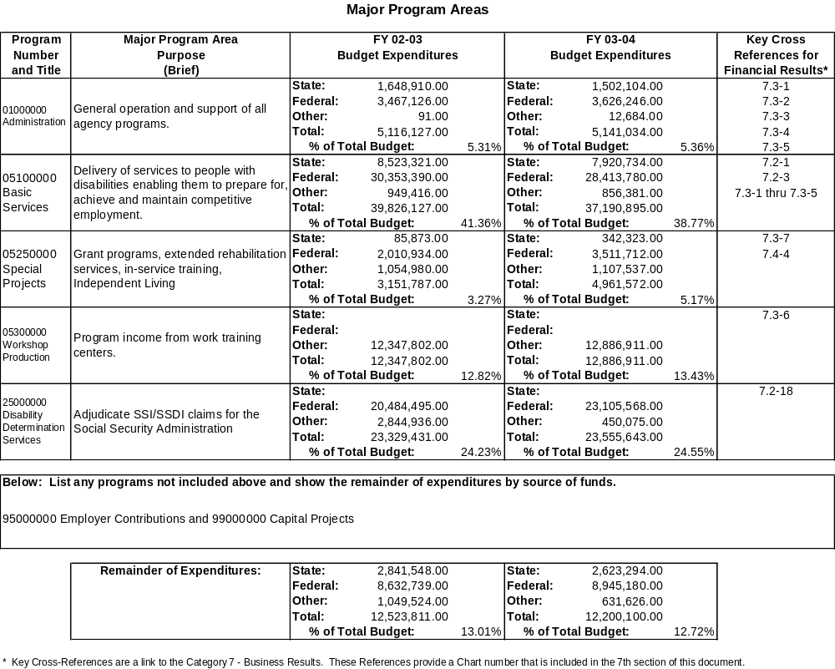

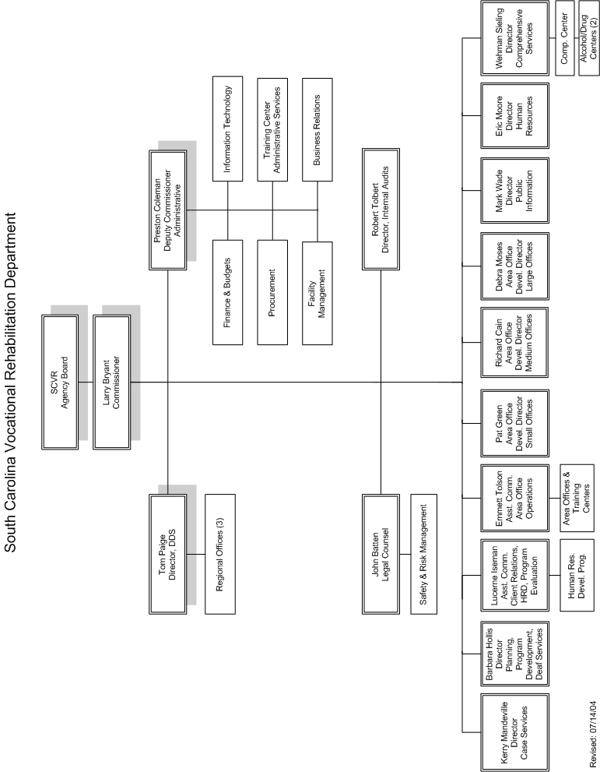

III. Elements of Malcolm Baldrige Award Criteria

1. Leadership
The department’s continuous improvement efforts require extremely strong leadership. Senior leaders continue to examine and evaluate all practices and procedures throughout the VR program to address the impact of internal and external factors. This is accomplished through constant attention to formal and informal feedback and to the most obvious indicator—successful employment outcomes for our state’s citizens with disabilities.
1.1 Senior leadership direction
Under the direct leadership of the commissioner, senior leaders set, deploy and communicate short- and long-term direction through a variety of mechanisms. An executive committee, under the commissioner’s direction, reviews policy and other major department functions regularly. At senior manager meetings, held at least monthly by the commissioner, a larger group of department leaders shares information on agency initiatives, progress, and causes for concern. These meetings allow for leaders with varying responsibilities to work together to achieve goals and promote intradepartmental cooperation. The Committee on Rehabilitation Excellence (CORE) is a group of senior leaders charged with analyzing, formulating and assessing action plans and evaluating the agency’s key performance measures.
CORE’s assessment of area operations includes the following:
- Area office development directors (AODDs) meet with the 18 area supervisors individually at the beginning of the year. Discussions involve strengths and needs. The commissioner has established a series of nine simple, concise expectations for area performance, and each supervisor has a self-assessed “scorecard” of their degree of success in meeting these expectations. At these preliminary meetings the status of progress toward these expectations is reviewed. Each supervisor then submits to CORE an action plan (Steps for Excellence) for addressing their area needs.
- On a quarterly basis the area supervisors in conjunction with AODDs update the Steps for Excellence form, noting progress to date and additional needs and plans.
- AODDs visit offices on a regular basis to coach and mentor the supervisors on techniques to improve office performance.
- CORE conducts a formal evaluation at the end of the year reviews the successes and opportunities for improvement in each area of expectation.

Throughout the process, an AODD works with each office to provide a liaison to the State Office and provides guidance in day-to-day operations.
The flow of communication throughout the organization is enhanced by the area councils that operate in each area office. The area council meets monthly and consists of the area supervisor, work training center manager, and other key staff. They review strategies and initiatives that have been discussed and implemented at senior manager-led quarterly supervisor meetings, review Program Integrity performance measures, and communicate with their staffs in a manner consistent with the rest of the agency. Local issues are discussed and feedback for CORE on successes and concerns is formulated. In this way the cycle of information continues to loop throughout the department.
Area office development directors and client service consultants in the State Office regularly visit and communicate with local area operations to assure that resources and appropriate training are available to serve customers effectively and efficiently. At quarterly meetings the department’s 18 area supervisors from throughout the state communicate agency issues and receive input. “Like-sized office” meetings provide opportunities for supervisors whose area operations have common characteristics to share strategies, concerns and best practices.
1.2 Focus on customers
Senior leaders establish and promote a focus on customers through emphasis on a central and common theme—the core mission of enabling eligible South Carolinians with disabilities to prepare for, achieve and maintain competitive employment, and the accomplishment of that mission while maintaining a balanced scorecard of measurable compliance assurance, quality customer service and productivity measures. Senior managers examine customer survey results as a regular component of the management process (see Sec. 1.1).
The mission statement is displayed in all offices, on desktop computer screens, on business cards and stationery, and in training environments. The “core duties” of every staff member relate to the agency mission. All training information is geared toward helping staff better understand the mission. The agency’s Integrated Service Delivery System is client-centered, with client involvement at all stages. Senior managers seek ways to empower staff to provide more timely service delivery for customers.
Client and employee achievements are appreciated and recognized through regularly scheduled events.
1.3 Maintaining fiscal, legal and regulatory accountability
Management accountability is accomplished through the commissioner’s communication with the agency board regarding any significant initiative or change to solicit the board’s support, guidance and approval. Policies, procedures, and state and federal regulations also guide the direction of the department. CORE assumes the role of ensuring that field operations are held accountable for carrying out policies and procedures consistently statewide. Compliance with case service policy is measured through the program evaluation unit, which is objective and consistent with all caseloads.
The Rehabilitation Services Administration (SCVRD’s federal regulatory agency) conducts an annual review to assess compliance with federal regulations.
Fiscal accountability is accomplished by adherence to state and federal laws and measured through annual state and federal audits. Federal audits break down expenditures into significant categories of service provision and administration. The state budget office, state legislature and governor’s office also provide oversight as the agency budget is developed for each year.
Federal and state auditors conduct annual financial, procurement and client services audits. They are by nature independent, reporting to external regulatory groups. The department seeks independence of its internal audit unit by having that unit report directly to the highest level in the organization—the commissioner.
Protection of clients’ interests is accomplished through the Client Assistance Program as well as the internal client relations office. Procedures are in place for any issues or grievances that clients may have with services or the staff providing services. There are also state and federal confidentiality laws outlined in agency policy and monitored by supervisors and the internal legal counsel.
1.4 Key performance measures
All performance measures are linked to the mission of the agency to achieve employment outcomes for South Carolinians with disabilities.
Senior leaders regularly monitor Program Integrity measures, including compliance reviews, customer service surveys and the accomplishment of productivity goals. The measures produce a rate in each category leading to the calculation of a “Program Integrity Index.” Program Integrity can be assessed by caseload, area and state groupings. These measurements are calculated quarterly and provide a definitive index of performance quality. Success of all measures is predicated on the achievement of the closure goal and a standard of 90.7 (91 for FY2005).
A key factor in Program Integrity is a set of national standards and indicators, required by the department’s enabling federal law, the Rehabilitation Act of 1973. The seven standards and indicators provide program effectiveness comparisons with VR agencies from all other states as well as regional comparisons.
Senior managers regularly review local and state goals for the number of customers served, number of rehabilitations, number of individualized plans for employment written, customer satisfaction data, income reports from the department’s work training centers, costs of services, and other measures.
1.5 Performance review/feedback
Organizational performance and capabilities are reviewed through Program Integrity measures mentioned above. Results of Program Integrity measures are used to establish short-term and long-term goals to improve performance. Senior leaders serve as team leaders for key result area (KRA) committees, which assess agency effectiveness and identify strategic planning initiatives. KRA subcommittees/work groups are developed to address needs as identified
Surveys and reviews drive initiatives to meet changing organizational needs. Recent performance review findings led to increased attention to clients with spinal cord injuries; clients with addictions; and clients in job readiness training, supported employment program, and career planning and employment services; and Social Security disability benefits recipients.
By listening and reviewing feedback from staff and customers, senior leaders make adjustments in structure of meetings or training and develop agendas based on needs expressed by staff. Leadership directs its attention to areas of need identified by performance in local office and statewide efficiency and effectiveness measures. The team concept that the department has emphasized for several years has built-in mechanisms for effectively responding to concerns generated by team discussions. The team concept applies to the State Office as well as to local area offices.
The commissioner conducts focus groups, both internal and external, for feedback to be used in continuous improvement efforts. In FY2004, focus groups were held with area supervisors, training center production coordinators, DDS examiners and DDS supervisors. Action plans were put into place to address issues brought forth in these focus groups. State and federal audits also reflect SCVRD performance and provide a basis for establishing goals.
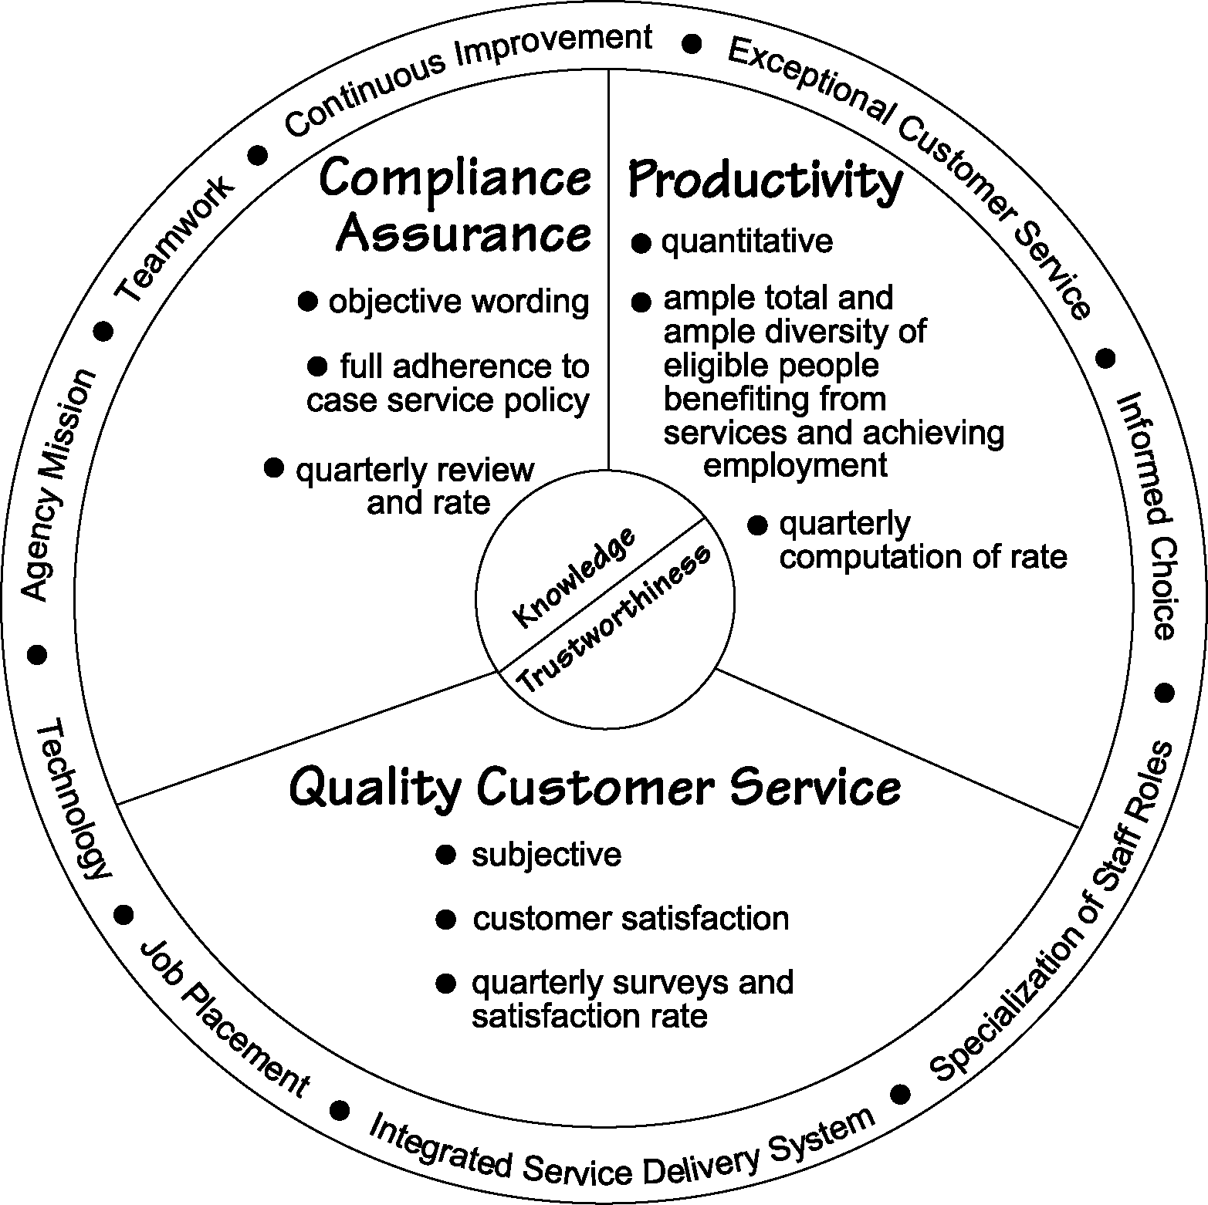
Program Integrity
A balance among…

Fig. 1.1
Train, Trust, Verify
1.6 Impact on public
In the agency’s area offices the local leadership stays in close contact with clients, business and industry partners, employers and referral sources to ensure program effectiveness. Formal surveys were developed for each of those groups as part of the Program Integrity measurement system to pinpoint areas of concern.
The department has numerous built-in mechanisms for ensuring ethical business practices. Vocational rehabilitation law contains very strict compliance measures that are monitored closely at different levels within the organization and through outside audits. The department’s administrative and case service policies outline agency standards for conduct and adherence to the law.
Public hearings allow management to consider the potential risks and effects of proposed policies before they are implemented. Senior managers work closely with the internal client relations specialist and, when necessary, the Client Assistance Program in the Office of the Governor to consider the merits of decisions and their impact on clients.
SCVRD also employs a full-time staff attorney for guidance in compliance issues and legal interpretations.
The agency’s risk management department promotes safety awareness to reduce workplace injuries and illnesses, provide a hazard-free work environment and lower Workers’ Compensation premiums. The agency’s 23 work training facilities include industrial-type settings for both staff and clients, so high standards for safety are imperative. The risk management department now processes all Workers’ Compensation cases for staff and clients. The department’s goal is to show a decrease in the number of Workers’ Compensation claims and therefore reduce the annual premiums. (see 7.6-1)
1.7 Priorities for improvement
The Committee on Rehabilitation Excellence (CORE) meets monthly to ensure achievement of the standards for compliance assurance, productivity and quality customer service. CORE collects and analyzes data, formulates, receives and assesses plans for corrective action and follows up to ensure implementation. The priorities for improvement arise from the Program Integrity index measures. These priorities are communicated through face-to-face discussions with managers and other staff, through written guidelines and policies, through EPMS goals, and through development of effective training modules.
Senior leaders also assume key roles in the strategic planning process. They serve as team leaders for key result area committees, which assess agency effectiveness and identify strategic planning initiatives.
1.8 Strengthening the community
The agency’s leadership firmly supports citizenship activities nationally, statewide and locally. Members of the senior leadership team are involved in civic organizations, disability advocacy organizations, task forces on disability and other community groups that can benefit from their expertise. The department has increased its collaborative efforts with private, non-profit organizations to expand its services to people with significant disabilities. The commissioner meets with other agency directors to strengthen these relationships.

SCVRD participates in the state’s emergency preparedness plan by providing personnel and equipment in the event of a major emergency. Crisis counseling and accessible transportation for people with disabilities are two key areas of contribution.
The agency is also quite active in community assistance projects such as The United Way, Red Cross blood drives, The Good Health Appeal, adopted family efforts during the holidays, Americans with Disabilities Act activities, National Disability Employment Awareness Month and National Disability Mentoring Day.
The department coordinates all activities of the Governor’s Committee on Employment of People with Disabilities, which reaches out to the business community and the public on the advantages of hiring people with disabilities. The Governor’s Committee is a hub for local mayor’s committees, which are spread throughout the state.
Community involvement is essential for SCVRD area supervisors and their staff. These contacts allow staff to spread the word about programs and encourage partnerships with businesses. Through involvement in local chamber of commerce activities, legislative delegations, Rotary groups and other community organizations, SCVRD staff members consistently form bonds within their communities that lead to employment for clients and outsourcing agreements with companies for work training centers.

2. Strategic Planning
2.1 Strategic planning process
The department’s strategic plan launched in the mid-1990s continues to evolve to address current customer needs. All of the key result areas (KRAs) of the original plan—values, mission vision; customer service; technology; government relations; partnerships; public information and education; human resource development and management; and continuous improvement—have become integrated into the daily operations of the department’s service delivery program. Under the guidance of the commissioner and agency board, these initiatives have been incorporated into staff development and training and into internal and external communications through supervisory meetings and directly into job descriptions and performance appraisals.
There is a KRA for each of the Baldrige criteria categories, and the KRA teams monitor existing initiatives and identify potential new initiatives for action.
Each key result area features strategic objectives and established time frames for implementation and review of each phase of the plan. Committees representing a wide range of perspectives are assembled to address specific needs and changes sparked by the strategic plan.
Internal and external feedback helps the department develop and deploy strategic planning initiatives. This is sometimes carried out through a statewide committee, where a pilot program may be developed, or at the local level as part of the action plan that each area office is required to develop and use.
Federal and state laws mandate that SCVRD convert as many eligible people with disabilities from unemployed tax consumers to tax-paying, competitively employed workers as the agency’s resources will allow. Strategic planning incorporates performance measures of Program Integrity involving compliance assurance, quality customer service and productivity.
2.2 Key strategic objectives
All of the department’s objectives are geared toward achievement of its mission to enable South Carolinians with disabilities to prepare for, achieve and maintain competitive employment. Accountability to our customers and the public at large is also an intrinsic part of all objectives. Current key objectives include:
- Program Integrity
- Committee on Rehabilitation Excellence (CORE)
- Professional Development Program (PDP)
- Partnerships
- Alternative funding
- Electronic case file (Disability Determination Services)
Details of these objectives, along with their action plans, are in the chart in Section 2.4.
2.3 Developing and tracking action plans
The agency’s Committee on Rehabilitation Excellence (CORE), part of the senior management team, oversees the development of action plans in each of the 18 area offices. The action plans, known as Steps for Excellence, address the commissioner’s nine expectations for area operations. These plans are monitored for compliance and achievement of the targeted goals. In turn, they are used as tools for training and the setting of new goals at the beginning of each year.
The management team helps establish local office goals for successful rehabilitations by taking into account staffing, client bases, referral sources, local demographics and economic conditions, previous accomplishments and other factors. These local goals add up to a statewide goal for successful rehabilitations, and allocation of resources is based on goals.
A key component in addressing strategic objectives is the design of customized technology upgrades. The Information Technology department works closely with State Office and local case service personnel to provide data needed to deploy strategic planning initiatives, such as identifying areas that need strengthening or setting appropriate goals.
Disability Determination Services’ long-range and short-range plans are developed or redefined at the beginning of each fiscal year. The objectives for the year are issued to all personnel as goals. Program goals are linked to objectives contained in Employment Performance Management System planning documents.

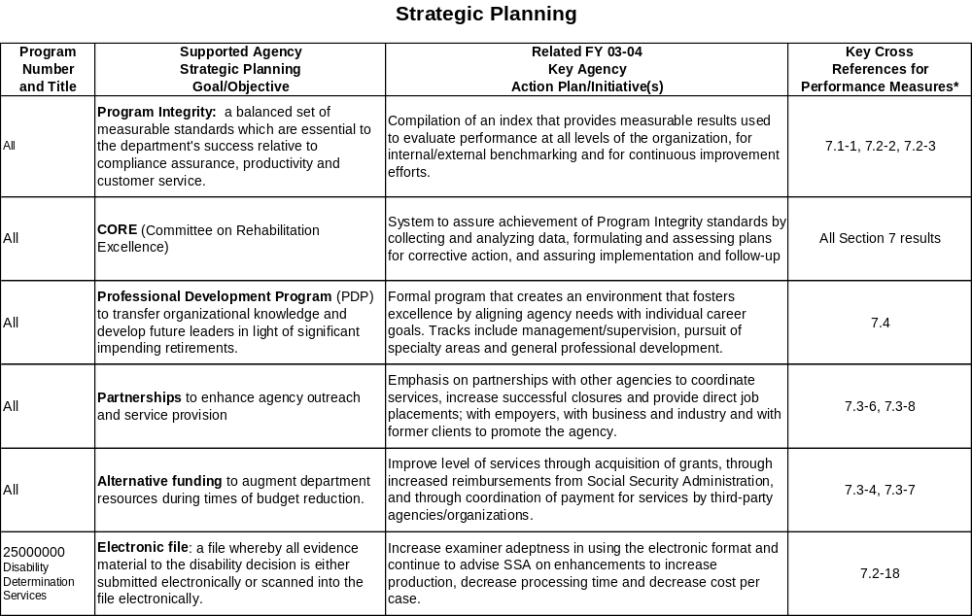
2.4 Key action plans and initiatives

2.5 Communication and deployment
Communication of strategic objectives, action plans and performance measures generally occur through verbal discussions and presentations and are likely to be complemented by supporting written communication. Quarterly supervisor meetings hosted by the commissioner often provide the setting for communicating objectives, plans and measures. Senior management provides follow-up throughout the year to ensure that communication cascades throughout the organization and that deployment is in place.
Thorough study of the validity and potential effectiveness of an action plan precedes deployment. Many major action plans have pilot programs to test their effectiveness and logistical requirements and to offer opportunity for feedback from staff and customers.
During deployment of any major initiative there is ample opportunity for questions or comments from supervisory or other affected staff. Training is developed to enhance staff understanding and “comfort levels” with new objectives or measures. The strategic plan is circulated to staff in all locations.
2.6 Strategic plan availability
The agency’s strategic plan is not yet available on the agency website, but is available to the public by e-mailing info@scvrd.state.sc.us.

3. Customer Focus
  - Key customers and stakeholders
The department determines its customers and customer requirements through a combination of legal compliance and listening/learning methods, both formal and informal. The department’s key external customers and stakeholders include:
- Individuals with impairments who intend to achieve an employment outcome
- Business and industry partners, including employers, companies who provide contract work for clients in job readiness training, and businesses taking part in SCVRD work assessment, training, mentoring and job shadowing services
- Other state agencies
- Private, non-profit organizations
- Vendors, including training institutions, physicians, hospitals, clinics, pharmacies, orthotic/prosthetic and hearing aid dealers, and miscellaneous retailers
- Taxpayers and the legislators representing them
- Referral sources

All individuals with impairments who intend to achieve an employment outcome are potential customers of SCVRD. They can be referred from about 30 different referral sources in their communities. Other agencies/public organizations provided the highest percentage of referrals in FY2004. Client requirements are determined based on individual needs regarding services and employment goals. At every major stage in the rehabilitation process, the client is at the center of the planning process.
The department has a highly qualified team of professionals who help the client understand the options that are available and guide them through the process. Identification of the requirements for a client’s successful rehabilitation results from a combination of professional assessment and client input.
Other customers include anyone who interacts with SCVRD, including business partners, other state agencies, vendors, taxpayers and legislators and referral sources. Their key requirements are determined by the nature of their relationship with the agency.
3.2 Keeping current with changing needs
The department enhanced its listening and learning methods by implementing targeted customer satisfaction surveys as part of the Program Integrity measurement. It also developed an enhanced system of tracking and reacting to client complaints. SCVRD reviewed customer service information from VR programs in other states as a way of seeking additional ideas.
The commissioner meets with the leaders of key agencies and conducts employer focus groups. The SCVRD state office also has consultants specializing in business and industry relations and has formed a Business Partnership Network. Business partners provide feedback about their needs in today’s marketplace, about contract services SCVRD performs for them, and about the clients they hire. Local work training center advisory board members provide ideas, feedback and advice on meeting the needs of their communities.
The department has established a network of successfully rehabilitated former clients who offer assistance in continuous improvement efforts. Agency leaders at the state and local levels stay in touch with members of the General Assembly and Congressional delegation to answer questions and provide information.
The agency’s web site is a growing and popular portal for persons seeking services or information. Inquiries are forwarded to the appropriate local offices to initiate services.
As staff members market the program, they also receive feedback from the community.
3.3 Using feedback information
It is required that the client is offered the opportunity for formal input at various stages of the rehabilitation process.
Attention to changing client needs is vital. SCVRD’s career planning and employment (CPE) services reflect that approach. Through community-based evaluations, a client with a particular job interest can try out that job in an actual work setting, “shadow” a person in the community who actually performs a certain job, or work under a mentor.
Referral sources are contacted on a frequent basis to assure continuation of collaborative relationships. Cooperative agreements are developed to assure mutually beneficial partnerships. Liaisons are assigned to specific service providers and to disability based private non-profit organizations. Members of the Business Partnership Network are consulted as to their needs for hiring or outsourcing work.
Focus groups are conducted to determine specific target area needs and to understand the nuances of particular audience needs. Individuals living with impairments, collaborating agencies, and private non-profit organizations are often included in staff development and training activities.
3.4 Measuring satisfaction
Through the department’s Program Integrity measurement system, the client customer service satisfaction rate is calculated quarterly at the area and state levels. Comparisons are made among organizational units and with previous years’ performance. Quarterly statewide customer service surveys are conducted focusing on a specific customer population (by impairment, by service, by referral source, employer, etc.). The survey results, compiled and issued to CORE, then distributed to area supervisors, become the subject of policy/procedure revision, staff training, consultation, management action or other continuous improvement application. In some cases the area of concern leads to the development of a KRA committee.
CORE and the department’s legal department review complaints received through the client relations office on a quarterly basis to formulate recommendations on policy/procedure revision, staff training or other action.
Each year the department conducts follow-up studies based on surveys of a random sample of successfully rehabilitated clients. This survey monitors satisfaction levels and rates of job retention. The department’s program evaluation staff regularly conducts area reviews that include clients who were not successfully rehabilitated to learn why they have not reached an employment outcome and to determine if dissatisfaction played a part.
In a general sense satisfaction from employers is measured in the success level of clients placed into employment, in the amount of outsource work contracted to SCVRD training centers, or through customer service surveys and focus groups. More specific feedback is gained through the daily relationships with those employers cultivated by local VR staffs. Area work training centers survey businesses for which they perform outsource work. This is used to correct deficiencies, strengthen client qualifications, and develop new contract opportunities.
3.5 Building positive relationships
The department’s focus on “informed choice” is the cornerstone for successfully building positive relationships with its clients, who are its primary customers. At every stage of the rehabilitation process, the client is involved in planning and signs off on his or her Individualized Plan for Employment (IPE). Staff promotes client choice in the selection of vocational objectives, services and service providers. Clients are encouraged to provide feedback formally or informally. The client must be satisfied with services and vocational rehabilitation outcome before the department claims a successful rehabilitation.
The department also builds positive relationships through cooperative agreements with other state agencies; through community outreach to solicit business and industry involvement with the program as employers, contractors, or advisors; through cultivation of ongoing relationships with successfully rehabilitated clients who are now firmly established in their communities and offer a great source of feedback and advocacy (this VR Partners group has grown to more than 200 participants); and through contact with community organizations and legislators.
The department has placed great emphasis on building positive relationships with other state and local agencies. SCVRD enhances the services of other agencies by providing clients of those agencies with the employment services they need to gain independence. There are more than 400 cooperative agreements with other organizations. These relationships are strengthened by SCVRD’s attention to providing prompt and thorough feedback to its referral sources as to progress and outcomes for clients they refer.
Marketing tools such as printed publications, television public service announcements, and the agency web site enhance relationship building efforts.
Each year, Disability Determination Services (DDS) managers develop outreach objectives and plans based on identified and/or projected needs. The administration designs a schedule for attending conferences and meetings and for individual visits with professionals, advocacy groups or claimants to disseminate information about the program and respond to requests for information. Division personnel make from 20 to 30 presentations each year to various groups. In addition, responses are provided to 8,000 to 10,000 inquiries from public officials, legal representatives or claimants.
The DDS Public Relations Office (PRO) has been expanded to include a public/medical relations officer in each of the regional offices. The PRO participates in professional conferences throughout the year. The PRO has actively recruited hospitals, clinics, doctor’s offices and other vendors to provide medical information electronically. Other education efforts target the Department of Education, legislators, attorneys and advocacy groups. A call center has been established in each regional office to provide exceptional service to all individuals calling for claim information.

4. Information and Analysis
4.1 Determination of measures
The department uses many performance measures, all tied into the accomplishment of the most important performance measure of all—its mission to enable eligible South Carolinians with disabilities to prepare for, achieve and maintain competitive employment.
Information to analyze the department’s success comes from a variety of internal and external sources. Each component of the service delivery system and support systems has performance measures that factor into the “big picture” of agency mission accomplishment. Through analysis of the department’s enabling legislation as well as other federal and state guidelines and through feedback from internal and external customers, the agency’s leadership has developed key performance measures.
National standards and indicators are used to compare SCVRD with other state programs at the national and regional levels. The department has developed a computer program that can analyze standards and indicators data by caseload, team, office and state.
Internal benchmarking has been divided into the three elements of the Program Integrity model: compliance assurance, quality customer service and productivity. New procedures, instruments and empirical methods have been developed to review caseloads, collect customer satisfaction information and expand the means of tracking and quantifying productivity. The Committee on Rehabilitation Excellence meets on a regular basis to coordinate the review and access the information gathered and to serve as a mechanism for feedback, decision-making and development of action plans. Program Integrity indexes can be calculated by area, region and the state, so that data collected can be used to foster improvement at any of those levels. Program Integrity measures go beyond direct client service to include other operational divisions of the department such as human resources, finance, information technology, and others.
Accountability to all taxpaying citizens is paramount and drives development of key measures. The department seeks to serve and rehabilitate the greatest possible number of people with disabilities as cost-effectively as possible and at the highest level of service as possible. Another performance measure is the rate of return on the taxpayer dollar. Key indicators are the length of time it takes for a rehabilitated client to repay the cost of his or her rehabilitation after becoming a taxpayer, the amount that the rehabilitated client repays for every dollar spent on his or her rehabilitation, and degree to which their earnings increase after rehabilitation.
4.2 Key measures
As mentioned above, all Program Integrity measures, including national standards and indicators, are considered extremely important because they reflect performance in the key areas of compliance assurance, customer service and productivity. All measures related to the successful employment of people with disabilities are key measures, including number of people rehabilitated, referrals, individual plans for employment written, direct job placements and cost effectiveness.
Disability Determination Services key measures include productivity, processing time, documentation and decision quality, and cost effectiveness.
4.3 Data quality, reliability, availability
Department staff throughout the state have gained much easier access to information necessary to support daily operations thanks to substantial upgrades in technology. This fiscal year brought further upgrades to computer programs to help streamline the service delivery process and meet compliance standards.
Through these upgrades, data quality, reliability, completeness and availability for decision making have been enhanced. Many case service reports that once required delays and personal assistance can now be accessed instantly on computer workstations by staff members. Often these reports are available in real-time. An example of the user-friendliness of this information is STARS (Statistical Tool and Reporting System), which enables users to build customized reports that include specific items about client service. The Local Office Information System (LOIS) provides additional specialized information that is a valuable management tool for the local office supervisor.
4.4 Using data/information in decision making
Information gathered in analyzing performance also is useful in spotlighting strengths and weaknesses and can be used to update the strategic plan. The department conducts area caseload reviews to ensure that SCVRD teams carry out their duties in compliance with federal and agency regulations and standards. Proper documentation of each stage of a client’s services is expected to detail appropriate services to meet the client’s vocational needs; appropriate spending for services, including documentation that external funding alternatives are being sought; provision of informed choices for the client; and efforts to secure suitable employment for the client and satisfaction for the employer.
The department uses reports to spot trends, project future needs and address federal key indicators. For example, the data can be used to anticipate staffing needs by analyzing the population or to establish training needs.
Customer satisfaction surveys are carefully evaluated and used in the consideration of improvements or new services in accordance with the Program Integrity measures mentioned earlier.
The Disability Determination Services maintains an extensive array of daily, weekly, monthly, quarterly and annual reports through comprehensive division, agency and Social Security computer reporting systems. Data on virtually every aspect of case processing, fiscal activity, quality assurance, and staffing are available on the DDS web page. Statistical reports are aimed at providing performance tracking information related to established goals and objectives. Data allows comparisons at the individual, unit, office, state, and national levels in areas such as productivity, processing time, documentation and decision quality, cost effectiveness and staff attrition. The DDS web page continues to be used as the major source of all reference material thereby ensuring the most updated and accurate information. Case folders will eventually be replaced with the electronic folder, which will be accessible to all components in the decision making process. This will enable more fluid movement of files, as well as decrease the amount of time it takes for medical and other evidence to be included in the file (eliminating mail delays).
4.5 Comparative data use
Selection and use of comparative data is based on national standards and indicators, which reveal how the department ranks in federally mandated measures. These figures are used by the Rehabilitation Services Administration, the department’s regulatory agency, to assess effectiveness of state VR programs. The department, in turn, uses them as a basis to consider improvements to service delivery when necessary.
The Program Integrity Index is an internal comparative data mechanism that enables the leadership to compare key performance measures at all levels of the service delivery system and foster continuous improvement.
Efficiency and effectiveness comparative data enables the agency to monitor and address trends in national, regional and internal benchmarking.
4.6 Management organizational knowledge/best practices
Succession planning is a key management tool for collecting and transferring organizational knowledge. The Professional Development Program facilitates this process by exposing candidates to a well-rounded study of the entire organization and a more focused study on their areas of greatest interest. Organizational veterans provide the knowledge base for this instruction.
Coaching and mentoring is provided to all new supervisors. Senior managers who are nearing retirement also provide a great deal of informal transfer of knowledge to their associates.
Best practices are routinely shared at all levels of training and supervisory meetings.
CORE’s members are at various stages of their careers, and knowledge is transferred within that group.

5. Human Resource Focus
5.1 Employee motivation to achieve potential
The department is committed to excellent employee-employer relations. This includes creating an environment where employees understand how their positions support the agency mission and feel valued for their efforts.
Career ladders have been established and continue to be refined for most major job categories to encourage employees in their development. The agency has developed matrices to help employees understand how promotions may occur and provide supervisors with a guide to employee development.
State regulations and policies govern employee compensation and benefits. While benefits are standardized across state agencies, the department exercises flexibility allowed by the regulations to provide pay increases for promotions, reclassifications, good performance, and additional knowledge and duties as well as bonuses. Such salary increases are tied directly to the accomplishment of the department’s mission and are approved only after the employee satisfies the published criteria for the attainment of each increase.
The “Celebration of Success” program is an innovative reward and recognition system that allows employees to recognize their peers for significant accomplishments. The program fosters a work environment that rewards employees for providing excellent customer service and for contributions to productivity and program excellence. Any employee who receives three awards may choose a prize from a catalog featuring a variety of products emblazoned with the agency logo. Another recognition program, the Disability Determination Services’ PRIDE (People Responsibly Influencing Decisional Excellence) awards, recognize superior job performance and provide awards for creative achievement, humanitarian service and special acts of service.
The Department’s “flex time” policy allows most employees to adjust their work schedules to accommodate outside commitments and to provide better internal and external customer service.
5.2 Key developmental and training needs identification
SCVRD’s Human Resources Development Center in West Columbia is a well-equipped, technologically advanced facility that supports a variety of training options. Training is designed around the identified goals of the organization and to support the employee’s needs in terms of job competencies and career development. Job orientation, leadership, safety, performance improvement, diversity and technical skills are specific areas of instruction.
Training is designed on three levels—basic, ongoing, and job enrichment. The department utilizes a federal training grant specifically for training that supports the agency mission and goals.
CORE makes recommendations for training based on client and other customer needs assessments and other Program Integrity results, and technological training is also emphasized to empower staff to fully utilize the computer technology advancements made within the department in recent years. There is a specific training program for all new counselors.
SCVRD has initiated a program to enable all counselors to meet required educational standards. This involves partnering with the University of South Carolina and South Carolina State University to provide advanced academic coursework in the classroom and through videoconferencing. In addition, Internet courses are used to accommodate the needs of individual counselors in meeting the requirements.
The department’s training and education approach balances organizational objectives with employee needs for development through a thorough analysis of the agency’s workforce, the Professional Development Program, mentoring and coaching.
New employees attend a two-day orientation session that covers a full range of information about the department’s programs, benefits and procedures. The department also offers job orientation programs designed by job titles and duties.
New supervisor training is a continuous emphasis; training varies according to the type of supervisor. All new area supervisors receive extensive guidance with one or more of the following:
- A two-day new supervisor training, which includes site visits to key offices and programs;
- The Budget and Control Board’s Division of Training; and/or
- The New Supervisors Institute at Georgia State University.
They also have colleagues who are assigned to mentor them, and area office development directors provide coaching on a daily, as-needed basis.
Professional growth is also addressed through the Professional Development Program (see 2.4).
The department has developed its own diversity training program. Ethics are incorporated into all orientation sessions as well as other training sessions.
Employee and workplace safety are the focus of training both at the state and local levels.
Training needs are identified through, management reviews (CORE), program reviews, customer service surveys, EPMS documents, training requests, staff input, and basic job competency requirements. From this information, development plans and training sessions can be established to enhance the employees’ ability to support the agency’s mission. Training needs are also established through external means such as federal regulations.
Organizational learning and knowledge assets are incorporated through the internal training staff, external trainers and consumers.
5.3 EPMS support of high performance
The department’s Employee Performance Management System process supports two-way communication between the supervisor and employee.
It is designed to be a cyclical process beginning with clear communication of job duties (from position description), success criteria, and performance characteristics. It continues with on-going performance communication, and culminates in an evaluation of the employee’s progress towards the achievement of the goals documented at the beginning of the cycle. The EPMS cycle generally is an annual process. However, when an employee changes job classifications, a shorter time frame is used to ensure that the employee is performing successfully in the new role or to remove the employee from the new position if performance is not acceptable.
If an employee is not performing at an acceptable level, the EPMS system incorporates an intensive process (Warning Notice of Substandard Performance) designed to provide the employee with additional supervisor support and resources and enhance his/her chances for reaching acceptable performance levels.
Core job duties have been developed for most position types within the agency and are consistent statewide. The EPMS allows for supervisors to add additional job duties to the core duties in order to meet local needs. The core job duties were designed around the work team roles required in the field offices.
The success criteria developed for use with the EPMS are the measurable and or observable results which should be achieved to indicate successful performance. Most success criteria relate directly to the Program Integrity measures of quality customer service, productivity and compliance assurance.
Performance characteristics include concepts such as teamwork, customer service, quality of work, etc. An employee is rated on these aspects to provide feedback on the manner in which the employee is performing the required tasks.
5.4 Employee well-being and satisfaction measures
The agency’s new employee job satisfaction survey tracks the effects of administrative and programmatic initiatives on employee job satisfaction. Employee job-satisfaction surveys are sent out quarterly (see 7.4-2). The feedback will be compared to national results to assist SCVRD in assessing its strengths and weaknesses as an employer. Feedback also will be used in designing policies and programs that promote job satisfaction. Focus groups will be formed as needed to address issues raised by the survey.
One measure to determine how effective initiatives have been in creating a positive and productive work environment is the employee turnover rate. SCVRD’s turnover rate is significantly lower than the national average for state and local governments.
5.5 Maintaining safe and healthy work environment
Safety assessments are conducted on each facility by State Office personnel at least once every two years. Safety concerns are documented after each safety assessment and a report is sent to the supervisor, who has 30 days to address and correct each concern.
New employees receive safety training at orientation, and new center managers and area supervisors receive safety training.
Safety teams meet quarterly in every facility. Teams are composed of representative employees from each section. Team duties include: implement the safety program with a goal of providing a safe work environment; enhance safety awareness among employees; identify hazards and suggest actions to eliminate them; identify employee safety training needs; develop and implement accident investigation procedures.
Each facility is required to prepare and follow safety plans, including: general safety plan; blood borne pathogens exposure control plan; hazard assessment plan; lock-out/tag-out plan; emergency action plan (tornado, fire, bomb threat); hazard communication plan.
Regularly scheduled training includes: fire suppression for all staff annually; blood borne pathogens and CPR annually for first aid responders; first aid every 3 years for first aid responders; forklift training every 3 years or after an accident or near-miss for all operators; driver safety training within 90 days of employment for all staff whose primary task is driving.
A safety hazard reporting system is in place. Respondents can fill out cards and put them in a drop box, anonymously if they so choose.
Quarterly accident reports from the State Accident Fund are summarized and information on the most frequently occurring accidents is shared with supervisors. Subsequent safety assessments place emphasis on preventing similar accidents.
A key safety measure is the Experience Modifier (EMOD) for each facility. The department’s goal is to see a decrease in experience modifier, meaning fewer accidents. This in turn accomplishes a cost savings in workers compensation premiums.
5.6 Community involvement
SCVRD is deeply involved in the many communities it serves, through personal donations and volunteer time, or involvement in community activities as agency representatives. (See Section 1.8)

6.0 Process Management
6.1 Key design and delivery processes
Every work process of the department can be defined and measured through the Program Integrity model. The Integrated Service Delivery System defines the members of the client service team and is designed to provide clients with a seamless program of quality services that comply with the law and lead to the desired employment outcome.
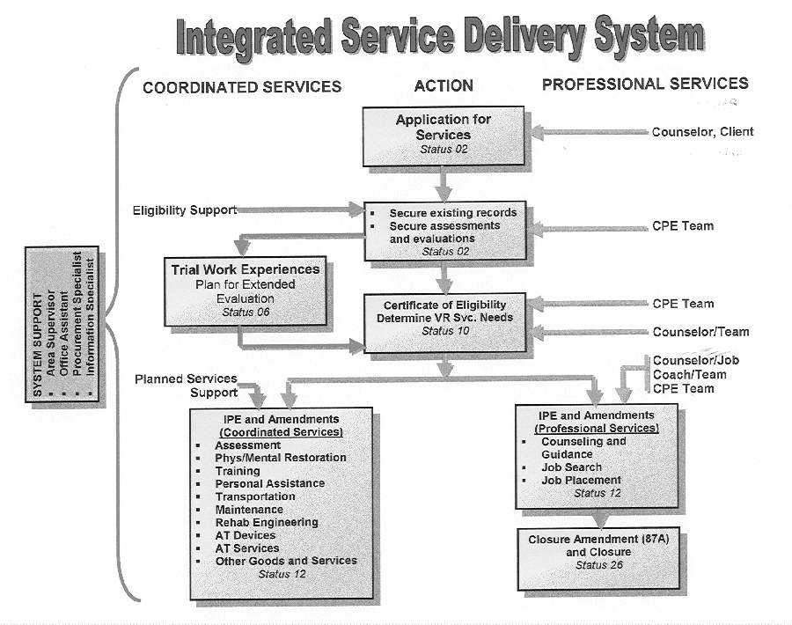
At each stop along the road in service delivery there are checks and balances to ensure compliance with the law and the client’s informed choice. In the Integrated Service Delivery System, an applicant for services has direct interaction with a counselor. Eligibility support personnel secure existing records, such as medical or psychological information, to help determine if the applicant is eligible for services. Using existing records whenever possible instead of ordering new examinations, tests, etc., has helped accelerate the eligibility process and reduce costs.
Sometimes a trial work experience is the best way to determine whether a person is employable and in some cases that applicant may be placed in extended evaluation.
Once the counselor and other members of the service delivery team make an eligibility determination, the applicant is either:
- accepted for services and certified as eligible, or
- denied services based on mandated eligibility requirements that a person must have a physical or mental impairment that substantially interferes with his or her ability to work and must require and be able to benefit from VR services that would lead to permanent, competitive employment.
Once found eligible, the client’s Individualized Plan for Employment (IPE) is formulated to determine VR service needs. This is done through coordinated services and professional services. This process is driven by the client, who normally chooses to develop the plan with the assistance of the counselor and other VR team members. The professional staff focuses on client and community interaction, while the support staff focuses on case management activities.
In addition to counseling and guidance, services might include:

Comprehensive evaluation/occupational or physical therapy
Alcohol/drug abuse treatment
Diagnosis and treatment
Rehabilitation technology
Interpreter services
Personal attendant services
Transportation
Maintenance
Supported employment
Job readiness training
Career planning and employment services
College/university training
Occupational/vocational training
On-the-job training
Miscellaneous training
Job search/placement
On-the-job supports
Technical assistance
Information and referral services
Post-employment services
Other services

Career planning and employment classes are offered to all clients as they prepare for employment. These include: disability-related classes that address specific disabilities and how they affect the client’s ability to work; pre-employment classes for filling out job applications, developing interview skills, and basic computer skills; and/or employment classes for job-ready clients, including job-seeking groups, advanced interview skills and other topics.
Job-readiness training helps the client develop positive work behaviors and the physical stamina needed for successful adjustment to a new job. This training usually includes performing work outsourced to SCVRD work training center by area businesses and industries.
As the client approaches the completion of the services on the IPE, the counselor and other team members focus on the job placement process. Many clients can and do find their own jobs. However, other clients require varying degrees of job placement assistance. The department places a strong emphasis on direct placement.
Once a client is placed into employment, there is regular monitoring of his or her progress. When a client has worked successfully on a job for at least 90 days and the employer and client are satisfied, the case is closed. The client signs off on the closure and is given the opportunity for feedback on the services received.
The department also has engineers who provide rehabilitation technology solutions to help clients with mobility and accessibility problems. This enhances job placement potential. Throughout the process, staff has access to customized technological tools such as computer programs that keep the rehabilitation process moving and allow for monitoring of activity to ensure compliance, quality customer service and productivity.
The Process Management KRA committee developed an inventory of key processes in every department within the agency; and examines and evaluates how these processes add value to the agency mission. These examinations result in identification of opportunities for improvement and recommendations for action.
6.2 Incorporation of efficiency and effectiveness measures into processes
The Program Integrity index was designed to monitor the key processes on a quarterly basis. This allows for trend analysis and quick response to problem areas. The Program Integrity model with each index component is an umbrella that covers the entire rehabilitation process. The index information is available in a statewide format, local area office format, and when applicable, by team. This allows management to identify specific problems with compliance assurance, customer service, and productivity as well as the specific location(s) of the problem.
New technology has been instrumental in continuous improvement processes. Users suggest improvements to computer applications through the use of the “81 Request for Information Services” electronic form process. This allows input from the field from those at the “closest to the process” level.
Technology advances in recent years that have positively impacted processes including customized electronic casework menus, Internet access, MS Outlook e-mail/ planners, availability of policies online, financial tools, electronic forms, HR and procurement documents and many other aspects of day-to-day operation. This evolution has included the participation of all work units in the design, development, and testing of new computer programs and menus.
Computer training provided by the Human Resource Development (HRD) staff has facilitated user proficiency with MS Office. The integration of MS Outlook into daily processes promotes effective communication among team members and is an effective method for advanced planning.
SCVRD frequently uses pilot projects to test new ideas before agency-wide deployment. Pilot projects have input from the staff involved. Creativity with exploring new methods and processes are encouraged.
The electronic Caseload Message Listing alerts casework field staff in the area offices about upcoming compliance requirements.
The Integrated Services Delivery System Timeline (Fig. 6.1) incorporating teamwork ensures the client moves efficiently through the rehabilitation process. Each team member has a specific role, function, and responsibility to the client during each phase of the rehabilitation process.
To confirm job satisfaction and performance, a client must be successfully employed for at least 90 days. The 90 days following employment is the time-span in which the team provides job support services for a successful employment outcome. Although this requirement is supported by regulation and policy, it is enforced by time requirements within the Case Service computer application.
Regulatory and policy mandated requirements are supported in computer applications. Mandated time-frames can not be exceeded or shortened due to SCVRD Case Service programs.
Implementation and interpretation of policies are important since they reflect current regulations. Case Service Policy is online and available to all users. This allows for updates as necessary and reduces the time involved in making the changes as well as cost savings as a result of using an electronic format.
6.3 Daily operation/meeting key performance requirements
The department’s Program Integrity measures are ingrained in daily operations, both at the direct client service level and administrative/support levels. Compliance assurance, quality customer service and productivity are monitored regularly through reviews of Program Integrity reports. The Committee on Rehabilitation Excellence coordinates reviews of all aspects of daily operations and makes recommendations for action plans to address opportunities for improvement in the department’s processes.
The Disability Determination Services program uses extensive quality assurance and operational analysis systems to maintain an ongoing assessment of work processes and costs.
6.4 Key support processes
Critical agency work processes are outlined in detail through role definitions and charts showing the flow of the rehabilitation process. Employees understand their roles in the process through formal training and team building on the job.
Personnel such as area supervisors, procurement specialists, accounting technicians, office assistants and information specialists provide administrative support in SCVRD area offices.
Some of the key State Office and other support processes include:

Administrative Services
Area Office Development
Budgets
Case Services
Center for Comprehensive Services
Client Relations
Deaf Services
Facility Management
Finance
Human Resources
Human Resources Development & Training
Information Technology
Internal Audits
Inventory and Supply Services
Office of the Commissioner
Planning & Program Development
Procurement Services
Professional Development
Program Evaluations
Public Information
Risk Management
Staff Attorney
Substance Abuse Treatment Facilities
Training Center Services

Each support process work unit functions under its own Program Integrity measures. These support components are improved and updated in response to internal and external surveys and focus groups or through technological upgrades, through development of mission-focused training modules, through the Employee Performance Management System process and through Key Result Area teamwork.
6.5 Supplier/contractor/partner interactions
The agency has very strict standards for suppliers, who must adhere to firmly established fee schedules for all purchased products and services in the client service program. Members of SCVRD teams constantly “shop around” for the best values in purchased services. When referring clients for needed medical services, the department requires that all physicians be approved for Medicare reimbursement. When sponsoring a client’s post-secondary education or training, the department requires certification of the institution. Qualifications of vendors are checked in the best interest of clients.
The department complies with all state and federal procurement regulations, requires competitive bidding in line with those regulations, and utilizes the advantages of the state contract system for purchases when possible. Suppliers who work with SCVRD are subject to regular state and federal audits.
A key component of the partnering process involves SCVRD Work Training Center partnerships with more than 350 businesses and industries statewide, nationally, and internationally. These companies provide outsource work to the centers, where clients get real work experience and get paid for their work. This is successful because it is mutually advantageous. Employers become involved with the training centers not simply because of a sense of compassion, but because they can get quality work done at a good price. Recruitment of businesses to participate in the program is essential, and center managers, area supervisors and other SCVRD staff continuously work on maintaining these partnerships through marketing efforts and community involvement. Partners often refer other businesses to our centers. Performance is improved through quality control measures and production standards that must match the high expectations of business and industry partners.
7. Results
7.1 Customer Focused Results

Fig. 7.1-1
PROGRAM INTEGRITY CUSTOMER SURVEYS
As part of the Program Integrity balanced scorecard, two customer groups are surveyed each quarter to measure their satisfaction with the agency’s services, staff and effectiveness in meeting their needs. Customers were randomly selected from case files in all SCVRD area offices.

Customer Groups: Overall Satisfaction Rating
FY2003 FY2004
Clients in Job Readiness Training 91.1%
Clients with spinal cord injuries 89.7%
Clients in alcohol & drug treatment 91.1%
Clients in supported employment 84.4%
Clients receiving career planning
and employment services 88.7%
Clients receiving SSI/SSDI 94.5%
Referral Sources 95.5% 97.2%
Employers 97.9% 98.3%
College, technical, or vocational training recipients 88.9%
High school students 88.7%
Some key customer groups are surveyed on a yearly basis, others at longer intervals.

Fig. 7.1-2
FOLLOW UP SURVEYS OF REHABILITATED CLIENTS show a highly favorable assessment of SCVRD services. The department surveys a random sample of clients one year after their cases are closed (therefore most recent data is from FY2003 closures).
Year in which cases were closed: FY 1999 FY 2000 FY 2001 FY2002 FY2003
Employed one year after closure 77% 75% 74% 73% 71%
Counselor willingness to listen to client’s
ideas and suggestions in developing
service plan 98% 97% 98% 99% 98%
Satisfied with adequacy of information
about their disabilities 97% 97% 98% 97% 98%
Satisfied with promptness of service
delivery 97% 97% 98% 98% 97%
Satisfied with kind of training received 93% 93% 93% 97% 93%
Satisfied with benefits of training received 97% 94% 96% 96% 92%
Satisfied with assistance in seeking job
and finding employment 95% 93% 95% 94% 94%
Satisfied with results of physical
restoration services 96% 96% 99% 95% 98%
Would recommend SCVRD to others 99% 99% 98% 99% 99%
7.2 Mission Accomplishment/Organizational Effectiveness Results

Fig. 7.2-1
SUCCESSFUL CLOSURES
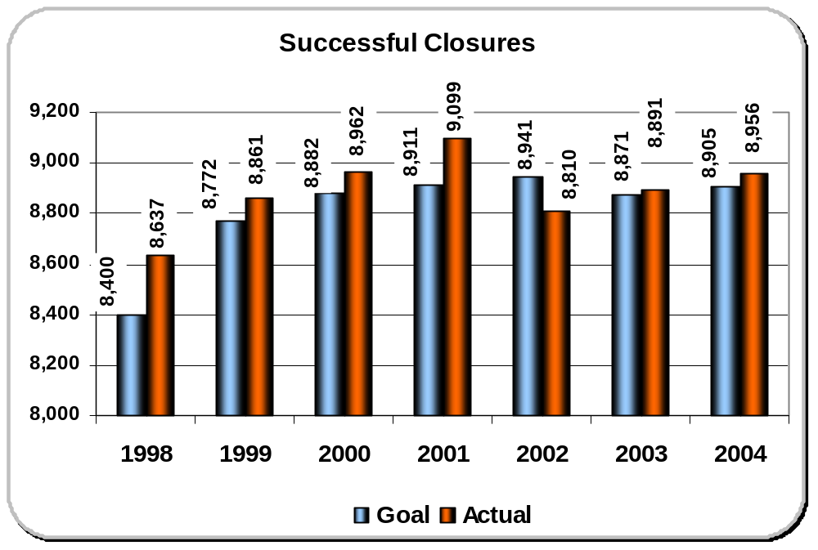The most important organizational effectiveness result is the number of successful closures SCVRD produces. This is the measurement of the number of people with disabilities that have employment outcomes after receiving SCVRD services, the primary mission of the agency. Decline in closures since 2001 is attributed largely to effects of 35 percent state appropriations reductions during that time frame. Gradual improvement has been shown since 2002, the only year that goal was not reached.

Fig. 7.2-2
PROGRAM INTEGRITY RESULTS
Program Integrity measures performance in three areas vital to the agency’s success—compliance with federal regulations and agency policy, customer service and satisfaction measures, and productivity based on federally mandated standards and indicators. The department combines the three elements into an overall Program Integrity Index to measure performance and to foster continuous improvement. These rankings can be as specific as one caseload or area office and as broad as the statewide performance shown below. These results form the baseline for future comparisons and trending.
FY 2003 FY2004
Compliance 94.1 % 93.2%
Customer Service 92.2 % 93.9%
Productivity 82.2 %* 82.1%*
Program Integrity Index 89.5 % 89.7%
* The department’s productivity based on federally required levels was 121%

SEE FULL CHART ON NEXT PAGE.
Fig. 7.2-3
PROGRAM INTEGRITY RESULTS BY AREA
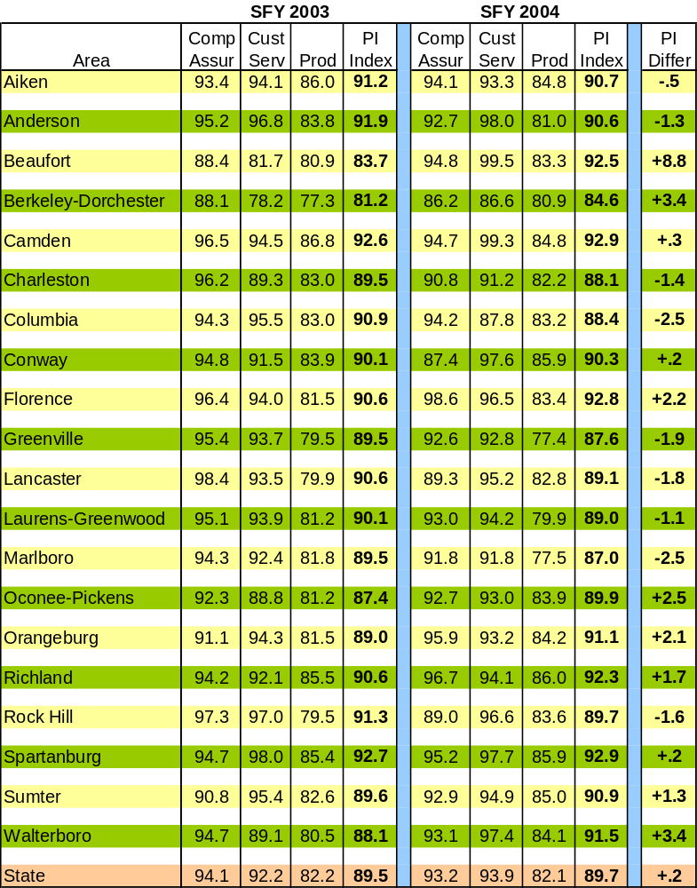
Fig. 7.2-4
REHABILITATIONS PER 100,000 POPULATION
For many years SCVRD has been #1 among the nation’s public vocational rehabilitation programs in the number of people rehabilitated per 100,000 population. The latest national figures, from 2002, show SCVRD at 201.2 people rehabilitated per 100,000. Vermont was second at 200.7. The Southeast average was 97 and the national average was 76.
2002 is the most recent year from which comparative data is available from RSA.
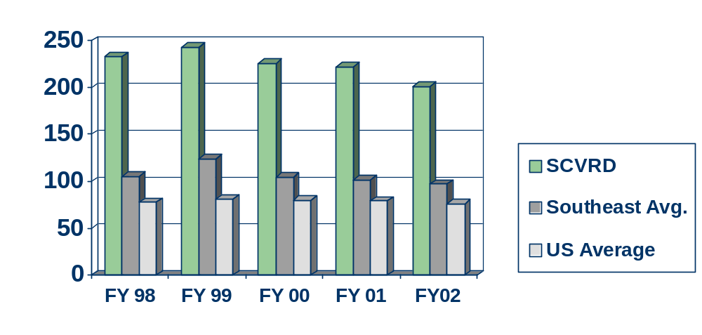
Fig. 7.2-5
DIRECT JOB PLACEMENTS
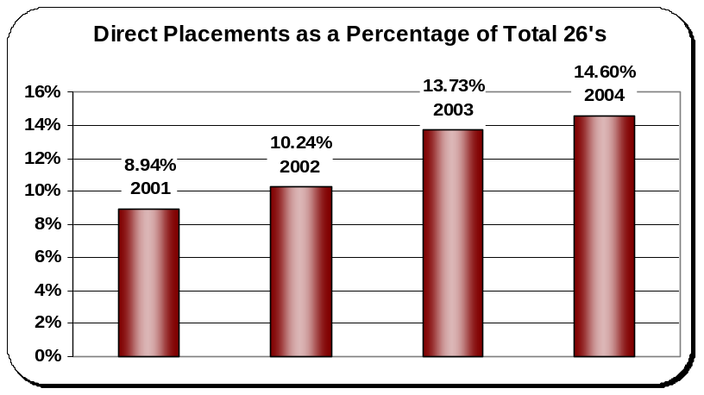
Some VR clients need more assistance than others in landing a job as they complete their VR services. A recent customer service focus in support of strategic objectives is an emphasis on direct job placements for clients.

Fig. 7.2-6
NUMBER OF REFERRALS
Client referrals (new applicants) are vital as the department seeks to increase its impact on employment of citizens with disabilities.
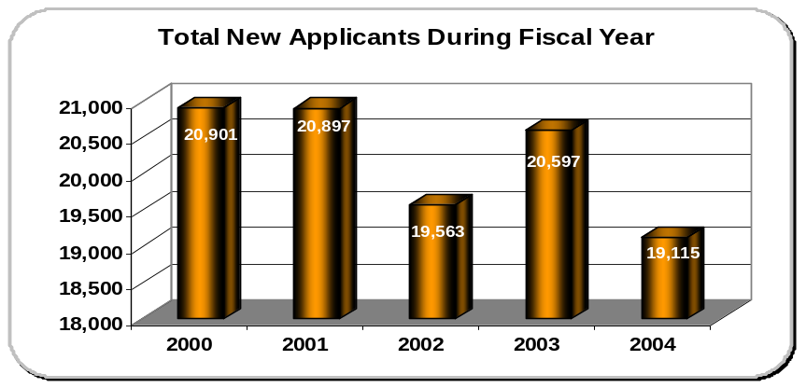

Fig. 7.2-7
NUMBER OF APPLICANTS ELIGIBLE FOR SERVICES
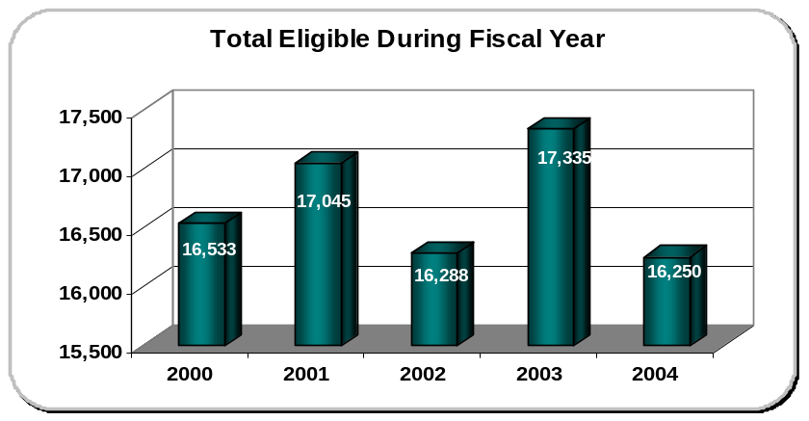
Clients who met eligibility criteria and began receiving services.

Fig. 7.2-8
NUMBER OF INDIVIDUALIZED PLANS FOR EMPLOYMENT (IPEs) WRITTEN
IPEs are written with client to coordinate a plan of services tailored to reach client’s job goals.
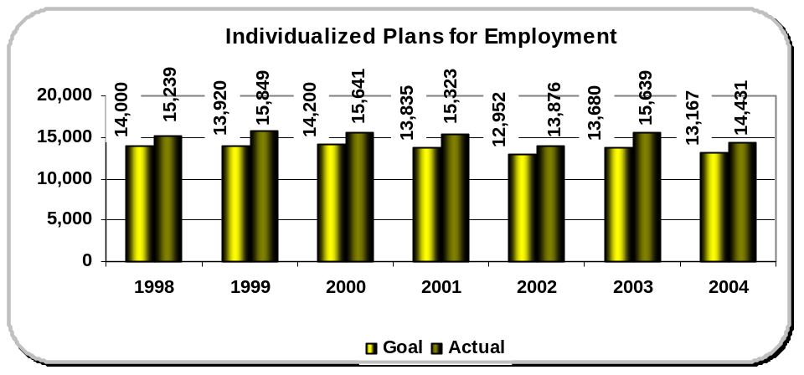
Fig. 7.2-9
TICKET TO WORK ASSIGNMENTS
Social Security disability benefits recipients receive “tickets” to access employment services from an “employment network” of their choice. SCVRD has the second highest number of ticket assignments among state VR programs in the Southeast. South Carolina and Florida were in the first group of states to roll out the program, accounting for higher total assignments. However, SCVRD also receives the second highest percentage of its state’s “tickets” (95%) in the region.
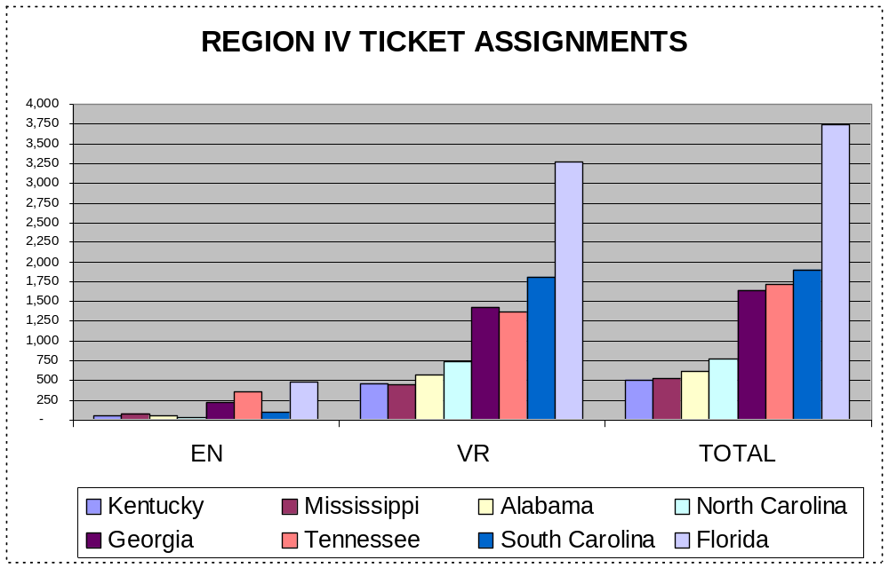
(“EN” designates employment networks other than VR agencies receiving tickets.)

NATIONAL STANDARDS AND INDICATORS established by the Rehabilitation Services Administration, U.S. Department of Education. 2002 is the most recent year in which standards and indicators comparative data is available; however the department met all seven required standards in 2003. Higher scores are better for each of these seven categories.

Fig. 7.2-10
Change in number of closures from previous year
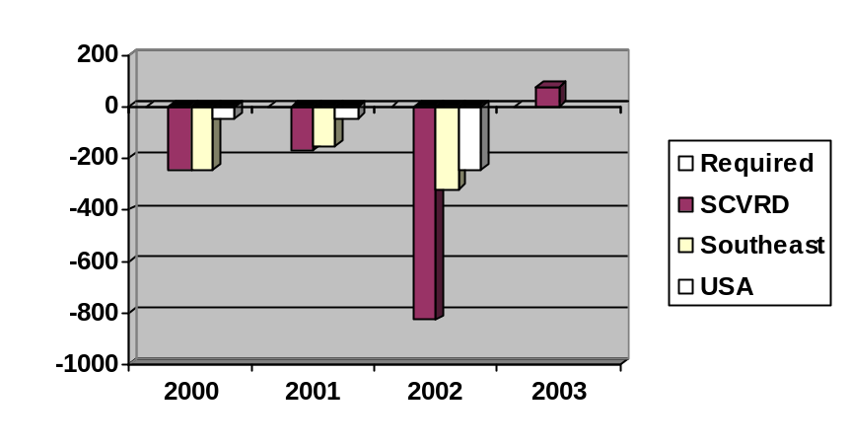
Fig. 7.2-11
Percentage of clients with employment outcomes
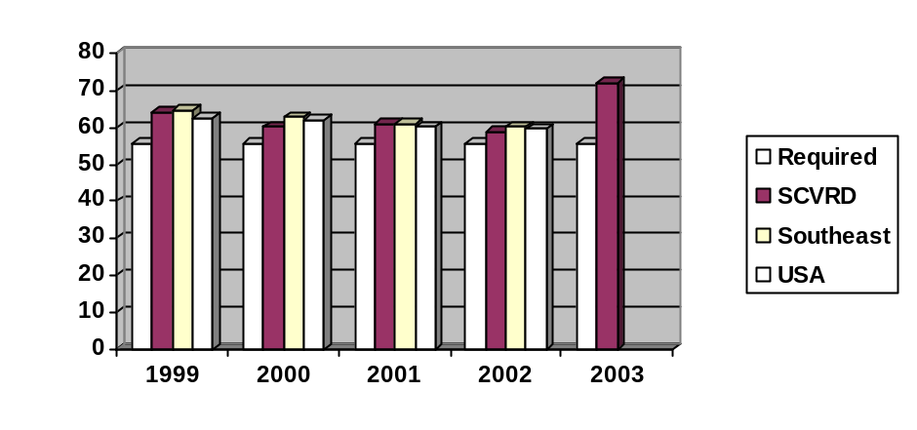

Fig. 7.2-12
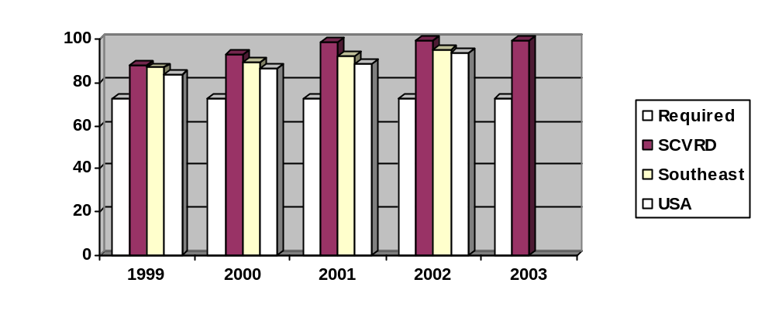Percentage of clients with employment outcomes who were competitively employed
SCVRD led the nation in this category in 2001 with 98.6%
and was third in the nation in 2002 with 98.5%.

Fig. 7.2-13
Percentage of competitively employed clients having “significant” disabilities
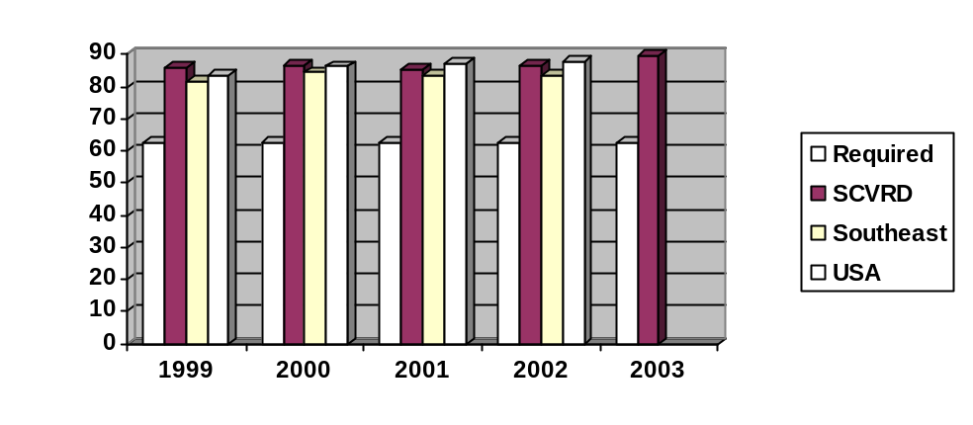
Fig. 7.2-14
better
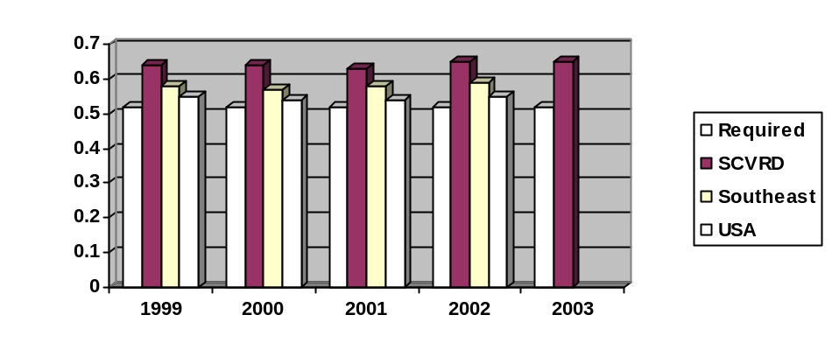Ratio of rehabilitated client wages compared to state average wage

Fig. 7.2-15
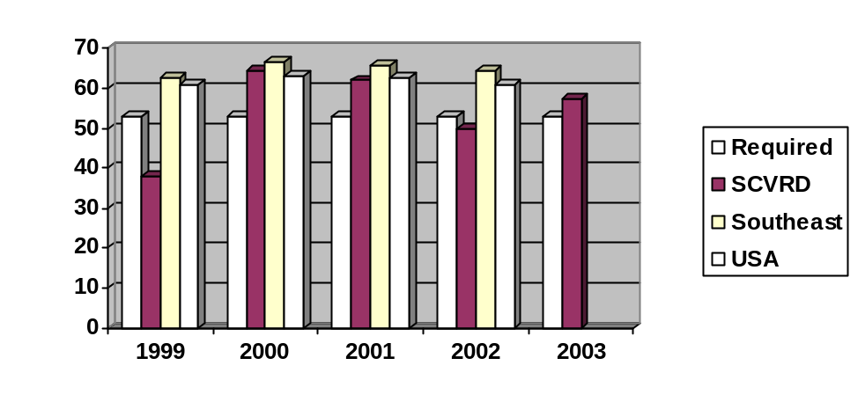Difference in percentage of clients self-supporting after services compared with before
better

Fig. 7.2-16
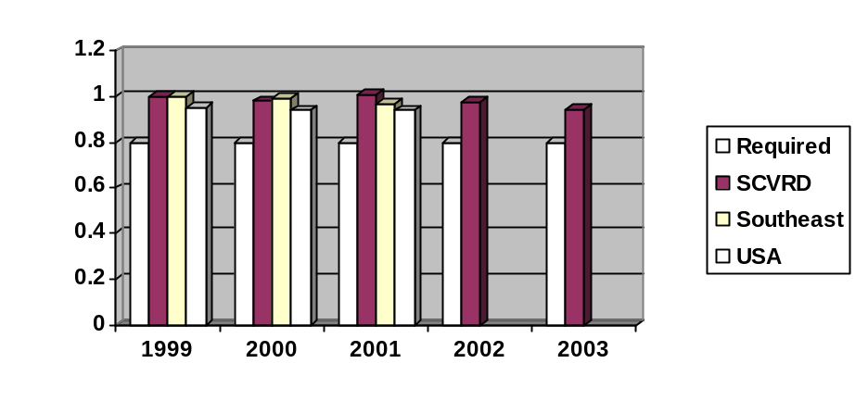Service rate for minority clients as ratio to non-minority
better

Fig. 7.2-17
CYCLE TIME FOR SUCCESSFULLY REHABILITATED CLIENTS
The most recent RSA statistics for mean time spent in the VR program for clients with employment outcomes show that SCVRD is ranked #1 nationally in shortest cycle time for clients to achieve employment.
better
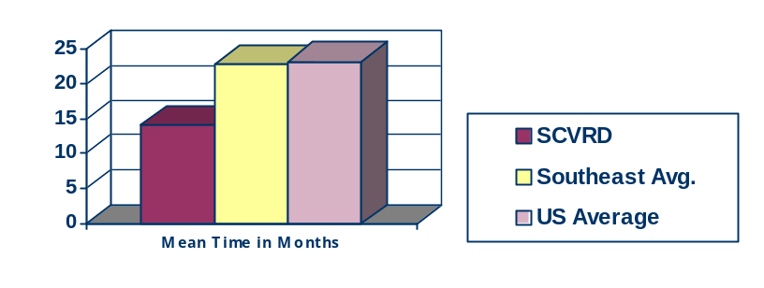

Fig. 7.2-18
DISABILITY DETERMINATION SERVICES
The Disability Determination Services (DDS) unit adjudicates disability claims for the Social Security Administration. DDS strives to achieve performance levels that are equal to or greater than the national average in the areas of productivity (number of claims produced for each FTE); cost per case; and medical cost per case.

DDS faces significant challenges in view of dramatic increases in application rates and limited funding for case processing. During federal fiscal year 2003-2004 the Disability Determination Services will receive, develop and adjudicate more than 75,500 claims on more than 60,000 individual applicants for Social Security or SSI benefits. (Some individuals will apply for both programs at the same time.) In addition, approximately 2,000 claims for disability benefits under the South Carolina Retirement System and approximately 100 applications under the disability provisions of the Homestead Exemption Act will be processed. This will result in more than 1,500 determinations per week with decisions reached in an average of 104 days or less. Through innovative approaches to case development and continued efforts to improve operational efficiency DDS expects to maintain or improve performance in key measurement areas.
Effectiveness and South Carolina Atlanta Region National Avg.
Efficiency Measures 2003 – 2004 2003 – 2004 2003 – 2004

Cost per case $369.56* $354.31 unavailable
Medical cost per case $98.93* $108.23 unavailable
Production per work year 264.6* 272.4 272.7
Processing time 103.5* 95.8 95.7
Documentation accuracy 92.4* 93.3 92

* DDS has bettered national averages in cost and production for several years. In March of 2004, the DDS was on par to adjudicate 103.7% of the budgeted workload, the production per work year (PPWY) was at an all time high of 305.2, with the national average being 293.8 and the regional average at 283.6. Due to the training requirements, learning curve and system readiness of the new electronic file for which South Carolina was chosen as a pilot state, there was a decline in production and PPWY. As enhancements are added to the electronic file system and the examiners become more adept at analyzing cases in an electronic format DDS will regain some of the lost ground. DDS will continue to look at other ways to increase production capability.

7.3 Financial and Market Results
Fig. 7.3-1
AVERAGE COST PER CLIENT SERVED
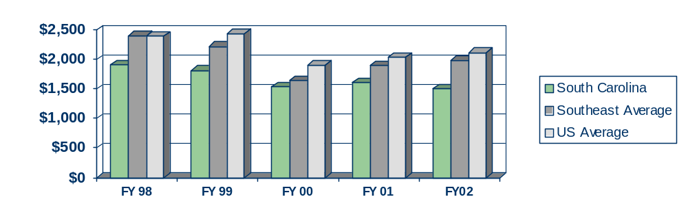SCVRD has consistently ranked among the nation’s best programs in the average cost per client served. In the most recently available national and regional comparisons (2002), the department had the 8th lowest cost per client served ($1,495) among state VR programs in the U.S. SCVRD also betters the average cost among the eight Southeastern regional states.
better

Fig. 7.3-2
AVERAGE COST PER CLIENT REHABILITATED
The department’s efficiency and effectiveness is reflected in its national prominence among VR agencies in cost per rehabilitation. For each successfully employed client, the department’s average cost was $7,977, the second lowest in the entire nation behind Texas ($7,780) in FY2002, the most recently available national data. In fact, SCVRD was number one in the nation in FY1998 and FY1999. The department consistently leads the eight Southeastern region states in this measure.

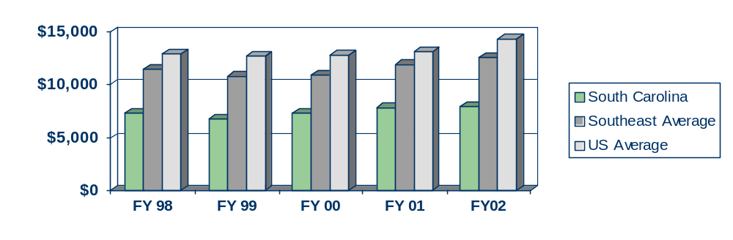
better
Fig. 7.3-3
RATE OF RETURN ON TAXPAYER INVESTMENT

SCVRD provides an excellent rate of return on resources invested in its clients. By becoming competitively employed, clients lessen their dependence on public assistance such as Social Security disability benefits, Medicaid, welfare, etc. Clients who become employed realize an increase in their earnings by $11.76 for every dollar of Vocational Rehabilitation Department funds invested in their rehabilitation. They return an estimated $2.99 in taxes for every dollar spent on their vocational rehabilitation. By paying taxes, they repay the cost of their rehabilitation in an average of 5.4 years. The following chart shows the annual rate of return for each successfully employed client. These rates have all improved the past two years.

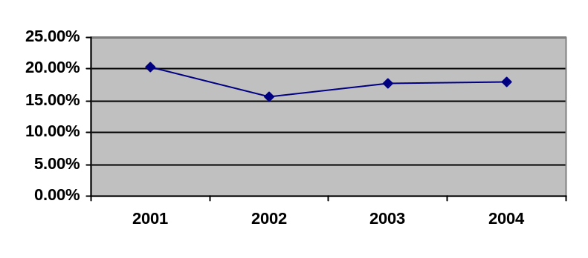
Fig. 7.3-4
REIMBURSEMENTS FROM SOCIAL SECURITY ADMINISTRATION
For converting recipients of Social Security disability benefits into competitively employed persons who no longer rely on those benefits, the department is reimbursed by the Social Security Administration for monies spent on those cases. Although the department’s reimbursement declined slightly in 2004, the department actually had a higher number of reimbursements (119 compared with 98 in 2003).

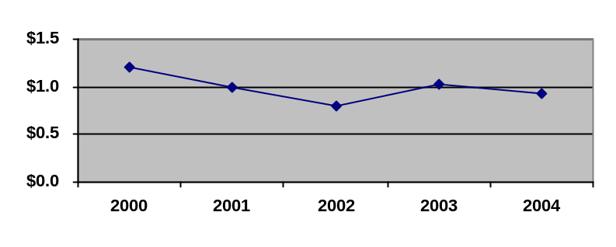SSA Reimbursements (in millions)
Fig. 7.3-5
PERCENTAGE OF EXPENDITURES SPENT ON ADMINISTRATIVE COSTS
The most recent RSA statistics show that SCVRD spent a smaller portion of its appropriations on administrative costs than the regional (8 states) and national average. This translates into a higher percentage of spending on direct client services leading to employment goals.
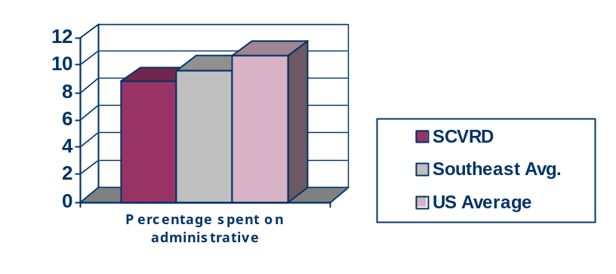

better

Fig. 7.3-6
WORK TRAINING CENTER REVENUES

Partnerships with South Carolina’s businesses and industries through more than 450 outsource agreements provide job readiness training opportunities for clients. The agreements generate revenues for SCVRD’s 23 work training centers. Some of the revenues are used as stipends for the clients who work on the contracts. The remainder is used for raw materials, supplies and other operating expenses. Revenues decreased for three years as the result of worsening economic conditions, including the movement of some outsource work to other countries; SCVRD increased its focus on marketing the centers to industry, and revenues increased in FY2004.

.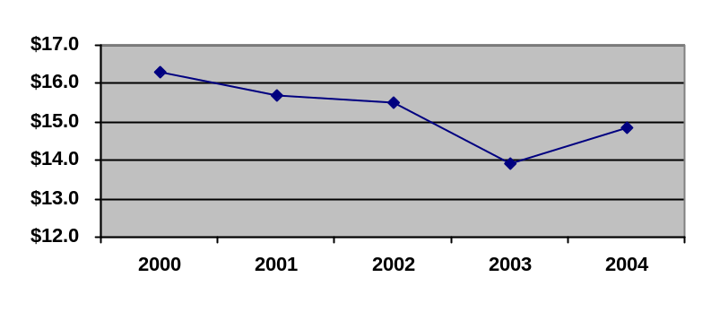
Work Training Center revenues (in millions)

Fig. 7.3-7
ALTERNATIVE FUNDING
One of the agency’s key strategic objectives is identification and acquisition of alternative funding sources, especially in light of recent budget cuts. Since 2001 four major grants have been acquired, and all are ongoing.

Literacy and Employment Outcome U.S. Dept. of Education/OSERS $949,750
South Carolina Telework Program U.S. Dept. of Education/RSA $957,860
S.C. Assistive Technology Loan Program U.S. Dept. of Education/RSA $542,285
S.C. Pathways Toward Employment (BPAO) Social Security Administration $1,575,000

Fig. 7.3-8
COOPERATIVE AGREEMENTS
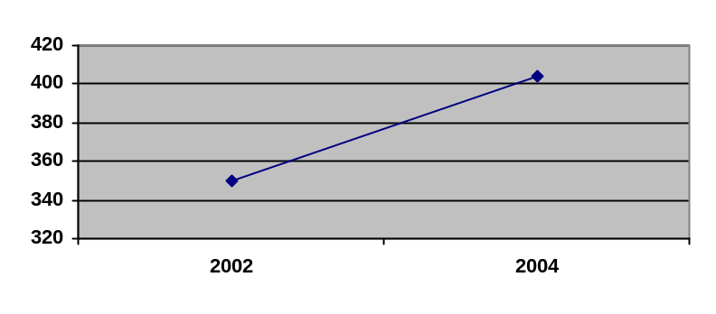A key strategic planning objective is the formation of close ties with community resources of all types. The department’s number of formal cooperative agreements has grown significantly:

7.4 Human Resource Results

Fig. 7.4-1
Cost reductions are evident in many areas because of increased automation and overall staff productivity. Personnel allocations are now related to per-employee productivity. The total number of eligible cases served remained stable over the last three fiscal years. Currently these cases are being served with approximately 20 fewer staff than two years ago.
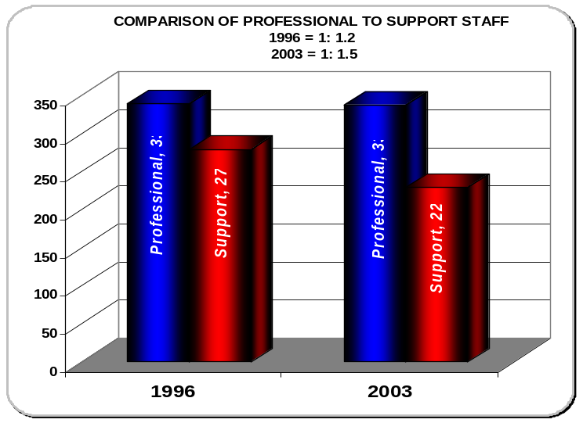
The department’s streamlining efforts of recent years has resulted in the shifting of duties to enhance customer service, resulting in a decrease in personnel devoted strictly to support duties.

Fig. 7.4-2
EMPLOYEE JOB SATISFACTION
In 2003 SCVRD initiated its employee job satisfaction surveys. Surveys were sent quarterly to cross sections of staff throughout the state. The survey tracks the effects of administrative and programmatic initiatives on employee job satisfaction. The feedback will assist SCVRD in assessing its strengths and weaknesses as an employer. Feedback also will be used in designing policies and programs that promote job satisfaction. Focus groups will be formed as needed to address issues raised by the survey and supplement survey information. Cumulative averages (covering six quarters, January 2003 through June 2004) for each response are shown below. Agreement levels were scored on a scale of 1 to 5, with 5 being strongest agreement.
Work expectations are clearly explained to me 4.41
The work resources I need to perform my job are available to me. 4.09
I have an opportunity to excel at performing my work every day. 3.95
Within the last week, I have received recognition or praise for doing good work. 3.09
My manager or other coworker seems to care about me as a person. 4.06
My development as an employee is encouraged by my manager or coworker. 3.67
My opinions are valued at work. 3.61
The department’s mission makes me feel important. 4.21
My coworkers are committed to doing quality work. 3.95
I have a good friend at work. 4.24
In the last six months, my manager/other coworker has talked to me about my progress. 3.69
This last year, I have had opportunities at work to learn and grow. 3.90
I feel that I am a member of a team within the organization. 3.96
Executive level management believes that the work in my area is important. 3.92
Executive level management understands my work area’s role in the organization. 3.82
Decision-making authority is delegated to the appropriate management level. 3.58

Fig. 7.4-3
EEO GOAL ATTAINMENT

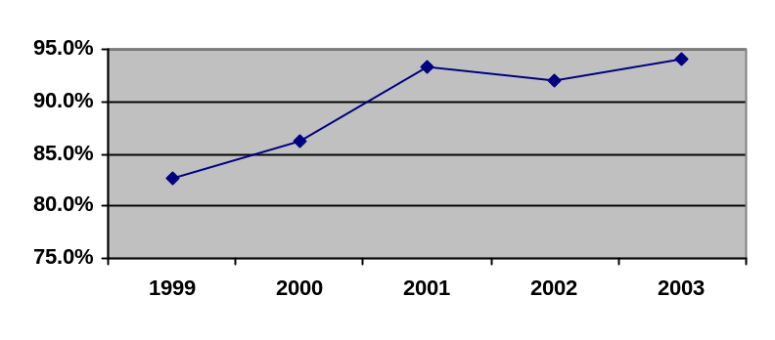The State Human Affairs Commission annually publishes its report on state agency hiring. This report details each agency’s efforts in recruiting, hiring and promoting individuals in various sex and race demographic categories and ranks agencies on how closely the makeup of the agency reflects the available workforce. In the last four years, SCVRD has increased its level of goal attainment 11 percentage points. In addition, the agency ranks 13th among all state agencies in goal attainment and third among large agencies of 1,001 employees or more.

Fig. 7.4-4

Human Resource Development and Training
Training Site Total Training Events Total Training Participants
FY02 FY03 FY04 FY02 FY03 FY04
Internal training/
videoconference sites 155 107 104 2,700 2,354 1,890
External training 82 161 249 178 621 907
Totals 237 268 353 2,935* 3,166* 2,797*
* Some staff members participated in more than one training event.

PROFESSIONAL DEVELOPMENT PROGRAM (PDP)

Following a intensive recruitment drive, the first year of the program attracted 121 participants. Sixty-seven participants indicated a primary interest in management and supervision and of those, 54 participated in a series of three, three-day leadership training sessions. Twenty-five promotions have come from the general PDP program. Enrollment will open again in November 2004.
The SCVRD Professional Development Program has gained national attention with presentations being made in Dallas to Region VI and in Atlanta to Region IV of the Rehabilitation Services Administration to agency individuals involved in succession planning. The program is also featured as a "best practice" on the RRCEP website: (http://recruitmentinitiative.org/mywebsite/id4.html).
A significant component of the PDP is experiential learning. Fourteen projects have emerged as a result of the PDP program. Participants have been involved in grant writing, process mapping, and the development of a code of ethics for the agency.
COMPENSATION/RETENTION/RECOGNITION
SCVRD revised its compensation plan to provide greater rewards for reclassification (from 6 percent to 10 percent), promotion (from 8 percent to 12 percent), and additional duty pay actions (from 6 percent to 10 percent). Salary increases (5%) have been awarded for the achievement of graduate and undergraduate degrees that relate to the performance of the employee’s job duties and/or the agency mission. As a result of revenue-generated funds, the agency was able to implement a bonus program that was directly tied to the performance of each work unit. This program was designed to support performance excellence and teamwork.
The department conducted salary studies among Southeastern states to determine competitive pay rates for two types of positions (counselors and examiners) and made adjustments to employment rates in order to be more competitive in attracting and retaining employees for these positions. Any employee in one of these positions with a salary below the employment rate had his/her salary increased to the new employment rate. The Department has also conducted studies to identify and resolve inequities in compensation among various types of positions.
Despite all the compensation changes, the agency’s personnel services expenditures remained virtually unchanged when compared to the previous fiscal year—2003: $42,780,593; 2004: $42,780,018 (data from Comptroller General’s Office reports). SCVRD believes this is due, at least in part, to greater efficiencies in staffing patterns achieved through the reengineering effort.
One measure to determine how effective our initiatives have been in creating a positive and productive work environment is the turnover rate for department employees. A comparison of the agency’s turnover rate for fiscal 2003/2004 against the national average for state and local governments shows that SCVRD experiences a significantly lower turnover rate than the national average (SCVRD – 7.94 percent; National Avg. – 14.5 percent). This 7.94 percent turnover rate is much lower than the previous year (11.6 percent).
The Celebration of Success reward and recognition program has been well-received by staff. In fiscal year 2003/2004, a total of 380 prizes were awarded to employees who had garnered three nominations from their peers. Many other employees had received one or two nominations.

7.5 Results for Regulatory/Legal Compliance and Community Support
A thorough Rehabilitation Services Administration (SCVRD’s regulatory agency) review completed in the past year revealed no significant negative findings. In the area of financial management, only two required actions were identified and the agency has responded appropriately. In the monitoring and technical assistance programmatic review, five recommendations were made and plans of action were submitted for review.
The department must adhere to budgeting and procurement codes, building codes, and various other state and federal regulations that any government agency would be subject to. Fiscal accountability is established through internal and external audits. The department’s audit results have been extremely positive for a period of several years. Annual state financial audit results for the past five years show no major misuse of funds. Minor reconciliation issues are expected to be corrected by new computer applications. Procurement audits, conducted by the state every three years, are extremely favorable. Benefits audits have shown some opportunities for improvement that the department is addressing through added involvement by the finance department to serve as a “check and balance.”
In its 2003 “Annual Report on Appeals Process” to the RSA, U.S. Department of Education, the department reported only one new request for mediation during the year, which was resolved prior to the development of a written mediation agreement; and one dispute resolved during an impartial hearing process. The client relations specialist, staff attorney, human resources department, commissioner’s office and Governor’s office work closely together to ensure ethical and fair treatment of agency clients before extreme measures would become necessary.
All SCVRD facilities receive great internal scrutiny in the area of safety. OSHA and Department of Labor standards are observed, and safety measures are a priority. Safety teams have been established in all office locations to assess safety issues for staff and clients. In addition these teams provide feedback to the Risk Management department on agency-wide safety issues and assist in developing tailored solutions to local safety problems.

Fig. 7.5-1
EXPERIENCE MODIFIER
A key business result for safety and risk management is the Experience Modifier (EMOD) measurement. SCVRD seeks to enhance the environment for its employees and clients by reducing accidents in its facilities, which in turn accomplishes a cost savings in workers’ compensation premiums.
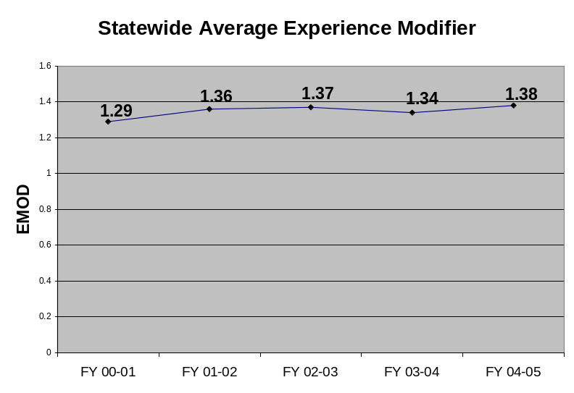

COMMUNITY RELATIONSHIPS
SCVRD has strong relationships with key state agencies and disability-related organizations in communities throughout the state, as required by the commissioner’s expectations list. Staff members are assigned to maintain relationships and be involved in the organizations’ initiatives, and SCVRD offers grants to associations for conferences when employment is a topic. SCVRD participates in the state’s emergency preparedness plan by providing personnel and equipment in the event of an emergency, especially in the areas of crisis counseling and transportation.
The department has increased its collaborative efforts with private, non-profit organizations to expand its services to people with significant disabilities. (see Fig. 7.3-8)
The agency is active in community assistance projects such as United Way, Red Cross, Salvation Army and the Good Health Appeal. Through involvement in local and state chambers of commerce activities, Rotary groups and other community organizations, SCVRD staff maintain high visibility in their communities.

Fig. 7.5-2
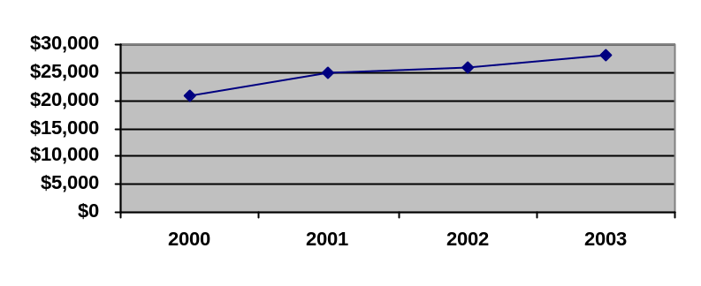SCVRD EMPLOYEE UNITED WAY CONTRIBUTIONS

