Accountability Report Transmittal Form

Agency Name: Public Service Activities – Clemson University

Date of Submission: September 15, 2005

Agency Director: Dr. John W. Kelly

Agency Contact Person: John T. Clemens

Agency Contact’s Telephone Number: 864-650-6001

Clemson University - Public Service Activities
Budget and Control Board Accountability Report for 2004-2005

“Putting Science to Work for South Carolina”

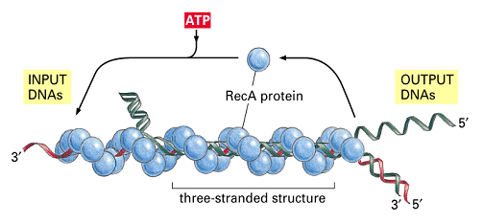


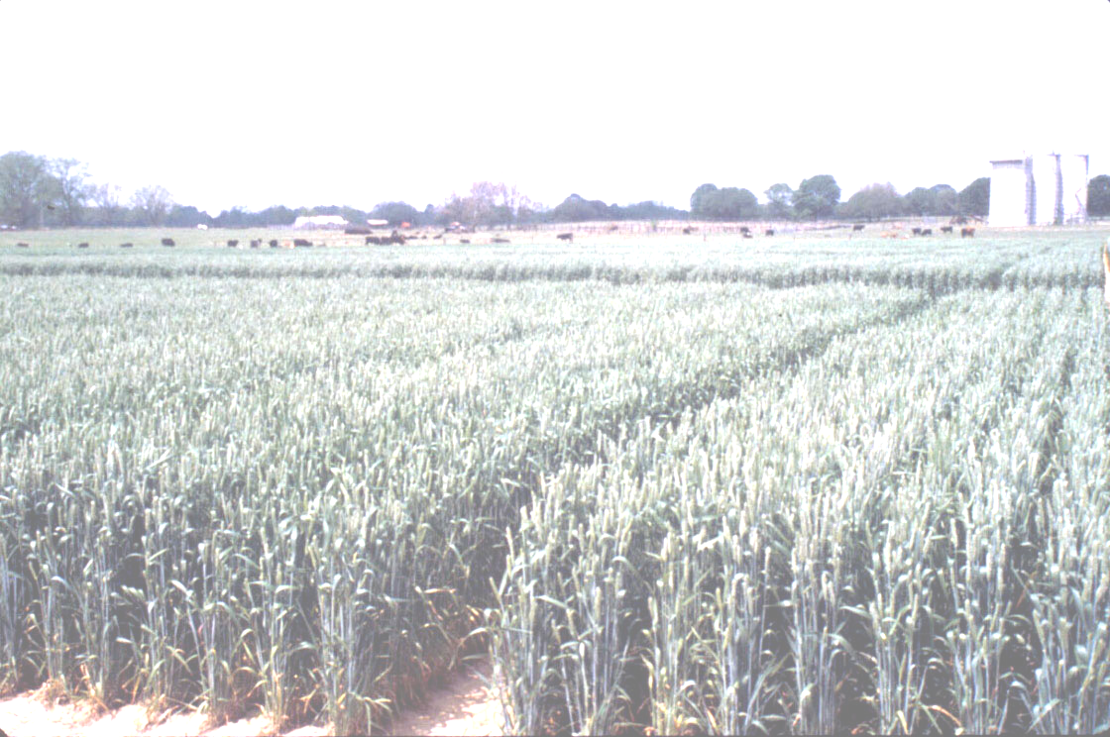



Table of Contents

Section I - Executive Summary . . . . . . . . . . . . . 2

Section II - Business Overview . . . . . . . . . . . . 16

Section III - Elements of

Malcolm Baldrige Award Criteria . . . . . . . . . 20

Section IV - Referenced Measures . . . . . . . . . 38

Putting Science to Work for South Carolina
Public Service Activities Accountability Report 2004-2005

Agriculture, an industry in transition, is no longer based simply on the farm – it is in the classroom, in the research lab, in various industries, in homeland security and yes, still on the farm. The industry faces new problems that require more sophisticated methods to answer. These problems are not just farm/food issues anymore but issues affecting communities, our youth, our environment and our safety. That is why Public Service Activities at Clemson University is using new technologies to find these answers.

In this document you will see references to various lists, objectives, emphasis areas and goals. Because of our belief in accountability and the use of the results, PSA must be able to demonstrate that our efforts meet the needs of our constituents. Accountability measurement is a worthwhile process that is a part of our responsibilities as a state agency serving the people of South Carolina. Throughout this document you will see that PSA continues to stay true to the five goal areas that were designated as the areas in which the people of South Carolina depend on PSA for assistance. That is why you will see that the divisions, departments, institutes, centers of our university and in every county of our state and in our partners across the world, Clemson's Public Service Activities is fulfilling this mission through research, regulatory, education and outreach efforts.

Public Service Activities Goal Areas

Agrisystems Productivity and Profitability. Clemson researchers, Extension specialists and regulatory agents are working with the state's agricultural and forestry producers to increase productivity and profitability, so South Carolinians can compete successfully in an increasing global economy. This includes financial planning, new technologies and agricultural systems, and management programs for farmers
Economic and Community Development. Thomas Green Clemson's gift to the state of South Carolina was intended to help the state's citizens improve the quality of their lives. That legacy continues through various programs that prepare local community leaders to bring jobs, new businesses and a more appealing downtown to rural communities throughout the state.
Environmental Conservation. Protecting and enhancing South Carolina's natural resources are vitally important for the quality of life in our state, as well as for the future economic development potential.
To this end, Clemson researchers, Extension agents and regulatory personnel are working with partners around the state to enhance our forest and wildlife populations and to ensure the safe and effective use of fertilizers and pesticides.
Food Safety. The United States has the safest, most affordable and most reliable food supply in the world, largely because of the contributions of land-grant universities such as Clemson. Clemson regulatory agents work closely with South Carolina producers to ensure that the state's meat, poultry and plant crops meet all the federal and export safety requirements.
Youth Development and Families. Strengthening the support for families and young people is becoming a major focus for South Carolina, making ongoing family and youth development programs conducted by Clemson increasingly important. The 4-H camps and local programs play a major role in teaching youth and adults necessary life skills, such as resolving conflict and becoming informed consumers.

Section I – Executive Summary

I-1 Mission and vision

Mission Statement
To develop new biological, physical and social science information and present educational programs and information on food, fiber, forestry, natural resources and economic growth that will help the citizens of South Carolina improve the quality of their daily lives.

To protect farmers, citizens and the ecosystem from the spread of animal and plant diseases and invasive species and to ensure the quality of seeds, fertilizers, meats and organically grown crops in South Carolina.

To provide opportunities for children, businesses and communities to realize their full potential and to develop an appreciation for the delicate balance of air, soil and water that will ultimately determine the quality of South Carolina’s future.
Vision Statement
To be acknowledged as the foremost provider of practical new discoveries, outreach education and technical assistance in the areas of agrisystems productivity and profitability, economic and community development, environmental conservation, food safety and nutrition, and youth development and families in order to enhance the quality of life for South Carolina’s citizens.
Clemson University was founded in 1889 on Thomas Green Clemson’s belief that education could create a better way of life for the people of South Carolina. Since its founding, Clemson University has served the state’s citizens, communities and businesses through Public Service Activities that include research, Extension and regulatory agencies for plant and animal health. As our state’s needs have changed over the years, the scope of Clemson’s public service has also changed in keeping with our mission to improve the quality of life for South Carolinians today and in the future.

Clemson University is part of a national system of land-grant universities established by the US Congress to improve the quality of life for the citizens in each state. Clemson Public Service Activities include research, outreach and regulatory responsibilities.
Values
Service – Clemson PSA serves all of South Carolina’s citizens through research, outreach and regulatory activities that enhance the quality of life in our state. We build partnerships with people, communities, industries and agencies to achieve our mission; we are responsive to their needs and we are proactive in our outreach.

Discovery – Clemson PSA conducts research to discover innovative technologies, products and processes that can enhance agribusiness industries, build rural economies and communities, protect the environment and natural resources, improve the nutritional quality and safety of the food supply, and prepare South Carolina’s youth to be productive citizens.

Knowledge Transfer– Clemson PSA believes that sharing and applying knowledge generated by scientific research is the best way to help South Carolina’s citizens make informed decisions about the major issues that affect their lives.

Respect – Clemson PSA pledges to provide a work environment that fosters collaboration and respect among our employees and for those we serve, regardless of race, faith, ethnic heritage, gender or sexual orientation. We value the state’s cultural diversity and strive to respect that diversity in our staffing and services.

These services are conducted by a statewide network of faculty and staff who are dedicated to addressing the major issues facing South Carolina’s population.

This work advances the competitiveness of agriculture and forestry industries, enhances the economic potential of rural communities, safeguards the food supply, preserves natural resources and prepares young people to become productive citizens. Clemson Public Service Activities personnel also provide research, training and information to decision makers in state agencies and municipal governments.

Through these efforts, Clemson University Public Service Activities touch the lives of every person in South Carolina.

I-2 Major achievements from past year
Discovery
Disclosures Received:
Title | Inventor(s)
Injection Molding Using Plant Based Material Kenaf | Danny Roberts, David Gangemi
Injection Molding Using Composites of Plant-based Materials: Kenaf, Corn & Tumeric | Danny Roberts, David Gangemi
Lectin Gastrodianin Confers Enhanced Tolerance to Phytophthora Nicotianae in Transgenic Plants | Guido Schnabel, Ralph Scorza, Desmond R. Layne
Disposable Pipette Extraction | Bill Brewer
Tobacco Harvester Modifications to Prevent Spread of Bacterial Wilt | Bruce Fortnum, Roy Dodd, Ahmad Khalilian
Municipal Solid Waste Treatment System | Annel Greene
Electrical-based Sanitizing Surface & Materials | Paul Dawson, Annel Greene
Sandhill Ant Exclusion Baffle | Timothy S. Davis, Bryan A. Glover, Paul M. Horton
The Recovery & Bovine Proteins for Therapeutic Use | Steve Ellis, Tom Scott
The Recovery & Use of Supramammary Lymph Node Proteins for Serum Replacement | Steve Ellis, Tom Scott
US Applications Filed:
Title | Inventor(s) | Type
Controlled Eutrophication Process | David Brune, John Collier | US
Adhesin-Specific Nanoparticles | Fred Stutzenberger, Bob Latour, Ya-Ping Sun, Tzuen-Rong J. Tzeng | foreign
Genes Controlling Winter Dormancy in Woody Perennials | Greg Reighard, Bert Abbott, Douglas Bielenberg | provisional
Feed Supplement Delivery System | Tom Jenkins, Karen Burg, Steve Ellis | provisional
A Novel Immunotherapy for Breast Cancer | Thomas R. Scott, Heather P. Borick, Ginger A. Swire-Clark, William R. Marcotte, Ashby B. Bodine | foreign
The Lectin Gastrodianin Confers Enhanced Tolerance to Phytophthora Nicotianae in Transgenic Plants | Guido Schnabel, Ralph Scorza, Desmond R. Layne | provisional
US Patents Issued:
Title | Inventor(s) | US Pat #
Process for Ozonating & Converting Organic Materials into Useful Products | Annel Greene | 6,835,560
System & Process for Treating Carbonaceous Wastes | Annel Greene | 6,893,565
- 103 Technical Contributions to scientific and technical journals
- 45 Mentions in the National Media

Efficiencies and Cost Savings Achieved
- Monetary savings for consumers where Regulatory Services' Department of Pesticide Regulation (DPR) investigated structural pest control activities were $801,889.00. This figure is a conservative estimate of the money refunded directly to consumers as a result of the DPR's activities. It includes legal settlements, refunds, and the value of repairs that would not otherwise have been made, but does not include the value of treatments already paid for by the consumer but properly completed because of the DPR’s involvement.
- Agriculture Service Laboratory, which is comprised of the Soil Testing Lab and Plant Problem Clinic, has been moved from Extension to Regulatory Services. Over the next five years it is the goal of the Agriculture Service Laboratory to become self-sustaining through grants and/or improved marketing of the product via retail outlets.
- A grant-support services position has been filled to help increase funding from alternative sources for the County Extension programs. For Extension to reduce its reliance on state support, a system must be installed that works with the complex set of funding opportunities possible for the Extension Service from a myriad of funding sources. These complex financial opportunities range from traditional sponsored programs to county MOUs, contract consulting, generated revenues, etc. Field staff will be hired to work with constituents for this new funding.
- Counties have begun leasing laptop computers to replace state-owned desktop computers to reduce Information Technology personnel costs and increase access to a computer. The Extension Service is adding DSL lines where available in the counties to increase internet efficiencies.
- Progress continues with the elimination of desk phones in appropriate areas and equipping people with cell phones. This will take some time to fully implement as it must be handled on a case-by-case basis. No cellular service has the complete statewide service that is needed in rural areas. Cellular service on campus must be improved as it is poor in several buildings. A system-wide contract should be investigated that allows for free minutes among CU employees which would greatly reduce its long-distance charges.
- Reorganization of the PSA administrative team has been completed to reduce administrative cost and improve efficiency. This effectively eliminates three associate dean positions, two county director positions and one development position. The combining of the responsibilities for the five PSA associate dean positions as follows:
  - Fran Wolak has assumed responsibility for Youth Development & Families in addition to Extension Field Operations and Chief Operating Officer for Extension.
  - Susan Barefoot will continue her responsibility for Food Safety & Nutrition in addition to Chief Operating Officer for the Experiment Station.
  - Bruce Pinkerton has assumed responsibility for Environmental Conservation and Agrisystems Productivity and Profitability in addition to acting as Associate Dean for Agriculture & Natural Resources.
  - Mac Horton has assumed responsibility for Economic & Community Development in addition to Director of the Clemson Institute for Economic& Community Development and the Sandhill Research and Education Center.
- The number of Extension regions has changed from six to four. Two of the four County Director positions have been filled with Research and Education (REC) Directors assuming this additional duty. Organization of County Extension programs will be via four regional areas.
  - George Askew has assumed responsibility as director of Extension offices in the Pee Dee region in addition to Director of the Pee Dee REC and Director of the Baruch Institute for Coastal Ecology and Forest Science.
  - Steve Meadows is now serving as Director of Extension offices in the Savannah Valley region in addition to director of the Edisto REC.
- Other personnel changes:
  - Neil Ogg has assumed additional duties as Associate Vice President of PSA to coordinate efforts in IT planning, accountability, marketing, information technology and grant services in addition to serving as director of Regulatory Services.
  - Projected benefits from this action: Increased coordination of PSA executive presence at constituent meetings and distance education opportunities.
  - Funding will be eliminated for the PSA development manager position. Duties will be absorbed by existing personnel.

Identifying Outside Resources
- Approximately $17.334 million in grant funding was secured to leverage, support and expand PSA activities (preliminary figures).

Education and Outreach
- Clemson Extension Service conducted nearly 19,000 educational programs throughout the 46 counties of South Carolina. The total number of participants in these programs was over 250,000. Of those individuals participating, 70% reported gaining knowledge.
- Approximately 584,300 contacts were made by Extension personnel in the delivery of educational information. In addition to programs, this total reflects repeated interactions with clientele via telephone, office walk-ins, farm and home visits, and newsletter and periodical distribution.
- The Master Wildlifer course is broadcast live via satellite and delivered to over 140 downlink sites in 12 states across the South in seven 3-hour sessions (21 hours total). The first course was delivered February through March and reached 4,821 landowners and natural resource professionals. The second course was delivered February through March and reached over 3,000 landowners and managers. Evaluation surveys were given to all participants of the first course in 12 states to measure impact. With over a 30% response rate of course participants, the following results and impacts were achieved from the first course: Course participants owned an average of 1,489 acres (8.8 million total acres), managed an average of 13,032 acres (3.3 million total acres), and leased for recreational use an average of 3,383 acres (9.9 million total acres); 77% of the participants reported that the course helped save an average of $5432.00 and 54% earned an average of $17,186.00; over 92% of the course participants plan to implement and/or make changes and improvements to wildlife habitat and/or sustainable forestry practices on their land. Evaluations from the second course are in progress. So far, as a result of implementing wildlife management plans, tree farmers have been able to generate alternate sources of income by leasing sections of property for the hunting of deer, turkey, small game and waterfowl.
- Family and Community Leaders volunteers contributed over 35,400 hours of time and over $620,000 in program support. Approximately 2,819 FCL volunteers conducted programs reaching over 5,000 persons.
- More than 130 youth participated in financial management programs. Over 90% of the participating youth have reported an increase in self-confidence while presenting before groups and a gain in knowledge and skills related to financial management.
- More than 950 youth participated in service learning projects and over 450 led service learning projects. Projects included: three 4-H youths participated in an exchange trip to Costa Rica and raised $1,000 to paint an elementary school; Youth participated in Project Spirit Veterans History Project; served 60 people at a local soup kitchen; held fundraisers for Tsunami victims; conducted food drives; food baskets were prepared for the elderly; 4-H Recycling Troopers conducted drive and recycled newspapers; Under supervision of the county agent, students in the “Youthbuild” program landscaped a Habitat for Humanity home; teens cleaned up trash from a mini park and planted flowers.. Over 10,000 youth were members of organized 4-H clubs. Youth report knowledge gained in workforce preparation and gains in developmental assets such as communication skills, organizational abilities, wise decision-making skills, independence, self-confidence, respect, and caring for others and the community. Many of the youth continue with the 4-H program into adulthood by becoming volunteer leaders, which help to maximize Extension's programming outreach to the public.
- In the Red Imported Fire Ant program, testing is being conducted of promising novel chemistry for action on RIFA in field trials. Clemson Extension has worked with companies such as DuPont, Tech Pac, Bayer Environmental Sciences, Bayer Home Products, and BASF testing new chemistry. A RIFA Training Manual for land managers has been funded for $26,000 and is nearly completed.
- Approximately 80% of cotton acreage in South Carolina is planted in cotton varieties genetically modified (GMO) for insect pest resistance. Cotton growers who produce GMO cotton and who have adopted the revised scouting and treatment thresholds developed by Clemson personnel have reduced their number of spray applications from an average of 13 per season to approximately 2-5 sprays. A recent survey indicated that cotton growers who usually or always follow Clemson University IPM program recommendations realized an increase of $58 per acre in net returns above growers who never or seldom follow recommendations.
- The Confined Animal Manure Management Training Program (CAMM) is an educational program that is required by state law for all livestock and poultry producers as a condition of their waste permit. All new producers must attend the program within one year of beginning operation. A new version of the state regulation, passed in 2002, requires that all existing producers to attend the training as well. In addition, all swine producers, and all large dairy and poultry producers are required to be certified animal manure managers. Producers are required to pass a comprehensive exam on manure management to obtain certification. In 2003-2004 (most recent data) the CAMM team trained 190 poultry producers and 82 swine producers. During this initial five-year period of the program approximately 1,217 individuals have attended the CAMM program in the following categories: 193 swine growers, 793 poultry growers, 96 dairymen, and 135 individuals from USDA-Extension, USDA-NRCS, regulatory agencies, and industry.
- County Extension Agents have been certified as ServSafe™ Food Protection Managers. Extension in South Carolina has delivered this food handler training via live videoconference and adapted food safety materials for Spanish-speaking food handlers and those with limited reading ability. Over 125 managers, chefs, and supervisors completed 16-hour training and passed a national certification exam to become ServSafe certified food protection managers. This group is now training their employees using the knowledge and skills they practiced during ServSafe manager certification. There is a critical mass of certified food protection managers who can train employees at various places across the state.
- More than 2,518 Master Gardeners conducted activities in which they contributed over 39,613 hours of service.
- Over 495 individuals who completed leadership development training programs collaborated with others in the region to address an issue or concern. Over $526,000 was raised to support community programs and collaborative efforts.
- More than 400 leaders have been trained by The Strom Thurmond Boys & Girls Club Leadership Institute.
- Initiated a series on plausibility and potential for impact of “No Child Left Behind” school choice provisions for SC’s neediest schools.
- $500,000 planning grant was awarded for Phase II of the Leadership Institute.
- Regulatory Services' Department of Plant Industry (DPI) destroyed 6,189 plants of the extremely invasive weed, Tropical Soda Apple (TSA) in 18 SC counties. This represents a 33% decrease in the number of TSA finds, indicating significant progress toward eradication.
- Survey efforts to detect introduction of Sudden Oak Death (SOD) continued following notification that susceptible host material had again been shipped to SC from nurseries in California that tested positive for the disease. DPI inspectors collected 166 samples from 12 retail outlets receiving these shipments. All samples were determined to be negative for the disease.
- All sweet potato fields in South Carolina were monitored for the presence of sweet potato weevil (SPW) in an effort to maintain the state’s weevil-free status and end a quarantine on SC sweet potatoes imposed by North Carolina as a result of a small outbreak of SPW in Barnwell County in 2003. Monitoring of 315 SPW traps resulted in detection of six weevils from two fields that had been planted with slips illegally introduced from an infested neighboring state.
- A survey was conducted to determine if a new and very invasive weed species known as benghal dayflower (Commelina benghalensis) has become established in South Carolina. This weed is highly resistant to glyphosate (Round Up®) herbicide and has infested over 200,000 acres of Round Up Ready® cotton and soybeans in Georgia. DPI inspectors conducted 387 inspections in 23 counties. No benghal dayflower was found during the survey, but surveillance efforts will continue.
- A complete revision of The Rules and Regulations for the Enforcement of the South Carolina Pesticide Control Act was completed in 2004 (approved by the SC Legislature in 2005). This is a significant achievement because revisions had not occurred to the regulations since 2000, and were needed to address new termite treatment technologies, homeland security, record keeping, direct supervision, minimum age requirements, and other issues relevant to safe and effective pesticide use.
- DPR now requires mandatory licensing in three additional Commercial pesticide applicator categories: Category 3 (Ornamental and Turf), Category 5 (Aquatic), and Category 8 (Public Health). The licensing requirement in these categories will help to ensure an increased competency in pesticide use in SC.
- Through the South Carolina Rural Communities Compassion Project, $400,000 in sub-awards was distributed among 35 faith- and community-based organizations across the state to build capacity to address community issues related to hunger, homelessness, at-risk children, people transitioning from welfare to work and those in need of intense rehabilitation such as addicts and prisoners.
- 730 leaders of non-profit organizations from across the state received technical assistance on capacity-building through distance learning events and workshops conducted across the state sponsored by the South Carolina Rural Communities Compassion Project.
- To date, 150 professionals have been trained and certified to implement the Olweus Bullying Prevention Program; they in turn have trained the staff of 400 schools across the United States.
- Through the Strong Communities for Children in the Golden Strip Project, approximately 3,000 volunteers, more than 100 churches, nearly 50 civic clubs and other voluntary associations, most of the public safety agencies, and all of the local governments in the service area, and more than 100 businesses have been involved in a community-wide initiative to keep people safe.
- Over 26,000 participants attended Youth Learning Institute programs.
- In excess of $3.8 million in external funds was generated for the operation of Youth Learning Institute programs and facilities. State appropriations represent less than 8% of the overall budget.
- The Youth Learning Institute designed and implemented an innovative curriculum for at-risk youth participating in the Youth Development Center.
- The Youth Learning Institute partnered with Inquest Ministries to coordinate and provide service learning opportunities for a summer faith-based summer camp program of over 2,000 youth from around the nation.

Homeland - Security, Food and Public Safety
- Regulatory Services received grant funding to conduct a statewide security vulnerability assessment of agrichemical processing and retail establishments. Preliminary results indicate that the risks and vulnerabilities associated with these facilities are minimal. Homeland Security contacts with the regulated community totaled 5,661 pesticide dealers and applicators, fertilizer manufacturers and retailers, aerial applicators, nurseries, and greenhouses. The Assistant Director of Regulatory Services continued to chair the statewide agroterrorism committee commissioned by SLED.
- Under Animal Health Programs (AHP) direction, South Carolina became one of the first states in the nation (October 2004) to begin registering premises as the first step in implementation of the National Animal Identification System (NAIS). AHP successfully competed for grant funding from USDA for this effort in an amount of just under $200,000. Collaboration and coordination with multiple departments within Clemson University, other state and federal agencies, and producer organization were part of this effort including the SC Department of Agriculture, Farm Service Agency (USDA), Area Office of APHIS/VS, SC Farm Bureau, and the SC Cattlemen’s Association.
- Livestock Poultry Health (LPH) enhanced animal emergency response coordination through participation in statewide exercises with the SC Emergency Management Division. Other accomplishments from LPH are as follows:
  - LPH provided inspection and surveillance at 101 slaughter and processing establishments and 12 livestock markets.
  - LPH successfully met the standards and criteria to ensure the continued health and safety of the livestock and poultry industries in the state
    - Meat Poultry Inspection Department - “equal to” status with the USDA/FSIS
    - USDA Qualified Pseudorabies-Free status and Validated Brucellosis-Free status in swine
    - USDA Certification for Brucellosis and Accreditation for Tuberculosis in Cattle
  - LPH supported Aiken CART responding to chlorine leak from rail accident.
  - First time set up all components of the ICS command structure to response to the Graniteville incident.
  - Conducted 14 Regional meetings on County Animal Response Teams (CART).
  - Attended 36 Planning Meetings for WMD exercises.
  - 50% County Animal Response Teams revised plans.
  - Eleven (11) personnel fit tested for ½ mask and full-face respirators to respond to an AI, chlorine and other agents that affect people.
  - Hired informatics/epidemiologist to link data – DHEC, VetLIMS, GIS, GDB, NAIS, SCEMD, CDC, NAHLNS.
  - Acquired PPE and equipment (trucks, generators, trailers, power washers, cattle panels, etc for CARTS.
  - Participated, coordinated, and consulted on animal issues for 11 WMD exercises at the state and regional level.
  - Developed and presented FAD course for SC MPID, SCAV, Extension and animal emergency responders
  - Conducted LSU Agroterrorism Awareness course
  - Met with Southeastern states to begin credentialing of first responders for disasters.
  - Five employees were trained at Anniston, AL for the AgERT (Ag Emergency Response Team) course.
  - Presented six agroterrorism and biosecurity presentations to SC MPID, SCAV, SC Cattleman’s Association, Rotary, Farm Bureau and SC Dairy Association.
  - Initiated Animal/Human Council to address issues that concern animals, humans and wildlife.
  - Established State Veterinary Animal Response Team (SVART) for initial FAD investigations and response.
  - Only state where the SC MPID veterinarians are FADD (Foreign Animal Disease Diagnosticians).
  - Implemented new federal BSE regulations and guidelines in 101 state-inspected processing and slaughter facilities and two rendering plants.
  - Acquired lab equipment for PCR capability and improved toxicology testing. Initiated molecular based diagnostic testing- PCR for Avian Influenza (AI) , Exotic Newcastle Disease (END), Eastern Equine Encephalomyelitis (EEE), and West Nile Virus (WNV).
  - Laboratory database currently hold information on 47,000 clients.
  - The laboratory performed 74,000 individual diagnostic tests during FY 2004-2005.
    - Regulatory testing comprises almost 80% of total tests performed by the laboratory
    - Total import/export testing – 5,192
    - Total number of tests for Animal Health Regulatory Programs – 50,919
    - Total number of Meat Inspection testing – 2,931
- The Soil Testing Lab created a data link with Phosyn Inc. enabling the lab to send results directly to the company database. Programming for tobacco greenhouse irrigation recommendations was completed, and the homeowner soil recommendations were updated.
- The Soil Testing Lab analyzed 36,403 soil, 7,575 plant, 1,647 feed, 624 water, 2,001 animal waste, and 5,670 other samples.
- The Soil Testing Lab contracted with Virginia Department of Conservation and Recreation for analyzing animal waste was completed and a new $43,000 contract for the next fiscal year was secured.

New Research Initiatives:
- Established “Virtual Consultancy” to aid in grants development.
- Strom Thurmond Institute is project manager of the Palmetto Institute project consisting of seven working papers plus one summary report.
- Co-sponsor for the University Biocomplexity Seminar Series.
- In addition to continued work on on-going projects three new research projects have been awarded: Reedy River Education Coordinator, a new position funded through SCDNR; The New York State Wetland Monitoring System: Establishing the use of Remote Sensing for a First Order Assessment; and Near Real Time Delivery of Imagery Data.
- Initiated an agreement with Georgia Tech for a workshop on issues in the Savannah River Basin.
- Initiated agreement with Georgia Tech, University of Florida, and Auburn University to find funding for a Southeastern US Water Research Institute.
- A patented process for treating animal waste was developed. This process destroys odors and greatly reduces organic loads in animal wastewater. The impact of this research will be to assist farmers in their animal waste remediation needs. Further research is pending.

Cooperative Research Information System (CRIS) Agriculture Impacts:
These are but a few of the impacts reported each year to the national website for agriculture research called CRIS. As a means to prevent duplication and/or unnecessary research, this agency of USDA reviews and approves agriculture research as well as catalogues the information in such a way to allow for quick searches for the sharing of results. For further information please link to http://cris.csrees.usda.gov/ for details.
- Research project supports a patented process for treating animal waste. This process destroys odors and greatly reduces organic loads in animal wastewater. The impact of this research will be to assist farmers in their animal waste remediation needs.
- Research found two main advantages of using DPX for the analysis of pesticides in fruits and vegetables. The first is that the extraction method is rapid, thereby allowing the analysis of more samples to ensure the food is safe for human consumption. The second advantage is that the DPX method does not use chlorinated organic solvents, thereby minimizing environmental pollution.
- Melon growers need to rotate fields planted to cucurbits away from crops in this plant family to allow time for infected crowns to decay completely so the gummy stem blight fungus dies. This pathogen was recovered from crowns left in the field for 45 weeks, which suggests that a one-year rotation is not long enough. Rotations shorter than two years lead to increased disease pressure, excess fungicide applications, and a greater risk of fungicide resistance. The new fungicide Pristine is an excellent choice to manage both gummy stem blight and powdery mildew.
- More than 250 varieties of peach and nectarine (both yellow and white flesh) has been evaluated over 5 years and three locations. All evaluation data for each year at each site plus other valuable information is available on-line at my peach website: http://www.clemson.edu/hort/Peach/index.php. This website is a valuable tool for growers seeking to make good decisions about variety selection for future plantings.
- Growers are able to better understand and manipulate the greenhouse light environment in order to improve crop production and greenhouse profitability. It is difficult to quantify the degree to which businesses alter their production methods, but it is clear that the many growers are now managing the greenhouse environment differently now. In general, growers are using less shade to produce higher quality and higher yielding crops. Stock plant management techniques have altered to allow for higher cutting production without excessive flowering.
- Passive economical remediation systems will be adopted by the nursery/greenhouse industry to remove nitrates, phosphates and pesticides from runoff water. These systems will reduce the potential for water pollution problems.
- The evaluation of programmatic approaches for control of bentgrass diseases has been adopted and adapted by other investigators as well as companies seeking to optimize the use of products for disease control. Programs developed and evaluated for disease control in South Carolina have been adopted by many golf course superintendents, and have improved summer disease control substantially.
- Results from these studies indicate ultra-narrow row cotton could be an alternative production system in South Carolina. Hail recoverability studies demonstrated the ability of cotton plants to compensate for early-season hail damage. Results from plant growth regulator, harvest-aid, and seed development studies will be used to strengthen and update South Carolina Extension Recommendations.
- These reductions save growers input costs and lessen pesticide loads on the environment. In South Carolina alone the economic impact is a savings of over $650,000 not spent on nematicides and a yield increase of at least 15% for more than 50% of the total cotton acreage or an additional $6,000,000 in lint produced in South Carolina. For the Southeastern United States this is a savings of over $5,000,000 in nematicides not applied and an additional $60,000,000 in lint produced.
- Predators and Bollgard II cottons are compatible and act together to control major lepidopterous pests in cotton. This reduces the need for insecticides, enhances environmental quality and worker safety and provides an economic alternative to cotton producers.
- The Liquid Lab Bioreactor Kit was placed as a product in the marketplace this year.
- This study should help dairy farmers and regulatory agencies better manage phosphorus generated by cattle. Understanding of phosphorus from animals-soil mineralogy interactions should help reduce loading of surface waters of phosphorus by erosion of phosphorus adsorbed to soil particles.
- Research results will allow regulators in SC to better predict copper toxicity in surface waters and aid in the development of site-specific water quality criteria.
- The results of promoting and sell locally harvested shrimp to target markets will result in greater revenue to the local shrimper and increased expenditures by visitors to South Carolina which has been identified as an objective of the South Carolina Department of Parks, Recreation and Tourism.
- These studies provided new information on the seasonal activity and baiting for native subterranean termites in South Carolina. This information can aid pest management professionals in controlling subterranean termites with baits.
- Our research on the Armillaria root rot pathogen provided first detailed information on the causal organisms for this most important peach tree disease in the southeastern United States. We provided a much needed tool to quickly and reliably identify Armillaria species and provided the basics for a better understanding of the disease, which we know now, is caused by several genotypes of a single species.
- Maps using data collected through this project were used in response to, and analysis of two real-world emergencies with potentially serious animal-health consequences (Graniteville train derailment and Laurens tire fire).
- This research should allow for a wider range of use of soy protein films since protein solubility is not limited to just alkaline conditions as now required for films made from soy protein isolates.
- The shrimp industry is undertaking a marketing program focused on the coastal counties, and members in the northern part of the S.C. coast are investigating the viability of a cooperative effort to establish and manage a processing facility.
- We expect to inform workforce investment boards in southern states on the potential in their areas for matching locally unemployed or underemployed workers with opportunities in the labor market not only in a given place but with opportunities within the place centered commuting zone.
- The stated ultimate goal of this project is to diversify South Carolina row crop agriculture by developing and implementing a comprehensive production plan for expanded peanut acreage. Peanut acreage increased from 10,000 to 19,000 (90 %) in 2003, followed by a 74% increase to 33,000 acres in 2004. This acreage increase translates into an annual increase of more than $ 17 million for the economies of some of the poorest rural counties. The applied research and extension activities from this CRIS project have been used to support this expansion of the peanut industry in S. C.
- Field trials conducted at the Pee Dee REC and on the farm have shown that bacterium can be spread very easily during mechanical topping and harvesting. If the topper was driven through infected tobacco the mechanical topper transmitted the pathogen easily to health tobacco. The only effective method of removing the bacterium from the cutter blades was steam. An experimental topper, using the Burch patented blade system, was constructed and evaluated for the control of mechanical transmission of R. solanacearum. Trials are continuing in 2005-2006.
- We have developed aphid and budworm resistant tobacco breeding lines with resistance to Black Shank, Granville Wilt, and tomato spotted wilt. Insects and diseases are major threats to tobacco production, and this type of resistance could be used worldwide to help reduce losses from these pests.
- Research projects were conducted which will promote the adoption of environmentally friendly agricultural and integrated pest management practices by growers and homeowners. The survey of cotton growers provided hard data on the benefits of Clemson IPM research and extension programs. These data can be used to justify future funding for IPM programs. The organic vegetable research will aid growers in their transition to more sustainable production practices. The market research will help to promote locally grown commodities and will facilitate the expansion of direct agricultural market programs.
- A program to map streamside management zones has been developed that can be used to map this zone based on any Forestry BMP manual used in any of southeaster US states. An accurate map of the streamside management zone can be developed from contours on the USGS Quadrangle maps.
- Conservation and enhancement of natural enemies can support pest management programs and promote sustainability. With the growing concern about the use of pesticides, this research offers alternatives to total dependence on chemical control of the sweetpotato whitefly, the banded cucumber beetle, the southern green stinkbug,and the diamondback moth on vegetable crops.
- Drought and high salinity limit plant growth and crop production worldwide. Knowledge of the molecular mechanisms underlying the response to these abiotic stresses is important for an understanding of stress tolerance and for germplasm improvement. Using differential mRNA display and quantitative RT-PCR, thirteen genes regulated by drought- and/or salinity-stress were identified. Their individual expression patterns defined three regulation categories, and suggest cross-talk between signal transduction pathways during osmotic stress response.
- Based on our AFLP fingerprint analysis we now can substantially improve control recommendations for P. cactorum, the causal organism of Phytophthora crown rot in strawberry.

I-3 Key strategic goals for present and future years
For several years, the mission of Public Service Activities at Clemson is to focus its efforts around programs in the following five goal areas:

(1) Agrisystems Productivity and Profitability
(2) Economic and Community Development
(3) Environmental Conservation
(4) Food Safety and Nutrition
(5) Youth Development and Families.

These goal areas compliment the university’s ten-year goals in the Southern Association of Colleges and Schools (SACS) assessment procedures and in the five-year plan of work, which is negotiated with the US Department of Agriculture. All of the units within PSA have aligned their programming, funding, evaluation, and accountability functions around these five goal areas which are then aligned with the following goals of Clemson University, in the spirit of “One Clemson.”

Clemson University goal areas:

(1) Academics, research and service
(2) Student Performance
(3) Campus life
(4) Educational resources
(5) Clemson's national reputation

A new initiative at Clemson was implemented last year and it directly affects PSA. The Academic Plan focuses on eight broad “emphasis areas” that foster collaboration and promote the integration of teaching, research, and service. Instead of marshalling all resources to departments and colleges, there is a focus on programs that provide interdisciplinary research and service venues, unique platforms for enhanced scholarship, and increased opportunities for graduate and undergraduate students.

These new emphasis areas are as follows:
- Leadership and Entrepreneurship | - Automotive and Transportation Technology
- Information and Communication Technology | - General Education
- Family and Community Living | - Biotechnology and Biomedical Sciences
- Advanced Materials | - Sustainable Environment

Now, as a result of a request from the Governor’s office, PSA is implementing a strategy based on an inventory of activities that stresses the strengths of the organizational expertise within PSA and the diverse needs of South Carolina. Although PSA’s accounting and reporting systems at Clemson University are not equipped nor designed to record data in this type of detail, plans are being implemented to redesign the accountability system to better report PSA’s activities and investments in these categories. As of this writing, this process of redesigning the accountability system will take approximately two years to complete. Once completed, the system will have more flexibility to not only accommodate various reporting needs for the myriad entities to whom PSA must report, but will also be able to handle changes and modifications to the categories for future needs.

Planned Efficiencies and Cost Savings
In recent years, Clemson PSA has lost millions of dollars in state funding and hundreds of positions, leaving PSA seriously understaffed in some of the core agricultural areas. Though an excellent beginning to rebuilding PSA began with last year’s budget increase, building needs to continue by focusing on areas that are important to economic development, such as agriculture, biotechnology and natural resources.

PSA has undertaken an in-depth assessment of the organization and is in the process of implementing a broad-sweeping strategic plan/initiative to not only reduce costs but to focus its resources on areas that are essential to its stakeholders and the citizens of South Carolina. Although this plan is dynamic due to the ever changing environment in which PSA operates, the plan currently represents its intentions for the coming years.

Primary Philosophies

Guiding Principles  - Support economic development  - Increase per capita income  - Encourage entrepreneurship  - Enhance quality of life  - Develop, transfer and utilize knowledge  - Build relationships with partners  - Provide incentives and rewards  Focus  - Dedicate ourselves to what we can do well  - Define more clearly what we do  - Align internal and external expectations  - Develop incentives/rewards for success | Strategies  - Follow guiding principles  - Implement structural changes  - Focus programs and budgets  - Create incentives/rewards  - Provide professional development  - Enhance advocacy/public relations  - Develop timeline  Timelines and Expectations  - Everything is on a 5-year plan  - Set up models to learn new strategies  - Set up mentor system for success  - Implement, evaluate and improve
Note: See Section III; Category 2; Strategic Planning; for details on PSA’s Strategic Plan

I-4 Opportunities and barriers that may affect the agency’s success in fulfilling its mission and achieving it strategic goals.
Opportunities
- Extension has agents that cover each county and subject matter specialists on campus at Research and Education Centers who provide direction for the major initiative areas within the organization through the development of programs, trainings, and education materials.
- Maintain national laboratory accreditation, qualified and certified disease free status and “equal to” status with the USDA/FSIS.
- Minimizing the impact of disease on the export markets.
- Successfully complete USDA/FSIS Comprehensive Review.
- Recruit, where needed, highly skilled professional and technical staff to fill mission critical positions.
- Enhance the concept of “One Clemson” by participating in research and teaching at the graduate and undergraduate level.
- Expand curriculum by collaborating with the REC to include masters and doctoral courses. Increase the number of doctoral graduates to assist faculty to achieve Top- 20 Status.
- Enhance pre-veterinary program.
- Utilize telecom to expand student participation.
- Decrease of dependence on State funds provides rationale for market approach to project billing and employee compensation.
- Opportunities exist to lead and partner with public, private and non-profit organizations to improve and strengthen communities.

Legislative Initiatives
Capital: | - Farm Animal Research Center
 | - Bio-processing Center
 | - Turfgrass Research and Extension Center
 | - Edisto Research and Education Center Infrastructure Improvements
Recurring: | - Agricultural Production and Animal Health
 | - Biotechnology Research
 | - Genetics and Human Nutrition

Barriers
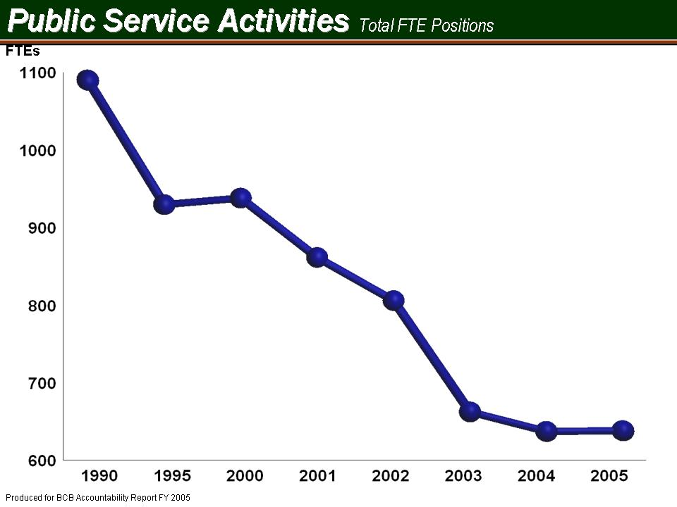
- The primary barrier that continues to inhibit the Extension Service and all of PSA from carrying out its mission and achieving its goals is decreased staffing as a result of state budget reductions, while the demand for educational programs and services from citizens increases. Budgetary constraints prohibit the organization from replacing all of the staffing losses.
- The ability to respond to staffing needs resulting from successful grant contract efforts is often limited and delayed by restrictive state personnel policies. A reassessment of options for bringing talented people in for short term assignments in all areas of PSA would enhance the ability to leverage funds.
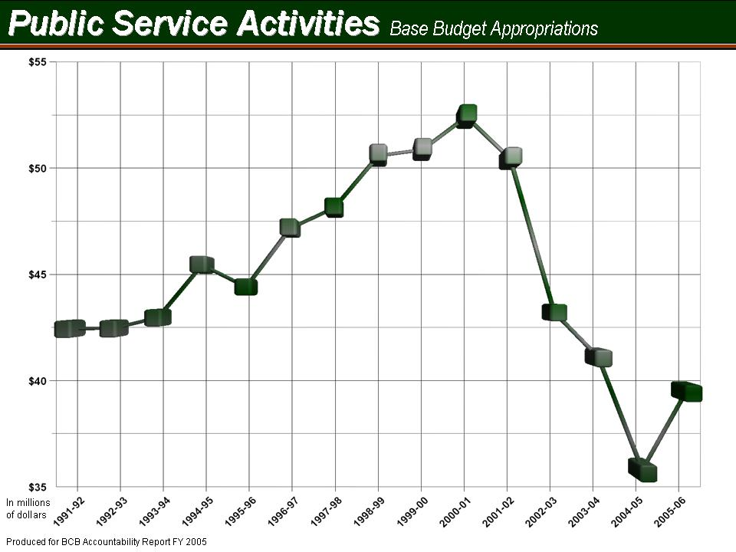
- Barriers for LPH include a shortage of critical professional and technical staff, and a lack of funded personnel positions for the federal cooperative grants.
- Rigidity in staffing policies is affecting quick response to opportunities and policies concerning incentives, bonuses, etc. even when no state funds are used.
- The inability to compensate trained professional and technical staff at a rate competitive with the private sector is a significant constraint.
- Due to significant loss of funds over the last several years, critical needs in key areas may threaten our ability to guarantee the security of food and agriculture in South Carolina.

I-5 How the accountability report is used to improve organizational performance
Each section of the accountability report is reviewed by the PSA Leadership Council to identify and prioritize specific areas where improvements and enhancements can be made before the submission of the plan for the following year. The implementation of identified recommendations to improve organizational performance begins immediately.

In addition, the performance excellence criteria in the accountability report are reviewed in relation to the plans and reports submitted both to USDA (South Carolina Plan of Work for Research and Extension) and to the Clemson University Office of Assessment.

PSA has established means of assessment and criteria for success for all programs. These are reported to the university on a timeline which parallels the reporting timeline of the SC Budget and Control Board Accountability Report, and while the two plans are formatted differently, the means of assessment are essentially the same.

Each year the annual report to the Office of University Assessment contains a description of the planned activities by PSA goal, the actual performance and a description of how the analysis of the reasons for discrepancies between planned verses actual performance is used to improve planning, programs and performance.

Due to space limitations in the BCB annual report, only the actual outputs and accomplishments of the previous year's activities are reported in Section I-2. The planned goals, the relationship of the planned activities to actual performance and how the results of analyzing the planned versus actual are used to improve programs are not included, once again, because of space limitations. A more generalized set of strategic goals is presented in Section I-3 (also see Section 3 category 2 for more information on strategic goals).

The annual report to the USDA is submitted in April of each year to accommodate research and Extension activities which are planned and reported in the plan of work run on the federal fiscal year (October 1-September 30). Reporting is more heavily focused on long range outcomes/impacts than on the shorter term outcomes. PSA is moving to develop and find resources to support the development of sophisticated impact and performance analysis for use in all three of the major accountability reports.

Section II – Business Overview

II-1 Number of Employees
As of this writing PSA has 792 employees in 647 FTE’s.

II-2 Operation Locations

Public Service Activities has at least one operation in every county in the state, in Extension offices, which are provided by the respective county government through a cooperative agreement. Operations are also carried out on Clemson University campus as well as on locations in the immediate vicinity and the following sites:
Aiken County……………..Long Leadership Center
Barnwell County………….Edisto Research and Education Center
Charleston County..............Coastal Research and Education Center
Clarendon County………...R.M. Cooper Leadership Center
Florence County…………..Pee Dee Research and Education Center
Georgetown County………Belle W. Baruch Institute of Coastal Ecology and Forest Science
Pickens County...................Clemson Experimental Forest
Youth Learning Institute
Richland County………….Sandhill Research and Education Center
Institute for Community and Economic Development
Livestock and Poultry Health
York County……………...Matthews Environmental Center
Dominica, West Indies…....Archbold Tropical Research and Education Center

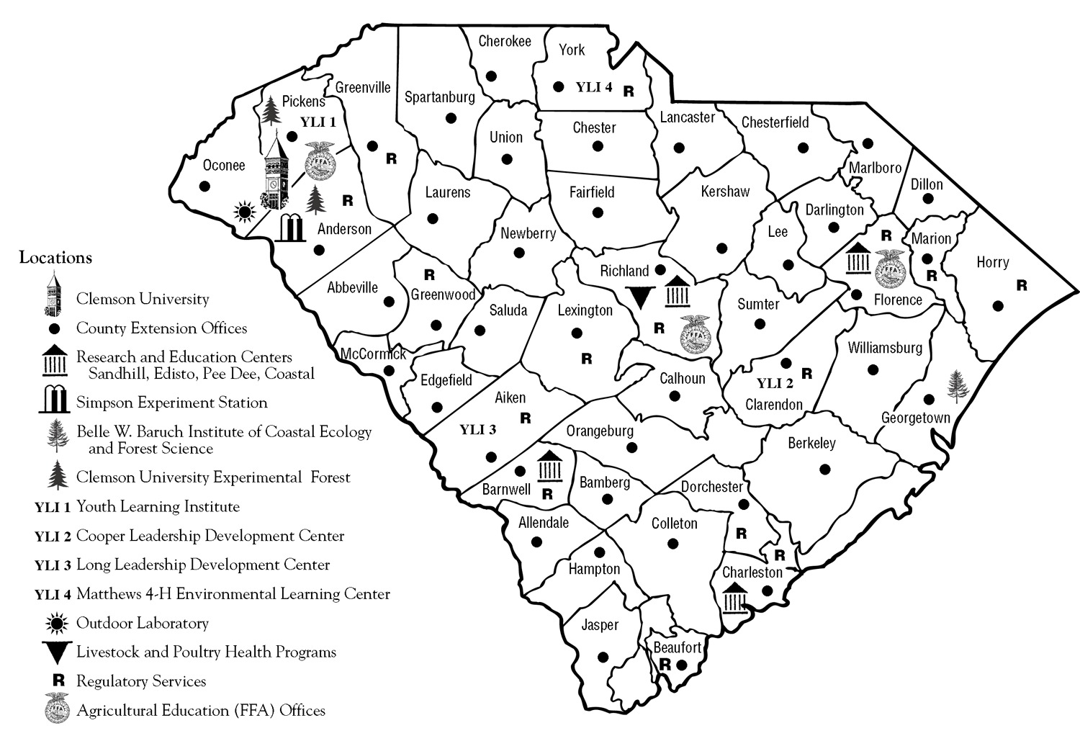

Figure I

II-3 Expenditure/Appropriations Chart

Base Budget Expenditures and Appropriations

 | 03-04 Actual Expenditures |  | 04-05 Actual Expenditures |  | 05-06 Appropriations Act
Major Budget Categories | Total Funds | General Funds | Total Funds | General Funds | Total Funds | General Funds
Personal Service | $34,466,140 | $23,373,597 | $33,284,793 | $21,129,935 | $36,324,757 | $29,346,461
Other Operating | $18,193,739 | $7,804,044 | $20,235,845 | $8,964,395 | $12,723,387 | $2,385,357
Special Items | $134,974 | $134,974 | $134,974 | $134,974 | $134,974 | $134,974
Permanent Improvements | $ | $ | $ | $ | $ | $
Case Services | $ | $ | $ | $ | $ | $
Distributions  to Subdivisions | $-177,247 | $-177,247 | $-209,614 | $-209,614 | $219,393 | $-219,393
Fringe Benefits | $10,173,858 | $7,498,892 | $9,110,533 | $6,090,410 | $10,553,727 | $7,960,735
Non-recurring | $ | $ | $2,753,047 | $ | $ | $
Total | $62,791,464 | $38,634,260 | $65,309,578 | $36,110,100 | $59,517,452 | $39,608,134

Other Expenditures

Sources of Funds | 03-04 Actual Expenditures | 04-05 Actual Expenditures
Supplemental Bills | $0 | $0
Capital Reserve Funds | $0 | $0
Bonds | $0 | $0

II-4 Major Program Areas Chart
Program Number and Title | Major Program Area Purpose (Brief) | FY 03-04 Budget Expenditures | FY 04-05 Budget Expenditures | Key Cross References for Financial Results*
I.  Regulatory Services | Regulatory and Public Services' mandated programs ensure:  - Safe and legal use of pesticides;  - Quality of fertilizer and lime;  - Prevention and control of  - introduced plant pests and pests of honey bees;  - Certification of seed purity/germination;  - Certification of freedom from plant pests in nursery, greenhouse and transplants; and administer  - Quality assurance and identity preservation for transgenic crops,  - Pesticide container recycling,  - Boll weevil eradication,  - and, since September 11th,  - Homeland Security. Our mission is to prevent, mitigate, and respond to agroterrorism. | State: 1,716,149  Federal: 890,020  Other: 1,834,862  Total: 4,441,041  % of Total Budget: 7% | State: 1,619,647  Federal: 1,028,161  Other: 2,168,453  Total: 4,816,261  % of Total Budget: 7% | Indicator 7.1;  Indicator 7.2;  Indicator 7.3; Indicator 7.4; Indicator 7.5; Indicator 7.6;  Indicator 7.7;  Indicator 7.8;  Indicator 7.9
II.  Livestock and Poultry Health | This organization has a major role in protecting the quality of life for humans, as well as companion and food animals. Routine functions include:  - Constant surveillance for diseases that affect both man and other animals,  - Providing the diagnostic expertise that allows for treatment & eradication of disease of domestic animals,  - Inspection & testing of processing of foods of animal origin,  - Veterinary diagnostic support for wildlife also is provided by our diagnostic laboratory.  - As the primary agency for ESF-17 in the State Emergency Operations Plan, our multi-agency coordination of statewide animal emergency response plans provides protection for livestock & wildlife, as well as supporting public health & safety. | State: 2,691,705  Federal: 1,353,745  Other: 227,078  Total: 4,272,528  % of Total Budget: 7% | State: 2,438,260  Federal: 2,398,372  Other: 688,389  Total: 5,525,021  % of Total Budget: 8% | Indicator 7.19;  Indicator 7.20;  Indicator 7.21;  Indicator 7.22
II. Agricultural Research | The Clemson Experiment Station:  - Develops unbiased, research-based knowledge for agriculture, natural resources, and the social sciences to enhance economic growth and development and quality of life. Clemson researchers  - Make discoveries and contribute to the body of knowledge in biotechnology, food safety and security, economic and community development, ornamental horticulture, turfgrass, nutraceuticals, packaging science, water quality and the environment, while continuing to support and enhance production agriculture and forestry. | State: 15,608,512  Federal: 3,740,932  Other: 1,921,688  Total: 21,271,132  % of Total Budget: 34% | State: 15,128,804  Federal: 3,782,011  Other: 2,730,955  Total: 21,641,770  % of Total Budget: 33% | Indicator 7.15;  Indicator 7.16;  Indicator 7.17;  Indicator 7.18
IV. Cooperative Extension | The Clemson Cooperative Extension Service provides sound, scientifically based information to South Carolinians and helps them use that information to improve the quality of their lives. Extension implements educational programs through:  - Systematic linkages with advisory boards and program identification committees,  - Effective networks with researchers within the land-grant system,  - Diverse, proficient and visionary staff,  - Strong statewide, national and global networks and collaborations with other agencies and organizations,  - An accessible information system, and  - State of the art technologies for program delivery. | State: 18,430,299  Federal: 6,982,145  Other: 7,206,738  Total: 32,619,182  % of Total Budget: 52% | State: 16,758,948  Federal: 6,813,094  Other: 9,566,770  Total: 33,138,812  % of Total Budget: 51% | Indicator 7.10;  Indicator 7.11;  Indicator 7.12;  Indicator 7.13;  Indicator 7.14
V. State Energy | The South Carolina Institute for Energy Studies (SCIES) is a state chartered research and development organization established in 1984 via the FY 1984 - 1985 General Appropriations Act. SCIES is administratively housed at Clemson University, reporting to the Vice President for Research. | State: 83,654  Federal:  Other:  Total: 83,654  % of Total Budget: 0% | State: 63,941  Federal:  Other: 10,960  Total: 74,901  % of Total Budget: 0% | Not Available
VI. BioEngineering | The Bioengineering Alliance of South Carolina is a unique state program that promotes biomedical engineering education and research among Clemson University, the University of South Carolina, and the Medical University of South Carolina. The Alliance shares faculty, research facilities, and other resources to foster interdisciplinary research among the participating campuses. | State: 103,930  Federal:  Other:  Total: 103,930  % of Total Budget: 0% | State: 100,500  Federal:  Other: 12,313  Total: 112,813  % of Total Budget: 0% | Not Available

Below: List any programs not included above and show the remainder of expenditures by source of funds.
 | Remainder of Expenditures: | State: |  |  | State:
 |  | Federal: |  |  | Federal:
 |  | Other: |  |  | Other:
 |  | Total: |  |  | Total:
 |  | % of Total Budget: |  |  | % of Total Budget:
* Key Cross-References are a link to the Category 7 - Business Results. These References provide a Chart number that is included in the 7th section of this document.

II-5 Key customers segments linked to key products/services
Although PSA’s key customers are and continue to be the citizens of South Carolina, PSA is reaching out into many new areas across the country and in other nations. The programs conducted by PSA are accessible to all people. The mission and goals of the organization lend themselves to people who are associated with agriculture, agricultural and forest products, business and industry, landowners and managers of natural resources, families and youth, limited-resource families and rural and community leaders.

Customers also include pesticide and fertilizer dealers and users, those who produce certified and enhanced seeds and plants, practicing veterinarians, county and local governments, business and industry, agencies who work in the areas of economic development, health, conservation, the environment, wildlife, water resources, technical education and youth and families.

II-6 Key stakeholders (other than customers)
Other than PSA’s customers, and of no less importance to its mission and values, are its own employees. Clemson University takes pride in being a “family” and that is certainly true in PSA. If it were not for its employees, PSA would not be able to serve its customers well. That is why these past few years have been troubling times for PSA administration. PSA has pursued, and will continue to seek, every possible way to balance its budget without having to lose any of its employees.

II-7 Key Suppliers
The term “suppliers” is being used to describe agencies, organizations, groups of individuals and classifications of individuals who support PSA programs with funding, matching or in-kind support. Advisory boards provide invaluable support that is used to “build” program initiatives so they are included here as well. See list below:
- Federal, State, and Local Government  - Agriculture Council  - Cooperatives – SC Cooperative Council  - 4-H Donors  - Farm Bureau  - Green Industries  - Livestock Breed Associations | - Private Industry  - Foundations  - Private Non Profit Corporations.  - SC Poultry Federation  - State and Local Fairs  - County Advisory Boards  - Public Service Activities Advisory Board
- Agriculture Industry Associations – i.e. Soybean, Corn, Cotton Growers Associations

II-8 Organizational Structure
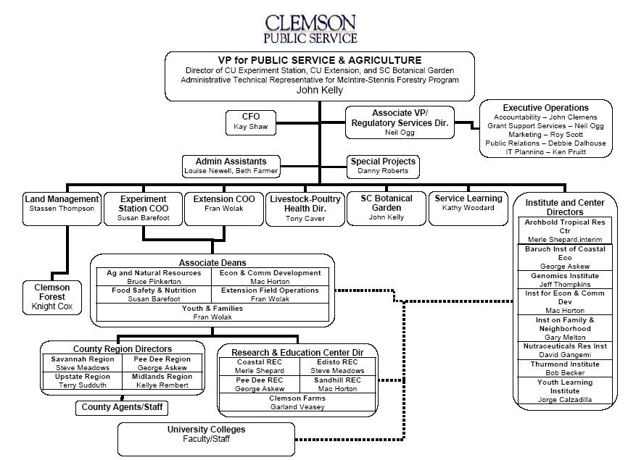
Figure II

Section III – Elements of Malcolm Baldrige Award Criteria

Category I - Leadership
Clemson University, under the leadership of President James Barker, has established new Vision, Mission, and 10-Year Goals. The vision is for Clemson University is to become a nationally ranked top 20 public institution. Public Service Activities, under the leadership of Vice President John Kelly, embraces the vision, mission, and goals. The President, Vice Presidents, Deans, Directors and every faculty and staff member will be evaluated by their contribution to those goals.

The new 10-year goals of Clemson University that most closely relate to PSA are: setting the standard for relevant public service; increasing research programs to exceed $100 million per year, which has now been achieved, and fostering Clemson's academic reputation through strong academic programs, mission-driven research, relevant public service and highly regarded faculty and staff. Performance measures to accomplish these, and other appropriate, 10-Year Goals have been incorporated into the performance review criteria for PSA’s employees.

For the several years PSA has based their activities on 5 goal areas that are closely aligned with the federal goals established for USDA. These 5 goal areas encompass historically-based agriculture and future-based needs associated with agriculture. Agriculture is no longer what it was 100 years ago when individual farms were the norm. Today, agriculture must recognize its importance to the present and future economies of the area, it must be concerned about how this industry influences the environment, it must be aware of the importance agriculture has on food safety and nutrition, and it must use its resources to help develop the state’s youth to better appreciate the importance of this industry.

The PSA Cabinet is responsible for implementing programs, initiatives and activities under the five goals. The Cabinet consists of the following key leaders:

VP for PSA
Associate VP for PSA
Directors of Research & Education Centers
Directors of Institutes
Chief Operating Officer, Experiment Station
Chief Operating Officer, Extension Service
Director, Livestock-Poulty Health
Special Assistants to VP
Director Public Relations, PSA
Senior Extension Agent, CUCES
Associate Deans
Director IT
Regional Directors
Assistant to VP for PSA
PSA Chief Financial Officer

♦How do senior leaders set, deploy and communicate?
Senior leaders empower employees in a university setting and through feedback mechanisms in staff meetings and reverse evaluations of supervisors. Professional development is offered formally in retreats or structured learning programs and in attendance in professional meetings. Meetings and training are often conducted with the advantage of distance communications systems which allow two-way video and audio and avoid travel expenses and lost travel time. Ethical behavior for all Clemson employees is identified in the University's Fiscal Policies and Procedures and Personnel Policies and Procedures Manual.

♦How do senior leaders establish and promote a focus on customers?
The commitment to customer service is reflected in the goals of PSA, and is supported by a sophisticated and long-standing network of advisory boards and committees at the county, regional and state levels. The focus on customer service is an element of each leadership team meeting. The President and Vice President meet with constituency groups on campus, at the Research and Education Centers and at Extension Service offices.

♦What key performance measures are regularly reviewed by your senior leaders?
The key performance measures, which are regularly reviewed by senior leaders include the numbers of individuals, groups, companies and agencies served, numbers of regulatory inspections and other services provided, the number of educational and public service events held, the number of patents, licenses, publications issued, resources leveraged, communication effectiveness and cost benefit analysis and other statistical measures of impact on the state and the nation. Performance measures are tailored to reflect performance in the five PSA goal areas and in the Clemson University goals and emphasis areas which were described in Section 1-2 above. There are additional measures which are cumulatively reflected as accomplishments in Section I.

♦How do senior leaders maintain fiscal, legal, and regulatory accountability?
The organization is well equipped to monitor itself to maintain fiscal, legal and regulatory requirements. As a part of Clemson University, PSA leadership relies on the various offices within in the university and within PSA to make sure all aspects of the organization are in compliance.

♦What key performance measures are regularly reviewed by your senior leaders?
An organization this large has many levels with each level having very specific responsibilities and processes to measure performance. However, there a few measures that are considered key to the overall “health” of the organization. The following are but a few of these key measures:

- Number, amount, and types of sponsored research
- Number and types of contacts with stakeholders
- Dollar amount of gifts and pledges
- Number of stakeholders benefiting from PSA programs
- Number and types of research publications
- Total patents and licenses
- Meeting regulatory standards
- Extension contacts
- Acceptance of practices
- Ag production improvements
- Animal health/compliance issues
- Disease control and eradication

Note: See indicators in Section IV of report for key performance measures from the major divisions of PSA

♦How do senior leaders use organizational performance review findings and employee feedback to improve their own leadership effectiveness and the effectiveness of management throughout the organization?
An ongoing review of key performance criteria and employee feedback is used to improve leadership and management effectiveness. Every few years, an extensive survey of its employees is undertaken that measures critical areas of leadership. This survey was not conducted last year due to several organizational changes and other factors but a survey should be conducted in the coming year to determine any strengths and weaknesses of leadership.

♦How does the organization address the current and potential impact on the public of its products, programs, services, facilities and operations, including associated risks?
PSA depends on feedback from its advisory system, a close working relationship with local and state elected officials and state and federal agency heads to monitor the impact of programs. Consensus building and broad based public relations activities precede the introduction of new programs in the state, in addition to the more formal review of new programs by the Merit review committee and the peer review of new research projects.

In addition, customer satisfaction surveys are conducted regularly and are detailed in Category 3-Customer Focus. These surveys along with more informal information gathering techniques provide a continual source of feedback. This feedback is used to address the current and potential impact of PSA activities on the public.

♦How does senior leadership set and communicate key organizational priorities for improvement?
The assessment process which is reported in the USDA Plan of Work, the Annual Report to the SC Budget and Control Board and the Annual report to the Southern Association of Colleges and Schools (SACS) assist the PSA Associate Deans and Directors and the PSA Council to gauge areas which merit the most effort for improvement.

Priorities are communicated throughout the organization to their respective faculty and staff. Priorities are communicated to Clemson University through the Vice President’s participation in the university Administrative Council, vice presidential meetings and in exchanges with the President and key members of the President’s staff and the staff of the vice presidents. The latest technologies are also employed to enhance communications capabilities, to include e-mail, teleconferencing via satellite and the internet and on the PSA web sites. Legislators are advised of priorities by the staff in the University’s Columbia office.

♦How does senior leadership actively support and strengthen the community?
The intent of the mission of PSA is to help people in South Carolina make informed decisions which will improve their lives and the communities where they live. PSA accomplishes this mission by developing new knowledge through research and transferring this knowledge to the citizens of the state through a range of educational techniques.

In reality, this is one of the primary missions of the PSA. With offices in every county, Extension agents working with stakeholders all over the state and research facilities in key agricultural areas of the state, PSA is constantly involved with community activities and growth.

Category 2 - Strategic Planning

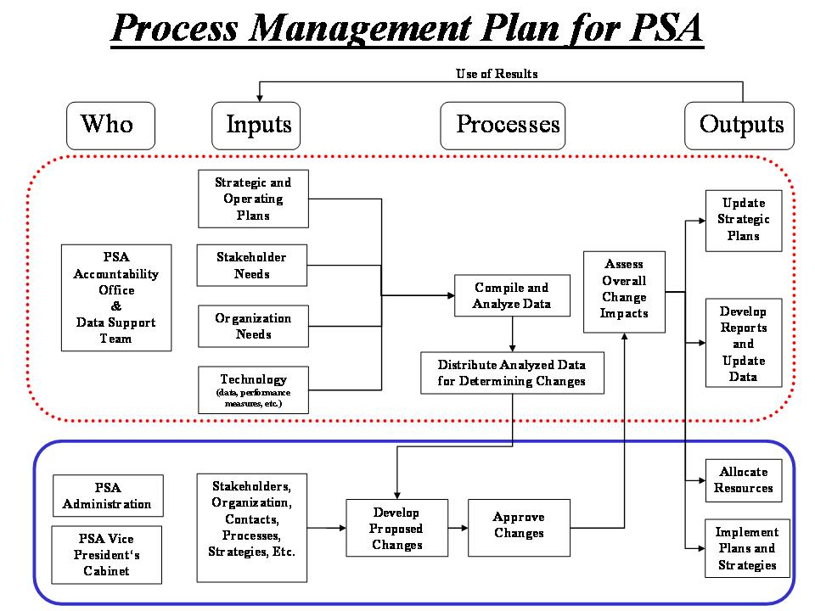
Figure III

♦What is your Strategic Planning process, including KEY participants, and how does it account for…?
PSA is committed to taking a leadership role in addressing challenges and realizing opportunities in South Carolina. PSA is poised for the future with its five strategic goals aimed at meeting the needs of South Carolina citizens and achieving the highest levels of scholarly excellence in research, outreach, and service. These goals are compatible with the Clemson University goals and emphasis areas.

With that philosophy in mind, the PSA administration gathers data from various input sources and processes this data to insure an initiative is within the scope of the goals, emphasis areas and strategic plan. Once a decision is made, all relative documents and plans are updated to reflect the new initiative and to allocate resources (see plan/model above).

♦What are your key strategic Objectives?
The PSA units collectively provide input to the strategic planning process. In addition, the strategic planning takes place within these units with a focus on what is best for PSA, Clemson University and the state of South Carolina. Key issues addressed include: recognition and clarification of mission, environmental scanning, identification and selection of issues, development of goals, and strategies, implementation of plans and monitoring and assessment of results (see Strategic Planning Chart for list).

♦How do you develop and track action plans that address your key strategic objectives?
Stakeholder input remains critical to the strategic planning process and, as such, input is sought from a variety of stakeholders - an information team collects relevant data via interviews, surveys, and personal contacts. Nominal Group Technique is also used at the county level to garner stakeholder input. Demographic data from all the counties through an environmental scan was also conducted. Customer needs, financial, societal and other risks, human resource capabilities and needs, operational capabilities and needs, and suppliers, contractors, partners’ capabilities and needs, were all considered in the planning process.

♦How do you communicate and deploy your strategic objectives, action plans and performance measures?
The success of programs, projects, and services, to a great extent, depends on the ability of employees to do the job and the extent to which they are up-to-date on the subject matter. PSA’s goal is to enhance the human resources by aggressively hiring outstanding faculty, researchers, agents, and support staff; investing in their professional development, and providing a supportive work environment. Several training and professional development opportunities are available to employees to improve their skills. The heads of PSA’s various units annually review the needs of each employee and then identify professional development opportunities for them.

♦If the agency’s strategic plan is available to the public through the agency’s internet homepage; please provide an address for that plan on the website?
Currently, the strategic plan is not available to the public through the agency’s internet homepage. The PSA homepage is in the process of being redesigned and is only displaying a limited amount of information. The new design will allow for the public and employee to easily see PSA’s strategic plan and various performance measures.

♦Strategic Planning Chart
Program Number and Title | Supported Agency Strategic Planning Goal/Objective | Related FY 04-05 Key Agency Action Plan/Initiative | Key Cross References for Performance Measures*
I.  Regulatory Services | - Agrisystems Productivity and Profitability  - Economic and Community Development  - Environmental Conservation  - Food Safety and Nutrition | - Mission Critical Awareness - 1) To enhance relations with members of the General Assembly and with officials of state and federal agencies which relate to our Division's mission. 2) To develop material to support needed increases in Regulatory and Public Service Programs funding for FY 2004-2005.  - Develop a system in 2004 to cover last-minute calls and inquiries in December regarding license renewal deadlines and fees.  - Complete the revisions to the “Rules and Regulations for the Enforcement of the South Carolina Pesticide Control Act.” | Indicator 7.1;  Indicator 7.2;  Indicator 7.3;  Indicator 7.4;  Indicator 7.5;  Indicator 7.6;  Indicator 7.7;  Indicator 7.8;  Indicator 7.9
II.  Livestock and Poultry Health | - Agrisystems Productivity and Profitability  - Economic and Community Development  - Environmental Conservation  - Food Safety and Nutrition | - Disease Eradication – To maintain the livestock-poultry disease free status for cattle brucellosis, swine brucellosis, classical swine fever, pseudorabies, tuberculosis and pullorum-typhoid for the purpose of protecting the health and marketability of South Carolina livestock-poultry.  - Disease Control - To increase awareness among producers of disease control programs e.g. South Carolina Voluntary Bovine Johne’s Disease Control Program (SC VBJDCP), SC Egg Quality Assurance Program (SCEQAP) and encourage participation in them.  - National Animal Identification System (NAIS) – 1) To develop a system to consolidate premises information on South Carolina livestock-poultry operations and coordinate that information with the national premises allocator and repository. 2) To compete for Cooperative Grants from USDA to help fund activities related to populating the premises identification system.  - Cooperative Agreements & Grants - To actively pursue available cooperative agreements and grants that are relative to our mission to supplement state appropriations.  - Animal Emergency Response/Agro-Terrorism - To further define the role of Livestock Poultry Health, Animal Health Programs in animal emergency response and training in SC and seek funding for these activities | Indicator 7.19;  Indicator 7.20;  Indicator 7.21;  Indicator 7.22
II.  Agricultural Research | - Agrisystems Productivity and Profitability  - Economic and Community Development  - Environmental Conservation  - Food Safety and Nutrition  - Youth Development and Families | - Agricultural Productivity and Profitability - To improve agricultural productivity and profitability in all the major crops, grains, fruits, vegetables, livestock, poultry, fish, cotton, and timber  - Enhanced Economic Opportunity and Quality of Life for Americans – To provide research which will enhance economic opportunities and improve the quality of life for South Carolinians.  - Greater Harmony between Agriculture and the Environment – To protect and enhance South Carolina's natural resources to insure the quality of life and the future economic development potential in the state  - A Safe and Secure Food System and a Healthy Well Nourished Population - To improve the quality of life for South Carolinians by developing and delivering food safety, food security and nutrition knowledge  - Family and Community Living - To strengthen the support for families and young people in South Carolina, through ongoing family and youth development research programs | Indicator 7.15;  Indicator 7.16;  Indicator 7.17;  Indicator 7.18
IV. Cooperative Extension | - Agrisystems Productivity and Profitability  - Economic and Community Development  - Environmental Conservation  - Food Safety and Nutrition  - Youth Development and Families | - Sustainable Forest Management and Environmental Enhancement-To conduct programs to develop landowner understanding of sustainable use and management of forestry resources.  - Risk Management Systems for Agricultural Firms – To conduct programs to assist farm managers in agricultural market assessment and appropriate marketing strategies for agricultural commodities in South Carolina.  - Agricultural Biosecurity – 1) To improve state, regional, and local capabilities to detect, recognize, diagnose and prevent agroterrorism and threats to food safety. 2) To respond to agroterrorism, foreign plant and animal diseases, and other disasters that threatens agriculture or food safety.  - Sustainable Agricultural Production Systems – To increase the use of environmentally sound and economically sustainable agricultural practices through educational programs.  - 4-H, Youth and Families - To empower and strengthen youth, families and communities by providing researched based educational programs.  - Natural Resources and the Environment – 1) To increase the adoption of best management practices that prevent water pollution from households, water quality and non-point source pollution, and to educate municipal, local government officials, and farmers, and forest landowners on alternative income opportunities from natural resources. 2) To conduct area wide RIFA Suppression Demonstrations and establish biological controls to demonstrate IPM strategies and traditional chemical treatments for RIFA.  - Household and Structural Pest Control and Pesticide Training - 1) Clientele will increase knowledge of structural design conducive to pest damage and increase their knowledge of wood destroying insect control alternatives. 2) Clientele will increase their knowledge and implementation of safe pesticide application and responsibilities under pesticide regulations through Extension conducted and sponsored training and educational programs.  - Integrated Pest Management – To increase the supply and dissemination of information and knowledge about IPM strategies and systems and increase the level of adoption of environmentally sound integrated pest management practices.  - Reducing the Impact of Animal Agriculture on the Environment - 1) To reduce the environmental impact of animal waste. 2) To develop and deliver education programs for training and certification of animal facility operators and present county and state programs on environmentally sound manure treatment, storage, and utilization systems. 3) To teach effective methods to reduce sediment loading of streams from pastures, loafing areas, and land application sites.  - Environmental Horticulture Education- To inform horticulture professionals, master gardeners, and consumers on environmentally sound horticultural practices.  - Food Safety and Nutrition - To deliver programs and teach consumers safe food handling and good nutrition practices.  - Community, Leadership and Economic Development – 1) To conduct leadership programs, 2) To increase the knowledge of community leaders and board members to adopt effective leadership skills and practices. 3) To conduct programs to increase business retention and expansion and workforce preparation. 4) To promote public issues education and the understanding of the process of shaping unified public policy | Indicator 7.10;  Indicator 7.11;  Indicator 7.12;  Indicator 7.13;  Indicator 7.14
V. State Energy | - Economic and Community Development  - Environmental Conservation | - To promote energy research and development in and for the state,  - To transfer energy technology developed by others to South Carolina applications,  - To contribute to national energy issues in areas  of excellence,  - To promote state-wide energy education activities. | N/A
VI. BioEngineering | - Agrisystems Productivity and Profitability  - Economic and Community Development  - Food Safety and Nutrition | - To increase enrollment of graduate students and post-doctoral fellows in the CU-MUSC Bioengineering Program  - To increase Infrastructure improvement through federal funding (U24 proposal with the College of Dental Medicine at MUSC)  - To establish an undergraduate research program in bioengineering in the low country of South Carolina  - Initiate major funding for research programs in bioengineering at the CU-MUSC Bioengineering Program  - To consolidation bioengineering education and research in the State of South Carolina  - To disseminate bioengineering education and research conducted in SC nationally and internationally  - To significantly impact cardiovascular, orthopaedics, dental, and neurological healthcare research in SC | N/A

Category 3 - Customer Focus
PSA’s key customers and stakeholders are the citizens of South Carolina. Included among them are South Carolina growers of any plant or animal commodity, citizens, consumers, government agencies, other universities, gardeners, youth, agribusiness, businesses and persons relating to any context of PSA’s research education and regulatory functions to include, commodity groups, residents of communities, cities, and rural areas. Included also are legislators, alumni, families, meat packing establishments, agri-chemical users, unidentified users of PSA electronic, printed, and broadcast information, and people who support the wide range of PSA units and their program activities.

Everyone member of the PSA workforce, especially the Extension Service, are the front-line employees who represents this organization. These individuals are the “sales force” representative who reaches the customer. In many people’s eyes, they are Clemson University whether they work for Extension Service, Regulatory or any other division of PSA.
PSA was built on “service” and that is what people have come to expect from us. Providing a high level of “service” despite staff cuts and limited program resources always is a challenge. Consideration and communication are two wise strategies to keep in mind while deciding on high and low priority services. Remember that good customer service centers on treating customers the way you would like to be treated yourself.
Marketing to customers and providing good customer service involves the processes of building relationships with clientele, establishing communication, building trust, developing mutual understanding and resolving problems or conflicts. All these involve two-way communication between you and the people you do business with--the customers PSA serves. Clients will know you value them when you practice the “Cs” of customer service:

- Consideration
- Commitment
- Caring
- Communication

♦How do you determine who your customers are and what are their key requirements are?
At Clemson University, stakeholder input is a key to successful extension programs. Clemson has a long history and tradition of seeking stakeholder input into the plan of work process. The process involved in seeking stakeholder input includes the following steps: 1) identification of stakeholders--internal and external that should have input in the Plan of Work process and 2) process used in seeking stakeholder input.

Identification of Stakeholders--Internal and External:
Internal stakeholders include Extension administrators, program administrators, county Extension directors, Extension agents, agent associations, specialists, faculty, department chairs, school directors, and faculty and administrators from Experiment Stations (Research). External stakeholders include Extension advisory boards, commodity groups, community leaders, human service providers, business/industry, and collaborators such as Farm Bureau, Chamber of Commerce, Farm Service Agencies, etc. To assure diversity, emphasis was placed on obtaining a cross-section of people that represent the local community.

Process Used in Seeking Stakeholder Input:
The most recent process included meetings that were held in all counties in the state to identify and prioritize issues concerning agricultural research and Extension. The meetings were attended by county advisory committee members and other key stakeholders. Participants were asked, “What are the major concerns, issues, or critical needs in your county that Extension and Research should address in the next five years?” A Nominal Group Technique (NGT) was used to garner stakeholder input to the Plan of Work process. NGT is a process where a group of individuals generate a large number of ideas in a relatively short period of time. NGT is helpful in identifying problems, exploring solutions and establishing priorities.

The responses to this question were summarized by county and by state as a whole. The initiatives and projects that were developed for the state plan of work are a result of this process which was later included in the strategic goals of Public Service and Agriculture (PSA) in South Carolina. The top ten issues identified were: 1) address environmental issues (farm and residential), 2) promote health/ nutrition programs for youth and adults, 3) preserve, rebuild, expand and promote 4-H and Youth programs, 4) increase staff and develop opportunities to maximize current expertise, 5) grow programs with existing staff, 6) continue research and education in agricultural production practices, 7) increase public awareness and visibility of Extension, 8) address local economic issues, 9) address land use, urban growth, and sprawl issues, and 10) increase support for agriculture and natural resources programs.

Sometimes a specific research need is identified, such as the appearance of a new pest or disease, a critical social or environmental phenomena or a production concern, in which case the customers that have the information need are contacted and the problems are discussed along with potential methods of obtaining the information that is needed to solve them. The proposals identify PSA’s capacity and how the researcher(s) are able to meet their needs.

♦How do you keep your listening and learning methods current with changing customer/business needs?
The annual nature of surveys and contact data gathering, coupled with the fact PSA has at least one service unit in each county of the state makes it possible to constantly assess the validity and strength of listening and learning methods. Extension Advisory Councils have played a significant role in providing input and feedback to PSA programs. Focus groups discuss how programs can be more meaningful to the group being served. In addition, the staff at the local level is in constant contact with state legislators, local elected officials and citizens who are served daily, which reinforces the annual approaches. The unanticipated occurrence of new diseases such as West Nile Virus (which impacts birds, animals and humans), plant pests such as Tropical Soda apple (which impacts pasture land and the environment), or Plum Pox disease (which impacts peach production) keys the various units in PSA to respond in a coordinated fashion with customers. Climatic changes and events such as droughts, hurricanes and varied rainfalls across the wide-ranging landscape of South Carolina require very specific answers to specific problems. With Extension personnel in nearly every county of the state, PSA can meet these various needs.

The potential threat of bio-terrorism sets a different series of processes in motion which mobilizes elements of all PSA units into a coordinated effort with the relevant agencies in state and federal governments.

♦How do you use information from customers/ stakeholders to keep services or programs relevant and provide for continues improvement?
Program evaluations provide feedback to faculty and staff. Periodic meetings with advisory boards, local leaders, and other stakeholders along with focus groups, provide feedback on how programs and initiatives are meeting their needs. Information gathered from meetings and from periodic survey instruments is conveyed to the PSA Cabinet members for review and recommendations for faculty and staff in the various PSA units. Advisory Boards have played a significant role in providing input and feedback which has been used to improve both services and programs.

♦How do you measure customer/stakeholder satisfaction?
PSA has a plan to measure the quality of services provided in all 46 counties of the state. Part of this plan involves a customer satisfaction survey (CSS) which has been developed to collect data from the customers. The goal of CSS is to find ways to improve program quality, information delivery, and more important, to assist in the accountability process. Four indicators (benchmarks) were identified to assess the quality and satisfaction of services provided. These include: 1) up-to-date, useful, relevant and easy to understand information, 2) the extent to which recipients had the opportunity to use the information, 3) the extent to which they have shared the information with others, and 4) the extent to which they are satisfied with the services provided. The following success criteria was also established: 1) 80% of the survey participants will report positively to all the questions, 2) 50% will report that they have used information, 3) 70% will report that they have shared extension information with their friends and neighbors, and 4) 80% will report that they are satisfied with the services provided.

In 2005, via the Cooperative Extension Service arm of PSA, a total of 695 individuals completed a customer satisfaction survey (CSS). The survey results indicated that PSA customers are very satisfied with the information they received from Clemson Extension offices in the counties. They indicated that the information they received was accurate, up-to-date, and relevant to their situations. In addition, customers indicated that they made use of the information to solve a problem or answer a question regarding an issue or a concern. Customers also indicated that they have shared the information with their friends and neighbors, indicating confidence and trust they have for Extension programs and the information received.

Relevance and Quality of Information: Customers who participated in Clemson Extension programs or visited the Extension office for information were very impressed by the quality of information they received relative to food safety, water quality, crops, financial management, community development, youth development, and others. Over 98% said that the information presented was up-to-date, accurate, useful, and easy to understand. Over 98% found it to be relevant to their situation.

Information Use: Over 87% of the respondents indicated that they have used the information. 76% said that the information changed their behavior and increased their knowledge. Over 81% said that they have shared the information with their friends and neighbors.

Customer Satisfaction: Finally, examination of customer satisfaction data (see Indicator 7.10 on page 42) reveals that over 97% of the customers (participants) were satisfied with the service they received from Clemson Extension Service. Data from CSS can be linked to not only knowledge and skills acquisition, but also inclination toward adopting a recommended practice. Collectively, these indicators enhance the credibility and quality of Extension programs and services provided by County Extension staff.

♦How do you build positive relationships with customers and stakeholders? Indicate any key distinctions between different customer groups.
Daily interaction, made possible by the location of PSA resources and personnel in every county, coupled with the delivery of information that is accurate, timely and usable are the keys to positive relationships with customers and stakeholders. Industries, large business operations and local governments require different levels of assistance than many citizens who have a very specific need.

Category 4 – Measurement, Analysis, and Knowledge Management
PSA has one of the best information systems of the land-grant colleges in CU-AIMS – Clemson University Activity Information Management Systems. CU-AIMS collects data from many sources and summarizes the data in such a way that allows the administration to be understand the complexities of the organization. CU-AIMS is able to collect all financial data from the University’s financial systems, from the system for tracking faculty performance, and data from several federal data sources which track research activities. CUMIS, the Clemson University Management Information System, is a computer-based on-line system developed for the collection and reporting of performance data for the Clemson University Cooperative Extension Service. Although the two systems are still evolving, PSA is able to comply with the continuing and growing demands of accountability.

♦How do you decide operations, processes and systems to measure for tracking financial and operational performance?
All programming must fit within the five PSA goals as well as meet the goals/objectives of the individual units within PSA and the university goals/emphasis areas. These units have their own established process to determine their success in addressing the needs of their customers/ stakeholders. This process could be peer review committees, focus groups, surveys, and personal contacts. Decisions are made that guide the units in directions that focus their programming on relevance, capacity and impact.

The PSA Directors and the PSA Council determine activities which will be measured. PSA has implemented a system-wide accountability system called CU-AIMS (Clemson University Activity Information System) that looks at all aspects of the organization. This system measures program activities and provides information to the various units in the organization for assessment and management purposes.

♦What are your key measures?
PSA’s key measures are basically those used by the University to compare and rate the performance of all identities within the University. With the increased emphasis by the University to collect outside funding, many of PSA’s key measures deal with the various ways in which it collects non-state supported funds such as (1) sponsored research; (2) gifts and pledges; (3) revenue producing activities; and (4) collaborative efforts with other institutions or federal and state agencies. However, PSA is not all about raising money but mostly about helping the citizens of South Carolina. Although not a complete list, the measures highlighted in section III under Leadership and in Section IV are many of the measures used to ensure PSA is progressing as it should.

♦How do you ensure data integrity, timeliness, accuracy, security and availability for decision-making?
Both CUAIMS and CUMIS take data from numerous sources and delivers it to three levels of PSA: the stakeholders, the users, and the decision makers. The stakeholders are informed of activities within PSA through the web-based system called “South Carolina Growing”. This system shows the general public, legislature, media, scientists, and other interested parties the current problem-areas being addressed by PSA, the solutions being discovered the information being disseminated from these discoveries, and the areas that PSA will be targeting in the future. By informing the public PSA encourages feedback from stakeholders to ensure that work is underway in the correct areas and addressing the critical needs and delivering the proper information.

The Professional Home Page (PHP) component of CU-AIMS is the connection to the expertise within PSA i.e. the scientists, the technicians, the staff, and other professionals that make it possible to solve the problems and deliver the information to stakeholders. By keeping them informed PSA can further ensure that they know what is being asked of them (through performance measurement subsystems), and showing them what their colleagues are doing (encouraging collaborative efforts), and giving them a process to communicate with the administration any discrepancies or misrepresentation of the data (electronic report transfer).

The final component of CU-AIMS is the Information Management System. It is the umbrella or the “core” of CU-AIMS. This is where all the data is stored and delivered to the administration. This system does high-level analysis of how the organization is working. It looks at spending trends, performance measurement, time analysis, account discrepancies, goal progress, and market analysis. This is the true decision making tool for the administration.

Various web sites representing all of PSA or its divisions have sections that are designated for faculty and staff use. These web sites present pertinent information to decision-makers for various uses.

♦How do you use data/information analysis to provide effective support for decision-making?
Data gathered by CU-AIMS and CUMIS is combined with data received from various survey instruments, advisory board sessions to support decision-making is available to the PSA Directors, the PSA Cabinet and to unit directors. Special reports are developed from CUMIS and CU-AIMS on request from the Directors and the Cabinet. The Chief Financial Officer also prepares special reports at the request of the Directors and the Cabinet.

♦How do you select and use comparative data and information?
CU-AIMS and CUMIS bring in information from all aspects of PSA. Much of this data is grouped into predefined areas that allows for comparing performance between departments, or stations, or problem areas (programs) or between individuals. These predefined areas have certain criteria or performance measures that can allow for these comparisons to be made.

Because CU-AIMS and CUMIS connect to numerous data sources, comparisons can be made between Clemson and with other “like” institutions across the country. This not only makes it possible to gauge performance (performance measures) but also presents opportunities to collaborate efforts with other institutions. Once CU-AIMS connects to commodity databases within the state, it will be possible to compare PSA efforts to those of industry.

With regard to CU-AIMS and CUMIS, PSA has initiated a plan to combine the two systems to report on every aspect of PSA. This will allow for better collection of comparison data plus give a more complete picture of the efforts within all of PSA.

♦How do you manage organizational knowledge to accomplish the collection and transfer and maintenance of accumulated employee knowledge, and identification and sharing of best practices?
PSA’s information systems (CU-AIMS, CUMIS, etc) are designed to transfer data to anyone requesting information which can be staff, faculty and administrators as well as the general public. Currently, PSA is in the process of redesigning all its systems to better ensure that the types of information needed by the organization and its employees as well as its stakeholders is being collected and utilized.

Category 5 - Human Resources
Public Service Activities Business Services works together with Clemson University Human Resources for all PSA employees. Many human resource activities which once were administered by PSA are now transferred to the university’s central office of Human Resources. The university’s office is much better qualified to work with all employees on personnel issues. PSA still maintains an office of Staff Development that insures personnel are better trained to meet the needs of their profession.

♦How do you and your managers/supervisors encourage and motivate employees (formally and/or informally) to develop and utilize their full potential?
Employees are encouraged and motivated to develop and utilize their full potential through the following university policy of allowing employees to take time off to attend Clemson University courses:

“Effective planning using the Employee Personnel Management System can encourage employees to develop their skills and abilities and by providing opportunities for employees to continue their education, at little or no cost.”

PSA has a number of incentive and awards programs to support the employees within the system. The organization has the standard performance incentive raises. However, an innovative Distinguished Agent position was created which is reserved only for those agents who perform at the highest level. Each professional organization that is tied to Extension, such as: the County Agricultural Agents, Family and Consumer Sciences Agents, 4-H Agents, Extension Secretaries, and Epsilon Sigma Phi, have awards programs to promote excellence in programming efforts. Three Superior Performance Awards are sponsored for agents and faculty as is an Outstanding Service Award for classified staff. In addition, the Clemson University Alumni Association sponsors the Distinguished Service Award each year for excellence in Public Service.

♦How do you identify and address key developmental and training needs, including job skills training, performance excellence training, diversity training, management/leadership development, new employee orientation and safety training?
The Office of Human Resources conducts a training needs-assessment survey designed for each University unit. From the information gathered, sessions are scheduled to meet the needs of the unit. OSHA training is done in accordance with regulations. New employee orientation is not mandatory at Clemson; however, each new staff member is invited to attend. All day sessions are held on the 1st and 2nd payday of each month.
PSA provides an in-service training program for all employees. The training is divided into three categories: Subject Matter; Professional Development (which includes Orientation); and Technology. Extension specialists and initiative teams develop subject matter trainings each year and provide them to agents to keep them up-to-date in the various program areas. A variety of Professional Development trainings are offered each year covering such topics as Grant Writing, Diversity, Developing Partnerships, Developing Survey Instruments, etc. An orientation program (provided face-to-face and on-line) is in place which includes an introduction to the Cooperative Extension Service and additional trainings in Civil Rights and Program Development. Technology trainings are offered which cover the use of several computer programs. In addition, the professional associations connected with PSA also offer trainings and updates both at the state and national levels.

♦How does your employee performance management system, including feedback to and from employees, support high performance?
The Office of Human Resources communicates expectations during the planning phase of the process - employees are allowed input into formulating the planning stage. The ratings allowed by policy in the evaluation phase include not only one for meeting the expectations, but also one for exceeding and one for substantially exceeding. The possibility of achieving a higher rating for work that is accomplished encourages performing at a higher level. Performance pay is also tied to the EPMS - can be an incentive for higher level performance; and support of the President's University Goals as a way in part of becoming one of the nation's top-20 public universities increases awareness of a mission above an individual's daily duties - supporting higher performance than usual. Each employee chooses one of the university’s goals to be included as part of their evaluation document.
Formal written performance evaluations and interviews are conducted with each faculty member to review accomplishments, weaknesses, and areas needing improvement. This information is utilized in determining the annual goals and objectives for the plan of work developed by each faculty member.

♦What formal and/or informal assessment methods and measures do you use to determine employee well being, satisfaction, and motivation?
Units periodically review well being, to include work level and schedule, satisfaction and expectations with personnel. Efforts are made to insure that supervisors are available to discuss issues with subordinates. Employees are encouraged to make suggestions for improvements

♦How do you maintain a safe and healthy work environment?
The Office of Human Resources ensures compliance with the Drug Free Work Force Act by annual distribution and enforcement of the Employee Drug and Alcohol policy; compliance with the DOT regulations governing training and drug testing of employees who are required to have a commercial driver's license (CDL). (Partnership stated under the first question of the assistance provided to employees in obtaining a license after requirement has been added to an existing position.) The University Smoking Policy is in compliance with the SC Clean Indoor Air Act; training is provided annually on causes and symptoms of violence in the workplace; the Employee Assistance Program provides confidential assistance/referral for employees experiencing difficulties in coping in a variety of life/work situations. The intent of the program is to enable them to return to a more productive employee.

The University and PSA focuses on encouraging safe work environment/habits. Ergonomics specialists on staff will provide recommendations for improving workstations, etc; and the University Wellness Center provides health programs and services at little or no cost to employees. These programs include in part recommendations for weight loss, improving diet and lifestyle changes.
Individual PSA units have a variety of complimentary approaches in the safety area to include training in pesticide management for employees (where appropriate to job duties), safety compliance officers who stress safety in laboratory areas and regular inspections of facilities and equipment.

Employees are monitored to ensure that all safety measures are followed. Employees that become aware of a potential safety problem or area in need of attention are encouraged to report the need to their supervisor.

♦What activities are employees involved with that make a positive contribution to the community?
PSA engages the community through partnerships, collaborations, and through many outreach efforts. Off campus and university faculty and staff are encouraged to involve themselves in community activities. Personnel serve as members and officers in numerous leadership and civic organizations. Several employees are involved in their local school system, serving as members of the school board. Participation in these type activities shows the commitment of PSA personnel to their community. PSA has projects which address: community volunteerism, educational improvement, civic engagement and environmental quality. PSA has developed formal networks with civic associations, volunteer training initiatives, private companies and governmental organizations.

Category 6 - Process Management
Because of the complexity of its mission, PSA utilizes many instruments to make sure that its divisions and representatives are working together to deliver quality service. PSA’s reliance on its mission and objectives, its close contact with its customers and stakeholders and the commitment to its employees ensures that it will work together to accomplish this.

♦What are your key processes that produce, create or add value to your customers and your organization, and how do they contribute to success?
The design of program initiatives is built around three primary criteria, relevance, capacity and impact. Needs assessments are targeted towards the customer base and systematically updated. Advisory boards with a broad cross section of members are asked to assess and provide input to the PSA Associate Deans, Directors and PSA Council on the design of program initiatives and the delivery of services. Each unit within PSA is directly involved in service delivery unique to its own specific mission. The design of the delivery systems is constantly being impacted by increased demand for services, new types of services, and new means of service delivery. Budgetary constraints directly impact the ability of PSA to respond to changing customer needs. Remote delivery of service using Internet technology, satellite, two-way video, and radio are examples of innovative approaches to service delivery.

♦How do you incorporate organizational knowledge, new technology, changing customer and mission-related requirements, cost controls, and other efficiency and effectiveness factors into process design and delivery?
The design and delivery of all PSA programs is built around achieving the objectives in the five PSA goals. Decisions are made in the design stage to focus research initiatives on the established goals. Spontaneous demand for service from customers is assessed in terms of PSA’s ability to deliver the service within the context of the five PSA goals. In instances where the service request is beyond PSA’s capabilities, mission or outside a goal area, efforts are made to refer the customer to other agencies, state or federal or two other land-grant universities, with appropriate specialties.

♦How does your day-to-day operation of these processes ensure meeting key performance requirements?
Communications is a key support process in the design, production and delivery of products to customers. PSA has a communications center, web page authoring and management staff, radio station, publications and graphics capabilities two-way video and satellite facilities, a broad base of computer support, and access on a reimbursement basis to a range of communications support from Clemson University. Facilities adjacent to the university and at strategic locations across the state (at least one facility in each county are maintained and supported by the Farm Research Services unit adjacent to the campus with specific support functions housed at each installation). PSA staff are responsible for the maintenance of computers, diagnostic and research equipment as well as vehicles, buildings and grounds. Maintenance can also be done either on a contractual basis with the university or an outside vendor. Personnel and property management are conducted internally. Legal, land management, computer, janitorial and legislative support services are shared with the university, funded by PSA at negotiated levels.

♦What are your key support processes and how do you improve and update these processes to achieve better performance?

As has been stated previously, communication and feedback from PSA staff and suppliers has been the key to achieving better performance. Statewide, regional and national meetings are frequently initiated or attended by key individuals in PSA to ensure the efforts among our suppliers and our own organization are coordinated in ensure duplication of effort is minimized and that cooperation of effort is maximized.

♦How do you manage and support your key supplier/contractor/partner interactions and processes to improve performance?
The primary suppliers for PSA are the federal and state government, companies, organizations, foundations and communities that invest funds in PSA. Interactions with suppliers, contractors and partners are carried out though visits, correspondence, periodic reporting and annual reporting as represented by this document. Quality outputs and outcomes, coupled with documented customer satisfaction that are shared with suppliers, contractors and partners on a timely basis, generates valuable inputs that are used to improve performance. Advisory boards and groups are also apprised of comments from these interactions and suggestions for improving performance are generated.

Category 7 – Business Results
PSA is all about “service”. It generates and transfers knowledge through research and education. If it is not serving its customers and stakeholders well, it is not doing its job. PSA’s primary deliverable is information. Whether the need is for a farmer in a rural county, the housewife, the researcher, an industry leader in the state, a member of the legislature, or a colleague in another state or across the world, PSA should be able to help them.

♦What are your performance levels and trends for the key measures of customer satisfaction?
PSA is interested in enhancing the quality of the information and services it provides to customers, while expanding or at least maintaining the numbers of customers served and enhancing the quality at the same time. Performance levels to date indicate that PSA is successful in providing educational programs, research initiatives and regulatory services which benefit the citizens of South Carolina and leaves with the recipient the view that they have benefited. Continuing to achieve this goal is becoming increasingly problematic in an era of decreasing budgets. PSA plans to increase customer satisfaction by achieving even more desirable performance levels through an expansion of a trend towards electronic mediums to meet customer needs and achieve customer satisfaction, and through a restructuring of primary components of the PSA delivery system.

PSA has developed a sophisticated, multi-part model for measuring customer satisfaction and this is described in Section III Customer Focus (see pages 28-30).

♦What are your performance levels and trends for the key measures of mission accomplishment and organizational effectiveness?
PSA has restructured to increase the focus on the five PSA goal areas, assigning an Associate Dean to focus on each goal area which in turn works with the university and within emphasis areas. This has had the effect of increasing performance in the areas and improving reporting. As the Associate Deans continue with their efforts and as PSA moves towards programs it is anticipated that the trend will be towards increased performance in each goal area.

♦What are your performance levels for the key measures of financial performance?
The impact of budget reductions, retirements and subsequent restructuring has challenged PSA employees to take on additional and often more complex responsibilities. PSA employees have responded positively in this rapidly changing environment. PSA will increase opportunities for employee involvement and is refocusing efforts to provide professional development and training opportunities.

♦What are your performance levels and trends for the key measures of Human Resource Results?
The average level of outside funding for PSA activities the past several years has steadily increased. This reflects increasing confidence on the part of federal, state and private partners in PSA’s ability to provide research, education and regulatory programs. Increased partnering with outside funding agencies, organizations and companies is necessitated by the declining state budget situation and the university goal of increasing overall research funding. The trend towards increasing collaboration with partners is expected to increase.

There has been a dramatic increase in activity on the regulatory side of PSA in preparing to respond in the areas of biosecurity, food safety and, security and to mitigate the threat of diseases resulting from the increasing terrorist activities. There has been increased coordination with state and federal agencies to coordinate response scenarios and these close working relationships are anticipated to continue and become more sophisticated. The security of the food supply and the ability to respond to threats to human life, livestock, air and water quality will become increasingly important elements of the overall PSA thrust in South Carolina.

PSA has systematically undergone a series of funding reallocations, budget reductions and faculty and staff reassignments with the long-term goal of capitalizing on state and federal funding and leveraging private funds to achieve the organizations five goals and compliment the university’s goals and emphasis areas. One of PSA’s top financial priorities continues to be increasing the return on the dollar while not compromising the unbiased nature of the information and services which are provided. PSA employees and those in leadership positions are going to extraordinary lengths to maintain, refine, and when possible expand the levels and quality of activities provided across the state. Budget reductions which cannot be offset by outside funding are requiring shifts in program emphasis, the elimination of some activities and new approaches to program delivery. The trend of positive, innovative responses and the concern of PSA staff and leadership to meet needs in the state and meet both the PSA and university goals are anticipated to continue.
Section IV – Referenced Measures
Regulatory Services Performance Measure Series  Indicator 7.1
  Obj. | FY 2005 Type of Measure | FY 2005 Output
  1 | The percentage of fertilizer lots sampled that are found to be deficient in nutrient content. Benchmark: Maintain deficiency rate of less than 20% . Result: 16.74% = higher quality. | 16.74%
  2 | The amount of fertilizer sampled as a percentage of the total fertilizer sold in SC. Benchmark: Sample at least 5% of the total tonnage sold. Result: 3.27% Note: benchmark not met this year due to concentration on raw material manufacturers’ fertilizer. | 3.27%
  3 | Seed lots (500 bushels or less) of seed production inspected for certification, and percentage of seed lots inspected that meet purity standards in laboratory tests. Benchmark: Maintain a minimum of 95% of all seed lots inspected meeting SC Certification standards for purity. Result: 100% compliance indicates effectiveness of inspections in ensuring that SC Certified seed meets high quality standards. | 359 seed lots  100%
  4 | The number of inspections required in addition to certification inspections conducted to certify plant/commodity shipments (transplants, nursery stock, seed, lumber) intrastate, interstate, and globally. Benchmark: Respond to phytosanitary requests within one week timeframe and maintain an acceptance rate above 94%. Result: This certification fulfills certification requirements for shipment of these materials. Shipments enhance the marketing and profitability of SC agricultural business. No rejections from foreign countries of 462 federal phytosanitary certificates issued in FY 2004. | 1747 inspections  Compliance rate  100%
  5 | The number of inspections conducted of commercial greenhouses, nurseries, dealers, turf/sod farms and vegetable transplant producers for insect and disease detection. Benchmark: Conduct one inspection annually of each licensed nursery. Achieve a 95% compliance rate of nurseries meeting inspection criteria. Result: Plant material shipped and sold in SC and nationally is free of insects and disease. This enhances the horticultural industries (2nd in cash receipts in SC) productivity and provides credibility to the industry and other states of our program. | 1127 inspections  compliance rate  99.7%
  6 | Invasive species surveys were conducted to detect/determine the presence of the invasive weeds Giant Salvinia in SC ponds and natural areas and Tropical Soda Apple in the state. Benchmark: Survey lower-state aquatic areas for Giant Salvinia, and survey TSA infested sites every six weeks from June 15th to killing frost to prevent mature fruit production. Result: No Giant Salvinia found in SC’s lower-state aquatic areas. Survey allows early detection and mitigation of new infestations. No TSA plants produced mature fruit at current infested sites. TSA populations are being reduced saving cattlemen and landowners thousands of dollars in production losses and control costs. | 422 aquatic sites surveyed  9,172 TSA plants found and destroyed 2004
  7 | The number of inspections conducted to assure proper pesticide use. Benchmark: There will be over 2,000 inspections to ensure safe pesticide use and structural pest control compliance with pesticide labels, state and federal law. Result: These inspections protect the environmental resources of South Carolina from the effects of pesticide misuse. They also protect consumers and their property from harm due to fraud and incompetence in the pesticide-application industry. | 2,230 complaint and compliance-assistance inspections by DPR
  8 | The number of pounds of pesticide containers recycled. Benchmark: Over 100,000 pounds of pesticide container plastic will be recycled. Result: The number of containers available for recycling has been declining steadily for the last few years. Part of this is due to the increasing dominance of “mini-bulk “ and other returnable containers in agriculture. | 175,000 lbs of pesticide containers recycled
  9 | The number of groundwater samples procured and analyzed for pesticide and nitrite contamination. Benchmark: Over 150 groundwater samples will be taken and analyzed. Result: Two hundred and forty-five (245) groundwater samples were obtained from privately-owned wells and from the DPR’s in-field study sites. Approximately 3.8% of the private wells sampled yielded detectable levels of pesticide residues, and about 80% of the wells sampled contained detectable residues of nitrate. The presence of a groundwater-monitoring program increases compliance with groundwater-protection measures in the applicator community. This program also serves to set the baseline for South Carolina’s groundwater protection efforts. | 245 wells sampled
  10 | Monetary savings of consumers where the Department of Pesticide Regulation investigated structural pest control activities. Benchmark: Over a million dollars of monetary savings will occur in 2001-2002. Result: This figure is a conservative estimate of the money refunded directly to consumers as a result of the DPR’s activities. It includes legal settlements, refunds, and the value of repairs that would not otherwise have been made, but does not include the value of treatments already paid for but properly completed because of the DPR’s involvement. | $1,991,922
  11 | Homeland Security prevention measures. Benchmark: The threat of terrorism will be reduced concerning agrochemicals or aerial application equipment. This will be measured by the actions taken to reduce terrorism and the success of those efforts. Result: Measures are in place to prevent and/or mitigate agroterrorism. | 5,661 inspections/contacts

Regulatory Services Performance Measure Series  Indicator 7.2 | 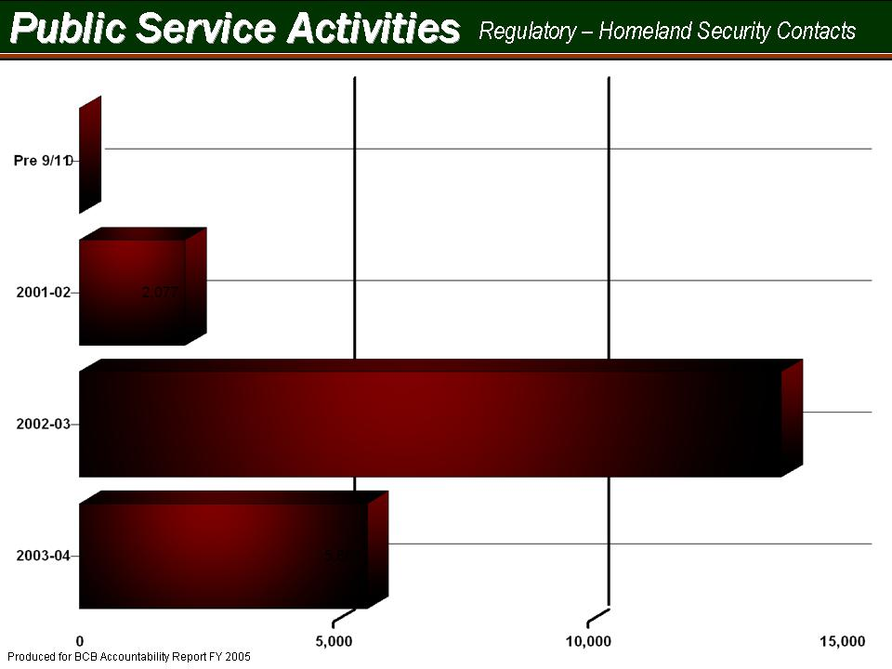
Regulatory Services Performance Measure Series  Indicator 7.3 | 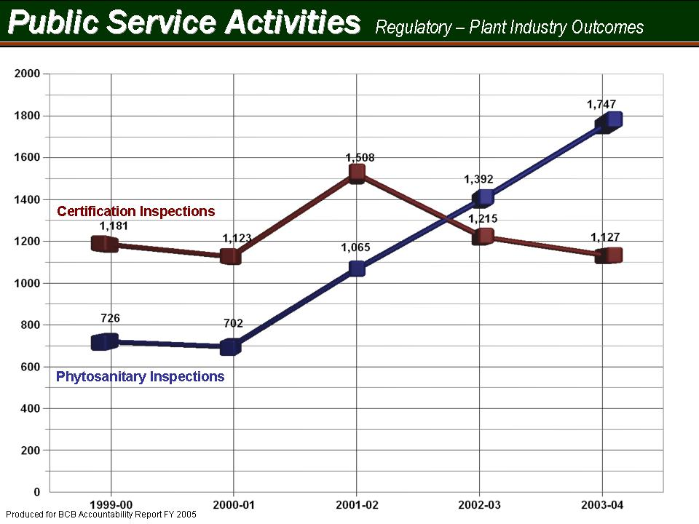
Regulatory Services Performance Measure Series  Indicator 7.4 | 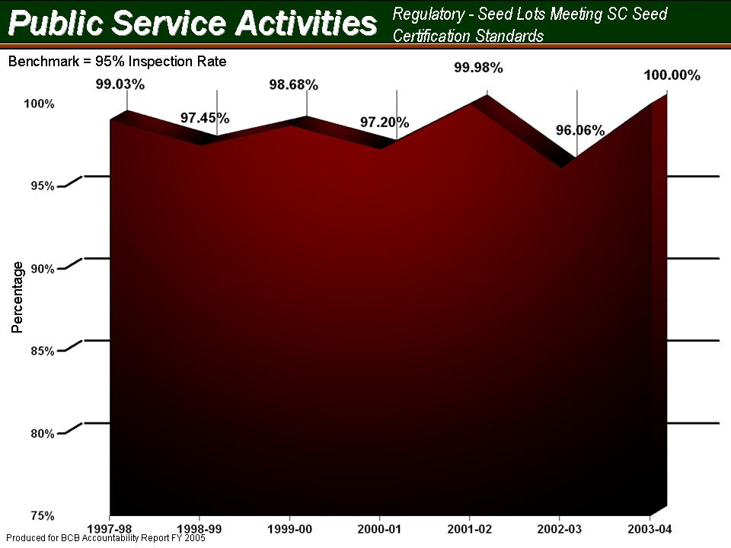
Regulatory Services Performance Measure Series  Indicator 7.5 | 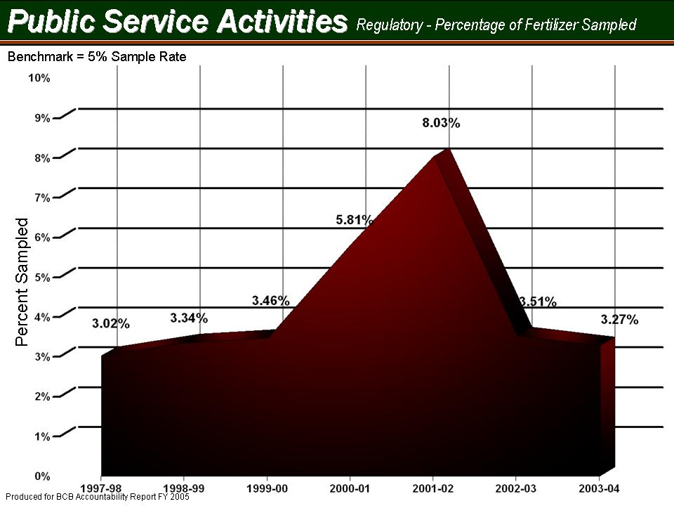
Regulatory Services Performance Measure Series  Indicator 7.6 | 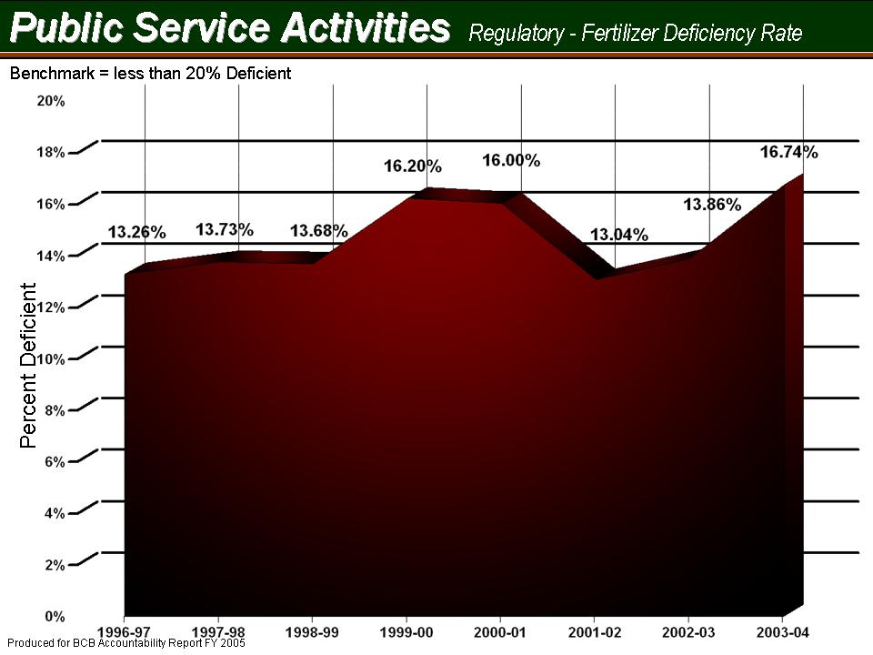
Regulatory Services Performance Measure Series  Indicator 7.7 | 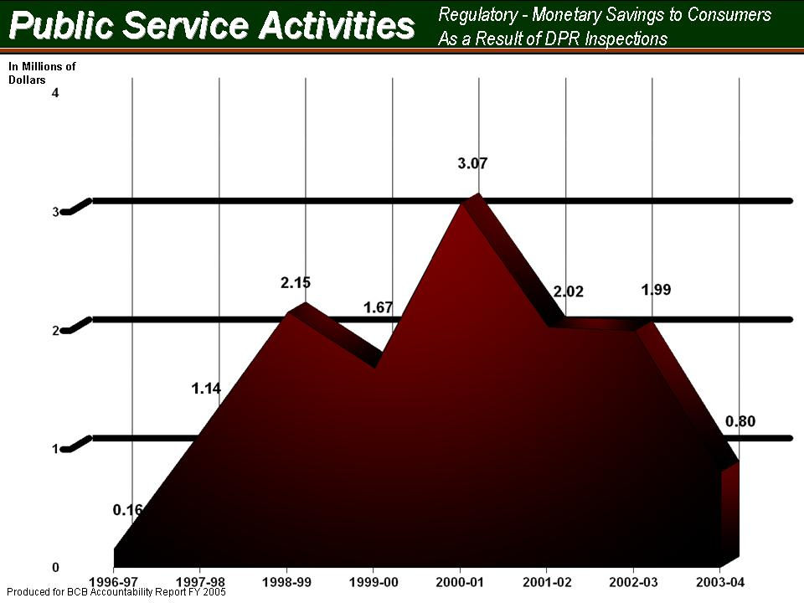
Regulatory Services Performance Measure Series  Indicator 7.8 | 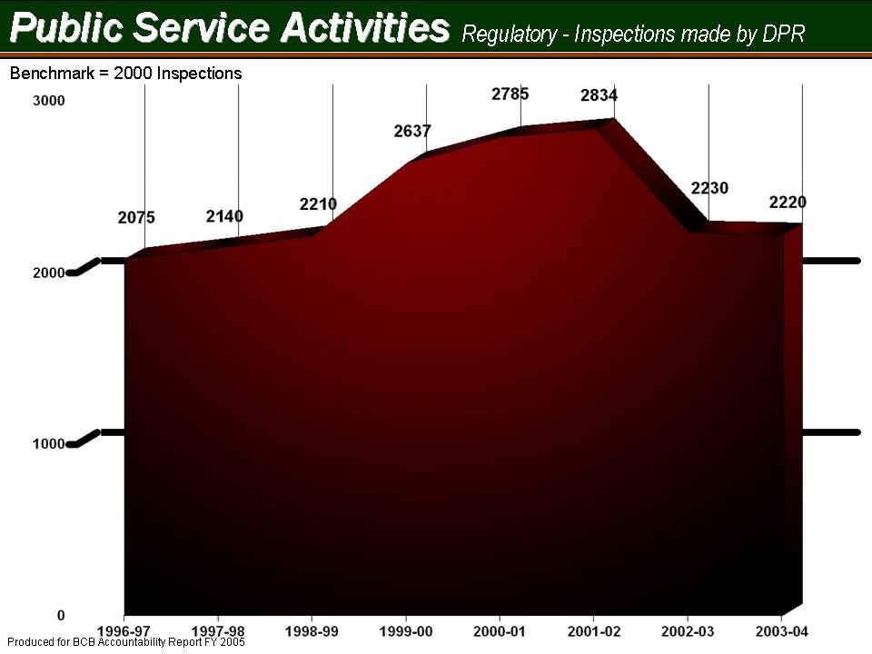
Regulatory Services Performance Measure Series  Indicator 7.9 | 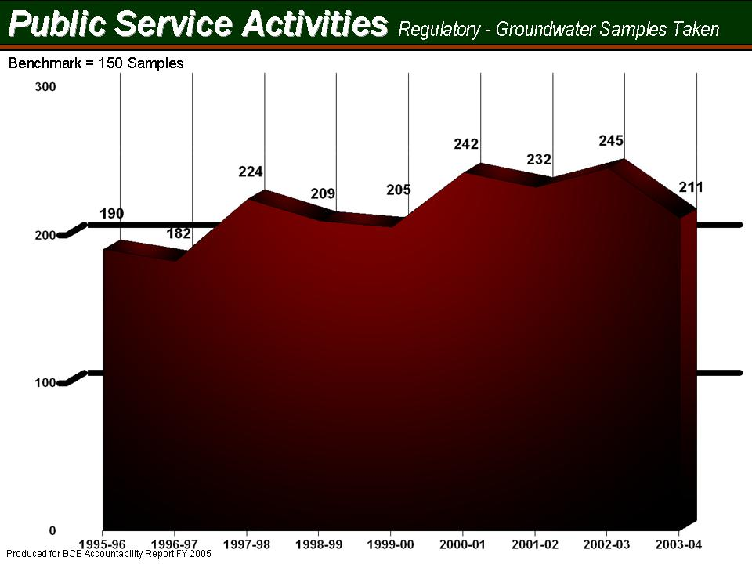
Extension Service Performance Measure Series  Indicator 7.10 | Customer Satisfaction Survey (CSS) Results  Based on FY 2005 results  Note: The CSS is only initiated every 2-3 years
  Extension Information | Frequency | Percent of Total Respondents
  Relevant | 641 | 98.71%
  Useful | 679 | 98.26%
  Up-to-Date and Accurate | 686 | 98.71%
  Easy to Understand | 685 | 98.70%
  Extension Clientele
  Used Information | 394 | 87.56%
  Changed Behavior | 524 | 76.05%
  Shared Information w/Others | 565 | 81.53%
  Satisfied w/Service Provided | 671 | 97.53%
Extension Service Performance Measure Series  Indicator 7.11 | 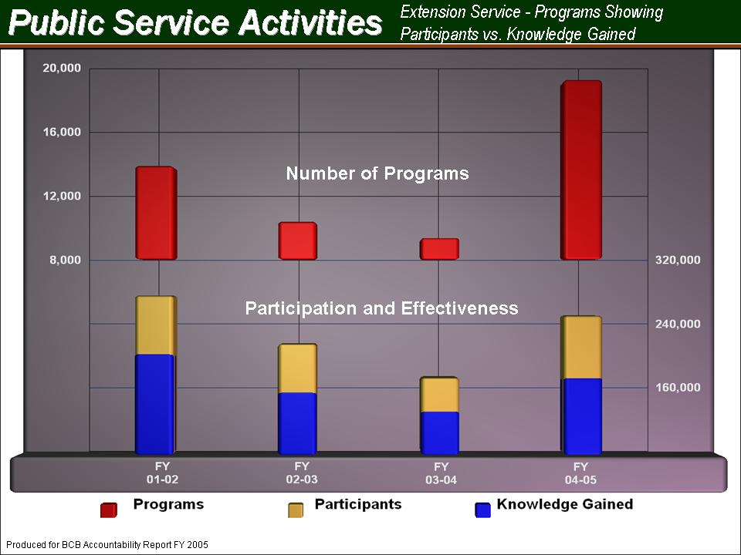
Extension Service Performance Measure Series  Indicator 7.12 | 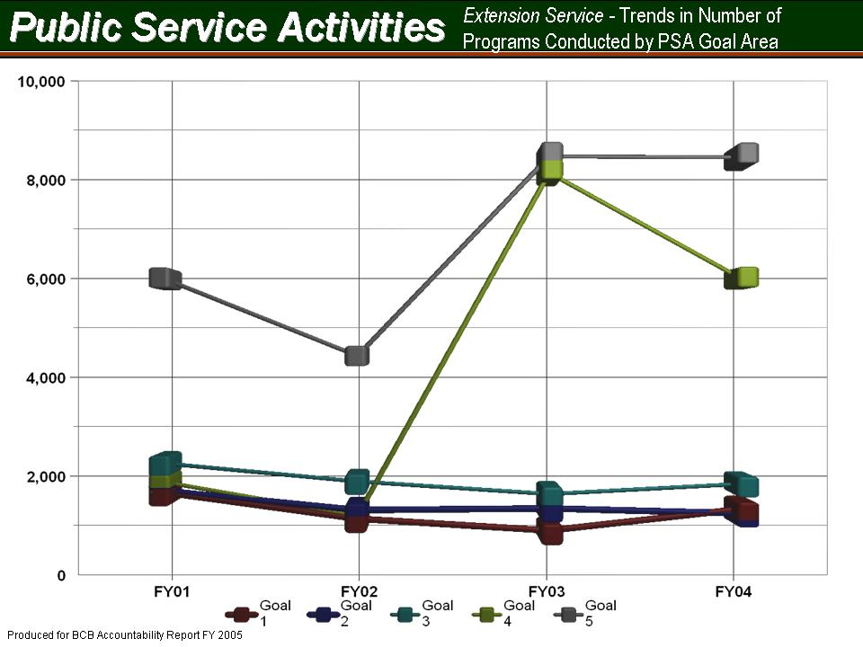
Extension Service Performance Measure Series  Indicator 7.13 | 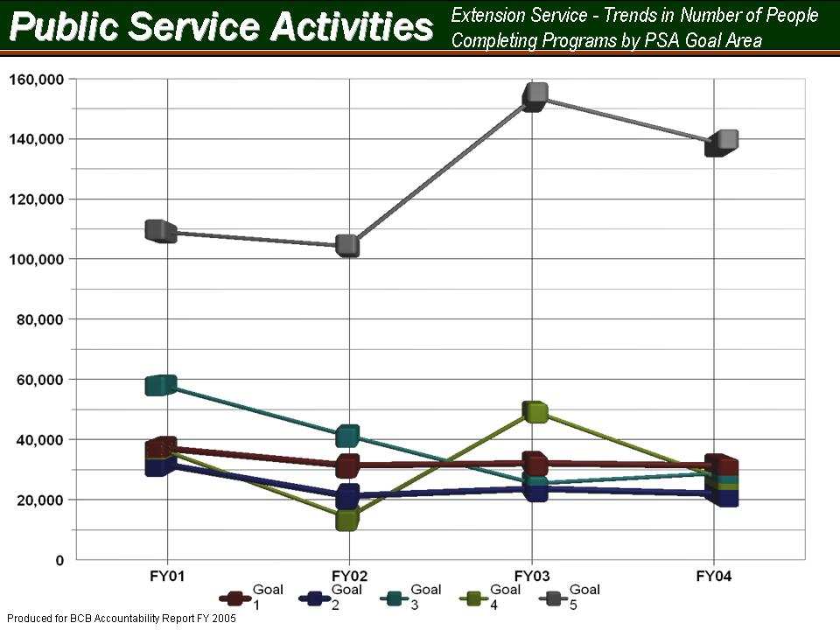
Extension Service Performance Measure Series  Indicator 7.14 | 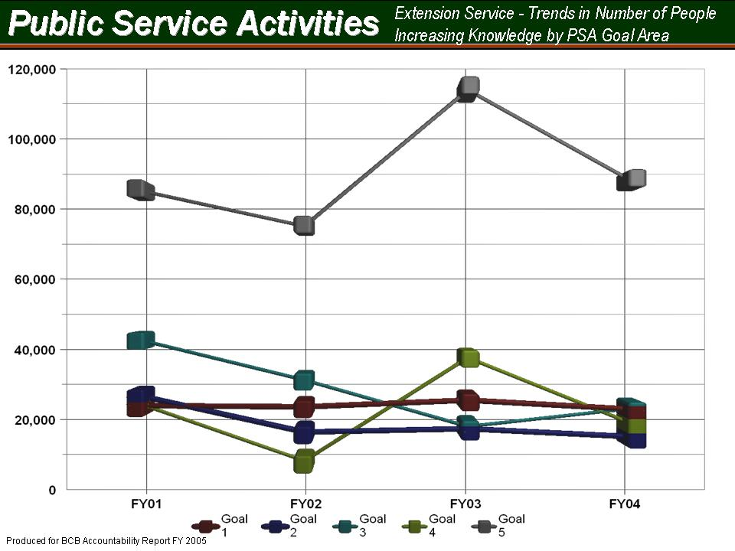
Agriculture Research /PSA Performance Measure Series  Indicator 7.15 | 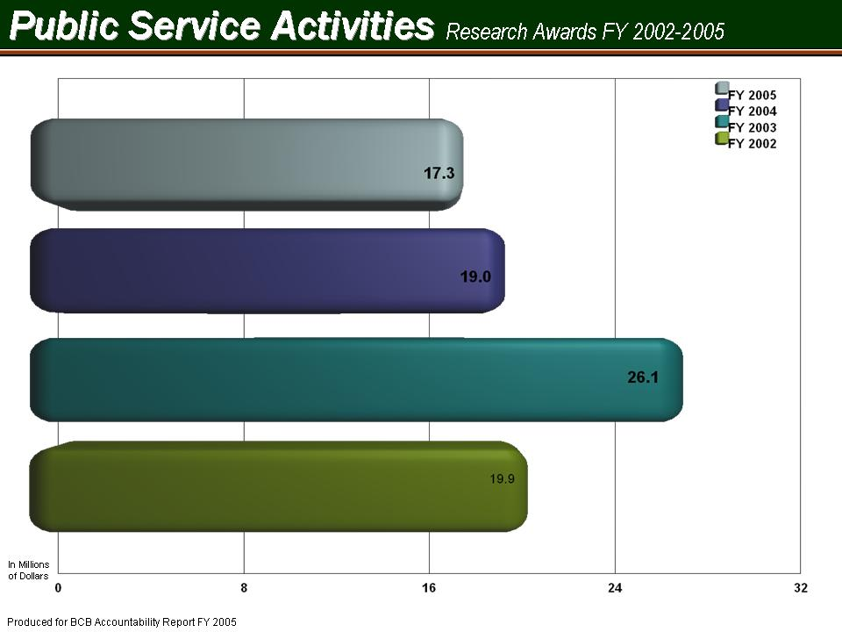
Agriculture Research /PSA Performance Measure Series  Indicator 7.16 | 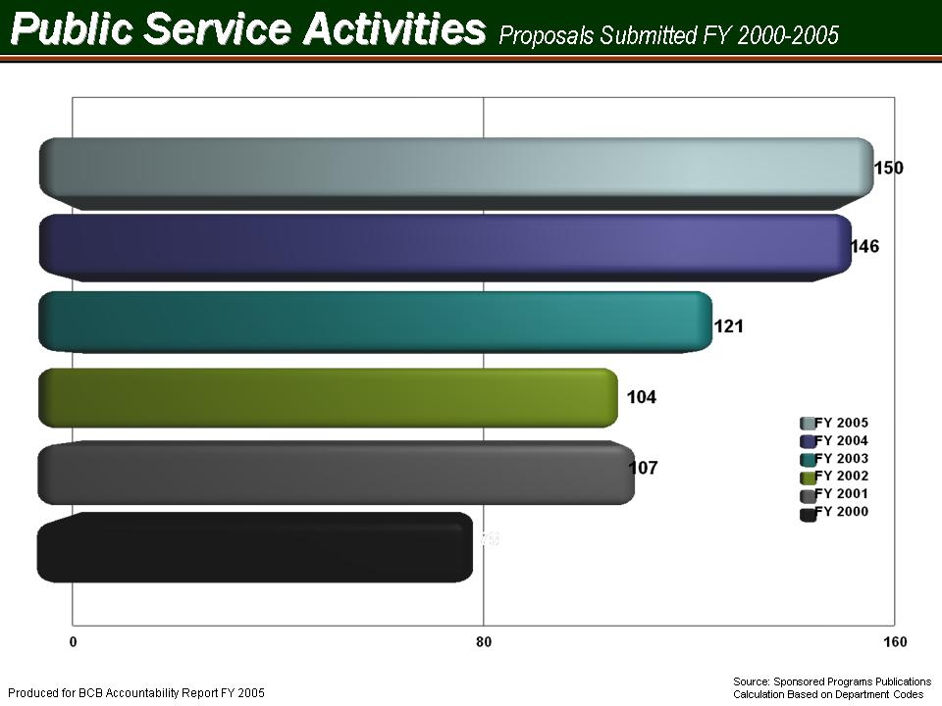
Agriculture Research Performance Measure Series  Indicator 7.17 | 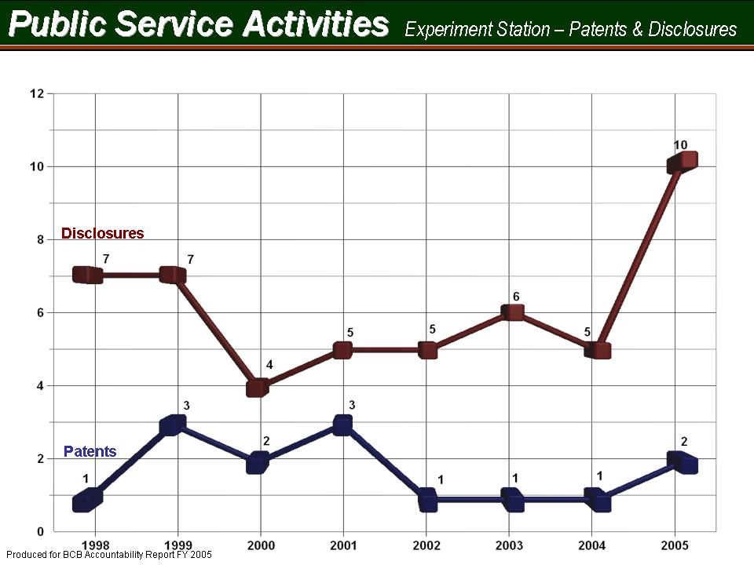
Agriculture Research Performance Measure Series  Indicator 7.18 | 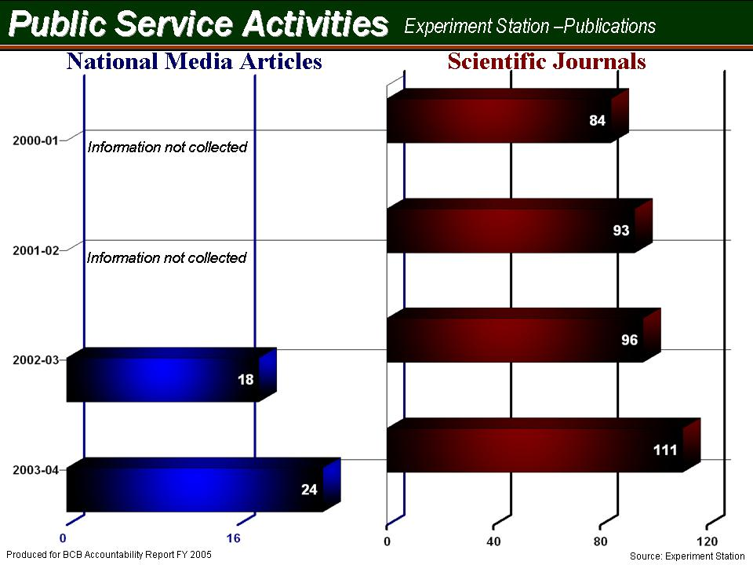
Livestock-Poultry Health Performance Measure Series  Indicator 7.19 | 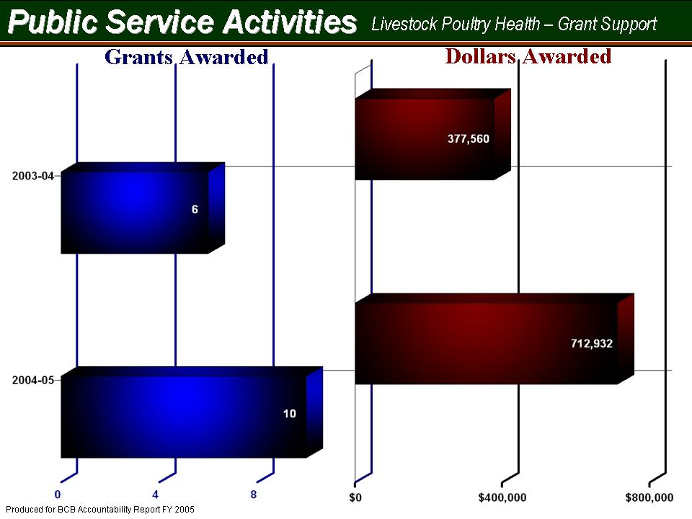
Livestock-Poultry Health Performance Measure Series  Indicator 7.20 | Disease Eradication Activity Measurements  Animal Health Programs  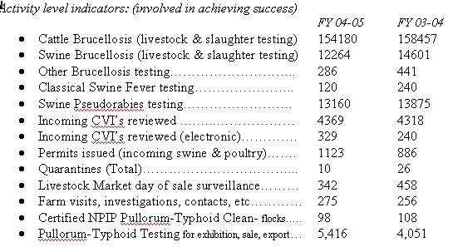
Livestock-Poultry Health Performance Measure Series  Indicator 7.21 | Disease Control & Awareness Program Measurements  Animal Health Programs  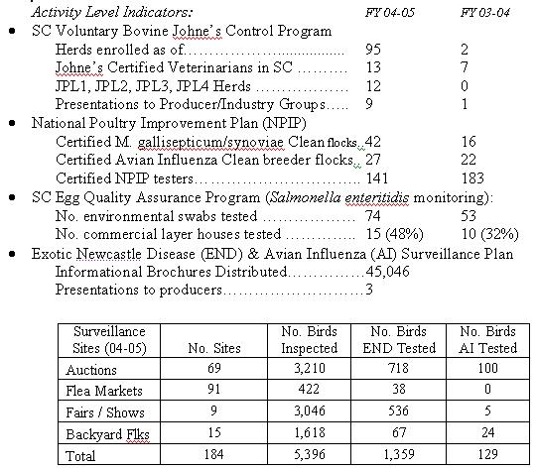
Livestock-Poultry Health Performance Measure Series  Indicator 7.22 | National Animal Identification System (NAIS)  Animal Health Programs  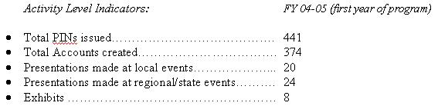

Clemson University Public Service Activities
Office of PSA Accountability
Room 126 Lehotsky Hall
Clemson, SC 29634

