Section I – Executive Summary

Mission and Values

The mission of the South Carolina Department of Insurance is the protection of the insurance consumer, the public interest and the insurance marketplace.

The South Carolina Department of Insurance (“the Department”) is responsible for ensuring the solvency of insurers, administering and enforcing the insurance laws of the State, and regulating the insurance industry in an efficient, courteous, responsive, fair and equitable manner. Our mission is carried out through professional services, including examinations and audits of insurers; consumer education, outreach and assistance; review and approval of certain insurance rates and policy forms; licensure of insurers, agents and related entities and disciplinary actions related thereto; and collection of premium taxes and fees on behalf of the State and its subdivisions. The Department adheres to certain principles and values that guide our actions:

- Integrity.
- Accountability.
- Concern regarding the issues affecting our stakeholders.
- Professionalism.
- Customer service.
- Leadership.
- Employee growth and development.
- Open lines of communication with all stakeholders.
- Quality performance.

2. Major Achievements Over the Past Year

- Passage of Senate Bill 686, the Property and Casualty Insurance Personal Lines Modernization Act, which partially deregulate homeowners insurance by eliminating overly burdensome, inefficient and ineffective strict prior approval rating for certain rate filings. This legislation was intended to attract insurers to South Carolina, primarily for the purpose of writing homeowners insurance along the coast.

- Passage of the Special Purpose Financial Captives Act, which provides for the creation of Special Purpose Financial Captives (“SPFC”) exclusively to facilitate the securitization of one or more risks as a means of accessing alternative sources of capital and achieving the benefits of securitization. The creation of SPFCs was intended to achieve greater efficiencies in structuring and executing insurance securitizations, to diversify and broaden insurers’ access to sources of capital, to facilitate access for many insurers to insurance securitization and capital markets financing technology, and to further the economic development and expand the interest of the State of South Carolina through its captive insurance program. South Carolina is currently the only state with this type of legislation and has licensed 5 SPFCs since passage of this legislation is currently considering several applications.

- For the calendar year 2004, South Carolina licensed 47 captive insurers, more than any other state. In the five short years since captive legislation was passed and implemented, South Carolina has become the 3rd largest domicile for captives in the U.S. There are currently 127 captives licensed and domiciled in South Carolina, providing a combined economic impact of $9,606,173 during 2004.

- The Department partnered with the insurance industry to present a property insurance forum in Charleston on June 24th to educate insurers not currently doing business in South Carolina about the legal, regulatory and business environment in South Carolina. The forum was attended by approximately 100 insurers, reinsurers, agents, brokers and consultants and has already resulted in one new company becoming licensed.

3. Key Strategic Goals

- Develop and implement a formal planning process.
- Review all Department business processes to ensure efficiency and alignment with changing marketplace.
- Continued initiatives to promote competition and innovation.
- Improve customer service through automation and better communication.
- Ensure that the Department’s technical skills are sufficient to regulate a complex industry.
- Achieve greater accountability.
- Leverage the marketplace to maximize the Department’s delivery of services with scarce resources.
- Improve technology.
- Maintain fiscal integrity.

4. Opportunities and Barriers

Opportunities

- Continue to look for ways to eliminate inefficient and ineffective laws, regulations and processes that create barriers to competition.

- Attract new insurers to South Carolina, both to write business and to establish operations in the State, because of our reputation as a business-friendly environment.

- Continue to grow the Captives program, particularly in the area of SPFCs as South Carolina is currently the only U.S. domicile where SPFCs can be formed.

Barriers

- Increased complexity and creativity of the insurance industry requires higher skilled staff than the Department is readily able to attract due to salary levels that are significantly lower than industry.

- Ability to adequately respond in the event of a disaster is compromised by lack of technology and availability of back-up power.

- Limited resources to combat efforts at federal intervention in insurance.

5. Organizational Performance and Continuous Improvement

This year’s Accountability Report (the first for Director Eleanor Kitzman, who became Director on February 24, 2005) will serve as the foundation for the Department’s strategic planning process. The strategic planning process will involve the assessment of customer needs and the re-design of Department programs, processes and procedures to align with those needs, as well as an on-going evaluation of performance against benchmarks and standards. The Accountability Report and the results of the strategic planning process will serve to clearly communicate our organizational mission, goals and objectives to our customers, employees and other state agencies, and will serve to promote continuous improvement with the Department.

II - Business Overview

The Department regulates, in some form or fashion, all lines of insurance and all insurance activity in South Carolina. The Department’s overriding objective is the creation of an insurance marketplace with abundant availability and relative affordability for all consumers. The Department operates five organizational divisions: 1) Executive, 2) Administration & Strategic Planning, 3) Legal, Agents Licensing & Consumer Services, 4) Market Services and 5) Financial Services.

Number of Employees

During fiscal year 2004-2005, the Department had 84 classified employees, 3 unclassified employees and 5 temporary employees.

Operation Locations

The Department’s main office is located at 300 Arbor Lake Drive, Suite 1200, Columbia, SC 29223. The Department maintains a small office at 145 King Street, Suite 311, Charleston, SC 29401, for meetings and other activities related to the Captives program.

Base Budget Expenditures and Appropriations
 | 03-04 Actual Expenditures |  | 04-05 Actual Expenditures |  | 05-06 Appropriations Act
Major Budget Categories | Total Funds | General Funds | Total Funds | General Funds | Total Funds | General Funds
Personnel Services | $4,030,848 | $2,834,630 | $3,885,718 | $2,444,487 | $4,483,238 | $2,540,945
Other Operating | $2,609,536 | $251,731 | $1,014,953 | $445,769 | $2,361,220 | $197,985
Special Items | $0 | $0 | $0 | $0 | $0 | $0
Permanent Improvements | $0 | $0 | $0 | $0 | $0 | $0
Case Services | $0 | $0 | $0 | $0 | $0 | $0
*Distributions  to Subdivisions | $96,773 | $0 | $1,862,108 | $0 | $1,277,500 | $0
Fringe Benefits | $1,090,870 | $752,828 | $1,008,657 | $668,784 | $1,211,266 | $666,494
Non-recurring | $0 | $0 | $0 | $0 | $0 | $0
Total | $7,828,027 | $3,839,189 | $8,561,941 | $3,559,040 | $9,333,224 | $3,405,424

Other Expenditures
Sources of Funds | 03-04 Actual Expenditures | 04-05 Actual Expenditures
Supplemental Bills | $52,788 | $45,308
Capital Reserve Funds | $0 | $0
Bonds | $0 | $0
*04-05 Reinsurance Facility 180,600
Insurance Companies 1,681,508
1,862,108

Major Program Areas Charts
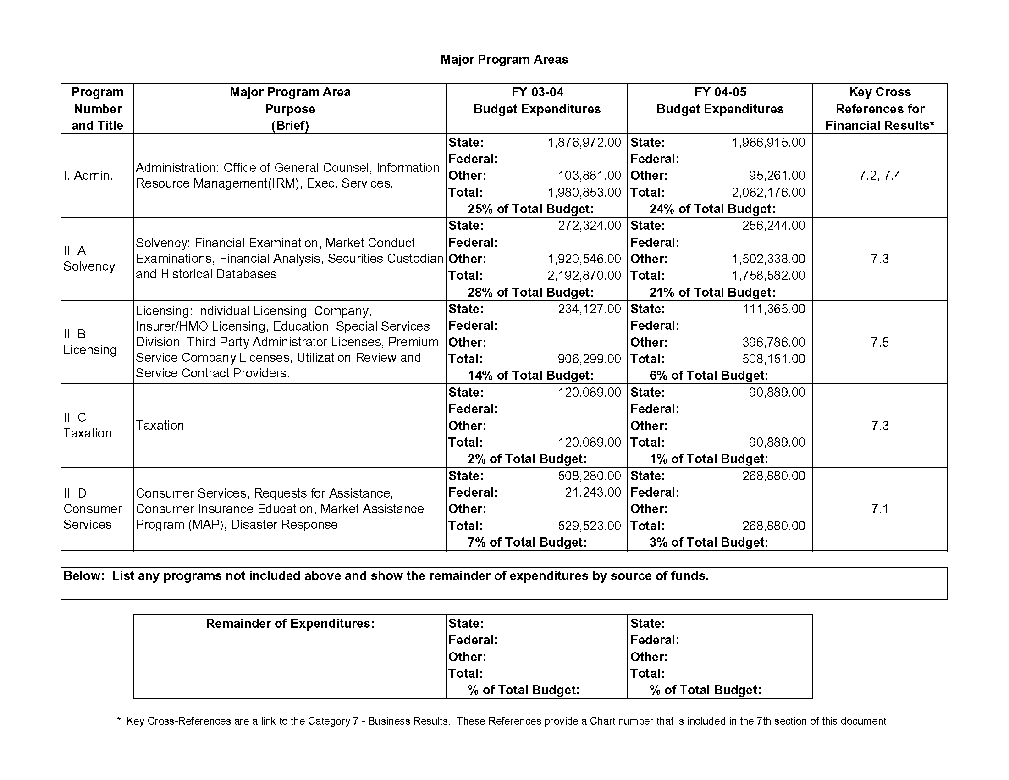

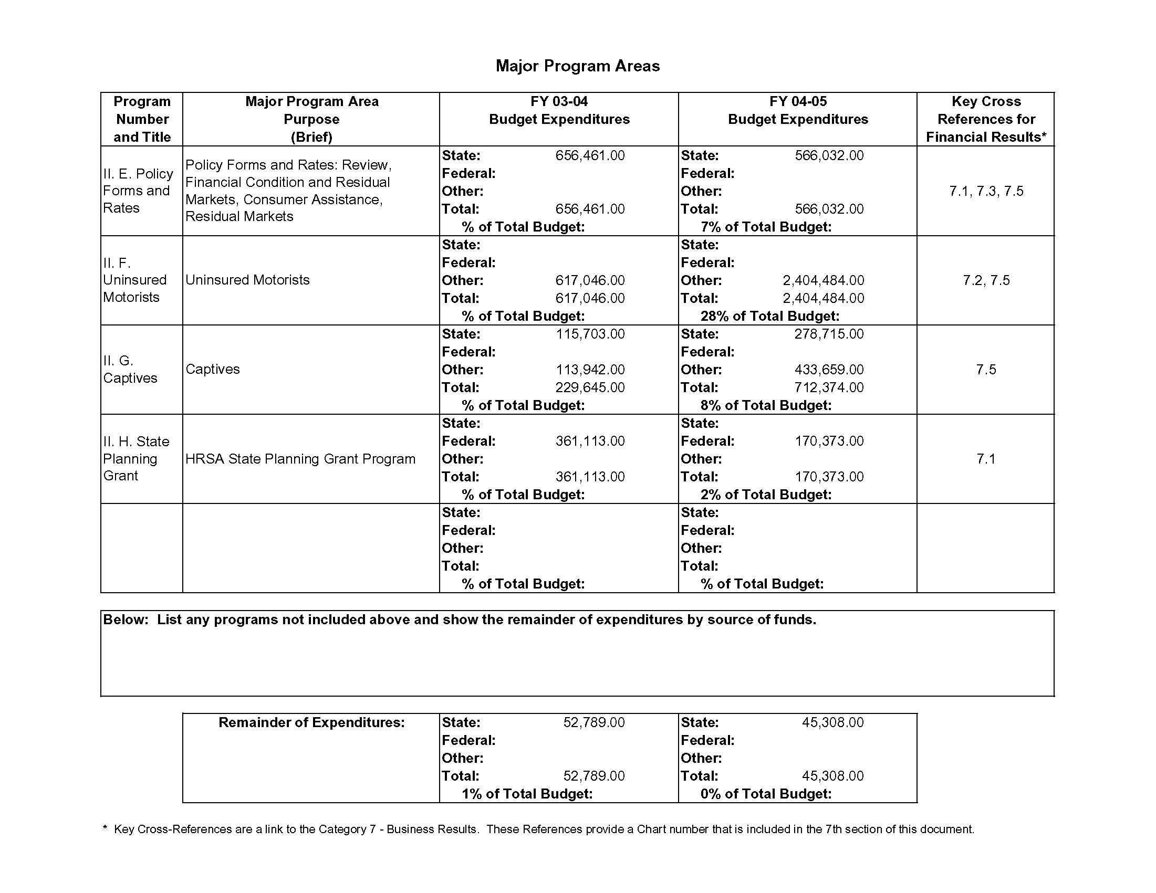
STRATEGIC PLANNING
Program Number and Title | Supported Agency Strategic Planning Goal/Objective | Related FY 04-05 Key Agency Action Plan/Initiatives | Key Cross References Performance Measures
Solvency, Financial Services | To strengthen financial analysis and examination process to prevent insolvencies | Hire Deputy Director for Financial Services who will be 100% dedicated to solvency surveillance | 7.3
 |  | Increase professional and technical skill level of analysis and examination staff
All Program Areas | To increase the use of technology to improve access, speed and quality of service | Automate license issuance and renewal process | 7.5
 |  | Create electronic rate and form filing process
 |  | Image rate and form filings
All Program Areas | Upgrade technical capabilities of staff in order to effectively regulate an increasingly complex insurance industry | Provide additional training to existing staff | 7.1-7.5
 |  | Recruit and retain staff with higher technical skills and professional designations
All Program Areas | Better align Department resources with priorities | Review current processes for efficiency and effectiveness | 7.1-7.5
 |  | Develop objective performance measures for all processes
All Program Areas | Attract more carriers to South Carolina, particularly for underserved markets and uncompetitive lines of business | Educate insurers not doing business in South Carolina about the regulatory and business environment | 7.1-7.5
 |  | Review and revise existing statutes, regulations and practices that stifle competition and innovation
Administration | Improve disaster response capabilities | Explore options for acquisition of back-up generator so that employees involved in disaster response will have telecommunications and IT capabilities in the event of a power outage at the Department | 7.1
 |  | Identify off-site facilities from which employees involved in disaster response can work and access the Department’s telecommunications and IT networks
Market Services | Grow and enhance the captives program | Pursue initiatives to attract new captive insurers | 7.5
 |  | Develop and implement post-licensing regulatory processes and procedures

Key Customer Segments and Key Services Provided

All citizens of South Carolina are key customers of the Department as all citizens are affected by insurance, in one way or another, on almost a daily basis. Other key customers are the insurance industry and the insurance marketplace generally. The Department is, first and foremost, a regulatory agency, but also has consumer education and outreach responsibilities, and marketplace development duties.

As a regulatory agency, the Department’s Financial Services Division licenses insurers, monitors and examines their financial condition and market practices, and is responsible for liquidating insolvent insurers. The Market Services Division is responsible for reviewing certain rates, rules and policy forms of insurers for compliance with State law. The Agent Licensing and Education section is responsible for licensing agents and insurance-related entities, including continuing education vendors. Consumer Services receives and responds to consumer inquiries and complaints. The General Counsel’s office enforces the insurance laws of the State, including disciplinary actions, suspension and revocation proceedings and representation of the Department in rate actions and other contested matters.

Consumer education and outreach is handled by both the Consumer Services section and the Executive Division through the Public Information Officer and the Director. These activities are carried out via the Department’s website, brochures and speaking engagements.

The Director and other Executive Division staff are actively engaged in marketplace development activities, such as the property insurance forum described above and numerous industry events and meetings at which the Department’s “open for business” message is communicated. Additionally, the Executive Division participates in NAIC activities and provides assistance to the legislative and executive branches of government on insurance matters, changes to existing insurance laws and resolution of constituent matters.

Key Suppliers/Vendors

The Department works with a number of suppliers and vendors. The following is a listing of the businesses and organizations with whom we conduct business on a regular basis: The South Carolina Budget and Control Board, Office of Information Resources for technology infrastructure, Central Supply, The South Carolina Department of Corrections, Industries Division, Gateway Company, J.M. Grace Corporation, Herald Office Systems, Kosi Office Systems, Minolta Corporation, Mac Paper Supply Company, General Services Print Shop, Dell Computer Corporation and Prestige Travel Services.

Organizational Structure

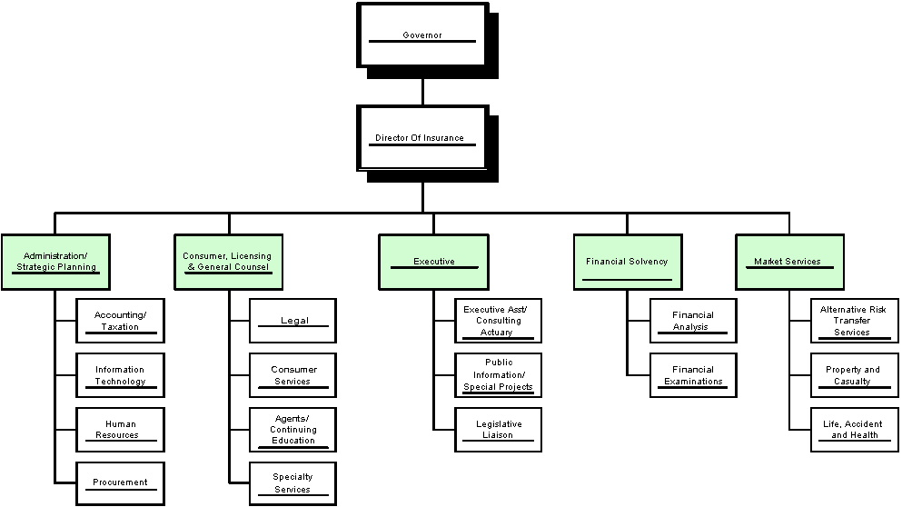

Section III – Elements of Malcolm Baldridge Award Criteria

1. Leadership

The leadership of the Department consists of three levels: the executive staff, managers and supervisors. The executive staff is comprised of the director and four deputy directors; there are nine managers and four supervisors.

1.1. How do senior leaders set, deploy and communicate: a) short and long term direction, b) performance expectations, c) organizational values, d) empowerment and innovation, e) organizational and employee learning, and f) ethical behavior?

a-f. Through her leadership team, the Director is working to effectively communicate the mission, goals and organizational values of the Department to all employees. This is being accomplished primarily through division, section and unit meetings, training sessions and other activities. The Director meets with her deputies weekly to discuss overall direction and initiatives. Subsequent meetings of the deputies with their management and supervisory staffs allow this information to be shared with front-line employees, thus ensuring consistent communication on the short and long term goals of the Department.

The Department is currently working to review and update its workflow and production processes, and to develop objective performance measures for each activity. The Department is implementing a universal review date of July 1 for the Employee Performance Management System (“EPMS”), which will be used to develop performance plans for key services and functions. The EPMS communicates management’s expectations for each employee and informs the employee of the specific performance measures that will be used to evaluate his or her job performance. Ethical behavior is the foundation of all employee performance, and job performance that is not ethical is simply not acceptable from any employee. The Department has revised, updated and expanded its policies and procedures manual to further highlight the expectation that all employees will adhere to the highest standards of ethical behavior.

EPMS should be an ongoing, two-way communication in which managers and employees collaborate to identify and find solutions to issues, problems and inefficiencies in the Department’s processes that compromise the Department’s ability to accomplish its mission. To further empower employees and ensure that they have the technical and other skills necessary to effectively perform their jobs, the Department utilizes numerous state and industry resources to provide training and professional development to employees. Employees attending these various programs, conferences and seminars share what they have learned with other employees through in-house training programs.

1.2 How do senior leaders establish and promote a focus on customers and other stakeholders?

The Department’s mission is specifically customer-focused and senior leadership continually reinforce this mission by closely monitoring the Department’s handling of consumer inquiries and complaints, responsiveness to industry filings and enforcement of insurance laws and regulations for the protection of the public.

  - How do senior leaders maintain fiscal, legal and regulatory accountability?

The Department maintains a strong system of checks and balances to ensure that fiscal, legal and regulatory accountability are maintained. Frequent meetings between legal counsel, the budget/finance manager and the procurement specialist facilitate compliance with established guidelines.

  - What key performance measures are regularly reviewed by your senior leaders?

Current key performance measures include analysis of consumer inquiry/complaint data to identify market conduct patterns, analysis of licensing data to evaluate cycle times and roundtable meetings with industry to obtain feedback on Department responsiveness with regard to filings. Additional key performance measures, organizational objectives and operational plans are being developed in conjunction with our process review initiative.
1.5 How do senior leaders use organizational performance review findings and employee feedback to improve their own leadership effectiveness and the effectiveness of management throughout the organization?

Senior leaders review previous outcomes, activity data, budget items and reports on progress toward Department goals and objectives regularly, and are able to adjust and modify their management plans accordingly to maximize overall effectiveness. Specific issues are addressed and changes in day-to-day operations are made as needed. Frequent communication between divisions further facilitates an integrated approach to delivering services by breaking down barriers within the Department.

  - How does the organization address the current and potential impact on the public of its products, programs, services, facilities and operations, including associated risks?

As an agency charged with protection of the public interest, the Department continually evaluates the ramifications of its activities on consumers. The Department solicits feedback from consumers in a variety of ways: on our website, through consumer inquiries/complaints, speaking engagements around the state, etc. We are exploring cost-effective options for additional consumer outreach programs to both educate consumers and receive more feedback.

1.7 How does senior leadership set and communicate key organizational priorities for improvement.

Weekly division and section meetings are utilized to set and communicate key organizational priorities for improvement and to develop specific action plans. Through these meetings and subsequent meetings with employees, all employees are expected to evaluate his or her role and performance in achieving the Department’s goals.

1.8 What is the extent of participation in improving the community?

The Department and its senior leadership actively support and strengthen communities by encouraging employee involvement in community activities and Department employees regularly speak and/or provide information and/or assistance to community organizations. In addition to its regulatory responsibilities, the Department is also involved in a number of state boards, commissions, committees and task forces, including the S.C. Budget and Control Board Cost Containment Committee, the Governor’s Workers’ Compensation Task Force, the Workers’ Compensation Advisory Board, the Commission on Healthcare Access, DHEC First Sounds Advisory Committee, the State Interagency Council for BabyNet and the Governor’s Budget Working Group.

2. Strategic Planning

2.1 What is your strategic planning process, including participants, and how does it account for: a) customer needs and expectations; b) financial, societal and other risks; c) human resource capabilities and needs; d) operations capabilities and needs; e) supplier/contractor/partner capabilities and needs?

a-e. The Department was without a Director for the first half of the fiscal year 2004-2005. Utilizing available State resources, as well as outside consultants, the Department will undertake a major strategic planning initiative in early 2006 that, pursuant to our mission, will focus specifically on the needs of consumers, industry and the public interest and assess our human resource and operational capabilities to meet those needs. In the meantime, the Department has taken a more tactical approach and is focusing on achieving the most efficient and cost-effective use of resources by reviewing current processes to adapt to recent changes in the legal environment and marketplace. Additionally, Department leadership is in regular and frequent contact with our customers, which provides a mechanism for receiving feedback that is incorporated into our process reviews and service delivery model.

2.2 What are your key strategic objectives?
STRATEGIC PLANNING
Program Number and Title | Supported Agency Strategic Planning Goal/Objective | Related FY 04-05 Key Agency Action Plan/Initiatives | Key Cross References Performance Measures
Solvency, Financial Services | To strengthen financial analysis and examination process to prevent insolvencies | Hire Deputy Director for Financial Services who will be 100% dedicated to solvency surveillance | 7.3
 |  | Increase professional and technical skill level of analysis and examination staff
All Program Areas | To increase the use of technology to improve access, speed and quality of service | Automate license issuance and renewal process | 7.5
 |  | Create electronic rate and form filing process
 |  | Image rate and form filings
All Program Areas | Upgrade technical capabilities of staff in order to effectively regulate an increasingly complex insurance industry | Provide additional training to existing staff | 7.1-7.5
 |  | Recruit and retain staff with higher technical skills and professional designations
All Program Areas | Better align Department resources with priorities | Review current processes for efficiency and effectiveness | 7.1-7.5
 |  | Develop objective performance measures for all processes
All Program Areas | Attract more carriers to South Carolina, particularly for underserved markets and uncompetitive lines of business | Educate insurers not doing business in South Carolina about the regulatory and business environment | 7.1-7.5
 |  | Review and revise existing statutes, regulations and practices that stifle competition and innovation
 | Improve disaster response capabilities | Explore options for acquisition of back-up generator so that employees involved in disaster response will have telecommunications and IT capabilities in the event of a power outage at the Department
 |  | Identify off-site facilities from which employees involved in disaster response can work and access the Department’s telecommunications and IT networks
 | Grow and enhance the captives program | Pursue initiatives to attract new captive insurers
 |  | Develop and implement post-licensing regulatory processes and procedures

2.3 How do you develop and track action plans that address your key strategic objectives? Note: Include how you allocate resources to ensure accomplishment of your action plans.

Most of the Department’s strategic objectives are Department-wide in scope and every deputy is responsible for developing the tactical plans to achieve those objectives within his or her area of responsibility. For those objectives that relate only to a particular division, the Director and/or the deputy for that division are responsible for achieving those objectives. In weekly management meetings between the Director and all deputies, these objectives, plans and progress toward implementation and achievement are reviewed. Certain of the Department’s funds are program-specific and are used to support related strategic and operational goals and objectives. Internal division financials are being developed to track non program-specific funds that support other goals and objectives.

2.4 What are your key action plans/initiatives?

See chart under 2.2.

2.5 How do you communicate and deploy your strategic objectives, action plans and performance measures?

The Department’s overall strategic plan, including objectives and action plans, are communicated to the divisions and sections through the weekly management meetings with deputies, the deputies’ regular meetings with their managers and supervisors, through written memos and through Department-wide meetings. As process reviews are finalized and performance measures developed for those processes, performance measures will provide the foundation for the planning stage of the EPMS, further conveying the Department’s overall strategic plan to all employees.

2.6 If the Agency’s strategic plan is available to the public through the Agency’s Internet homepage, please provide an address on the website for that plan.

The Department’s strategic plan is being updated and is not currently available to the public, but will be posted on our website upon completion.

3. Customer Focus

3.1 How do you determine who your customers are and what their key requirements are?

Our customers are defined by statutes and by our mission statement as insurance consumers, the public interest and the insurance marketplace. Many of their key requirements are likewise dictated by statute. Ancillary customers and requirements are determined through interaction with consumers, industry, legislators and federal, state and local government officials.

  - How do you keep your listening and learning methods current with changing customer/business needs.

The Director, her deputies and other Department staff are in continuous communication with consumers, industry and other government officials. We attend and participate in numerous industry conferences and consumer outreach activities, and serve on many boards, committees and task forces made up of representatives of industry, consumers and other government agencies. Additionally, we leverage those constituencies to provide training and updates to Department staff from time to time. The Department strongly encourages open lines of communication so that our listening and learning methods stay current in order to serve our customers to the best of our ability.

  - How do you use information from customers/stakeholders to keep services or programs relevant and provide for continuous improvement?

The Department gains valuable and much-needed feedback from our customers/stakeholders through the various communication mechanisms and forums described above, and are guided by that feedback in determining the appropriate level and delivery of services. Program and performance data are reviewed by management to ascertain the need for modifications in service or programs in order to better serve our customers/stakeholders.

3.4 How do you measure customer/stakeholder satisfaction?

While the Department does not currently utilize formal customer satisfaction surveys on a Department-wide basis, managers follow-up by telephone with customers on a random basis to gauge our overall responsiveness and service delivery. Additionally, we rely heavily on informal feedback from our customers/stakeholders. Some areas have sent out surveys in the past with very good response and very good results: 90+% satisfactory. We are exploring how customer satisfaction surveys could be employed for the diverse constituencies served by the Department.

3.5 How do you build positive relationships with customers and stakeholders? Indicate any key distinctions between customer groups.

Through formal conferences and other programs, as well as informal meetings and activities, the Department has successfully developed collaborative relationships with its customers and stakeholders.

4. Measurements, Analysis, and Knowledge Management

4.1 How do you decide which operations, processes and systems to measure for tracking financial and operational performance?

Some of the Department’s performance measures are directed by statute or other legal or governmental authority. After ensuring compliance with those requirements, senior leadership of the Department further defines other operations, processes and systems that should be measured.

4.2 What are your key measures?

The Department has recently undergone a reorganization of its management structure, which has resulted in new, different and/or expanded roles for the senior leadership. We are working to develop outcome measures to demonstrate our effectiveness in achieving our goals and objectives.

4.3 How do you ensure data integrity, timeliness, accuracy, security and availability for decision making?

Internal operational data is reviewed by management to ensure that accurate indicators of services are being captured and reported. We are reviewing the need for additional controls to ensure the security of confidential data. We are also working with the CIO’s office to establish appropriate monitoring systems to ensure the quality, reliability and availability of data used in decision-making.

  - How do you use data/information analysis to provide effective support for decision-making?

Operational data gathered from individual program areas is reviewed by senior leadership, managers and supervisors on a weekly, monthly, quarterly and/or annually, based on programmatic requirements, and informs the decision-making process.

  - How do you select and use comparative data and information?

The NAIC publishes an annual Insurance Department Resources Report that provides data for the 50 states, the District of Columbia and the four territories, on staffing, budget and funding, examination and oversight, insurer and producer licensing, consumer services, etc. This information allows the Department to compare itself to our counterparts in other states and to develop relevant benchmarks for performance. We are exploring meaningful ways of comparing our performance to other state agencies. We are also considering what types of inter-Departmental comparisons might be useful.

5. Human Resources

  - How do you encourage and motivate employees to develop and use their full potential?

The Department encourages all employees to develop and use their full potential in alignment with the Department’s goals and objectives. As part of the Department’s reorganization, an attempt is being made to assess employees’ strengths and weaknesses, to improve on weaknesses through training, where feasible, and to make better use of employees in positions suited to their skills.

  - How do you identify and address employee-training needs?

Training needs are addressed primarily through communication between employees and their supervisors with respect to existing and on-going job duties. Other training may be provided as new duties, processes or procedures are imposed by the NAIC or other third parties. The Department has had conversations with OHR and others concerning the general need for various types of training for Department employees.

  - How is high performance supported by the EPMS?

In order for employees to perform at a high level, they must first understand the mission, goals and objectives of the Department. Additionally, they should have some input into the development of action plans for meeting the goals and objectives. Communications is key. Through use of the EPMS, the Department expects to improve supervisor-employee communications, which is the most effective means of supporting high performing employees. The EPMS will also serve as the primary tool for documenting and evaluating employee performance, thereby increasing productivity. The Department expects to increase the overall effectiveness and productivity of its workforce through improved employee performance.

  - How do you determine employee satisfaction, well-being and motivation?

The Department’s Human Resources Manager maintains an open-door policy and is accessible to all employees for job-related matters. Additionally, the Department strives to provide promotional or transfer opportunities to its employees in order that they will remain challenged and stimulated in their jobs. The Department has a very low turnover rate among its employees.

  - How do you maintain a safe and healthy work environment?

The Department is located in a facility that offers a safe, secure and healthy work environment in a park-like setting. Employees are provided with a manual of safety policies and procedures and ongoing training is held for employees with respect to general office safety and security, and specific staff actions that are necessary in the event of an emergency.

  - What is your involvement in the community?

The Department supports employee participation in a variety of local, regional and national organizations. Many employees volunteer in their communities and participate in local events and charities. The Department sponsors blood drives, collects needed items for the underprivileged or victims of disasters, and participates in fundraising for organizations such as March of Dimes and United Way.

6. Process Management

6.1 What are your key processes that produce, create or add value for your customers and your organization, and how do they contribute to success?

The Department’s key processes are financial analysis and examination, licensing, consumer services and rate and form approval. These processes support the Department’s mission of protection of the consumer, the public interest and the insurance marketplace by ensuring solvency, enforcing the insurance laws of the State and making insurance products available to consumers and businesses at an affordable rate.

6.2 How do you incorporate organizational knowledge, new technology, changing customer and mission-related requirements, cost controls, and other efficiency and effectiveness factors into process design and delivery?

While the Department’s mission does not change, the range of activities necessary to achieving that mission are changing and growing. Leveraging new technology with organizational knowledge has been and will continue to be critical to the ongoing success of the Department and our ability to perform those wide-ranging activities. The Department’s website has proven both efficient and effective for dealing with many of our customers. Additionally, insurers may make certain rate and form filings electronically. As process reviews are completed, we expect to identify numerous opportunities to make our process design and delivery more efficient and effective.

6.3 How does your day-to-day operation of these processes ensure meeting key performance requirements?

The Department’s key processes are specifically related to its mission to protect the insurance consumer, the public interest and the insurance marketplace. All aspects of daily operations are reviewed on a regular basis by managers and supervisors and recommendations are made to leadership for changes to improve the Department’s processes. Additionally, the Department is currently working with an independent third party to conduct comprehensive reviews of all of the Department’s processes to identify opportunities for improvement.

6.4 What are your key support processes, and how do you improve and update these processes to achieve better performance?

While output from the key support processes are delivered to Department staff and not to customers directly, those processes have a direct impact on the Department’s ability to meet the needs and expectations of its customers. Each support process work unit functions under its own performance measures and will be improved and upgraded in response to internal and external feedback. The key support processes are: legal, human resources, accounting, information technology and procurement.

6.5 How do you manage and support your key supplier/contractor/partner interactions and processes to improve performance?

The Department has very strict standards for suppliers, contractors, vendors and consultants, who must adhere to established fee scheduled for all goods and services. The Department complies with all procurement laws and regulations, requires competitive bidding consistent with those laws and regulations, and takes advantage of the State contract system for purchases whenever possible. Additionally, the Department complies with and embraces initiatives and directives concerning contracting with minority-owned businesses.

7. Business Results

  - Customer Satisfaction

While the Department does not currently utilize formal customer satisfaction surveys on a Department-wide basis, managers follow-up by telephone with customers on a random basis to gauge our overall responsiveness and service delivery. Additionally, we rely heavily on informal feedback from our customers. Some areas have sent out surveys in the past with very good response and very good results: 90+% satisfactory. We are exploring how customer satisfaction surveys could be employed for the diverse constituencies served by the Department.

The Department provides customer services through its five organizational divisions. Executive Services provides assistance to the legislative and executive branches of government regarding the creation of new statutes and regulations, as well as constituent matters. There was a 7.6% decrease in the number of constituent matters reviewed and resolved by the Department for fiscal year 2004-2005 vs. fiscal year 2003-2004.

Consumer Services provides assistance to consumers with the resolution of claims and/or complaints through various mechanisms to include e-mail, telephone and faxed requests for assistance. There was a 7.7% decrease in the number of requests for assistance in fiscal year 2004-2005 compared to the 2003-2004 fiscal year.

Agents Licensing issues producer, agency, broker, adjuster, public adjuster and appraiser licenses. This office issued 26,216 licenses during the 2004-2005 fiscal year, an increase of 29.4% over the 2003-2004 fiscal year.

The Continuing Education section provides oversight for continuing education courses and administers the examination process. The overall pass rate improved to 71% compared to last year’s rate of 56%.

7.2 Mission Accomplishment

As stated in the Department’s mission, the Department is charged with the protection of the insurance consumer, the public interest and the insurance marketplace. Accomplishment of this mission is measured through a variety of means, including monitoring of calls for consumer assistance, compliance with statutes and other requirements in performing required examinations and analysis and solvency of the market, the effectiveness of the administration and enforcement of South Carolina’s insurance laws and the fair, equitable and efficient regulation of the insurance industry.

The Office of General Counsel provides legal representation to the Department, including acceptance of service of process, drafting of legal documents and bulletins, requests for proposals, contracts and legislation. The Office is responsible for investigating violations of the South Carolina insurance laws and taking administrative disciplinary action where appropriate. The General Counsel also represents the Department in both state and federal courts, and provides advice, counsel, training and technical assistance to all divisions within the Department.

There was a 16% increase in the number of summons and complaints in civil actions and a 10% increase in the number of pleadings from the South Carolina Workers’ Compensation Commission.

The number of investigations received increased by 4.8% while 7% more files were closed in this fiscal year than to last fiscal year. These actions resulted in $460,000 in administrative fines, 45 revocations and 1 license suspension. Ten files were referred to the Insurance Fraud Division of the South Carolina Attorney General’s Office for criminal investigation and prosecution.
The Office of General Counsel is currently handling 6 receiverships. During the 2004-2005 fiscal year, the Director suspended 3 insurer licenses, revoked 5 licenses due to hazardous financial conditions and placed 1 company in ancillary receivership.

  - Financial Performance

The Division of Financial Services is responsible for: monitoring the financial solvency and trade practices of insurers transacting business in South Carolina; licensing insurers and health maintenance organizations; and enforcing South Carolina insurance laws and regulations regarding solvency. Financial examinations are performed on each domestic insurer at least once every five years and at least once every three years for each domestic health maintenance organization. These comprehensive examinations, as well as interim or additional limited or targeted examinations, test internal controls, management issues and the financial condition of the company. In addition to being required every three or five years, these examinations must be completed and examination reports issued within specific time periods. During this fiscal period, 24 examinations were initiated. This reflects a 25% increase in the number of examinations initiated compared to last fiscal year.

The Division of Administration is responsible for the collection of premium taxes from insurers and brokers and the deposit of these taxes into the State’s General Fund on a quarterly basis. Beginning on March 1st, all premium tax returns are audited annually and total amounts collected are balanced to the general ledger by June 30th. Fire taxes are collected from insurance companies doing business in South Carolina and are distributed to the counties annually through the State Treasurer. During this fiscal year, the Department collected in excess of $136 million in insurer and broker premium taxes. Of this amount, approximately, $9.8 million was distributed to county governments, $6.5 million was transferred to the Department of Labor, Licensing and Regulation and $3.6 million was drawn to cover insolvent self-insured workers’ compensation claims. The remainder (approximately $116.1 million) was transferred to the General Fund.

  - Key Measures of Human Resource Results

Human Resources will play a key development role in the process review initiative currently being undertaken by the Department. Human Resources will be included in the Department’s planning and development of Department goals, objectives and action plans. The Department’s leadership team and Human Resources will work together to fully integrate human resources management into the planning process so that it will become a fundamental and contributing factor to Department planning and operations.

The Department’s measures of human resources efficiency and/or effectiveness are generally output-oriented and focus on processes and activities, and are used to make improvements to Human Resources policies and procedures. As the Department refocuses its activities to broader organizational issues, these measures will also need to be expanded to gauge the impact that Human Resources has on the Department’s mission and goals so that such information can be used in Department decision-making.

  - Measures of Regulatory/Legal Compliance and Community Support

The Department is responsible for the regulation of the insurance industry in an efficient, courteous, responsive, fair and equitable manner. The Department accomplishes this mission through professional services, which include but are not limited to examinations and audits of insurance underwriters, consumer education, outreach and assistance; premium tax and fee collection on behalf of the State and its subdivisions; prior review of insurance premium rate and insurance policy forms; and the licensure of insurers and insurance-related individuals and entities.

The Life, Accident and Health and the Property and Casualty sections within the Market Services Division review insurance policy forms and rates to ensure that they do not contain provisions that are unfair, deceptive, ambiguous, misleading or unfairly discriminatory. These reviews are generally completed within a 30-60 day period depending upon the type of policy form. Certain property and casualty rate filings are subject to a “flex-band” in which rate changes of +/-7% may be implemented within 30 days of filing if not disapproved by the Department within that time frame. For fiscal year 2004-05, there was a decrease of 5% in Life, Accident and Health rate and form filings and a 1% reduction in Property and Casualty rate and form filings.

The Market Services Division assists in solvency monitoring by providing technical assistance on financial condition examinations, providing actuarial analysis on loss reserves, assessing company practices with regard to claims operations and evaluating market conduct practices. Actuarial assistance was provided for 5 examinations of insurance companies during fiscal year 2004-2005.

The supervision of residual market mechanisms is also a responsibility of the Market Services Division. Those organizations include: the South Carolina Associated Auto Insurers, South Carolina Wind and Hail Underwriting Association, South Carolina Reinsurance Facility, South Carolina Medical Malpractice Joint Underwriting Association, the South Carolina Property and Casualty Guaranty Association, South Carolina Life, Accident and Health Guaranty Association, the South Carolina Health Insurance Pool, South Carolina Workers’ Compensation Assigned Risk Plan and the South Carolina Small Employer Insurer Reinsurance Program. Department staff attends meetings and participates in committee work.

With the passage of Act No. 331 in 2000 of the Captive Insurance law, the Department is responsible for developing and regulating the captive insurance industry in South Carolina. This emerging market provides alternative forms of insurance to South Carolina consumers and has proven a successful mechanism for economic development opportunities. Within five years, since the creation of the Captives Program, South Carolina has grown to be the 3rd largest domicile for captives in the U.S. To date, the Department has licensed 127 captive insurers. During the 2004 legislative session, H.5002 passed, which provides for the creation of Special Purpose Financial Captives. This is yet another tool for expanding the presences of licensed captive insurance companies in South Carolina. Since the passage of H. 5002, the Department has licensed 5 Special Purpose Financial Captive insurers.

