State Regulation of Public Utilities Review Committee
Energy Advisory Council

Distributed Energy Resources Initial Draft Report
November 2013



Post Office Box 142
Columbia, SC 29202
(803) 212-6625

Table of Contents
Executive Summary 1

Introduction 2

How to Use this Report 3

The Nature of Distributed Generation 4

Lower/Higher Penetration 4

Benefit-Cost Approach to Valuing Distributed Energy Resources 6

The Basics of South Carolina’s Electricity Industry 8

Retail Electricity Market Structure in South Carolina 8

Regulatory Oversight of Investor-Owned Utilities in South Carolina 10

Regulated Utility Ratemaking 10

The Present Paradigm: Sole-Provider Generation Model 12

The Root of the Matter: South Carolina’s Retail Electric Rate Structure is Outdated 12

The Sole-Provider Model’s Interaction with Distributed Generation 14

The Future Paradigm: Customers Rely on Distributed
Generation and on Central Plant Utility Providers 18

Translating Net Benefit Studies into Rates 18

A Discussion of Retail Rate Parity for Solar Distributed Generation 20

Crossing the Bridge from Present to Future 23

Starting Point in Crossing: The Current Electric System 23

First Step in Crossing: Understanding Growth Potential in Distributed Solar 28

Second Step in Crossing: Envisioning Near-Future Distributed Solar Deployment 31

Third Step in Crossing: Envisioning a Future System with
Higher DG Penetration and Emerging Technologies 33

Flexibility is Key: Integrated Resource Planning 38

Other Factors to Consider in Crossing the Bridge 41

Renewable Energy Certificates 41

Third-Party Sales of DG as Related to Utility’s Legal Obligation to Serve 45

List of Figures

Figure 1: Common Value Streams Considered in Determining Distributed Solar Net-Value

Figure 2: High Penetration of DG Could Have Positive or Negative Impacts Across the Electricity Value Chain

Figure 3: Percent of Total 2011 South Carolina Retail Sales, by Provider

Figure 4: Top Five Retailers of Electricity in South Carolina, 2011

Figure 5: BFCs for Select Electric Service Providers

Figure 6: Simplified Electricity Ratemaking Formula

Figure 7: Regulated Utility Cost of Service Ratemaking

Figure 8: Utility’s Cost to Serve a Typical Residential Customer vs. Residential Rate Design

Figure9: NEM Programs in South Carolina

Figure 10: Residential Net Metering Under Existing Rate Structures and Policies

Figure 11: Advantages and Challenges of Net Energy Metering (NEM)

Figure 12: Rate Alternatives to Traditional Residential Net Energy Metering Transaction

Figure 13: Factors Affecting the Cost of Energy – from the Grid and from Customer-Owned DG Installation

Figure 14: South Carolina Retail Rate Parity

Figure 15: Equivalent Days of Operation per Year

Figure 16: Deployed Solar Capacity

Figure 17: Comparison of Solar Resources by Region of U.S.

Figure 18: U.S. PV Installation Forecast, 2010-2016

Figure 19: Options for Increasing Power System Flexibility to Accommodate Renewables

Figure 20: Electric Grid Energy Storage Services

Figure 21: 2013 Data from Central Electric Power Cooperative, Inc.’s Help My House Weatherization Pilot Program

Figure 22: Solar PV Price Trends – Large Scale Solar Farms – Carolinas

Figure 23: State Renewable Mandates

Figure 24: REC Markets and Their Characteristics

Appendices

Appendix A: Glossary of Terminology Used in this Report
Appendix B: Benefit-Cost Terminology
Appendix C: Bonbright’s Ratemaking Principles
Appendix D: Net Energy Metering (NEM)
Appendix E: Supplemental Charts and Graphs
Appendix F: The Electric System as it Exists Today
Appendix G: RECs – Renewable Energy Certificates
Appendix H: H.3425—The Energy System Freedom of Ownership Act

Executive Summary

As various regions of the U.S. experience increasing amounts of distributed generation (DG) and demand-side management (DSM), the electricity industry realizes that the electric utility business model must change. The future electric grid will evolve into a different system that will be significantly more dynamic and versatile than today’s system. Electricity rate structures must likewise evolve to reflect a more technologically advanced and flexible environment in which DG is a major component of the energy mix.

Thus, South Carolina is faced with a paradigm-shift: from the current rate structure that assumes sole provider or utility-owned electricity, to one that would be relevant, effective, and equitable for a distributed generation environment. The shift is highlighted by the potential for large numbers of DG-inclined customers to generate some (or, in the long-term, possibly all) of their own electricity and (with passage of statutory changes) perhaps purchase electricity from third parties other than the traditional utility.

In the short term and with some adjustments, the current electric rate structure in South Carolina can accommodate lower penetration levels of distributed generation. However, existing retail electricity rate structures do not contemplate higher penetrations of distributed generation, specifically rooftop solar. In today’s environment, distributed generation costs are rapidly declining and increasingly competitive with retail electricity rates. In addition and at least for a while longer, federal and state tax incentives for customers to install DG exist. Given these factors, increased levels of DG penetration are certainly in the offing.

Current residential and commercial pricing structures in South Carolina may not accurately reflect the actual costs and benefits of providing electric service to customers whose net purchases of energy are very low. Policy updates should be aimed at accurately and fairly identifying and allocating costs and benefits accruing from DG; maintaining necessary investments in the grid to ensure reliability and safety; and continuing to encourage distributed generation development in response to demand.

A significant challenge in remodeling the retail electric rate structure to effectively accommodate higher penetrations of distributed generation in the future is that the incumbent utility will continue to be responsible for the reliable operation of the system within the bulk electric grid even though the utility may not have direct ownership or absolute control over many of the future distributed resources. Utility business models and legislative and regulatory policy must address all of these factors in a comprehensive manner in order to best promote a reliable electric supply and the interests of customers within an evolving electric service industry in the years to come.

As a State, we are poised on the edge of a sea change that requires proactive policymaking and the Energy Advisory Council (EAC) recognizes that it will be best to ride the crest of the distributed-generation wave in a proactive rather than reactive way. How state policymakers structure the legal, regulatory, and economic environment will be critical in setting the stage for successful development and promotion of distributed generation in South Carolina.

Introduction

The State Regulation of Public Utilities Review Committee (PURC) created an Energy Advisory Council (EAC) in 2010 to conduct research primarily focusing on expanding energy efficiency and renewable energy in South Carolina and provide recommendations or information to PURC for consideration in reviewing and developing state energy policy. The EAC solicited volunteers to form a working group to create an initial draft of a report to educate policymakers on the issues surrounding distributed energy resources. This draft is a product of that working group and is intended to elicit public comment on its content before it is presented for acceptance by the EAC for submission to the PURC.

A 2012 report on renewable resources commissioned by the PURC EAC concluded that South Carolina, like many Southeastern states, possesses a significant solar resource. This 2013 report, also commissioned by the PURC EAC, serves to provide state policymakers South Carolina’s options for rate structures that better accommodate distributed energy resources while maintaining a modern, affordable and reliable grid. This central theme consists of eight core questions:

- How does the basic facilities charge on the typical electric power tariff in South Carolina reflect the actual fixed costs of providing service?

- What alternative rate structures/schedules could be available for consideration that better accommodate distributed generation technologies?

- At what point will retail rate parity for solar distributed generation be reached?

- How do the characteristics of various forms of generation compare to those of distributed energy resources?

- How does the Integrated Resource Planning process work for South Carolina utilities?

- What experience have other states had with the establishment of a REC market to meet Renewable Portfolio Standards or Energy Efficiency Portfolio Standards and how does this impact the viability of such a market in South Carolina?

- How does distributed generation through third-party sales of electricity interface or interact with the legal obligation to serve in South Carolina?

- Regarding H.3425 specifically, what impacts would this bill have on South Carolina utilities in the areas of load, revenue, fuel savings, avoided system costs, diversification, and legal obligation to serve, as well as on the utility’s choice of business model?

How to Use this Report

Underpinning the discussion of distributed generation throughout this report and essential to understanding its implications are the concepts of 1) penetration (on a continuum from lower to higher) and 2) benefits and costs analysis. Following this page, the section of this report entitled The Nature of Distributed generation – Understanding the Issues is a must-read.

The Basics of South Carolina’s Electricity Industry section provides basic information on the current retail electricity market structure in South Carolina.

Next are several sections devoted to discussion directly related to the research questions put forth by the EAC. These questions are answered within the following conceptual sections of the report:

- The Present Paradigm: Sole-Provider Generation Model
- The Future Paradigm: Customers Rely on Distributed generation and on Central Plant Utility Providers
- Crossing the Bridge from Present to Future
- Other Factors to Consider in Crossing the Bridge

While not totally correlated by section, in general the EAC questions are addressed by section as follows:

- Question 1: The Present Paradigm: Sole-Provider Generation Model
- Questions 2 & 3: The Future Paradigm: Customers Rely on Distributed generation and on Central Plant Utility Providers
- Questions 4 & 5: Crossing the Bridge from Present to Future
- Questions 6 & 7: Other Factors to Consider in Crossing the Bridge
- Question 8: Appendix H
The Appendices contain significant material including a general glossary of terms used throughout the report, benefit-cost terminology, a primer on the electric system as it exists today, various supplemental charts and graphs, and information on H.3425.

To enhance readability, italicized terms throughout this report are defined in the Glossary.

The Nature of Distributed Generation

The discussion of distributed generation as it relates to the issues facing South Carolina policymakers can best be understood by appreciating the nuances of the lower-to-higher penetration continuum and the give-and-take trade-offs inherent in the analysis of benefits and costs. The effects of lower and higher levels of penetration from distributed generation should be considered in the context of the Benefits and Costs discussion that follows the Lower/Higher Penetration discussion in this section of the report.

Lower/Higher Penetration
The effects of distributed generation are different based upon how much distributed generation is installed and where the generation is located on any particular electrical grid. Generally, the higher the penetration of distributed generation, the higher the impacts, whether they be positive or negative. Conversely, the lower the penetration of distributed generation, the lower the impacts. This is intuitive, but the relationship between penetration and impacts is not always linear or easy to quantify. The analysis of impacts also varies greatly based upon the focus of the question. For example: Is the focus financial or operational? What are the specifics of the particular electric system (is it winter peaking or summer peaking)? What is the type of generation under consideration (solar PV versus combined heat and power)?

Accordingly, understanding the impacts at different penetrations requires subdividing the issue further.

Impacts can be generally grouped into two categories: impacts that affect the utility business model and impacts that affect the utility operational model. The utility business model represents the financial planning for and investments in the generation, transmission, and/or distribution grid and the means of recovering prudent and necessary expenditures as well as the manner in which costs are assigned to and revenues are collected from grid users for the value created by the grid. The utility operational model represents the technical planning for and management and operation of an electrical energy delivery system (grid) that meets customers' electricity demand now and in the future.

Utility Business Model Considerations

Lower
Effects at lower levels of customer adoption of distributed generation can best be understood as involving cost shifting. These effects are caused by how retail electricity is priced in South Carolina. As the Rocky Mountain Institute (RMI) explains, “Mechanisms are not in place to transparently recognize or compensate service (be it monetized grid services like energy, capacity or balancing supply and demand, or less consistently monetized values, such as carbon emissions (savings) provided by the utility or the customer. To the utility, revenue from DER customers may not match the cost to serve those customers. To the customer, bill savings or credit may not match the value provided.” This effect can best be described as a cost shift.

That shift will either flow toward or away from owners of distributed generation, depending upon the value provided to the utility by the distributed generation system, but the existence of this shift is unavoidable under current retail rate structures. Because these effects are caused by rate structure, they will grow in a linear fashion and will not be mitigated by scale. Absent a change in rate design, at some point in the future customers or policymakers will decide that the amount of cost shift is too much, and that point will, practically, serve as the distinction between higher and lower penetration from a business model perspective. (Appendix H provides a bit of a case study on this point centered on H. 3425 as proposed.) These impacts are analogous to other cost shifting impacts that utilities currently deal with on their system including energy efficiency investments, policies that lead to reduced customer demand, and natural variability in the weather.

Higher
Absent a change in structure, customers or policymakers could decide that the amount of cost shift is too great; in practical terms, that point will serve as the distinction between higher and lower penetration from a business model perspective. Among other things, higher penetration could effectively alter the assumptions underlying prior resource planning and asset investment, thus leading to stranded costs.

Utility Operational Considerations

Lower
While experience has shown that utilities can manage a certain amount of bidirectional flow and electric systems are designed to handle micro-variability in load, every DG installation has some effect on the local distribution system, often termed the “distribution feeder.” Utilities routinely conduct interconnection studies to ensure the safe interconnection of DG. So long as distribution level impacts are identified through interconnection studies and mitigated through equipment upgrades or even programming of equipment, there is a general expectation that the overall operational impacts of DG, particularly distributed solar, will be manageable under lower penetration scenarios.

Higher
Effects of higher penetrations of distributed generation on utility operations are non-linear and increasingly complex. These impacts will vary substantially from utility to utility based upon particularities such as the size of the utility, its location, its configuration, and the nature of the loads it serves. The operational impacts at higher penetration levels occur at the distribution, transmission, and generation levels.

Summary
Absent utility-specific studies identifying the transition points from lower to higher levels of penetration, it is not possible to identify with any precision when exactly that transition will occur, from a business model perspective and from an operational perspective. However, there are studies upon which South Carolina policymakers can draw to better understand how to quantify the business model impacts. These include studies from institutions such as RMI and the Interstate Renewable Energy Council (IREC), both of which have provided some guidance about how we might quantify the impacts of distributed generation. On the operations side, various national laboratories and independent system operators (ISOs) have authored informative studies that provide frameworks that South Carolina’s utilities can use to test high penetration scenarios.

Benefit-Cost Approach to Valuing Distributed Energy Resources
In recent years, a number of utilities, solar advocates, and/or regulators have sought out approaches to identifying and attempting to measure all of the impacts associated with distributed generation and the grid, both positive and negative, netting those, and then determining what the value of distributed energy resources are to the utility and its customers.

This value is then used as a baseline to consider the implications of various rate designs, including current rate options like net energy metering, as well as new rate design approaches focused on durability and responsiveness to changes in the net-value of distributed generation and grid services under a variety of solar penetration scenarios.

Inasmuch as South Carolina policymakers seek to lay the groundwork for distributed generation expansion in the State, consideration of these new approaches to rate design may be valuable due to the fact that these benefit-cost based approaches are more responsive to changes in the net-value of distributed generation and grid services as customer adoption of DG increases.

Figure 1 identifies a number of common categories of impacts, both positive (benefits) and negative (costs), that have typically been used in the dozen or so solar PV distributed generation value assessments conducted over the past five years in the U.S. For further discussion of common categories of impacts, see Appendix B.

Figure 1: Common Value Streams Considered in Determining Distributed Solar Net-Value

* Transmission and Distribution (T&D)
In addition to the assessments that have been done by select states and utilities, there are several meta-studies that have attempted to glean best practices from across the country. These studies have concluded that there is no one “model” study after which all others should be crafted. Instead, there is a significant range of estimated value across studies, driven primarily by differences in local context, input, assumptions, and methodological approaches.

With that said, South Carolina can benefit from the best practices in benefit-cost studies identified in these meta-studies. For example, if South Carolina’s policymakers were to undertake a comprehensive study of the effects of distributed generation at different levels of penetration, they might also want to consider these factors:
- Benefit-cost analyses conducted with an eye to transparency have better odds of being widely accepted by customers, utilities, and the solar industry.
- Benefit-cost analyses are not necessarily transferable. Instead, the scores are geographically and grid operator-specific.
- Benefit-cost analyses will vary by solar scenario. Two-hundred megawatts of widely distributed, small rooftop solar installations may yield outcomes markedly different from 4 x 50 megawatt solar farms.
- Benefit-cost results can vary by economy: is the electric service provider seeing net load growth? Net load loss?
- Benefit-cost results will vary at different levels of penetration. The capacity benefits assigned to an incremental solar kW may decline as more solar is interconnected, for example. Thus, any methodology should be responsive to market changes.
- Benefit-cost results can change over time; as solar PV penetration increases, so too might the magnitude of values; revisiting benefits and costs at prescribed moments in time is instructive, as is comparing prospectively generated benefit-cost impacts to actuals.
Figure 2 illustrates possible impacts that higher penetration levels of DG could have across the electricity value chain.

Figure 2: High Penetration of DG Could Have Positive or Negative Impacts Across the Electricity Value Chain
Source: Net Energy Metering, Zero Net Energy and the Distributed Energy Resource Future, Rocky Mountain Institute, 2012.

The Basics of South Carolina’s Electricity Industry: How retail electricity rates are developed in South Carolina

As legislators consider how best to craft legislation and regulators consider how best to craft distributed generation policy and regulation for South Carolina, it is important to understand the current retail electricity market in South Carolina.

Retail Electricity Market Structure in South Carolina
South Carolinians are served by one of three different types of electric service providers: investor-owned utilities (IOUs) (e.g., SCE&G, Duke Energy); public entities (e.g., South Carolina Public Service Authority, hereafter Santee Cooper, and municipalities); and member-owned entities called cooperatives or co-ops.
Figure 3: Percent of Total 2011 South Carolina Retail Sales, by Provider Type | Figure 4: Top Five Retailers of Electricity in South Carolina, 2011
Source: Energy Information Agency.
Each of these entities has both the right and obligation to serve those customers located in its assigned territory. Each prices the electricity it sells using a traditional utility pricing model, often termed ratemaking.

For most basic service residential customers, the rates reflect a basic facility charge (BFC) assessed each month and then a volumetric charge based upon consumption of electricity. Some entities apply a tiered structured for the volumetric charges. Some tiered structures have volumetric charges that increase with increasing consumption while others have structures that decrease with increasing consumption. While the BFC does not include all costs of providing service, the BFC typically reflects a portion of the cost of serving the customer, including bill processing and mailing, meter reading, and basic customer service. The costs reflected in the BFC vary across electric service providers.

Figure 5: BFCs for Select Electric Service Providers
Source: Energy Information Agency, Company websites.

In South Carolina, residential customers pay published rates for the electricity they consume each month. These rates vary among electric providers in the State, as do the manner in which the rates are approved. Following are the types of electric providers in South Carolina.

Member-Owned Electric Service Providers
Member-owned utilities, such as electric cooperatives, charge residential members rates that are set by the cooperatives’ individual boards of directors. Cooperative board members are elected to their position by vote of their members; thus, the members themselves are charged with regulating their own rates.

Investor-Owned Electric Service Providers
Investor-owned utilities (IOUs) are motivated by duties to their customers and shareholders. IOU shareholders allocate capital (purchase publicly traded shares of the company) based on their view of the company’s potential to earn a competitive rate of return with this capital. The Directors of these corporations have a duty to govern the organization in accordance with shareholders’ interests while simultaneously balancing the needs of other stakeholders such as regulators, customers, employees, and the communities they serve.

Public Entity Electric Service Providers
There are two general types of public entity electric service providers in South Carolina: 1) those that serve in and around municipalities through the grant of their constitutional rights to do so (“electric cities”), and 2) the South Carolina Public Service Authority (“Santee Cooper”). All cities and towns may grant the exclusive franchise of providing electricity to their own municipal government and inhabitants by vote of the qualified electors of the given municipality. The municipality must fix a maximum rate for the electric city providing electric service, both for public and private consumption. Municipalities’ rates are set and controlled by publicly elected bodies (City Councils or Commissions). There are 21 electric cities operating as public entity electric service providers in South Carolina.

The Governor of South Carolina appoints the members of Santee Cooper’s Board of Directors. Board members are confirmed by the South Carolina Senate and must possess certain abilities and experience established by law. Santee Cooper’s board members have a fiduciary duty to make decisions that balance the preservation of Santee Cooper’s financial integrity with just and reasonable rates, promote economic development in South Carolina, and follow good business practices and applicable laws and regulations. This Board sets rates according to the guidelines established in its enabling laws.

Regulatory Oversight of Investor-Owned Utilities in South Carolina
As with the state’s other electric utilities, South Carolina’s IOUs have both the exclusive right and obligation to serve customers in their assigned territories and the opportunity to earn a set rate of return on capital deployed. South Carolina’s Public Service Commission is empowered to ensure a balance exists between the public’s interest and an investor-owned utility’s interest in recovering its costs incurred to provide service and having a reasonable opportunity to earn a return on capital investments made to serve customers.

IOUs are often termed “regulated” utilities because of the unique oversight relationship that they have with a state’s public utilities commission (e.g., South Carolina’s Public Service Commission), which regulate many aspects of the IOUs’ business operations—including customer rates, allowed rate of return on invested capital, product and service offerings, and service quality.

The Office of Regulatory Staff (ORS) is charged with representing the public interest of South Carolina in utility regulation for the major utility industries before the Public Service Commission of S.C., the court system, the S.C. General Assembly, and federal regulatory bodies. The public interest, as defined by Act 175 of 2004 that created the ORS, is a balance among three essential components expressed in the agency’s mission statement:

To represent the public interest in utility regulation by balancing the concerns of the using and consuming public, the financial integrity of public utilities, and the economic development of South Carolina.

Regulated Utility Ratemaking
The rates of regulated electric service providers consist of two basic components: 1) the recovery of reasonable and necessary operating expenses, including depreciation and 2) the return on investments through the allowed rate of return on invested capital.

The most straightforward way to estimate the average cost of providing electricity is to add the utility’s return on invested capital costs (return on the utility’s investment, including interest and equity costs) and the operating costs (fuel, depreciation, operation and maintenance expenses, taxes). That sum is then divided by the number of kilowatt-hours sold in the particular period in which costs were measured, as shown in Figure 6. This average cost-per-kilowatt-hour sold is representative of the charge a customer pays based on the amount of kilowatt-hours the customer consumes each month, as measured by their electric meter. As discussed on page 20, a number of policy factors also influence ratemaking decisions, including the goals of making rates transparent, stable and equitable.

Figure 6: Simplified Electricity Ratemaking Formula
Return on invested capital costs + Operating costs | = Cost per kWh
Energy sold | = Cost per kWh

In South Carolina, IOU retail electric rates are established through the ratemaking process known as cost of service regulation.

Cost of service entails a utility determining a revenue requirement that reflects the total amount that must be collected through rates in order for it (the utility) to recover its costs and have an opportunity to earn a reasonable rate of return. Electric service providers typically apply a four-step process to determine retail electricity rates:

Figure 7: Regulated Utility Cost of Service Ratemaking

- Conduct cost of service study and determine the appropriate cost allocations. Cost allocation refers to how to align the costs incurred by the company to the various groupings of customers served by the company based on their usage patterns. This is determined by a cost of service study, whereby the utility studies customer-class usage patterns, their related costs, and attempts to group the costs with the different customer classes who, in general, “caused” the costs. Cost-causation is an important principle in the rate-making process. This measurement of cost is determined by a test year, a 12-month period in which a utility measures its costs.
- Determine the revenue requirement of the customer classes. Revenue requirement refers to how many dollars it will cost the electric service provider to serve each class of customer for the electricity needs in a given year.
- Design new rates. Rate design refers to how the utility prices its services to individual customers within each class and attempts, to the extent practicable, to reflect the cost of providing service to individual customers. In total, it will collect enough dollars from various groups of customers in order to meet its revenue requirement.
- Seek approval and implement. The utility must seek approval of the new pricing structure from electricity regulators, such as the South Carolina Public Service Commission. Once approved, the electric service provider will implement the new pricing mechanism by publishing a new tariff (pricing sheet) and notifying customers of the change.
While the adoption of distributed generation has implications on each of these steps, the impacts on steps 2 and 3 are emphasized in this report.

The Present Paradigm: Sole-Provider Generation Model

The Root of the Matter: South Carolina’s Current Retail Electric Rate Structure is Outdated
The underpinning or “root” of South Carolina’s current retail electric rate structure is this key assumption: The utility is the sole provider. With all signs pointing to increasing levels of distributed generation in South Carolina, the current business model will not be able to accommodate the “fruit” of higher penetration levels and wider-scale adoption of DG. To remain relevant and equitable, the model for the retail electric rate structure must evolve. There must be a paradigm-shift from the current way of doing business to a new one.

The Sole-Provider Model: Background
For decades, the fundamental assumption in South Carolina has been that an electric service provider is the sole provider of electricity to the customer. Every electric service provider in the State has an assigned territory where it has both the right and obligation to serve customers.

The historical basis for a utility’s obligation to serve in South Carolina arises generally from the theory that electric service is most appropriately provided through a natural monopoly and that such a monopoly must be economically regulated. In a basic sense, a natural monopoly exists where the costs and/or delivery of a particular product or service will be most efficiently accomplished through a single provider, such that any duplication of the development and distribution of the product will be inefficient.

As a result of this sole provider foundational assumption, electric service providers have assumed in their ratemaking process that revenues from particular classes of customers would remain predictable and that customers will not switch to other providers. Furthermore, in South Carolina, retail electricity rates have, as a general matter, not been designed to a scenario with customers opting to invest in distributed generation.

Ratemaking Principles in the Sole-Provider Model
Generally, South Carolina utilities have designed retail rates with an eye towards Bonbright’s ratemaking objectives (Appendix C), which are often cited in various rate-related proceedings. These objectives – encompassing revenue requirements, revenue collections and practical concerns – serve as guiding principles to rate design. However, in practice utilities are faced with significant trade-offs in setting rates. For example, setting rates so as to promote economically efficient consumption would ideally entail a real-time pricing mechanism where the price customers pay for energy is dependent on the cost to produce that energy at the time it is being demanded. Yet for residential customers and to a lesser degree for other customers as well, most utilities eschew more accurate price signals in favor of practicality.

Another example of a ratemaking trade-off relates to the objective of apportioning rates fairly within customer classes. South Carolina utilities generally do not differentiate individual households within the residential customer class for rate-setting purposes; as a consequence, residential rates are uniform across housing types and sizes and across urban, suburban, and rural locations.

A final example of ratemaking trade-offs is the tension between the need of the utility to recover its costs of serving customers and the objective of maintaining stable rates. External factors like stricter regulations, prevailing economic conditions, advancing technology and even weather can impact rate stability.

These are just a few of the trade-offs inherent in the ratemaking process. As distributed generation becomes more and more attractive to energy users, additional trade-offs are likely to emerge, and these trade-offs represent both challenges and opportunities for utility rate-setting.

Cost Recovery Mechanism in the Sole-Provider Model
Historically, there have been three primary mechanisms for revenue collection often termed cost recovery in the utility sector:

- Basic facilities charge (BFC) ($/month),
- Volumetric energy charge (cents per kilowatt-hour), and/or a
- Demand charge (dollars per kilowatt)
Typical South Carolina residential customers are charged for electricity through the basic facilities charge ($/month) and a volumetric energy charge (cents per kilowatt-hour). The volumetric energy charge is termed a “bundled energy rate” because it reflects the bundling of costs to serve the customer—including the variable and most fixed costs associated with generation, transmission, and distribution of electricity—that are bundled into an “all-in” energy rate, as opposed to appearing on the customer’s bill as line items.

This rate structure is easy to understand and provides a simple price signal to customers to reduce their energy consumption (see Figure 8). The fixed charge on a customer’s bill (specifically, the Basic Facilities Charge or BFC) represents (on a state average) 8% of a customer’s bill, while the fixed costs to serve a typical residential customer are approximately 55% - 75% of the bill.

Figure 8: Utility’s Cost to Serve a Typical Residential Customer vs. Residential Rate Design
92%
63%
37%
8%

Typically a volumetric energy charge, but include some demand charge which vary with level of consumption
37%
Variable

92%

Basic Facilities Charge: ranges from $6.50 to $24.95 for a set of South Carolina electric service providers

63%
Fixed

8%
Residential Rate design
Cost to Serve

Source: Adapted from “Net Energy Metering, Zero Net Energy, and the Distributed Energy Resource Future,” Rocky Mountain Institute, 2012.

The Sole-Provider Model’s Interaction with Distributed Generation
A typical customer’s electricity bill would change as a result of installing distributed generation, such as rooftop solar PV. This transaction typically occurs through a special rate called net energy metering (NEM).

As defined by the Solar Electric Power Association: "Net-energy metering (NEM) is a billing mechanism for electric utility customers with grid-connected distributed generation (DG). NEM facilitates use of the electric utility system, allowing customers to virtually ‘bank’ generation not used immediately, in exchange for kilowatt-hour (kWh) and/or financial credits. Those customers subsequently may draw on their credits at other times to offset consumption and/or charges when the DG system is not meeting their full energy needs, up to the total amount they have banked within the applicable period (often 12 months). Specific utility NEM policies dictate how any credits remaining at the end of the period are ‘rolled over’ to future periods, compensated or retired. DG customers displace energy usage directly.”

For example, if a residential customer has a PV system on the home's rooftop, it may generate more electricity than the home uses during daylight hours. If the home is net-metered, the electricity meter will run backwards to provide a credit against what electricity is consumed at night or other periods where the home's electricity use exceeds the system's output. Customers are only billed for their "net" energy use.

The reader may learn more about the statutory basis for NEM, both nationally and in South Carolina, and about the various South Carolina utilities’ methods for implementing NEM, by referring to Appendix D.

Net Energy Metering Rates: Designed to be User-Friendly
By design, NEM is a simple-to-understand rate that was originally used to encourage the adoption of small-scale renewable energy systems, such as residential rooftop solar PV. Because these customers still require services from the grid, NEM ensures customers have a reliable source of energy from the grid during times that their distributed generation systems are not producing enough energy or producing too much energy.

When a customer chooses NEM, the utility will replace the meter at the customer's home with a bidirectional meter that is capable of measuring the two-way flow of electricity. Net metering customers are charged only for the “net” power that they consume from the electric service provider. Over a given period, if their renewable energy-generating systems make more electricity than is consumed, they may be either credited or paid directly for the excess electricity contributed to the grid over that same period. This is subject to an annual reset of customer credit balances by South Carolina investor-owned utilities and electric cooperatives.

Figure 9: NEM Programs in South Carolina
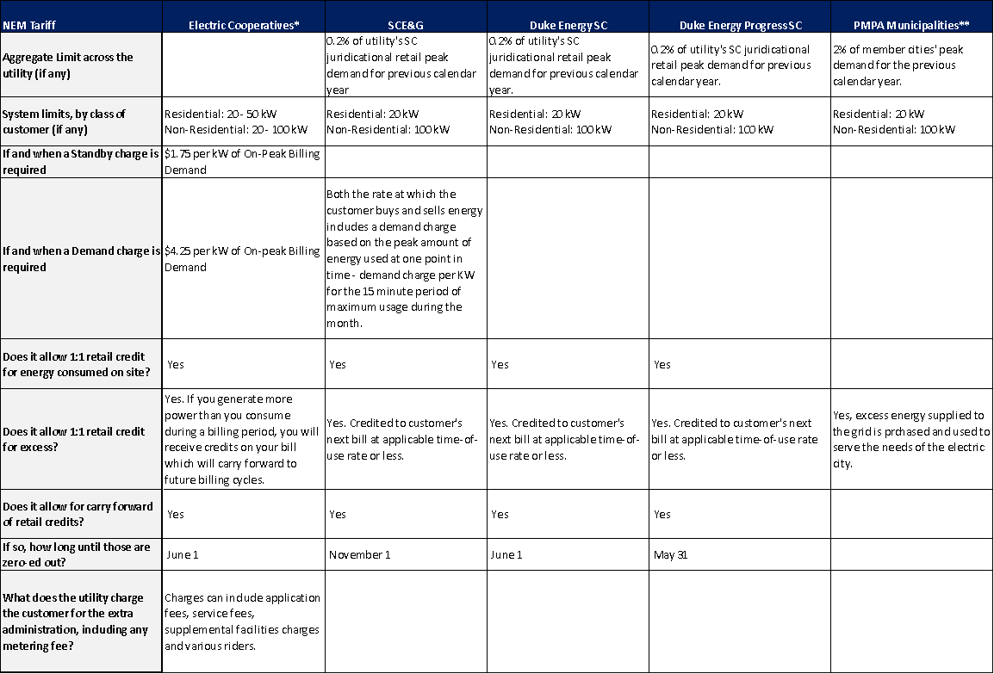

* This information is presented as a range or aggregation of data available from individual electric cooperatives and may not be representative of all electric cooperatives' NEM programs.

** This information is presented as a range or aggregation of data available from individual electric cities and may not be representative of all electric cities' NEM programs.

NEM plus Residential Rate Design under the Sole-Provider Model: 3 Scenarios
The adoption of distributed generation has a significant impact on rate design. When a customer reduces his consumption by the amount of energy produced by a distributed generation facility, such as rooftop solar PV, the utility’s variable costs to serve him are also reduced. For example, his reduction in kilowatt-hours of consumption results in reduced fuel and some variable operating and maintenance costs for a utility. These are costs that the company did not have to incur because the customer generated his own power and represent cash savings to the utility (i.e., purchasing less fuel).

Because the customer did not “consume” these services due to generating a portion of his own power, it is fair that charges for these services are not included on the bill. However, the fixed-cost component of the customer’s bill is more complicated. A benefit-cost analysis would be required to determine whether the typical net metering customer was underpaying for services received or was undercompensated for value they created for the grid (see Figure 10).

Figure 10: Residential Net Metering Under Existing Rate Structures and Policies 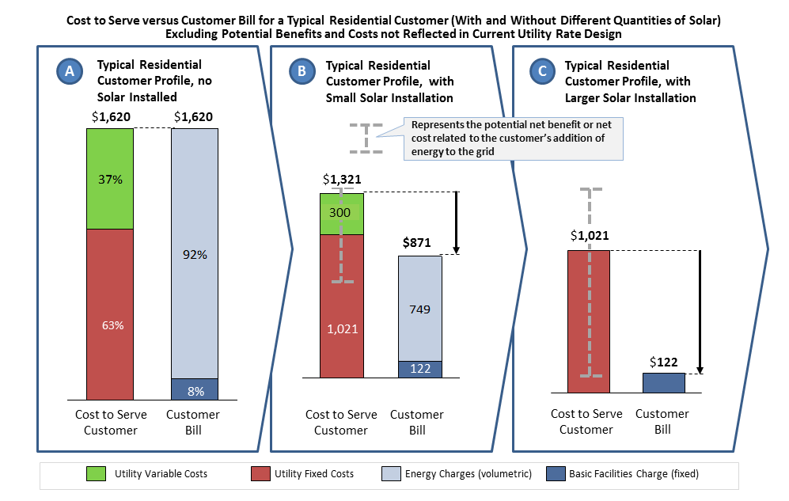
Here in Scenario C, the typical residential usage customer installs enough solar PV (~8kW) to generate as many kilowatt-hours as he consumes in year. The customer receives several benefits, including back up power and power quality. In this scenario, the utility is under-compensated. However, unrecognized potential benefits or costs may influence under- or over-compensation.
Scenario A depicts a typical South Carolina residential customer who uses about 12,500 kilowatt-hours and spends $1,620 /year on electricity. As shown by the equal heights of the bar on the right and the left, the utility fully collects its costs to serve through a combination of a small basic facilities charge (BFC) and a volumetric energy rate.
In Scenario B, the typical residential customer decides to install a small solar panel on his home (~4 kW), generating half of the kilowatt-hours he needs annually. The utility’s “cost to serve,” relative to Scenario A, is reduced. In this scenario, the utility is under-compensated. However, unrecognized potential benefits or costs may influence under- or over-compensation.

Source: Adapted from “Net Energy Metering, Zero Net Energy, and the Distributed Energy Resource Future,” Rocky Mountain Institute, 2012.

As noted above, Scenario A depicts a typical South Carolina residential customer who uses about 12,500 kilowatt-hours and spends $1,620 /year on electricity. As shown by the equal heights of the bar on the right and the left, the utility fully collects its cost to serve through a combination of a small basic facilities charge (BFC) and a volumetric energy rate.

In Scenario B, the typical residential customer decides to install a small solar panel on his home (~4 kW), generating half of the kilowatt-hours he needs annually. The utility’s cost to serve, relative to Scenario A, is reduced. In this scenario, the utility is under-compensated. However, unrecognized potential benefits or costs may influence under- or over-compensation.

In Scenario C, the typical residential usage customer installs enough solar PV (~8kW) to generate as many kilowatt-hours as he consumes in year. The customer receives several benefits, including back-up power and power quality. In this scenario, the utility is under-compensated. However, unrecognized potential benefits or costs may influence under- or over-compensation.

Implications of NEM
Like many aspects of utility rate design, traditional NEM presents trade-offs. While NEM satisfies some principles of good ratemaking (like simplicity), it fails to satisfy several other principles of good ratemaking (like durability). Residential distributed generation with the existing residential retail rate structure (i.e., low BFC and volumetric energy charges) and NEM rates present both advantages and challenges:

Figure 11: Advantages and Challenges of Net Energy Metering (NEM)

Advantages | Challenges
Rate design simplicity | Potential for cost shifting from utility to customer who installs DG
Predictability for distributed generation customers and utility | Potential for cost-shifting from customer who installs DG to utility
Promotion of innovation in supply and demand | Potential for cost shifting from DG customer to non-DG customer

Balancing competing stakeholder interests and state policy goals may require complementing traditional NEM with other rate-related mechanisms, as explored in the next section.

The Future Paradigm: Customers Rely on Distributed Generation and on Central Plant Utility Providers

Where do we want to go from here? Planning a Rate Structure that Includes DG
As South Carolina experiences increasing deployment of new technologies such as solar PV, wider scale adoption of distributed generation can be seen on the not-too-distant horizon. Policymakers can take proactive steps to revise the retail pricing structure in preparation for the sea change that is surely coming.

Revising the retail pricing structure in a manner that is just and reasonable to all stakeholders should be considered as South Carolina experiences increased deployment of new technologies, such as rooftop solar PV. While there are lessons learned and experiences gained by utilities and states across the country, there is no silver-bullet approach to ratemaking for distributed generation. In general, potential new rate structures should be designed with the following principles in mind:

- Fair to both adopters and non-adopters of distributed generation
- Applicable across a variety of resources, not just rooftop solar PV
- Appropriate to the level of DG deployment
- Rooted in sound ratemaking principles: comprehensive consideration of the range of benefits and costs of distributed generation while utility maintains ability to recover its costs and earn a return on investments

Translating Net Benefit Studies into Rates
In The Nature of Distributed Generation section of this report, the reader can find a thorough discussion of the benefit-cost based approach to valuing distributed energy resources, such as solar PV, including common value streams that should be considered in determining distributed solar net value.

After quantifying the net impacts of distributed generation at different levels of penetration and taking into account the various factors outlined in the aforementioned section on the benefit-cost based approach, South Carolina regulators and policymakers could then translate the results into an appropriate rate structure reflecting BFC ($/month), volumetric energy charges (cents per kWh), demand charges ($/kW-month), or other new charges.

In terms of rate design, there are several potential options (see Figure 12), including the creation of a new residential rate solely for distributed generators. Another option would be modification of the NEM transaction to better align with the cost to serve the NEM customer, by adding either stand-by or demand charges. Another alternative to the current NEM structure might be to replace NEM, which is a retail price transaction, with a wholesale price transaction called a Buy-All/Sell-All. The adoption of any rate alternatives to net metering should be based on a comprehensive benefit-cost analysis (see benefit-cost discussion in Nature of Distributed Generation section).

Figure 12: Rate Alternatives to Traditional Residential Net Energy Metering Transaction
Potential Option | Description | Notes
Restructured  Rates for All  Customers | Utility adjusts rates for all retail customers by removing all fixed costs from volumetric energy rates. Thus, all customers’ basic facilities charge (BFC) would be the same as or very close to the cost to serve the customer. | Depending on its structure, this could address some of the cost shifting issues associated with DG. However, lower volumetric rates mean that NEM customers receive less value. Critics also cite that lower per kWh rates may also affect customers’ future willingness to conserve energy or shift their energy usage patterns. Sometimes termed decoupling or unbundling.
New Residential Rate for Self-Generators | Implement rate class for DG customers. Determine cost to serve this discrete, new class of customers and then develop fair and reasonable BFC based on the cost to supply “minimal” energy and volumetric charge reflective of the value of grid services and the value of the solar energy delivered to the grid. | Critics cite that correlation of future benefits created from distributed solar to the DG customer difficult and therefore this solution is sub-optimal.
Modify NEM Rates, add Standby Charge | Implement a monthly standby charge linked to the installed size of solar PV system ($/kWp dc of installed PV capacity/month). Customer-generated energy is still credited at full retail rate. | Charge would be 1) based on the comprehensive benefit-cost analysis of providing NEM customers with access to and use of the electric system 2) scaled to the size of the DG system and thus adopters of DG would be incented to match size of DG facility with their load.
Modify NEM Rates, add Demand Charge | Implement a monthly demand charge linked to fixed costs based on max consumption on a monthly basis. Customer-generated energy is still credited at the full retail rate. | Charge would 1) be based on the cost of providing NEM customers with access to and use of the electric system that supports them when their DG system is not available and 2) be scaled to the maximum demand on a monthly basis and an energy charge based on the net volumetric energy consumed (consumption net of production) 3) provide customers with an incentive to both shift their energy usage away from peak periods and align their DG production with their energy consumption patterns.
Buy-All/Sell-All | Offer DG customers who sell all output to the grid at a rate directly related to the net value provided by the resource. | Configuration is currently available to many South Carolinians, although the rate is set at the utility’s avoided cost, which values energy and capacity only. In a “net value” scenario, the “buy-all” price would be calculated annually and specifically designed to reflect both the benefits and costs to the grid that are associated with distributed generation.
Net Revenue Loss Adjustment | Bill customers either quarterly or annually based upon actual utility gains or losses. | This reduces the impact of “lagging” cost recovery between utility rate cases but retail rates will continue to increase (which non‐solar customers pay) if costs exceed benefits.

A discussion of retail rate parity for solar distributed generation
A thorough discussion on revising the retail electric rate structure should also take into account the issue of retail rate parity for solar distributed generation.

Retail rate parity is the point at which a customer would pay a substantially similar price for purchasing additional energy from an electric utility under an approved rate tariff as he would pay for energy from his own solar installation. Retail rate parity is not the same as cost parity, in which levelized costs of production of generation technologies are compared, or grid parity, in which solar PV prices are compared to wholesale electricity prices. For a detailed analysis of levelized costs of energy (LCoE), the reader may want to review Lazard’s Levelized Cost of Energy Analysis – Version 7.0.
http://gallery.mailchimp.com/ce17780900c3d223633ecfa59/files/Lazard_Levelized_Cost_of_Energy_v7.0.1.pdf

It is important when discussing retail rate parity between solar generation and utility energy to note that this comparison is between two different “products.” A kWh of electricity supplied by a solar system responds to factors outside of the customer’s control, like weather, time of day and geographical location. A kWh of electricity supplied by an electric provider, in comparison, is tied to the customer’s demand and, for the most part, is available independently of factors outside of the customer’s control. So, even when there is parity between the price of a kWh of electricity generated by a solar system and a kWh of electricity generated through conventional means, the difference in products remains.

Two components determining retail rate parity are 1) the cost to the customer to purchase energy from his utility and 2) the cost of generating power from his own solar installation. The customer’s cost to purchase energy is based on the approved rate tariff under which the utility customer is buying services from the utility. Determining energy charges under an approved rate tariff is a function of (in a broad sense) the items in Figure 13.

Figure 13: Factors Affecting the Cost of Energy – from the Grid and from Customer-Owned DG Installation

The customer’s grid energy charges under the approved rate tariff are a function of: | The customer’s cost of generating power from owned solar installation is determined by:
- Fuel costs  - Capital investment  - Equipment life  - Non-fuel operation and maintenance (O&M)  - Administrative and general expenses (A&G)  - Property taxes  - Financing costs including debt expense and return on investment, if applicable  - kWh sales  - Ratemaking methodology  - Sustainable recovery mechanism of costs over all regulated services | - Material and Installation costs  - Useable Federal tax credits  - Useable State tax credits  - Useable local incentives  - Other financial incentives such as accelerated and bonus depreciation  - O&M and A&G costs  - Property taxes  - Equipment life  - Financing costs  - Interest rates

Figure 14 illustrates retail rate parity in South Carolina. The typical South Carolina residential tariff consists of a basic monthly charge ranging from $7.00 to $24.95 per month. There is also an energy charge assessed on each kWh of electricity consumed which ranges from $0.08 per kWh to just over $0.14 per kWh.

By varying the installation cost of a solar PV system from $4.50 per Wp direct current (DC) (the capacity of the modules installed in a solar PV system) down to $1.00 per Wp DC, one can begin to see in the figure below when retail rate parity would be achieved relative to installation cost. Between $3.75 and $2.00 per Wp DC, retail rate parity would be achieved under existing retail rate design and tax incentives. In the absence of any tax incentives, it would require a price in the area of $1.75 to $1.00 per Wp DC.

Figure 14: South Carolina Retail Rate Parity
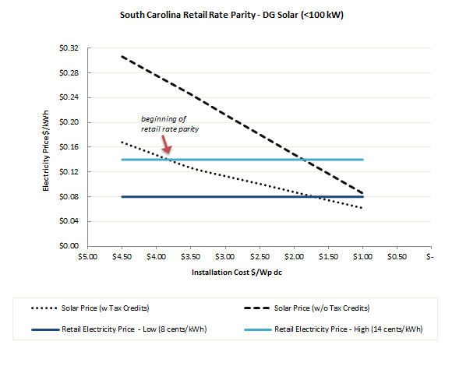

Chart data can be found in Appendix E-1.

It is important to note that installation costs for solar PV systems are expected to continue to decline in price at close to historical rates that have averaged almost 11% per year. (See Appendix E-1 for chart of declining residential solar PV installation costs.) Tax incentives, however, are expected to diminish or roll off over time. Under current legislation, the federal investment tax credit will drop from 30% to 10% starting January 1, 2017 for both commercially owned and residentially owned systems. The South Carolina State Investment Tax Credit for both commercially and residentially owned systems will go to zero (0%) starting January 1, 2016.

Some limits on this analysis
The continuing validity of any analysis of retail rate parity is predicated upon the varying retail rate structures from electric providers remaining the same as well as the continuation of net metering programs as they currently exist. A change in rate structure of net metering programs can have important implications on the relative costs of energy from generation technologies like solar. Currently, financially successful solar installations require competitive installation costs, competitive financing, and the ability to benefit from offered tax incentives.

What are the implications of reaching retail rate parity?
Retail rate parity is a point that is expected to bring a marked increase in adoption of solar PV. Due to differences in rate structures and insolation (solar radiation received at earth’s surface), different service territories in South Carolina will reach retail rate parity at different times. Furthermore, even within a given service territory, the timing of retail rate parity could differ for customers on different rate tariffs from the same utility due to differences in rate structure. Some individuals are willing to adopt solar PV earlier and pay a premium. Others may be more skeptical and require a larger savings; they will wait until after retail rate parity. Others will be unable to have rooftop solar due to renting their home/condo/apartment or simply having a rooftop that is insufficient or shaded by trees. However, there will be a noticeable uptick in solar PV systems at the time of retail rate parity.

Crossing the Bridge from Present to Future

Crossing in Measured Steps: What will the New Paradigm Be Like?
Substantial decreases in costs combined with updated policy and regulatory frameworks have made solar the predominant distributed generation option for homes and businesses in many states across the country. Assuming a lower penetration level of solar persists over the next 3-5 years, what are the opportunities and challenges that distributed solar presents for South Carolina’s utility system as it exists today? Also, what regulatory and policy considerations are relevant to planning for increased solar penetration in South Carolina, both in the short- and long-term?

Starting Point in Crossing: The Current Electric System
A primer on the electric system as it exists today can be found in Appendix F where one can read in detail about the processes, equipment, and infrastructure in the current system and issues related to the function of the current system.

Prior to a discussion of possible future scenarios involving distributed generation, particularly rooftop solar PV, it may be useful to keep in mind some key functional characteristics of the current electric system (further detailed in Appendix F):

- Transmission of electricity requires significant investments in infrastructure and upkeep in order to maximize the reliability of the operation. As an interstate service, transmission is the most highly regulated and scrutinized aspect of the utility system.
- Normally, distribution lines are operated in a manner where power flows in one direction from the substation to end user and are inherently more susceptible to outage events such as traffic and storm damage than high-voltage transmission lines. If there is an event on the line that causes an outage, customers on the other side of that event can often be switched over to be fed from another direction until the line is repaired. This is not always the case because some lines are only fed radially from one direction and therefore cannot be fed from an alternate source. Although the distribution component of an electric system is designed to carry electricity in only one direction, the introduction of a customer generating their own electricity can cause electricity to flow backwards through the customer’s meter and can cause operational and safety issues for utilities. Sometimes, utilities create new distribution facilities quickly in response to new development; however, in the case of existing lines, modifications and upgrades have been made over longer periods for changing and evolving customer loads. Due to their potential magnitude and characteristics, electric vehicles and distributed generation could drive an unprecedented investment in distribution facilities.
- Load shape typically refers to the average load of each hour during the day. However, just as the load varies hour by hour, load also varies in real-time on a second by second basis. This real-time change in load must be responded to in real-time by a change in generation. This process is generally referred to as load following and requires generating units to be operated in a manner so that, in combination, generation can meet the changing load. Each electric service territory has its own unique load shape. Electric cooperatives in South Carolina, as a system, are highly residential with load shapes that peak in the wintertime. However, even within this system, individual cooperatives in the Upstate have a summertime peak. Investor-owned utilities in South Carolina are more of a mix of residential, commercial, and industrial loads that create summertime peaks. The cumulative loads created by all customers dictate the needs of each system; these loads are influenced by the weather, daylight hours, working hours, and the requirements of all who are served.
- The capacity of a utility’s electric system must be enough to meet the actual system demand, or some customers could be without power as the utility sheds load in order to balance loads with resources. If a system’s demand exceeds its capacity, manual and/or automatic mechanisms must be implemented in order to maintain the frequency of the interconnection, and the resultant reliability issues could include problems such as blackouts.
- Since bulk electricity must be produced virtually at the same instant it is consumed, some generating units must be dispatchable. In other words, system operators must be able to increase or decrease their power output as the load on the system fluctuates. If the power generated does not meet the load level, either being too much or too little, then within seconds the system voltage and frequency can exceed their limits. The system will become unstable and, if not checked, outages will ensue. This load and demand mismatch occurs continuously at unpredictable rates and magnitudes requiring constant attention and adjustments.
- Ramp rate is the term used for the speed at which a unit is able to approach its full output capabilities after it begins operating. Large, baseload units, such as coal-fired units, will have a lower ramp rate than combustion gas turbines, which are known for their fast-start capabilities. Likewise, nuclear units usually run at full output and are not used to follow the system load. Pondage hydro units and pumped storage units, where water can be released quickly to generate power, are excellent facilities for following load. Additionally there are also “quick start” units, such as lightweight peaking turbines, which can be brought online in minutes from a cold start. Based on experience, dispatchers learn to anticipate some of the daily increasing and decreasing of system load that results from the daily pattern of life. However, there is much uncertainty and randomness that must be dealt with in the process. For example, the pattern of weather as it crosses the system can have a significant effect on load.
- Certain must-take resources, as the name implies, must be integrated by the operator of the electricity system regardless of the need for the generation (aka, demand), market prices, or other conditions. Among them are non-dispatchable resources, such as solar and wind energy, which the grid operator must integrate when the energy is available.
- In order to provide power reliably to the system, a utility must have reserve capacity. There are two kinds of reserves to consider: operating reserves and planning reserves. As the name implies, operating reserves refer to generating units or demand response assets that are held in reserve and available quickly to support the system. To operate an electric system, the utility needs enough generating capacity to meet the system demand every second, plus enough operating reserve capacity to respond quickly to fluctuations in load or the sudden loss of generation assets.
- Operating reserves refer to the next few minutes or to the next few days on the system while planning reserves deal with the next several weeks to the next 15 years or more. Planning reserves refer to the long-range planning horizon and normally reference annual peak season or peak demand. Planning reserve levels are set with the goal of having enough generating capacity available to meet the load and to meet the required level of operating reserves. Factors that come into play in determining the level of planning reserves include: maintenance outages, unplanned forced outages, load growth and weather sensitivity of the load.
- Reserve margin is a measure of the amount of capacity expressed in terms of a percentage of their peak demand that utilities can provide in excess of their forecasted loads. Best practices generally dictate a reserve margin in the range of 15% to 20%.

Generation Types
Generation types can be divided into three general categories: conventional, renewable, and other resources.

Conventional Energy Generation
Conventional forms of generation are typically large-scale facilities with varying cost structures that use uranium (nuclear power), coal, or natural gas to fuel electricity generation.

Natural gas and coal-fired power plants, in particular, convert energy contained in fossil fuels to electricity by burning them to power a turbine connected to a generator that creates electricity. The burning of fossil fuels releases gas emissions into the earth’s atmosphere and the increasingly stringent regulation of these gases has created risks and uncertainties for electric service providers that rely on their operation to meet electricity demands.

Natural gas technologies include both the simple cycle and combined cycle plants. Simple-cycle natural gas plants consist of a combustion turbine linked to a generator to produce electricity. A combined-cycle gas plant has additional components that capture the hot exhaust from combusting natural gas. This exhaust is used to create steam to drive a steam turbine and generator. While a combined-cycle gas plant is more efficient than a simple cycle, it takes longer to ramp up to full capacity.

There are also a range of older coal technologies based around the combustion process of the coal which has been mechanically processed to enhance energy recovery. These range from subcritical to supercritical to ultra-supercritical processes. The critical point refers to the temperature and pressure at which the coal is combusted. Higher temperatures and pressures result in more efficient use of the coal.

However, coal-based generation is under pressure to reduce air emissions—including CO₂, SO₂, NO_{X}, mercury—and a host of other metals and other compounds. Integrated Gasification Combined Cycle (IGCC), another coal technology, seeks to ease some of these challenges. IGCC technology chemically transforms the coal into a syngas product that can then be run in a plant very similar to a combined-cycle gas plant. One of the benefits of this technology is that the carbon emissions are produced in a concentrated stream that can be potentially captured and stored to avoid release to the atmosphere. IGCC is still an expensive technology that has not been proven for widespread commercial use.

Other conventional forms of generation include nuclear reactors and hydroelectric dams, technologies that use resources that avoid the regulatory risks associated with greenhouse gas emissions.

Renewable Energy Generation
It is important to understand that although sources of energy can be either renewable or non-renewable, electricity itself is neither renewable nor non-renewable—electricity is simply one of the various forms of energy.

Renewable energy generation technologies are considered to be those that use inexhaustible “fuel” sources to produce electricity, thus the term “renewable.” Energy that is contained in moving water (e.g., run of rivers, tidal currents), organic materials (e.g., woody biomass, municipal solid waste), the earth’s core (i.e., geothermal), solar irradiation, and wind are the most common renewable sources for electricity generation.

The attractiveness of Renewable Energy generation is that, in many cases, it has very low operating costs and, in most cases, no fuel cost. Furthermore, these technologies often do not have emission profiles or significant water consumption requirements. However, the trade-off for many of these technologies is that they have relatively high capital costs and in some cases (e.g., solar and wind) are not dispatchable.

Wind technology is fundamentally the same as the other technologies discussed but is differentiated based on location. Wind drives the blades that are linked to a generator to produce electricity. A single wind turbine can range in size from less than 1 MW to as large as 7 MW. Larger scale wind towers are typically more efficient, but require placement in areas with extremely strong and consistent winds, typically offshore locations. Onshore wind farms will use relatively smaller, less efficient turbines, and distributed wind towers will be still smaller and less efficient.

There are two main types of solar technology, including solar thermal and solar photovoltaics (solar PV). Solar thermal technologies rely upon capturing the heat from solar irradiation. In terms of electricity generation, some common technologies include parabolic troughs and solar towers and are often referred to as Concentrated Solar Power (CSP). Heat of the sunlight is used to concurrently or eventually drive steam production to generate electricity much like a coal plant. Solar photovoltaics (PV) use semiconductor technology to capture energy from the photons (tiny packets of sunlight) and transfer it to electrons in the atoms of the semiconductor to produce electricity. There are different PV technologies based upon different types of materials (e.g., silicon, cadmium-telluride, copper-indium-gallium-selenide) used as semiconductors.

Other Resources
In addition to both conventional and renewable energy generation sources, electric service providers have access to a range of technologies and resources to further diversify their ability to meet customer demand.

Energy storage technologies enable the consumption of electricity at a time not concurrent with its production. This enables electric service providers to use more cost-effective production technologies to meet demand at peak hours. Storage technology ranges can be described across two sizing parameters: 1) Discharge rate as measured in kilowatts and 2) Storage size as measured in kilowatt-hours. Pumped hydro storage would be an example that scores high on both discharge rate and storage size.

Small and large-scale energy storage, if ever developed to be economically viable, will be a key technology bridging efficient utility operation with the integration of renewable energy.

Additional options to meet demand include the ability to alter the demand itself through demand response programs and energy efficiency programs. Demand response is termed a “program” because it involves the electric service provider and a customer working together during crucial peak demand hours, – for example, to curtail select customer demand. In exchange for granting this option, customers typically receive some form of payment such as a more favorable rate. Energy efficiency programs are similar in concept: The utility provides incentives or devices that, when installed at the customer premises, will lead to consistent reduction in a customer’s energy usage.

Other grid benefit technologies, like monitoring and communication devices, can improve operations by allowing the exchange of real-time information to facilitate supply and demand coordination between electric service providers and customers. This information can help electric service providers balance generation outputs with demand for electricity throughout the day, but most importantly at moments of peak demand.

The integration of information and communication technologies with the electric grid infrastructure to enhance the efficiency, reliability, and functioning of the system will continue into the future. This will be critical when customers play a larger role in controlling both the loads and the generation needed to meet those loads.

Generation Portfolio Diversity
Standing alone, no single fuel source or generating technology is capable of meeting all electricity demand reliably and efficiently. Electricity output depends on many factors, including power plant operating characteristics, fuel prices, the availability of renewable resources, and daily and seasonal changes in electricity demand. Wind turbines only operate when the wind is blowing; natural gas plants are called on to manage fluctuations in demand; coal plants schedule maintenance for the spring and autumn when electricity demand is down. The figure below illustrates how many days each generation type typically operates over the course of a year in the United States.

Figure 15: Equivalent Days of Operation per Year
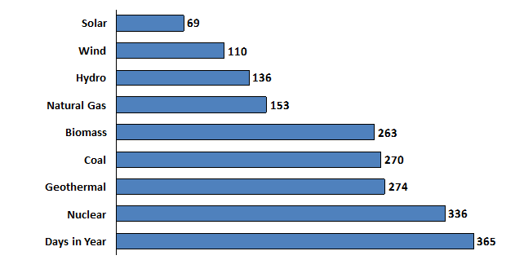
Source: EPRI - Comparing Electricity Generation Technologies presentation, 2011.

Maintaining diversity among fuel sources helps to protect customers from risks associated with uncertainties such as fuel commodity and/or transportation unavailability, fuel price fluctuations and changes in regulatory practices. Diversity also protects against overdependence on any one type of resource. In addition, while all fuel sources used in the generation of electricity involve some environmental impact, a diversified portfolio of generation resources allows many of those environmental impacts to be balanced while still ensuring that affordable and reliable power is available whenever customers demand it.

First Step in Crossing: Understanding Growth Potential in Distributed Solar

Distributed Energy Resource Generation as it Relates to Distributed Solar
In contrast to conventional generation and large-scale renewable energy generation, distributed energy resources (DER) are smaller scale generation sources interconnected to a utility’s distribution grid, hosted on a customer’s property and used to offset/meet some or all of a utility customer’s electricity demand. DER can encompass a range of technologies from solar to wind to biomass to natural gas simple cycle. Furthermore, one can also include storage, such as the charging and discharging of electric vehicles, and demand response technologies in DER. However, throughout this report, DER generally means customer-sited solar PV, or distributed solar.

Distributed Solar Growth
Nationally, deployed solar capacity has increased exponentially from 4 megawatts in 2000 to 3,313 megawatts in 2012 as depicted in Figure 16. Declines in installed costs of approximately 50% over that time have been a primary factor in the solar industry’s growth. In addition, much of the recent growth in distributed solar in Western and Northeastern states has been driven by the federal investment tax credit, net metering, solar leasing, third-party solar sales and state mandated Renewable Portfolio Standards. In the Southeast, utility programs like Georgia’s Advanced Solar Initiative and North Carolina’s renewable portfolio standard, or state-specific tax credits for renewable energy – such as in North Carolina, South Carolina and Missouri – have contributed to increased solar development. (For more information related to the growth of distributed solar, see Appendix E-2.)

Figure 16: Deployed Solar Capacity

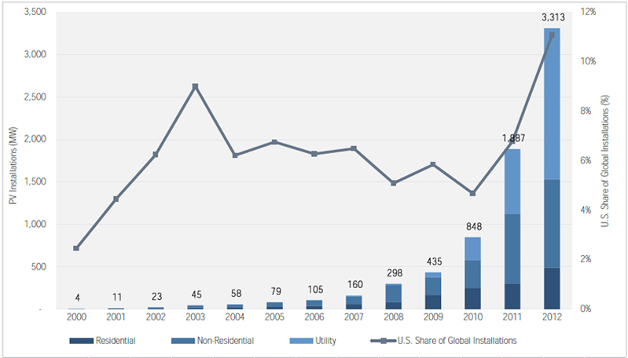
Source: Greentech Media/Solar Energy Industries Association, 2012.

A 2012 report commissioned by the State Regulation of Public Utilities Review Committee’s Energy Advisory Council (PURC EAC) concluded that South Carolina, like many Southeastern states, possesses a significant solar resource. Much of the development potential in South Carolina lies in the fact that the State is blessed both with thousands of acres of undeveloped or agricultural land suitable for large-scale solar farms and with relatively good solar insolation, or solar radiation received at the earth’s surface.

While South Carolina’s solar resources are not comparable to those of the southwestern U.S., they are better than those found in the northeastern U.S. In the Southeast, North Carolina and Florida are ranked in the top 10 states for solar capacity, while Georgia and Virginia have established targets for increased solar deployment over the coming years. South Carolina now has an opportunity to benefit from the lessons learned on solar across the country and from neighboring states, as well as from the limited solar experience of South Carolina’s utilities. See Figure 17.

Figure 17: Comparison of Solar Resources by Region of U.S.

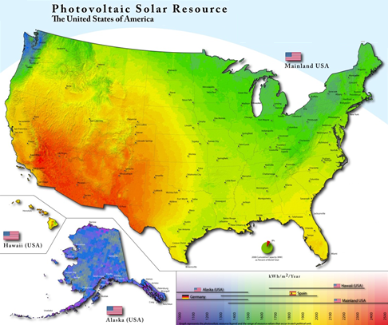
Source: National Renewable Energy Laboratory, 2009.

Distributed Solar Potential
One of the great appeals of solar PV is the fact that it is modular, scalable power generation. Heretofore, the electric power infrastructure of the United States has been built on the assumption that the vast majority of generation will originate at “central plants” or large power generation stations capable of providing hundreds of megawatts of capacity. In contrast, all solar PV systems in the world are composed of panels that range in size from approximately 50 Watts to maybe 500 Watts. This construct is true for both residential rooftop systems and the massive arrays in the desert. The technology is essentially the same, and the operating efficiency is essentially the same. The second great appeal is that the price of solar PV is declining at a rapid rate while panel efficiency is simultaneously increasing. These trends are leading solar PV, or distributed solar, to be the predominant DER technology option for customers. Figure 18 shows the anticipated growth in the residential distributed solar market over the next few years.

Figure 18: U.S. PV Installation Forecast, 2010-2016

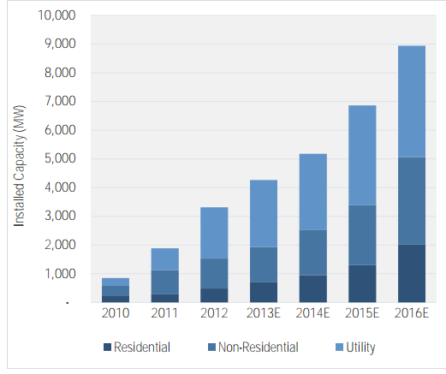
Source: GTM Research/Solar Electric Industries Association.

Second Step in Crossing: Envisioning Near-Future Distributed Solar Deployment (a lower penetration scenario)
As discussed earlier, costs for distributed solar in South Carolina may soon reach retail rate parity, thereby resulting in wider adoption of distributed solar. Because distributed solar has near-term potential, it is critical to understand the implications of how the integration of distributed solar will impact utility operations, utility shareholders, and other utility customers. It is also necessary to consider the policy and regulatory options that make distributed solar more or less cost-competitive while taking into account the value that distributed solar represents.

Each utility system in South Carolina has unique characteristics, and additional study will be required to determine exactly how much distributed solar each system can accommodate and to identify areas of specific concern related to any adverse impacts to the transmission and distribution system.

In general, though, questions about how solar can impact grid operations and how costs and benefits are distributed within the system are addressed below.

Integration
Solar offers a unique set of characteristics that are atypical of conventional generation resources. Therefore, integrating distributed solar resources into the grid requires a different set of considerations for regulators and policymakers due to the unique nature of the resource.

As solar DG continues its anticipated growth in South Carolina, some adjustments to the current utility business model may be needed to ensure the costs and benefits of distributed solar at lower penetration levels are fairly allocated among the utility, DG customers, and non-DG customers. Under a lower penetration scenario, a utility would not be expected to build additional capacity to address the intermittency of solar; however, some fundamental change in how a utility collects revenues may be appropriate.

At a more micro-level, lower penetrations of distributed solar will alter how a utility operates its system and will require some analysis of individual solar systems to ensure that the utility is still able to reliably and safely operate its distribution system. As discussed earlier, a variety of rate-design options are available to better ensure that the costs and value of any solar power added to the grid is properly assigned to the correct party.

Ultimately, it will be incumbent upon policymakers and regulators to establish a process for managing the integration of solar systems onto the utility grid in a way that adequately addresses the needs of all parties involved. As an example, best practices have been developed for interconnection standards of solar systems that are tiered based on system size. This approach standardizes the process for customers while requiring proper evaluation from the utility perspective to ensure that a particular solar installation won’t have a negative impact on the transmission and/or distribution system in a particular area. Where technical barriers exist, the system would be prevented from interconnecting. South Carolina already has interconnection guidelines and requirements for a limited range of solar system sizes.

Policy and Regulatory Considerations
There is a broad array of policy and regulatory considerations that can be made in the context of expanded solar deployment, and the list continues to grow as states implement new tools for adopting and adapting to the growth of solar on utility systems.

A key component of these considerations correlates to the rate options available to customers that invest in solar. Net metering has been the traditional model for a home or business owner to offset their energy demand by selling a portion of the solar electricity back to the utility. In some jurisdictions, net metering works in concert with other rate structures like time-of-use rates or inclining block rates.

Additional rate options that have been implemented in other jurisdictions include value-of-solar rates, net billing, and various additional customer charges like standby fees or increased facilities fees. Some rate alternatives to traditional residential NEM were discussed on page 19.

Beyond rate-related considerations, policies and regulations have also been adopted to further solar deployment at a variety of scales and at a variety of penetrations levels in jurisdictions outside of South Carolina. These include solar leasing and third-party electricity sales options, renewable portfolio requirements, tax incentives and utility-sponsored programs for purchasing solar from customers and commercial developers.

Third Step in Crossing: Envisioning a Future System with Higher DG Penetration and Emerging Technologies
In the longer term, the future of solar in South Carolina can be considered in two primary contexts: the economic consequences of the State’s solar policies and regulations and the future of federal regulatory action on energy related investments. Among the economic considerations at hand are rate impacts, job creation potential, and revenue generation potential. Federal regulatory considerations include the future cost of carbon; increased control requirements for emissions like sulfur dioxide, nitrous oxide and mercury; requirements for nuclear decommissioning and waste storage; water withdrawal limitations; and more aggressive regulation of hydraulic fracturing techniques for extracting natural gas. (See Appendix E-3 for a figure on energy system benefits and impacts.)

Prelude to Future Higher Penetration Utility Systems
An excerpt from the Department of Energy’s “SunShot Vision Study” describes the challenges ahead for higher penetration renewable generation:

The electric power system has developed historically with thermal power plants as the main source of generation. Nearly 90% of the installed generation capacity in the United States is composed of dispatchable natural gas, coal, and nuclear power resources. Incorporating a large fraction of electricity from photovoltaic (PV) and concentrating solar power (CSP) systems will require changes to many of the practices and policies that are designed for dispatchable thermal plants.

The variability and uncertainty associated with solar generation requires new sophistication of real-time operations and planning practices. Maintaining reliability and the most economic dispatch will undoubtedly require new strategies to manage the grid. The need to evolve new grid operating paradigms becomes even more significant considering the likely deployment of both solar and other variable generation sources such as wind. Studies of increased levels of solar and wind generation show that the variability and uncertainty associated with weather-dependent resources can be managed with increased operating reserves, increased access to flexibility in conventional generation plants, demand response and storage, better cooperation among adjacent electrical operating areas, and incorporation of solar and wind generation forecasting into system operations.

The set of technologies and mechanisms enabling greater penetration of solar energy can be described in terms of a flexibility supply curve that can provide responsive energy over various timescales. Figure 19 provides a conceptual flexibility supply curve that summarizes the options for incorporating variable generation. The optimal mix of these technologies has yet to be determined, but several sources of flexibility will likely be required for the most cost-effective integration of solar at high penetrations.

Figure 19: Options for Increasing Power System Flexibility to Accommodate Renewables
Source: Denholm, 2008.

As various regions of the U.S. see relatively large amounts of distributed generation and demand-side management, the industry realizes that the electric utility business model is changing. The future grid will evolve into a different system that will be significantly more dynamic and versatile than today’s system.

This future, dynamic system may start at the retail customer site, which will be composed of a mixture of traditional loads; new loads like electric vehicles, on-site generation and energy storage; demand response mechanisms; and a host of deeply integrated electronic devices. The retail customer will be connected to a dynamic utility grid interface that communicates with customer-owned resources in such a way as to manage the load and generation for the benefit of the electricity grid, as a whole. The active grid will be a combination of utility- and customer-owned resources that will be primarily managed by the utility within parameters agreed to between the utility and the customer. The willingness of the customer to participate in this partnership will be driven by the rates, the convenience of participation, and other factors such as environmental sensitivity. (See Appendix E-4 for a figure showing the potential transformation of the power system.)

A significant challenge presented by this future scenario is that the incumbent utility will continue to be responsible for the reliable operation of the system within the bulk electric grid, even though it may not have direct ownership or absolute control over many of the future distributed resources. Utility business models and legislative and regulatory policy must address all of these factors in a comprehensive manner in order to best protect a reliable electric supply and the interests of customers within an evolving electric service industry in the years to come.

Consider a rapid deployment of distributed generation over the next 10 years:

- What would be the roles of customers, state and federal commissions, and utilities that own the distribution, transmission, and generation infrastructure and are solely responsible for the provision of safe and reliable electricity?
- Would third-party ownership of distributed generation play a part, and how would fair, equitable, and safe rules be implemented to ensure third parties serve customers legitimately?
- How could the State create and encourage an efficient system that allows load, infrastructure, and generation resources to be shared, charged for, and compensated for while increasing reliability and resilience, thereby benefiting all stakeholders and decreasing risk and environmental harm?
Most existing, dispatchable, utility generation will have a major role to play in this higher technology world. Providing much of the baseload and dispatchable generation capacity as well as voltage support and system stability and reliability will continue to be the role of central-station generating units for decades to come. How will rate structures be modified to accommodate these changes in a fair and equitable manner? Contemplating these questions today will give us a glimpse into what the future will bring as utilities continue to grow and evolve.

A Higher Penetration Case Study: Hawaii
South Carolina can draw experience from areas of the nation that are already experiencing higher penetration levels of intermittent generation. Below is a case study from Hawaii. While the information is instructive, it should be noted that these circumstances are not typical for utilities in the Southeast.

Kauai Island Utility Cooperative (KIUC) is the only franchised utility located on the fourth largest Hawaiian island with a population of 65,000. KIUC is a stand-alone, vertically integrated electric utility and, as such, provides all of the facilities, equipment, and personnel required to meet the power generation, transmission, and retail distribution needs of its customers. KIUC’s all-time peak load is 78 MW, and this load is supplied by a mix of generation sites – including diesel, gas turbine, small hydro, and solar. The cost, around 40cents/kWh, of generating with diesel and gas turbines is roughly 4 times higher than average costs in South Carolina today. Already they have 14.5MW of customer-owned solar and 7.5 MW of Utility-scale solar on their system, which provides about 6% of the annual energy needs. Despite the potential of having to curtail the utility-owned solar, they plan to incorporate even more solar energy into the mix. Two more utility solar projects, each 12 MW, will bring the total annual contribution from solar to 18% by the end of 2014. With an eye on 50% renewable energy by 2023 (18% hydro, 20% solar, 12% biomass), they are forging through the operational issues by including grid investments in energy storage and a highly integrated smart grid infrastructure.

Emerging Technologies
Many technologies in renewable energy—limited energy storage, smart grid capabilities, energy efficiency and demand response—are available today in South Carolina. From the utility’s perspective, these technologies are judged from a benefit-cost perspective. Good and bad experiences in other states and regions of the world with higher penetrations of renewable energy and other emerging technologies already offer lessons on how South Carolina may incorporate higher penetrations of renewable energy and develop the dynamic grid to manage that energy.

The interconnected North American electric system is the largest and most robust infrastructure on earth, and utilities are charged, by law, with ensuring its reliability around the clock. Emerging technologies can potentially change the operation of the electric grid. The grid will be providing services, by virtue of these technologies, never before provided or requested. Policies and cost-recovery mechanisms must be put in place to ensure that the right technology is in place for the grid to keep pace and that the benefits and costs are properly allocated.

Energy Storage
Small- and large-scale energy storage, if ever developed to be economically viable, will be a key technology relating to the utility operation and integration of renewable energy. Energy storage works by moving energy through time; therefore, energy generated at one time can be used at another time. The table below is a list of the many benefits that energy storage can offer the grid.

Figure 20: Electric Grid Energy Storage Services
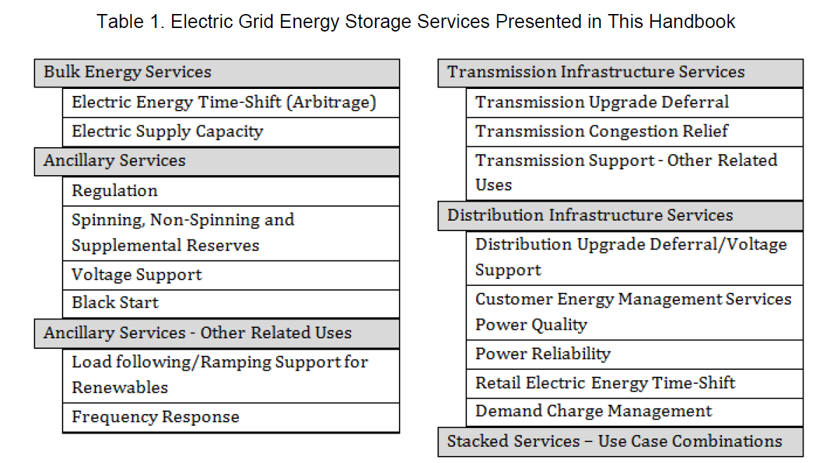
Source: DOE/EPRI 2012 Electricity Storage Handbook in collaboration with NRECA.

Energy Efficiency
Energy efficiency (EE) is another resource that offers all of the benefits of the unneeded kilowatt hour (i.e., avoided fuel cost). Furthermore, while EE does result in a decrease in load, it does not significantly change the overall shape of the current load curves. Unlike wind and solar, meeting the energy needs of the State through EE acts by reducing load, not increasing generation.

As an example, Figure 21 shows the pre- and post-hourly energy use of 125 homes that participated in the S.C. cooperative weatherization pilot program in 2012. The information provided below relates to a typical winter day. The energy consumption in these homes was reduced over 30%. While this is a significant result, even more notable is that the demand also fell accordingly each hour, thus reducing the need for peak generation.

Figure 21: 2013 Data from Central Electric Power Cooperative, Inc.’s Help My House Weatherization Pilot Program
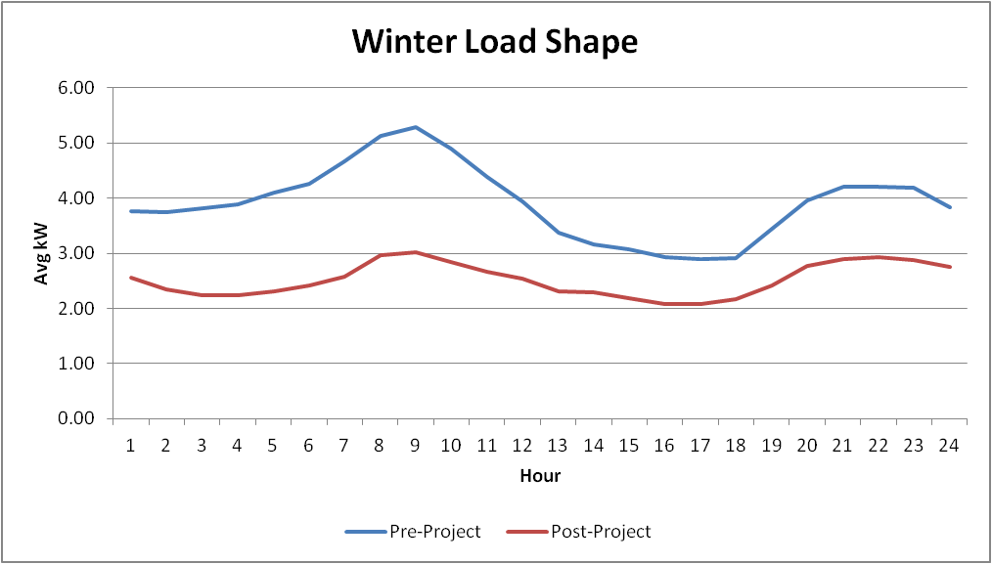

Demand response
Demand response is the control of loads for the benefit of the utility and end user. The customers of the utility benefit because the utility is able to operate the grid more efficiently (by avoiding purchasing energy or building peaking generation); the end user benefits financially through the rate or incentives. While significant reduction in peak demand can be achieved with demand response programs, the market potential of both energy efficiency and demand response is not unlimited.

The Role of Rates in a Higher Penetration Scenario
Although rate design has been discussed earlier in this report, it is instructive to revisit the issue specifically in the context of a higher penetration scenario. Rate design is a key ingredient to making the future grid work rationally. With the correct rate signals in place combined with sufficient smart-grid applications to inform electricity users, customers will be properly incentivized to manage their house loads, charge and discharge their cars to the benefit of the grid, allow utilities to actively manage the loads for them, inject power onto the grid, hold off from pushing excess energy to the grid, charge batteries on-site, and much more. With a well thought out public policy and the correct rates in place, concerns over fairness and cost shifting should be adequately addressed. With the appropriate rate structures in place, customers and the utility will be charged and compensated for their investments in the grid. Because customers’ levels of self-generation and on-site demand capabilities will vary quite a bit, it is important that rates are designed both to accommodate the spectrum of customers and to ensure that benefits and costs of the electric system are borne by the appropriate customers.

Flexibility is Key: Integrated Resource Planning

For decades, electric utilities across the United States have engaged in Integrated Resource Planning, or IRP. In order to provide affordable and reliable electric service, utilities must combine various generating and demand-side resources and deploy them in combination with transmission and distribution facilities and other electric infrastructure. They must plan to serve the current and future load while simultaneously remaining flexible with their plans into the near and far future.

The IRP process allows utility planners to systematically examine different resource combinations for meeting long-term electric demand, and the chosen plan guides them over time through major capital-investment programs. The choices utilities make for these investment programs ultimately determine the price of electricity, the level of reliability, and the environmental impact.

IRP requirements vary by state, and many states have periodically updated their rules to reflect current industry conditions. Over time, new analytical tools and methodologies have become available that have improved IRPs. As the electric power industry evolves, utilities, regulators, and stakeholders must ensure that the resource planning process remains effective.

The IRP Process in South Carolina
Under South Carolina law, investor-owned electric utilities (IOUs) and the South Carolina Public Service Authority (Santee Cooper) must prepare IRPs. IOUs, such as South Carolina Electric & Gas Company and Duke Energy, are required to file their IRPs with the Public Service Commission of South Carolina (PSC). Santee Cooper is required by Section 58-37-10 et seq of the SC Code of Laws, 1976, as amended, to prepare an IRP and submit it to the State Energy Office. Santee Cooper utilizes an IRP methodology similar to that of the IOUs under the jurisdiction of the PSC. All IRPs must be submitted every three years and updated annually. Copies of IRPs may be found at www.energy.sc.gov/utilities.

IOUs must follow the PSC’s orders concerning IRPs. The objective of the IRP (found in Order No. 91-1002 dated November 6, 1991 and issued by the PSC) is as follows:

“The objective of the Integrated Resource Planning process is the development of a plan that results in the minimization of the long-run total costs of the utility’s overall system and produces the least cost to the customer consistent with the availability of an adequate and reliable supply of electricity while maintaining system flexibility and considering environmental impacts.”

Subsequently (in Order No. 98-502 dated July 2, 1998), the PSC required electric utilities under its jurisdiction to include in their IRP the following information:

- The demand and energy forecast for at least a 15-year period
- The supplier’s or producer’s program for meeting the requirements shown in its forecast in an economic and reliable manner, including both demand-side and supply-side options
- A brief description and summary of cost-benefit analysis, if available, of each option considered, including those not selected
- The supplier’s and producer’s assumptions and conclusions with respect to the effect of the plan on the cost and reliability of energy service and a description of the external, environmental, and economic consequences of the plan to the extent practicable

After a utility files its IRP with the PSC, interested parties may file written comments concerning the plan. If further proceedings are appropriate, then the PSC has the discretion to initiate them.

Within that context, each electric utility determines the short- and long-term generating resources (supply-side) and demand-side management programs that it will need to meet projected energy demands. In South Carolina, the IRP provides each utility’s projection of its customer’s demand and energy needs in the future and what resources, demand-side and supply-side, the utility expects to use to meet those needs while maintaining reliability, environmental compliance, and economic efficiency. It should be emphasized that the resource plan reflected in the IRP represents a reasonable plan at that point in time and is not necessarily a decision or approval to act.

Distributed Energy Resources and the IRP
The variety of technology options discussed in this report is considered in the IRP, but some technologies may only be considered implicitly. For example, when a utility identifies need and commits to constructing baseload generation, it may or may not explicitly consider additional baseload generation technologies in subsequent IRPs. Instead, it may consider appropriate technologies – i.e., intermediate or peaking technologies – to meet the projected profile of its load above and beyond the committed baseload resource. However, with interest in renewable resources such as solar, wind and biomass becoming so prominent, these options are explicitly considered by studying the value to the system of the energy produced by candidate portfolios.

Since there is considerable uncertainty associated with planning for the future electricity demands of each system, utilities analyze alternate scenarios. Production-cost simulation models are often used to vary input variables one at a time or in combination to help understand sensitivities, and candidate portfolios are evaluated to measure the value of energy to the system under those various sensitivities. As distributed-scale technologies decline in costs and customers’ interests increase, the electric utilities will evaluate and plan for system impacts of various penetrations of distributed energy resources from a reduction of customer load and/or a supply of resources for the system.

Distributed energy resources such as solar bring a new set of considerations to the IRP process, and resource planners are now gathering current data and modifying production-cost modeling to evaluate these resources. There is an opportunity for utilities and regulators to interface with each other and with industry stakeholders both to share data and insights and to implement new analytical tools and approaches. An increasingly standardized set of methodologies for assessing solar benefits and costs is emerging among industry analysts. Moving forward, effective resource planning will mean incorporating best practices for analyzing distributed generation resources as they are developed and further refined.

Other Factors to Consider in Crossing the Bridge

The growth of distributed generation in South Carolina and elsewhere brings attention to potential market dynamics that policymakers must consider in planning the economic, legal, and regulatory frameworks capable of supporting higher penetration levels of DG. Two such areas of consideration are 1) renewable energy certificates and 2) third-party sales of distributed generation.

Renewable Energy Certificates
As legislators may be seeking to spur development of solar generation in South Carolina, this section sheds light on one of the most significant drivers of demand for renewable energy – namely, state renewable statutes and the mechanism by which utilities comply with those statutes, through the mandatory purchase of renewable energy certificates or RECs (pronounced “reks”). A REC represents the property rights to the environmental, social, and other non-power attributes of renewable electricity generation. A REC can be unbundled and sold separately from the underlying physical electricity associated with a renewable-based generation source. (For more information on how RECs work and the difference between a REC and a renewable mega-watt hour, see Appendix G.)

In areas where an RPS (Renewable Portfolio Standard) mandate that requires utilities to purchase large volumes of renewable energy by certain points in time is in effect, a significant gap may exist between the incumbent market prices of conventional energy and renewable energy. The assignment of that gap or “premium” payment (e.g., the REC) to the incumbent utility has the effect of spurring the development and interconnection of more megawatts of Renewable Energy generation than otherwise would have been developed.

Conversely, in a state like South Carolina, where an RPS mandate does not exist and the cost of a solar megawatt-hour exceeds the wholesale power cost proxy (technically, the avoided cost), the absence of a REC buyer results in few large-scale solar farms being built in the State. This situation could change if the wholesale power cost proxy were to rise, the cost of solar were to fall further, or if the State were to authorize investor-owned utilities to purchase and then recover the costs of premium-priced solar energy through a rider mechanism, for example.

Drivers of Renewable Development in the U.S.
As with any other industry, the renewable industry is driven by supply and demand factors. At play today in the United States on the supply side of this equation are 1) the falling prices per kilowatt of wind and solar technologies and 2) federal and state subsidies that further reduce the price of the energy. The following figure illustrates solar PV price trends on large-scale solar farms in the Carolinas based on various federal and state incentives or subsidies, or the lack thereof.

Figure 22: Solar PV Price Trends – Large Scale Solar Farms – Carolinas
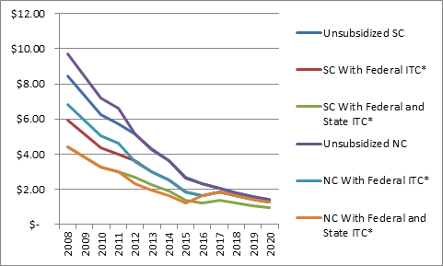
*Regarding the representation of a solar price utilizing the SC Solar Tax Credit, “the amount of the credit in any year may not exceed three thousand five hundred dollars for each facility or fifty percent of the taxpayer's tax liability for that taxable year, whichever is less. If the amount of the credit exceeds three thousand five hundred dollars for each facility, the taxpayer may carry forward the excess for up to ten years.”

At the wholesale power market level, the drivers of demand heretofore have been the Renewable Portfolio Standards. In the states with RPS mandates (and the few additional with non-binding RPS goals) illustrated in Figure 23, RPS has spurred the development of thousands of megawatts of large-scale wind, solar, biomass, and landfill gas into energy development in the US.

Figure 23: State Renewable Mandates

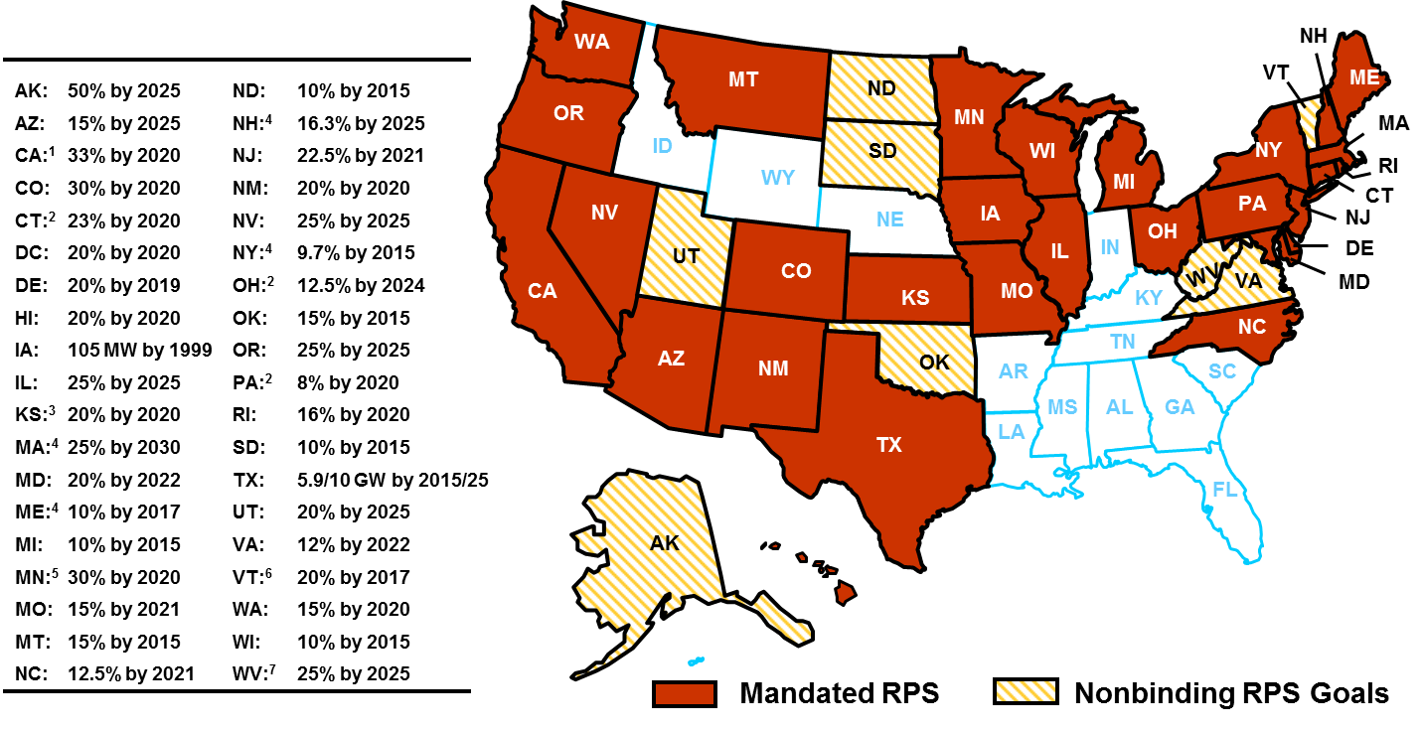
Source: Database of State Incentives for Renewables and Efficiency. http://www.dsireusa.org
At the retail level, drivers of demand for solar include customer preference (such as a desire to displace grid energy consumption with “green” energy) as well as rational economic behavior. The latter is particularly evident in areas like Hawaii or Puerto Rico where solar energy is available at a cost lower than the retail rate from incumbent electric service providers.

There are two types of REC markets: compliance markets and voluntary markets. Figure 24 portrays the main characteristics of each. Increasingly, RECs are seen as the “currency” of both the statutory and voluntary renewable electricity markets. They can be bought and sold; they allow their owner to claim that renewable electricity was produced to meet the electricity demand they create; and various public and private groups monitor the REC market to ensure against counterfeiting, double-counting, or otherwise compromising the integrity of the REC marketplace.

Figure 24: REC Markets and Their Characteristics
Market type | Compliance Market | Voluntary Market
Customers | Electric service providers across the United States | Large nonresidential customers are purchasing RECs; Federal agencies, Fortune 500 companies, local and state governments, universities; US military
Motivation | Compliance with statutory obligations | GHG reduction goals, sustainability goals, energy security goals
Regulation | State public service commissions | Self-regulation
REC tracking | ERCOT, MRETS, NARS, NCRETS, GATS, etc. | Green-E, attestation

To a developer of renewable energy, a REC enables the monetization of additional attributes of renewable power, separate from commodity power attributes. The revenue stream from the sale of this attribute, when added to the revenue from the sale of the power, should equal or exceed a renewable energy developer’s “revenue requirement” or levelized cost of energy (LCOE).

RECs serve the role of laying claim to and accounting for the associated attributes of renewable-based generation. As renewable generators produce electricity, they have a positive impact, reducing the need for fossil fuel-based generation sources to meet customer demand. RECs embody these positive environmental impacts and convey these benefits to the REC owner.

What experience have other states had with the establishment of a REC market to meet RPS Standards?
By definition, states with RPS requirements have REC markets. The size of the market and the price signals (supply/demand, tenor of contract) in each market are largely determined by the RPS statute. For example, if the statute states that “any utility who does not buy the requisite number of RECs each year shall pay a penalty of $300 per REC,” then that alternative compliance payment will drive market pricing. In this instance, if supply were constrained and demand were great, REC marketers may price their product at $299 per REC. Alternatively, if supply were not constrained, suppliers would be more likely to price their renewable energy much closer to the developer’s revenue requirement, thus minimizing the REC payment in order to find a long-term off-taker of the renewable energy.

How do other states’ REC markets impact the viability of such a market in South Carolina?
In South Carolina, there are two voluntary REC markets: Santee Cooper Green Power and Palmetto Clean Energy (PaCE), both of which are mechanisms for retail customers to displace their consumption of conventional energy with renewable energy. In both cases, the utility customer voluntarily opts-in and makes a payment to the green power program, either a one-time payment or a monthly payment. The program administrator will then buy renewable energy using the payments from customers to purchase the non-power attributes.

While both Santee and PaCE have enabled more than 349 kW of solar energy contributing to nearly 400 kW of renewable energy to come online in the past ten years, critics of green power programs often say that voluntary programs are not enough. That is, they do not stimulate hundreds of megawatts of renewable development; instead, they stimulate hundreds of kilowatts of small solar and landfill-gas installations.

How do states operate REC certification, tracking and verification systems?
Because RECs are monitored and verified, individuals and organizational buyers can purchase RECs and be confident that electricity generated on their behalf was done so with renewable energy resources.

There are two approaches to verifying REC ownership and the right to make environmental claims: 1) self-certification through REC contracts and an audit of the chain of custody (so-called “attestation” route) and 2) use of REC tracking databases. Most state public service commissions that regulate utility compliance with renewable mandates require utilities to use a REC tracking database. (See Appendix G-2 for a map of REC tracking systems in North America.)

REC tracking systems do not necessarily provide sellers or buyers with transparency into supply and demand. Rather, they enable buyers and sellers to track the provenance of RECs, from the point of creation to their point of retirement or final use. For example, REC registries enable a buyer to view the following attributes of a REC:

- The type of renewable resource producing the electricity
- Vintage of the REC (i.e., the date when it was created)
- Vintage of the renewable generator, or the date when the generator was built
- The renewable generator’s location

What are the average costs of these programs?
Information on average costs is not available at this time.

Do markets exist for out-of-state RECs?
Yes, markets exist for out-of-state RECs. At the time of this writing (2013), however, these markets are unusually depressed because of the over-supply of wind-energy RECs. For example, the clearing price for out-of-state RECs from wind energy facilities has hovered in the $1-2/REC range for several years due to the abundance of wind-energy generation in certain parts of the US and particularly windy weather.

Is there a potential market for in-state RECs outside of the utilities?
Yes, in South Carolina, some customers are willing to pay more for their energy – or pay more in order to displace their grid electricity purchases with renewable energy purchases – as evidenced by the green power programs operated by Santee Cooper and PaCE. The real question is this: how elastic is this demand? How many customers are willing to pay more and, if so, how much more?

Third-Party Sales of DG as Related to Utility’s Legal Obligation to Serve

In considering the possibility of distributed generation through third-party sales of electricity in South Carolina, one should examine 1) the historical reasoning behind a utility’s legal obligation to serve and 2) the impact that DG through third-party sales would have on the legal obligation to serve.

Historical Reasoning Behind a Utility’s Legal Obligation to Serve in South Carolina
As noted earlier in this report, the historical basis for a utility’s obligation to serve in South Carolina arises generally from the theory that electric service is most appropriately provided through a natural monopoly and that such a monopoly must be economically regulated. In a basic sense, a natural monopoly exists where the costs and/or delivery of a particular product or service will be most efficiently accomplished through a single provider, such that any duplication of the development and distribution of the product will be inefficient.

Based on this reasoning, electric service providers are given both the exclusive service franchise opportunity and a corresponding obligation to serve customers located within their assigned territories. All such franchises have the effect of an indeterminate permit that may be terminated by operation of law (e.g., statutes providing for revocation upon determination by the Public Service Commission of South Carolina (PSC) that the service rendered by the provider has been inadequate after the provider has been given an opportunity to cure the inadequacy) or by lawful forfeiture by the provider holding the franchise (e.g., the utility ceases conducting business in the
State).

In exchange for the grant of exclusive franchise, an electric service provider is subject to some measure of state regulation including, in the case of IOUs, economic rate-of-return regulation by the PSC. This conceptual exchange or trade-off, particularly in the economic context, is generally referred to as the regulatory compact. Pursuant to this compact, the service provider is compensated for taking on the obligation to serve all customers located within an assigned service territory with recovery – including an opportunity to earn a reasonable rate of return – of the costs incurred to meet that obligation.

Although required to act in accordance with various federal and state regulations that dictate standards for safety and reliability and the acceptable basis for a utility’s rate schedules (e.g., cost of service principles, non-discriminatory rates, just and reasonable rates), the primary responsibility of an electric service provider is to fulfill its obligation to provide electricity service to all customers within its assigned service territory. This obligation includes 1) planning and building generation facilities and the infrastructure required for their deployment and 2) connecting generation facilities with customer loads to supply electricity to all customers (e.g., transmission and distribution lines, substations, transformers, and meters).

The obligation to serve is intended to ensure the public has uniform and non-discriminatory access to an essential service. The obligation also features economic development aspects because the service provider holding the franchise rights and responsibilities is responsible for planning and preparing to serve its service territory’s entire needs, now and in the future. The obligation to serve requires service providers to make themselves available to provide service on reasonable terms to all who desire service within the utility’s assigned territory. This means that electric service providers are not free to choose to serve only those customers who are convenient or profitable to serve. If providing service to a customer within the utility’s service territory is possible and can be accomplished on a reasonable basis, the utility is required to make arrangements to do so.

In summary, the regulatory compact is simultaneously an exclusive right enjoyed by the service provider to service load in its assigned territory and a corresponding obligation to serve that load, making whatever investments might be required to accomplish that. While the conceptual framework of the obligation to serve is fairly clear, this legal mandate entails several different facets that affect the way service providers operate in light of its requirements. As part of the required IRP process (discussed earlier in this report), utilities must make plans to meet present and future customer demands by designing their generation mix to make reasonably priced electricity adequately available on a reliable basis. The obligation to plan their generation carries over into the utilities’ obligation to build or purchase the generation necessary to serve all of their assigned customers. In addition, public utilities have an obligation to build transmission and distribution networks, to supply electricity to meet market demand, and to deliver electricity to customers. These planning obligations would encompass taking into account the deployment of DG as sought by customers seeking greater control over their energy production and use.

What impact would distributed generation through third-party sales have on electric utilities’ legal obligation to serve?
Supplying electricity on a reliable basis depends greatly on having a clear understanding of which entity holds the legal obligation to serve customers and, therefore, has the authority to control sources of generation that can be deployed to meet demand. A clear assignment of franchise rights and obligations within service territories also works to keep costs of service down.

As noted earlier, under current South Carolina law, only the franchised electric service providers are permitted to sell power directly to retail customers within their assigned service territories. Customers may install their own generation and consume any power they produce or alternatively send the power back into the respective utility’s distribution system, pursuant to applicable net metering or power purchase arrangements between the customer and that utility.

The following two points are central to this discussion:

- The continued growth and proliferation of distributed generation subject to current South Carolina law and regulation would not alter in any way, absent a change in law, the regulatory construct within the State or any utility’s corresponding obligation to serve any customer electing to participate in available distributed generation options.
- However, any change to current law that would result in allowing third parties to serve retail customers directly in lieu of their being served exclusively by franchised utilities, pursuant to some form of purchased power agreement or operating lease, would change the balance of interests underpinning the regulatory compact.
The prospective and actual impact of the authorization and proliferation of distributed generation owned and operated by third parties – such as customers or electric power suppliers other than the State’s franchised monopoly service providers – will depend upon the specific parameters of any legislation enabling third-party, non-incumbent, electric power suppliers to sell electricity at retail directly to South Carolina customers.

In developing any such new policies, many key questions must be considered, including the following:

Will third parties be permitted to sell power directly to customers?
In the event that direct sales to retail customers are permitted from third-party electric power suppliers, the exclusive relationship between the franchised utility and its customers as currently defined is altered. Policymakers should address if the possible removal of exclusivity in service provider would affect the franchised utility’s obligation to provide service to the participating customer including removing, in whole or in part, that obligation.

Will third parties be permitted to lease systems to customers?
In the case of lease arrangements–whereby changes in state law would allow the customer to lease generating equipment from a third party, operate it, and consume that generated electricity–the relationship between the franchised utility and retail customer would remain intact. The third party in this arrangement would merely provide the means for the customer to self-generate electricity without having to make the significant upfront capital investment in the equipment. If allowed, such an arrangement would not put the third party in the place of the franchised utility because it would not be selling electricity to the customer; rather, it would be providing the means for the customer to generate the electricity for his own use.

What types of generation resources will be eligible for use in selling power directly to retail customers?
Distributed generation resources can take several forms and use a variety of fuels. From a policy perspective, if lawmakers want to allow some level of retail choice for electricity, they will need to identify whether all or certain types of generation resources can be used by third parties to sell electricity to the State’s customers. For example, if the State desires to promote renewable energy development, such an opportunity could either be open to all or limited to some sub-segment of renewable resources.

Which power suppliers, if any, will carry the obligation to serve South Carolina’s retail customers?
If the exclusive right to serve were altered by policymakers, they might consider whether it is also appropriate to alter the related obligation to serve. To the extent that franchised utilities retain an obligation to serve customers who elect to take service from third parties, consideration should be given to fairly addressing the challenge that such incremental demand places on utilities. Such consideration could include possible adjustments to rates and pricing for service to such customers.

Which power suppliers will be subject to regulatory oversight at the PSC, and to what extent?
The PSC provides an important consumer protection function relating to electric rates and service. Should that function be diminished in the context of any proposed policy changes relating to distributed generation?

What should be done about any costs incurred by the franchised utilities that are stranded due to customers’ election to participate in third-party distributed generation options?
In instances where net costs are incurred when customers formerly served exclusively by a franchised utility have chosen to receive electric service from another supplier, pursuant to a legal change allowing for retail choice, the utility’s costs incurred to serve those particular customers would not be recovered from those customers. Current regulations allow that, if such costs were prudently incurred, the utility is entitled to recover them from its other customers. Any change in policy that allows some measure of retail choice for electricity in South Carolina should also address the recovery of the franchised utility’s stranded costs, to the extent they exist. Not all situations would result in a stranded cost to the utility.

How should a utility’s costs to provide standby or backup capacity and energy to third-party-served customers be priced and allocated to those customers?
A customer electing to take part or all of his electric service from a third-party power supplier may need the franchised utility to back up the third party to ensure that the customer’s service is not disrupted, in the event that the third-party supplier fails to meet its obligations. Under current law, the relevant utility must plan its resources accordingly to provide this service in the event of a third-party supplier’s default or inability to perform. Providing this type of back-up service has a cost, and policymakers should determine whether the costs exceed the benefits afforded by customers who provide DG to the system, and how those costs and benefits should be allocated.

How should the potential benefits of distributed generation to the grid be quantified and allocated?
It is important to note, as stated in the RMI study, “Mechanisms are not in place to transparently recognize or compensate service (be it monetized grid services like energy, capacity or balancing supply and demand, or less consistently monetized values, such as carbon emissions savings) provided by the utility or the customer. To the utility, revenue from DER customers may not match the cost to serve those customers. To the customer, bill savings or credit may not match the value provided.”

This series of questions illustrates the considerations that policymakers must address in weighing and adopting changes to South Carolina law relating to distributed generation and possible third-party involvement in the provision of retail electric service to customers within the State. Changes to the existing regulatory framework in South Carolina will have significant consequences, both intended and unintended. Therefore, any such policy changes should attempt to fairly and practically solve for those consequences in a comprehensive fashion, to the extent possible.

Appendices

Appendix A: Glossary of Terminology Used in this Report

Active grid - An electricity network that can integrate the behavior and actions of all users connected to it—generators, customers and those that do both—by utilizing technologies allowing for two-way communication and control techniques in order to ensure the economically efficient and reliable operation of electric systems.

Actual system demand - The amount of electric power required for consumption at any specific point or points on a system. The requirement originates at the energy–consuming equipment of the customers.

Administrative and general expenses - These expenses usually refer to costs that cannot be assigned to a particular operations function and generally include salaries and wages, office supplies, outside services, regulatory commission expenses, rents and general plant maintenance. As a component of an electric provider’s cost of service, these expenses are recoverable through cost-based rates set forth in accordance with the principles of cost of service regulation.

Alternating current (AC) - Electricity that flows through a conductor in one direction in one instant and in the opposite direction in the next instant. The frequency of this periodic reversal can be expressed in cycles per second, or hertz (Hz), such that in the case of the standard commercial grid frequency of 60 Hz, this periodic reversal occurs 60 times a second. Maintaining this standard frequency on the grid is important because most AC electrical equipment is designed to function properly at or close to 60Hz. See “Automatic generation control.”

Assigned service territory - In regulated retail markets for electricity, the defined geographical area exclusively served by a state-designated electric provider, within which that electric provider has both the right and obligation to provide retail electric service to all customers who request to receive such service.

Automatic generation control (AGC) - Control systems embedded in some generating units that detect deviations from the normal grid frequency of 60 Hz and automatically ramp the generating unit up or down to compensate for the deviation and restore normal conditions.

Avoided cost - The cost to produce or otherwise procure electric power that an electric utility does not incur because it purchases this increment of power from a qualifying facility (QF). It may include a capacity payment and/or an energy payment component.

Avoided system costs - The capital outlays, investments and expenses associated with the addition and expanded operation of generation, transmission and distribution facilities that would be needed to meet electrical demand, but that the utility is able to defer or avoid having to make due to the new capacity added to the utility’s system by the owners of distributed generation systems that are connected to the utility’s electric system.

Base electric rates - The portion of the total electric rate covering the general costs of doing business that are unrelated to fuel expenses and are represented by a fixed kilowatt-hour charge for electricity consumed that is independent of other charges and/or adjustments.

Baseload - The minimum amount of electric power delivered or required over a given period of time at a steady rate.

Baseload generation - The generating equipment normally operated to serve loads on an around-the-clock basis.

Basic facility charge/charges (BFC) - A monthly fee for expenses related to the meter located at the customer’s premises and other costs that do not vary with the amount of electricity consumed. These costs include utility plant investment, operation and maintenance costs, depreciation, administrative and general costs such as billing and property taxes. Generally, basic facility charges in South Carolina do not recover all of these costs. See “Increased facilities fees.”

Benefit-cost results - The outcomes of a benefit-cost study that help guide an electric utility’s determination of whether proposed projects or investments should be pursued.

Benefit-cost studies - Analyses of proposed projects or investments that estimate and tally the equivalent monetary value of the benefits and costs to help determine whether they are worthwhile.

Bidirectional meter - A meter designed to measure power flows going into and out of the utility customer’s home or business that is required for use by customers participating in net energy metering programs.

Biomass - Biological material derived from living, or recently living organisms. Most often refers to plants or plant-derived materials which, as a source of renewable energy, can either be used directly via combustion to produce heat, or indirectly after converting it to various forms of biofuel.

Block rates - Electricity rates structured with a provision for charging a different unit cost for various increasing blocks of demand for energy. A lower or higher rate may be charged on succeeding blocks, known as declining or inclining block rates.

Bundled energy rate - The portion of a residential customer’s electric bill that represents a fixed “volumetric energy charge” assessed on each kWh of electricity consumed in order for the electric utility to recover certain costs incurred by the utility in serving the customer each month, including the variable costs as well as most fixed costs associated with the generation, transmission and distribution of electricity. Charges to recover such costs are bundled into single rate (as opposed to appearing on the customer’s bill as separate line-items) that is assessed independently of other rate-based cost recovery mechanisms such as the utility’s basic facility charge.

Buy-all/Sell-all - An agreement under which distributed generation customers sell all of the electricity they generate to an electric utility while purchasing all of their electricity directly from that utility.

Capacity - The real power output rating of a generator or electric system, typically expressed in megawatts and measured on an instantaneous basis. The amount of electricity delivered or required for which a generator, turbine, transformer, transmission circuit, station or system is rated by the manufacturer. The maximum power that can be produced by a generating resource at specified times under specified conditions.

Capacity factor(s) - The ratio of average generation to the capacity rating of an electric generating unit for a specific period of time (expressed as a percentage).

Capacity savings - Generation, transmission, or distribution capacity that would be necessary to meet electrical demand but that an electric utility does not have to build or procure because of the addition of capacity to the utility’s electric system from distributed generation.

Choice of business model - The strategic management and operational methods analyzed and employed by a utility with regard to providing a chosen array of electricity services to its customers.

Class/Customer Class - Customers grouped by similar characteristics in order to be identified for the purpose of setting a common rate for electric service. Customers are usually classified into groups identified as residential, commercial, industrial, and other.

Combustion turbine(s) - A fuel-fired turbine engine used to drive an electric generator. Combustion turbines, because of their generally rapid firing time, are used to meet short-term peak demands placed on electric systems.

Conservation - The sense of being careful and conscious of the energy used. In contrast to energy efficiency, conservation is about using less energy by reducing the service provided. Turning off a light is an example of conservation while replacing an incandescent bulb with a much more efficient CFL (compact florescent light) or an LED (Light Emitting Diode) bulb is exercising energy efficiency to save energy. See “Energy efficiency.”

Conventional generating units - Coal, natural gas, oil, nuclear, and hydro units.

Conventional generators/generation - See “Conventional generating units.”

Cost allocation - The manner in which a public utility’s revenue requirement is divided up among various groups of customers based on their usage patterns.

Cost of service regulation - The regulatory scheme traditionally used by states whose retail electricity markets are characterized by electric providers being granted monopoly rights over the provision of retail electric service in their assigned service territories. Most cost of service regulation principles are designed so that customers can rely on regulators to ensure that electricity rates are fair and reflect the costs incurred by the utility to serve its customers. Utilities likewise rely on regulators to provide an opportunity to earn a reasonable return on capital investments made by the utility to meet its customers’ energy requirements.

Cost of service study - A study designed to determine the cost of providing service to various classes of customers used as a basis for establishing various electric rates. Factors that must be considered in rate design are the value of the service, the cost of competitive services, the volume and load factor of the system, load equalization and stabilization of revenue, promotional factors and their relation to the social and economic growth of the service area, political factors such as the sizes of minimum bills, and regulatory factors.

Cost recovery - A key concept in the design and development of electricity rates under cost of service regulatory principles that is intended to ensure that the utility’s filed rate schedules only recover allowable costs incurred by the utility to serve its customers.

Customer-sited - This term is most often used in reference to distributed generation technologies which can be located on or contiguous to a customer’s premises. However, not all distributed generation is customer-sited.

Declining block rates - A rate structure that prices successive blocks of power use at increasingly lower per-unit prices. The more energy a customer uses, the lower the average price.

Demand - The rate at which electric energy is delivered to or by a system at a given instant or averaged over a designated period, usually expressed in kilowatts or megawatts.

Demand response - Programs and resources that are designed to enable customers to reduce their electricity usage in a given time period, or shift that usage to another time period, in response to a price signal, financial incentive, environmental condition, or reliability signal. This contributes to energy load reduction during times of higher demand, thus saving customers money by lowering their high-priced peak time energy usage.

Demand-side management (DSM) - Programs and resources utilized by electric utilities and their customers that are to influence the amount and timing of electricity use. Included in DSM are the planning, implementation and monitoring of utility activities that are designed to influence customer use of electricity in ways that will produce desired changes in a utility’s load shape such as direct load control, interruptible load and conservation, among others.

Demand-side resources - Resources on the customer’s side of the meter which permit demand-side management and can take the form of either energy efficiency and conservation measures or load control programs intended to defer or reduce the requirement for additional generating capacity on the electrical grid.

Deployed solar capacity - The amount of power than can be generated by solar generation systems that are installed and operational.

Direct current electricity (DC) - Electricity that flows through a conductor in a single direction.

Dispatchable/Dispatchability - The ability to call on a resource, e.g. generation, as needed. The value of dispatchability lies in the availability of the resource to meet system needs. For generation, the shorter the time it takes to bring the generation online, ramp up and down, and go offline, the more valuable to the utility.

Dispatchable generation capacity - A generation resource that can be called on and controlled as needed, similar to an emergency generator on a home or business. As a grid resource, the generation resource can be started on short notice and can be used either as baseload generation or to follow the requirements of the load up to the generator’s full rating.

Distributed energy - Electricity that is produced at or near the point where it is used. Also referred to as distributed generation and distributed energy resources.

Distributed energy resources (DER) - Demand- and supply-side resources that can be deployed throughout an electric distribution system to meet the energy and reliability needs of the customers served by that system. Distributed resources can be installed on either the customer side or the utility side of the meter. This includes generation, managed loads (including electric vehicle charging), energy storage, and other technologies that can provide energy, load management, and ancillary services such as reserves, voltage control, reactive power, and black-start capabilities.

Distributed generation (DG) - Electricity not produced at a central station generating unit, such as that using fuel cell technology or small-scale customer-sited generating equipment. Distributed generation includes any electric generation device connected at the distribution level installed on the customer’s side of the meter that is interconnected with the grid, such as distributed solar PV, wind or combined heat and power (internal combustion engines, fuel cells, microturbines, gas turbines).

Distributed generation customer - A customer who ̶ in addition to receiving electric service from an electric utility ̶ owns, operates and/or purchases electricity produced by a distributed generation system.

Distributed generator - A generator that is located close to the particular load that it is intended to serve. General, but non-exclusive, characteristics of these generators include interconnection with an electric utility’s distribution or sub-transmission system (138 kV or less) and an operating strategy designed to support the served load.

Distributed scale technologies - See “Distributed energy resources.”

Distributed solar - Solar generation located on an electric utility’s distribution network. Often, solar sited on the distribution network is both sized to and located with customer loads of similar scale. However, sizing generation to the load is not a requirement. See “Distributed energy resources.”

Distribution - The system of lines, transformers and switches that connect between the transmission network and customer load. The transport of electricity to ultimate use points such as homes and businesses. The portion of an electric system that is dedicated to delivering electric energy to an end user at relatively low voltages.

Distribution lines - Medium-voltage lines that make up an electric utility’s distribution system, carrying electric energy to end users.

Diversification of resources - The electric utility system's load is made up of many individual loads that make demands upon the system usually at different times of the day. The individual loads within the customer classes follow similar usage patterns, but these classes of service place different demands upon the facilities and the system grid. The service requirements of one electrical system can differ from another by time-of-day usage, facility usage, and/or demands placed upon the system grid. Electric utility planners typically aim to make use of a diverse portfolio of generation technologies to economically and reliably meet electricity demand. A diversified generation mix allows all generation technologies to play useful roles that capitalize on their strengths.

Dynamic utility grid interface - Technology that improves grid operation by allowing an electric utility to control the loads of certain customers through demand-side management and communication with and control over distributed generation and energy storage resources.

Economic dispatch - The process of determining the desired generation level of each of the generating units in a system in order to meet customer demand at the lowest possible production cost given the operational constraints on the system.

Electric cooperatives (Co-ops) - Independent, not-for-profit electric utilities legally established to be owned by and operated for the benefit of those using their services. They will generate, transmit and/or distribute supplies of electric energy to a specified area not being served by another utility. Such ventures are generally exempt from Federal income tax laws. Many were initially financed by the Rural Electrification Administration, US Department of Agriculture.

Electric grid - The layout of an electrical distribution system. A system of synchronized power providers and customers connected by transmission and distribution lines and operated by one or more control centers.

Electric providers - See “Electric service providers.”

Electric service providers - All enterprises engaged in the production and/or distribution of electric energy for use primarily by the public. Included are investor-owned electric utilities, municipal and State utilities, Federal electric utilities, rural electric cooperatives, and third-party power suppliers.

Electric system(s) - The generation, transmission, distribution and other facilities operated as an electric utility or a portion thereof.

Electric vehicle - A motor vehicle powered by an electric motor that draws current from rechargeable storage batteries, fuel cells, photovoltaic arrays, or other sources of electric current.

Energy Advisory Council (EAC) - A group of technical experts and other energy industry stakeholders which, as part of the State Regulation of Public Utilities Review Committee (PURC), is called upon to study and make recommendations for state energy policy, including on subjects such as net energy metering, renewable energy sources, energy efficiency, building codes, and energy education.

Energy charge - That portion of the charge for electric service based upon the electric energy (kWh) consumed or billed. The “commodity charge.”

Energy demand - The requirement for energy as an input to provide products and/or services. The maximum load at which a customer uses electricity for a given period of time. Demand is measured in 15 minute and 30 minute intervals. A customer’s demand is recorded on the customer’s meter.

Energy efficiency - Using less energy to produce the same service. In the utility industry, savings are generally achieved by substituting technologically more advanced equipment that uses less electricity to produce the same level of services. Examples include high-efficiency appliances, efficient lighting programs, high-efficiency HVAC systems, efficient building design, and advanced electric motor drives. See “Conservation.”

Energy storage - Energy storage mediates between variable sources and variable loads. Without storage, energy generation must equal energy consumption. Energy storage works by moving energy through time. Thereby, energy generated at one time can be used at another time.

Exclusive service franchise - A special privilege conferred by a state or local government on an electric utility to operate as the sole provider of retail electric service within an assigned service territory for the benefit of the public as a whole.

Federal Investment Tax Credit - A system of federal tax credits to encourage electric utilities and individual customers to invest in distributed generation. The credit is set to expire December 31, 2016 if not extended by act of Congress.

Fixed costs - Costs associated with capital investment such as equipment, overhead and property taxes. Any cost included in the cost of service that does not tend to fluctuate with the amount of energy produced.

Follow/Following/Load following - The use of generation equipment to respond to the intra- and inter-hour changes in customer loads.

Fuel and purchased power clauses - Clauses in a rate schedule that provide for adjustments to customers’ bills when the cost of fuels used to generate electricity fluctuate or when energy from another electric system is acquired and the cost of that energy varies from a specified unit base amount.

Fuel cost - These costs include the fuel used in the generation of electricity. Other associated expenses can include transportation and unloading the shipped fuel and all handling of the fuel up to the point where it first begins being used in the production of electricity.

Generating asset - Any combination of physically connected generator(s), reactor(s), boiler(s), combustion turbine(s), or other prime mover(s) operated together to produce electric power.

Generation - The process of producing electric energy by transforming other forms of energy such as steam, heat or falling water. Also, the amount of electric energy produced expressed in kilowatt-hours (kWh) or megawatt-hours (mWh).

Generation capacity - The real power output rating of a generator or system, typically in megawatts, measured on an instantaneous basis. The amount of electric power delivered or required for which a generator, turbine, transformer, transmission circuit, station or system is rated by the manufacturer. The maximum power that can be produced by a generating resource at specified times under specified conditions.

Generation mix - See “Generation Portfolio.”

Generation portfolio - The array of generation technologies available for use by electric utilities to economically and reliably meet customers’ energy demands. A diversified generation portfolio allows utilities to operate their chosen generation technologies in different manners so that each technology plays useful roles that capitalize on their strengths.

Generation resources - See “Generation technologies.”

Generation technologies - The various types of central station power plants and distributed generation systems utilizing different combinations of physically connected generators, reactors, boilers, combustion turbines, and other prime movers operated together to produce electric power.

Georgia Power Advanced Solar Initiative - A solar energy purchase program approved in 2012 that contracts for 210 megawatts (MW) of solar capacity over a two-year period. Designed to spur economic growth within Georgia’s solar community, it offers pricing that encourages more renewable development, avoids upward rate pressure, and maintains reliability for customers.

Grid - See “Electric grid.”

Grid energy consumption - The amount of electricity demanded and actually consumed by a customer or group of customers at a given point in time.

Grid parity - A type of parity that occurs when an alternative energy source can generate electricity at a levelized cost of energy (LCoE) that is less than or equal to the price of purchasing power from the electric grid. The term is most commonly used when discussing renewable energy sources, notably solar power and wind power.

Hydroelectric - Electric power generated when turbine generators are driven by falling water.

Inclining block rates - A rate structure that uses price signals to encourage customers to moderate energy usage by making incremental consumption beyond a minimum block more expensive (a “block” is simply a defined amount of usage, for example 1,000 kilowatt-hours [kWh]).

Increased facilities fees - An increase in what a utility charges its customers for expenses related to the meter located at a home or business, and that also includes other costs that do not vary with the amount of energy. These costs may include utility plant investment, operation and maintenance costs, administration and general costs, depreciation, administrative costs such as billing, and property taxes. See “Basic facility charge.”

Industrial customers - A class of electric utility customers generally defined as manufacturing, construction, mining, agriculture, fishing and forestry establishments. Standard Industrial Classification (SIC) codes 01-39. The utility may classify industrial service using the SIC codes or based on demand or annual usage exceeding some specified limit. The limit may be set by the utility based on the rate schedule of the utility.

Integrated resource plan (IRP) - A plan required by many regulatory agencies to be filed by electric utilities who own generation assets that evaluates the full range of alternatives that a utility may incorporate into its generation mix and electric system to provide adequate and reliable service to electric customers at lowest system cost.

Integrated resource planning process - The development of a plan that results in the minimization of the long-run total costs of the utility’s overall system and produces the least cost to the customer consistent with the availability of an adequate and reliable supply of electricity while maintaining system flexibility and considering environmental impacts.

Interconnected/Interconnecting/Interconnection - When this term is capitalized (Interconnection), any one of the four synchronized bulk electric system networks in the North American Electric Reliability Corporation: Eastern, Western, Electric Reliability Corporation of Texas, and Quebec, which are only connected through DC ties. When this term is not capitalized (interconnection), the facilities that connect two or more systems or control areas.

Interconnection standards - Interconnection standards are requirements for connecting solar and other electrical generation systems to the grid. These rules apply to both electricity customers and utilities.

Intermediate/Intermediate load - The range from baseload to a point between baseload and peak. This point may be the midpoint, a percent of the peak load or the load over a specified time period.

Intermediate load generation/Intermediate technologies - Generation resources that serve loads within a range from baseload to peak.

Intermittent/Intermittency/ Intermittent renewable generation - An electric generating plant or other resource with output controlled by the natural variability of the energy resource rather than dispatched based on system requirements. Intermittent output usually results from the direct, non-stored conversion of naturally occurring energy fluxes such as solar energy, wind energy, or the energy of free-flowing rivers (that is, run-of-river hydroelectricity).

Interstate Renewable Energy Council (IREC) - A non-profit organization accelerating the use of renewable energy and energy efficiency since 1982.

Investor-owned utility/utilities (IOU/IOUs) - A utility organized under state law as a publicly traded corporation for the purpose of providing electric power service and earning a profit for its stockholders.

kWp DC - Kilowatt peak direct current. A capacity measure for solar panels, the kWp DC size of system is calculated by counting the number of modules in a solar system and multiplying by the module’s size. Since the electricity grid operates on AC current, solar energy is converted to DC electricity first and then converted by a device called an inverter to AC electricity.

Lease systems - Distributed generation systems are owned by third-party power suppliers that are leased to third-party served customers for the generation of electricity used to meet some or all of the customer’s load.

Light-weight peaking turbine - A simple-cycle gas turbine that can start quickly and has the capability to ramp up and down to follow load. These turbines allow the grid operators to meet the strenuous demands of a quickly changing load that is both predictable and unpredictable. They also provide reliable standby power in the event of a grid emergency. What they lack in efficiency when compared to a combined cycle gas turbine, they make up for in flexibility and ramp speed.

Limited energy storage - See “Energy storage.”

Load - The amount of electric power delivered or required at any specific point or points on a system. The requirement originates at the energy–consuming equipment of the customers. The load of an electric utility system is affected by many factors and changes on a daily, seasonal and annual basis, typically following a pattern. Electric system load is usually measured in megawatts (MW). Also, to “load” a governor is to set the governor to maintain a given pressure as the rate of gas flow through the governor varies.

Load centers - The areas where large amounts of electricity are consumed.

Load management - The management of load patterns in order to better utilize the facilities of the system. Generally, load management attempts to shift load from peak use periods to other periods of the day or year.

Load shape - A method of describing peak load demand and the relationship of power supplied to the time of occurrence.

Long-term resource decisions - Many utility assets require a long timeline to design, acquire, and develop. These assets include transmission lines and utility-scale generation like nuclear power. Because of this, utilities make every effort to anticipate the system needs many years ahead of the need and must commit money and effort today to make that happen.

Member-owned entities/utilities - See “Electric Cooperatives.”

Microgrid - A regionally limited energy system of distributed energy resources (generation and/or storage) and customers that includes power quality and reliability, sustainability and economic benefits. It may continuously run in off-grid or on-grid mode, as well as in dual mode by changing the grid connection status.

Must-take resources - A specific generating unit that has been designated by the system operator to be on-line or on-the-grid to ensure the flow of electricity. This “must take” unit is outside of economic dispatch and may or may not be a system’s most efficient unit. A unit may be designated as “must take” for operating reasons that may include system reliability, voltage control or system stability.

Natural gas turbine(s) - A turbine typically consisting of an axial-flow compressor, which feeds compressed air into one or more combustion chambers where liquid or gaseous fuel is burned. The resulting hot gases are expanded through the turbine, causing it to rotate. The rotating turbine shaft drives the compressors as well as the generator, producing electricity.

Net billing - Similar to net metering and used to provide credit to distributed generation customers for electricity produced that they cannot consume. The difference between net billing and net metering is that in net billing, the adjustment is made to the dollar amount of the bill. In net metering, the adjustment is made to the amount of electricity consumed which then impacts the dollar amount of the bill.

Net energy metering (NEM) - A billing option that credits customers with solar panels for the electricity they generate and send back to the grid. The customer remains connected to the electric grid and uses the utility to supply electricity when their solar panels can’t produce enough power, which is more than 80 percent of the time.

Net load - System load minus solar generation.

Net value - The value of the assets in a company, an estate or an investment portfolio after accounting for all liabilities. Mutual funds use the term "net asset value" (NAV) to describe the value of their portfolios net of fund liabilities and expenses, and companies use the term "book value" to describe the shareholder equity value.

Non-dispatchable resources - A term for an energy system that cannot be expected to provide a continuous output to furnish power on demand, because production cannot be correlated to load. Hydrocarbon-based or nuclear power plants are dispatchable, but solar and wind power are non-dispatchable (without some added component for storage), since the supply of sunlight or wind is periodic and cannot be predicted and controlled. Thus, non-dispatchable power or energy.

Non-distributed generation - A term referring to central station generation normally located away from load centers and requiring transmission lines to move the energy to the loads. The scale of non-distributed generation is normally in the hundreds to thousands of megawatts of power.

Non-spinning reserves - Generating units that are not connected to the system but are capable of coming on-line within a specified time, or interruptible load that can be removed from the system in a specified time.

Nuclear units - Facilities in which heat produced in a reactor by the fissioning of nuclear fuel is used to drive a steam turbine.

Obligation to Serve - The obligation of a utility to provide electric service to any customer who seeks that service, and is willing to pay the rates set for that service. Traditionally, utilities have assumed the obligation to serve in return for an exclusive monopoly franchise.

On-site generation - Generation of electricity from many small energy sources on or near the site where it is used.

Operating efficiency - The capability of an enterprise to deliver products or services to its customers in the most cost-effective manner possible while still ensuring the high quality of its products, service and support.

Operating reserves - The reserve generating capacity necessary to allow an electric system to recover from generation failures and provide for load following and frequency regulation. It consists of spinning and non-spinning reserves.

Operations and maintenance (O&M) - Includes the day-to-day activities necessary for a utility and its systems and equipment to deliver reliable electricity. A facility cannot operate at peak efficiency without being operated and maintained properly.

Peak - Highest use or demand.

Peak demand - The maximum load during a specified period of time.

Peaking generation - Generating equipment operating during peak load to meet higher usage demand.

Peaking technologies - Advancements in the electric utility industry designed to meet the needs of peak demand in stable, efficient, and cost effective ways. Battery storage, solar generation, demand side management, and energy efficiency are examples of peaking technologies.

Peak load - The maximum load consumed or produced by a unit or group of units in a stated period of time.

Peak load generation - See “Peaking generation.”

Photovoltaic (PV) - Solar technology generates electricity by converting solar radiation into direct electrical current. PV panels have achieved success in residential, non-residential, utility-scale and off-grid applications.

Piedmont Municipal Power Agency- A joint action agency formed by ten municipal electric utilities in the northwest section of South Carolina. The Agency provides wholesale electric services to its Members primarily through a 25 percent ownership interest in unit 2 of the Catawba Nuclear Station, located in York County, South Carolina.

Planning reserves - Anticipated electricity generated above demand load to ensure enough is generated at any given time. Planning reserves can be located anywhere on the grid.

Plug-in electric vehicle - A motor vehicle that can be recharged from any external source of electricity, such as wall sockets. The electricity is stored in rechargeable battery packs that power or contribute to power the wheels.

Pondage hydro units - Plants in which the reservoir permits the storage of water over a period of, at most, a few weeks. In particular, a pondage hydro plant permits water to be stored during periods of low load to enable the turbine to operate during periods of high load on the same or following days. Some small hydropower plants fall into this type, especially high head ones with high installed capacities (> 1.000 kW).

Product parity - Similarity between products of the same type. Products can be considered substitutable.

Public entities/utilities - A public utility (usually referred to as utility) is an organization that maintains the infrastructure for a public service (often also providing a service using that infrastructure). Public utilities are subject to forms of public control and regulation ranging from local community-based groups to state-wide government monopolies.

Public Service Commission of SC (PSC) - The state regulatory body that essentially functions as a court for cases involving utilities and other regulated companies. The PSC has broad jurisdiction over matters pertaining to investor-owned electric and gas utility companies, water and wastewater companies, telecommunications companies, motor carriers of household goods, hazardous waste disposal, and taxicabs.

Pumped storage units - Move water between two reservoirs located at different elevations (i.e., an upper and lower reservoir) to store energy and generate electricity. Generally, when electricity demand is low (e.g., at night), excess electric generation capacity is used to pump water from the lower reservoir to the upper reservoir. When electricity demand is high, the stored water is released from the upper reservoir to the lower reservoir through a turbine to generate electricity. Pumped storage projects are also capable of providing a range of ancillary services to support the integration of renewable resources and the reliable and efficient functioning of the electric grid.

Purchased electricity (Wholesale sales) - Energy supplied to other electric utilities, cooperatives, municipals, and federal and state electric agencies for resale to end-use customers.

Qualifying facilities - Cogeneration facilities and small power producers. In 1978, Congress enacted the Public Utility Regulatory Policy Act (PURPA) that requires electric utilities to purchase the output from Qualifying Facilities (QFs) at a rate not to exceed the utility’s avoided cost.

Quick start units - Electricity generators designed with shorter start-up times to better meet increases in demand or reductions in supplies. Generally, these are smaller natural gas, diesel, or steam turbines designed to operate for shorter intervals. Newer generation units can have less than 30 minute start-up times. It is predicted that these types of electric generation will be needed as more renewables produce electricity for the grids.

Ramp rate - The rate, expressed in megawatts per minute, at which a generator changes its output.

Ramp(ed) up/down - Increasing or decreasing a generator’s output to follow system load. Some generation technologies and designs allow for faster ramp up and down rates than others, thus giving more flexibility to grid operators.

Rate design - The development of electricity prices for various customer classes to meet revenue requirements dictated by operating needs and costs within current regulatory and legislative policy goals.

Ratemaking - The regulated process whereby investor-owned utilities engage in the development of electricity prices for various customer classes to meet revenue requirements dictated by operating needs and costs within current regulatory and legislative policy goals.

Rate signals - Signals for an electric utility provided by the components of the rate structure applicable to electricity usage. A price signal delivers a clear message about the cost impact of taking an action, or even not taking an action.

REC contracts - Agreements between renewable energy generators and buyers of the electricity produced. These agreements would include ones between owners of solar and utilities that purchase power generated onto the grid. See “Renewble energy credits/certificates.”

REC tracking - Systems that are operated by states or independent entities that track the generation, sale, and resale of certified renewable energy certificates so that their validity may be confirmed by potential purchasers who inquire about how the REC was generated and to whom it has been subsequently transferred. See “Renewble energy credits/certificates.”

Regulatory compact - An agreement that guides the traditional manner of state regulation of electric service providers, under which electric service providers are granted service territories in which they have the exclusive right to serve retail customers. In exchange for this right, electric service providers have an obligation to serve all customers in that territory on demand.

Reliability - The degree to which the performance of the elements of a system results in power being delivered to customers within accepted standards and in the amount desired. The degree of reliability may be measured by the frequency, duration and magnitude of adverse effects on customer service.

Renewable energy credits/Renewable energy certificates (RECs) - Credits that represent the environmental attributes of the power produced from renewable energy projects and are sold separate from commodity electricity. Customers can buy RECs whether or not they have access to renewable energy through their local utility or a competitive electricity marketer. They also can purchase RECs without having to switch electricity suppliers.

Renewable generation - Energy derived from natural processes (e.g. sunlight and wind) that are replenished at a faster rate than they are consumed. Solar, wind, geothermal, hydro, and some forms of biomass are common sources of renewable energy.

Renewable generation capacity - The output a renewable generator can produce under specific conditions. This is a function of two pieces: the equipment and the availability of the renewable resource. It is the ratio of energy produced over time under normal resource available conditions to the nameplate, or maximum generation capabilities of the plant under ideal conditions. Consider a solar PV array with a nameplate capacity of 10kW. Under ideal sunny conditions, this array will produce 10kWh in one hour. If the sun is only available for 6 hours out of 24 hours (or 25% of the time), then the renewable generation capacity is also 25% since the generation is limited by the resource (the sun), and not the capabilities of the solar array in this case.

Renewable Portfolio Standards (Renewable Electricity Standards) (RPS/RES) - Policies designed to increase generation of electricity from renewable resources. These policies require or encourage electricity producers within a given jurisdiction to supply a certain minimum share of their electricity from designated renewable resources. Generally, these resources include wind, solar, geothermal, biomass, and some types of hydroelectricity, but may include other resources such as landfill gas, municipal solid waste, and tidal energy. Some states such as North Carolina also allow RPS requirements to be met by implementation of energy efficiency measures or via participation in REC markets.

Reserves - Generating capacity available to the system operator within a short interval of time to meet demand in case a generator goes down or there is another disruption to the supply. Most power systems are designed so that, under normal conditions, the operating reserve is always at least the capacity of the largest generator plus a fraction of the peak load.

Retail rate parity - Retail rate parity is the point at which a customer would pay a substantially similar price for purchasing additional energy from an electric utility under an approved rate tariff as he or she would pay for energy from their own solar installation.

Revenue requirement – The total of all costs prudently incurred to provide electric service.

RPS mandate – A mandate that requires utilities to increase production of energy from renewable sources such as wind, solar, biomass and other alternatives to fossil and nuclear electric generation. Normally enforced by individual states.

Solar capacity - Solar installations can be measured by two capacity measures. Solar panels produce DC current and are measured in terms of kWp DC. However, the electricity grid operates on AC current so solar energy is converted to DC electricity first and then converted by an inverter to AC electricity. The kWp DC size of system is calculated by counting the number of modules in the system and multiplying by the module’s size. The ratio between kWp DC and kW AC for different solar PV systems can vary.

Solar Energy Industries Association - Established in 1974, the Solar Energy Industries Association (SEIA) is the national trade association of the U.S. solar energy industry. SEIA works with its member companies to make solar a mainstream and significant energy source by expanding markets, removing market barriers, strengthening the industry and educating the public on the benefits of solar energy.

Service providers – See “Electric service providers.”

Smart grid capabilities - Capabilities that allow computer-based remote control and automation by two-way communication technology and computer processing. These advances have led to improvements in energy efficiency on the electricity grid and in the energy users’ homes and offices. They also allow for more efficient transmission of electricity, quicker restoration of electricity following outages, reduced operations and management costs for utilities, reduced peak demand, increased integration of large-scale renewable energy systems, better integration of customer-owner power generation systems, and improved security.

Solar leasing - An approach for a customer to access distributed generation solar PV by leasing the facilities from a third party. Solar leases are typically 15-20 years in length and involve the payment of a predetermined monthly fee in exchange for access to the electricity produced by the system. Conceptually this is much the same as leasing a car. Same as third-party lease or third-party solar lease.

Solar PV (Photovoltaic) - A unit or device that converts solar energy into useful energy forms by directly absorbing solar photons—particles of light that act as individual units of energy—and converting part of the energy to electricity (as in a photovoltaic [PV] cell).

Spinning reserve - Unused capacity available from units connected to and synchronized with the grid to serve additional demand. The spinning reserve must be under automatic governor control to instantly respond to system requirements.

Standby fee (Charge) - A set unit fee payable at the outset by the recipient of a service based on total entitlement imposed on each unit of natural gas not purchased from, but transported by, the pipeline (Similar to a “demand” charge). The charge is intended to recover fixed costs otherwise recoverable in the sales commodity charge.

State Regulation of Public Utilities Review Committee (PURC) - A bipartisan committee of legislators and members of the public created in 2004 by the S.C. General Assembly to advise on energy policy and oversee the state Public Service Commission (PSC) and the state Office of Regulatory Staff.
State-specific tax credits for renewable energy - State tax credits that reduce the state income tax liability of individuals and businesses based on the taxpayer’s installation of certain eligible renewable systems.

Substation - Facility equipment that switches, changes or regulates electric voltage. Substations route and control electrical power flow, transform voltage levels and serve as delivery points to industrial customers.

System - A combination of generation, transmission and distribution components comprising an electric utility or group of utilities.

System operations - The activity of running an electric utility balancing the available generation to the real time, minute-by-minute electric demand of the customers served and includes generation, transmission, and distribution resources as well as interconnection to adjacent utilities. This is the process of managing the flow of power over all areas of the grid.

Technical potential - Technical potential for distributed generation refers to the amount of distributed generation that can be installed in an area adjusting for considerations of whether it can actually be installed at a customer site. Commonly used for solar PV distributed generation. The number of homes with shaded rooftops, insufficient structural characteristics of the roof, or roofs tilted/oriented in an inappropriate direction would reduce the technical potential in a given area for installing distributed generation.

Third party - An entity that provides customers with access to distributed generation facilities through a contractual arrangement, most often a lease. Third-parties are so designated since they can provide the equivalent of electric service but are, in an increasing number of states, not subject to the same regulatory oversight as utilities.

Third-party distributed generation - Distributed generation systems owned by third-party power suppliers who enter into contractual arrangements providing for the sale of electricity used to meet some or all of the third-party served customers’ loads or under which distributed generation systems are leased to, operated by, and located on the premises of third-party served customers.

Third-party leasing - Allows the customer to lease solar generating equipment from a vendor rather than having to spend the upfront costs to purchase it. Though the customer doesn’t own the equipment that is installed on his roof, he still uses the electricity the system produces to meet his energy needs.

Third-party power suppliers - Entities that enter into contractual arrangements providing for the lease of distributed generation systems to third-party served customers or for the sale of some or all of the electricity needed to meet the loads of retail customers who were formerly served exclusively by a designated electric service provider.

Third-party sales - Sales that occur when a non-utility owner of a solar facility sells electricity directly to a retail customer. South Carolina and North Carolina do not allow third-party sales nor do several other jurisdictions with fully regulated utilities.

Third-party served customers - Customers who were formerly served exclusively by a designated electric service provider but who have entered into contractual arrangements in order to have some or all of the customers’ respective loads met by electricity from distributed generation systems that are leased from or that are owned and operated by third-party power suppliers.

Third-party solar sales - See “Third-party sales.”

Time-of-use (TOU) rates/pricing - A rate design imposing higher charges during periods of the day when relatively higher peak demands are experienced.

Traditional full-service customer - An electric customer who has all of his or her electric needs met by the utility, and whose energy needs conform to that of a typical customer. Customers are grouped into classes such as residential, small commercial, etc. The traditional full-service customer does not have on-site generation.

Transmission - The network of high voltage lines, transformers and switches used to move electrical power from generators to the distribution system. Also utilized to interconnect different utility systems and independent power producers together into a synchronized network. Transmission is considered to end when the energy is transformed for distribution to the customer.

Utility-scale facilities - Those facilities that generate solar power and feed it into the grid, thus supplying a utility with energy. Most utility-scale solar facilities have a power purchase agreement (PPA) with a utility that guarantees a market for its energy for a fixed term of time.

Value-of-solar rates - Rates designed around the concept of purchasing electricity produced by customer-sited distributed generation PV at a rate that reflects its value to the utility including considerations for incremental costs and benefits.

Variability (Volatility) - A measurement of the price fluctuation of an underlying instrument that takes place over a certain period of time.

Verification agency/agencies - Agencies whose primary objectives are to help buyers of Renewable Energy Credits (RECs) avoid double counting and double claims and to ensure against fraud.

Vertically integrated electric utility - A traditional electric utilities’ structure. Generation, transmission, and distribution combined into a single firm.

Volumetric charge - A price assessment according to the amount of a product consumed. In the case of electric power from a utility, this would be called a volumetric energy charge. The unit of measure is the kilowatt hour and represents the consumption of 1000 watts continuous power over the period of one hour (the same energy as running a hair dryer on medium for one hour). If the utility charges 10 cents per kilowatt hour ($0.10/kWh) for a bundle of energy, and a home owner uses 1,000 kWh in a month, then the volumetric energy charge for that month would be $100.00 (1000kWh times $0.10/kWh).

Volumetric energy charge - See “Volumetric charge.”

Wholesale power cost (sales) - Sales for resale in bulk power markets, natural gas, and oil.

Appendix B: Benefit-Cost Terminology

Figure B-1: Common Value Categories for Determining Distributed Solar Impacts
Category | Definition/Example
Generation Impact - Energy | This refers to the potential reduction in fuel purchases and variable operations and maintenance at generational plants due to the fact that solar DG reduces the on-site energy usage of those customers. This reduction is typically calculated using the utility’s marginal cost of energy for the corresponding hour of PV generation and would be performed for each hour of the year that the PV system is generating, and then summed to derive annual energy-cost impacts.
Generation Impact - Capacity | This refers to the capacity (kW) value of the DG. Capacity value will be specific to each utility and depends heavily on two factors: when (in what year) the utility shows a need for incremental generation, and what capacity value they assign to solar PV. For example, utilities with excess capacity in the near-term would assign little to no value to incremental generation such as DG systems, because they are not avoiding or deferring generation additions until those years when load growth or retirements are forecast to establish a need for incremental generation capacity. For utilities that do show a need in the near term, DG systems could be attributed with deferring that incremental capacity; however, the actual amount deferred is contingent upon how well solar PV aligns in that utility’s territory with its load curve (i.e., solar production peaks between 12pm and 3pm; if the incumbent utility’s peak is in the early morning, then they will ascribe little capacity value to this solar facility).
T&D Line Loss Impacts | Distributed solar projects generate energy at the point of use, reducing consumption of energy from the utility grid. In reducing grid energy requirements, the localized distribution feeders and transmission lines serving the utility may experience the benefit of reduced line losses. Transmission and distribution (T&D) line-loss impacts are typically calculated separately from each other, as the values differ for each system and even more by individual distribution-system feeder (inasmuch as data is available). T&D line loss impacts are typically calculated hourly, based on the marginal cost during the hours of PV production.  There may also be utility capital costs associated with adding distributed solar to the grid. As market penetration of DG systems increases, utilities must prepare the grid to accept this variable generation, and to perform well with two-way power flows. Costs of such grid preparation include technical and operational investments and expenses. In some cases, analysts must be careful not to double-count grid upgrade costs that are accounted for as utility “smart grid” engineering upgrades, or as part of regularly scheduled system infrastructure upgrades. DG systems also may have infrastructure O&M impacts, including possible savings or costs.

Net Impacts on T&D Investments and O&M | Solar DG systems often impact the capacity levels on T&D systems, either by decreasing the capacity requirements during periods when distributed solar is being consumed on-site, or by increasing the capacity on the lines when excess power is exported to the grid. Capacity impacts are largely a function of the penetration of solar DG within individual feeder lines and within the overall service area as well as the operational characteristics and timing alignment between the solar and the specific circuits hosting the resource.  As solar DG penetration increases, there may be feeder circuits where the utility could defer or eliminate capital investments in the system because the solar output coincides with peak demand on that circuit. Some utilities highlight tension with this potential value, relaying that reliance on DG resources to ensure the utility meets it regulatory requirements for reliability and safety is a practice that is shouldered with uncertainties and yet evolving with regulators.  Other utilities and utility-published studies report that this situation is theoretically realizable, but currently rare in practice. The situation is most likely to occur where there is relatively high solar penetration on circuits that experience a peak that can be offset by solar, combined with low- or flat-load growth.
Environmental Impacts | Solar, and distributed solar within that broader category, is associated with a number of environmental impacts. Some of these occur as solar displaces conventional generation and related pollutants. A few occur as utilities increase their use of (typically natural gas) generators that can respond quickly to variable solar generation. In addition, there may be impacts on O&M costs for associated emission control equipment. Because solar market penetration is just becoming consequential for a few utilities, the calculation of these impacts is subject to different assumptions and methodologies. A full, net accounting may be complex. Analysts must be careful to avoid double-counting benefits that are embedded with costs in other categories.

Fuel Price Hedge Impacts | Electricity generation from solar resources has an embedded fuel price hedge-like value, since its cost of generation is known with reasonable certainty over the expected system life. This hedge-like value remains in place for the full life of the solar resource and as such can be referred to as fuel-price insurance, a known price for a defined outcome. Many utilities hedge against future fuel price uncertainty through the purchase of commodity futures, though state regulators may prescribe a particular approach and most often these hedging practices are short-lived (e.g., three to five years in duration). The generation output of a fleet of distributed solar systems provides insurance against future fuel price uncertainty equal to the annual generation of the fleet, but adjusted for any increase in fossil fuel use needed to ensure that these conventional plants can ramp up or down as needed to accommodate the intermittent nature of solar production.
System Reliability Impacts | A fleet of distributed solar systems may impact utility system reliability either positively or negatively. Examples of potential system reliability benefits range from the value of preventing blackouts and brownouts, to that of providing back-up power to critical customers, to the value of providing ancillary services and reactive power support to the grid. Studies have recognized that these reliability impacts could be designed into DG system deployment, but since these implementations remain largely theoretical, they treat them in a qualitative manner. A California CPUC order describing solar value calculation methodologies has described these as reliability benefits yet to be characterized and currently sets their value at zero.  There are also impacts of intermittent generation on system reliability such as islanding, voltage drops, etc. These impacts are reported by utilities as specific to individual electric system characteristics; some such costs are borne by the customer deploying the DG resource while other costs are socialized.
Gross Lost Revenues | As discussed previously, solar-DG customers reduce their energy bills through use of the on-site generation, at times exporting energy to the grid and receiving credits for those kWh. This reduces utility energy sales, and it reduces gross utility revenues. For utility rate classes with flat retail energy rates, the calculation is merely the annual generation of the DG fleet multiplied by the retail energy rate. For utility rate classes with demand charges, seasonal differentials, time-of-use, and/or inclining block rates, the calculation becomes more complex. In these instances, an hourly analysis may be required.
NEM Excess Generation Payments | Typically, DG customers who generate excess energy above their on-site energy requirements through NEM rates receive a billing credit for this unused generation, which is carried over into other hours or subsequent months. In some states, a periodic “true up” event occurs, wherein any excess generation by the customer for the period is quantified, and the customer is compensated. The rate and level at which customers are compensated varies, ranging from full retail rate compensation, to the average annual utility avoided cost of energy, with many variations in between. Perspectives have differed between solar stakeholders and utilities on the level of compensation that is most appropriate. Most states cap excess generation compensation to a percentage (typically 10-20%) above the annual energy requirements of the customer’s facility. In this case, any excess generation above the cap would not be compensated. Regardless of how the customer is compensated, payments for excess billing credits are often considered a cost to the utility, depending on how the cost and value of this energy compares to the alternative the utility would have undertaken.
Program Administration Budget Impacts | This is the total utility cost for running the solar-DG program. It may include costs of utility personnel to manage and market a distributed solar program, to process incentive applications, to conduct engineering reviews for interconnections, to inspect customer systems, and other program related costs. It may also include costs for NEM billing, which are often hand-billed by utilities in South Carolina. Program administration costs are typically defined by the utility’s program budget and are subject to the same type of regulatory review as other program costs.
Other environmental impacts | As noted previously, the environmental impact of NEM is not completely assessed by only looking at the utility’s cost reductions. Reduced emissions, water usage/temperature rises (due to less combustion turbine cooling), and certain health impacts have been enumerated in studies. For utilities, these costs are not typically covered in rates; thus, some analysts have noted that it may be necessary to enact laws that charge for these costs, rather than justifying NEM, in part, on these externalities.
Source: “Ratemaking, Solar Value and Solar Net Energy Metering,” Solar Electric Power Association, 2013.

Appendix C: Bonbright’s Ratemaking Principles

Figure C.1: Bonbright’s Ratemaking Principles

Source: “Ratemaking, Solar Value and Solar Net Energy Metering,” Solar Electric Power Association, 2013. James Bonbright wrote the seminal work on utility rate design in 1961 (Principles of Public Utility Rates).

Appendix D: Net Energy Metering (NEM)

The Energy Policy Act of 2005 required state utility commissions to consider adoption of standards to require regulated utilities to offer net metering to their customers. Section 1251 of the Act specifically required each state commission to initiate a proceeding within two years of the Act’s adoption to consider the adoption of net metering standards.

To carry out its duties under the 2005 Act, the S.C. Public Service Commission (PSC) held a hearing on implementation of metering provisions on May 15, 2007 and issued an order providing for net metering in South Carolina. The PSC set limits on the capacity of individual facilities that can net meter (20kW residential and 100kW commercial) and on the overall energy that can be provided by such facilities in the aggregate (by limiting total net metered capacity to 0.2% of a system’s prior year peak load).

In 2008, the South Carolina Office of Regulatory Staff and the South Carolina Energy Office issued a report with several recommendations for improving net metering in South Carolina. Reflecting those recommendations and agreement by parties in the net metering docket, on August 6, 2009, the PSC approved several changes to the utilities’ net metering program. The PSC required that Duke Energy, Progress and SCE&G standardize their programs to promote uniformity and clarity for the public; to adopt rates paid to residential net metering customers to reflect 1:1 standard retail rates; and to eliminate stand-by charges for residential customers. The PSC also stated that the net metering program may be reviewed within four years at the request of the PSC or the parties. In 2013, the PSC sought comments on the performance of net metering to date in South Carolina, and multiple submissions were received.

The Santee Cooper net billing rate is designed with an on and off peak demand charge component to separately recover fixed generation, transmission, and distribution costs that are generally embedded in average retail kWh rates. The rate also consists of energy charges based on seasonality and time of use, and a monthly customer charge. Customers are billed for the energy they consume based on time of day/year, and receive a credit (at the same energy charge rate) for the energy they produce and deliver to our system based on time of day/year. Under the Net Billing rate design, customers only receive compensation for the energy delivered to the grid, and are not compensated for the fixed costs incurred by Santee Cooper.

Appendix E: Supplemental Charts and Graphs

Retail Rate Parity

Figure E-1: The Continuing Decline in Cost of Residential Solar PV Installations 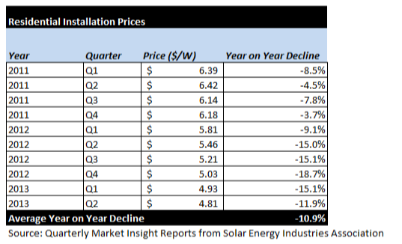

Figure E-2: Chart Data for Figure 14: South Carolina Retail Rate Parity, page 21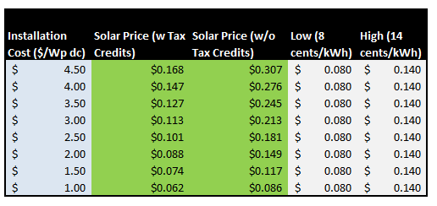

Growth in Distributed Solar

Figure E-3: Average PV System Price

Figure E-4: Third-Party-Owned Residential Installations (Q1 2009 – Q2 2012)
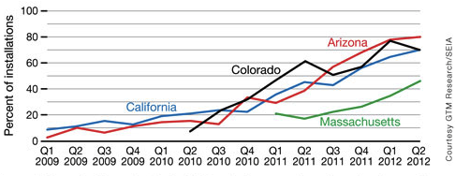

Energy System Benefits and Impacts

Figure E-5: Energy System Benefits and Impacts
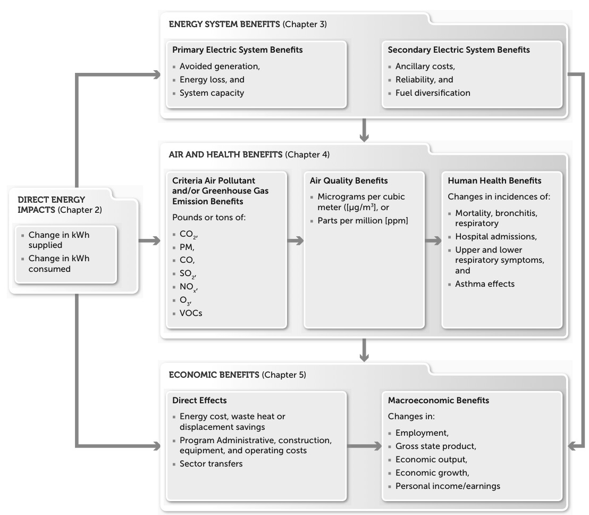
Source: United States Environmental Protection Agency.

Figure E-6: “Future” Electric Grid

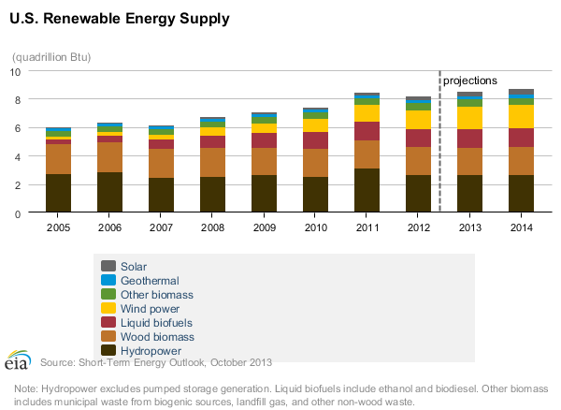
Figure E-7: United States Renewable Supply

E-5
Appendix F: The Electric System as it Exists Today

While the range of technologies available to help utilities produce and deliver electricity to consumers have grown significantly in recent years, the principles of providing these services remain virtually unchanged. The processes, equipment and infrastructure used in providing these services are collectively known as electric systems. The nation’s electric grid is the web of electric systems that are networked to one another. This section is intended to serve as a primer on issues related to the function of the electric system.

Converting Energy
The first law of thermodynamics states that energy is neither created nor destroyed. Rather, we use various methods to convert energy from one form to another so that it is suitable for its desired use (e.g., the chemical reactions that occur when food is digested and converted into various forms of energy or when wood is burned in furnaces and converted to thermal energy used to heat homes). Among several other common points of comparison, electricity generation technologies are often evaluated on the basis of their “operating efficiency,” which is a measurement of the amount of energy that the generating unit can extract from the resource in the production of electricity with respect to the total amount of available energy.

Generation
Electricity is generated at a power plant using some type of fuel as an energy source that is converted into electricity. Energy sources used in the generation of electricity include tangible materials that can be extracted from the earth such as coal, natural gas and uranium. Some of the energy contained in the earth’s natural processes such as sunlight, wind and water can be harnessed and converted into electricity through the use of various generation technologies. The majority of generation technologies today use energy released by carbon based or nuclear fuel sources.

Transmission
Transmission refers to process of moving large amounts of electricity from large scale generation to the areas where it will be consumed (“load centers”). Once generated, electricity leaves the power plant by flowing across high-voltage wires called transmission lines. Transmission lines carry electricity to various substations near load centers that reduce the voltage of the electricity so that it will be suitable for distribution to individual consumers. Because they are interconnected, the transmission system is designed to isolate specific substation outages at a given location and still get power to other substations on the network. This system protection scheme is the basis for the most reliable electricity supply in the world. Power often flows in both directions on a network of transmission lines and conditions are highly variable. All parts of the system are continuously monitored and modeled in real time for reliability and efficiency. Transmission requires significant investments in infrastructure and upkeep in order to maximize the reliability of the operation. As an interstate service, transmission is the most highly regulated and scrutinized aspect of utility system.

Distribution
After the voltage of the electricity has been reduced or “stepped-down” at the substation, it is delivered to nearby consumers across medium-voltage wires called distribution lines. Normally, distribution lines are operated in a manner where power flows in one direction from the substation to end user and are inherently more susceptible to outage events such as traffic and storm damage than high-voltage lines. If there is an event on the line that causes an outage, customers on the other side of that event can often be switched over to be fed from another direction until the line is repaired. This is not always the case as some lines are only fed from one direction and therefore cannot be fed from an alternate source. Although the distribution component of an electric system is designed to carry electricity in only one direction, the introduction of a customer generating their own electricity through distributed generation resources can cause electricity to flow backwards from a customer’s meter toward a substation and can cause operational and safety issues for utilities operating distribution lines. Sometimes, utilities create new distribution facilities quickly in response to new development, but in the case of existing lines, modifications and upgrades have been made over longer periods for changing customer loads. Due to their potential magnitude and characteristics, electric vehicles and distributed generation could drive an unprecedented investment in distribution facilities.

Figure F-1: Basic Structure of the Electric System
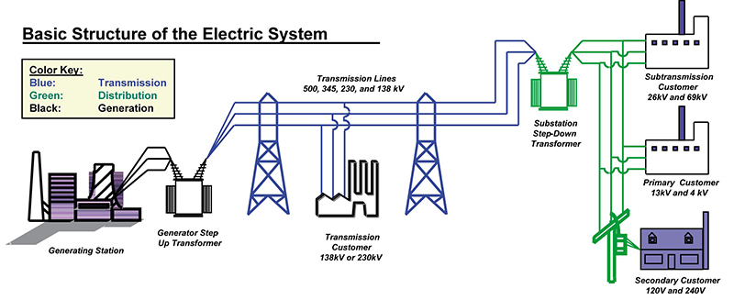
Source: Greg Möller, University of Idaho.

Load
“Load” refers to the amount of electricity actually required at a specific time, or over a specific period of time, by an individual consumer or an electric system in the aggregate. The electric grid has evolved over the last 100 years to where it is today. The kinds of generation resources primarily used today like hydro, natural gas, and nuclear came into play through very deliberate decision making processes like Integrated Resource Planning in order to keep the cost of energy as low as possible while keeping the reliability of electric systems as high as possible. Since load has large variances over the course of days and seasons, multiple types of generation are required to meet the consumption requirements in a reliable and cost effective manner. Traditionally, customer behavior has been the prime factor driving the size of load. Utilities have traditionally been in the position of reacting to these needs by generating and delivering power to meet those loads.

“Load shape” typically refers to the average load of each hour during the day. However, just as the load varies hour by hour, load also varies in real-time on a second by second basis. This real-time change in load must be responded to in real-time by a change in generation. This process is generally referred to as “load following” and requires generating units to be operated in a manner so that, in combination, generation can meet the changing load. Each electric service territory has its own unique load shape. Electric cooperatives in South Carolina as a group are highly residential with load shapes that peak in the winter time. However, even within this system, individual cooperatives in the upstate have a summertime peak. Investor owned utilities in South Carolina are more of a mix of residential, commercial, and industrial loads that create summertime peaks. The needs of each system are dictated by the cumulative loads created by all customers; and these loads are influenced by the weather, daylight hours, working hours, and the requirements of all who are served.

Baseload, Intermediate, and Peak Generation
Regardless of time of day or time of year, some amount of power is always consumed, and, accordingly, there is a need for electric providers to generate it. The minimum load that is experienced year round is referred to as the baseload, and it requires generation resources that can run around the clock. This generation is called “baseload generation.” Commercial nuclear power is a great example of baseload generation. The nature of nuclear power is to run very close to 100% output continuously. Commercial nuclear is designed to be baseload generation, and so it cannot be started or shouldn’t be stopped quickly, and options for ramping to lower generation levels are generally limited. While most coal plants are also used as baseload generation, some can ramp down as well.

The next level of generation used is “intermediate load generation,” which operates most of the day most days of the year but can be turned on and off and ramped up and down within operational limits. The top of the stack generation used by utilities is “peak load generation,” and are the generation assets that follow the changes during the day. This peak load generation is often hydroelectric generation (because the energy source is fixed – there is only so much dammed water available– and therefore should be used when most valuable) and natural gas turbines (because these units can be started and stopped relatively quickly, with start times ranging from a few minutes to several hours).

In addition to the manual management of generation levels as needed, utilities are required to follow the normal fluctuations of load with automatic generation control (AGC), which is typically deployed on a number of units capable of ramping within defined bands. Matching load with resources across the electric system in real-time is imperative in order to maintain a system frequency of 60 Hz across the interconnection.

Demand vs. Consumption
Electric providers operating in South Carolina have a legal obligation to provide electricity at any and all hours, to any and all consumers located in their service territories. In order to fulfill this obligation to serve, providers engage in a structured planning process designed to forecast how much power consumers will need in the future, and come up with a plan on how the provider will meet that forecasted demand. “Demand” can be understood as the maximum amount of electricity that a customer could require to be available for their consumption at a given point in time (as opposed to “load” or “energy” which are more aggregate terms for the amount of electricity used over a period of time). Typically, demand is not measured and separately charged for residential customers. Rather, the residential customer is charged for the amount of energy used throughout the month without regard to the actual demand at any point throughout the month. Demand is typically measured for commercial and industrial customers and they are often charged for both the peak amount of electricity they use (demand) and the amount of electricity they use throughout the month (energy).

Capacity
The sum of the maximum power that is available from a utility’s generating resources is often referred to as its generation “capacity.” The capacity of a utility’s electric system must be enough to meet the actual system demand or some customers could be without power as the utility sheds load in order to balance loads with resources. If a system’s demand exceeds its capacity, manual and/or automatic mechanisms must be implemented in order to maintain the frequency of the interconnection and the resultant reliability issues could include issues such as blackouts.

Dispatchability
Since bulk electricity must be produced virtually at the same instant it is consumed, some generating units must be dispatchable, that is, system operators must be able to increase or decrease their power output as the load on the system fluctuates. If the power generated does not meet the load level, either being too much or too little, then within seconds the system voltage and frequency can exceed their limits, transmission switches will open and the system can crash. This load and demand mismatch occurs continuously at unpredictable rates and magnitudes requiring constant attention and adjustments. Ramp rate is the term used for the speed at which a unit is able to respond to changes in load. Large, base load units, such as a coal-fired unit, will have a lower ramp rate than a combustion turbine. Nuclear units usually run at full output and are not used to follow the system load. Pondage hydro units and pumped storage units, where water can be released quickly to generate power, are excellent facilities for following load. Additionally there are also “quick start” units, such as light weight peaking turbines, which can be brought online in minutes from a cold start. Based on experience dispatchers learn to anticipate some of the daily increasing and decreasing of system load that results from the daily pattern of life. However there is much uncertainty and randomness to be dealt with. For example the pattern of weather as it crosses the system can have a significant effect on load

Must-take resources
Literally, resources that must be integrated by the operator of the electricity system regardless of the need for the generation (aka, demand), market prices, or other conditions. Among the must-take resources are non-dispatchable resources, such as solar and wind energy, that the grid operator must integrate when the energy is generated.

Reserves
In order to provide power reliably to the system, a utility must have reserve capacity. There are two kinds of reserves to consider: operating reserves and planning reserves. As the name implies, operating reserves refer to generating units or demand response assets that are held in reserve and available quickly to support the system. Operating reserves are further classified as spinning or non-spinning.

Spinning reserves are generating units with their turbines spinning and synchronized to the grid and capable of adding power to the grid automatically and instantaneously.

Non-spinning reserves are generating units that are off-line or demand response assets that are capable of adding power to the grid shortly after the spinning generators within 15 minutes. To operate an electric system, the utility needs enough generating capacity to meet the system demand every second plus enough operating reserve capacity to respond quickly to fluctuations in load or the sudden loss of generation assets.

Planning reserves refer to the long range planning horizon and normally references annual peak season peak demand. Operating reserves refer to the next few minutes to the next few days on the system while planning reserves deal with the next several weeks to the next 15 years or more. Planning reserve levels are set with the goal of having enough generating capacity available to meet the load and to meet the required level of operating reserves. Factors that come into play in determining the level of planning reserves include: maintenance outages, unplanned forced outages and weather sensitivity of the load.

Reserve margin is a measure of the amount of capacity expressed in terms of a percentage of their peak demand that utilities can provide in excess of their forecasted loads. Best practices generally dictate a reserve margin in the %range of 15 to 20%.

F-5

Appendix G: RECs – Renewable Energy Certificates

How do RECs work? How is a REC different from a renewable megawatt-hour?
To understand how RECs work, it is helpful to understand how electricity is delivered across the utility grid, as well as what makes renewable electricity generation attractive to individuals and organizational buyers.

Within the United States, electricity demand is met by various types of generation technologies and fuel resources. These electricity generators feed electrons onto the utility grid for delivery to consumers through a complex network of wires and distribution infrastructure. Because the electrons produced from the different technologies and fuel resources are physically the same, it is impossible for individuals or organizations to know what type of generation technology or resource produced the electricity that reaches their particular facility.

All grid-tied renewable-based electricity generators produce two distinct products 1) the commodity electricity, (e.g., the electrons) and 2) the environmental and other non-power attributes of generation represented by a REC.

The figure below shows how renewable energy certificates (RECs) and electricity take different pathways to the point of end use. RECs represent the right to claim the attributes and benefits of the renewable generation source.

Figure G-1: Renewable Energy Certificates versus Renewable Megawatt-hours

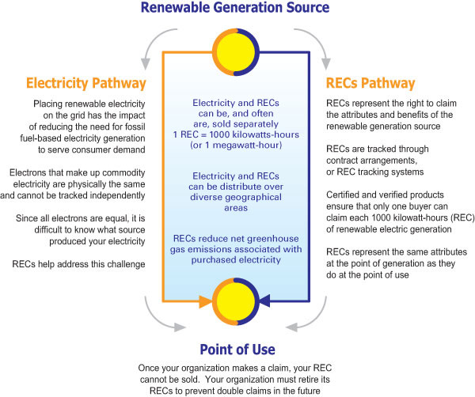
Source: United States Environmental Protection Agency, Green Power Partnership.

At the point of generation, both product components can be sold together or separately, as a bundled or unbundled product. In either case, the renewable generator feeds the physical electricity onto the electricity grid, where it mixes with electricity from other generation sources. Since electrons from all generation sources are indistinguishable, it is impossible to track the physical electrons from a specific point of generation to a specific point of use.

As renewable generators produce electricity, they create one REC for every 1000 kilowatt-hours (or 1 megawatt-hour) of electricity placed on the grid. If the physical electricity and the associated RECs are sold to separate buyers, the electricity is no longer considered “renewable” or “green.” The REC product is what conveys the attributes and benefits of the renewable electricity, not the electricity itself.

Figure G-2: North American Renewable Energy Tracking Systems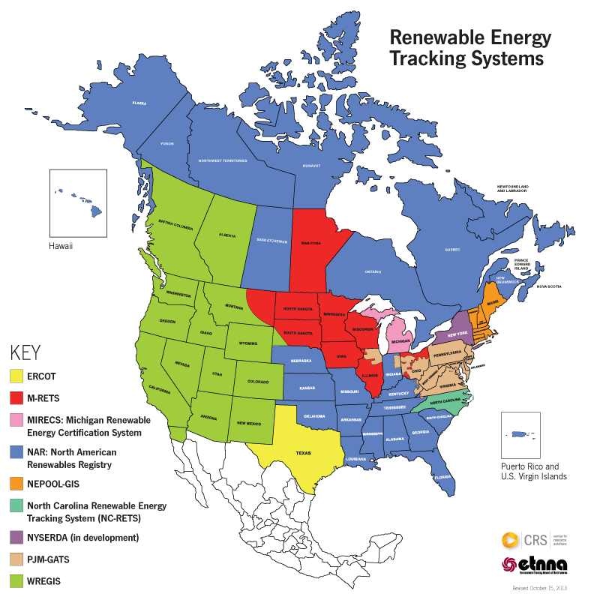
It is important to note that the agencies listed in the figure above do not represent REC “exchanges” or marketplaces but, for the most part, verification agencies whose primary objectives are to help buyers avoid double counting and double claims and ensure against fraud.

Appendix H: H.3425—The Energy System Freedom of Ownership Act

H.3425 is legislation that allows a prescribed amount of solar and other distributed generation in South Carolina through contracts between utility customers and third parties. Installed capacity under H.3425 would be capped at 2% of the peak demand within each utility service territory. Two percent demand in solar provides 0.5-0.6% of annual energy. Over the next decade, this would translate to a limit of an estimated 350 to 400 MW of distributed solar and other renewables, divided between Duke Energy Carolinas, Duke Energy Progress, South Carolina Electric & Gas, Santee Cooper, the Electric Cooperatives of South Carolina, and other electric utility providers.
Assessing the Impacts of Distributed Generation
This section addresses the impacts of H.3425 to utility load, revenue, and fuel consumption. In this section, we do not address potential avoided system costs, diversification, and other related effects of distributed generation because this information is not reliably available without in-depth, comprehensive, South Carolina-specific benefit-cost analyses. General information about benefits and costs of distributed generation is available in The Nature of Distributed Generation section of this report.
Load
At the generation dispatch level, H.3425 would not have a significant impact on utilities in South Carolina given the limited loads involved. The more significant impact of H.3425 would occur with load management at the distribution level. Any amount of distributed generation must be accounted for by electric utilities on the local distribution system, and these considerations impact planning and costs.
Methodology and Results
Figure H-1 and H-2 below show the total estimated load, revenue, and fuel consumption impacts of H.3425 to South Carolina utilities taken together. The analysis assumes that all installed capacity under H.3425 is solar PV.
Load impacts were calculated by applying an 18% annual capacity factor to the solar capacity (in kW-ac) allowed under H.3425, and assuming a 10-year deployment time frame and a 50% annual growth rate in installed capacity.
Revenue impacts were calculated using average residential and commercial class electric rates and multiplying by the annual load impacts for each class, assuming that half of the installed capacity each year is residential-scale and half is commercial-scale. All systems are assumed to be net metered, and both non-fuel and fuel components of electric rates are assumed to grow by 2% annually. All figures are given in 2010 dollars.
Figure H-3 below shows the estimated number of customers installing PV systems, calculated assuming an average residential system size of 4 kW-dc and an average commercial system size of 100 kW-dc.

Figure H-1: SC Utility Load Impacts of H.3425

Figure H-2: SC Utility Revenue and Fuel Savings Impacts of H.3425

Figure H-3: Number of Customer Installations under H.3425

Legal Obligation to Serve
H. 3425 does not extinguish the obligation of electric providers to serve customers within their assigned territories nor does it establish an obligation of third parties to serve customers. It does affect electric providers’ exclusive right to serve within their assigned territories. A more detailed discussion can be found in the body of the report in the section entitled Other Factors to Consider in Crossing the Bridge.

http://www.epa.gov/greenpower/documents/gpp_basics-recs.pdf
See Dkt. No. 2005-385-E, Order No. 2007-618 at 2 (Aug. 30, 2007)
See Order No. 2009-552, Dkt. No. 2005-385-E at 5-6 (Aug. 6, 2009)
Comments submitted on net metering: http://dms.psc.sc.gov/dockets/dockets.cfc?Method=ShowDocketMatters&DocketID=95943

