NO. 30

JOURNAL

of the

HOUSE OF REPRESENTATIVES

of the

STATE OF SOUTH CAROLINA

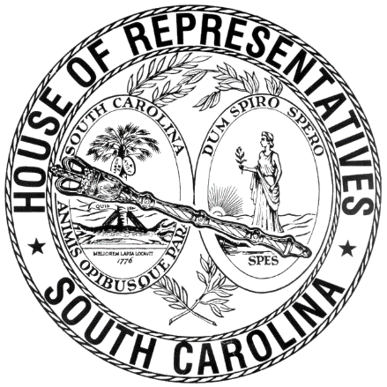

REGULAR SESSION BEGINNING TUESDAY, JANUARY 10, 2017
________

FRIDAY, MARCH 2, 2018
(LOCAL SESSION)

Indicates Matter Stricken
Indicates New Matter

The House assembled at 10:00 a.m.
Deliberations were opened with prayer by Rev. Charles E. Seastrunk, Jr., as follows:

Our thought for today is from Psalm 80:3: “Restore us, O God; let your face shine upon us and we shall be saved.”
Let us pray. Gracious Lord, let Your light shine upon these Representatives and staff as they do the work for the people. Enable them to provide the services necessary for this State to be a light shining on the hill. Bless these Members and staff as we go into the weekend. Give them rest and relaxation to refuel for the week ahead. Look in favor upon our Nation, President, State, Governor, Speaker, staff, and all who contribute to the success of this Assembly. Bless and protect our defenders of freedom and first responders as they protect us. Heal the wounds, those seen and those hidden, of our brave warriors who suffer and sacrifice for our freedom. Lord, in Your mercy, hear our prayers. Amen.

After corrections to the Journal of the proceedings of yesterday, the SPEAKER ordered it confirmed.

SENT TO THE SENATE
The following Bills were taken up, read the third time, and ordered sent to the Senate:

H. 3565 -- Reps. Fry, Crawford, Elliott, Burns, Clemmons, Allison, Jordan, Yow, Johnson, Atwater, Duckworth, Ryhal, Loftis, Hewitt, G. R. Smith, V. S. Moss, D. C. Moss, Daning, Hardee, Felder, Erickson, Bales, Hamilton, Huggins, Putnam, Anthony, Bedingfield, West, Atkinson, Bennett, B. Newton, Lucas, Arrington, Ballentine, Chumley, Crosby, Davis, Delleney, Forrester, Gagnon, Hixon, Long, Lowe, Murphy, Pitts, Pope, S. Rivers, Sandifer, Simrill, Stringer, Taylor, Thayer, White, Bannister, Tallon, McCravy, Quinn, McEachern and McGinnis: A BILL TO AMEND SECTION 1-23-600, AS AMENDED, CODE OF LAWS OF SOUTH CAROLINA, 1976, RELATING TO TIMELY REQUESTS FOR CONTESTED CASE HEARINGS UNDER THE ADMINISTRATIVE PROCEDURES ACT AND RELATED PROVISIONS, SO AS TO ESTABLISH AN AUTOMATIC STAY CONCERNING LICENSE ISSUANCES, RENEWALS AND THE LIKE, AND TO PROVIDE FOR THE CIRCUMSTANCES UNDER WHICH THE AUTOMATIC STAY MAY BE LIFTED.

H. 4596 -- Reps. Collins, Allison, Felder, Govan, Taylor, Bradley, Knight, West, Erickson, Funderburk and Stringer: A BILL TO AMEND THE CODE OF LAWS OF SOUTH CAROLINA, 1976, BY ADDING SECTION 59-19-360 SO AS TO PROVIDE A PROCESS FOR THE EXEMPTION OF COMPETENCY-BASED SCHOOLS FROM CERTAIN APPLICABLE LAWS AND REGULATIONS, AND PROVIDE RELATED REQUIREMENTS FOR COMPETENCY-BASED SCHOOLS, THE STATE DEPARTMENT OF EDUCATION, AND THE COMMISSION ON HIGHER EDUCATION.

ADJOURNMENT
At 10:17 a.m. the House, in accordance with the ruling of the SPEAKER, adjourned to meet at 12:00 noon, Tuesday, March 6.
***

H. 3565 1
H. 4596 2

