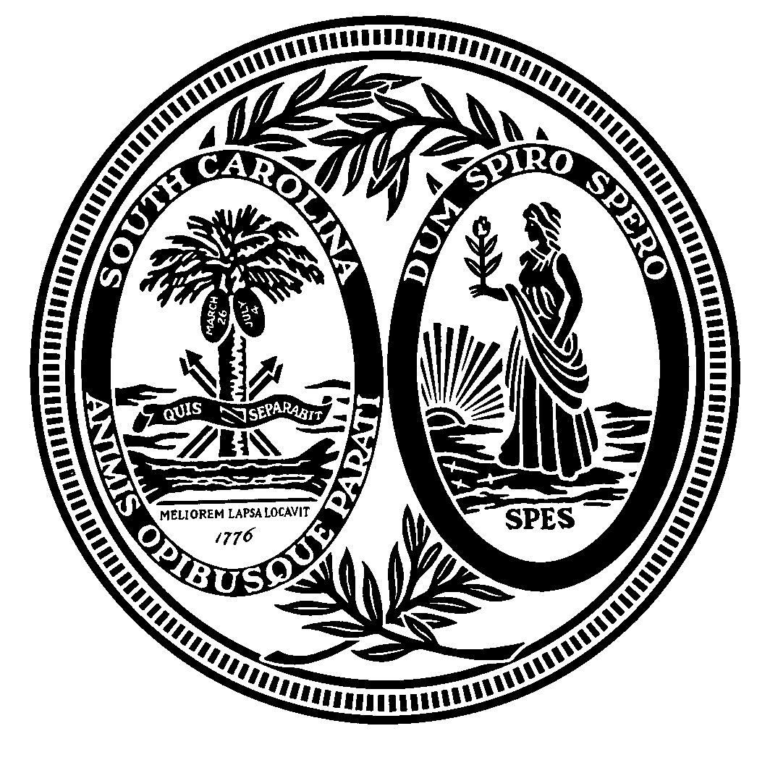

SOUTH CAROLINA BROADBAND TECHNOLOGY AND COMMUNICATIONS STUDY COMMITTEE

October 4, 2007

AGENDA

I. Call Meeting to Order Senator Rankin

II. Presentations

A. E-NC Authority Jon Hamm, Embarq

B. S.C. Telco Alliance Brent Groome, Horry Tel Cooperative

C. S.C. Cable Television Association Frank Ellerbe

D. AT&T Cindy Cox

E. Verizon Stan Bugner

F. S.C. Telephone Association Jerry Pate

III. Discussion of Issues to be Addressed at Next Meeting

IV. Adjournment

