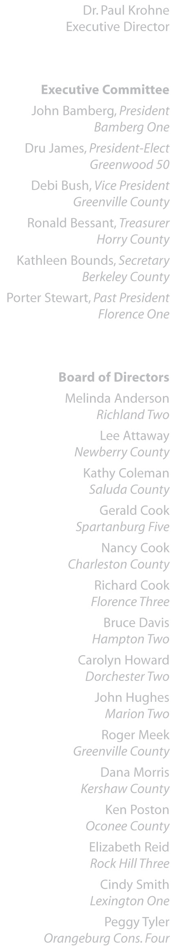 | October 24, 2006  The Honorable Robert W. Hayes, Jr.  Chairman, Joint Education Funding Study Committee  205 Gressette Building  Columbia, South Carolina 29202  Dear Senator Hayes:  The South Carolina School Boards Association (SCSBA) supports amending the State Constitution to increase the current general obligation debt limit of 8 percent to at least 12 percent of the assessed property value of a local school district.  Increasing the debt limit capacity would offer locally elected and appointed school boards additional resources and more flexibility to address crucial school building construction and renovation needs across the state. Many school boards efficiently utilize their 8 percent capability for constructing new schools to address student enrollment growth and for renovating existing schools to address safety concerns, changing technology and equipment needs for the classroom.  As you are aware, the other option to school boards for addressing school building needs is through a local referendum. And while this option is often viable and successful, the referendum process does not always lend itself to allowing districts to quickly react to market conditions.  An additional consideration is the possible passage of the reassessment cap amendment on the November 7th ballot. If approved, the cap would impact the growth in a school district’s assessed value, and, thus, the amount of bonds school districts would be able to sell under their 8 percent debt limit. An increased constitutional debt limit would be helpful to addressing this concern.  Thank you for your consideration. Please contact me with any questions.  Sincerely,  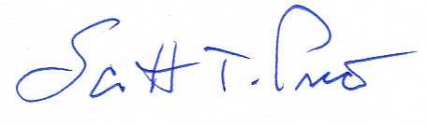  Scott T. Price  General Counsel

