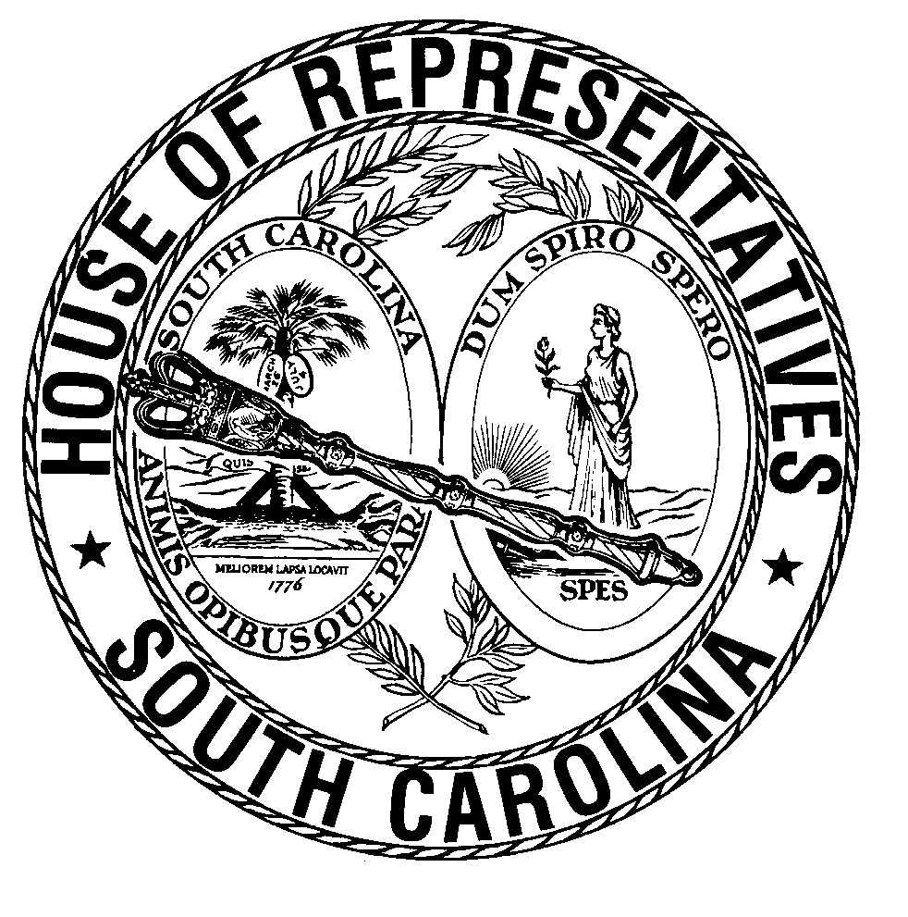
Office of the Speaker
SOUTH CAROLINA HOUSE OF REPRESENTATIVES

FOR IMMEDIATE RELEASE Contact: Don Hottel
August 1, 2005 (803) 734-3125

HARRELL TASKS SPECIAL COMMITTEE TO FIND A FAIR SOLUTION TO PROPERTY TAX ISSUES

(Columbia, SC) – House Speaker Bobby Harrell today announced the formation of a special House committee to study all aspects of property tax issues. The twenty member ad hoc committee appointed by Speaker Harrell and to be chaired by Rep. Bill Cotty is charged with examining the property tax system and how changes would affect homeowners and businesses, state and local governments and the state’s revenues and economic development efforts.
“Members of the House have heard loud and clear from our constituents – they want something done about their property taxes. This committee has the charge and duty to examine this issue and recommend a legislative resolution. I ask that committee members seek a workable solution that is fair and to consider the effects of their recommendations on homeowners and businesses” Speaker Harrell said.
The committee is a direct outgrowth from an earlier special subcommittee formed during the 2005 session under then Ways and Means Chairman Bobby Harrell. Speaker Harrell noted that it became apparent during last session that this issue needed a House-wide approach: “This committee reflects the House of Representatives – it first and foremost includes geographic representation but also reflects party and urban-rural aspects that have to be considered if we are to come to a compromise that will work.”
Upon being named by Speaker Harrell as the Chairman of the committee, Rep. Cotty said “I am honored to lead this committee on its mission to help the General Assembly resolve this difficult and complicated issue. We will look at all aspects of the property tax structure. We will be holding our first meeting soon and will be holding public hearings all around the state in an effort to hear what people have to say. We are going to listen to everyone.”
Speaker Harrell has tasked the committee to prepare recommendations and legislation in time for the 2006 session. The committee’s first organizational meeting will be announced soon.
If you have questions or comments on this issue, please contact either Don Hottel at (803) 734-3125 or Beverly Smith at (803) 734-3144.

