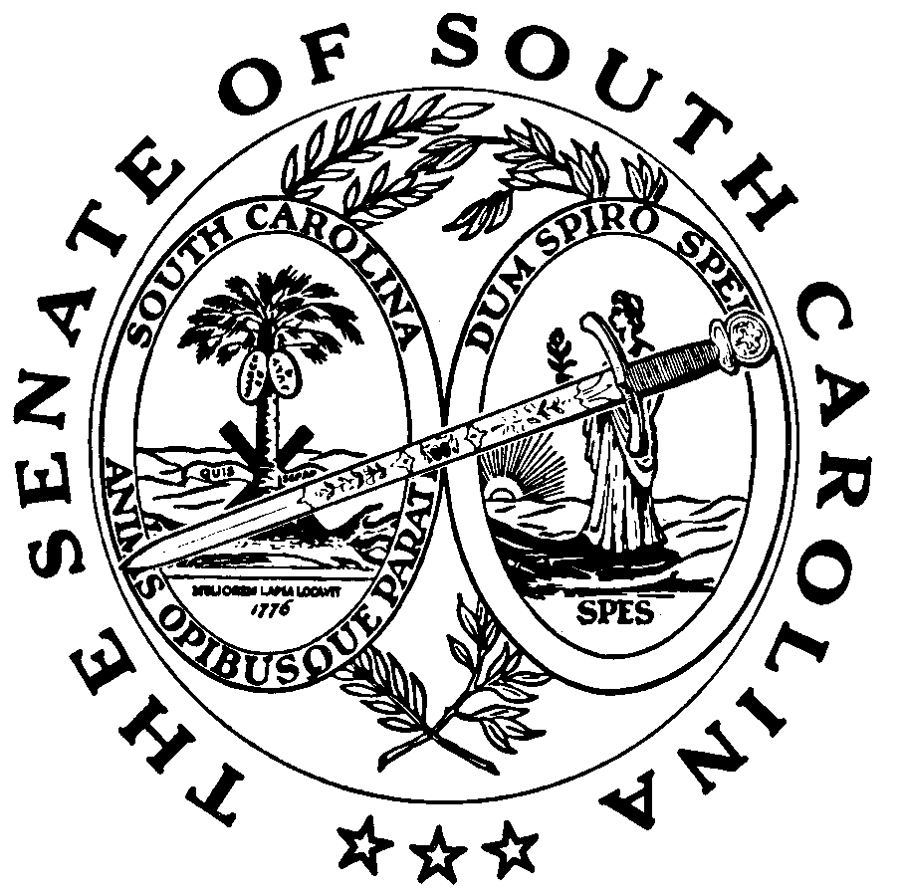
Press Release
For Immediate Release Contact: E. Katherine Wells
Senate Judiciary Committee
101 Gressette Building
Columbia, South Carolina 29201
(803) 212-6610

Senate to Study Government Spending Caps

The first meeting of the Senate Study Committee on capping state government spending is scheduled for Wednesday, October 24, 2007 at 1:00 pm in Room 105 of the Gressette Building in Columbia, South Carolina. Senator Glenn McConnell appointed seven Senators to this study committee, which is tasked with considering the constitutional amendment introduced by Senator McConnell last year that would cap the growth in spending by the State. Senator McConnell also asked the task force to consider whether the constitutional amendment should be altered to place the same caps on local governments.

Senator Greg Gregory (Lancaster-R) will chair the study committee. Other members include Senator Robert Ford (Charleston-D), Senator Larry Martin (Pickens-R), Senator Jim Ritchie (Spartanburg-R), Senator Vincent Sheheen (Kershaw-D), Senator Kevin Bryant (Anderson-R), and Senator Joel Lourie (Richland-D). Because a constitutional amendment is to be considered, several public hearings will be scheduled around the State, in order to receive input from the public on this matter.

Senator Gregory said he was pleased to be asked to chair this study committee. As he stated, “Controlling governmental spending is one of the most important duties we have as legislators. Knowing where the money is going and being sure that it is not wasted are key components to good government.”

Senator McConnell further stated that: “I believe that if South Carolina is to have an orderly, predictable, and consistent growth rate in state spending, this can only be accomplished on a lasting basis by constitutionally mandating it. It cannot be accomplished on a reliable basis by hanging on to slim majorities in the legislature and having the right Governor. The political pressures are too great unless there is a constitutional bridle in the process.”

