COORDINATION OF TRANSPORTATION
IN SOUTH CAROLINA

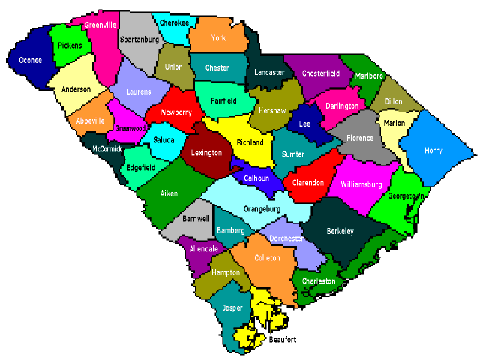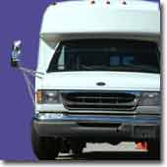
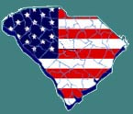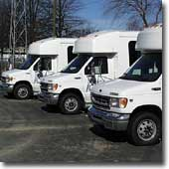

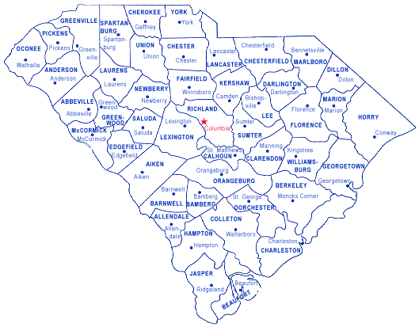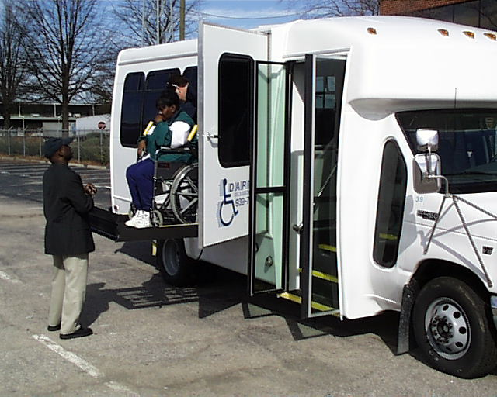
Interim Report To
The Senate Transportation Committee &
The House Education and Public Works Committee

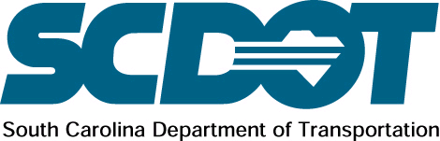

January 2004
INTERIM REPORT

ON

COORDINATION OF TRANSPORTATION SERVICES

E X E C U T I V E S U M M A R Y

JANUARY 2004

The potential benefits from coordinating transportation services can be significant. Benefits include increased service levels, increased mobility for all consumers, better quality of service for riders, cost savings (especially on a unit cost basis), upgraded maintenance programs, better reporting and record keeping, more equitable cost sharing between participating agencies and individuals, more professional delivery of transportation services, and safer transportation services. An absence of coordinated planning processes has resulted in duplicated services, gaps in service, and greater expenditures for transportation operations.
Coordination does entail financial and political commitment, and should not be viewed as the solution for all transportation problems. It may be initially more expensive, more difficult, and more time-consuming to achieve than most agency representatives expect. Coordination may increase overall cost-effectiveness or reduce unit costs but the significant unmet need in most communities will mean that these savings may not necessarily be available for other activities.

Coordination strategies can improve the performance of various individual transportation services as well as the overall mobility within a community. It wrings inefficiencies out of the disparate operations and service patterns of a multiplicity of providers. Coordinated services can achieve economies of scale not available to smaller providers and can result in higher quality services. Greater efficiency helps to stretch the limited funding and personnel resources of these agencies. Coordination helps to control fraudulent activities associated with financial accountability. Coordination can also lead to significant reductions in per trip operating costs allowing communities to use these savings to expand services to persons or areas not previously served. A person with special transportation needs benefit from the greater amount of transportation and higher quality services when transportation providers coordinate their operations. Organizations participating in coordinated efforts often find that they have access to a greater number of sources for matching funds when applying for transportation funding. Lastly, when there is a well-organized local coordinated planning effort, elected officials, agencies, consumers and others become aware and educated about the planning processes of a wide range of community services.
MPOs and COGs are appropriate organizations to prepare plans, collect and analyze data, develop strategies, and allocate funds. MPOs participate in the prioritization of projects that span over a variety of highway, transit, mobility, and coordination needs in a given region. They can play a significant role in stimulating regional cooperation among agencies and help minimize the fragmentation of services provided in a community or region. MPOs and COGs often take a multi-jurisdictional approach to coordination planning and problem solving, engaging a wide range of groups including human service and transit providers. Therefore, MPOs play a lead role in coordinating specialized transportation services in a metropolitan area.
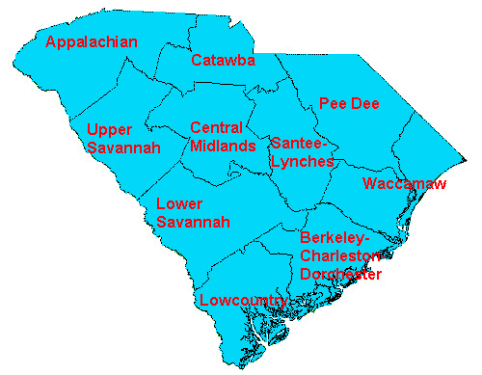
One such coordination success story is being played out in the Lower Savannah Council of Government where they had taken on the role of being a broker when it comes to coordinating services within the COG region. The COG entered into a cooperative agreement with agencies that provide transportation services with the ultimate goal of identifying coordination opportunities and fostering partnerships that concentrate on providing safe, reliable, and efficient transportation regardless of client needs. Last year the LSCOG assumed the role of reviewing all applications for vehicle and purchase of service requests to get a better understanding of the process and identify the needs of the region. The exercise was a positive step toward understanding coordination realities and that one size may not fit all agencies. This year the goal of the LSCOG is to review all applications for federal and state funding for transportation services and determine the coordinating opportunities along with submitting one regional application for funding. The goal is to funnel the funds through the COG, so they may administer the funds directly to the participating agencies based on identified needs. As needs change, the COG is in a better position to administer the appropriate action that will benefit the entire region.

Executive Director’s Commitment to Coordination

- SCDOT is partnering with state, regional, and local agencies and organizations to enhance
transportation while encouraging state leadership that SCDOT remain as the lead agency
for coordinated transportation

- SCDOT continues to place more emphasis on coordination of transportation through committees and partnering meetings with regional planning agencies

- SCDOT is committed to ensure stability for public transportation providers while providing good quality service which is responsive to passengers and clients, while developing a statewide coordinated system

- SCDOT is committed to ensuring that passengers experience a safe, reliable, and efficient transportation system that meets the needs of every community and offers opportunities for a better quality of life for our citizens

I N T R O D U C T I O N
The need for better mobility and access in small urban and rural communities is placing new emphasis on the availability of public transportation services. Public transportation has become essential both to sustain and guide the growth in flourishing areas, and to revitalize areas that continue to struggle. Regardless of current economic fortunes, small urban and rural communities often lag behind in adequate public transportation. Nearly two-thirds of all residents in these communities have few if any transportation options. This is an extraordinary hardship for the thousands of car-less households and non-drivers who reside in non-metropolitan areas of South Carolina. The lack of transit options puts low-income families and the elderly and persons with disabilities, especially, at a tremendous disadvantage economically. In small urban and rural communities statewide, there is a growing need for public transportation that will provide:

- Greater freedom and independence to live and work in a variety of settings
- More choice in how we travel and how we use valuable time and money
- Greater access to varied daily destinations
- Enhanced opportunity for individuals, families, businesses and industry
Note: The 2002 and 2003 numbers represent agencies that operate SCDOT funded vehicles. The total state ridership is much higher when grouped with SC Health and Human Services (SCHHS), SC Department of Social Services (SCDSS), and SC Disabilities and Special Needs (DDSB). The final report due out in May 2004 will reflect total ridership and cost data.

While strides have been made in the last decade to provide more transportation choices, more support is needed in small urban and rural communities. Capturing these benefits in the years ahead will require continued innovation, significant increases in transit investment and broad support from political and community leaders.

Coordination Goals
- Develop a State-Wide Transportation Coordination Plan
- Secure dedicated state funding for transit
- Obtain support from local, regional, and state levels
- Develop and utilize new technologies
- Enhance responsiveness to the needs of the public

The South Carolina Department of Transportation has taken many initiatives regarding coordination:
- Innovative State and Regional Projects
- Elderly and Persons with Disabilities Program Initiative
- Job Access and Reverse Commute Program
- Meetings with Providers
- Partnering Meetings with Planning Organizations

S C D O T I N I T A T I V E S

INNOVATIVE REGIONAL PROJECTS

LOWER SAVANNAH REGIONAL TRANSPORTATION MANAGEMENT AGENCY (RTMA)

The Lower Savannah Council of Governments (Lower Savannah COG) in Aiken, South Carolina, broke new ground in 2001, when the region was designated by the South Carolina Department of Transportation (SCDOT) a Regional Transportation Management Agency (RTMA). The RTMA brought together elected officials and public and private transit operators, in a cooperative effort to coordinate the region’s public rural, elderly and disabled transit operations.

SCDOT and Lower Savannah RTMA is excited about the progress made during the past year regarding meetings with our providers, or partners, as we now call them. All of the public, private, and Title XIX providers in the region meet monthly to discuss concerns and ways to better coordinate. These agencies include Aiken County Transit, Aiken Area Council on Aging, Ervin Transportation, Bamberg County Office on Aging, Generations Unlimited, Allendale County Office on Aging, Lowcountry RTA, and Santee Wateree RTA. These efforts are an outgrowth of the Strategic Planning Session held earlier in the year. One of the priorities discussed by the group was a way to open communication between the properties.

- Service Expansion

The RTMA has continued to meet with Allendale County Alive and representatives from Allendale County service agencies, medical facilities, and local government to determine the type of transit services needed in the county. On July 15th, this group, the RTMA and Lowcountry RTA will meet to determine how services now offered by Lowcountry RTA can be reconfigured to more appropriately meet the needs of the area.
- Public Relations

The RTMA determined a need, based on the work currently underway with Commuter Choice, to better publicize the transit services of the region. Several promotional items have been purchased and are being distributed through the partners. The materials either promote Commuter Choice alone, or both Commuter Choice and the Regional Transit effort. Some of the items carry the phone numbers of each of the partners.

- Regional Drug and Alcohol Consortium

To be administered on behalf of the region by the Santee Water RTA, showing another example of coordination between agencies. Mr. Joe Embler conducted the required training and First Lab is on board to begin the testing, etc. Currently, three providers are participating in the project - Aiken County Transit, Bamberg Office on Aging, and Ervin Transportation.

- Private Providers

Four additional private agencies have requested information for certification by the RTMA. Ervin Transportation is the only firm currently certified by the RTMA and they have been contracting with the public providers in the area to deliver transit requests that the public providers are unable to meet or find less than cost-effective. S&S Transportation has submitted a request but it is questionable that they can meet the insurance requirements. No response has been received from the remaining three firms requesting materials.

Other Initiatives being explored by the Lower Savannah Regional Transportation Management Agency:

- Conduct meetings of the Regional Technical Advisory Committee, Policy Committee, and Governing (LSCOG) Board.

The RTMA Advisory Committee reviews the work of the partners and to offer suggestions for new directions in the coming years.

- Continue meetings with local hospital boards, funding agencies, and other interested parties to find ways to maximize the trips made by service providers transporting clients to various services and activities.
Meetings are continuing with several agencies within Bamberg, Barnwell, and Allendale counties in an effort to coordinate transportation for work-related trips. Work is underway with the Bamberg County Hospital and the Bamberg County Office on Aging to launch a new project for dialysis patients. Section 5310 Elderly and Persons with Disabilities funds have been approved for this project.

- Continue work with local service providers to determine actual trip costs and assist them in making informed decisions on route expansions, client services, and provision of services to industries.

Work on this effort has been finalized and all agencies have been provided information on ways to determine actual trip costs. By the end of March, 2004 SCDOT will have implemented the RouteMatch Schedule & Dispatch software at 16 public transit providers and two regional Councils of Governments. Using RouteMatch, transit providers can share route information with each other and link services to make more effective use of their vehicles and personnel. Regional planners can use RouteMatch to identify where services overlap and work with their area providers to improve the overall efficiency and customer service of the region’s transportation system. RouteMatch also provides the ability to export mapping data into GIS systems, allowing sophisticated graphical analysis of transportation services and proposals.

- Continue discussions with S. C. State University as to the provision of student-based services funded through a student fee, which would be operated by the Santee Wateree RTA and other private providers as deemed necessary.

This effort may receive new life as the University has contacted Santee Wateree RTA as to the possibility of starting a pilot project. The University has received a large grant for this effort through earmark funds.

- Begin meetings with county governments to seek their financial support for expansion of public transit services in their area and to expand services in “un-served” areas.

Work is continuing in Allendale County to increase funding and services in the area.

- Finalize the Coordinated Services Action Plan and ensure that agencies support the actions and strategies that are identified.

The plan has been finalized and communicated to all groups. This will be an on-going process throughout the year.
- Development of a regional training program.
The first phase of this program took place on September 25th when the RTMA hosted a training session through the S. C. Safety Council entitled “Transporting Passengers with Special Needs”. A total of 19 persons were trained in the session.
Additionally, both Generations Unlimited and Aiken Area Council on Aging have agreed to participate as trainers in programs for the region. The RTMA participated in providing a portion of the cost of the drug testing training held in Aiken, S.C., and in the cost of defensive Driver Training. A committee of the Partners group is developing a training calendar to advertise training opportunities throughout the region.

- Develop consistent marketing information for the region.

A brochure of the partners was developed and widely distributed. This will also serve as an insert in the Lower Savannah COG newsletter, furthering the press coverage of the RTMA work. Lunch bags and mugs have been distributed widely to promote both commuter choice and the RTMA partners. Magnets were recently received and are also being distributed.

Unique Transportation Coordination in Bamberg County

The Bamberg County Office on Aging and the Bamberg County Hospital, along with Dr. John Ross (a local surgeon) have joined other service agencies in making available to end-stage renal disease patients a unique opportunity for access to vital medical care. The intent of this partnership is to assist these patients to receive vascular surgery procedures related to Dr. Ross' access dialysis management program.

Trained part-time drivers with the Bamberg County Office on Aging are used to transport clients to Dr. John Ross, who has perfected a procedure to remove clots from these end-stage renal disease patients in a minimal amount of time and get them back on dialysis promptly.

The drivers, working with both the Office on Aging and the hospital, use this vehicle along with their own fleet to coordinate the transportation service for these patients. Clients are provided the needed health care in a timely manner and the drivers are provided additional hours of work through this partnership.

The Office on Aging received approval to use 5310 funds through the Lower Savannah Council of Governments and its RTMA program to help with the cost of this service for clients who are not Medicaid eligible or who do not have insurance to cover transportation.

INNOVATIVE STATEWIDE PROJECTS

Virtual Transportation Enterprise Initiatives

RouteMatch Project (Schedule & Dispatch System)
SCDOT Mass Transit has selected RouteMatch Software™ to provide the statewide automation solution for scheduling and dispatch which SCDOT will now make available to South Carolina rural and demand-response public transit operators. RouteMatch™ addresses a comprehensive set of essential transit operating functions, including Routing, Scheduling, Dispatch, GIS-based Route and Schedule Optimization, Billing and various types of local,

South Carolina and Federal reporting requirements. The contract also stipulates for RouteMatch™ consultants to go into the field to support the conversion and go-live deployment efforts to provide greater assurance our provider partners can truly maximize South Carolina’s investment. The contract will also provide for high-quality customer support and software maintenance after implementation for up to five years.
In September the SCDOT began deploying in the RouteMatch Scheduling and Dispatch software to South Carolina’s small urban and rural transit providers. Phase I of this four month implementation project started with public providers of demand-response services in the area served by the Lower Savannah Council of Governments (LSCOG).

(The system rollout was preceded by both basic and advanced user training conducted in Columbia in August and September 2003.

The agencies initially starting up include Generations Unlimited (Barnwell County), Bamberg County COA, Aiken Area COA, Ervin Transportation, Lowcountry RTA and the Orangeburg region of service by Santee Wateree RTA. These providers alone collectively serve more than 6,000 clients in LSCOG’s region, dispatching more than 160 vehicles to run about 1,500 demand-response trips daily.
The RouteMatch system will help public transit providers automate the business process of collecting and updating client information, scheduling trips and recommending efficient routing, dispatching transit vehicles, and verifying and inputting actual trip data. The system uses geo-coded information for each client and service parameters applied at the funding source level to recommend efficient routing and can export shape files for use in GIS systems to map service region-wide. RouteMatch can use billing parameters for each funding source to produce invoices more efficiently and accurately.

Statewide Vehicle Acquisition and Replacement Program

Over the past two years, the SCDOT has worked diligently to develop a vehicle acquisition program to provide transit vehicles to all public transportation providers. The objective of the program is to maximize use of congressional earmarks along with providing a financing option through the State Treasurer’s Office in the absence of future earmarks. These initiatives along with placing large transit buses on state contract will assist each transit agency in acquiring much needed replacement vehicles. SCDOT received three congressional earmarks totaling $19.8 million to assist in replacing aging transit vehicles. Vehicle inventories of each public transit agency have been reviewed and the needs are calculated through year 2013.
In January 2003, the SCDOT began furnishing newly acquired transit vehicles to South Carolina public transportation providers. In September 2002, fifty-five (55) medium duty, 17 passenger, wheelchair lift equipped vehicles were ordered at a cost of $2,761,189.00 dollars. As of March 9, 2003, SCDOT received all 55 vehicles ordered. The remaining 160 vehicles will be ordered beginning in September 2003 with an estimated delivery date of between February and June 2004.

As of December 2003, transit providers began placing orders for 15 large transit buses and 20 medium duty buses that will begin drawing down the FY 02/03 Congressional earmarks. By SFY 2006 SCDOT is projected to spend over $18 million on new vehicles.

Ms. Elizabeth S. Mabry, Executive Director, SCDOT presenting the keys of a new bus to Mr. Jim Griffith, Executive Director, Edgefield County Senior Citizens

Elderly And Persons With Disabilities (Section 5310) Initiative

For the past several years SCDOT has been the administrator of funding that primarily was used to purchase vehicles for agencies that served elderly and persons with disabilities. Each year the funding application would state that a conscience effort must be made to coordinate and contract with other agencies in the area through “Purchase of Service Contracts” to provide transportation. Each year SCDOT purchased more and more vehicles instead of encouraging “COORDINATION”.

Section 5310 – These funds are used to assist private non-profit organizations in meeting the transit needs of the elderly and disabled population through vehicles purchases or purchase of service contracts with other transit providers.
In 2003, that roller coaster ride was over. With the adoption of a new policy by the SCDOT Commission the Mass Transit Office only funded vehicle purchases if the provider could justify that no other agency in their local area can provide transportation services. The intent behind “Purchase of Service Contracts” instead of purchasing vehicles was to encourage coordination, reduce the overall vehicle fleet, and open communications among service agencies that ultimately may lead to a reduction in duplicative services. This is but one more step in the pursuit of organizing a coordinated transportation system in the State of South Carolina.

INTERSTATE TRANSPORTATION COORDINATION
Aiken County Transit has been pleased to work with the City of North Augusta and the City of Augusta, Georgia to provide a connection to the Augusta Public Transit System. Aiken County Transit also participates in the activities of the Lower Savannah RTMA. With the new connection to Augusta, the potential exists to offer service from Orangeburg to Augusta.

There is also collaboration between the City of Rock Hill and the Charlotte Area Transit System (CATS) to provide transportation services from the City of Rock Hill to Charlotte, North Carolina for daily commuters. Additional service to the Charlotte Metro Area is currently being studied.

JOB ACCESS AND REVERSE COMMUTE PROGRAM
The Job Access and Reverse Commute Program (JA&RC) is a Federal Transit Administration (FTA) Competitive Grant Program, authorized under Section 3037 of the Transportation Equity Act for the 21st Century. Job Access projects are designed to assist in transporting welfare recipients and low-income individuals to and from jobs and activities related to their employment. The first round of activities for SCDOT’s statewide Job Access and Reverse Commute Program ended October 31, 2002. SCDSS provided the required 50% match for this initial round of funding.

The 50% matching funds for round two of the program were secured from the sources, and in the amounts, as listed below:
SCDOT $ 100,000

SCDSS $ 500,000

SC ENERGY OFFICE $ 250,000

LOCAL MATCH FROM
NINE PARTICIPATING
TRANSIT PROVIDERS $ 538,455

TOTAL MATCH $1,388,455

The $1,388,455 of matching funds allowed SDCOT to leverage Job Access & Reverse Commute Program federal funding resulting in a total of $2,776,910 being available for second round Job Access and Reverse Commute Program activities. Cooperative Agreements between SCDOT/SCDSS and SCDOT/SCEO have been prepared and executed.

PARTNERING MEETINGS WITH PLANNING ORGANIZATIONS

The SCDOT is partnering with the ten Councils of Government (COGs) and Metropolitan Planning Organizations (MPOs) in addressing local and regional coordination. The Santee-Lynches Council of Government was selected to be the lead in developing a coordination strategy for the Santee-Lynches Region.

Santee Wateree Regional Transportation Authority will be working closely with the Santee-Lynches COG in identifying coordination opportunities. This initiative is another opportunity for a regional COG to exercise regional leadership in the development of a coordinated transit system to serve Kershaw, Lee, Sumter, and Clarendon Counties.

Coordination studies are also ongoing in the Catawba and Lowcountry Councils of Government to develop plans to coordinate funding and resources. The vision is to include neighboring COG regions through partnering meetings. The hope is that a “snowball effect” will be fostered and that other COG regions will recognize the efficiency and effectiveness of coordinated transportation.

MEETINGS WITH PROVIDERS

The SCDOT meets regularly with public transit providers and human service organizations to seek input on key issues that affect South Carolina’s transit industry. These meetings provide a forum in which local staff members can share information to enhance the quality of transportation services.
The latest meeting occurred August 20, 2003 at the Carolina Center, during which representatives from the Federal Transit Administration conducted a State Management Review Workshop to inform transit providers of identified problems during recent triennial and state management reviews. SCDOT also attends monthly meetings with the Transportation Association of South Carolina (TASC). These regular meetings allow for the exchange of ideas and provide feedback from providers on SCDOT initiatives.


GOALS FOR THE FUTURE

- Continue to emphasize coordination efforts and stress “Partnering” during Councils of Government and Metropolitan Planning Organization meetings statewide
- Provide an efficient and effective transit system that maximizes federal and state transit funds
- Develop “Partnerships” between the SCDOT and state agencies
- Acquire new and efficient transit vehicles statewide

