What Is
the Penny
Buying for

South Carolina?
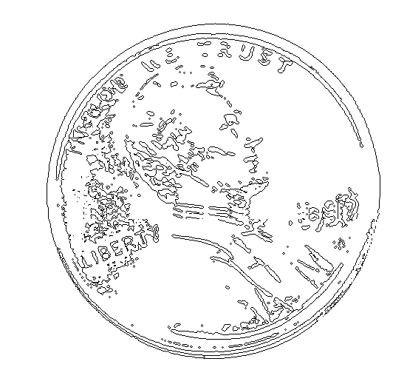

Sixteenth Annual Reporting
on the South Carolina
Education Improvement Act of 1984

South Carolina State Board of Education

December 2000

