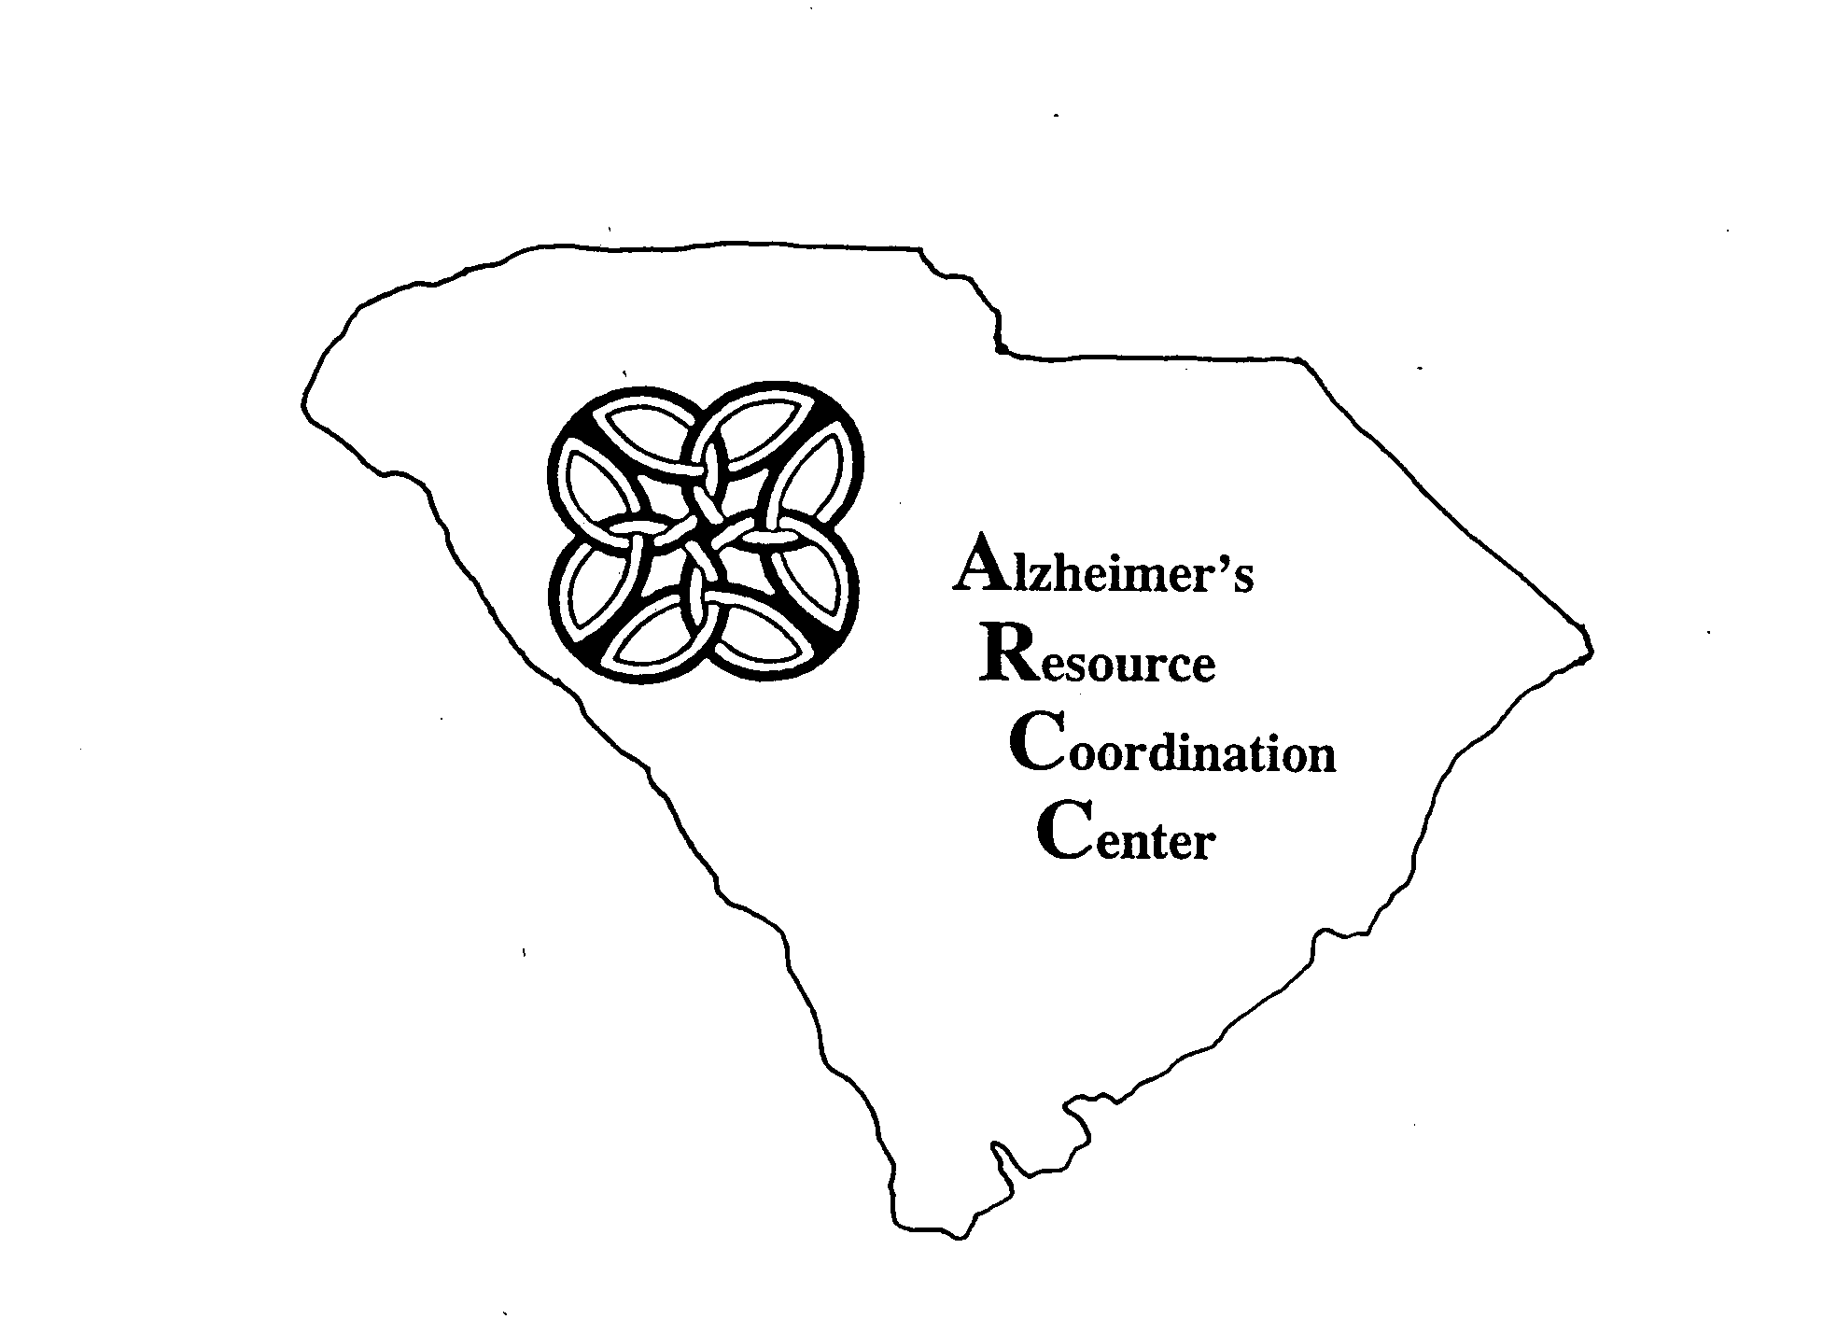

Alzheimer’s Resource Coordination Center

Annual Report

July 1, 2006 through June 30, 2007

Presented to the

South Carolina General Assembly
April, 2008

Lieutenant Governor’s Office on Aging
Alzheimer’s Resource Coordination Center
1301 Gervais Street, Suite 200
Columbia, South Carolina 29201
(803)734-9900

ARCC ANNUAL REPORT TO THE LEGISLATURE
Fiscal Year 2006-2007

EXECUTIVE SUMMARY

In 1994, the state legislature created the Alzheimer’s Resource Coordination Center (ARCC) in response to the recommendations of the Blue Ribbon Task Force on Alzheimer’s disease in South Carolina. The mission of the ARCC is to improve the quality of life for persons with Alzheimer’s disease or related dementias, their families and caregivers through planning, education, coordination, advocacy, service system development and communication. It is guided by a twenty-four member Advisory Council appointed by the Governor. The Advisory Council includes representatives from state agencies, professional organizations, universities, and caregivers with an interest in providing and improving care and services for the population.

The 2006 SC Alzheimer’s Disease Registry Annual Report identified 52,741 persons in South Carolina diagnosed with dementia as of January 1, 2004. Approximately 250,000 persons care for these individuals. The Registry predicts that the number of persons affected by Alzheimer’s disease and other related dementias will double in the next 15 years and nearly triple in 25 years. A recent study by the National Institute on Aging suggests that those numbers may be higher since the declining death rate after age 65 may mean that more people will survive to the oldest ages (after 85) where the risk for Alzheimer’s disease and other disorders are the greatest. Therefore, this is an issue of growing concern. Appendix A illustrates the projected growth in the number of persons with dementia in South Carolina in the next 25 years. These projections underscore the need for the development of community-based services.

Eighty percent of care for persons with Alzheimer’s disease or related dementias is given in the home by family or friends. The physical, emotional, and financial demands on unpaid caregivers are huge, especially for those caring for a person with dementia. Families want to keep their loved one at home. However, the absence of supportive services which enable families to care for their loved one at home may lead to premature placement in an institutional setting, increasing the economic cost to the state and the psychological cost to the family caregiver.

The Alzheimer’s Disease Registry reports that of the 52,741 persons currently living with Alzheimer’s disease in South Carolina, 19,542 (37%) are known to reside in nursing homes and 33,199 (63%) reside in the community. Using a conservative estimate of $35,000 per year to care for an individual in a nursing home, the annual cost of this nursing home care in South Carolina is $683 million. Most persons with Alzheimer’s disease are cared for at home by family members who provide care at great cost to their own physical, emotional, health and financial status. Assuming an annual care cost of only $13,500 per person, maintaining 33,199 people at home costs $448 million each year. The estimated total cost of nursing home and care in the home is $1.13 billion annually. A large portion of this cost is borne by the Medicaid program. Families or informal caregivers also pay for a considerable portion of this cost. If all Alzheimer’s Registry patients resided in nursing homes, the cost would be approximately $1.84 billion each year. South Carolina must find ways to assist and support caregivers in maintaining their loved ones and friends at home as long as possible in order to avoid or delay institutionalization as long as possible.

Part of the mission of the Alzheimer’s Resource Coordination Center is to foster the development of a system of care that will provide families throughout the state with access to support and appropriate services. Whether those services are delivered in the home, the community or a residential setting, they should be responsive to the needs of the person with dementia and the primary caregiver.

Caregivers of persons with Alzheimer’s disease in South Carolina have identified their top three needs:
1. Caregiver support, in the form of emotional support, family support and
support groups;
2. Information and resources on the disease; and
3. Respite. (Respite services allow caregivers to take a short break from their 24/7 care giving responsibilities).

A major barrier to proper care and services for individuals in South Carolina has been the lack of resources to fund the continuum of services needed by families through the course of the progressive disease.

The Legislature has addressed this need by allocating $150,000 in state funds to the ARCC each year to develop community based respite programs, caregiver education and training, and other supportive services to caregivers of persons with Alzheimer’s disease and related disorders. Since 1995 small seed grants have been awarded to communities for dementia specific respite and educational programs. These programs include group respite, in-home respite, and a voucher based respite program in which consumers can choose the type of respite that best meets their needs. Educational programs target persons with Alzheimer’s disease and their caregivers, the medical community, colleges and universities, first responders, such as police, fire and emergency medical personnel, and the general public. Recipients of the grants are required to equally match state grant funds through other resources.

The ARCC is the only entity in South Carolina that awards grants to start respite and education programs in communities. It monitors and provides technical assistance to grantees to ensure that the standards remain at the highest level. It offers information and resources to the grantees as well as the general public. The ARCC continues to encourage and support grantees after their grant award has ended, offering technical assistance to encourage the sustainability of their programs.

Alzheimer’s disease is one of the costliest and most uninsured health risks South Carolina families are likely to face. With the Baby Boomers aging and with in-migration, South Carolina’s senior population is going to drastically increase. With the increase in the numbers of seniors and the increase in life expectancy, the impact of Alzheimer’s disease on families, government and businesses may reach epidemic proportions. By preparing for the future now and providing the much-needed supportive services for families caring for loved ones at home, South Carolina will be ready to meet the challenges of Alzheimer’s disease and related disorders with programs and services in place rather than trying to handle the epidemic after it has started.

Support Services Provided By First and Second Year ARCC Grantees in 2006-2007:

Number of Unduplicated Respite Participants 57
Hours of Respite Provided 8,488
Number of Support Group Meetings 63
Number of Educational Participants 1,509
Number of Hours of Education 60

Nine first year grants were awarded in 2006-2007, including four respite programs and five educational programs. Ten second year grants were awarded, eight of which were respite programs, with two grants devoted to education. All ARCC grant awards are equally matched with community funding and resources. A plan is required for continuation of the program after grant funding is discontinued. Site monitoring of grant programs is conducted to ensure fidelity to the objectives as outlined in the grant.

As part of the grant process the ARCC sponsored a Grant Application Workshop in March 2007, a Grant Procedures Workshop in June 2007, and an Educational Workshop for ARCC grantees in May 2007. Additionally, Alzheimer’s information is made available “on-line” through the web site, www.aging.sc.gov.

Alzheimer’s disease is one of the costliest and most uninsured health risks South Carolina families are likely to face. By providing the much-needed supportive services for families caring for loved ones at home, there is the possibility of preventing or delaying the much higher cost of assisted living or nursing home placement. We thank the South Carolina Legislature for its support in providing relief, respite, and education to South Carolinians with Alzheimer’s disease and related disorders and their caregivers.

TABLE OF CONTENTS

I. Background
A. Enabling Legislation
B. Responsibilities Assigned by Legislation
C. Community Grants

II. Advisory Council

III. Appendices
- Chart Showing Projections of Alzheimer's Disease in South Carolina
B. Governor Appointed Members of the Advisory Council
C. Grants Funded in FY 2006-2007

I. Background

A. Enabling Legislation

The Alzheimer’s Resource Coordination Center was created in the Division on Aging (now the Lieutenant Governor’s Office on Aging) by act of the South Carolina Legislature effective April 20, 1994. The purpose of the Center is to “provide statewide coordination, service system development, information and referral, and caregiver support services to individuals with Alzheimer’s disease and related disorders, their families, and caregivers.”

B. Responsibilities Assigned by Legislation

According to the SC Code of Laws Section 33-36-320, the center shall:
(1) initiate the development of systems which coordinate the delivery of programs and services;
(2) facilitate the coordination and integration of research, program development, planning, and quality assurance;
(3) identify potential users of services and gaps in the service delivery system and expand methods and resources to enhance statewide services;
(4) serve as a resource for education, research, and training and provide information and referral services;
(5) provide technical assistance for the development of support groups and other local initiatives to serve individuals, families, and caregivers;
(6) recommend public policy concerning Alzheimer’s Disease and related disorders to state policymakers;
(7) submit an annual report to the Joint Legislative Committee on Aging and to the General Assembly.

C. Community Grants

According to the SC Code of Laws Section 44-36-325, the Alzheimer’s Resource Coordination Center was further directed to “develop a grant program to assist communities and other entities in addressing problems relative to Alzheimer’s disease and other related disorders. In awarding grants, consideration must be given to recommendations made by the advisory council to the center on priority needs and criteria for selecting grant recipients. As a condition to receiving a grant, the community or other entity shall provide matching funds or an in-kind contribution equal to the amount of funds awarded in the grant.” This act took effect July 1, 1996.

II. ADVISORY COUNCIL

The ARCC is supported by an advisory council appointed by the Governor including, but not limited to, representatives of:
1. Alzheimer’s Association Chapters
2. AARP
3. Clemson University
4. Department of Disabilities and Special Needs
5. Department of Health and Environmental Control
6. Department of Mental Health
7. Department of Social Services
8. Department of Health and Human Services
9. Medical University of South Carolina
10. National Association of Social Workers, South Carolina Chapter
11. South Carolina Adult Day Services Association
12. South Carolina Association of Area Agencies on Aging
13. South Carolina Council on Aging Directors
14. South Carolina Association of Nonprofit Homes for the Aging
15. South Carolina Association of Residential Care Homes
16. South Carolina Health Care Association
17. South Carolina Home Care Association
18. South Carolina Hospital Association
19. South Carolina Medical Association
20. South Carolina Nurses Association
21. South Carolina Alzheimer’s Disease Registry
22. South Carolina State University
23. University of South Carolina

The Advisory Council meets quarterly. Committees are appointed by the Chair and activated as needed.

Appendix A

Projections of Alzheimer's Disease in South Carolina: 2005 – 2030

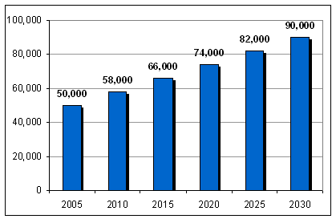

Alzheimer's disease is a progressive gradual decline in the ability to think and remember, as well as to function physically. It is irreversible and there is no cure. According to the Arnold School of Public Health of the University of South Carolina, which compiles the state's Alzheimer's Disease Registry, there were 52,741 individuals in the registry who showed symptoms of Alzheimer's disease or related disorders (ADRD) as of January 1, 2004. Related disorders include dementias associated with vascular disease and chronic conditions such as Parkinson's disease. Nine percent of South Carolinians aged 65 and over and 27 percent of those aged 85 and older had ADRD in the same year.
By the year 2030, there will be an estimated 90,000 people with ADRD on South Carolina's Alzheimer's Disease Registry.
According to the Alzheimer's Disease Registry, the number of people with ADRD in South Carolina is probably undercounted. Individuals with mild forms of the disease who have not yet been diagnosed do not appear in the registry. In fact, previous studies suggest that the number of individuals with ADRD may be 50 percent greater than the number diagnosed with ADRD. South Carolina's Alzheimer's Disease Registry, however, is widely recognized as the best population-based registry of ADRD in the country. The registry uses data from a wide variety of sources to capture as many diagnoses as possible.
Among South Carolinians diagnosed with ADRD:
- 64% have Alzheimer's disease.
- 16% have dementia due to stroke.
- 20% have a dementia related to other chronic conditions.
- 38% live in nursing facilities, 57% reside in the community, and 5% live in unknown locations.
- 66% are women.
- 33% are African American.
- 38% are 85 years or older.

Appendix B

Governor Appointed ARCC Advisory Council Members

Dr. Roger L. Amidon
AARP

Ms. Cindy Alewine
Alzheimer's Association Upstate Chapter

Dr. Julie Eggert
Clemson University

Ms. Mildred Lilley
Consumer/Caregiver

Dr. Jacobo E. Mintzer
Medical University of South Carolina

Ms. Carol Ann Beard
National Association of Social Workers, South Carolina Chapter

Ms. Susan Wrigley
South Carolina Adult Day Services Association

Ms. Sharon L. Seago
South Carolina Association of Area Agencies on Aging

Pending
South Carolina Association of Council on Aging Directors

Ms. F. Ann Shealy
South Carolina Association of Non-Profit Homes for the Aging

Ms. Karen S. Bowman
South Carolina Association of Residential Care Homes

Ms. Carol Cornman
South Carolina Alzheimer's Disease Registry

Dr. Graeme H. Johnson
South Carolina Department of Disabilities and Special Needs

Mr. Michael D. Byrd
South Carolina Department of Health and Environmental Control

Ms. Maria Patton
South Carolina Department of Health and Human Services

Dr. Paul Switzer, III
South Carolina Department of Mental Health

Ms. Mildred Washington
South Carolina Department of Social Services

Pending
South Carolina Health Care Association

Mr. Jeffrey K. Neipp
South Carolina Home Care Association

Pending
South Carolina Hospital Association

Dr. Terry Dodge
South Carolina Medical Association

Ms. Marilynn Koerber
South Carolina Nurses Association

Ms. Donnis K. Zimmerman
South Carolina State University

Dr. James Laditka
University of South Carolina

Staff:
Barbra Link
Eve Barth

Appendix C

New Grants Awarded in July 2006 for FY 2006-2007

The Ark $20,000
Education
Dorchester County

Alzheimer’s Association $12,000
Education
*Multi-county area

Alzheimer's Family Services of Greater Beaufort $5,000
Education
Beaufort County
Edgefield County Senior Citizens Council $3,000
Education
Edgefield County
Genesis I Adult Day Care Services, Inc. $20,000
Respite
Florence County
Hopewell Senior Day Care Center $20,000
Respite
Williamsburg County
Lean On Me Home Care Services, Inc. ($10,000)**
Respite
Clarendon County
Reliant Healthcare, LLC $10,000
Education
York County
St. Paul Adult Day Care $20,000
Respite
Union County

*Counties included are Aiken, Allendale, Bamberg, Barnwell, Beaufort, Berkeley, Calhoun, Charleston, Chesterfield, Clarendon, Colleton, Darlington, Dillon, Dorchester, Florence, Georgetown, Hampton, Horry, Jasper, Kershaw, Lee, Lexington, Marion, Marlboro, Orangeburg, Richland, Sumter, and Williamsburg

** Grantee unable to implement program.

Second Year Grants Awarded in July 2006 for FY 2006-2007
Aiken Area Council on Aging $5,000
Respite
Aiken County
Alzheimer's Family Services of Greater Beaufort $5,000
Respite
Beaufort County
Capital Senior Center $2,500
Education
Richland County
Catawba Area Agency on Aging $5,000
Education
York County
Dillon County Council on Aging $5,000
Respite
Dillon County
Lancaster County Council on Aging $5,000
Respite
Lancaster County
McCormick County Senior Center $5,000
Respite
McCormick County
New First Missionary Baptist Church $5,000
Respite
Colleton County
Oasis II Adult Day Care Center $5,000
Respite
Georgetown County
Reid House of Christian Service $5,000
Respite
Charleston County

TOTAL FIRST AND SECOND YEAR GRANT AWARDS
IN FISCAL YEAR 2006-2007 $157,500

