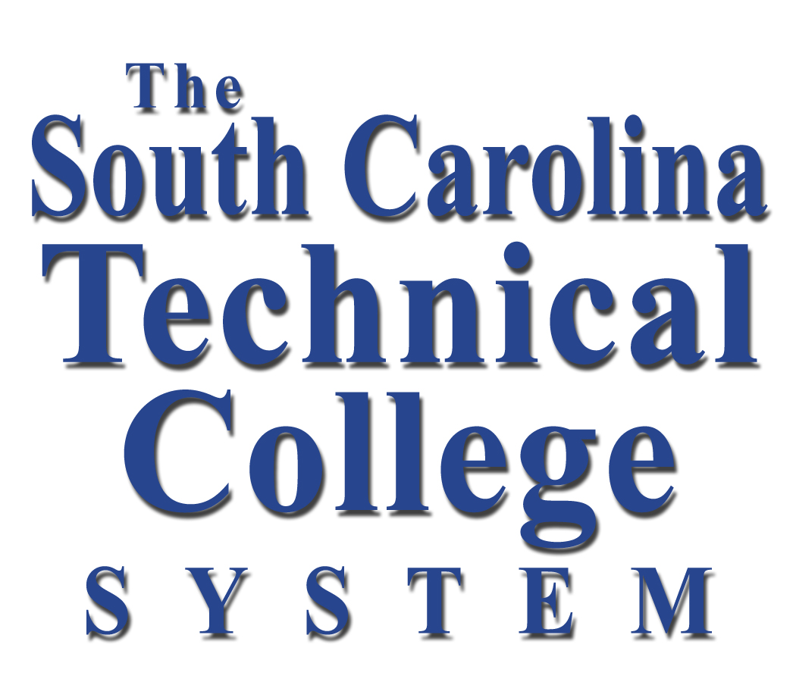
the south carolina technical college system
Agency Accountability Report
FY 1999-2000

The State Board for Technical and Comprehensive Education
111 Executive Center Drive - Columbia, SC 29210
(803) 896-5280

The State Board for Technical & Comprehensive Education

October 20, 2000

Mr. Les Boles
Director, Office of the State Budget
1122 Lady Street, 12th Floor
Columbia, South Carolina 29201

Dear Mr. Boles:

The State Board for Technical and Comprehensive Education (The South Carolina Technical College System) appreciates the opportunity to submit this transmittal of the Board’s Accountability Report for FY 1999-2000. This report is submitted as required by Section 1-1-810 and 1-1-820 of the South Carolina Code of Laws, as amended and Proviso 72.58 of the FY 2000-2001 Appropriations Act.

The South Carolina Technical College System comprises a State Office and 16 technical colleges located strategically across the state. Because all the colleges report separately in accordance with Section 59-101-350, this document will concentrate primarily on the System’s Special Schools program which provides pre-employment workforce training to businesses and industries that create new jobs in South Carolina. Additional information regarding the sixteen colleges and the System Office’s leadership role in achieving the technical education mission may be found with the South Carolina Commission on Higher Education.

The Technical College System, according to principles promoted by the Malcolm Baldrige Quality Award, has used an extensive process of coordinated planning and activity management to develop and deploy work plans designed to make the System more effective and efficient. As part of its continuous improvement process, the System is committed to enhancing its planning, management and assessment process to even more closely conform to South Carolina state government’s adoption of Baldrige management and planning criteria.

During the past year, the South Carolina Technical College System provided educational and training opportunities to over 240,000 students through credit, continuing education and pre-employment industry training. This represents a four-year trend of increases. Additionally, Technical College System undergraduate enrollment has increased by over 32,000 students since 1995 and the System’s technical colleges serve nearly 40% of all South Carolina undergraduates.

For information or assistance regarding this report, please contact Mr. Lawrence Ray, Director of Communications, at (803) 896-5321.

Sincerely,

James L. Hudgins, PhD.
Executive Director
Section II, Executive Summary

The Accountability Report for FY 1999-2000 emphasizes the Technical College System’s continual efforts to work collaboratively with all System partners, using management principles set forth in the Malcolm Baldrige quality criteria, to coordinate activities and initiatives designed to enhance educational opportunities for people of all ages and to support our state’s economic development efforts.

The South Carolina Technical College System’s continual trend of success substantiates the premise that the educational and training opportunities provided by the System’s sixteen colleges have contributed greatly to making South Carolina’s economy what it is today. Each and every technical college has become a central partner within their community by supporting new industries and providing top quality educational opportunities to local residents.
Customer-Focused Performance Excellence: The state’s 16 technical colleges are accredited by the Commission on Colleges of the Southern Association for Colleges and Schools and continue to achieve reaffirmation on a regular cycle. The state’s sixteen technical colleges are the System’s primary delivery points for services to the people of South Carolina through:

- College Credit programs – The Technical College System’s 16 colleges provide cost-effective access to post-secondary education for wide diversity of students across the state.
- Continuing Education programs – In accordance with the System’s enabling legislation (59-53-20), the System’s 16 technical colleges provide continuing education and other training opportunities designed to keep South Carolina’s existing workforce up-to-date with changing technology.
- Developmental Education Programs – The Technical College System’s 16 colleges provide programs to assist students who are not yet prepared to enter college-level programs.
- Student Development programs and Services - The Technical College System’s 16 colleges provide a variety of programs and services including skills, ability and interest assessment, academic counseling, leadership development, student activity programs and job placement services.

In accordance with Act 359, the System’s colleges operate under the state’s performance funding legislation. The Technical College System’s overall average performance funding score for FY 1999-2000 was 2.53. The System continues to work in cooperation with the Commission on Higher Education to ensure that the performance funding indicator definitions do not conflict with the unique mission of the System.

In its effort to offer relevant, effective educational opportunities for students, the System offers approximately 301 degree, 126 diploma and 615 certificate programs across a broad spectrum of career disciplines in addition to the customized pre-employment training of the Tech Special Schools program.

Nearly six percent of the state’s population between the ages of 17 and 44 benefited from the programs offered by the Technical College System last year. During the FY 1999, credit program enrollment (for degrees, diplomas or certificates) at the 16 technical colleges totaled 88,948 and the colleges awarded 9,625 degrees and other formal awards. The number of awards presented to technical college graduates has been increasing every year since 1993. This represents a positive trend that mirrors increased enrollment figures. The System operated on a budget of $341,689,529 with $25,328,632 acquired federal funds during the past year. Regular audits of the system are conducted and filed with the Office of the Comptroller General and the State Auditor. Performance data and related technical college institutional effectiveness data can be found through the Commission on Higher Education.

Collaborative System-wide Planning: In 1999, the System hosted a Joint Summit of State Board members, Area Commission members, College personnel, partner agencies and System Office personnel that created the framework for the System’s 5-year strategic vision. The planning summit resulted in the creation of a document “Creating the Future” which outlines the Technical College System’s vision and strategic goals for the new millennium.

During the past year, the presidents of the 16 South Carolina’s Technical Colleges collaborated with System trustees and state office staff to advance priority initiatives that support the System’s strategic goals. The college presidents along with the System’s Executive Director identified a number of initiatives that were made a priority for action. Significantly, collaborative planning and work-plan implementation produced results detailed later in this report.

Partnerships with other agencies: The South Carolina Technical College System works with other state agencies and selected private organizations in order to accomplish its higher education and economic development missions. Primary state agency partners include: The sixteen technical colleges, the Governor’s Office and the General Assembly, The SC Department of Commerce, The SC Department of Education, The Employment Security Commission, The Commission on Higher Education, The Budget and Control Board businesses and industries in the state and higher education institutions. Other key partners include local economic development organizations and chambers of commerce, the South Carolina Chamber of Commerce, local, regional and national economic development organizations and local, regional and national education organizations.

Providing Support for Economic Growth in SC: The Technical College System has become a vital element of the state’s economic development strategy since its inception in 1961. The critical program behind the creation of the System is the Tech Special Schools program. The Tech Special Schools program was established by the Legislature and is designed to provide pre-employment workforce training to new and expanding businesses that create new jobs in the state. The System’s Economic Development Division is responsible for the management of the Tech Special Schools program. The System has become a much-copied model, and has been visited by representatives from more than 40 states and numerous foreign countries.

In concert with the Workforce Investment Act and other legislation designed to promote the creation of jobs in South Carolina’s rural communities, The Tech Special Schools program has conducted collaborative evaluation and planning for the creation of new workforce training initiatives and programs with several of its key partners. These programs will be implemented in the coming year and are focused on meeting critical workforce needs around the state.

Throughout its history, the System’s Special Schools program has been credited by many of the state’s new industries as being a critical factor in their decision to locate in South Carolina. During FY 1999-2000:

- More than 7,800 state residents completed Tech Special Schools programs;
- 123 business and industries were provided with pre-employment training programs;
- 47% of businesses were new, 53% of businesses were expanding;
- Average age of Tech Special Schools trainee - 33.3 years old;
- 49% trainees were African-American, 47% trainees were White, 04% were other;

Additionally, during FY 1999-2000 the South Carolina Legislative Audit Council completed an audit of the Tech Special Schools program. The review by the LAC found the Special Schools program had followed state laws and had not mishandled any state funds. The examination did identify areas where the Special Schools program could strengthen data collection and review procedures for each project.

Challenges Facing the Technical Colleges: The strength of the South Carolina Technical College System lies in its approach to face the challenges by working together to create opportunities for improvement of the System and the services we provide to our customers. For the next year, The System is continually adopting new efforts to implement performance excellence. Therefore, it has developed strategic goals and that are focused on the following issues to ensure performance and accountability to the people of South Carolina:

Ensure excellence and value by providing high quality, relevant programs and services to all customers.
- Implement an initiative to promote the South Carolina Technical College System as a priority sector of higher education to all constituents;
- Develop a reward structure to encourage the development of quality programs or services to address state priorities;
- Develop strategies to increase enrollment in technology programs where employment and demands are high;
- Encourage partnerships among colleges in developing programs and services that respond to the changing needs of the workforce;

Achieve greater efficiency and effectiveness in fulfilling the System's mission through coordinated college and state-level leadership.
- Organize and fund a faculty and staff development plan to include information on System values, priorities and initiatives;
- Clarify roles and relationships in the System's governance and administration to achieve greater System alignment;
- Explore collaborative arrangements with state universities to offer graduate programs in formats accessible to technical college faculty;
- Increase communication and cooperation among the System's governing boards;
- Create a leadership development program to develop leadership skills among system employees;
Develop a world-class workforce to fulfill the demands of an evolving and diversified state economy.
- Ensure the technical college presidents and the executive director provide a leadership role in implementing the Workforce Investment Act;
- Develop an "Innovative Technical Training Plan for the 21st Century";
- Assist employers in assessing the ability of their existing workforce to meet changing technology demands and offer targeted training programs;
Provide responsible and flexible access to education, training and retraining through distance learning technology.
- Develop a quality Internet and Intranet Web pages;
- Develop policies and procedures, including funding and evaluation plans, to ensure quality program delivery;
- Include Special Schools as a resource for developing state-of-the-art, customized and modular distance learning programs;

Acquire the financial and infrastructure resources necessary to achieve the Technical College System's mission.
- Develop and maintain a comprehensive legislative action plan that includes all stakeholders;
- Develop an economic benefits/impact study of technical education to demonstrate a foundation for increased state resources;
- Ensure the Technical College System receives an equitable share of a fully funded higher education Mission Resource Requirement (MRR);
- Acquire the equipment and technology essential for relevant educational programs and implementation of the Technology Plan;
- Seek funds to increase faculty and staff salaries to competitive level;
- Ensure that state scholarship programs support technical college students;
- Seek and obtain a larger share of the state's Carl Perkins funding allocation;
- Seek "School to Work" funding from the legislature for post-secondary education;
- Seek additional state-funded, full-time-equivalent (FTE) faculty and staff positions;

Demonstrate accountability for achieving the System mission.
- Develop systems for more consistently and accurately defining and measuring performance indicators;
- Assist the South Carolina Department of Commerce in attaining the state's economic development goals;
- Establish a flexible, reliable, system-wide relational database;
- Identify and develop performance measures and standards for student success.

These initiatives are designed to directly support the priority initiatives identified by the technical college presidents through the System’s collaborative planning process.
Section III, Mission Statement

The State Office of the State Board for Technical and Comprehensive Education has gone to great lengths to ensure that each of the Technical Colleges and their local boards, State Board members and all other System employees understand the vision and mission of the South Carolina Technical College System. The System’s vision and mission were clarified and re-defined through a series of sessions that culminated in a joint planning summit held in July 1999. Through this process of re-defining the System’s mission, System staff and partners have emphasized the vision for the future while maintaining and following the enabling legislation (59-53-20) that created the State Board.

The System’s Vision Statement is the guiding principle for the future collaboration of the System and its partners. The Mission Statement ensures that our actions are in harmony with the System’s original enabling legislation. The definitions of the Technical College System’s vision and mission are:

Vision
The System Office of the State Board for Technical and Comprehensive Education is to be a cohesive and innovative organization that helps the South Carolina Technical College System lead the nation in technical education and training

Mission
The System Office of the State Board for Technical and Comprehensive Education provides leadership, services, accountability and coordination of resources in support of the education and training goals of the South Carolina Technical College System essential for the human resources development and the ultimate economic development of South Carolina.

Section IV, Leadership System

The South Carolina Technical College System is governed by the State Board for Technical and Comprehensive Education, a twelve-member board appointed by the governor.

The System (System Office) is managed by Dr. James L. Hudgins, Executive Director. Reporting to the Executive Director is an eight-member executive council comprised of four
Associate Executive Directors, two office directors and two executive assistants. The System Office executive council members involve employees at the division level to obtain input in strategic planning and build agency consensus.

The executive council members also advise the Executive Director on internal management issues and act as functional liaisons to the Technical College System Presidents’ Council. The Technical College System Presidents’ Council, comprised of the sixteen technical college presidents, advises the executive director on policy and matters pertaining to the technical colleges and alignment of college initiatives.

Through a collaborative process guided by the Executive Director, the Presidents’ Council, Institutional and Functional Peer Groups and System Office staff, System-wide strategic planning is achieved through alignment of common goals and objectives that support the System’s long range plan.

The collective strategic planning process established the following key initiatives as the focus for collaborative work during the past year:

- Efforts to inform legislators and other key partners of Technical College System objectives and budget requests, including a coordinated series of legislative delegation meetings across the state along with individual contacts;
- A public information initiative dedicated to telling the System’s story to its key publics;
- A Performance Indicators Task Force successfully worked in partnership with CHE to refine performance indicators for the sixteen technical colleges;
- A Peer Group Involvement Task Force developed a handbook designed to coordinate and guide the planning and work process of the System’s institutional officer peer groups;
- A Leadership Development Task Force focused on providing opportunities for professional development for Technical College System staff,
- An Innovative Technical Training Committee focused on distance learning strategies and laid the groundwork for our partnership program with the Department of Commerce for a “smart jobs” training strategy;
- A study was designed to identify the impact of the Technical Colleges and Special Schools programs on the state;
- Efforts to find new ways to interact with our local governing Boards;
- Efforts to find new ways to improve Human Resources operations and to become more effective and efficient.

The System Office continued its commitment to operate in close alignment with the 16 technical colleges. In that continuing process and under the direction of the Executive Director, an outside consultant worked closely with the System Office executive council and the sixteen technical college presidents to develop cohesive working and planning guidelines.

To further ensure alignment of college actions, planning and implementation of System-wide initiatives are coordinated though the activities of Institutional Officer and Functional Peer Groups comprised of representatives from each college and the System Office. These peer groups develop and drive the actual work plans to support the initiatives established by the college presidents. The college presidents and System Office executive staff monitor progress of work plans on a monthly basis and continually assess the effectiveness of activities.

System office employees are kept up to date of the progress being made and how their function contributes to the overall achievement of System goals through regular staff meetings. At all meetings, efforts are made to reaffirm the System’s values that guide its collective efforts to provide quality higher education and training opportunities for the people of South Carolina.

System employees are expected to adhere to the following value statement and performance expectations:

Value: Integrity
We base our working relationships upon mutual trust and respect. We recognize that the reputation of the South Carolina Technical College System is rooted in the honest and ethical treatment of our customers and each other.

Value: Teamwork
We value results that are achieved through teamwork. We approach our work as a team focused on creating a positive work environment that results in a higher quality of performance.

Value: Diversity
We value the individual differences and contributions of each member of our organization. We embrace open-mindedness, creativity, and the ability to adapt to change. We believe each employee is a valuable and important resource.

Value: Commitment to Excellence
We set high standards for quality in our work and hold ourselves accountable. We strive for continuous improvement and seek to use innovation and cutting-edge technology to work effectively among ourselves and with our customers.

Value: Service
We value our role as a service provider to the System and seek to be responsive, accurate and compassionate.

Section V, Customer Focus and Satisfaction

Because the 16 technical colleges are located in diverse geographic areas, from metropolitan centers to rural communities, many needs for services or programs are unique to each college’s service area.

Through coordinated planning between the colleges and the System Office, the Technical College System is able to make a greater impact on the state as a whole. Therefore, in the process of responding to customer input and to more closely align the Technical College System’s strategic planning and implementation of key externally focused initiatives, the System is utilizing the colleges to determine needs of the end consumer (students and employer partners) in the communities served. Determining needs at the local level is a core component of the System’s coordinated strategic planning process and allows the Technical College System to more efficiently provide programs and services statewide.

The System Office has incorporated the results of customer expectation questionnaires to the colleges and System Office employees, sampled at the end of FY 1998-1999, into its strategic planning. Additionally, to determine internally focused priorities for System initiatives, the Technical College System utilizes its Peer Group system to determine what support services and initiatives the System Office can implement to make the System more efficient.

A prime example of innovation based on customer input and customer focus is evident in the collaboration between the System Office’s Human Resources Division and the Information Resource Management Department. In response to internal customer feedback on personnel issues, the System’s Human Resources and IRM staffs have developed a computer-based module to streamline the employee annual leave data collection and verification process. The System HR and IRM staffs have also developed a computer-based Employee Performance Management System (EPMS) to streamline employee’s annual review processes. These modules are currently migrating into the colleges as well as to other areas of state government.

In 1998 the General Assembly requested an audit of the Special Schools Program to determine its compliance with state law and regulations. This audit was completed during FY 1999-2000 and the results produced 17 recommendations for action by the State Board for Technical and Comprehensive Education. The State Board welcomed the thorough review by a team of independent auditors. The audit identified several examples of inadequate internal controls to document proper audit protocol. The System accepted the independent recommendations for improving internal controls as a helpful assessment of division operations and has begun to incorporate the recommendations into work plans that will be addressed by the end of 2000.

In the effort to be responsive to the audit report, the System developed a detailed response to the 17 recommendations and shared it with legislative leaders and state executive officers. Six months after the audit results were released, a progress report on actions taken to accomplish the audit’s recommendations was presented to the State Board for Technical and Comprehensive Education, the Legislative Audit Council and legislative leaders.

Section IV, Other Performance Excellence Criteria

The South Carolina Technical College System has in years past begun incorporating the principles of quality management into its planning and assessment of services. Due to a change in executive leadership during FY 1998-99, implementations of total quality practices have not progressed rapidly. However, the Technical College System is committed to further embrace and integrate additional quality management practices into its current collaborative strategic plan development and deployment as encouraged by the Governor’s office and other government leaders.

Strategic Planning:
The Technical College System has begun the process of including internal partners (the State Board, the sixteen technical colleges and their Area Commissions) and external partners (key state agencies including the Department of Commerce, the Department of Education, the Employment Security Commission and others) in crucial areas of the System’s strategic plan development process.

The strategic planning process is designed to determine customer needs, and assess current programs. The planning process begins on a macro scale with input from the State Board and other key partners. The Presidents’ Council and the State Office staffs then use the strategic plan to determine key initiatives. These key initiatives drive the work plans of each System Office division and the Institutional Officer Peer Groups and System Office staffs. Work progress is tracked on a monthly basis during regularly scheduled meetings of the System’s Presidents’ Council.

To support the effort of fully incorporating quality management practices into the strategic planning development and deployment process, the executive director has begun coordinating periodic meetings with outside consultants to provide instruction on all Malcolm Baldrige criteria. Additionally, the System’s division of Human Resources has been charged with developing a comprehensive plan to fully integrate all seven Baldrige criteria into System Office operations. Additionally, the System’s executive staff are participating in quality training sessions to develop core skills that will help guide future quality management efforts.

Information Collection and Analysis:
In response to the System’s strategic plan and customer focus, the System Office is coordinating the implementation of processes and data collection measures that will streamline the colleges’ reporting as required by state law. An example of action initiated by internal customer input includes the development and coordination of a data processing and data reporting system that will standardize System reporting and data management. This data system, designed by the firm Datatel, is currently being installed and systematically tested at many colleges around the System. The Datatel system will support the state’s requirements for college reporting for CHEMIS data and will incorporate other key data collection and analysis functions such as student, financial and human resources data.

Further, the Technical College System is investigating how to assess current operations in concert with the implementation of Baldrige criteria in the System’s strategic plan development process. Plans for information collection and analysis should be incorporated into the next iteration of the System’s strategic plan.

Human Resources Focus:
The Executive Director of the Technical College System has realigned the State Office staff for efficiency and to address elements of the System’s strategic plan. The System was formally organized into five divisions under the direction of Associate Executive Directors: Academic Affairs and Technology, Human Resources, Economic Development, Finance and IRM, and Planning, Development & Communications. In response to customer needs addressed in the System’s strategic plan, the System Office executive staff has now been aligned to comprise four Associate Executive Directors heading up the Academic Affairs and Technology, Human Resources, Economic Development, Finance and IRM divisions and two office directors heading up Communications and Development. Further, each division office has begun to realign staff in order to become more customer-focused and efficient. Each division is focusing on increased training when appropriate in order to stimulate staff development.

For example, the Economic Development Division has implemented reorganization to better meet customer needs and utilize internal resources more effectively. This reorganization includes the formation of “Technology Teams” that are focusing on five specific industrial sectors: biotechnology, semiconductors, pharmaceuticals, information technology and computer-based interactive training. With the reorganization, the division has empowered its field managers to train for specific industrial sectors and incorporate discipline-specific work teams across the state with the sixteen technical colleges to develop training and academic programs to support industries in these new technology sectors.

Systems and Processes:
In response to an audit conducted by the Legislative Audit Council, the System’s major program, Special Schools, has begun implementation of additional systems and processes for assuring the quality of services. Action on the audit recommendations is expected to improve internal controls throughout the Special Schools program development process and maintain the flexibility essential to support our state’s economic development process. The LAC’s 17 recommendations can be grouped into three categories of responses. These include:

- Assessment and documentation of the outcomes of Special Schools projects;
- Appropriate documentation of all training agreements;
- Update, clarification and expansion of the policies and procedures of the Special Schools program.

The audit process has been utilized as an independent assessment of program effectiveness and management. This process has allowed the Economic Development Division to develop comprehensive systems and processes that will strengthen internal controls and become more customer focused. Addressing the LAC recommendations will also result in deeper cooperation in assessment and evaluation of projects between the division’s key partner agencies.
Section VII, Description of Programs

Program Name: Special Schools

The South Carolina Technical College System’s Economic Development Division manages the program. The Special Schools program is the primary program of the System Office. Other programs are delivered on the college level.

Program Cost, FY 1999-2000:

$10,488,787 (state general funds)

Program Goal:

The primary goal of the Special Schools pre-employment workforce training program is to promote and support South Carolina’s economic development efforts in rural and metropolitan areas of the state.

Program Objective:

Develop and deliver high quality, customized pre-employment workforce training for new and expanding businesses that are creating new, high paying jobs in South Carolina. This program objective is ongoing each fiscal year.

This results in providing training opportunities to the citizens of South Carolina so that they can qualify for new, higher paying jobs in all areas of the state.

Key Results:

During FY 1999-2000, the Technical College System’s Special Schools program achieved the following results:

- Plants (companies) served - 126: 59 new and 67 expanding;
- Total trainees for new and expanding businesses - 7,872: 3,873 new and 3,999 expanding;
- Trainees by sex – 56% male (4,406), 44% female (3,466)
- Trainees by race – 49% African American (3,866), 47% White (3,728), 4% other (278)
- Total trainees since 1961 – 205,898

Section VII, Program Data Graphs

PLANTS SERVED

NUMBER TRAINED

PERCENT TRAINED BY RACE
PERCENT TRAINED BY SEX

