State of South Carolina

Department of Probation, Parole and Pardon Services

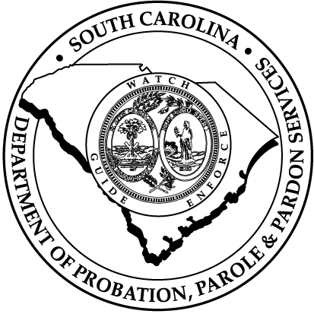

Agency Accountability Report

Fiscal Year 1999-00

October 20, 2000
Table of Contents

Transmittal Letter Page 1

Executive Summary Page 2

Mission Statement Page 5

Leadership System Page 6

Customer Focus and Satisfaction Page 8

Customer Wheel Page 11

Other Performance Excellence Criteria Page 12

Strategic Planning Page 12

Information and Analysis Page 13

Human Resource Focus Page 13

Process Management Page 15

Key Results Areas Page 16

Offender Supervision Page 16

Parole and Pardon Operations Page 19

Residential Services Page 21

Parole and Pardon Board Operations Page 23

Victim Services Page 24

State of South Carolina
Department of Probation, Parole and Pardon Services


JIM HODGES STEPHEN K. BENJAMIN
Governor Director

2221 DEVINE STREET, SUITE 600
POST OFFICE BOX 50666
COLUMBIA, SOUTH CAROLINA 29250
Telephone: (803) 734-9220
Facsimile: (803) 734-9440

October 20, 1999

Mr. R. Lester Boles, Jr., Director
Budget and Control Board
Office of the State Budget
1122 Lady Street
Columbia, South Carolina 29201

Dear Mr. Boles,

I am pleased to present The South Carolina Department of Probation, Parole, and Pardon Services Accountability Report for fiscal year 1999-00. Again this year, our vision in approaching the report, was to create a practical, consistent and systematic process to measure and report compliance with laws, policies, and procedures, in all areas of the Department, and to ensure this is being done in a positive environment fostering continuous improvement and innovation.

Using the Department=s Strategic Plan and the Malcolm Baldridge National Quality Award Criteria as a foundation, each division began to complete a comprehensive and systematic self assessment of its performance during FY 99-00. The Department=s Quality Office, Office of Internal Audit, and Administrative Services Division provided technical assistance and consultation services to staff and managers throughout the process. The final product is a consensus of our organization=s performance on meeting our legislative mandates and progress on our strategic plan.

For information or assistance regarding this report, please contact Mr. William Bray, Budget Office, at (803) 734-9336.

Sincerely,

Stephen K. Benjamin
Executive Summary

Fiscal year 1999-00 was a remarkable, innovative and productive year for the Department characterized by significant systems improvements, and enhancements to service delivery capabilities. Indeed, the challenges were tremendous. Yet, through sound planning and leadership at all levels of the organization, we excelled. During FY 1999-00, several key areas were pursued to enable the Department to achieve these business results.

The Department has made great strides at increasing the visibility and accessability of our Agents in the community. This is being accomplished in several ways:

** Agents moving toward taking reports from offenders in the community where they reside instead of requiring the offender to report to the county office. Agents are more visible in the community.

OSEPR Chief Mike Nichols accepts Strom Thurman Award for Excellence in Law Enforcement

** Working with local law enforcement on warrant service efforts.

** The Chief of the Office of Safety, Enforcement and Professional Responsibility was awarded the Strom Thurmond Award for Excellence in Law Enforcement.

In an effort to address the ever shrinking availability of state funds, we have formally required self assessments of all program areas within the Department. The results of these self assessments are then used to align and focus resources on to strategic goals of the agency. The Department=s strategic or long-term goals are:

** To promote public safety through increased offender accountability ensuring that citizens are confident in the safety of their surroundings.

** To employ sound fiscal practices in the compensation of agents in order to retain quality, well trained agents.

** To increase the visibility of Agents in community policing efforts, and emergency response situations as requested by the Governor.

** To improve the Department=s information technology infrastructure in order to provide Agents with the technology to efficiently and effectively manage their caseloads.

We have continued to address our organization=s ability to accomplish our public safety responsibility. Included in that responsibility is the duty to identify and respond to the violation of conditions of probation and parole that have been imposed. The Department has engaged in many activities that are intended to enhance our effectiveness in this area. These efforts include:

** Improving our training, concerning arrest mechanics for front line agent staff;

** Providing additional safety equipment to front line agent staff;
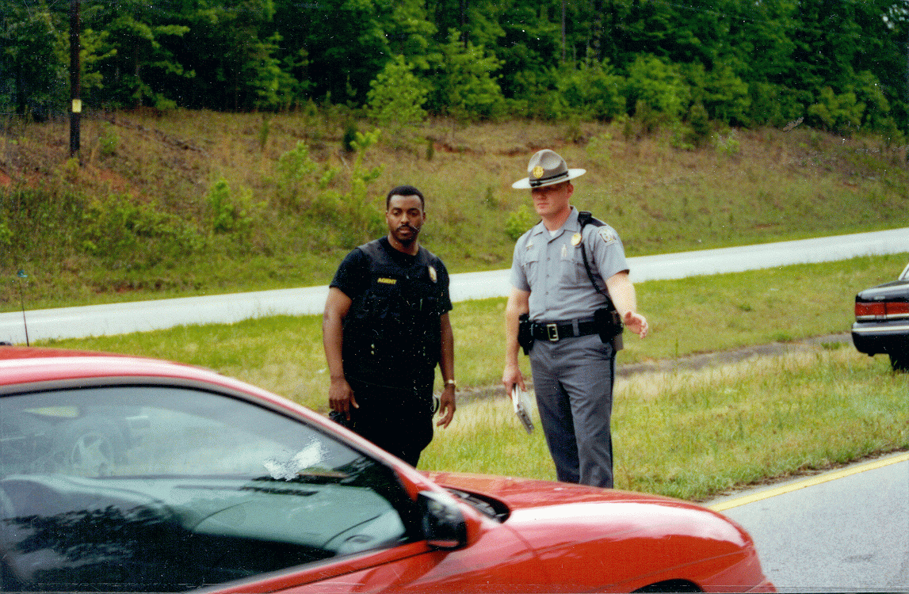
SCDPPPS Community Policing Project – Probation & Parole Agents worked with the State Highway Patrol to conduct warrant sweeps at traffic check points.

** Continuous review of our arrest techniques and policies and providing additional training in this area;

** Cooperating with other law enforcement agencies concerning the sharing of appropriate information and the apprehension of offenders who violate the order of the Courts of General Sessions or the Board of Parole and Pardons. Over 150 warrants have been served on absconded offenders in this joint venture since 1999.

These initiatives are designed to focus on fostering quality as a method for achieving a successful work environment, improving efficiency, and enhancing customer relations.

By focusing on quality, we have been more efficient in complying with legislative mandates. We are the only state agency mandated by the General Assembly to provide community supervision of criminal offenders placed on probation by the Court, released from prison by the Board of Paroles and Pardons, or released through early release programs. The majority of all criminal offenders (36,888) under the state=s jurisdiction are under the supervision of our Department. As the number of criminal offenders grows, we have had to take specific measures to manage our responsibilities within our available resources. We have consolidated county operations to eliminate certain supervisory positions, sought alternative and less costly methods of extraditing offenders, and created unique partnerships with other agencies to work on issues of common interest. These partnerships allow for the best utilization of resources in a variety of circumstances. Examples of our present efforts include:

** Working in partnership with the U.S. Marshal=s Service on the identification and return of absconded offenders;

** Continued development of a seamless criminal offender substance abuse strategy with the S.C. Department of Corrections (SCDC), and the S.C. Department of Alcohol, and Other Drug Abuse Services (SCDAODAS);

** Partnering with the Department of Juvenile Justice and the Aiken County Detention Center to allow for the cooperative use of our Electronic Monitoring technology;

** Coordinating efforts with the U.S. Immigration and Naturalization Service and SCDC to identify illegal aliens;

** Participation in a Drug Court program with the Judges and Solicitor of the Eleventh Circuit;

** Coordinating with the Department of Social Services (DSS) to identify fleeing felons;

** Utilizing a private sector company to accomplish long distance extraditions;

** Continuing to work cooperatively with SCDC and the Budget and Control Board=s Office of Information Resources to expand the parole video conferencing system.

The Department is also mandated to operate a variety of community supervision programs for criminal offenders. Some of these programs include restitution centers, a community control center, and public service employment. In fiscal year 1999-00, 788,701 hours of public service employment were performed by offenders. We have also recognized the many challenges raised by the illegal use of drugs among offenders and the need for treatment within the offender population. Based on this recognition, we implemented a pilot project to determine the incidence of illegal drug use among probationers leaving court and Youthful Offenders leaving a correctional facility. The results of the pilot project demonstrated the need to implement a zero-tolerance policy which has now been implemented statewide.

Mission

The Department of Probation, Parole and Pardon Services strives ...

To appropriately supervise those offenders who are placed under the Department=s jurisdiction;

To investigate cases, assemble information, and make sound recommendations for use by the courts and Board of Paroles and Pardons, to assist them in there decision-making processes;

To promote public safety;

To accomplish this mission, The Department of Probation, Parole and Pardon Services will:

Develop, operate and evaluate a variety of community sanctions and supervision capacities for offenders under the Department=s jurisdiction;

Provide assistance to victims to include keeping them informed of the status of their respective cases;

Enhance the public=s awareness of the Department=s mission, vision and policies;

Develop, implement and review policies and procedures to ensure that the aforesaid is properly accomplished.

Leadership System

The Director is actively and personally involved with the senior managers of the Department in setting directions, developing and maintaining an effective, performance-oriented leadership system for Probation, Parole and Pardon Services. Those systems and components are illustrated below:

Management Meeting and Communications System

- Director conducts routine meetings with his Executive Management Team (EMT)

- Chief of Staff=s Executive Division Staff Meetings; monthly status meetings with Public Information, Grants Administration, Research and Evaluations, Internal Audit, Legislative Liaison, Quality Office, & Victim=s Services. Progress is measured through minutes and tracking activity on action plans and reviewing performance measures.

- Deputy Director of Field Services has monthly meetings with Central Office staff, monthly meetings with Regional Directors, and quarterly meetings with County Agents In Charge to identify issues or processes to improve and review.

- Deputy Director of Administration has monthly individual and group meetings with Divisional Managers.

Director Leadership Activities:

- The Director conducted approximately 380 customer ( internal and external) contacts per month during FY 99-00 to learn of customer concerns and issues regarding department services.

- The Director participated in Bike Week, hurricane and other deployments during the year.

- The Director participated in the statewide unveiling tour of the absconder unit.

- Mr. Benjamin is the recipient of the Compleat Lawyer Award given by the University of South Carolina School of Law.

- Mr. Benjamin was awarded the Junius W. Williams Award in recognition of accomplishments in the legal profession and continuous commitment to the community and society by the National Black Attorneys - Young Lawyers Division.

- Mr. Benjamin is the co-publisher of an article on Domestic Violence in the American Bar Association publication The Affiliate, Vol. 25, Number 4, March/April 2000.

- The Director participated in the Sisters of Charity Foundation of South Carolina, Task Force on Fatherhood Policy Project Office.

- The Director participated, sponsored and was the key note speaker for the Stay in School program held for intercity children.

- The Director participated, sponsored and was the key note speaker at the opening ceremony for City Year.

Leadership, and Other Initiatives

- Deputy Director for Field Services has completed and the Deputy Director for Administration is currently are attending the S.C. Executive Institute

- The Department=s Executive Coordinator has been selected to attend the Governor=s Excell Leadership program. This is a leadership school for middle manager=s.

- Leadership curriculum developed; training ongoing.

- Quality Director assists other agencies in their continuous improvement endeavors. Serves as Facilitator for multi agency team charged with developing AOne Stop Shopping= for the issue of business licenses. Serving as Vice Chair, SC State Government Improvement Network, and on steering committee for SC Quality Forum, and presently serves as a National Malcolm Baldrige Examiner.

Customer Focus and Satisfaction

The Department has identified its customers as part of the Strategic Planning Process and has provided increased focus towards enhancing systems for measuring customer expectations and levels of satisfaction with agency services.

Sponsorship and Involvement with Community

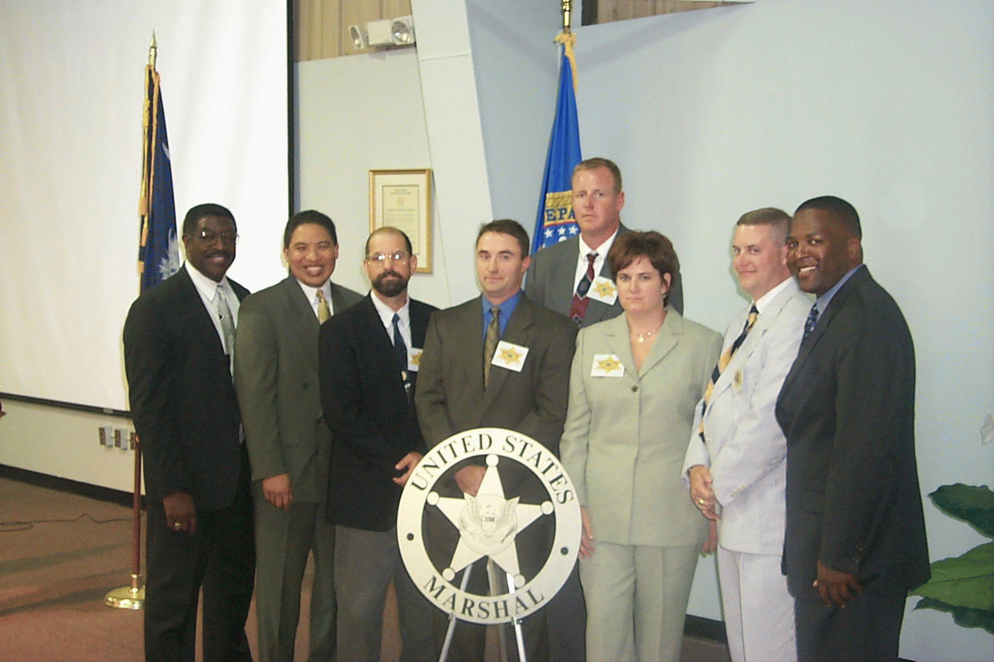
Agents sworn in as Special Deputies of the U.S. Marshall’s Service for “Operation Intercept”
- Partnership with the U.S. Marshal=s Service to identify and return absconded offenders results in significant savings of time, effort and resources allowing Probation and Parole Agents to allocate more time to offender supervision.

- Staff participated in providing safety and security during ABiker Week@ in Myrtle Beach, SC, and other deployments as called on by the Governor.

- Staff participated in evacuation and relief efforts for Hurricane Floyd.

- Developing a criminal offender substance abuse strategy with SCDC and SCDAODAS.
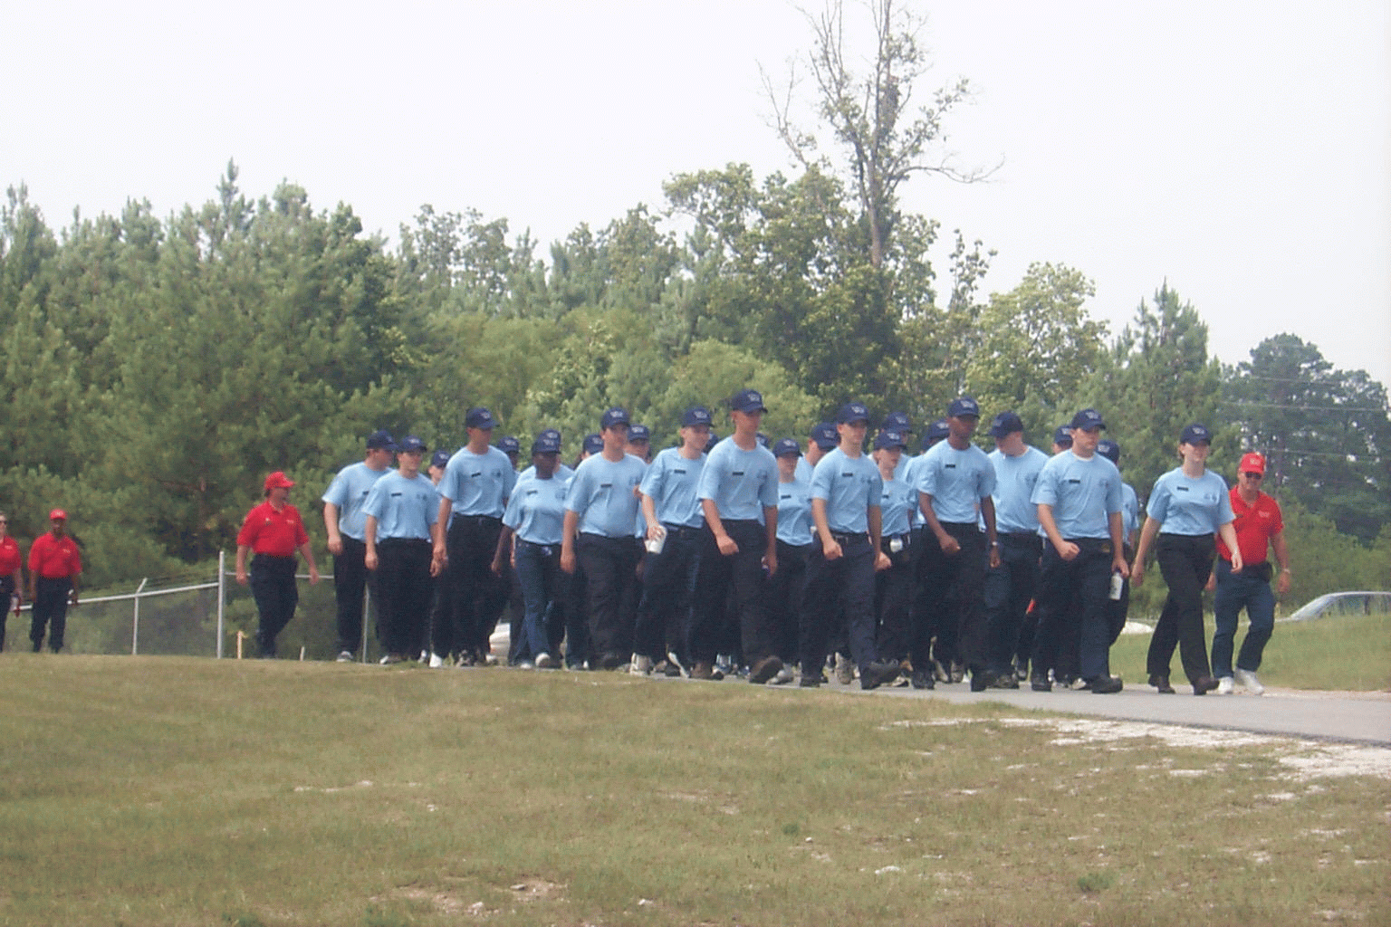
Cadets march in formation as part of their daily drill
- Coordinating certain efforts and identifying fleeing felons with the Department of Social Services.

- SCDPPPS and S.C. Department of Juvenile Justice collaborated to provide for the cooperative use of the Department=s Electronic Monitoring technology with juvenile offenders.

- The Department supported the Police Cadet Academy an effort supported and encouraged by the Director.

- The Department sponsors the Lunch Buddies program at A.C. Moore Elementry School. This is a mentoring program for at need children.

- The Department sponsors the Table Talkers program which provides elementry school children from repressed neighborhoods are provided career oriented professional mentorship.

External Customers Satisfaction

- Office of Victim Services (OVS) significantly increased victim contacts over the past 10 years. (See Chart)

- The OVS has not received a formal complaint to date, referred through the Victim=s Ombudsman Office (Office of the Governor)

- The Office of Victim Services is in the process of developing a customer service questionnaire to ensure that our customers needs are being serviced.

- Skill training requirements and elective training requirements determined by Agency mission, advice to staff, management, judges, lawyers, and offenders, determined by needs assessments.

- Standards require that all customer complaints receive prompt and immediate responses. Implementation of additional measurements will identify any failure to resolve customer complaints effectively and promptly.

Internal Customers Satisfaction
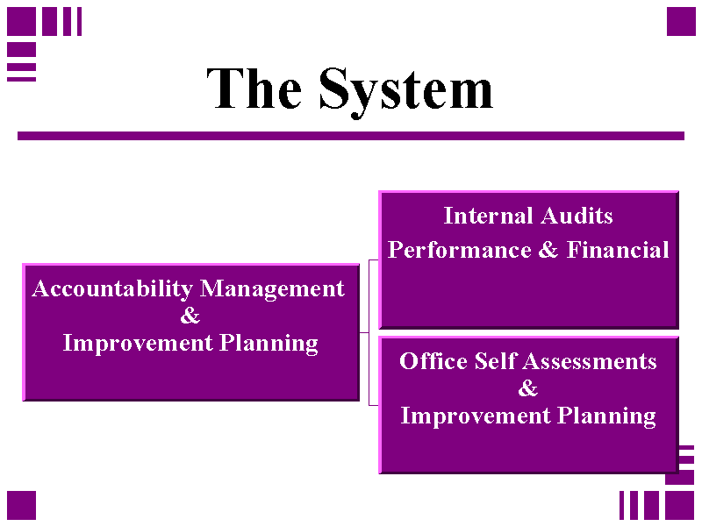

- The Internal Quality Audit process employs self assessment methods, as well as customer focus groups, as a means of gathering data to assist managers to pro-actively address issues in work performance, problem and cause analysis, and customer satisfaction with the audit process.

- The Office of Internal Audit designed, and implemented, a comprehensive customer satisfaction survey to be used in conjunction with service delivery. Results are tracked, trended, and published to all customers via agency local area network.
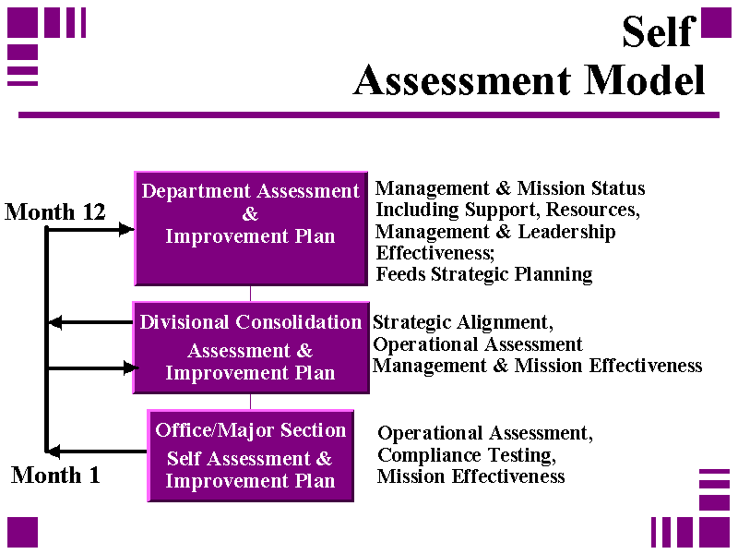

- A main focus of the Office of Internal Audit is to identify innovations and Best Practices that will result in improved quality of services;

- Customer Commitment Pledge developed and published to all customers. Results of surveys are compared against these standards as well as benchmarked against industry standards and other government agencies.

The Customer Wheel

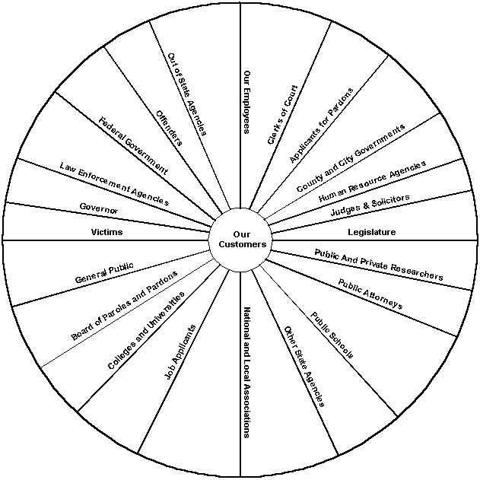
The Department values all of its customers. No one customer is more important than another as represented by the spokes of the wheel.

Other Performance Excellence Criteria

Strategic Planning

- Department maintains an active strategic plan. Components reviewed and approved by the Department=s Quality Council and Executive Management Team on an ongoing basis.

- The Department=s strategic plan was revised during fiscal year 1999-00. The plan is 90% deployed throughout the Department, with 100% deployment to the divisional manager level in two of the largest division (Field Services, Administration).

Quality Infrastructure

- Department Quality Council, representing a cross section of department, meets monthly to review improvement suggestions and recommend programs and training;

- Maintains five Regional Quality Councils representing a cross section of regional staff and managers, each addressing regional issues and quality improvement suggestions;

- Maintains a Central Office Quality Council, representing divisional staff and managers addressing central office issues and quality improvement suggestions;

- Regional and Central Office Quality Councils linkage established to Departmental Quality Council;

- Representatives of each Regional and the Central Office Quality Council attend Departmental Council Meetings.

- 117 employee suggestions were reviewed by the Quality Councils.

- Prioritization matrices being utilized to assist with promotion selection and employee hiring; also used to select regional and central office award recipients.

- The Department is a strong supporter of the S.C. State Government Improvement Network with the largest individual agency membership in state government.

Information and Analysis
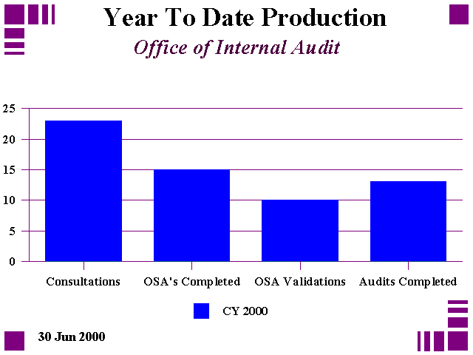
Quality Audit Services

- Internal Quality Audit Section completed six performance audits during the initial six months of operations. Audits results reviewed by Executive Management Team, Quality Director and affected staff.

- 84 % Customer Satisfaction with audit functions, as indicated on customer feedback surveys.

Human Resource Focus

The Office of Staff Development and Training (SDT) conducted a survey as part of their self assessment. This survey asked several questions about how valuable the training offered by SDT is in the everyday duties of the trainees. The following results were found:

- SDT training is Valuable - 83.4% agree or strongly agree

- SDT technical training can be applied - 85.5% agree or strongly agree

- Supervisor supports technical training - 86.4% agree or strongly agree

- Supervisor supports supervisor/personal/professional training - 73.1% agree or strongly agree

- Supervisor expects trainees to apply technical training - 83.9% agree or strongly agree

- The Office of Staff Development and Training uses the DACUM (Develop A Curriculum) process to identify desired employee skills. In this process, a panel of technically proficient staff, including designated instructors, develop an occupational definition and then analyzes the job related tasks and duties resulting in an occupational panel chart. The results from the DACUM process are then used for training program development, evaluation of position descriptions, American with Disabilities Act compliance, and personnel interviewing and selection.

- Over 50 classroom slots in Department=s training offered to other agencies free of charge;

- Modeled use of Multi-Agency trainers to conduct classes to promote inter-agency cooperation, growth and learning;

- Staff frequently speak at civic group functions , schools and colleges to promote the agency mission and provide public awareness and understanding;

Process Management

Policy and Procedures Management System

- Immediate access to on-line Departmental policies and procedures;

- Immediate access to policy and procedures updates;

- All employees have On-line access to submit suggestions for improvements;

- Policy and Procedure Committee, representing cross section of employees, reviews all policies and procedures and all employee suggestions for improvement submitted.

- Linkage to Departmental Quality Council.

Key Results Areas
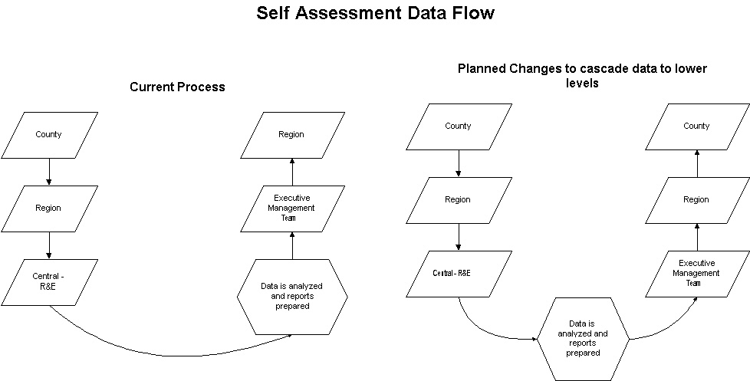

Area: Offender Supervision

Program Cost: $38,430,441

Program Goal: To appropriately supervise those offenders who are placed under the Department=s jurisdiction and to promote public safety.

Program Objective(s):

- To engage in selective interventions that are calculated to reduce the likelihood of future criminal conduct by the adult criminal offenders placed under our jurisdiction.

- To appropriately address all violations of the conditions of supervision that may be committed by offenders under our jurisdiction.

- To make the best utilization of our available resources in meeting the challenges presented by the supervision of adult criminal offenders.

Key Results:

Inputs:

Active Offenders (7/1/99) 36,728
Admissions (FY 99-00) 17,496
Active Offenders (6/30/00) 36,888
Number of Probation and Parole Agents (6/30/00) 633

Outputs:

*Number of Offender Drug Tests Administered 325,056
Active Public Service Employment Accounts
during FY 99-00 11,927

Outcomes:

Offender Closures (FY 99-00) 17,336
Successfully Completed Supervision 11,912
Supervision Revoked 5,424

*Number of Offenders Drug Tested 30,767
Number of Offenders Testing Positive 12,307

*During the reporting period the Department initiated baseline testing for all new offenders at the onset of their supervision. In addition to baseline testing, individual offenders are drug tested "for cause" and randomly. During the testing session or episode, the offender may be tested for one or more drugs. Each "drug panel" utilized equals a drug test conducted. This results in multiple test being conducted on a single offender. During the reporting period 325,056Adrug panels@ , or tests were conducted on 30,767 offenders. Of the offenders tested during the year, 12,307 tested positive for one or more drugs.

Number of Public Service Employment Hours
Completed by Offenders (FY 99-00) 788,701

Number of Violation Hearings Conducted 10,753

Efficiency:
- During FY 99-00 the number of Drug Tests conducted increased 65,042 over the previous fiscal year

Successful Closure:

- Offender has meet all terms of supervision.

- Offender has made payment of all restitution and or fines ordered.

- Offender has no new convictions.

Unsuccessful Closure:

- Offender has violated conditions of supervision.

- Offender has failed to pay restitution and or fines as ordered.

- Offender has absconded.

- Offender has a new offense.
Area: Parole and Pardon Operations

Program Cost: $1,364,766

Program Goal: To prepare cases, assemble information, and make sound recommendations for use by the Board of Paroles and Pardons, to assist them in their decision making process.

Program Objective(s):

1. To deliver timely and accurate information to the board.

- To notify victim, sheriffs, solicitors, judges, and inmates of upcoming parole and pardon hearings.

- To prepare release certificates for adult and Youthful Offender Act (YOA) parolees, supervised furlough, and community supervision offenders and complete the release of these certificates.

- To provide administrative review of information and prepare documents on offenders eligible for early release and community supervision programs.

- To schedule and staff all parole, pardon, and adult revocation and Youthful Offender Act revocation hearings.

Key Results:

Inputs:

Inmates eligible for parole 9,580 (estimate)

Outputs:

Number of parole and pardon case summaries prepared
(including waivers) 8,323

Number of hearing days scheduled and staffed 77
Number of parole and pardon notifications 51,978
(Notices sent to Victims, Concerned Citizens, Judges, Solicitors,
Law Enforcement, and Inmates. 70% of the notices are to Victims and
Concerned Citizens)

Outcomes:

Number of offenders paroled or released to a community

supervision program 3,073

Number of offenders released to Supervised Furlough II-A 546

Efficiency:

Concurrence rate of Parole Board with the findings/recommendations of Parole Examiners

Area: Residential Services

Program Cost: $3,312,020

Program Goal: To appropriately supervise those offenders placed in the Department=s statutorily created Restitution Centers and Community Control Center and to promote public safety.

Program Objectives:

  - To require offenders to be gainfully employed.

  - To distribute the monies earned by offenders in this program to victims who are owed restitution, and to distribute monies to others consistent with court orders (fines, child support, etc.).

  - To provide a controlled, structured, and regimented environment for adult criminal offenders who are placed in the program.

  - To provide offenders who are placed in the program with intensive and highly focused interventions that are intended to reduce the likelihood of future criminal conduct.

Key Results:

Inputs: | Columbia | Spartanburg | Charleston | Control Center | Total
Capacity of Center | 60 | 64 | 48 | 48 | 220
Offender Population on 7/1/99 | 58 | 59 | 30 | 48 | 195
Offender Population on 6/30/00 | 55 | 60 | 28 | 48 | 191
Total Number of Admissions (FY 99-00) | 185 | 223 | 141 | 152 | 701

Outputs: | Columbia | Spartanburg | Charleston | Control Center | Total
Total Offenders Discharged (FY99-00) | 178 | 222 | 143 | 102 | 645
Total Wages Earned | $628,775 | $666,583 | $521,466 | Note 1 | $1,816,824
Intervention Hrs. Delivered | Note 2 | Note 2 | Note 2 | 168,252 | 168,252

Outcomes: | Columbia | Spartanburg | Charleston | Control Center | Total
Victim Restitution Paid | $270,416 | $298,633 | $223,624 | Note 1 | $792,673
Other Monetary Obligations Paid | $264,269 | $284,396 | $228,037 | Note 1 | $776,702
% of Bed days Utilized | 90.0% | 93.0% | 79.0% | 85.0% | 86.75%
Successful program completions | 138 | 136 | 88 | 102 | 464
Unsuccessful program discharges | 40 | 86 | 55 | 40 | 221

Efficiency: | Columbia | Spartanburg | Charleston | Control Center | Total
% of successful program completions | 77.5% | 61.3% | 61.5% | 71.8% | 67.7%
Note 1: Offenders in the Control Center program cannot have jobs. The purpose of the program is to provide offenders with life skill training.
Note 2: Offenders in the Restitution Center program are required to have jobs. The purpose of the program is to collect victim restitution.

Area: Parole and Pardon Board Operations

Program Cost: $526,734

Program Goal: To consider statutorily eligible inmates for parole and statutorily eligible individuals who apply for pardons.

Program Objective(s):

1. To review information in advance of parole and pardon hearings.

2. To conduct hearings.

3. To make decisions on parole or pardon on those cases presented.

Performance Measures:

Inputs:

Number of pardon cases heard 247
Number of parole special consideration cases 175
Number of parole requests for rehearing 258
Number of parole violations presented 484

Outcomes:

Number of pardons granted 133
Number of parole rehearing requests granted 12
Number of parole violations continued 32

Efficiency:

Board cost per case review. $65.99

Area: Central Office -- Victim Services Program

Program Goal: To keep victims informed about the status of offenders under the Department=s supervision and those who are considered for a parole or pardon by the Parole Board.

Program Objective(s):

(1) To notify victims of parole or pardon hearings.

(2) To notify victims of any post-sentence hearings initiated by the Department.

(3) To render assistance to victims attending parole or pardon hearings.

(4) To notify victims, upon request, of the results of a specific parole or pardon hearing.

- To respond to victims= telephone calls in a timely manner.

(6) To disseminate accurate information to victims.

Performance Measures:

Inputs:

Last year Victims Services received 1,394 victim notification requests, 4,073 telephone calls and 12,243 letters of opposition.

Outputs:

Last year, 2,174 victims attended the parole hearings. Also, 888 victims who could not attend the hearing were notified of the results of the hearing.

Quality:

The Office of Victim Services has not received any complaints regarding the level or quality of services provided.
Efficiency:

Notifications by Type

 | FY 1994-95 to FY 1998-99 | FY 1999-00
Notice of YOA Release | 1,967 | 411
Result of Parole Hearing | 2,452 | 888
Notice to Victims, Inmate waived parole | 358 | 38,996

Note: Effective August 2, 1999, the Notification Section became a part of the Office of Victim Services.

