ANNUAL
ACCOUNTABILITY
REPORT

Fiscal Year 1999-2000

Public Service Activities
Clemson University

The Many Faces and Places of Public Service Activities
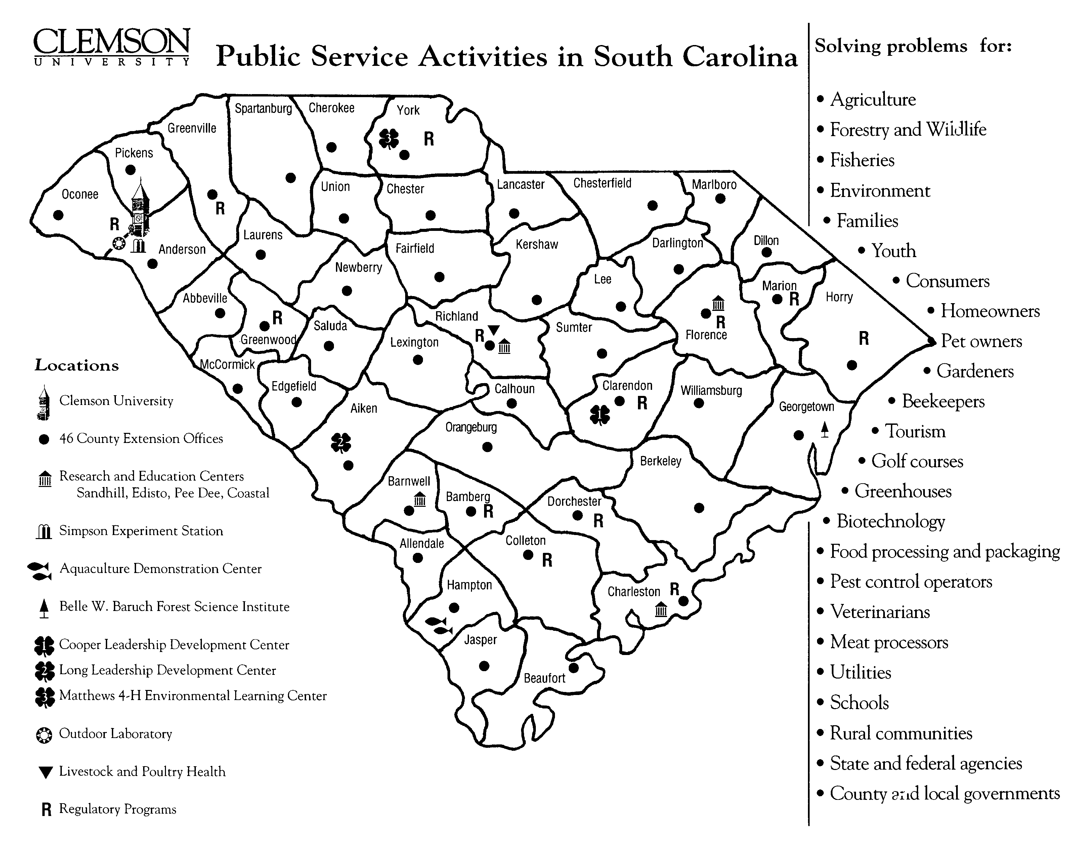
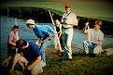
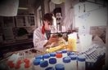
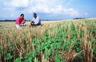

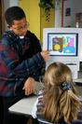
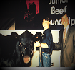


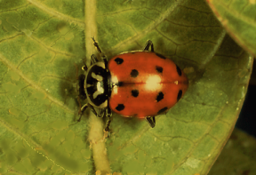

Table of Contents

ANNUAL ACCOUNTABILITY REPORT FISCAL YEAR 1999-2000 1
Public Service Activities in South Carolina (map) 2
Table of Contents 3
Major Divisions of Public Service Activities 4
Public Service Activities Flow Chart 4
Transmittal Message 5
Executive Summary 6
Public Service Activities Mission Statement 9
Leadership System 9
Customer Focus and Satisfaction 10
other performance excellence criteria 11
Public Service Activities Programs 12
Agriculture and Forestry Research 12
Clemson University Cooperative Extension Service 14
Regulatory and Public Service Programs. 19
Livestock-Poultry Health Programs . 24

Major Divisions of Public Service Activities
Regulatory & Public Service
Livestock-Poultry Health
Agriculture & Forestry Research
Cooperative Extension Service
Clemson University
Public Service Activities
Public Service Activities Flow Chart within Clemson University
Transmittal Message

We are very pleased to submit the 1999 - 2000 Annual Accountability Report for public service activities at Clemson University.

Clemson was founded in 1889 as a land grant institution with the three-pronged mission of teaching, research, and Extension. Research and Extension are included under public service activities, as well as Livestock-Poultry Health Programs, and Regulatory and Public Service Programs.

The mission and priority areas of public service activities at Clemson was developed through extensive discussions with senior staff members and administrators of the university's public service programs, in conjunction with the Vice President for Public Service and Agriculture.

We in the division of Public Service Activities are serious about accountability. Our information management system has been recognized nationally as a model for all land-grant universities. But we are not satisfied. We are constantly refining our system and processes to better manage our resources and inform our stakeholders about what we do. Our development of programs in both the Extension Service and in Agriculture and Forestry Research will better utilize our faculty and their expertise to solve the many problems our state and nation must face in the coming years. This new approach, along with our accountability system and a yet to be developed performance measurement system, will be a true management system for our division.

For more information, please contact John T. Clemens at the address listed below.

Sincerely,

John W. Kelly
Vice President for Public Service and Agriculture

For questions concerning this report, please contact:
John T. Clemens
Manager of Information Services
Clemson University
Room 100 McAdams Hall
Clemson, SC 29634
Phone: 864-656-3216 Fax: 864-656-2629 E-mail: clemens@clemson.edu
Executive Summary
Public Service Activities (PSA) at Clemson University touch the lives of virtually every South Carolinian. From safe food handling education to 4-H youth organizations, the impact on the quality of life is formidable when viewed from a family’s perspective. The professionals who carry out the mandate of Thomas Green Clemson are committed to the research, teaching, and public service that make Clemson University the champion of knowledge.

These activities cover a broad spectrum of service to the citizens of South Carolina. The primary PSA organizations at Clemson University are:
- Agriculture and Forestry Research
- Cooperative Extension Service
- Regulatory and Public Service Programs
- Livestock-Poultry Health Programs

These organizations work closely together, with daily scientific and staff interaction. With the exception of the Livestock-Poultry Health Programs, which is located in Columbia, the PSA organizations are within close proximity of each other on the main campus and at the four Research and Education Centers (RECs) around the state. In addition, there is an extensive network of Cooperative Extension offices around the state. Four other areas within the PSA division are not individually reflected in this report but are an integral part of the overall responsibilities of PSA. These areas are the Bioengineering Alliance, State Energy Program, Agromedicine, and the Strom Thurmond Institute. Their responsibilities and reporting are grouped as part of the other divisions’ data.

Working relationships are maintained with other state agencies, such as the Department of Commerce, Department of Health and Environmental Control, Department of Agriculture, Technical Education colleges, Forestry Commission, Department of Natural Resources, as well as with local and federal agencies.

Our community and economic development programs are working hand-in-hand with chambers of commerce, with development boards, and with industries. Industry outreach is our answer to the need for more and better jobs. The youth of South Carolina are a priority of Public Service Activities. 4-H and FFA reach into every community with education and leadership training. We recognize the importance of giving our youth the tools they need to make good decisions in a time when choices and consequences are many.

Public Service Activities at Clemson University are defined by our constituency, the people of this state who tell us what they need to improve their lives and to reach their goals. Clemson PSA brings research-based knowledge to them so that they may live in a safer environment armed with accurate information. Traditionally, the Cooperative Extension Service has been our messenger of scientifically-based information. We are strengthening this service through technology. The regulatory programs are stronger than ever as the demand for interpretation and compliance takes on a greater role in monitoring agriculture practices.
Thus, Public Service Activities at Clemson University welcomes the opportunity to address the state’s changing needs. Exciting solutions are being developed at Clemson to help South Carolinians face the challenges of today and prepare for the future. In order to address the state’s changing needs, we have grouped our efforts into five priority areas:

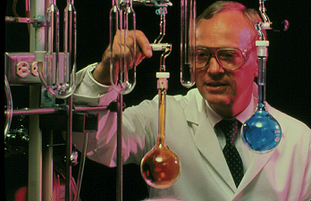Agrisystems Productivity and Profitability
Clemson researchers, Extension specialists, and regulatory agents are working with the state’s agricultural and forestry producers to increase productivity and profitability so South Carolinians can compete successfully in an increasingly global economy. This includes financial planning, new technologies and agricultural systems, and management programs for limited-resource farmers. Other efforts include using biotechnology to develop crops that are naturally resistant to disease and insect damage for higher yields and better quality. In addition, alternative construction materials, such as bamboo and laminated wooden beams, are being developed to improve the productivity and profitability of the forestry industry. Other efforts include research projects to identify environmentally friendly and economically viable production methods and waste management strategies for livestock, food, fiber, and forestry producers.

Economic and Community Development
Thomas Green Clemson’s gift to the state of South Carolina was intended to help the state’s citizens improve the quality of their lives. That legacy continues through Palmetto Leadership, a program that prepares local community leaders to bring jobs, new businesses, and a more appealing downtown to rural communities throughout the state. In addition, economic development alternatives are identified and pursued in partnership with the S.C. Department of Commerce and the S.C. Downtown Development Association.

The Strom Thurmond Institute at Clemson provides scientifically based information to help local, county, and state leaders in strategic planning and policymaking. And Clemson economists, sociologists, and urban planners are working with local communities to develop transportation systems that match workers in rural areas with jobs in urban areas.
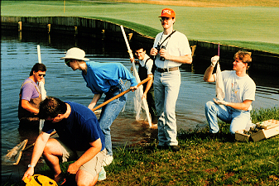Environmental Conservation
Protecting and enhancing South Carolina’s natural resources are vitally important for the quality of life in our state, as well as for future economic development potential. To this end, Clemson researchers, Extension agents, and regulatory personnel are working with partners around the state to enhance our forests and wildlife populations and to ensure the safe and effective use of fertilizers and pesticides.

Programs have been developed to recycle waste for the hotel industry, recycle water for commercial plant nurseries, and recycle empty pesticide containers for farmers and pest control operators. The Master Waste Educator program also teaches community volunteers how to dispose of solid waste through recycling.

Water quality continues to be assessed for the livestock industry and the state’s golf courses to ensure minimal environmental impact. In addition, management strategies are being developed to enhance the economic growth of agriculture and forestry, while minimizing their environmental impact.
Food Safety and Nutrition
The United States has the safest, most affordable and most reliable food supply in the world, largely because of the contributions of land grant universities such as Clemson. Clemson regulatory agents work closely with South Carolina producers to ensure that the state’s meat, poultry and plant crops meet all federal and export safety requirements. Other food safety activities include profiling ongoing training in safe food handling practices for individuals, restaurants and commercial food processors to prevent outbreaks of food-borne illnesses.

In addition, the Expanded Food and Nutrition Education Program (EFNEP) teaches low-income individuals from preschool to senior citizens how to prevent health problems through better diet and nutrition. And lunchroom personnel in schools and child-care facilities are being trained in nutrition and safe food-handling practices to ensure that healthful food is served to our children.

Plant scientists at Clemson are also studying the ingredients in plants that can be used against cancer and other diseases. Plants being investigated include ginkgo, Saint John’s wort, goldenseal, raspberry and Echinacea.

Youth Development
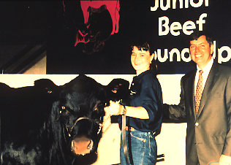Strengthening the support for families and young people is becoming a major focus for South Carolina, making ongoing family and youth development programs conducted by Clemson increasingly important. The 4-H camps and local programs play a major role in teaching youth and adults necessary life skills, such as resolving conflict and becoming informed consumers. Families are also learning skills to help them focus on the their strengths and learn to cope with changes and transitions in their lives through 4-H and Extension programs.

Elementary and middle school children are learning an appreciation for our state’s natural resources through Teaching Kids About The Environment, a joint project with state, civic, and corporate partners conducted at the 4-H leadership centers. And first-time juvenile offenders are being given a second chance through the Outdoor Youth Development Program provided by the 4-H leadership centers in conjunction with the S. C. Department of Juvenile Justice.

Public Service Activities Mission Statement

Mission: Meet the agricultural, family and youth, environmental and regulatory needs of the citizens of South Carolina

Priority Areas: Agricultural productivity and profitability
Economic and community development
Environmental conservation
Food safety and nutrition
Youth development

Each division within Public Service Activities has established a clearly defined mission statement that reflects its overall purpose and how it must interact with the other divisions to fulfill the mission of Public Service Activities. Each division relies upon the others for a specific purpose to better solve the needs of the State. Agriculture and Forestry Research conducts the research to address the needs that have been proposed by our stakeholders. The Extension Service works with our stakeholders to identify their needs or problems and then ensures that the solution(s) are communicated and practices adopted. Regulatory and Public Service Programs and Livestock-Poultry Health Programs monitor and, in some cases, oversee industry practices to ensure compliance with state, federal, and international mandates. This system is highly efficient and productive in that it addresses all aspects of problem solving and implementation.

Leadership System
The structure of Clemson Public Service Activities follows the basic structure of most organizations. We have four main divisions reporting directly to the Vice President for Agriculture and Public Service. This organization has become more diversified and proactive than in years past. Although much of its activities still center around agriculture-related problems, public demand and socioeconomic needs have directed our expertise in other areas such as the environment and youth development. These new directions are a direct result of our “listening” to our stakeholders — the citizens of South Carolina.

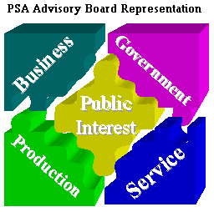Although each division of Public Service Activities uses very distinct methods of working with their stakeholders and customers, Public Service Activities has an overall Advisory Board with representation from areas that will better help us direct and implement programs to benefit South Carolina. This board is charged with the following:
Government
Business

- Review objectives and planning documents
- Provide advice and counsel on the development and identification of new program areas and centers of excellence
- Be a communications bridge with other cultural, social, and professional leaders of the community, state, region, and nation
- Assist in development of increased resources and facilities
- Promote, within and outside of their own professional area, a strong image of research accomplishments

Unlike many agencies, Public Service Activities has a division whose sole purpose is to benefit/serve the citizens of South Carolina — the Extension Service. Much of what we do in the other divisions comes from our stakeholders working with Extension agents. But the process is much more formal than that. The chart to the right shows what goes into making a successful Extension program. Extension programs are fully studied before implementation, first learning the local issues, then finding the knowledge and skills necessary to address the issues, and, finally, deciding how best to establish a program. It is because of this process that Extension has been as successful as it has in meeting the needs of South Carolina and its citizens.
Decision
Making
Skill
Development
Elements of a Successful Extension Program
Local
Development
Issues
Increase
Knowledge
Base

Research uses a somewhat different method to evaluate needs and direct research activities where needed. Unlike the Extension Service whose focus is on the dissemination of knowledge, Agriculture and Forestry Research is in the business of developing knowledge through creative research. But in order for this process to work properly, both divisions must work closely together to understand the needs of stakeholders. To ensure that research is working on issues it should be, a thorough review is required to approve all research projects. This starts by setting up programs for research that fit the goals of PSA. Each program is developed by seeking input from faculty and stakeholders then assuring that the program meets three basic criteria: relevance, capacity, and impact. If the program does not meet these criteria, it does not get funded.

Customer Focus and Satisfaction
Step 1
Stakeholder contacts PSA Representative
Step 2
Research takes place
Step 3
Extension Service or Regulatory division delivers communicate results and regulate practices
Step 4
Results of research are studied
Customer focus and satisfaction is an essential component of Public Service Activities. If not, we would not exist. Our organization may be one of the best examples in the state of how to work with customers/ stakeholders. PSA was organized to serve people by first working with them to learn about the problems, then researching the problem to find solutions and then getting this information (knowledge) to the people who need it. Agriculture and Forestry Research, in cooperation with other state agencies and divisions, develops the knowledge and passes this information on to the Extension Service. The Extension Service uses this knowledge to solve the problem and also feeds the state’s needs back to the research division. The system has worked well for years and should continue to
work even better with a more focused, goal-oriented approach
to solving problems.

With this link to the public, we are able to gather feedback about how the public is accepting our practices and whether or not we need to direct our activities to other areas. Therefore, many of our performance indicators are from the Extension Service operations. Performance indicators on research are ambiguous and, in many cases, not reflective of the hours and work performed.

Other Performance Excellence Criteria
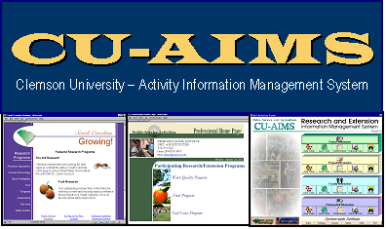Various forms of accountability reporting have been a part of our organization for a number of years now. We were one of the first land grant universities in the country to implement an organization-wide accountability system. Our system, called CU-AIMS, links every aspect of the organization’s focus to a centralized data collections system. This system disseminates data to our stakeholders — the public and PSA faculty, staff, and administrators — via three distinct products: the “Professional Home Page” for faculty and staff, “South Carolina Growing!” for the public and industry, and “Information Management System” for PSA administration. We believe that if we share as much as possible about what our organization does, then our faculty will perform better, the public will use the results of our research more effectively, industry will become more productive, and our administrators can make better decisions to direct resources and solve problems.

We are also realigning our operations within the two PSA divisions of Extension and Research to better meet these needs. These two divisions are in the process of grouping related activities into programs. Much like putting pieces of a puzzle together, these programs will address specific needs/problems of the state, nation, and world, thereby allowing us to bring expertise and resources together to address these needs/problems. We can then better track and monitor our resources and better identify our accomplishments. It also will encourage our Extension Service and Research scientists to work better together and thus improve communication and the delivery of results. In addition, we will be implementing a new performance measurement system called productivity indexing. This process will allow us to decide on specific measurement criteria, give those criteria weighted scores based upon their importance, establish benchmarks and goals, and ultimately score our results. Over a period of time, we can then plot the results of these scores and compare them with other programs within the organization. This process would result in our being able to identify areas that are either performing well and reward them appropriately or those areas that need help in accomplishing their goals. In the near future, much of our accountability systems within Public Service Activities will be based upon this new approach. See example on following page.

Program Title: Agriculture and Forestry Research

Mission: Develop biological, physical, and social sciences information to improve the quality of life for South Carolinians.

Program Cost: State: $23,696,843
Federal: $ 2,445,659
Earmarked:
Other: $ 2,792,987
Total: $28,635,489

Program Description: Agriculture and Forestry Research at Clemson University is part of an international network of scientists working to develop unbiased, research-based knowledge for agriculture, natural resources, and the social sciences to enhance economic development and the quality of life for all people. Clemson researchers are making break-through discoveries in plant biotechnology, food safety, ornamental horticulture, packaging science, aquaculture, and the environment, while continuing to improve production agriculture and forestry.

Agriculture and Forestry Research is in the process of moving towards a program-based reporting system. Currently, significant portions of research activities are being conducted in these research programs.

Program Objectives: • Increase the use of biotechnology to enhance specific characteristics of crop plants at the molecular level
• Expand current and emerging technologies, such as satellites and computers, to improve the productivity, profitability, and competitiveness of the state’s agriculture and forestry industries.
• Increase the growth in nutraceutical and horticultural industries.
• Explore renewable energy sources produced by crop plants.
• Identify new approaches to communicating research discoveries to producers, processors, and distributors.

Program Results:
Measuring the performance of research is difficult at best. Our best measurements of how well we are doing are generally the number of patents, licenses, and new varieties we produce. The following chart and graph reflect only a small portion of the information we are currently collecting, but they do reflect much of what we consider to be meaningful measures of productivity. As our programs become better developed, more areas of measuring productivity will be collected and reported.
Actuals
Trend Line
Actuals
Trend Line
Actuals
Trend Line

Program Title: Clemson University Cooperative Extension Service

Mission: Transfers scientifically based information to individuals, groups, and communities to help improve the quality of life.

Program Cost: State: $24,526,597
Federal: $ 7,275,578
Earmarked:
Other: $ 4,911,349
Total: $36,713,824

Program Description: Clemson Cooperative Extension implements educational programs which address critical issues and needs through: (1) state of the art technologies for program delivery; (2) a diverse, proficient and visionary staff; (3) an accessible information system; (4) effective linkages with researchers; (5) strong linkages and collaboration with other agencies and organizations both within and outside the land-grant system; and (6) an effective award and reward system that recognizes employee achievement at all levels.

Base programs of the state and the national Cooperative Extension System drive our four-year (1997-2001) statewide plan of work. The statewide plan includes broad parameters for program development by both university and county faculty. In addition, Extension advisory boards and program identification committees also provide input to the statewide plan of work. The statewide plan of work contains five PSA goals, 16 initiatives, and 70 projects, covering a variety of topics and programs that address the needs of South Carolina citizens.

Program Objectives: • Foster the improvement of agriculture, agricultural products, and related industries
• Improve the management of natural and environmental resources (including forest, wildlife, and marine)
• Strengthen the family as individuals and as a unit
• Foster the development of youth
• Enhance rural and community development
• Develop human resources (including leadership and citizenship)
• Fulfill national and/or state mandated programs

Program Results:
The Cooperative Extension Service is starting the third year of implementing a comprehensive accountability system. Last year’s data was the first year of collection and now that data has been collected for two years, the division can make realistic decisions on goals and objectives for the coming year. The following data reflects the current year’s information:

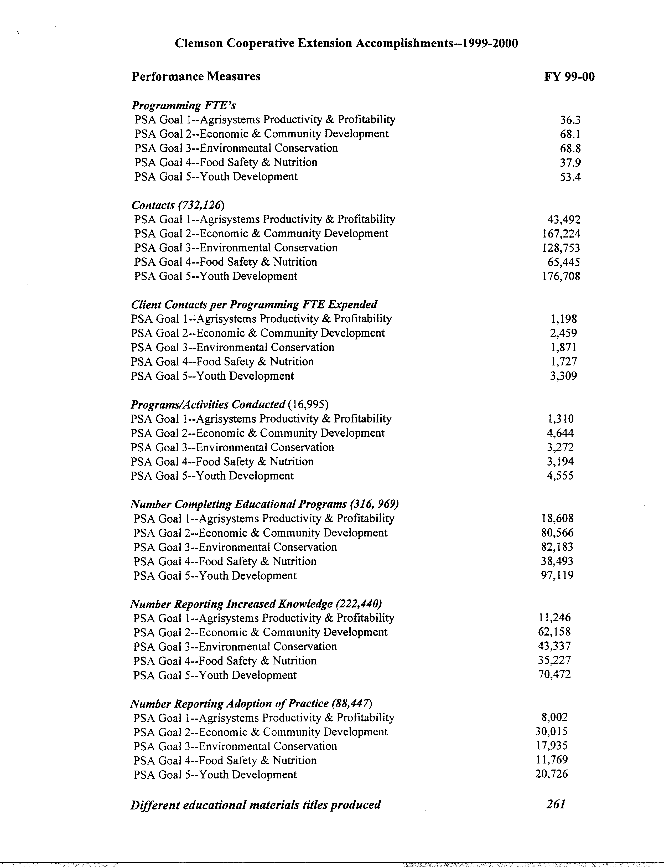

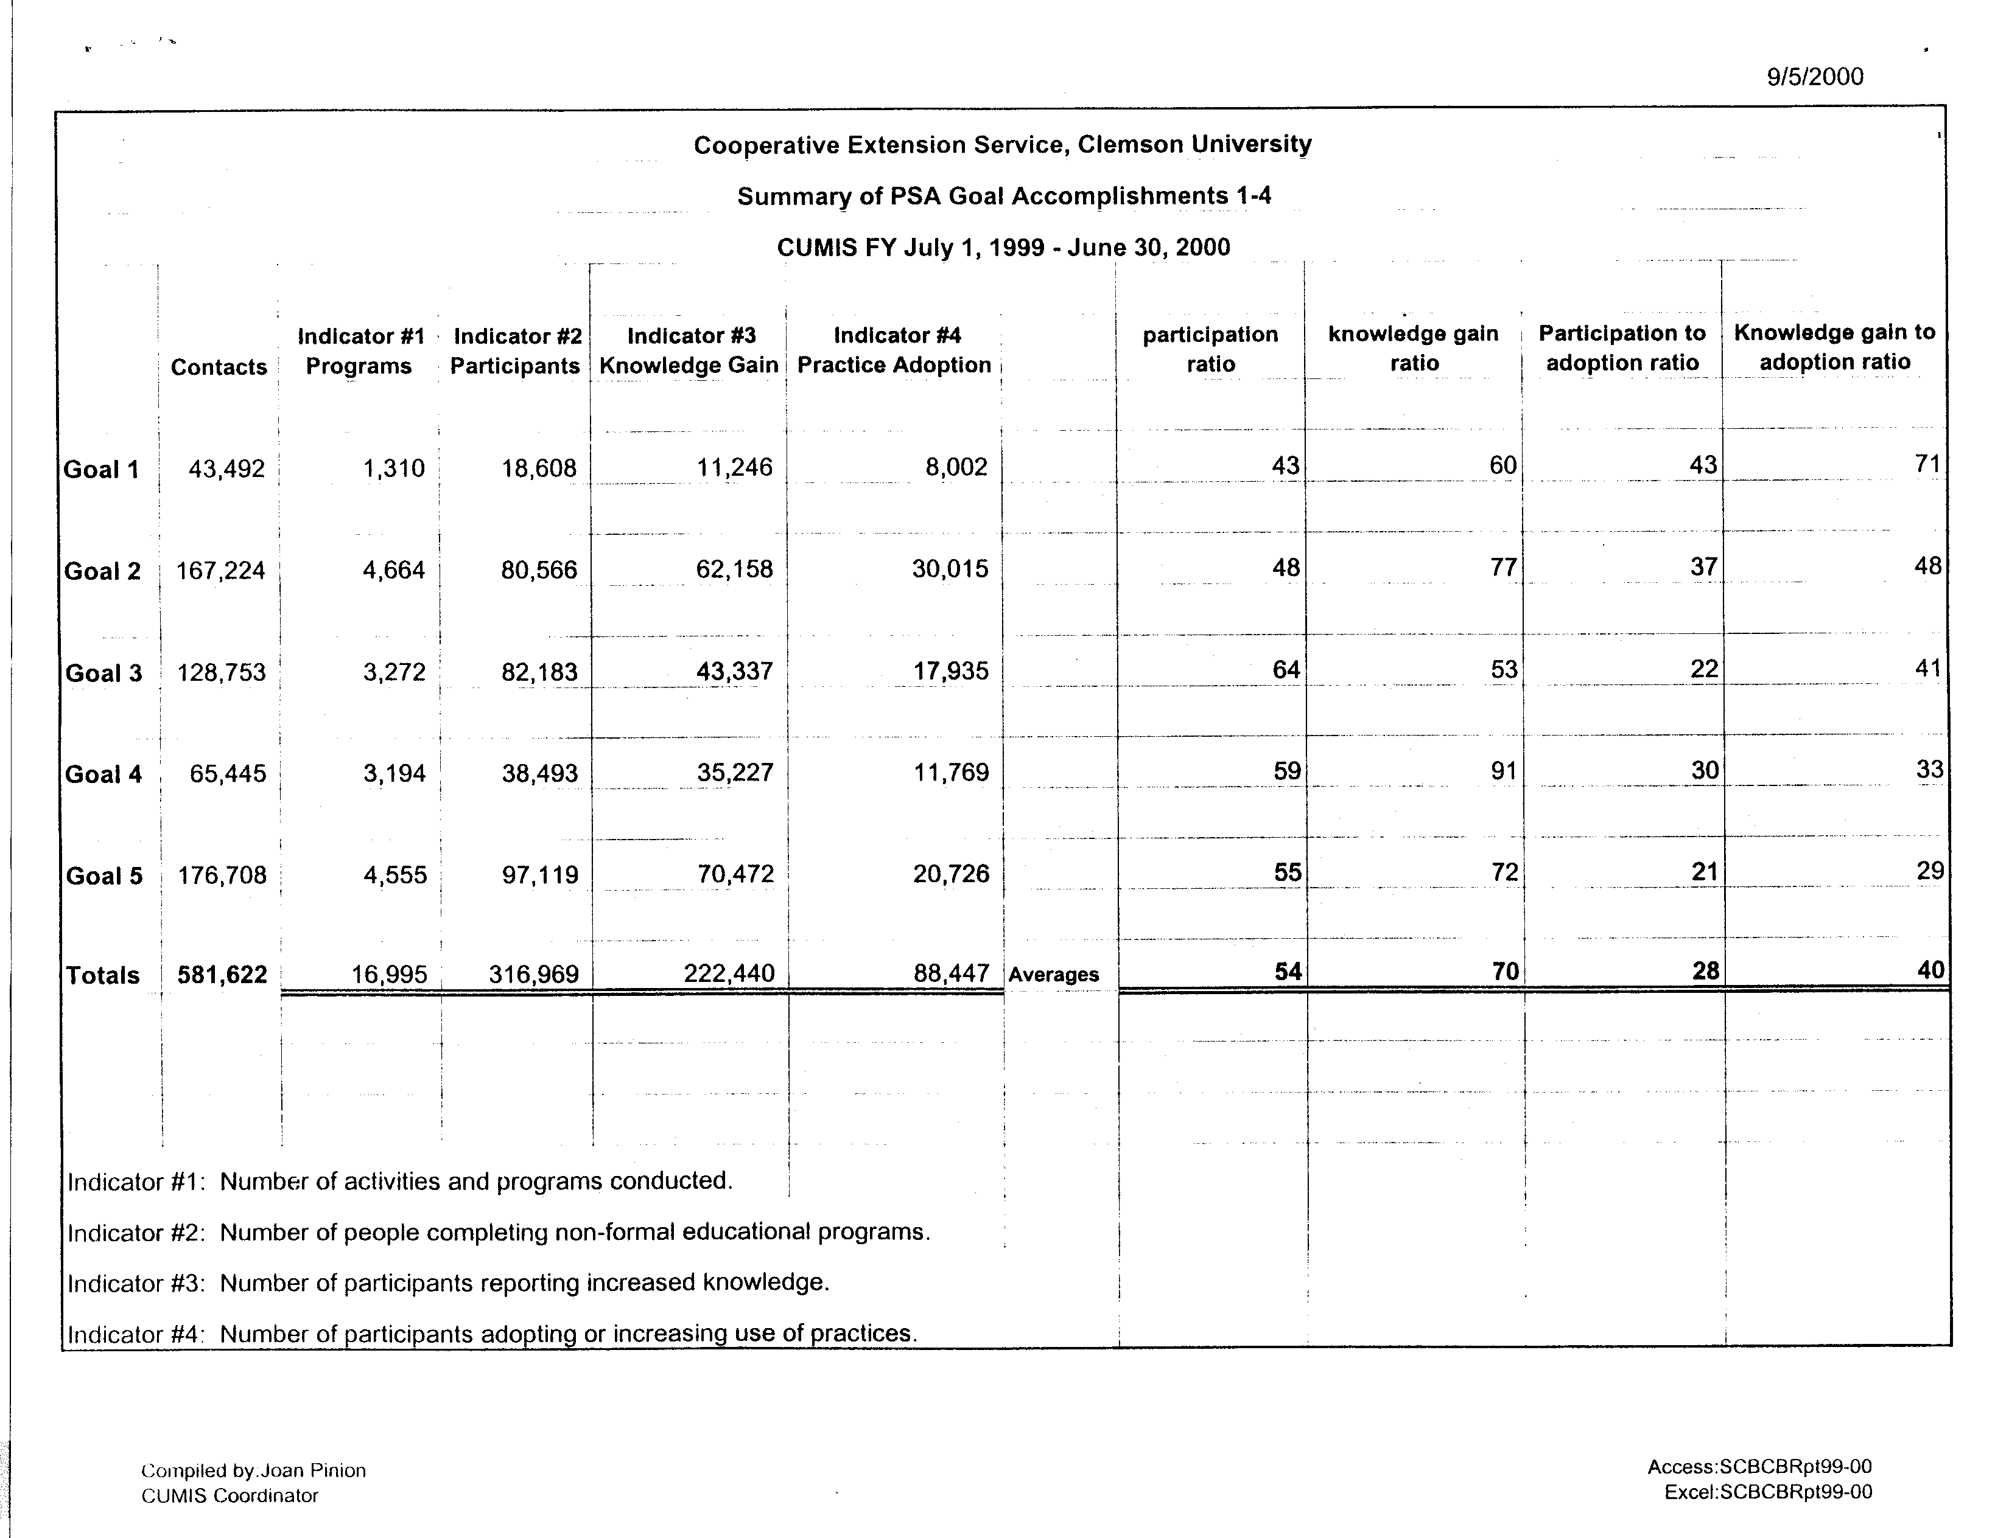

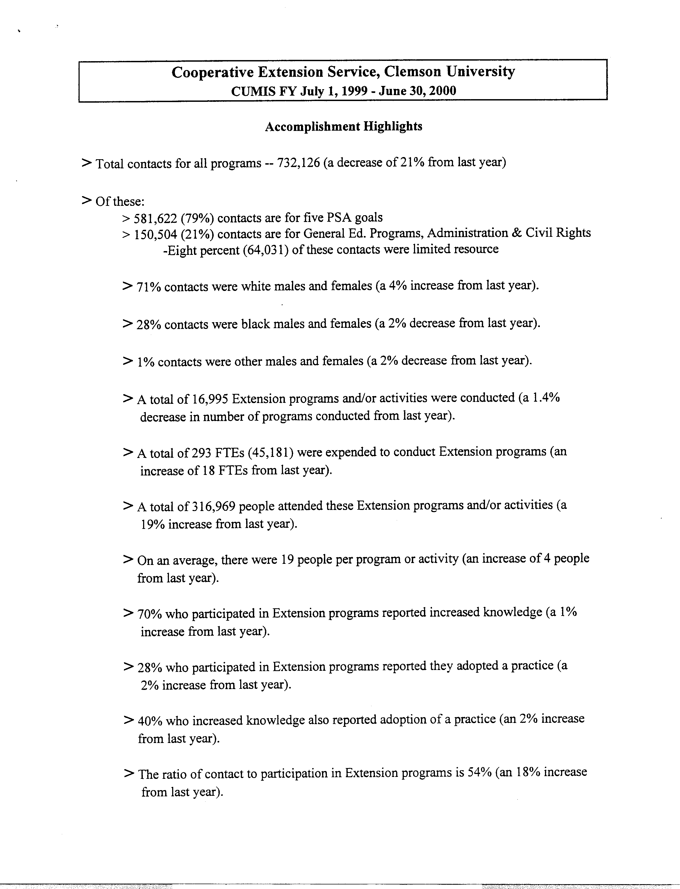

Cooperative Extension Service Contacts Summary

Cooperative Extension Service Accomplishment Indicators by Priority Area

Program Title: Regulatory and Public Service Programs

Mission: Administration of legislation to ensure safe and legal use of pesticides; the quality of fertilizer and lime; the prevention and control of introduced plant pests and pests of honey bees; the certification of seed purity/germination; the certification of freedom from plant pests in nursery, greenhouse and transplants; and administration of such programs as Quality Assurance and Identity Preserved for transgenic crops, pesticide container recycling, IPM in public schools, and boll weevil eradication.

Program Cost: State: $2,333,574
Federal:
Earmarked:
Other: $1,067,289
Total: $3,400,863

Departmental Demographics and General Information
Historical Overview: Regulatory and Public Service Programs (RPSP) has been located at Clemson University since 1890. Our location at Clemson University has allowed us to: 1) to take an educational approach to regulation; 2) facilitate the cooperation of those regulated; and 3) cooperate with other Public Service Activity units, thus furthering common missions.
Our agency began in 1889, when South Carolina passed a tax on fertilizer at 25 cents per ton. A year later, the state instituted the fertilizer inspection and analysis agency, which also oversaw the state's tax on fertilizer.
The farmers of South Carolina built and supported the college and all of its functions through the regulatory tax they paid on fertilizers. Clemson's Trustee House, Sikes Hall, Hardin Hall, Holtzendorff YMCA, Earle Hall, Kinard Hall, Godfrey Hall, and part of Tillman Hall are some of the buildings on campus funded through the agency that has evolved into today's Regulatory Services. The University no longer receives funds from the fertilizer tax; it is remitted to the South Carolina State Treasurer’s office.
The following are regulatory milestones: 1) 1901 entomological inspections began; 2) 1912 the South Carolina Plant Quarantine Act was passed, an act to prevent non-native injurious weeds, insects, and other plant pests from invading and spreading in South Carolina; 3) 1945 the Seed Law was passed, assigning to Clemson the South Carolina Crop Improvement duties; and 4) 1947 the South Carolina Economic Poisons Act for regulating pesticides was passed and assigned to Clemson University. Each Act has been revised and updated in subsequent years.

Responsibilities: RPSP houses three departments: the Department of Pesticide Regulation (DPR), Fertilizer and Seed Certification Services (FSCS), and the Department of Plant Industry (DPI). RPSP protects and enhances the quality of life in South Carolina by promoting a safe environment; assuring that fertilizers, pesticides and seed meet standards that enhance efficient and profitable crop production; enforcing quarantines and other regulations that protect South Carolina agriculture and the environment from invasive weeds, insects, and diseases; regulating the structural pest control industry; and ensuring the safe use of pesticides. Recognizing that voluntary compliance with regulations is enhanced by a strong educational approach, RPSP maintains close coordination with the Clemson University Cooperative Extension Service and Agriculture and Forestry Research.

Customers: Regulatory Services’ customers are those whom we regulate: pesticide and fertilizer users, those who produce certified and enhanced seed and plants, any South Carolinian who grows plants, and citizens at large who are affected by areas regulated (e.g., a citizen with a complaint of pesticide misuse or a child exposed to pesticides at school). A consumer focus survey was conducted among homeowners who contacted our agency regarding pesticide use and the pest control industry. This survey found that over 91% were positive about the inspection, our inspectors, and the written report issued. Data show that over 92% of those consumers said that they could not have resolved their problem without our assistance and that they would refer our agency to others. Over 96% of those consumers said that our agency was responsive to the public and provides a valuable service and only 33% of these same respondents stated that government agencies normally were responsive to the public. Other RPSP units are implementing similar customer surveys.

Strategy: Units within RPSP will continue to:
- Maintain exceptional regulatory and service programs by educationally enforcing legislative mandates in pesticide, fertilizer, lime, chemigation, and plant industry, while also setting a national standard for cooperative programs with federal partners in groundwater monitoring, worker protection, pesticide container recycling, IPM in public schools, witchweed and boll weevil eradication, and gypsy moth surveys.
- Administer genetic and quality standards for certification of seed and vegetatively propagated materials.
- Enforce detailed standards, which help protect structures from wood destroying organisms, and protect property and people from pesticide misuse.
- Inspect and certify the national and global movement of plant industry products, as all states and most foreign countries require pest-free certification before nursery stock can be imported or exported.

In the future, RPSP units will strive to:
- Continue to improve electronic web-based services,
- Increase funding to build up the Department of Plant Industry to –
- keep pace with the faster growing plant nursery industry, which we regulate,
- prevent invasive species from entering or spreading within South Carolina,
- Provide quality assurance and identity preserved programs for enhanced crops,
- Eradicate invasive species whenever feasible.

An increase in funding is necessary to accomplish strategies 2-4. If RPSP is unsuccessful in obtaining the needed increase in funding, South Carolina’s ecology will irreparably change for the worse, as invasive species will continue to be introduced. The single bright spot in South Carolina agricultural production, the nursery and greenhouse industry, is dependent on pest-free certification for sales of plant materials, which the Department of Plant Industry must provide.

Interface with Clemson University President’s Goals
RPSP will strive to provide extended outreach, one of the five main goals set by Clemson’s President Jim Barker.

Implementation of Public Service Activities’ (PSA) Goals
RPSP programs further the following PSA Goals: Agrisystems Productivity and Profitability, Goal 1; Economic and Community Development, Goal 2; and Environmental Conservation, Goal 3.
Program Objectives:
1) Continue education, survey, and eradication efforts to rid SC of Tropical Soda Apple.
Assessment of Results
TSA survey and control treatments were conducted in 1999 in all infested counties except Jasper County. Only one plant was found in Jasper County last year and subsequent inspections have been negative. Two temporary employees were hired in September 1999 to survey high-risk sites throughout the state. As a result, a new infestation was found in Beaufort County, consisting of approximately 200 acres. Dorchester County, a new county of record, was found to be infested in 1999. New infestations were found in Pickens and Cherokee Counties. Currently there are 2,400 acres involving 22 infested sites.
Use of Results
Infestation information was conveyed to Clemson University Cooperative Extension Service and the USDA. The information gathered from surveys, treatments, and observations is transferred to various agricultural groups at meetings and is used by DPI to plan for next year.

2) Work toward developing and implementing a user fee system for services provided to the various industries regulated by Plant Industry.

Assessment of Results

Regulation establishing a user fee for commercial nurseries and nursery dealers was drafted and readied for submission to the legislature in 2000. The legislation passed.
Use of Results
An additional DPI inspector will be placed in Aiken County. This will help DPI keep pace with the fast-growing nursery industry and stop the introduction and spread of invasive species in South Carolina.

3) Develop and begin implementation of an Integrated Pest Management Program for schools to maximize the use of non-chemical controls where appropriate and the safe use of pesticides where necessary to decrease potential exposure of children to residues.
Background
Integrated Pest Management Program (IPM) for South Carolina schools could be instrumental in maintaining an appropriate environment while simultaneously reducing the exposure of children to pesticide residues.
Overall Assessment: We have made substantial progress in both outreach and IPM in Schools.

Table of Numerical Assessment Results for Regulatory Services 1999-2000

# | Type of Measure | Output
1 | Acres of soybean and small grain seed production inspected and acres that were rejected for failure to meet certification standards. Result: Savings of $37,536 in conditioning and bagging costs to seed producers, and increased productivity and profitability of crops produced from Certified seed through higher germination and freedom from weeds and diseases. (Indicator changed with crop planting practices.) | 12,695 total acres  334 acres rejected
2 | The deficiency rate and number of fertilizer and lime samples expressed as a  percentage of total fertilizer sold in SC compared to NC and GA. Result: In  1999-00, $46,562 was refunded to consumers by fertilizer dealers as  compensation for deficiencies and lost productivity. (This indicator changed to more accurately depict deficiency rate, which we strive to keep low. Total fertilizer sold varies each year, thus percentage stabilizes indicator.) | 16.2% deficient  2,243 samples  (0.51% sampled)
3 | The number of inspections required in addition to certification inspections conducted to certify plant/commodity shipments (transplants, nursery stock, seed, lumber) intrastate, interstate, and globally. Benchmark: Respond to phytosanitary requests within a week’s timeframe and maintain an acceptance rate above 94%. Result: This certification fulfills certification requirements for shipment of these materials. Shipments enhance the marketing and profitability of SC agricultural business. No rejections from foreign counties of 217 federal phytosanitary certificates issued in FY 2000. | 726  compliance rate  97.4%
4 | Invasive species surveys were conducted to detect/determine the presence of Plum Pox Virus disease in SC peach orchards and Tropical Soda Apple (invasive weed) in the state. Benchmark: Collect 10,000 peach leaf samples for analysis and survey TSA infested sites every six weeks from June 15th to killing frost to prevent mature fruit production. Result: No Plum Pox Virus found in SC’s $40 million peach industry. Allows continued shipment of peach fruit and budwood to other states and foreign counties. No TSA plants produced mature fruit at current infested sites. TSA population is being reduced saving cattlemen and landowners thousands of dollars in production loses and control costs. | 11,5232 peach leaf samples collected  3,146 TSA plants found and destroyed 1999
5 | The number of inspections conducted of commercial greenhouses, nurseries, dealers, turf/sod farms, and vegetable transplant producers for insect and disease detection. Benchmark: Conduct one inspection annually of each licensed nursery. Achieve a 95% compliance rate of nurseries meeting inspection criteria. Result: Plant material shipped and sold in SC and nationally is free of insects and disease. This enhances the horticultural industry’s (2nd in cash receipts in SC) productivity and provides credibility to the industry and other states of our program. | 1,181 inspections  compliance rate 97.4%
6 | The number of inspections conducted to assure proper pesticide use. Result: The environment and human health is protected from pesticide use. Agricultural productivity is enhanced due to continued availability of pesticides, which allow commodities production. Cancellation of those pesticides by the EPA would occur if not adequately regulated and used according to label directions. | 2,210 inspections  compliance rate varies by type of inspection
7 | The number of pounds of pesticide containers recycled. Result: Each container recycled is one less container that ends up by the roadside or in a landfill. Mature program, consistently exceeds the 150,000 container benchmark. | 200,000 containers
8 | The number of groundwater samples procured and analyzed for pesticide and nitrite contamination. Result: Less than 4% of groundwater samples are contaminated with pesticides. This regulatory and monitoring program protects SC residents’ health. Program consistently exceeds the 150 samples per year benchmark. | 208
9 | Monetary savings of consumers where Dept. Pesticide investigated structural pest control activities. | $2,157,984

Graphic Representation of RPSP Assessment Table Outcomes

Program Title: Livestock Poultry Health Programs

Mission: To ensure the safety and health of livestock and poultry produced in
South Carolina, as well as the health of companion animals and wildlife

Program Cost: State: $3,457,089
Federal:
Earmarked:
Other: $ 531,850
Total: $3,989,939

This division has a major role in protecting the quality of life for humans, as well as companion and food animals. Daily functions of Livestock-Poultry Health Programs include constant surveillance for diseases that affect both humans and other animals, providing the diagnostic expertise that allows for treatment and eradication of diseases of domestic animals, and inspections and testing of processing of foods of animal origin. Our diagnostic laboratory also provides veterinary diagnostic support for wildlife.

MEAT INSPECTION

The 1999-2000 year was a very busy and successful one, bringing 107 plants in compliance with HACCP requirements and implementation of Salmonella Performance Standards.

All plants owners/managers and department inspection personnel attended and successfully completed an International HACCP Alliance accredited a three-day training course sponsored and conducted by department supervisors. During the week of January 25, 2000, a basic compliance audit of 107 permitted plants HACCP plans was conducted; 104 plant’s HACCP plans were in compliance, enforcement actions were taken against three plants and these three plants were in compliance within thirty days from the date of the audit. Final results were that all permitted plant’s HACCP plans were in compliance by March 1, 2000.

The regulatory phase of the Salmonella performance standard was implemented on January 25, 2000. This is an on-gong program. As of this date, all permitted plants are in compliance with this performance standard.

Computers for all field inspection personnel have been procured. All inspectors have been trained and the initial phase of the FAIM program has been implemented.

ANIMAL HEALTH PROGRAMS (REGULATORY)

Animal Health Regulatory Programs maintained disease free status of program diseases and implemented a comprehensive Animal Emergency Response Program.

Equine Programs
- Zero cases of EIA in 1999
- Successful regulating initiatives of a number of violations
- Low numbers of EEE cases for the 1999-year

Animal Emergency Response
- Completed first three (3) sections of Standards of Operation (SOP) to support animal Emergency Response ESF-17 Annex.
- Records of successful stabling in excess of 1500 horses evacuated during Hurricane Floyd
- Equine Rescue Training Seminar at SC Fire Academy in February 2000
- Initial development of three Equine Rescue Teams to work Upstate, Mid-state and Lower state areas.
- Four (4) SERT members attended SC Hurricane Conference in March 2000
- Two (2) SERT members attended National Animal Disaster Conference in March 2000 – 1 member participated in presentation
- Developed portion of Clemson Animal Emergency Response Web-Page and links for public information (www.clemson.edu/ep)
- Developed Pet-Friendly Hotel/Motel list> 200 establishments in South Carolina, North Carolina, and Georgia

Poultry Health Programs
- Successfully quarantined and depopulated diseased poultry flock without spread of disease to neighboring poultry farms
- Completed environmental testing of all commercial table layer farms in SC to begin establishment of baseline
- Conducted egg movement trace back, on-farm environmental sampling and egg testing of layer farm implicated in an out-of-state SE (egg related) food-borne outbreak.

REGULATORY

- Successfully traced back to farm of origin all suspect and/or reactor laboratory results
- Random testing by NVSL of swine LAM testing for classical swine fever
- Negative quarterly dairy BRT samples
- Participation in MCI and MST (market swine testing) programs
- Increase of beef and dairy herd testing for Johne’s disease
- Field veterinarian attended number of producer and veterinary meetings to discuss and promote Johne’s program

DIAGNOSTIC LABORATORY

The Diagnostic Laboratory received full AAVLD accreditation and handled the greatest number of accessions ever, and through its new facilities continues to expand its scope of services.

- Obtained full American Association of Veterinary Laboratory Diagnosticians (AAVLD) Accreditation.
- Mailed new lists of tests and price list to clients. We are in the process of starting similar lists and on-live submission forms on our web site.

- Revised three (3) submission forms that are being used by our clients.
- Each lab tech and veterinarian can easily retrieve cases to their monitor. Yearly reports are being suggested to the laboratory director.
- We are still in the process of developing immunohistochemistry procedures.

