Executive Overview

General Information. The South Carolina Department of Revenue is a regulatory agency of South Carolina state government. Our primary responsibilities include administering and collecting the 32 state taxes, such as income tax, sales tax, manufacturing property tax, and retail business licenses. The department also regulates and licenses bingo operations and issues alcoholic beverage permits. The scope of our responsibilities puts the department in direct contact with nearly every South Carolina resident and many nonresident taxpayers and corporations. Therefore, it is very important that we manage our enterprise in a customer-focused, fair, and efficient manner.

Our major customers include individual income taxpayers, small business owners, corporate executive officers, certified public accountants, tax attorneys, industry associations, legislators, county officials, the executive branch of government, interstate associations of taxing officials, the Internal Revenue Service, and other state agencies.

The department has 754 full-time permanent and 31 other-funded employees who work in 10 offices throughout South Carolina and six major metropolitan areas across the United States. In addition, our permanent workforce is supplemented by approximately 135 non-seasonal temporaries and up to 230 seasonal temporary employees during the peak months of the individual income tax filing period. Over the period since 1991, we have sustained a 13.4 percent decrease in our permanent workforce, while at the same time the workload has increased by 53.4 percent.

The Year In Review–A Year Of Transitions. This year we not only made significant progress addressing the key results of our strategic plan, but we also saw many transitions.

Leadership: In January 1999, Governor Hodges appointed Elizabeth Carpentier as Director of our department. The department was very fortunate to have an experienced executive leadership team for a number of years. This year, however, six of the nine senior management team reached retirement eligibility after 30 or more years of service. In anticipation of this transition, Ms. Carpentier made an intense study of the organization and its future challenges and shaped a new leadership team to meet those challenges. The Leadership section of this report on pages 7-10 outlines how senior leadership at the department sets direction, seeks future opportunities, and monitors performance excellence.

Organizational Structure: Significant transitions occurred not only with the leadership team, but also with the organizational structure. Most notable in this regard was both the ramping up for video poker enforcement and later dismantling the same organization as a result of the ban on video poker. Our new organizational structure is shaped around core

business competencies and support functions. The chart on page 5 gives a picture of the new structure and our leadership.

Otis Rawl is the Deputy Director for Revenue and Regulatory Operations, which consists of audit, collections, processing and document management, registration and licensing, and local government services. These represent the core business functions of our department. The other two divisions are strategically aligned to support these business functions. Harry

Cooper is the Deputy Director for Legal, Policy, and Legislative Services which supports our criminal investigations, legislative, legal, policy, and public information functions. Ike Nooe is the Deputy Director for Support Services which manages the human resource, training, quality, planning, technology, and financial management needs of the department. Twelve senior managers report to the deputies and serve as the senior management team of the department.

Strategic Planning: Four primary components shape our department’s ways of doing business and managing our processes: (1) strategic planning; (2) annual business planning; (3) total quality management; and (4) performance measurement. Our strategic plan tells us what to do. Our annual business plan contains action initiatives that tie directly to key results of the strategic plan. All work groups in the department participate in this annual planning process. Through the use of quality improvement principles, we both identify and address improvement opportunities. Performance measurement enables us to gauge effectiveness and efficiency.

In July 1999, the leadership team made a commitment to revisit and revise the strategic plan of the department. This process and the implementation of the new plan spanned the entire year as we took an in-depth look at our strengths, weaknesses, opportunities, and challenges. We strategically planned the key results we intend to achieve and identified the strategies we believe will take us there. The new plan was implemented July 1, 2000. We enhanced our planning by adding a five-year planning process to better focus our major initiatives, projects, resources, and measurements.

The four key results of our strategic plan are:

Maximized compliance;
Strong stakeholder relationships;
Effective and efficient agency and enterprise services; and
Capable, satisfied and diverse work team.

Pages 11-12 of this report describe our strategic planning process and its deployment to all department employees. We also describe how we align each individual’s job and performance measurement to the key results of the strategic plan.

Results. Achieving our key results is the department’s bottom line. Our processes are set up to ensure accountability for our actions, decisions, and results. The sections of this report on
Customer and Market Focus, Information and Analysis, Human Resource Focus, and Process Management can be found on pages 13-23. We describe our processes in the context of the first six Baldrige criteria to illustrate the use of a quality organizational approach to process improvement, deployment, and measurement.

Results are reported beginning on page 24 in the Business Results section. Following the Baldrige criteria, they are broken down in the areas of customer focus, financial and market results, human resource results, supplier and partner results, and organizational effectiveness results. In most cases, data is presented to indicate trends.

Highlights include:

Total collections have increased 86.2 percent since 1991, despite budget reductions, 13.4 percent reduction in permanent staff, and a 53.4 percent increase in workload.

Enforced collections increased 16 percent this year.

Process improvements resulted in a 55.6 percent increase this year in the number of individual income tax refunds delivered to the taxpayer within 30 days or less.

Customer satisfaction, as measured by the University of South Carolina’s external survey, showed that we continue to significantly meet or exceed the needs of our customers.

South Carolina once again was the leading state in percentage of electronically filed returns (36 percent), a more convenient filing alternative for the taxpayer and a more efficient processing method for the state. The filing deadline was extended to May 1 as an incentive for those filing electronically.

Through debt setoff, the department reflected an increase from the first year of implementation of $9.5 million to a high of $46.5 million this year for state and local entities.

Our cost to collect a dollar of revenue for the state is seven tenths of one cent.

Among the 28 agencies with 500 or more employees, we ranked fifth in EEO statistics in our annual legislative report. We rose from an overall ranking of 39th last year to 12th this year.

The department’s turnover rate, including retirees, is only 8.3 percent, as compared to the statewide average of 14 percent.

Each department employee received an average of 33.7 training hours.

Over the last nine years, the number of returns processed by each employee has increased from 5207 to 7988.

Collections have increased from $4,542,000 per employee to $8,458,106 since 1991.

Since the beginning of our quality journey in 1989, our department and its work teams have dedicated significant efforts toward developing a quality organizational culture and processes. This report is organized around all seven of the Malcolm Baldrige criteria. In most cases, we have invested years developing, implementing, and enhancing the fundamental processes and systems described in criteria one through six. Therefore, those process descriptions should and do closely resemble the descriptions in the department’s 1998-99 Accountability Report. Enhancements made to these fundamental processes are outlined in this year’s report. Business results are reported in Baldrige criteria seven. As requested, additional results are reported by program areas.

Our combination of a strong leadership team, the new organizational structure and work teams, the new strategic plan, and our quality and measurement processes promise continued capacity to address both expected and unexpected challenges.

South Carolina Department of Revenue
Organizational Chart

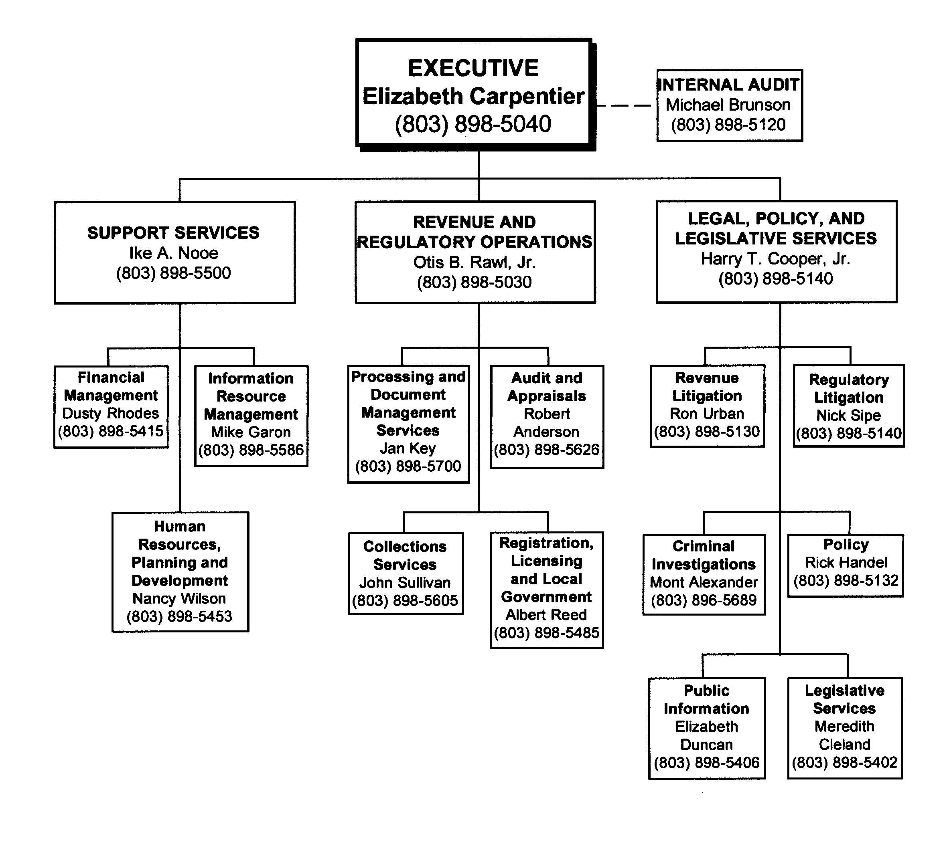

THE SOUTH CAROLINA DEPARTMENT OF REVENUE
MISSION

The mission of the South Carolina Department of Revenue is to administer the revenue and regulatory laws of this state in a manner deserving the highest degree of public confidence in our integrity, effectiveness and fairness.

To accomplish this mission, the South Carolina Department of Revenue will:

Administer revenue and regulatory laws in a fair and impartial manner;

Collect the revenue due the state;

Recommend improvements to the laws administered;

Ensure a professionally-trained staff of employees;

Continually improve the quality of services and products; and

Provide guidance to foster compliance with revenue and regulatory laws.

Leadership

Senior leadership in the department is the crucial driver of setting direction, seeking future opportunities, and monitoring performance excellence. Elizabeth Carpentier has been Director of our Cabinet agency since January 1999. Effective May 1, 2000, her executive management team consists of three deputy directors who lead the major business and support divisions. The administrators of each of the major operating units complete the senior management team that provides leadership and direction to accomplish the vision, mission, and action on the strategic issues important to the department’s success.

Our vision statement exemplifies the high standards to which the department aspires:

We, the employees of the South Carolina Department of Revenue, will be leaders and drivers of innovation and excellence, exceeding the expectations of South Carolina’s citizens while maintaining the highest level of public confidence. The Department of Revenue will be the international standard for efficient, effective and timely service, and will partner to continuously improve all governmental services of the State of South Carolina.

The agency’s mission statement describes what legislatively we exist to do. It is found on page 6 of this report. Senior leadership led the process of setting key results. They are the broad results or key priorities against which we’ll measure our progress. Each of the four key results is broken into several strategies that more specifically state actions we take to reach each result.

Key Result 1: Maximized Compliance
Provide quality customer service.
Educate individuals, businesses, and tax professionals on regulatory, filing and payment
requirements.
Reduce the stress, time, and cost of compliance by simplifying forms and instructions.
Promote voluntary compliance with focused innovative enforcement.
Work cooperatively with the Legislature to develop fair and simple tax laws.
Use advancing technology to develop convenient alternatives for filing and payment.

Key Result 2: Strong Stakeholder Relationships
Partner with stakeholders to understand and meet their expectations.
Provide employees the tools, systems, and information to effectively perform their duties.
Provide stakeholders the right information at the right time.
Provide a variety of customer-friendly options to communicate effectively with stakeholders.
Make processes streamlined, proactive, and responsive.
Effectively market and promote Department of Revenue services available to stakeholders.

Key Result 3: Effective and Efficient Agency and Enterprise Services
- Identify, prioritize, plan, and implement flexible, long-term agency and enterprise services.
- Administer and continuously evaluate services to ensure stakeholder needs are met while adhering to rules, regulations, and statutes.
- Continuously evaluate and implement innovative technology to improve the quality and speed of service delivery while minimizing cost.

- Evaluate, provide, and manage agency resources to include equipment, facilities, employees, services, and tools.
- Market services and communicate procedures and policies to educate stakeholders.

Key Result 4: Capable, Satisfied and Diverse Work Team
Provide forward-thinking leadership that is creative, clear, innovative and demanding of excellence.
Actively recruit and employ highly-qualified, diverse individuals who are committed to providing public service.
Provide competitive compensation and recognition systems which thank employees for their individual and team efforts and encourage innovation.
Provide comprehensive, meaningful employee training and knowledge management systems that use up-to-date techniques and technology.
Ensure a flexible organizational culture that promotes high performance, lifelong learning, and employee satisfaction in a safe work environment.

Our values represent our guiding principles or the things about which we care most as we carry out our mission. Senior leadership not only models these beliefs, but also clearly and consistently articulate these values throughout the organization. Our intent is to demonstrate these beliefs in all our dealings with our customers, both external and internal. These values include: customer focus, equal treatment, integrity, continuous improvement, informed decision making, knowledge, teamwork, open communication, and recognition.

The senior leadership team is a critical and visible link in both development and deployment of our strategic plan and annual business plans. Their role and the involvement of all employees in the annual planning process is described in detail in the following section of this report. Senior leaders personally participate and actively lead the process of establishing the annual business plan. They monitor the quarterly business plan progress reports and performance measure results.

Senior leaders establish and reinforce the environment for innovation and empowerment by living their commitment to continuous improvement and results orientation. Our senior leaders have been trained in fourth generation quality management principles, team leadership, and Baldrige criteria. Leaders walk the talk through participation in training and teams using the quality tools and process.

Our senior leaders are recognized for their abilities statewide and nationally through their positions in many professional organizations and task forces. The department was the first state agency to receive the Governor’s Quality Achiever Award; and E. Gregorie Frampton, recently retired executive administrator, won the Milliken Medal of Quality this year. We have in place an Executive Leadership Development process to ensure that our future senior leaders have both the skills and experience to excel and continue the tradition of excellence in leadership. We are in the third year of a mentoring program in which senior leaders are matched one-on-one with mentees to provide development opportunities.

The department demonstrates its public responsibilities and practices good citizenship in many ways. Public trust is a vital component of maintaining high levels of voluntary compliance with the state’s tax laws. Actively demonstrating our values of customer focus, equal treatment, honesty, and accountability are essential. Our methods of accomplishing customer focus and listening to their concerns and problems are detailed in pages 13 through 15 of this report. We assure ethical business practices proactively through policy and training. Several teams work annually (1) to ensure compliance with implementation of new statutes; (2) to identify suggested improvements to the laws; and (3) to communicate advisory opinions and regulations to assist taxpayers. Direct e-mail, the Problems Resolution Office, monthly interviews, and the Taxpayer Advocate are avenues for citizens to resolve concerns. Taxpayer errors and calls are monitored to identify where improvements are needed.

The department is a leading agency in the government community. On the state level, our employees lead or participate in multi-agency teams to improve the processes of government. We have trained not only our employees, but also many from other agencies in the quality skills and tools. We regularly facilitate teams in other agencies. We are actively involved with professional groups in leadership roles, such as the Federation of Tax Administrators (FTA) Best Practices and Benchmarking Team. Ms. Carpentier serves on the Board of FTA and is President of the Southeastern Association of Tax Administrators this year. Several of our employees serve in critical leadership roles in many of the leading technical issues in tax administration. These collaboration efforts not only help us identify best practices, but we also have the opportunity to be a partner in continuously improving all governmental services for our citizens.

We partner with business groups, such as the State Chamber, Municipal Association, Association of Counties, and the Small Business Chamber on joint projects. Our collaboration with state partners includes the Departments of Transportation, Health and Environmental Control, Commerce, and Labor, Licensing and Regulation, to name but a few. We have taken the lead for the Master Application System (SCBOS) that will provide a more streamlined one-stop shop approach for citizens registering to do business in South Carolina. We have regularly served as a pilot site with the Internal Revenue Service to bring taxpayer friendly programs to South Carolina citizens, such as issuing federal employer tax identification numbers through our offices. We frequently are called upon to make presentations to a wide variety of audiences about both taxation and our quality leadership approach.

Our agency actively supports other community groups, such as the United Way, the Good Health Appeal, United Black Fund of the Midlands, Cooperative Ministries, the Red Cross, Harvest Hope Food Bank, the Ronald McDonald House project, First Ladies’ Walk for Cancer, and our community schools. Our employees actively support the Governor’s emphasis on education through voluntary individual contributions of time and money to agency public education projects, purchase of “Apple” license plates, and inclusion of school readiness tips on tax forms. We piloted a TaxsmART program this year to help children understand where their parents’ tax money goes, and to help them anticipate where and why they’ll pay taxes in the future.

TaxsmART won the Federation of Tax Administrators award this year for Taxpayer Service and Education.

Public responsibility and citizenship begin with leadership. Our senior leadership team has modeled the importance of these issues through their individual participation and through policies and training that reinforce our responsibility and customer focus.

Strategic Planning

The department’s strategic plan is the basis for both our long- and short-term planning processes. Ms. Carpentier and the leadership team made the commitment in July 1999, to revisit and recast our strategic plan to meet the challenges of the future. We significantly broadened the scope of input to include a planning team of more than 60 managers, many agency employees, and external groups and individuals. Our strategic planning process gave us a future-oriented basis for business decisions, resource allocation, and management.

STRATEGIC PLANNING MODEL

Stakeholder  SWOT Analysis  Setting Strategic
Analysis (Strengths, Weaknesses, Opportunities and Threats) Direction
 
Gaining Commitment Identifying Key
to Plan Issues
 
Evaluating  Implementing the  Developing Strategies
Improvement Plan

An intensive stakeholder research and analysis process gathered input from employees, business and non-business taxpayers, elected officials from both state and local government, tax practitioners, media, other state agencies, government entities within the state, and professional associations. Teams were assigned to each of the stakeholder groups and we collected information via surveys, interviews, personal contacts, and other available means.

Next we examined our strengths, weaknesses, opportunities and threats. This involved both an external and internal scan and an internal assessment of each of our divisions. In the external scan we identified external factors that will impact either what we do in the future or how we do it. These included technology; socioeconomic and demographic considerations; cutting edge business trends; IRS reorganization and its impact on the department; political trends, including the media and lottery; federal mandates; and intergovernmental issues, including other state revenue departments and state/local government.

The internal assessment focused on the strengths and weaknesses of our department. Areas assessed included our culture, human resources, structures, systems and processes, services, and technology. The results of the focus group responses were made available via e-mail to all employees.

Using all data gathered, a team of more than 60 managers formulated statements of mission, values, and vision to reflect the department’s strategic direction. We then identified four major key results and strategies to support their accomplishment.

The plan was communicated both in large group meetings with all employees and was reinforced by sectional meetings within each division. In addition, through other media such as e-mail, brochures, posters, and contests, we continue to promote the plan’s key components and results.

Deployment of this plan involves all department employees. Each year each natural work team and project team sets objectives that target one or more of the strategies. Our Annual Business Plan addresses improvement opportunities at the team, operating division, and agency level. Progress is reported quarterly. Planning is an annual cyclical process that we believe not only aligns employee efforts with the issues of most importance to our agency, but also helps us monitor progress and use resources wisely. In addition, we have supplemented the annual business planning cycle with a five-year planning process that better ties the strategic key results with our annual business planning. Our five-year plans address 13 major initiatives we believe will focus our resources to better accomplish our key results for fiscal years 2001-2005. New employees are oriented to the agency and this strategic planning process in a course we call “DOR-101.”

We underline the significance of aligning individual duties and accountability to the strategic plan through explicitly tying job duties to key results on each employee’s position description and EPMS. In addition, we have implemented quarterly coaching sessions for each employee during the EPMS process. Part of that coaching includes reinforcement of the key results and the employee’s unique responsibilities that will help us better accomplish our mission.

In addition, performance measures help us track and evaluate our progress. Measures were identified and prioritized by all divisions that tie directly to the issues of the strategic plan. They include items that are important to our customers and that address efficient use of resources. These include cycle time reduction, error rates, customer service satisfaction, electronic filing rates, and enforced collections. We also participate in benchmarking projects with the Federation of Tax Administrators to identify best practices and this year visited the Governor’s Quality Award winner, McLeod Hospital in Florence.

Strategic planning, quality improvement, and performance measurement are three major interlocking pieces of our strategy. Our strategic plan directs our long-term paths; quality management and improvement is the way we will accomplish the plan; and performance measurement helps us gauge how well we’ve succeeded. All three are necessary for our long-term success.

Customer and Market Focus

Through our strategic planning process and implementation, our major customer and stakeholder groups have been identified as: individual taxpayers, business and non-business taxpayers, tax practitioners, elected officials and federal, state and local governments. We regard these groups as integral in receiving input and feedback on department processes. A variety of methods are employed to determine customer and market requirements and expectations. These include:

Workshops
Forms Design Teams
Publications
Taxpayer Assistance, Taxpayer Advocate, and Taxpayer Education
Tax Helpline
Forms Drive-By
Internet E-Mail

The department in conjunction with Clemson University and the Internal Revenue Service holds workshops throughout the state to update taxpayers on tax law changes and forms revisions (i.e., Clemson Individual Income Tax Workshops, Small Business Workshops, and Sales and Use Tax Workshops). Additionally, other regional workshops are conducted periodically on a variety of tax matters. These workshops allow us to gain valuable input to our processes. Capitalizing on a “best practice” initiated last year, the department includes tax practitioners, tax accountants and CPA’s in our forms design teams. This customer input has proved invaluable in simplifying content and format of information on our tax forms.

The department stays in constant contact with federal, state and local governments to determine how best to address the needs of these groups and their customers. Workshops are coordinated by the department for county officials to identify and resolve various issues of concern to them. We keep abreast on current and future trends in the federal arena by our participation in the Federation of Tax Administrators (FTA). We are currently working with local, county, and other state government representatives to design a more seamless method for customers to make application and register their businesses in South Carolina (SCBOS). These workshops and other efforts have been lauded by participants as great strides in serving the customers in our state.

The department has structured ways in which to educate and be responsive to the various needs of our customers. The second Sales Tax newsletter was published this year, which answers many questions of that particular customer group, as does our Bingo newsletter. Informational brochures on various tax topics, along with our long-standing publication Revenews, continue to inform the public about various tax issues. Our web site contains a variety of tax information,

tax policies, tax regulations, and opinions as well as the newsletters mentioned above. Additionally, as one of only six states, we allow internet income tax filing and refund inquiry ability in an effort to be accessible to our wide audience.

Every taxpayer in South Carolina lives within 50 miles of one of our nine taxpayer service centers around the state or our main Columbia office. Taxpayer assistance officers are employed and trained to deliver the kind of service our customers want and expect. The main office also employs a Taxpayer Advocate to assist taxpayers and a Taxpayer Education Coordinator. The Taxpayer Education Coordinator is a new position to increase the amount of materials, educational seminars, public service announcements, and other taxpayer outreach initiatives that will be provided to our customers. These positions along with the department’s Problems Resolution Office are used not only as a way to assist our customers, but also a mechanism to listen and learn what trends are emerging and determine if a change in strategic direction is required.

A tax helpline and our web site’s frequently asked questions section are also employed to answer routine taxpayer questions. Each April the department conducts a “forms drive-by” to allow taxpayers the ability to pick up their state and federal tax forms without leaving their automobile. This year we provided forms on Thursday, Friday and Monday for the April filing deadline to those taxpayers who needed last minute forms and information. Feedback on this service has been overwhelmingly positive.

In response to customer input for product/service features, the department employs a wide variety of methods in which our customers can file their taxes and obtain forms. This past year we provided tax preparers and tax practitioners forms via CD Rom. Our web site allows for certain tax filings, and both current and past year tax forms are available. Also available via the web site and our Refund Hotline is refund status information. Internet filing is available, as is the telefile program which utilizes touch tone phones for entering income tax return data. Electronic filing and the paper filing methods continue to be available as well. We also accept credit card payments for delinquent taxes via an Interactive Voice Response (IVR) system.

The department is participating as one of the pilot states in the Federation of Tax Administrators (FTA) Best Practices and Benchmarking project, which is designed to measure the output and outcomes of our processes. These measures have been incorporated in the agency level performance measures and the data is collected and reported at appropriate intervals. This comparison data allows us to determine the effectiveness of our processes as compared to similar processes in other states.

Activity based costing is another area in which the department has moved in an effort to provide our taxpaying customers the best value for their tax dollar. This process has begun to enhance the evaluation of services provided on a cost basis.

The department has employed several methods to collect customer satisfaction input and determine the strength of our relationships. These include:

- Monthly Customer Satisfaction Interviews
- Customer Comment Cards
- Annual Customer Satisfaction Survey
- Taxpayer Education Initiatives

Managers in our nine Taxpayer Service Center offices around the state conduct monthly customer satisfaction interviews. These interviews are conducted with customers who have had recent contact with the department; therefore; the feedback is current. Interviews have resulted in predominate positive feedback with many good suggestions for improving our processes.

Customers are encouraged to provide feedback on aspects of our services through postage paid customer comment cards which are available in all of our offices throughout the state. We have aligned those questions with our annual customer satisfaction survey so we can address customer issues throughout the year rather than only on an annual basis. Both the monthly surveys and the annual survey ask customers to respond to their impressions on such aspects of our service as the length of time to be served, accuracy of information received, and courtesy and helpfulness of our staff. Information is used to pinpoint any potential problem areas as well as recognize the fine efforts of our staff.

The University of South Carolina’s Institute of Public Affairs Biannual Survey of the South Carolina Public is utilized to conduct our annual satisfaction survey. In addition to those questions listed above, addressed issues include familiarity with the department, recent contact with the department, and a series of satisfaction measures focused on overall service delivery, quality of information received, and the ease of the process. Questions asked in the Spring 2000 survey have been asked since 1996, giving the department trend data. The results of this year’s survey are located on page 24 of this report.

Continuous improvement means we must always be open and responsive to the ever changing expectations and needs of our customers. The department has secured enabling legislation to allow us to become the central collection point for state debt. We have begun this process with various state agencies, local governments, and institutions of higher education and had positive reactions from those entities who wish to participate. We are continuing to enhance both our electronic filing and payment methods as a result of customer feedback.

Information and Analysis

For several years the department has had in place a performance based measurement system consisting of a number of identified measures. This year 129 agency-level objectives were developed by the divisions for FY 1999-2000 to reflect the information needed to make data-based decisions, to monitor inputs, outputs, and outcomes, and to improve the system by eliminating special cause variations. Our measurements are a result of input from the users of our systems, both internal and external.

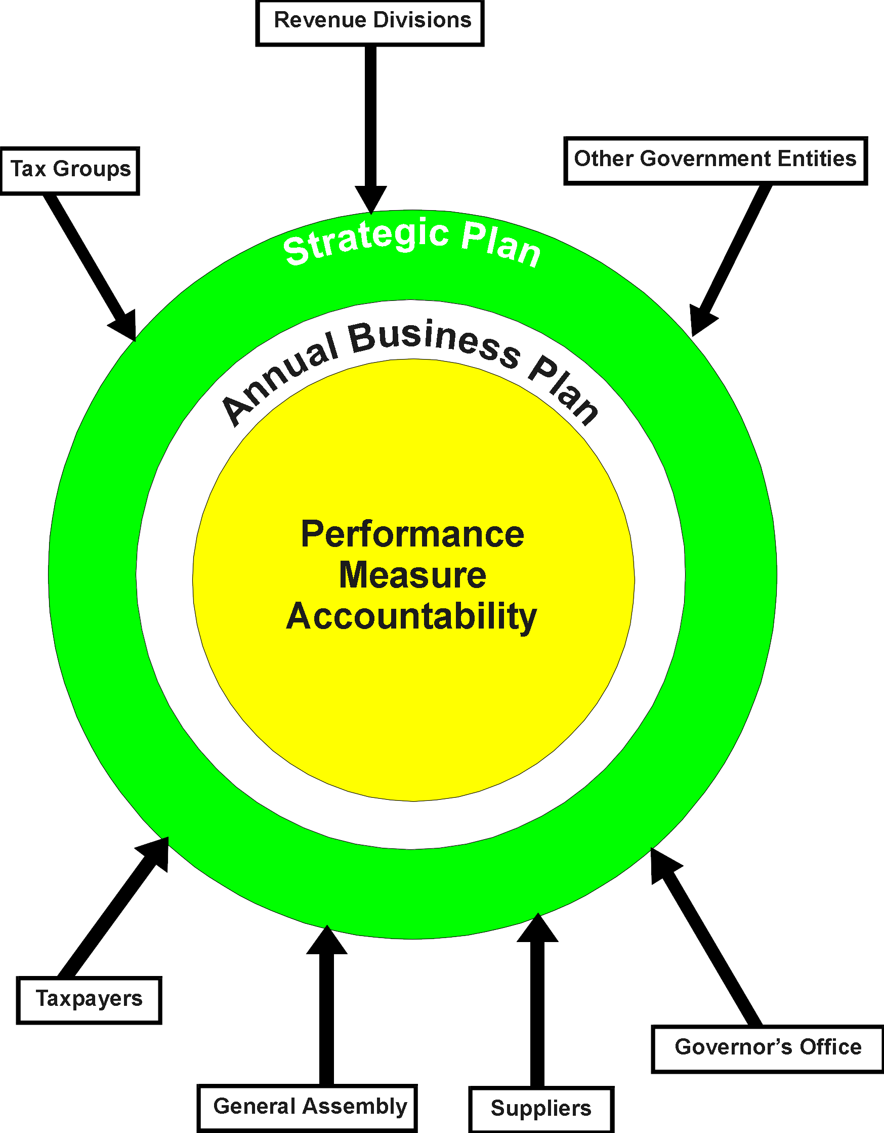

We look to taxpayers, tax groups, the Governor’s Office, the General Assembly, and suppliers to identify those items which each feels reflect the productivity of the department. Of the performance measures that have been identified by the agency, 21 were identified as agency-level measures. These measures have been appropriately tracked daily, weekly, monthly, quarterly, and/or annually to ensure that systems are operating properly to meet the customers’ expectations. As indicated in our strategic plan, the selection of proper indicators and tracking of data has become a part of the everyday work life of our management and employees.

The department is an integral part of a national movement by state revenue departments to identify performance measures that are common to all revenue departments. Once these

measurements have begun to serve as true benchmarks and as the data expands, this will better aid in identifying best practices and improvements. To date, 35 national performance measures have been identified that measure service delivery. Areas being measured link directly to customer satisfaction, compliance, rework, timely deposits, and recognition of funds. Many of the measures demonstrate effective use of resources, as well as being a monitor for expected outcomes. They give the department an accurate reflection of its operating positions in comparison to other revenue departments.

The department has expanded its senior leadership appraisal system to the next management level. The criteria include performance measures and accountabilities which are tied to Baldrige criteria, the strategic plan, and the managers’ areas of responsibility.

Our major performance measures tie directly to the core processes and the key results of the strategic plan. The department measures improved compliance by monitoring enforced collections, fraud referrals, cases prosecuted, and cases won. Additionally, the department uses feedback from focus groups and partners to identify statutes which will maximize voluntary compliance and reduce the burden of compliance.

The department is continuing to work towards activity based costing to determine the cost associated with each of our numerous processes. To date, databases and schedules with the capability to support some outsourcing decisions in the Tax Operations program have been developed. Dialogue with the Management Analysis Section has begun to further refine and adapt this information in FY 2000-2001. Likewise, the mapping of systems continues to enhance the decision making process on allocation of dollars and personnel to achieve effective use of resources.

Many of our performance measures are geared to customer expectations. One of these measures is the cycle time for issuance of a refund. In most instances, a request for refund is the only contact that taxpayers may have with the department. For that reason a short refund cycle is a key indicator of customer service and satisfaction. The improvements in refund cycle time is attributable to electronic filing initiatives, process improvements, and resource allocation. Results of these improvements are detailed in the Business Results section on page 24. Another measure is the timely deposit of revenue. Our external customers, the governor and General Assembly expect the department to deposit revenues timely so that the maximum earning on investments can be realized.

Other systems and processes the department continually monitors are electronic fund transactions and electronically filed returns; both allow us to reduce processing costs. We also benchmark South Carolina’s participation rates with those of other revenue departments.

The department measures alignment with our key human resource measures by looking at our recruiting practices to insure that the department is hiring a qualified and diverse work team. The department’s tracking of turnover rate allows for the constant review of reasons employees

leave the department so that management can address issues directly related to employee departure. Additional measures are outlined in human resource focus.

Human Resource Focus

The department has identified its core business processes and their respective stakeholders. Organizational restructure and realignment around core competencies was completed this year.

Our operating divisions are accountable for design, implementation, and continual improvement of processes within the core functions of registration and licensing; taxpayer guidance, education, and marketing; revenue processing, compliance; dispute resolution; and administration and support. Each division has work teams that have specific responsibilities. These work teams involve 754 permanent, 31 other funded, and 135 non-seasonal and approximately 230 seasonal temporary employees in the Columbia headquarters office and nine major taxpayer service centers, which also staff 19 satellite offices in South Carolina. We also maintain offices in six major metropolitan areas in the United States. To succeed, these teams are empowered to cross team and/or division lines to communicate issues and collaborate to optimize service delivery. Cross-divisional work teams are chartered to work on substantive improvement and implementation issues.

The talents and initiative of our employees are the ultimate keys to our success. Key result four and its strategies are all directed to ensuring we have a capable, satisfied and diverse work team. Recruitment is the first step. Many of our jobs require associates, bachelors, or advanced specialized degrees. Therefore, our recruitment strategy involves representation at college career days around the state; participation in targeted career fairs for immediate openings, such as the State Government Career Fair; contact with accounting professors across the state; and use of diverse access methods (Internet postings and job application, dial-a-job recordings, fax). We made significant recruitment efforts this year to ensure we have diversity in our workforce and our EEO statistics help us monitor our effectiveness. In addition, we recruit college interns from across the state. One particularly successful initiative this year has been a formalized graduate assistant program through the Darla Moore School of Business at the University of South Carolina to not only provide skilled assistance on projects today, but also to serve as a recruitment source for tomorrow.

Formal job development plans or career paths are in place for 72 percent of our non-management workforce. These include tax technicians, tax examiners, revenue officers, tax auditors, non-resident auditors, property analysts, taxpayer assistance, and criminal investigators. We are unique in South Carolina government in providing this benefit to this degree since ongoing funding for progressions within these plans is absorbed by the agency. Specific skills, duties, and training are required for certification and progression to the next step of each plan. Each such employee can reach the top of the individual plan with dedicated effort. Tuition reimbursement, and variable work week or work hour options are also available to assist those interested in completing accounting hours or degree requirements to qualify for entry into another job area in our agency. We improved our tuition reimbursement program this year to

include payment for business-related courses not necessarily tied to a degree program and lowered the eligibility from one year to six months of employment. Our low turnover rate reinforces our belief in the effectiveness of these programs.

Our compensation system is based upon market studies, internal equity, and available funding. The department has chosen to reinforce its emphasis on teamwork, customer focus, and organizational results by aligning discretionary increases (merit and bonuses) with success in these areas. The importance of these factors, together with the specifics of the department’s overall performance, is reinforced when communicating these increases.

Formal and informal recognition is another key factor in our success. Our Suggestions, Thanks and Recognition (STAR) program which is run by an all-employee committee, promotes both individual and team recognition. In addition, suggestions for improvement are actively solicited through this program and are stressed personally by the director. Quarterly visits are made to the nine taxpayer service centers and at the central office for the STAR awards. Senior management is represented at all of these functions. We have served as a benchmark for other state agencies on this program.

The department has been recognized in state government and in our profession for its progressive and sustained efforts to improve employee skills through training and development. Beginning with the hiring process, we send all new employees a booklet before the first day of work that introduces them to the mission, vision, values, structure, and functions of our agency. That information is reinforced by structured checklists for supervisors and a training session for new employees (DOR-101). The senior management team comes to each class, and participants have the opportunity to experience the flow of work through the agency to better understand our mission.

Both formal and informal needs assessments are continuing processes that help identify specific skill needs. The methods of assessment span the spectrum of individual conversations to formal focus groups. Throughout the year we offer many formal classes that target the identified needs in areas such as tax law, computer systems, computer software, quality, and leadership. All career paths require formal training that is systematically built into the plan. The higher levels of the career paths require teaching others through structured on-the-job training or classroom training. Additional courses are targeted to specific needs, such as project management, negotiation skills, speed reading, and business writing. External conferences and seminars also help us keep current with industry trends.

In addition, we have taken specific steps to improve the skills of those who deliver both on-the-job training (OJT) and classroom training. We use a nationally benchmarked course design and delivery process that uses accelerated learning techniques. Evaluations are a structured part of all courses, and we continue to improve our long-term strategies to evaluate training effectiveness.

Technology is a growing resource in training. Implementation of resource rings, or Intranet discussion groups for our five major tax areas, was completed this year as both a training initiative and an effort to provide timely answers to complex tax questions. Through collaboration on the state level, we will begin offering in FY 2001 selected internet courses through SmartForce to our employees. We are actively researching best practices in the area of technology and training. We completed a “bulldoze” of our all agency computers to leased state-of-the-art Dell computers to ensure each employee has the tools for their jobs.

The department is a state benchmark for quality improvement and leadership training. For the last 11 years we have introduced our employees to the quality tools and process through our quality and leadership training plan. We have trained many employees from other state agencies through our courses and will continue this collaborative effort. Our Executive Leadership (XD) program was benchmarked using best practices of successful Fortune 500 companies. Individual 360 degree feedback is a cornerstone of the XD program development process. Ms. Carpentier has also participated in the 360 feedback process.

Employee well-being and satisfaction is a significant indicator of return on our investment. Our measures include results of focus groups, exit interview feedback, turnover, absenteeism, and grievance statistics. We couple the diversified state benefits package with other initiatives that have proven successful. Active communication of statewide benefit options is complemented by ongoing health screenings and benefit support throughout the year. An ergonomics audit was completed and significant improvements were made in this area. Tuition reimbursement and variable work week or work hour options assist employees in balancing their lives and professional development needs. The availability of a laundry pickup and delivery service, ATM, childcare referral, on-site meal delivery, and postal services in the main office building have been well received. Job-sharing is an option we use on a limited basis. The Employee Assistance Program is available to all employees. In addition, this year one of our department’s past chairmen has expanded his privately funded John T. Weeks Scholarship program to provide scholarships to children of our employees attending any of the University of South Carolina system colleges.

Process Management

The department benchmarks the systems of other revenue departments and similar entities in the private sector for processes to enhance the delivery of services to taxpayers. The department uses natural work teams to identify personnel and system issues related to any proposed programmatic implementation or change. This year the department has initiated in excess of 50 process improvement teams to review existing processes. Some of these undertakings are: (1) expanding collection services for other state and local government entities; (2) establishing a program for taxpayers to make installment payments through bank drafts; (3) conducting a feasibility analysis of centralizing lien information for credit bureaus and attorneys; (4) working to implement a master business registration system to reduce redundant state activities and increase compliance; (5) actively soliciting, recording and utilizing customer comments received through the Web, mail, telephone solicitation, focus groups, post audit questionnaires, and surveys; (6) sponsoring a spreadsheet template for the 46 counties to aid in computing millage in a reassessment year; (7) collaborating with DPS and DOT to reinstate the dyed fuel program; (8) forming a risk assessment team to define and rank organizational components; and (9) formulation of a strategic plan for the department with interviews, focus groups and survey with agency senior and middle management, elected officials, federal, state and local government officials, business and non-business taxpayers.

Evaluations of service are keyed to technology advances in the work place. Every design is driven with the taxpayer in mind. Ease of compliance and reduction in burden are the key components in any service the department delivers. In the past year, the department has used the Internet and electronic methods to address the issues of compliance and ease of filing. Taxpayers are now allowed to file returns via the Internet, by Telefile (use of a touch-tone telephone), and other electronic means.

Our citizens face not only the cash outlay of taxes, but also the cost and burden of filing and compliance. Reducing this burden is a primary focus for the department. Our customers want fast, accurate, infrequent contact with the department. Through expansion of the use of the Internet, Telefile, Electronic Data Interchange (EDI) and the Electronic Filing (ELF) program, we reduce the burden of filing and paying taxes.

South Carolina continues to be first in the nation in the percentage of taxpayers filing returns in a non-paper environment. More than 700,000 taxpayers filed electronic returns this year, an increase of 20 percent over the prior year. Electronic filing saves the state money, too. This filing season the due date for income tax returns was extended to May 1 for those who filed electronically. Payment by electronic methods is growing with more than 42 percent of all department collections made by electronic means. With the expansion of the EDI Program to 2,500 larger sales and use tax accounts, electronic payments will exceed 60 percent of total revenue collections. The state benefits by increased investment earnings through quicker

deposits of refunds. The taxpayer benefits through easier filing and paying, which in turn increases voluntary compliance for the state.

Partnerships with local political subdivisions and other state agencies continue to produce beneficial results in several areas of the strategic plan. Examples of this collaborative effort include serving as a central delinquent debt collection depository. Also, we are collaborating with 11 state agencies, the Association of Counties and Municipal Association, to develop a single point registration process for the citizens doing business in South Carolina (SCBOS).

Through this year’s Strategic Plan and five-year business plan, we have charted our long term direction. We have identified core functions that transcend agency boundaries. The department is structuring itself to be the statewide collector for all state and local agencies’ debts. The department is currently collecting debts for DHEC, LLR and the Second Injury Fund. We are anticipating signing contracts with several other major state and local entities. The Refund Offset Program has generated $46.5 million from 192,000 debts to state and local political subdivisions. This year taxpayers can pay delinquent taxes by credit card over the telephone. More than $483,000 has been collected by this method.

For the past eight years, the department has expanded technology use in an “as can afford it” environment. Initiatives have been limited by the department’s 1980's era technology infrastructure. Taxpayer expectations have skyrocketed with anticipation of additional on-line services, Internet access, and quicker refund turnarounds. The Director recognized the difficulties in attracting a trained, seasonal staff to capture key-entry based information. Ms. Carpentier addressed this significant issue, presented the case to the executive and legislative branches, acquired “seed” funding for the project, and engaged a nationally recognized firm to assist in charting the technology future. The issues include operations, potential risks to a revenue stream if technology is not upgraded, governmental enterprise opportunities, and the department’s technology direction for the next 20 years. We are proceeding to plan a technology infrastructure to accomplish the state’s and the department’s goals to the extent feasible with funds provided. Estimates indicate that following the technology upgrades over a five-year period, state and local revenues could increase by $60 million annually for an ongoing cost of $6-7 million. Return of the full investment in technology could be realized within 30 months after implementation.

The Internal Audit staff has performed a department-wide risk analysis. They interviewed the agency’s external report customers to re-ascertain their deadlines and requirements, determined how the information was used, mapped the department’s process for creating the reports, checked for quality controls, suggested improvements or innovations to better serve our customers.

Business Results

Customer Focus. The department continues the use of a market based survey conducted by the University of South Carolina to determine customer satisfaction with service delivery. The survey indicates that 89.8 percent of the time the department met or exceeded the expectations with the service delivery. The trend over the last five years continues to show positive results of our emphasis on customer satisfaction.

Customer Satisfaction With Service Provided
*Asked Only Respondents Who Had Contact With The Department In The Past Year

*The customer satisfaction measure looks at customer service as measured by the University of South Carolina survey. The respondents who had contact with us overwhelmingly indicated in all five years that they were satisfied with our services.

The ability of department employees to respond to walk-in and telephone solicitation is an integral part of our daily activities. The department maintains data reflecting abandonment rate on incoming telephone calls as well as queue time. A comparison to the national benchmark standards of revenue departments ranks South Carolina second in average call queue time and third in abandonment rate. These two items measure our ability to answer incoming calls in a timely fashion.

- Over 820,000 taxpayers visit or call district offices to receive customer service. The total contacts have grown slightly over the last years with the majority of contacts coming in the months of January through May. (Income Tax Filing Season)

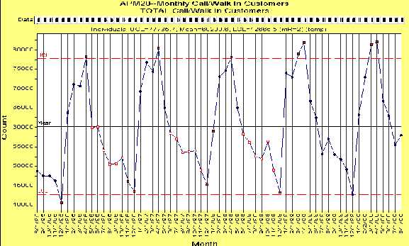
Quality Customer Service is the motto of the department. Although taxpayers dealing with a revenue agency often exhibit great stress, the customer service satisfaction survey
conducted by the University of South Carolina for the department continues to demonstrate the commitment to excellence. More than 89 percent of those conducting business with the department are satisfied with the service. The survey is not only used to gauge customer satisfaction, but also to receive feedback for areas in need of improvement. Comments from the survey indicate that most of the dissatisfied customers are dissatisfied by factors not under the jurisdiction of the department. Through analysis of comments from the survey, stakeholder analysis in developing the new Strategic Plan, comment cards, e-mails, Revenews, and tax practitioners’ surveys, the department identifies customer concerns that need to be addressed. Customer focus and satisfaction is also exhibited through the delivery of service to the taxpayer. Data captured depicts a 55.6 percent increase in the number of refunds delivered to the taxpayer within 30 days or less.

The cycle time for long form refunds has been reduced from 35.09 days in 1999 to 27.28 days in 2000. The short form refund cycle time dropped from 37.81 days in 1999 to 26.66 days in 2000. The department is focusing its efforts to provide additional electronic filing opportunities to taxpayers to expedite the refund processing system.

Financial and Market Results. The primary areas for analysis are enforced collections, lost investment opportunity, deposits by electronic funds transfer, filing by electronic means, and voluntary compliance.

Enforced collections for FY 1999-2000 were $316.8 million, a positive response to the flat-rate of growth in FY 1998-1999. This year’s rebound of 16 percent is attributable to management’s monitoring of the proper indicators and responding accordingly, additional tax law training, and the ability to increase the number of audits performed by improving technology.

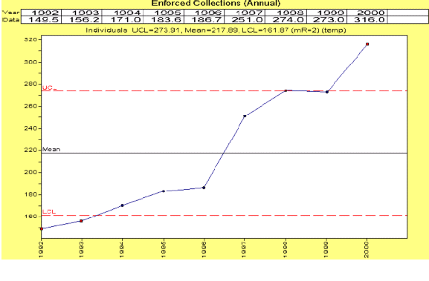

Again, South Carolina leads the nation in percent of electronically filed returns.

This included filing by four different technologies.

Total electronically filed individual income tax returns increased by 19.99 percent over last year.

This filing season, the due date for income tax returns was extended to May 1 for those who filed electronically. Since the program’s inception in 1995, electronically filed returns have increased by 121.55 percent.

Human Resource Results. Recruiting is the initial step in ensuring a highly qualified workforce. Many of our minimum training and education requirements exceed those of the respective state job classification, and 47 of our 48 new hires exceeded DOR’s minimum job requirements (98 percent).

Educational Levels
The statewide EEO report showed our department as 12th of all state agencies with a 94.4 percent goal attainment. This is a significant change from an overall ranking of 39th in last year’s EEO report. Of the 28 agencies with 500 or more employees, we rank 5th in EEO statistics. We have made significant gains in attracting a diverse work population, actively managing this process and educating our supervisors at each hiring opportunity. Seventy-four percent of the total applications received were minority applications, an increase of 11 percent from last year.

As to turnover this year, 25 employees retired (3.4 percent) and 35 resigned (4.9 percent). This is significant in a year with a very tight labor market and one in which the overall state turnover rate was 14 percent. Exit interviews overwhelmingly showed that those who resigned left for better individual job opportunities. No employee grievances were filed this year. Twelve compensable worker’s compensation claims were filed this year, as compared to 17 last year.

Job development plans or career ladders help us both develop employee skill levels and reward individuals for their ability to apply those skills. We increased the percentage of non-supervisory employees covered under these plans this year from 65 percent to 72 percent.

Analysis of retention statistics this year indicates that employees in a development plan are less likely to leave our employment. At year-end, $35,215.50 had been reimbursed to employees for 197 hours of college credit earned. We anticipate that the program will continue to grow with this year’s program improvements.

Last July we expanded our flexible work hour program to include flexible work week options to help our employees balance their professional and personal lives. Feedback from employees on the options has been overwhelmingly positive. We actively promote the benefits available to our employees (e.g., the department has the highest participation rate (77 percent) in the State Deferred Compensation program). In addition, we provide and promote other employee benefit programs such as laundry pickup and delivery, an automatic teller machine, daycare screening service, and twice-a-month take-home meal delivery. This year 679 employees participated in various health benefit programs, such as health screenings, mammograms, and flu shots. Also, one of our former Commissioners expanded his privately funded scholarship program to include children of our employees.

Our recognition program (STAR) formally recognized 756 individuals and/or teams last year for their contributions in one of seven different categories. Thirty individuals completed the formal mentoring program this year and 40 more began a mentoring partnership in May.

Skills and knowledge are critical to employee performance. We address knowledge management through a combination of both internal and external training.

Training Hours Per Employee.

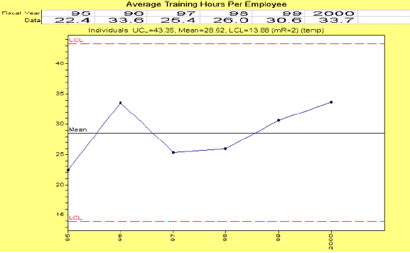
Our employees attended a total of 25,422 hours of training for an average of 33.7 hours per employee. Employees who administer tax law attended 9,785 hours of training for an average per employee of 19.6 hours. In addition, a total of 9,519 hours of quality and leadership training was offered for a total of 12.6 hours per employee. This excludes on-the-job training (OJT) that is a basic training tool of all sections. Eighty-four structured OJT modules were developed this year to help standardize the OJT process.

Supplier and Partner Results. The department continues to build partnerships and relationships with customers and suppliers. The ability to enhance compliance at the state and local level has led the department toward collection of state and local debts. Over the last eight years, the number of income tax refund debt offsets has increased from 40,000 items per year to a high of 196,201 per year. The corresponding collections reflect an increase from the first year of implementation of $9.5 million to a high of $46.5 million.

To enhance collection capabilities, the department has formed a partnership with collection agencies to collect out-of-state debts and some in-state delinquent debts. During FY 1999-2000 the private collection agencies collected $3,856,413, at a cost of 12 percent of the total amount collected.

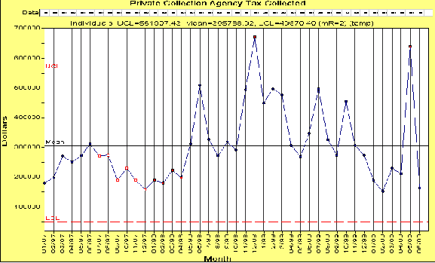
The department is currently collecting debts for DHEC, LLR, and the Second Injury Fund. We are anticipating signing contracts with several other major state agencies and local entities.
Likewise, a group of 11 state agencies, in conjunction with the Association of Counties and Municipal Association, are collaborating to develop a single point registration to do business in South Carolina. This initiative called SCBOS (South Carolina Business One-Stop) will register taxpayers with all agencies, thus reducing excessive duplication in government and reducing the burden of compliance for taxpayers.

Organizational Effectiveness Results. In analyzing the effectiveness of any revenue organization the standard is the cost to collect each dollar of revenue. For the South Carolina Department of Revenue, the cost of collection has been declining from one cent for every dollar collected in the past several years to seven tenths of a cent. To measure effectiveness, the department benchmarks itself to several other states nationally and fares favorably.

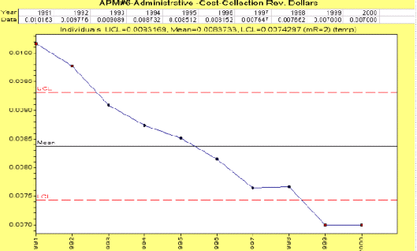
The department reviews the number of returns processed by our employees and the average dollars collected to determine workload increase. Over the last nine years the number of returns processed by each employee at the department has increased from 5207 to7988. Likewise, collections have increased from $4,542,000 per employee to $8,458,106. Dramatic increases in workload and collection have occurred while incurring a 13.4 percent reduction in total employees over the same period of time.
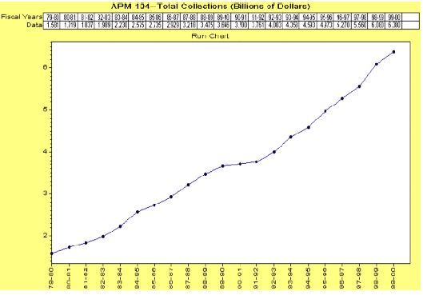

Program Descriptions

Program Title: Tax Operations-Office

Program Rank: 1

Program Cost: State: $6,592,644
Federal:
Earmarked:
Other: $1,644,950 (Agency Fees)
Total: $8,237,594

Program Goals: Responsible for the administration of the South Carolina Code of Laws
and regulations as they relate to income tax on banks, savings and loan associations and insurance companies; income tax on corporations, fiduciaries, and individuals; license fees on utilities; disposition of unclaimed property; tax-exempt corporations and partnerships; and the estate and gift tax statutes of the state. The administration of the laws and regulations governing licensing and registering firms, individuals and contractors; furnishing tax report forms; processing tax documents; maintaining taxpayer files and records of entry; processing claims for refunds and applications for machinery exemptions related to sales and use tax statutes; notices generated to taxpayers who fail to file; proofing of tax reports; assessment of delinquent taxpayers; issuance of credit memoranda; generation of audit leads; securing bonds from local and foreign contractors and the tracking of their contractual activities is performed in this program. Additionally, business license, admissions, electric power, and motor fuel (other than gasoline) taxes are administered by this program.

All monthly or quarterly returns are received and processed by this program as well as the pre-audit of income tax returns. Some examples are: the collection of admissions tax, documentary tax, electric power tax, registrations fees, highway use tax, public recreation license tax, soft drink tax, forest product tax, and radioactive waste disposal tax. All carrier permits and decals required by law are issued in this program.

A complete mail room and courier service is provided by this program

Program Objectives: Develop and make recommendations for the final notice prior to revocation of a business license.

Implement collection of taxes by credit card.

Work with all interested agencies to plan implementation of a master registration system to enhance customer service.

Investigate methods to accelerate the check deposit process during the individual income tax filing period.

Develop a data base of current local county/municipality sales (or gross receipts) taxes.

Complete implementation of program enabling taxpayers to file and pay sales taxes by electronic means.

Issue a Federal Employer Identification Number (FEIN) to prevent taxpayer from having to make return visits to complete registrations.

Timely issuance of requested refunds to taxpayers.

Examine and improve the processing of electronically filed signature documents.

Improve performance standards for corporate income tax processing

Timely deposit all revenues received by the department for investment by the State Treasurer.

Re-engineer the jobs development credit process.

Develop strategy for re-engineering the front end processing function.

Review department data bases to insure that information is complete and accurate.

Make improvements to taxpayer booklets and forms.

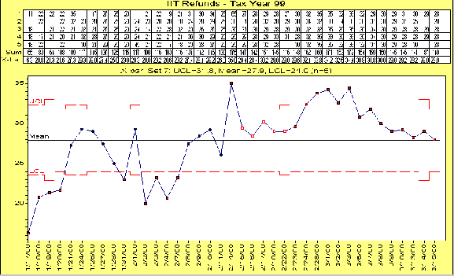
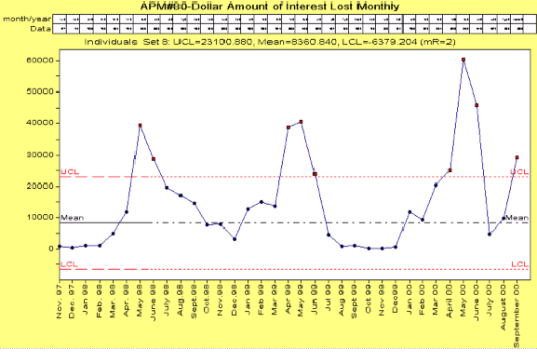

Program Title: Information Resource Management

Program Ranking: 2

Program Cost: State: $6,050,789
Federal:
Earmarked:
Other: $4,017,294 (Agency Fees)
Total: $10,068,083

Program Goals: This program maintains master files and delinquent control notifications. It performs computer audits of sales and use tax and individual income tax returns; prepares statistical and accounting reports; balances all refunds issued; executes the necessary functions for key data entry, computer operations and programming. It ensures computer capacity, maintains security of data, and continually updates computer operations and the knowledge and skills of programmers. This program provides the photo copier center, microfilm, records management and forms design. It provides the system development effort.

Program Objectives: Enhance forms access by making them available through CD ROM, Internet, and diskette services.

Benchmark agency core processes against world-class private and public entities.

Continue to develop, improve and implement electronic commerce strategies which encompasses returns filling, updating of data files, tax payments, forms ordering, Electronic Data Interchange (EDI), Electronic Funds Transfer (EFT), interactive voice response and the Internet.

Enhance the Web refund tracking system to improve ease of use for the customer.

Implement a rapid response team for equipment problems and maintain data on service calls.

Create an offline prototype structure to allow multiple agencies to be supported by the Business Taxpayer Registration system.

Conduct a study of the Sales Tax Processing system to determine if a re-design is necessary to improve multiple local option formats.

Complete readiness for Year 2000 and develop contingency plans.

Promote continual growth in the volume of alternative filings of returns (Internet and/or electronic).

Monitor the new Alcoholic Beverage Licensing system to ensure it is meeting customer needs.

Develop and implement a motor carrier property tax system.

Implement Tele-file system for sales and withholding zero payment tax returns.

Re-evaluate the feasibility of using 2-D barcode technology on tax returns.

Plan and coordinate department issues involving the Office of Information Resource Data Center’s relocation to Broad River Road.

Upgrade the main office wiring to support future applications such as image retrieval to all desk tops.

Program Title: Tax Operations-Field

Program Ranking: 3

Program Cost: State: $12,653,952
Federal:
Earmarked:
Other: $917,399 (Agency Fees)
Total: $13,571,351

Program Goals: This program is responsible for all field audits, delinquency collections, for all taxes both domestic and foreign, and taxpayer assistance.

Statewide coverage is accomplished through nine taxpayer service centers. The program audits and enforces collections of individuals and businesses operating within or outside of the state to ascertain if a tax liability or overpayment exist. It also, assists taxpayers with compliance of the tax statutes of the state.

Program Objectives: Develop an improved set of criteria for audit selection.

Design and implement a tax audit coverage plan to provide coverage of key areas and certain high-risk industries.

Establish a program for taxpayers to make installment payments through bank drafts.

Increase enforced collections.

Increase the use of statistical sampling, computer assisted audit programs and managed audits.

Increase assessment of withholding tax against responsible party.

Standardized the documentation required of a taxpayer when verifying a claim for refund.

Increase taxpayer assistance coverage during peak usage to enhance customer service.

Implement option to use credit cards for payment of taxes.

Actively solicit, record and utilize customer comments through post audit questionnaires.

Evaluate permanent and temporary staffing allocations to include a focus on increasing collections.

Work with Human Resource Planning and Development on improving career development plans for revenue officer, tax auditor, nonresident auditor, property analysts and tax technicians.

Initiate a statewide debt collection for another agencies and governments beyond refund debt set-off.

Investigate issues involved with implementation of a centralized call center.

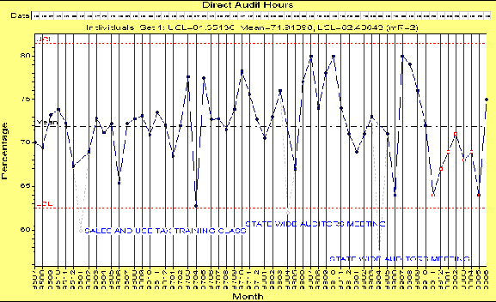

Program Tile: Tax Operations-Property

Program Ranking: 4

Program Cost: State: $1,456,121
Federal:
Earmarked:
Other: $387,821
Total: $1,843,942

Program Goals: This program is responsible for the administration and enforcement of the property tax statutes and collection of the state’s portion of South Carolina property tax. It ensures that all property required to be appraised is accurately assessed and certified for collection (the real and personal property of all manufacturers, public utilities, pipeline companies, motor carriers, and business personal property in the state). It assist and directs a program of reassessment and equalization of all real property of counties.

It administers the equalization of property tax assessments among the state’s 46 counties and provides technical assistance to county appraisers and assessors. Comprehensive technical appraisal and mapping assistance is provided to all county governments through this program. Improvement in the level of appraisal quality in the state is achieved through better control of assessment procedures maintained by this program.

Program Objectives: Develop audit coverage requirements for property tax audits of manufacturers.

Develop and implement a comprehensive cooperative program with the South Carolina Auditors, Treasurers and Tax Collectors (SCATTS) and the South Carolina Association Assessing Officials (SCAAO).

Improve the Fee-in-Lieu of Tax process by instituting initial taxpayer reporting.

Continue to enhance working relationships with the Comptroller General and local government officials through consensus to clearly delineate and communicate each entity’s responsibilities.

Develop a standardized audit check sheet to conduct county office audits of property tax issues.

Develop an information system to be used by counties under reassessment orders.

Provide training to counties, municipalities, and school districts by providing on-line access to assessments and exemptions.

Program Title: Regulatory

Program Ranking: 5

Program Cost: State: $509,891
Federal:
Earmarked: $344,546
Other:
Total: $854,437

NOTE: The Regulatory Division was reorganized as a result of the legislative ban on video poker. It was merged in the department’s reorganization into the Registration, Regulatory Licensing and Local Government Services Section of the Revenue and Regulatory Operations Division.

Program Goals: To register, issue licenses and maintain reports reflecting the activities of the video poker, bingo and alcoholic beverage functions. Insurance of compliance of the statutes and issuance of policy decisions affecting these industries is the responsibility of this program.

Program Objectives: Review regulations and statutes for alcoholic beverage license, bingo, and video poker to insure proper enforcement of the laws.

Develop documented procedures for alcoholic beverage license, bingo, and video poker licensing and violation reports.

Maintain effective communication and ongoing training programs with the State Law Enforcement Division (SLED) for the enforcement of alcoholic beverage licensing and bingo.

Develop and conduct alcoholic beverage licensing, bingo, and video poker training programs for internal and external customers.

Develop a violation tracking system for alcohol beverage licensing, bingo, and video poker.

Re-engineer the local option process for alcoholic beverage license.

Program Title: Administration, including Executive, Office of General Counsel, Internal Audit, Human Resources, Training, Planning and Quality

Program Ranking: 6

Program Cost: State: $5,675,178
Federal:
Earmarked: $228,772
Other: $9,226,311
Total: $15,130,261

Program Goals: Increase taxpayer awareness of the benefits and responsibilities of tax compliance through public information, taxpayer education, and assistance activities. Utilize information resources and technology as key strategic assets and manage these resources from an agency-wide perspective. Continue emphasis on employee development and retention as a central factor in the agency’s ability to effectively serve the citizens. Strengthen the development of the organization by providing a strong foundation for directing tax administration into the 21st Century. The Administrative Division provides the basic support functions rendered by the agency for Accounting, Budgeting, Internal Audit, Legal, Special Investigations, Tax Policy, Research, Human Resources, Planning, Quality, and Training.

Program Objectives: Work with the Attorney General’s Office, SLED, and Governor’s Office to determine the Agency’s role in the implementation of the tobacco settlement and enforcement

Participate in the Comptroller General’s local government finance steering committee study to develop changes to the property tax laws.

Work with the Governor’s Office and Legislature to research and review the administration of lottery systems nationwide.

Recommend legislation to correct technical errors, simplify, and reduce the burden of compliance and administration of tax laws.

Establish procedures requiring the Department of Labor, Licensing and Regulation to confirm taxes have been paid before issuing a license by that agency.

Develop systematic programs to identify and prosecute violators of the tax laws.

Update and publish brochures for customers, including new topics such as a Tax Guide for Senior Citizens, and a Tax Practitioners Guide to the Department of Revenue and South Carolina Taxes.

Inform the citizens on state tax filing methods, direct deposit, Internet filing, and other timely topics.

Provide guidance to the public, political subdivisions, other state agencies, and department employees through the publication of policy documents.

Investigate and implement opportunities for collaboration between state agencies.

Restructure line divisions and districts to align with the agency’s core competencies and best use of staff.

Investigate and evaluate implementation of an integrated financial system.

Develop plans to implement activity based costing.

Define and rank each component of the audit universe based on the level of risk for the department.

Evaluate and streamline Human Resource processes to reduce paperwork requirements and cost to the agency.

Continue and enhance the agency’s mentoring process.

Continue implementing the Executive Development Program to ensure the department’s senior level managers are prepared to meet future leadership challenges.

Continue efforts to ensure a diverse workforce in all Equal Employment Opportunity categories.

Implement a variable work hours option for agency employees.

Review the Tuition Assistance Program for needed policy changes and/or updates.

Update and improve the Employee Performance Management System policy and process, including training for reviewers.

Plan and coordinate a Benefits and Health Fair to communicate available state benefits and to promote wellness and health screenings.

Implement the Tax Law Training Plan for all employees in the agency by providing instruction in all introductory courses and begin development and delivery of intermediate and advanced courses.

Provide tax systems training to all new employees affected by new or changed systems.

Provide leadership and management training across the agency, to include specific human resource, quality, and supervisory development skills.

Identify and train at least one internal Baldrige assessor for all divisions.

Research internal awards for community and professional service. Submit nominations for those employees who meet the award criteria.

Continue to improve contact and communication with employees in field offices.

Research and formulate a new Department of Revenue Strategic Plan to be implemented July 1, 2000.

Redefine the process of performance measurement and standards in the agency to tie directly to the new Strategic Plan.

Actively support the Governor’s Educational Initiative using the skill and knowledge of employees.

Benchmark agency core processes against world-class private and public entities.

Improve the administrative oversight of the accommodations tax funds.

Customer Satisfaction With Service Provided
Asked Only Respondents Who Had Contact With The Department In The Past Year

