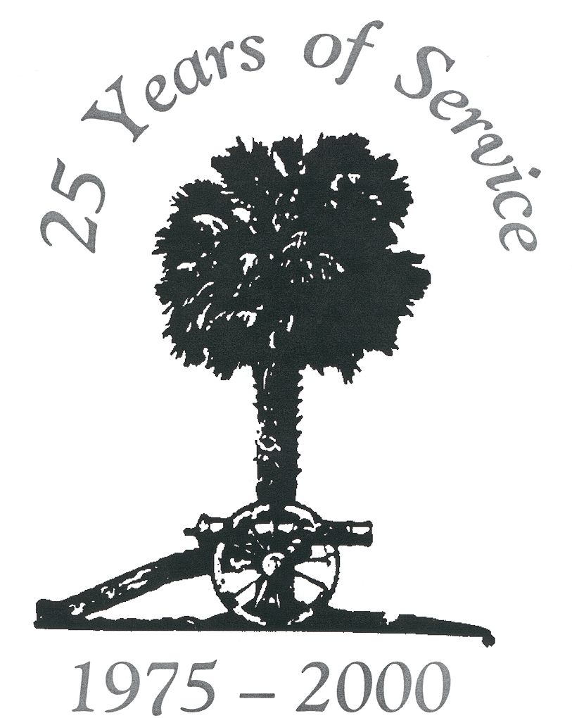

South Carolina General Assembly

LEGISLATIVE Audit Council

Annual Accountability Report

FY 99–00

Table of Contents

I. Transmittal Letter
II. Executive Summary
III. Mission Statement
IV. Leadership System
V. Customer Focus and Satisfaction
VI.A. Strategic Planning
VI.B. Information Collection and Analysis
VI.C. Human Resource Focus
VI.D. Systems and Processes for Assuring Quality
VII.A. Description of Program
VII.B. Key Results
TABLE Measurements of Audit Inputs, Audit Quality, and Audit Results

I. Transmittal Letter

July 31, 2026

His Excellency, James Hodges, Governor
and Members of the General Assembly:

We are pleased to provide the annual accountability report of the South Carolina Legislative Audit Council for the fiscal year ended June 30, 2000. The LAC encourages legislative requests for performance audits and is committed to audit work that will be responsive to legislative needs. Please call me or Cheryl Ridings, Deputy Director, at (803) 253-7612 with questions or comments.

Respectfully submitted,
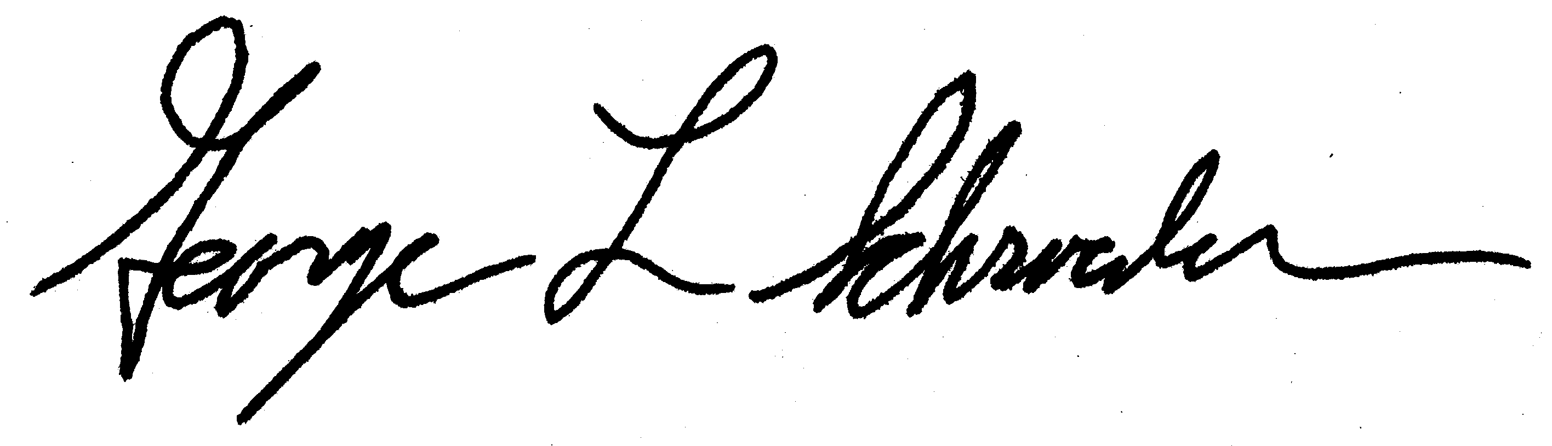
George L. Schroeder
Director

II. Executive Summary

The LAC’s single program is to conduct performance audits at the request of the General Assembly. In the process, the LAC maintains ongoing communication with the General Assembly and the public. In addition, there is open communication among LAC staff of all ranks in the decision-making processes of the agency.

The audit staff of the LAC all have graduate degrees or professional licenses. The agency’s audits are conducted in compliance with the requirements of Government Auditing Standards published by the Comptroller General of the United States.

Results In FY 99-00

 A Review of South Carolina School Bus Purchases
 A Review of the Medical Malpractice Patients’ Compensation Fund
 A Review of the South Carolina Special Schools Program
 A Review of Medical Services at the SC Department of Corrections
 A Review of the Charleston Naval Complex Redevelopment Authority’s 1999 Lawsuit Settlement With Braswell Services Group
 A Review of the Human Affairs Commission’s Hiring Practices and Timeliness of Investigations
 A Review of the Department of Revenue’s Vehicle Assessment Guides

We identified financial benefits that exceeded the LAC’s budget many times over. In addition, we recommended many ways to improve the performance of state government; these improvements may not be financially quantifiable, but they contribute to the effectiveness of government operations.

III. Mission Statement

The Legislative Audit Council conducts independent, objective, performance audits of state agencies and programs, as requested by the General Assembly and mandated by state law. In this oversight role, the LAC provides information that helps the General Assembly determine whether state agencies are efficiently, effectively, and lawfully managing public resources, and whether the agencies are meeting their objectives.
IV. Leadership System

The Legislative Audit Council’s leadership system is comprised of a governing body, a director, a deputy director, and three audit managers. When setting direction for the agency, the following influences the leadership:

State Law

Section 2-25-10 et seq. of the South Carolina Code of Laws outlines the authority and responsibilities of the Legislative Audit Council.

Federal Standards

Our qualifications and work are subject to Government Auditing Standards, as established by the Comptroller General of the United States. Every three years, a team of auditors from throughout the United States conducts a “peer review” of our procedures and working papers for compliance with these standards.

Views of Staff

Several times a years, the leadership has meetings with staff, at which ideas and views are exchanged about our work.

Each year at least one LAC quality team, which includes a representative from the leadership, reviews policies and procedures within the agency and suggests improvements. In FY 99-00, one team suggested ways to conduct audits more quickly while another team suggested a process for assessing compliance with our audit recommendations. At the end of FY 99-00, management was in the process of determining policy and procedural changes needed based on the teams’ suggestions.

More important than the above-mentioned formal structures, is the LAC’s atmosphere of informal discussion and debate among employees of all ranks regarding both internal policies as well as the substance of ongoing audits. We have found that thoughts and ideas can best be formed and refined through constructive dialogue.

In FY 00-01, LAC leadership will initiate a periodic employee survey to more formally measure the views of staff. This survey will enable us to improve our leadership system in two ways. First, it will enable management to establish annual goals regarding the success with which we listen to the views of staff. Second, it will enable us to measure changes in the perceptions of staff across time.
Views of Customers

Next, in part V of this report, we summarize how we obtain customers’ views, which we use to guide our decisions.

V. Customer Focus and Satisfaction

The Legislative Audit Council has two primary customers, the General Assembly and the public. We routinely obtain information from the General Assembly and the public regarding their satisfaction with our services.

Input From the General Assembly

State law requires that all audits of the LAC be requested by five or more legislators or be mandated by state law. At the beginning of each requested audit, we meet with the legislative requesters to ensure that we understand their concerns. We then send a letter with our audit objectives to the requesters. After each audit has been published, we conduct written satisfaction surveys of the legislators to obtain feedback regarding the usefulness and timeliness of the audit. These contacts and feedback enable us to continuously reevaluate our processes as we strive to improve.

Input From the Public

Determining the requirements, expectations, and preferences of the public is a complex task. Often, members of the public contact us about an agency that is alleged to be performing in a substandard manner. We give instructions to such callers regarding how audits can be requested through their local legislators. Upon request, we also meet with members of the public to discuss their concerns.

Dissemination of Audit Reports

All LAC audit reports are available free of charge. Audit reports and information about the LAC are also published on the Internet at www.state.sc.us/sclac.

The news media are crucial to communication between the LAC and the General Assembly and the LAC and the public. A news story will often highlight a concern of members of the General Assembly or the public that is relevant to an upcoming or ongoing audit. For the overwhelming majority of the public, news stories are their only source of information regarding LAC audits. We therefore provide news media from around the state copies of our reports and respond to questions they may have.

VI.A. Strategic Planning

Although the Legislative Audit Council does not have a formal strategic plan, we have two strategic performance goals:

 Identify specific ways to reduce the cost of state government.
 Identify specific ways to improve the performance of state government.

Our methods for meeting these goals have been refined over the years by consensus among the leadership and staff. Other audit organizations in South Carolina government focus on compliance with laws, regulations, and accounting principles. A unique aspect of our role is to provide recommendations for improvement even when an auditee is in compliance with applicable laws, regulations, and accounting principles. We also note accomplishments made by the agencies we audit.

Performance Objectives

The type of auditing we do and the way we get our assignments make it difficult to quantify objectives and benchmarks that relate to reducing the cost and improving the performance of state government. Most LAC audits are requested on an ad hoc basis by members of the General Assembly, preventing us from knowing in the planning process what programs we will be auditing. In addition, organizations similar to the LAC in other states do not always audit the same programs that are audited by the LAC. Therefore, to date we have not established quantified objectives and benchmarks for cost reduction and performance improvement.

Although we do not have quantified performance objectives, we measure and report:

- Financial benefits identified in LAC audits.
- Recommendations made in LAC audits.

In FY 00-01, LAC leadership will begin a process by which we measure and report:

- Financial benefits realized from LAC audits.
- Recommendations implemented from LAC audits.

This process will be modeled after one developed by the federal General Accounting Office and will be fully implemented in FY 01-02. To account for year-to-year volatility in the data, the audit results we measure and report will include four-year averages in addition to annual statistics.

Internal Management Objectives

We have established quantified internal management objectives that we associate with quality and efficiency. Below is a list of current internal management objectives and a new objective we established for FY 01-02:

- 90% of auditors will have graduate degrees or professional licenses.
- 100% of auditors will have a minimum of 20 training hours in the past year and 80 hours in the past two years.
- The LAC will comply with Government Auditing Standards.
- 80% of South Carolina legislators will be satisfied with the quality of our audits.
- In FY 01-02, we will initiate a timeliness objective developed by the federal General Accounting Office. For each audit, we will communicate to the legislative requesters our projected date of publication. We will seek to publish 80% of audits by the date projected.

Further discussion of the above objectives can be found in V, VI.B, VI.C, VI.D, and VII.B.

VI.B. Information Collection and Analysis

We regularly collect and analyze information regarding inputs, results, and quality. The measures listed below were developed and refined by our leadership and staff.

Audit Inputs

Audit inputs include the percentage of auditors with graduate degrees or professional licenses, the percentage of auditors with minimum training hours, and the percentage of our audits published by the projected date.

Audit Quality

Audit quality includes the degree to which we have complied with Government Auditing Standards, determined every three years in a peer review of our operations by a team of auditors from throughout the United States. It also includes the percentage of legislators indicating in written surveys that they are satisfied with the quality of our audits.

Audit Results

To date we have measured the results of our work through the financial benefits identified and the number of recommendations made.

In FY 00-01, LAC leadership will begin a process by which we assess the degree to which financial benefits have been realized and the degree to which our recommendations have been implemented. This process will be fully implemented in FY 01-02. It will replace, in part, the audit follow-up role of the State Reorganization Commission, which was terminated in 1998.

VI.C. Human Resource Focus

At the end of FY 99-00, the Legislative Audit Council had 15 auditors and 3 administrative employees. Through training, performance management, and an employee feedback system, we maintain a quality workforce that participates in the operation of the agency.

Each auditor is required to have or obtain a graduate degree or a professional license.

We have a training program to support our strategic priorities and objectives of reducing the cost of government and improving its operation. Upon being hired, each auditor is sent to a one-week performance auditing training program. Each auditor is required by Government Auditing Standards to undergo 80 hours of additional training every two years. In addition, each audit manager attends the Executive Institute of the South Carolina Budget and Control Board.

At the conclusion of each audit, the performance of each auditor is reviewed in writing by the manager of the audit. Annually, the performance of each administrative employee is reviewed in writing by the deputy director. Each performance review is discussed in a private meeting, during which views of the staff member and the supervisor are exchanged.

As discussed in part IV, in FY 00-01 the LAC leadership will initiate a periodic survey of all staff to more formally measure their views.

VI.D. Systems and Processes for Assuring Quality

In a sense, the primary product of the Legislative Audit Council is our system for ensuring the quality of our analysis. We provide information, without conflict of interest, that has been subjected to a structured process for ensuring accuracy. Other potential sources of information available to legislators, such as the affected agencies, consultants, citizen groups, and the news media, often do not meet these standards.

Avoidance of Conflict of Interest

The LAC receives no funding from the state agencies it audits. Prior to each audit, each staff member is required to sign a statement indicating whether the staff member has a conflict of
interest or the appearance of a conflict of interest. Audit supervisors ensure that auditors are not assigned to areas where there is a conflict of interest or the appearance of a conflict of interest. In addition, each member of our governing body signs a conflict of interest statement.

Assurance of Accuracy

All of the narrative in our reports is supported by documentation that we maintain in our files. The degree to which the narrative is supported by valid documentation is determined by the auditor’s supervisor and a coworker not assigned to that audit. In addition, our staff attorney reviews the accuracy of any legal citations in the narrative.

Adherence to Audit Standards

Every three years, a team of auditors from throughout the United States conducts an on-site peer review of our agency’s operations. The team assesses the degree to which our agency is in compliance with Government Auditing Standards established by the Comptroller General of the United States.

Improving Processes and Systems

As discussed in part IV, the LAC leadership and staff have been working together to identify and implement ways to improve our processes. Current projects address improving audit timeliness,
measuring the implementation of our recommendations, and surveying the views of LAC staff.

VII.A. Description of Program

A. Program Name: Performance Audits of State Agencies and Programs.

B. Program Rank: This is the LAC’s single program.

C. Program Costs: Program costs of $1,181,180 comprised the LAC’s entire expenditures in FY 99-00.

D. Program Goal: To recommend to the General Assembly and state agencies, in an unbiased, competent, and responsive manner, specific actions through which costs can be reduced and performance improved.
E. Program Objectives:

- To ensure that audit staff have or obtain graduate degrees or professional licenses (e.g. certified public accountant).
- To ensure that all audit staff receive the type and quantity (at least 20 hours per year and 80 hours per two-year period) of training that is required by Government Auditing Standards published by the Comptroller General of the United States.
- To ensure that audits are conducted in a timely manner.
- To ensure that all audits are conducted in compliance with Government Auditing Standards published by the Comptroller General of the United States.
- To ensure that legislators are satisfied with the LAC’s audits.
- To recommend specific ways to reduce the cost of state government.
- To recommend specific ways to increase the performance of state government.
- To determine the extent to which South Carolina agencies have complied with state law.
- To determine the adequacy of the services provided by South Carolina agencies compared with the services provided in other states and/or the private sector.

VII.B. Key Results

In FY 99-00, we published the following audits:

 A Review of South Carolina School Bus Purchases
 A Review of the Medical Malpractice Patients’ Compensation Fund
 A Review of the South Carolina Special Schools Program
 A Review of Medical Services at the SC Department of Corrections
 A Review of the Charleston Naval Complex Redevelopment Authority’s 1999 Lawsuit Settlement With Braswell Services Group
 A Review of the Human Affairs Commission’s Hiring Practices and Timeliness of Investigations
 A Review of the Department of Revenue’s Vehicle Assessment Guides

As shown in the following table, we identified cost savings that exceeded the LAC’s $1,181,180 budget many times over. In addition, we recommended many ways to improve the performance of state government that do not involve cost savings.
Measurements of Audit Inputs, Audit Quality, and Audit Results

Audit Inputs

 | FY 96-97 |  | FY 97-98 |  | FY 98-99 |  | FY 99-00 |  | FY 00-01 |  | FY 01-02
 | Objective | Results | Objective | Results | Objective | Results | Objective | Results | Objective | Results | Objective | Results
Auditors with  Graduate Degrees  Or  Professional  Licenses | 90% | 100% | 90% | 93% | 90% | 100% | 90% | 100% | 90% |  | 90%
Auditors with  Minimum  Training Hours | 100% | 100% | 100% | 100% | 100% | 100% | 100% | 100% | 100% |  | 100%
Product  Timeliness |  |  |  |  |  |  |  |  |  |  | 80%

Audit Quality

 | FY 96-97 |  | FY 97-98 |  | FY 98-99 |  | FY 99-00 |  | FY 00-01 |  | FY 01-02
 | Objective | Results | Objective | Results | Objective | Results | Objective | Results | Objective | Results | Objective | Results
Three-Year  Peer Review | Pass | Passed |  |  |  |  | Pass | Passed
Legislators  Satisfied With  Quality of Audits | 80% | 99% | 80% | 100% | 80% | 90% | 80% | 100% | 80% |  | 80%

Audit Results¹

 | FY 96-97 | FY 97-98 | FY 98-99 | FY 99-00 | FY 00-01 | FY 01-02
Financial Benefits Identified  Annual  Four-Year Average | $151.4 million  $44.3 million | $74.5 million  $61.1 million | $30.1 million  $68.3 million | $48.5 million  $76.1 million
Number of Recommendations  Annual  Four-Year Average | 110  108.5 | 188  114.5 | 118  130.8 | 75  122.8

- For Audit Results, we include four-year averages to account for year-to-year volatility in the data. We do not have objectives for Audit Results for the reasons discussed in part VI-A.

