________________________________________________________

South Carolina Department of Commerce

FY 1999-2000 Annual Accountability Report
________________________________________________________

- Transmittal Message:

The South Carolina Department of Commerce is the State’s marketing arm and sales force. Every aspect of the Department’s Operations are aimed at accomplishment of this task. Major strategic goals of the Department have resulted in specific work plans with targets and accomplishments as summarized in our Annual Report to the Legislature. That report is based on the calendar year. Major highlights of that report are repeated herein on a Fiscal Year Basis.

- Executive Summary:

As a marketing and sales group, we measure our results based on sales. South Carolina, in Calendar 1999, achieved a fifth consecutive year of $5+ billion in capital investment, actually exceeding $6 billion for the first time ever. Data for Fiscal Year 1999-2000 maintains this continued positive trend as capital investment for F/Y 2000 reached a record $6,637,000,000.

The following graph shows the very positive trend in Capital Investment Growth over the last seven years.

Capital Investment by Fiscal Year (in Billions)

As a sales group, we measure our success in terms of both raw data, as shown above and in comparison to our competitors. While our direct competitors are primarily our neighboring states, Alabama, Virginia and Tennessee, we measure our success against all of the 17 states that comprise the Southern Economic Development Council region, which also includes all of our major competitors. For Calendar Year 1999 (the latest information available) South Carolina was not only number one in per capita capital investment but was actually number one in total capital investment for the17-state region.

South Carolina’s economic growth last year was fueled by new investments by companies such as Carolina Phone, Ford Credit, Musashi South Carolina and ClientLogic Corp as well as expansions by existing South Carolina companies such as BMW, Honda, Kimberly-Clark, Robert Bosch and Michelin.

- Mission Statement:

“To increase the wealth of South Carolina’s
citizens – particularly as measured by per capita
income and the number and geographic distribution
of well-paid jobs – in a manner that supports and
enhances a high quality of life.”

Organizational Structure:

The following page contains the Department’s Organization Chart.

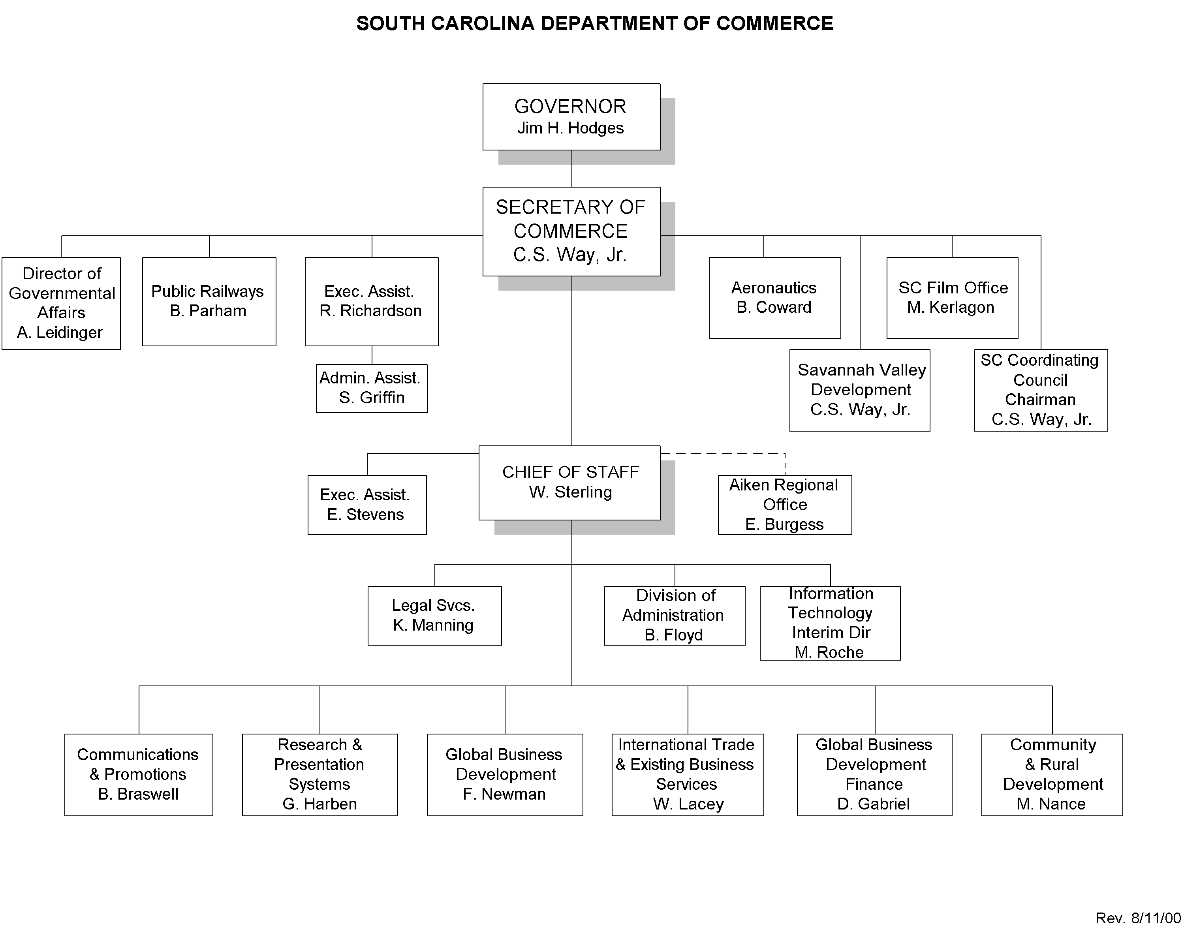

Program Summary:

The Department of Commerce operates one core program - - Economic Development. The major component units of this program are:

- Global Business Development (Investment Recruitment)
    - Recruitment of New International Companies to South Carolina
    - Recruitment of New National Companies to South Carolina
    - Competitive Business Expansion -- expansions by or new investments by companies with a SC business, especially where failing to get an expansion results in another location (state) getting the expansion or where losing the expansion also runs a risk of losing the existing company, as in the case of consolidations of operations
    - Technology Development (actually part of each of the other three, but so important to our future, we are focusing extraordinary attention on this market)

- Global Business Finance

- Trade Development (especially International Trade Development)

- Community and Rural Development

- Research and Presentation Systems

- Community Grants

- Recycling Market Development

These programs are, for the most part, fully integrated and seamlessly operated in order to maximize the utilization of the assets available to the Department. As an example, we operate a field agent program in our Existing Business Services unit of our Business and Trade Development Division. This operation serves the needs of the major existing manufacturers of the state in providing them with face-to-face contacts with representatives of the Department in order to:
  - Ensure that they are aware of the programs offered by Commerce
  - Ensure that the state’s existing businesses are aware of the overall pro-business climate in the state
  - Monitor the areas of concern among our constituents through carefully designed customer surveys to ensure we are fully aware of the perceived business climate as well as to enable us to address issues of concern
  - Pass feedback about the states business climate to the appropriate government entities

At the same time, this operation serves to generate leads for:

The Business Expansion effort

The Recycling Market Development Council

Trade Development

Therefore, this one program component, that costs less than $250,000 annually to operate, impacts nearly every other major unit at Commerce.

Further, this operation develops commentary that can lead to follow-up and training/advisory services as necessary for community leaders through our Community and Rural Development Division. Perhaps, even more important than any of the above, it often targets companies that are having difficulties and helps us to take pro-active action to avert layoffs.

Similar interactions, cross-linking of job duties and responsibilities make it difficult to precisely separate the services we provide into different programs.

Another difficulty in breaking out programs and measuring performance by program is illustrated by our Research and Presentation Systems Division. While, based on the FTE count, this is our largest division, looking at this program in isolation would cause one to wonder what they produce. All of their efforts are aimed at supporting other divisions. Yet, they are not an overhead group but a “cost of sales” function in that their primary efforts are in preparing the information, reports, proposals and presentations needed to make sales. Their “revenues” are almost zero, yet, we can’t make a sale without them. Think of them as the paint shop in the auto plant. Just try selling a car without a paint job!

The Department also operates the following programs that, while focusing on Economic Development are less integrated with the rest of the operation, in that their goals and missions are different. Even these divisions provide numerous opportunities to work together on common economic development opportunities and goals.

- South Carolina Film Office

- Airport Development

- Savannah Valley Development

- Public Railways

Lastly, the Division of Administration provides administrative support, human resource services, accounting, budgeting and other support services to the entire department and the Division of Information Technology provides systems support and computer infrastructure to the entire department.

Performance Measures:

Workload Indicators: FY2000
Conducted 646 liaison visits to existing state industries
Conducted 150 community development meetings
Provided advice to Governor and Legislature on programs and legislation to improve business climate and competitiveness
Provided training to 96 local officials through the Economic Developers School.
Conducted Governor's Rural Summit with 327 community leaders participating-
Published annual reports on economic activity including announced capital investments and employment
Compiled and published S.C. Industrial Directory
Conducted strategic research for targeted marketing program
Participated in 16 export trade shows
Hosted 2 foreign buying missions
Rendered export assistance to 760 SC companies
Developed and disseminated 3,048 export trade leads
Conducted 9 domestic marketing trips
Conducted 2 international marketing missions
Initiated 517 new projects
Provided 297 written proposals to prospects
Conducted 742 community visits with prospects

Efficiency Measures:

A major efficiency measure used by the department is the General Fund Dollars spent per million dollars of capital investment. Since inflation equally affects the dollars spent and the dollars invested, this is a sound measure of effectiveness that holds true over a period of time. The last few years show a positive trend with the Department becoming even more efficient in this regard.

Effectiveness Measure:

1494 firms committed to new capital investments in the amount of $6,637,305,983 with projected additional employment of 33,915

Efficiency Measures:

$432 (versus $447 last year) of general fund revenue invested per new job announced, for an increased efficiency of 3.4%

$2,208 (versus $2,433 last year) of general fund revenue invested per million dollars of announced capital investment for an increased efficiency of 10.2%

4.4% increase in per capita income from $22,544 (1998) to $23,545 (1999) (most recent data) - State Ranking improvement from 42nd to 38th

The Department of Commerce reports most economic development data on a calendar year basis, as do all of our competitor states. A comprehensive annual report is issued each spring on this data. That report is available on the internet at:

http://www.callsouthcarolina.com/departmentofcommerce.htm

