Accountability Report Transmittal Form

Agency Name | State Budget and Control Board
Date of Submission |  |  | September 6, 2001
Agency Director |  | Frank Fusco
Agency Contact Person |  |  |  | Hardy Merritt
Agency Contact’s Telephone Number |  |  |  |  | 803-734-1881

Section I: Executive Summary

Major Achievements
The South Carolina State Budget and Control Board is unique among state agencies, both within this state and nationally, with a membership drawn from both the legislative and executive functions of government under one authority. The five-member board is comprised of the Governor, the Chairman of the Senate Finance Committee, the Chairman of the House Ways and Means Committee, the State Treasurer, and the State Comptroller General. This Board provides for a continuum of executive and legislative oversight when the General Assembly is out of session.

The various offices of the Board have made progress in integrating the elements of the Malcolm Baldrige National Quality Award Criteria into the organization’s culture. The Office of General Services (OGS) has focused attention at the team level incorporating values, mission, strategic objectives, and performance measures into the workplace. Emphasis is being placed on developing the data necessary to produce accurate measures that can be compared to best practices benchmarks. OGS also completed the Fleet Management Imaging Program, making 32,000 documents available to customers via the Internet. For this, they won the South Carolina 2001 Innovation Award. Additionally, Facilities Management completed an assessment survey and condition index on the 24 most valuable buildings the state owns to determine budgetary needs in this area.

In November, the Office of Information Resources (OIR) unveiled South Carolina’s new Web portal. MySCgov.com is designed for citizens to access government anytime, anywhere. On-line services such as driver’s license renewal, state tax payments, criminal record checks, and accessing a multitude of governmental forms from one location saves citizens time. Additionally, OIR completed the physical consolidation of seven disparate data centers into one state-of-the-art facility, achieving parity with peers on cost efficiency as evaluated by the Gartner Group, an international technology consulting group. Additionally, the Board this year established a new Chief Information Officer (C.I.O.) to coordinate technology development and deployment, and to encourage innovation in the use of information technology.

The significant achievements for the Retirement Systems include the successful implementation of several legislative initiatives. The most profound impact to the system was realized as a result of the Teacher and Employee Retention Incentive (TERI) program. Of the 14,415 retirement applications received in FY 2001, 60 percent were for TERI participants with retirement dates of January 1, 2001 through June 30, 2001. Fifty-nine percent of the 3,290 school district employees electing TERI participation were teachers. Unprecedented numbers of members gained retirement eligibility as a direct result of the implementation of 28-year retirement and service purchase reform, both of which were legislatively enacted in 2000.

In surveys conducted by Governing Magazine in both 1998 and 2000, the Budget and Control Board’s Human Resources system was ranked number one nationally among state governments. The Office of Human Resources (OHR) used these surveys and organizational performance review findings from a KPMG performance audit to establish direction in two important areas. First, OHR stepped up efforts to involve agencies in workforce planning resulting in the first state report on the topic in 2001 and initiated an annual survey of agencies. The desired outcome of these initiatives is to ensure the stability of the workforce in the future. Second, OHR is now actively working with national human resources organizations to attempt to establish reliable benchmarking for various human resources services.

The Office of Local Government was cited by the Environmental Protection Agency for superior loan functions without any defaults as reflected in the “Best Practices” report by the EPA’s Inspector General. Also, the office was recognized by the General Assembly with a Concurrent Resolution “…expressing the appreciation of the General Assembly…and recognizing the able service of the management and staff of the Office of Local Government.”

The Office of Research and Statistics (ORS) completed road naming and address matching for 44 of 46 counties for 911 emergency services. ORS also completed the South Carolina and Georgia boundary survey near the mouth of the Savannah River, concluding 10 years of work with the Georgia Geodetic Survey. It also developed and deployed customized Web-based information sites for information concerning Census 2000 and the Traffic Crash Reporting System.

In December 2000, the Office of State Budget partnered with the Department of Juvenile Justice to reduce a projected operating deficit. As a result of cost containment measures and identification of other funding sources, the deficit was reduced from $3.1 million to $1.9 million.

The Office of General Counsel managed the successful litigation effort in the Supreme Court on a Petition for Rehearing that resulted in a judgment in favor of the Board and the South Carolina Retirement System. The case involved $1.95 billion in disputed benefits. This was the largest class action suit in the history of South Carolina.

Vision Statement
We will be known for excellence by those we serve.

Mission Statement
“The South Carolina Budget and Control Board leads state government in maximizing the return on South Carolina’s investments in human, fiscal, capital, and technological resources entrusted to government. The Board fulfills its mission by:

- Providing centralized support services to government agencies and employees;
- Providing direction through policies and oversight to foster effective government;
- Providing information, expertise and consultation to support decision making;
- Developing an effective workforce by providing services and benefits.”
Core values include dedication to service, commitment to a quality work product, dependability, loyalty, professional competence, teamwork, innovation, and personal integrity.

Key Strategic Goals
- Provide leadership to state government.
- Identify, research and evaluate the issues for which leadership is required.
- Communicate and build consensus around the issues.
- Advocate for the policy changes necessary to address the issues.
- Educate state officials and employees about the application of best practices.

- Enhance the Board’s efficiency, productivity, and effectiveness.
- Recruit, retain, and develop a productive workforce.
- Enable employees to make decisions and exercise discretion.
- Recognize and reward performance.
- Analyze and improve business processes.

- Satisfy stakeholders/customers.
- Engage stakeholders and customers continuously in a dialogue regarding their needs, wants, and expectations, and our performance relative to them.
- Measure and respond to stakeholder/customer feedback.

- Secure stable and predictable resources in order to provide better services.
- Ensure that our products and services are delivered in a timely manner, are fairly priced, and meet the needs of the customer.
- Inform the customer about what they are buying and the value they are receiving.
- Seek and develop new market opportunities.
- Identify and evaluate the necessity of current services and products.
- Make the business case that the results justify the dollars invested.
- Educate stakeholders about the value of our programs.

- Increase diversity across the organization.
- Increase awareness of the value of diversity.
- Ensure that the Board’s employee profile reflects compliance with the agency’s affirmative action plan.

Opportunities and Barriers
Extreme financial pressure creates new management strategies and new market opportunities. The state faces serious financial challenges for the upcoming years. This financial pressure enhances the desirability of our services to new markets. However, budgetary reductions of revenue funds result in lowering our ability to meet customer expectations and missed opportunities to invest and thereby create future cost savings.

Section II: Business Overview
Number of Employees and Operations Locations
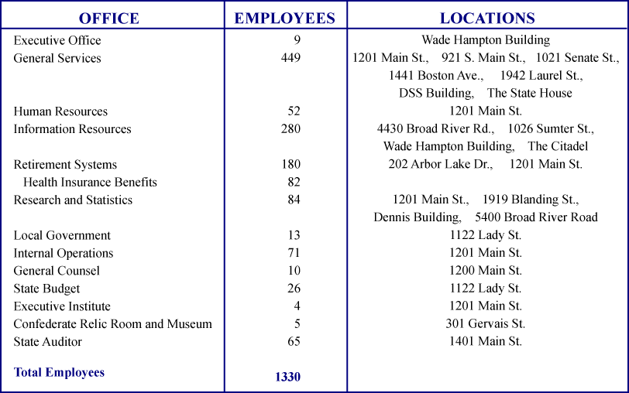
Note: The Board contracts with 214 employees.

Base Budget Expenditures and Appropriations¹
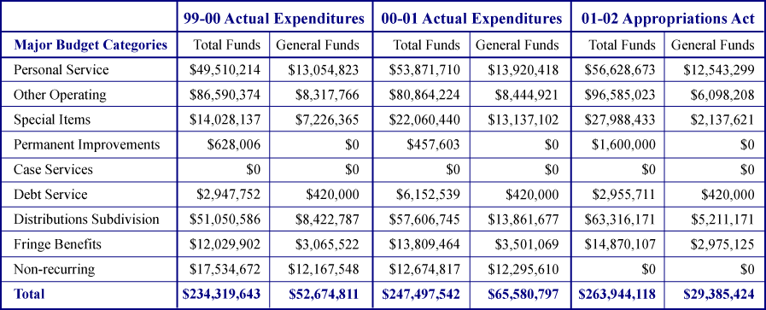
¹These figures represent the combination of F05 – Budget and Control Board, Division of Executive Director; F07 – Budget and Control Board, Division of Operations; F09 – Budget and Control Board, Division of Budget and Analyses; F11 – Budget and Control Board, Division of Regional Development; and F29 – Budget and Control Board – Retirement Division. The figures do not reflect F27 – Budget and Control Board, Auditor’s Office; F30 – Budget and Control Board, Employee Benefits; or F31 – Budget and Control Board, Capital Reserve Fund.

Note: The non-recurring major budget category would include all expenditures from supplemental funds and capital reserve funds; it may also include other expenditures. “Permanent Improvements” does not include bond expenditures, which are reported separately below.

Other Expenditures and Appropriations
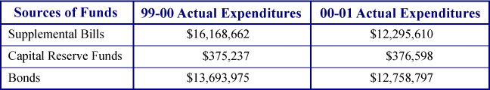

Organization Chart

Key Customers
The following matrix identifies the key customers of each of the Budget and Control Board's offices.

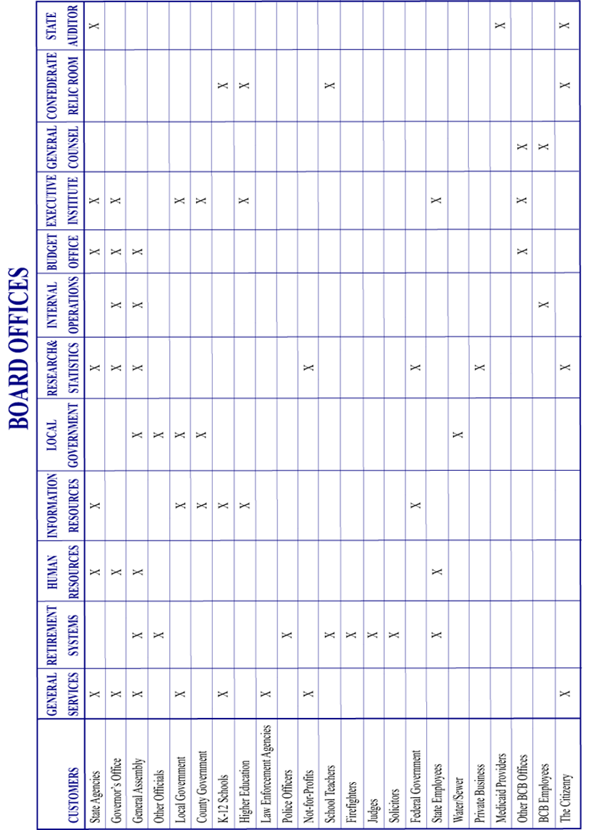

Key Suppliers
The Budget and Control Board enjoys a reciprocal relationship with other state agencies which serve both as providers of information and customers for the Board’s services.

The Board’s key suppliers include the 21,000 vendors eligible to bid on state contracts and the participating employers who remit member and employer contributions, enroll members, and provide verification information to the Retirement Systems. They include the computer technology and telecommunications firms who contract with Information Resources to provide needed support; the federal government from which the Office of Local Government obtains matching funds for infrastructure development; and information providers for the Office of Research and Statistics including federal and state agencies, local governments, private sector businesses and non-profit organizations.

Section III: Elements of Malcolm Baldrige Award Criteria
1.0 Leadership

1. How do senior leaders set, deploy and communicate: a) short and long term direction; b) Performance expectations; c) organizational values; d) empowerment and innovation; e) organizational and employee learning; and f) ethical behavior.

1.1.a-f The Office of the Executive Director developed a strategic plan in FY 2001 and is working to ensure that employees are aware of the mission, vision, and values of the organization. Customer requirements as communicated through face-to-face discussion between staff and members, surveys, intercept interviews, and focus groups help in setting the direction of the Board. A management team composed of division directors, senior staff, and office directors from operational and administrative departments serve to advise and review policy matters. This team meets monthly to establish and monitor the direction of the Board. The office directors communicate this information to all employees through staff briefings. We continue to work on an agency-wide approach to the leadership issue.

Performance expectations of the Board are reinforced through periodic staff briefings, work measurement, and positive reinforcement. These performance expectations are derived from the goals and objectives found in the Board’s strategic plan. Section and unit meetings are held to focus on matters with a more defined objective. Performance expectations are communicated through the use of the Employee Performance Management System (EPMS) program. Performance excellence is promptly rewarded with letters, recognition at office-wide events, and personal one-on-one “thank-yous.”

For example, within the Office of Human Resources (OHR), leadership has continuously worked to ensure that employees are aware of the mission, vision, and values of the Board and OHR. Nearly one-third of the OHR staff is directly involved in an annual planning session to review the past year’s accomplishments and update OHR’s strategic plan for the upcoming year. Their managers involve the remaining staff members as the action plan items are updated in each program area.

The Board’s organizational values include continuous improvement, innovation, employee development, and ethical conduct. General Services communicates these values through its annual review process and its annual leadership conference. OHR’s strategic plan emphasizes the continuous development of the workforce to meet customer expectations. Both organizational and individual development plans are created. Recognized as the “benchmark” for decentralized HR offices in state government by Governing Magazine, OHR’s flat organizational structure and emphasis on creating HR generalist consultants who can assist agencies in many ways demonstrates leadership’s commitment to empowering the workforce.

Throughout the Board, the ongoing integration of the senior leaders’ management philosophy and the restructuring of work roles and processes have resulted in a more customer-oriented, team-focused organizational culture much “flatter” than a traditional hierarchy. The senior leaders continually assess and improve the organizational climate while striving toward the goal of having everyone in the organization practicing the same reciprocal leadership philosophy, both employees and employers, and with management and staff aligned by mutually understood expectations.

To be effective leaders, management must meet the development needs of the Board’s employees. Conversely, each employee is responsible for taking the initiative to solicit appropriate feedback from his or her supervisor or team leader. For example, the leadership team of the Office of Information Resources recognized that the quality of the office’s services and the contributions of its employees could be greatly enhanced through participation in timely and structured training opportunities. Toward this end, the Office established a Training Committee, which developed a training program that structures employees’ development to maximize contributions to both the employees and the organization. It is consistently available throughout an employee’s career and it provides supervisors with a method to recognize individual talents, skills, and career goals. The Board, through its new Training Center, is expanding this initiative to include all employees.

Ethical behavior is communicated through personal examples of the senior leaders as well as general discussion of cases and policy decisions. The goal is to lead by example through establishing shared standards of excellence to which all are held accountable.

2. How do senior leaders establish and promote a focus on customers?

1.2 Senior leaders promote the Board’s customer-focused mission through the use of customer service surveys, focus groups, field visits, interviews, and intelligent observation to generate information. They use this information to focus management attention on customer concerns. General Services publicly reads congratulatory letters from customers to all employees and posts them on the “Wall of Success.” The Office of Information Resources uses an “instant rewards” program and the Office of Human Resources uses its “Partners in PerfOHRmance” program to recognize superior customer service.

- What key performance measures are regularly reviewed by your senior leaders?

1.3 Performance measures reviewed by senior leadership include customer satisfaction, human resources effectiveness, procurement effectiveness, facilities and fleet vehicle management effectiveness, risk management effectiveness, local government loans and grants effectiveness, asset management effectiveness (mail, surplus property, central supply), administrative support effectiveness, and the cost of telecommunications and computing services. The results are reported in Category Seven.

4. How do senior leaders use organization performance review findings and employee feedback to improve their own leadership effectiveness and the effectiveness of management throughout the organization?

1.4 The Board used organizational performance review findings from the 1998 and 2000 Governing Magazine reviews to establish direction in two important areas. First, the Office of Human Resources stepped up efforts to involve agencies in workforce planning, resulting in the first state report on the topic in 2001 and an annual survey of agencies. Second, OHR is now actively working with national HR organizations to attempt to establish reliable benchmarking data for various HR services. For the past three years, the Office of General Services (OGS) has used a Leadership Characteristics Survey to obtain employee feedback. Each of the OGS leaders are rated by their team members on how effectively they engage in 25 characteristics of leadership. Each leader also completes a self-evaluation on the same characteristics. This allows each to compare “the way I see it” with “the way you see it.” The leaders then meet with their raters to explore how they can improve their leadership characteristics. This process is being evaluated for use throughout the Board.

5. How does the organization address the current and potential impact on the public of its products, programs, services, facilities and operations, including associated risks?

1.5 The impact of the Board’s services is determined through the use of customer, stakeholder, and staff surveys, intercept interviews and focus groups, and one-on-one conversations with affected agencies and individuals. As the repository of data from the departments of Social Services, Mental Health, Juvenile Justice, Corrections, Public Safety, and Health and Environmental Control, the Board, in its Office of Information Resources, houses sensitive personal data of the state’s citizenry. The organization is very meticulous with such data and protects it through the use of physical and technological security.

The Board’s Office of Human Resources has contact with the public through its web site and the Career Center. Leadership has been proactive in providing clear information and hands-on services in both. A grant has been obtained to provide the disabled with better access to state-of-the-art onsite services. The web sites are designed to provide quick access to state employment information and allow those with disabilities to easily maneuver to get required information. In addition, OHR has participated with private sector companies, such as Blue Cross and Blue Shield of South Carolina, to facilitate the outplacement of state employees affected by reductions in force. OHR was instrumental in getting the Governor to declare State Employee Recognition Day on May 9, 2000, and encouraged state agencies to have associated events.

6. How does senior leadership set and communicate key organizational priorities for improvement?

1.6 Key priorities for improvement are communicated through the development of the strategic and action plans, and reinforced through monthly management team meetings, regular e-mails to all Board staff from the Executive Office and weekly, monthly and quarterly staff meetings within the offices.

7. How does senior management and the agency actively support and strengthen the community? Include how you identify and determine areas of emphasis.

1.7 Community volunteerism is encouraged by the senior leaders and supported through accommodation of staff scheduling requests. These efforts are actively supported by senior management. There are opportunities within the organization to participate in charitable giving through contributions to the United Way, the United Negro College Fund, Fill-A-Stocking, Harvest Hope Food Bank and the Community Health Charities (formerly the Good Health Appeal). Employees participate in the annual First Ladies’ Walk for Life and periodic on-site American Red Cross blood drives. Additionally, the Board participates in school districts’ Lunch Buddies programs. Notable individual volunteerism includes guardian ad litem efforts, pet therapy, and pro bono legal representation. These areas are based on employee suggestions and are emphasized in the quarterly newsletter.

2.0 Strategic Planning

1. What is your strategic planning process, including participants, and how does it account for: a) customer needs and expectations; b) financial, societal and other risks; c) human resource capabilities and needs; d) operational capabilities and needs; e) supplier/contractor/partner capabilities and needs.

  - a-e The Board commenced its strategic planning process last year with the assistance
of the University of South Carolina’s Center for Governance. Senior management, including the Office of the Executive Director and the division directors, worked together to develop the Board's vision, mission, and core value statements. They analyzed the organization's strengths, internal weaknesses, opportunities for improvement, and external threats, and defined the Board's strategic objectives. The next step, currently being accomplished, is to develop action plans to address the strategic issues identified in the strategic plan. These action plans are being developed to focus on customer needs, financial management, human resource development, process improvements, and partnerships with other agencies of government. Teams of senior employees are currently at work pursuing this.

2. How do you develop and track action plans that address your strategic objectives?

2.2 The Board as a whole does not yet have a systematic approach to developing and tracking action plans; however, individual offices have initiated procedures to do so. Each work team in General Services develops action plans in alignment with the office’s strategic objectives. Management reviews these annually during the preparation of the office’s internal Accountability Report and changes are made as necessary. Employee EPMS reports reflect the degree to which goals are achieved.

The OHR work plan is located on an Intranet in the office and is accessible to all employees. The plan’s objectives have strategies, specific initiatives, and activities deployed to all employees, by name or group, with time frames for completion. A formal review of all action plan items by the OHR management team and supervisors is conducted twice yearly and individual items are discussed bi-weekly at management team meetings. Measures of progress are also reviewed (See 4.0).

OIR has also posted its plan on the Internet and has directed each manager to review the plan and the performance measures contained in it with employees. Supervisors are required to link employee performance objectives and training plans to the strategic plan. The work of these offices will be used a model throughout the Board commencing this fiscal year.

3. How do you communicate and deploy your strategic objectives, action plans and performance measures?

2.3 The Board, having just completed its strategic plan, has not yet systematically communicated and deployed these items. The offices have begun to use the development of the annual Accountability Report to commence this process.

3.0 Customer Focus

1. Identify key customers and stakeholders.

3.1 The Board’s key customers and stakeholders include state agencies, public school systems, state colleges and universities, public employees, state government retirees, the general public, elected and appointed officials, and other governmental entities. Portions of the Board deal primarily with internal customers, assisting them to carry out their responsibilities.

2. How do you determine who your customers are and what are their key requirements?

3.2 Retirement Systems customers are identified through legislation that defines eligibility for participation. Insurance Benefits Management customers are the state employees who are covered by the State Health Plan. The Office of Human Resources, by state laws and regulations, has both oversight and service responsibilities with state agencies, state employees, job seekers, and job applicants. The customers for the Office of Information Resources include both governmental and quasi-governmental entities purchasing voice, video, data and/or data center services. The customers of General Services include all vendors who wish to sell goods and services to the state, landlords who wish to rent property to state agencies, other government entities that own facilities and wish them to be maintained, public and private sector organizations that wish to conserve energy, and state entities that purchase property and casualty, and/or liability insurance. The Office of Local Government provides financial assistance to local communities. The customers of the Confederate Relic Museum include schools, researchers, and the general public. The offices of Internal Operations, General Counsel, and State Budget support internal customers and state agencies.

Customer and stakeholder requirements are identified through surveys, focus groups, interviews, direct customer feedback via the Internet, participation in forums, monitoring of legislative activity, workshops, conferences, and observation.

- How do you keep your listening and learning methods current with changing customer/business needs?

3.3 The Board has found that there is no substitute for direct customer contact in learning about customer needs. Offices of the Board have daily contact with many customers via the telephone or the Internet. To keep current with changing customer and business needs, the Office of Information Resources participates in regional and national meetings of peer group and trade association training sessions, and is an active participant in various state-wide professional associations. The Office of General Services conducts extensive market research to study customer buying trends and habits. The Office of Human Resources hosts career fairs and has opened a State Career Center for job seekers and applicants.

- How do you use information from customers/stakeholders to improve services or programs?

3.4 The Board uses multiple data collection methods to collect customer information. Written surveys provide information regarding what has happened in the past, and focus groups and interviews provide current information regarding both the present environment and future expectations. Customer feedback is critical to the Board’s commitment to continuous improvement of customer service quality. Within General Services, each work process is reviewed based on the feedback from customers. From customer feedback cards to ready access to front-line workers to personal and electronic access to supervisors and managers, customer input is communicated immediately and used to update services and programs. Due to the importance of communication, Retirement Systems customers were asked through surveys and focus groups about their preferences for the types of communication they receive. Based on their responses, telephone communication regarding retirement, benefit, and service credit information were most often requested. This information is being used to upgrade service delivery in this area. Customer input was solicited by the Offices of Human Resources and used to update state human resources regulations, change the delegation audit process, change the reduction-in-force (RIF) policy, and make changes to the Certified Manager program. Additionally, Malcolm Baldrige-based education and human resources measurement services have been created in response to stated customer needs.

5. How do you measure customer/stakeholder satisfaction?

3.5 The Board has used both customer satisfaction surveys and focus groups to determine customer satisfaction. Customer evaluations are collected for all training activities, as are customer service cards in association with services delivered by General Services and Information Resources. The surveys and focus groups address five dimensions of customer concerns common to all customers, public or private.

- Reliability: The ability to perform the promised service dependably and accurately.
- Responsiveness: The willingness to help customers and provide prompt service.
- Empathy: Caring, individualized attention.
- Assurance: Employees are knowledgeable and courteous and are able to convey trust and confidence.
- Tangibles: Physical appearance of facilities, equipment and people.

6. How do you build positive relationships with customers and stakeholders? Indicate any key distinctions between different customer groups.

3.6 The Board differentiates among its customers based on the type of services being rendered. The Customer Services staff of the Office of Information Resources meet regularly with customers to identify needs, to offer technology solutions to meet those needs, and to plan and assist in implementing the solutions. They also participate in the annual S.C. Information Technology Directors Association conference with customers to discuss new services, successful programs, and the direction the state is taking with regard to technology. Within General Services, based on extensive conversations with customers, the State Fleet Management section has implemented a Universal Fuel Credit Card usable at both state and private facilities that has allowed the State Highway Patrol to avoid an estimated $1 million in fuel costs annually. One of the most effective steps the Office of Human Resources has taken to develop positive customer relationships has been to create a single point of contact for agencies for compensation and employee issues. Additionally, OHR’s developmental plan calls for all consultants to spend as much time as possible in agencies developing relationships and learning that agency’s business.

4.0 Information and Analysis

1. How do you decide which operations, processes and systems to measure?

4.1 The Board decides which operations, systems and processes to measure by determining for each office the individual indicators of cost effectiveness, efficiency, and customer satisfaction. The majority of Retirement Systems’ transactions have imposed deadlines determined either by statute or customer request. The Retirement Systems also measures and closely monitors the large volume of transactions for required efficiency. The Office of Internal Operations provides service to internal Board customers; therefore, the efficient delivery of these services (personnel, procurement, financial) is measured. Similarly, General Services measures the processes, operations, and systems that provide management information necessary for evaluation of customer service. The Office of Human Resources’ dashboard of indicators contains information regarding partnership (mission performance), employee satisfaction, customer satisfaction, and financial performance. These measures are tied to the strategic goals identified in OHR’s work plan and reviewed by senior management.

2. How do you ensure data quality, reliability, completeness and availability for decision making?

4.2 Because of the interrelated nature of the Retirement Systems’ operations and processes, all must be performing satisfactorily to ensure required business results. Any deficiencies in the quality, reliability, and availability of the data are immediately reflected in the business results of the office. In General Services, a user requirement is access to data in a rapid and reliable manner. The computer network providing this, including both systems and software, is continuously reviewed by the Business Services and Information Services teams. In addition to in-house diagnostics, the Office of Information Resources uses Internet information statistics from vendors and customers to analyze problems. Within Internal Operations, data is reviewed by management to provide the most accurate indicators of service delivery. Data can be gleaned from the accounting system (GAFRS) and through documents readily retrievable for sampling and verification. The Office of Human Resources has begun to centralize data collection on a shared in-house server for its primary measure of effectiveness, the Partnership Index. Much of the remaining data for “hard” measures is compiled via internal databases and is audited periodically.

3. How do you use data/information analysis to provide effective support for decision making?

4.3 In General Services, each team reviews its management data monthly and forwards the results to management. A year-end analysis is the final step. Each team’s “Accountability Report” details the level at which the team performed in comparison to its measures and goals. This review provides the team leader with guidance for updating the following year’s goals and a comparison to the overall goals of the organization. The Office of Information Resources routinely monitors technical performance data such as peak demand on the mainframe computer to decide when more resources are needed. They also monitor trouble calls to determine if there are patterns to troubles that can be addressed systematically, and revenue data to determine cost efficiencies. In the Office of Internal Operations, performance data is charted and used to reveal trends as well as specific management information. This information is then communicated to the various sections. Retirement Systems operational data is reviewed on a weekly basis by all levels of management. This same information is generally posted in departments and/or made available to employees to reinforce fact-based decision-making. Within the Office of Human Resources, Partnership Index data will be available to all employees on demand in FY 2002. Operational data gathered in individual program areas is currently available to managers on request and is routinely used to make programmatic decisions.
4. How do you select and use comparative data?

4.4 Where practicable, the Office of Information Resources compares itself to private sector benchmarks. In order to achieve valid comparisons, the office has employed the Gartner Group, a technology consulting firm, to compare the operation of several key lines of business to those in comparable peer groups. General Services compares its performance to private sector competitors through the use of Building Office Maintenance Association (BOMA) standards for facilities maintenance, market basket prices of the top 25 items handled by Central Supply, the national Insurance Services Office (ISO) for risk management, and other equivalent national private sector benchmarks for its various services. Use of comparative data has been difficult for Human Resources. Because the state has a decentralized HR system, the office cannot directly compare itself to the benchmark organization, the Saratoga Institute. However, in both surveys conducted by Governing Magazine (1998 and 2000), the state of South Carolina’s human resources system was ranked number one nationally among state governments.

5.0 Human Resources

1. How do you and your managers/supervisors encourage and motivate employees (formally and/or informally) to develop and utilize their full potential?

5.1 Throughout the Board, employees are encouraged to develop, in conjunction their supervisors, individual career development plans and training plans to identify specific needs aligned with the Board’s goals. This policy initiative is not completely implemented across all offices. To facilitate this, the Board is consolidating such efforts through a new Training Center that will coordinate and maintain records for all individual employee training and development plans. Policies such as tuition assistance offer opportunities for employees to broaden their horizons and develop their potential. Several offices use cross training to better use resources and to motivate employees with new challenges. The Office of Human Resources uses a process called Partners in Performance (PIP) to provide additional motivation. PIP encourages managers and peers to nominate employees for achievement in seven different categories. Nominations are reviewed monthly and employees who receive two or three awards can redeem them for $25 or $50 gift certificates.

- How do you identify and address key developmental and training needs, including job skills training, performance excellence training, diversity training, management/leadership development, new employee orientation and safety training?

5.2 A well-trained, knowledgeable and skilled workforce is essential to the Board’s success and efficiency. Board employees are encouraged to pursue opportunities for professional and career development through participation in a variety of programs. The ultimate goal of this continued focus on training is to develop a workforce with the knowledge, skills, and attitudes important to 1) present and future organizational success in meeting missions and goals; 2) present and future individual employability and job success and 3) optimal fit of organizational and individual goals. Training needs are identified through observation and assessment by supervisors, identification by employees, and more formally, through the use of the Employee Performance Management System.

Job-skills training is provided in many areas, with more intensive and in depth training provided in the technical and customer services areas. Employee orientation and safety training are required for all new employees, and are provided centrally through the Office of Internal Operations. A formal plan to provide diversity training, leadership self-management, Baldrige techniques, and workforce planning is being developed for administration by the new Training Center. This specific training and focus on process improvement and measurement will be continuous, with the development of a comprehensive plan to be implemented in FY 2002, incorporating Baldrige as a common element to all staff training. Additionally, key staff will be provided training opportunities in self-performance measurement.

3. How does your employee performance management system, including feedback to and from employees, support high performance?

5.3 The Employee Performance Management System is a formal mechanism that allows managers and employees to jointly discuss and document employee performance. Board employees are encouraged to “go beyond the call of duty” through the use of the EPMS and other employee recognition programs. The Office of Information Resources established a recognition program designed to honor and encourage employees and work teams who contribute to the success of the organization. General Services has done the same with its Team of the Quarter and “Hall of Fame,” wherein letters of appreciation are posted for all to see. The Office of Human Resources uses the Meaning at Work program. This program asks employees to evaluate the importance to them of 22 keys to meaningful workplaces and then indicates the degree to which those keys are present in the workplace. This data is used to identify developmental opportunities. It is the Board’s intent that these programs serve to motivate employees toward excellence in service.

4. What formal and/or informal assessment methods and measures do you use to determine employee well being, satisfaction and motivation?

5.4 The Board currently does not have a standard, organization-wide method to measure employee satisfaction, well being, and motivation. Several of the offices track sick leave and turnover rates as proxy measures. Informal methods include anecdotal information, observation, and verbal dialog between employees and management. The Meaning at Work survey mentioned previously provides the Office of Human Resources information regarding overall satisfaction with the work environment.

5. How do you maintain a safe and healthy work environment?

The Office of Internal Operations offers a variety of workshops that educate employees in relevant areas. These include stress management, hazardous communications, and the Employee Assistance Program. Regular safety inspections of the physical plant by General Services and the State Fire Marshal contribute toward maintenance of a safe work environment, as do regular fire drills and inspections of equipment such as fire extinguishers. OSHA training for safety awareness is required for all employees. Annual health screenings, flu shots, blood drives, and wellness walks contribute toward a healthy workforce.

Retirement Systems and Human Resources have installed ergonomic workstations where possible for employees whose duties require continuous or multiple-window viewing of information on a computer screen, such as Call Center employees.

The Office of General Services also manages the South Carolina Fleet Safety Training Program. This program was developed to ensure that state-owned vehicles are operated and maintained in accordance with basic State Vehicle Safety Policy. It is South Carolina policy that the state-owned motor vehicle fleet be operated and maintained in such a manner as to minimize deaths, injuries, and costs associated with state vehicle accidents. The Program includes:
- Basic criteria concerning driver qualifications and selection, screening education, and discipline of drivers;
- Required and prohibited driving practices;
- Safety maintenance requirements; and
- Accident reporting and review procedures.

6. What is the extent of your involvement in the community?

5.6 Employees of the Board participate in a variety of local, regional, and national organizations. Many hold leadership positions in organizations such as the United Way, local churches and schools, S.C. School to Work, the United Negro College Fund, Rotary, S.C. Bar Association, S.C. Chamber of Commerce, American Society for Quality, Habitat for Humanity, the American Red Cross, Pets, Inc., the guardian ad litem program, and others. Board employees also volunteer for service with the Emergency Preparedness Division’s disaster support team.

6.0 Process Management

1. What are your key design and delivery processes for products and services, and how do you incorporate new technology, changing customer and mission-related requirements into these design and delivery processes and systems?

6.1 The Board has a number of key business processes including human resources services such as grievance and mediation services, classification and compensation, employee relations, training and development, TempO (temporary employment), and the Certified Public Manager Program. Key information resources processes include customer service requests and operational Data Center processes for virtual tapes, job scheduling, and virtual printing on the Internet. Internal operations processes include financial management and personnel services. Critical Retirement Systems processes support the accurate and timely provision of retirement benefits to annuitants. Numerous key business processes for General Services define the methods of delivery of its variety of services.

A typical process design incorporating new technology and customer requirements includes: discussing changes or evolving needs with the affected customers and employees, conducting customer surveys or focus groups, drafting for internal and/or external approval, and evaluation after implementation.

2. How does your day-to-day operation of key production/delivery processes ensure meeting key performance requirements?

6.2 The Board employs a wide variety of techniques to manage its key processes. At the highest level, senior management reviews and makes adjustments to various Board-wide processes such as safety compliance, staff training and development, information services, human resource management, and financial management. Staff input is ongoing in all offices. The form of such input varies by team in accordance with the specialized needs of each customer set. Customer service feedback is sought on a continuing basis by all offices; methods for developing such measures vary to meet different circumstances. These methods include periodic customer surveys, direct customer contact, targeted sampling of customers, process review teams, and focus groups.
Performance measures for both effectiveness and efficiency are used to assure that the desired levels of quantity and quality outcomes are achieved. These measures also provide an ongoing means of identifying avenues for improvement. Typical measures include unit cost efficiency, timeliness and responsiveness, output quality, and benchmarking of best practices.

3. What are your key support processes and how do you improve these processes to achieve better performance?

6.3 The Board’s key support processes include procurement, accounts receivable and payable, information systems applications, facilities management, Malcolm Baldrige-based accountability implementation, and intergovernmental relations. During the past year, process improvement teams comprised of specialists from each of the operating offices assisted the Office of Internal Operations in a review of several of these key processes. The results of that review helped streamline procurement and financial management processes. Thirty-two of 41 recommendations have been implemented. The balance have been deferred due to budgetary constraints. General Services conducts periodic improvement reviews analyzing trends, benchmarks, and current performance levels. Both formal and informal contacts with other governmental entities provide information used to improve relationships. Preparation of the annual Accountability Report focuses all levels of the organization on the requirements of the Malcolm Baldrige National Quality Award.

4. How do you manage and support your key supplier/contractor/partner interactions and processes to improve performance?

6.4 Many of the Board’s suppliers are selected through a competitive bid process. The goal is to ensure that the bidders are provided with a complete and accurate description of the work for which they are bidding. In other cases, partners are mandated by legislation. One such example is the relationship that General Services’ Surplus Property section has with the Federal General Services Administration. In these cases, the most important ingredient is open communication between the parties. Also, the Office of Information Resources tracks, monitors, and evaluates its 205 vendors each month using a Vendor Effectiveness Report. This provides management with information concerning failure rates within vendor warranty timeframes, failure rates for each specific type of procured equipment, and average failure rates per vendor. In combination, these measures define vendor overall quality.

The Retirement Systems is completely dependent upon partner relationships with employers since they provide the information needed for financial accounting, and with members for the information necessary to process service and disability retirement claims. The Field Services unit actively promotes the Electronic Employer Services system in training sessions, onsite visits, and newsletters. This system enables employers to identify reporting errors and to initiate corrections immediately.

7.0 Business Results

7.1 Performance Levels and Trends for the Key Measures of Customer Satisfaction.

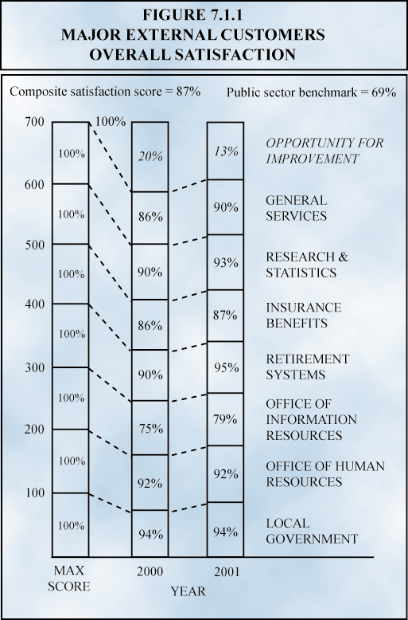The Board continues to receive high satisfaction ratings from customers. Chart 7.1.1 indicates that overall satisfaction remains high. This is an additive chart. Each office can score a maximum of 100 for an agency total of 700, as indicated by the first column. The second and third columns contain the actual scores of each office for the last two years. These seven scores are added together and the sum subtracted from the maximum of 700. The result is the overall satisfaction score for the agency. The difference between the sum of the actual scores and 700 represents opportunities for improvement. The public sector benchmark is taken from the American Customer Satisfaction Index for the public sector computed annually by the University of Michigan.

Charts 7.1.2 – 7.1.4 show customer satisfaction within each of the three key communities that receive services from the Board – individuals, agencies and stakeholders. Chart 7.1.2 represents the satisfaction of individual customers such as retirees who interact with Retirement Systems.

Chart 7.1.3 represents the satisfaction of other public agencies with the several Board offices such as Information Resources and Human Resources that provide services to the agencies.

Chart 7.1.4 represents the satisfaction of stakeholders such as members of the General Assembly and the Governor's Office with Board offices such as Research and Statistics that provide information and services to them.

The Offices evaluated customer satisfaction along five dimensions: reliability, responsiveness, empathy, assurance, and the physical appearance of people and facilities. Using a combination of customer focus groups and anonymous written rating processes, the Office of Human Resources scored between 4 and 5 on a 5 point scale for all dimensions of service quality. This is equivalent to approximately 92 percent when converted to a standardized scale, as illustrated in Figure 7.1.1. General Services also used focus groups and written surveys to evaluate customer satisfaction with the services delivered by the Office’s thirty-eight work teams, receiving an overall score of 90 percent satisfied. The Office of Information Resources, using both their Annual Customer Satisfaction Survey and their Customer Focus Group Meetings, obtained a 76 percent overall satisfaction rating. Focus groups rated satisfaction with telecommunications services quite high at 92 percent and satisfaction with the Consolidated Data Center at 82 percent. However, both the areas of Customer Communications (76 percent) and Range and Type of Services Offered (78 percent) afford opportunities for increased performance.
100%
Max.
Points

The Retirement Systems measured customer satisfaction through surveys, focus groups and intercept interviews. The Office sent an 11-question survey to all 769 covered employers and a 15-question, multi-faceted survey to a random sample of 2,362 members who had retired from April 2000-2001 (within the previous 12 months). Almost 54 percent of employers responded to the survey, yielding an overall excellent or good rating of 88 percent. Fifty-five percent of employers responded that the service provided by the Retirement Systems improved from FY 2000. Of the more than 34 percent of retirees responding to the survey, 96 percent rated the overall performance of the Retirement Systems as excellent or good. Almost 35 percent of retirees responded that service had improved during the previous year.

In addition to the surveys, three sets of focus groups were conducted, one consisting of active members and two comprised of employer benefits and/or finance personnel. Also, a series of intercept interviews were conducted with individuals immediately after they received services from a retirement consultant. The results supported the findings of the written surveys. Retiree satisfaction was rated at 98 percent, active member satisfaction was rated at 95 percent, and employer satisfaction was rated at 92 percent.

Since 1994, the Office of Insurance Services has conducted an annual customer satisfaction survey that has documented a rise in overall satisfaction from 81 percent to 87 percent. The Office has recently been realigned into the Offices of General Services (Insurance Reserve Fund) and Retirement Systems (Insurance Benefits Management). This year, the latter used written surveys, intercept interviews, and focus groups in association with the Retirement Systems to ascertain customer satisfaction with their services. They found 92 percent active employee satisfaction, 95 percent retiree satisfaction, and 82 percent employer satisfaction with the services provided by Insurance Benefits Management. The dimensions of timeliness, accuracy, courtesy, and clarity were tested. Of these, active employees ranked clarity the lowest at 72 percent, retirees ranked accuracy the lowest at 83 percent, and employers ranked timeliness, accuracy, and courtesy all at 80 percent, providing several opportunities for increased performance.

The annual customer service survey of the Office of Local Government reported that 94 percent are satisfied with the service they receive, the same finding that was reported last year. Interviews and daily interactions with the various customers support the finding. Office staff often travel to customers’ locales to provide more convenient access to service and to receive immediate customer feedback.

Through a newly created Family of Measures (FOM) Coordinating Team, the seven sections of the Office of Research and Statistics reported a composite customer satisfaction measure of 93 percent. This compares favorably with the 90 percent customer satisfaction documented last year. However, since the measurement criteria have changed, one cannot directly compare the two. The FOM is currently developing procedures to evaluate organizational performance by integrating customer, technical, financial, and human resource indicators into a set of indices.

Four Offices of the Board support internal customers. The Executive Institute measures its customer satisfaction by tracking repeat business. During the past 11 years, 26 agencies have nominated participants on an at least every-other-year basis and most have had participants each year. The State Budget Office, through the use of informal discussions, found that customer satisfaction is fairly high. One area of opportunity that warrants improvement is increased communication. Several customers indicated they would like to be kept better informed throughout the appropriation process. This is currently under review. For the second year, the Office of General Counsel conducted a survey of office directors, division directors, program managers, and the Office of the Executive Director. This, combined with a focus group of the above, resulted in a customer satisfaction of 98 percent, identical to last year’s rating. Customer satisfaction results for the Office of Internal Operations are reported in Figure 7.1.5. Satisfaction in the procurement and personnel areas decreased slightly during the past year, indicating areas that will benefit from improvement activity. In procurement, the area receiving the lowest ranking was concerned with keeping the customer informed. In the personnel area, the two topics receiving the lowest rankings dealt with assisting customers to attain diversity goals and the Office’s reorganization into generalist consultant roles.

7.2 Performance levels and trends for the key measures of mission accomplishment.

A core value identified in the Board’s strategic plan is that of teamwork: “We add value and achieve our greatest successes by working collaboratively and by forming partnerships with others.” In FY 2001, the Office of Human Resources launched a new performance measurement process to better evaluate the degree to which the office effectively partners with state agencies to ensure the provision of high quality human resource services. The Partnership Index (see Figure 7.2.1) is a measure of seven different categories of human resources functions: workforce planning, employee relations, compensation, recruitment and selection, human resource, human resources information systems (HRIS) utilization, and partner relationship. The outcome is a measure of partner relationship. The index measurements indicate the extent to which OHR is involved in a working relationship with agencies in each category of service.
For example, the 2.96 score for workforce planning (WFP) indicates the level of involvement and deployment of this service to the agencies. A 10 would mean that the workforce planning effort has been fully deployed throughout the agencies.

Each category has a maximum value of 10, but the optimum score in each category will vary from agency to agency based on agency size, complexity and nature of the agency’s functions. FY 2001 will serve as the baseline year for all but the partner relationship category, for which a baseline will be created in FY 2002. The information shown in each category is the mean score for 69 reported agencies.

Each category of the Index indicated some strength. Cooperative efforts between agencies and OHR in providing workforce-planning data through surveys have led to the state’s first workforce plan. Many agencies have taken advantage of suggested flexible work options and initiated new programs in the past year. Compensation data indicates good results from delegation audits and significant use of the state’s flexible pay options. Almost all agencies now post jobs on OHR’s web site or provide links to their jobs page. More than half of the state agencies used either OHR’s open enrollment or customized training courses. HRIS reviews indicate that agencies are providing the system with accurate data. OHR will be analyzing individual agency data in FY 2002 to identify additional opportunities for improved partnership.

The Office of General Services supports the Board’s strategic plan by pursuing its mission to “…provide the highest quality centralized business services for state government at the lowest cost.” It encompasses the following functions: procurement, facilities maintenance, vehicular fleet management, mail delivery, surplus property, central supply for disposable goods, engineering services for construction and planning, energy management, property appraisal and leasing, capital improvements processing, and Insurance Reserve Fund management.

General Services procures goods and services through requests for bids (RFB), requests for quotes (RFQ) and requests for proposals (RFP). The Procurement Index illustrated in Figure 7.2.2 measures the cycle time for these activities.

A score of 1.0 is based on mean cycle time over the past seven years. Over this period, processing time for RFPs averaged 70 days and processing time for RFBs/RFQs averaged 30 days. The scale is derived from adding the two together and dividing by 10 to obtain a decimal score. The goal for next year is to reduce cycle time by 10 percent.

Figure 7.2.3 presents the State Fleet Management Index, which is comprised of the sum of thousands of vehicles leased long term plus thousands of vehicles provided full support by the Civilian Vehicle Repair Program (CVRP), divided by the vehicle repair cycle time. General Service’s goal is to have two thousand vehicles under long-term lease, five thousand vehicles in the CVRP program and a 7-hour repair cycle time at the State Fleet Maintenance Shop. This would result in an index score of 1.0 (2.0 + 5.0/7). The index score will increase with a decrease in repair time or an increase in the number of vehicles leased and/or repaired, or a combination of both. This year’s index improvement is due to a decrease of 2.3 hours in repair cycle time, an increase in the number of leased vehicles from 2,000 to 2,200, and an increase in the number of vehicles in the SVRP program from 4,500 to 4,600.

The Facilities Management Office provides custodial, electrical, mechanical, maintenance, and horticultural services for 65 state buildings. This is more than 1.5 million square feet of building space and 144 acres of grounds. By providing these services, Facilities Management saves the state $1.48 per square foot (figure 7.2.4). The bench-mark comes from Building Owners Maintenance Associa-tion (BOMA) figures. The state saves in excess of $2 million annually by using its own Facilities Teams. This saved the state agencies more than 20 percent compared to the BOMA benchmark (figure 7.2.5). Costs have risen because of the steep price increases for fuel.
Statewide Building Services contracts with state agencies to provide facilities manage-ment services. Last fiscal year, 201 buildings and their grounds were maintained by Statewide Building Services, at significant savings.

The State Central Supply program provides office supplies and equipment to state agencies. Taking the top 25 highest volume sales of supplies and comparing them to the cost of the same supplies at Office Depot, Staples, Office Max, and Forms and Supply saved $733,952, which is about 20 percent (figure 7.2.6).

The Federal and State Surplus Property program has returned millions of dollars to state agencies and local governments. Surplus Property takes these entities’ surplus equipment and sells it for them, returning the proceeds to the owner, minus a small fee. By centralizing this function, we are able to obtain a better price. Figure 7.2.7 shows that the Board generated $5,925,944 for the agencies.
The State Engineer provides oversight and assistance to agencies, architects, engineers, contractors, and other parties on new construction. They provide information, interpretations, pro-cedures, documents, and other consultation to ensure compliance with the South Carolina Consolidated Procurement Code and building codes.

This service saved the state $1,431,973, about 60 percent less than these services would have cost if contracted from the private sector (Figure 7.2.8).

The Office of General Services offers mail services to state government and counties. As illustrated in Figure 7.2.9, this program delivers all mail within 24 hours at a cost that is 80 percent less than U.S. Postal Service rates. This saved state agencies $4,400,000 last fiscal year.

The goal of the Insurance Reserve Fund (IRF) is to provide insurance at a lower rate than commercial insurers. The Insurance Services Office (ISO) is a national ratemaking organization that sets rates used by many commercial insurers.

Figure 7.2.10 shows that IRF rates are on average 50 percent lower than ISO rates, a savings of $89 million, and demonstrates that the Insurance Reserve Fund has been successful in meeting its objectives.

The Office of Local Government serves as a source of financial and technical assistance in aiding local governments and other public entities to provide water, sewer, and related infrastructure necessary for economic development, environmental protec-tion, and public health. As illustrated in Figure 7.2.11, these programs have extensive leveraging effects that occur as a coordination process with other local, state, and federal funding sources. In the current fiscal year, $7 million in grant expenditures leveraged $26.1 million.

The Office of Internal Operations has established a goal of processing invoices for payment within two days and processing appropriations transfer requests within four days. An effectiveness index has been constructed by summing the two and dividing the result by 6, the combined goals for the two processes. The resulting annual effectiveness measure is provided in Figure 7.2.12. The management goal is to reduce the index to less than 1.0.

Customer satisfaction and the timeliness of service delivery are core indicators of the effectiveness of the Retirement Systems. The Retirement Services Effectiveness Index presented in Figure 7.2.13 is computed by multiplying average customer satisfaction (converted to decimal) by the average time it takes to issue the first service annuity benefit check. A score of 1.0 represents the management goal of 100 percent customer satisfaction and 30 days to issue the first service annuity benefit check. In FY 2001, customer satisfaction increased from 90 percent to 95 percent and the time it takes to issue the first service annuity benefit check decreased from 28 days to 26 days as compared to FY 2000.

The Office of Information Resources (OIR) responds to the Board’s core mission of service delivery by providing computing and communi-cations services to the agencies of government. Figure 7.2.14 shows that OIR responded to growing customer demand for more phone service by increasing the number of telephone ports from 46,202 to 49,251 while maintaining the current staffing level.
As illustrated in Figure 7.2.15, consolidating the work order process into a more efficient process decreased the actual number of Customer Service Business Requests by 3.6 percent. The number of Trouble Repair Orders increased by only 3.0 percent this fiscal year despite the considerable number of new telephone and voice mails added. In addition, the expected number of trouble calls normally rises as equipment ages. This will result in an increase in technicians or an upgrade of equipment in the future.

As illustrated in Figure 7.2.16, the Office of Information Resources has maintained the cost per minute of long distance telephone services at 8.94 cents compared to 9.41 cents in the private sector.

Figure 7.2.17 shows that the cost per minute for a state calling card is 15.50 cents compared to 25.04 cents in the private sector, a 38 percent savings.

Local service PBX rates were lowered by 22 percent to an average of $18.05 and contracted Centrex costs were lowered by 15 percent to rates considerably lower than the private sector (Figure 7.2.18).

The master plan for data center consolida-tion projected the capacity for the two mainframe processors installed at the State Data Center would be 501 mainframe compu-ting units (MCU) by the end of FY 2001. This projection proved to be 13 percent less than customer agencies actually required by July 2001.
As illustrated in Figure 7.2.19, MCU growth increased from 524 to 567, whereas projected growth was anticipated to be only 501 units. This increase was accomplished with no increase in staff.

Internet connections have been provided to 100 percent of public schools in South Carolina as compared to 94 percent nationwide.

For the fourth consecutive year, OIR delivered more than 99 percent of print jobs from the Print Shop on time.

In May 2001, the Gartner Group performed an information technology analysis of the state of South Carolina’s Data Center mainframe operations. The study revealed that the State Data Center is in the top ten percent of cost efficient performers in Gartner’s client database, and that the State of South Carolina ranks among those that have achieved the most significant economies of scale advantages. This is illustrated in Figures 7.2.20 and 7.2.21.

7.3 Performance Levels and Trends for the Key Meas-ures of Employee Satisfact-ion, Involvement and Devel-opment.

Section III, Category Five provides an in-depth discus-sion of the Board’s various recognition and awards programs. Currently, there are no comprehensive Board-wide measures of employee satis-faction. These measures are being developed and will be reported next year in association with the development of the Board’s consolidated training and development program.

The Office of Human Resources evaluated employee satisfaction in FY 2001 using the Meaning At Work employee assessment. This process asks each employee to evaluate both the importance and prevalence of 22 keys to a meaningful workplace on a 1-7 scale. By comparing the two scores, it can be determined how effectively the organization is meeting the individual needs of its employees, as well as those of the organization as a whole. An optimum situation occurs when an organization matches the need and prevalence scores at 100 percent on all 22 keys. As illustrated in Figure 7.3.1, OHR scored 81 percent or higher on 16 of the 22 keys and had no score lower than 69 percent. Four keys were identified as needing improvement and actions are being taken to address the employee concerns.

The Retirement Systems launched a pilot employee satisfaction survey consisting of five statements with which employees could agree or disagree. The statements gauged general job satisfaction, facilities, supervisory encouragement and empowerment, being kept up-to-date, and top leadership capability. A random sample of 17 employees responded to the survey. The pilot survey yielded an overall strongly agree or agree rating of 91.01 percent. One hundred percent of the employees responding strongly agreed or agreed that top leadership is capable and that the employees’ work setting is attractive and pleasant. Ninety-four percent of respondents strongly agreed or agreed that they are generally satisfied with their jobs. Eighty-two percent of respondents agreed or strongly agreed that the Retirement Systems does a good job of keeping them informed about current developments. Only 79 percent agreed or strongly agreed that their supervisor encourages them to utilize their full potential. These two areas will be emphasized in improvement efforts in FY 2002. The Retirement Systems also plans to expand the employee satisfaction survey in FY 2002.

7.4 Performance Levels and Trends for the Key Measures of Supplier/Contractor Partner Performance.

The Office of General Services maintains supplier/contractor/partner relationships in a number of key areas. The Commercial Vendor Repair Program (CVRP) contracts with more than 700 private maintenance shops throughout the state to provide maintenance for the state fleet of leased vehicles. Customer surveys report a 90 percent user satisfaction with this program. The CVRP program operates in partnership with 4,600 customers who drive the vehicles. These customers call the CVRP staff to find a shop closest to them when vehicle problems occur and maintain contact to ensure that repairs are done quickly and correctly. All complaints are pursued. In FY 2000, only three complaints were registered against CVRP suppliers. In FY 2001, this fell to two complaints. For quality assurance purposes, the staff visited 68 vendor shops during FY 2001and randomly inspected 35 vehicles immediately after the vehicles were repaired.

The Materials Management Office (MMO) has strong relationships with its many suppliers and partners. The State Procurement Office maintains a relationship with more than 21,000 private sector suppliers. More than 3,000 of them receive the monthly subscription to the monthly South Carolina Business Opportunities publication. There were 2,850 procurement contracts managed by MMO last fiscal year. The Office manages 177 state term contracts worth in excess of $160,000,000. They administer 2,850 contracts with vendors, which are worth more than $3,250,000. They processed more than 733 solicitations last fiscal year.
MMO has a formal process to resolve contract disputes with suppliers. Last fiscal year, 3.81 percent of all solicitations were protested and only .57 percent of these were won by the protestant (see Figure 7.4.1).

Among the Retirement Systems’ suppliers and partners are the participating employers. Employers remit member and employer contributions, enroll members, provide verification of member information, and file periodic contribution reports. The Retirement Systems strives to facilitate all of these processes for employers. One such mechanism is the Electronic Employer Services (EES) system. This partnership with employers is a component of meeting the customer requirement of convenient access at the worksite. The Retirement Systems’ goal is to increase the number of employers who use the EES system each year so that at least 50 percent of all employers are using the EES program by FY 2004.

Figure 7.4.2 shows that the number of employers using the EES system increased in FY 2001 to 207, or 27 percent of all employers, from 63 employers in FY 2000. These 207 employers represent 68 percent of the Retirement Systems’ active membership, so although less than half of all employers are using EES, the 207 employers using EES are serving more than half of the Retirement Systems’ active membership. Ultimately, availability of the system will be constrained by a lack of local resources.

OIR is very dependent upon its suppliers and part-ners in delivering services, especially in the area of telecommunication. Therefore, OIR pays particular at-tention to vendor performance with regard to res-ponsiveness and reliability. (Figure 7.4.3)
7.5 Current Levels and Trends of regulatory/legal compliance and citizenship.

The Information Technology Management section of the Office of Research and Statistics approves all state agency information technology requests outside the annual planning process. Figure 7.5.1 shows that the time to process small requests (less than $100,000) increased slightly from 4.3 days in FY 2000 to 5.0 days in FY 2001. The time to process medium requests ($100,000 - $500,000) increased from 6.2 days to 8 days and the time required to process large requests (more than $500,000) increased from 10.8 days to 12 days. These increases are attributed to a decrease in staff.

The Office of Internal Operations regulates all classification and compensation actions for the Board and ensures compliance with applicable law. Figure 7.5.2 shows that 97 percent of these actions were processed within the three-day management goal.

As illustrated in Figure 7.5.3, OIR has assisted all counties in the implementation of Wireless 911 Phase I, which provides a callback number for each 911 emergency call and the location of the nearest tower. All counties that have completely implemented E911 have also implemented Phase I with at least one wireless vendor in their respective area. Phase II will provide a callback number along with the latitude and longitude within 125 meters of the 911 call.

OIR completes the federal requirements for E-rate reimbursement for all 86 school districts. This has provided an enormous financial resource for providing technology to the state's K-12 community. OIR also provides guidance and leadership to all districts and manages the vendors providing the resources to all K-12s. OIR and the K-12 Technology Initiative have worked with the public schools in South Carolina assisting them in their filing for E-rate funds. OIR requests reimbursement for Internet expenses; however, the schools submit their requests independently. See Figure 7.5.4.
Medicaid audits conducted by the State Auditor found $2.02 million in adjust-ments to payments to Medicaid providers that resulted in the Department of Health and Human Services certifying receiv-ables in excess of $1.35 million (Figure 7.5.5).

The Board has had what is commonly referred to as “clean opinions” on its financial audits for the past five years, and for a number of years before that. A “clean opinion” means that, in the opinion of the auditors, the financial statements presented fairly, in all material aspects, the financial position of the Board and the results of its operations in accordance with generally accepted accounting principles.

Additionally, the Retirement Systems has had no exceptions in its external audits since 1987 and has received the Government Finance Officers Association Certificate of Achievement for Excellence in Financial Reporting for 14 consecutive years. The Office of Local Government has had no findings in any of its audits, including the Board's internal audit, the Environmental Protection Agency Inspector General's audit, annual federal on-site visits, and the annual Statewide Single Audit. Additionally, the Office of Human Resources' Certified Public Manager was recertified by the national organization.
7.6 Current Levels and Trends in Financial Performance
As shown in Figure 7.6.1, the cost of providing centralized human resources services per state employee has risen only .04 percent since FY 1996, while the number of FTE’s served per OHR staff member has grown 41 percent (Figure 7.6.2). This reflects the trend of more agency delegation and flexibility, and the utilization of centralized HR staff as experts/consultants rather than regulators.
Figures 7.6.3 and 7.6.4 provide financial information regarding the State Health Plan. Through the last two quarters, income has exceeded expenditures. The cash balances are slightly increasing in comparison to liabilities.

The Office of General Services spends about $60 million annually to save government more than $80 million annually. During FY 2001, the Materials Management Office saved $15.6 million from negotiated bids (Figure 7.6.5). The original winning bids were reduced through negotiation by almost 10 percent. The office also managed 177 state term contracts worth almost $161 million. Economies of scale made it possible for the state to save $50.3 million as benchmarked against prices for the same goods in the private sector.
The State Fleet Management program saved the state more than $9 million during FY 2001. The state saved $1,990,278 by leasing vehicles to state agencies, at a cost per mile that is 21 percent less than the private sector benchmark taken from the National Association of Fleet Administrators (Figure 7.6.6). Another $6,832,987 was saved by the state’s vehicle maintenance programs at the state shop and through the Commercial Vendor Repair Program. These vehicle maintenance savings are 44 percent less than the private sector cost per mile benchmark (Figure 7.6.7).
The measure of financial performance for the Retirement Systems is included in the Retirement Systems Effectiveness Index presented in Figure 7.2.13.

