State of
South Carolina

Governor’s Office of Executive Policy and Programs


Agency Accountability Report

Fiscal Year 2000-2001

Section I - Executive Summary

The Governor’s Office of Executive Policy and Programs (OEPP) provides a wide variety of key services to the citizens of South Carolina. Whether providing assistance to abused and neglected children, children with emotional and behavioral problems, victims of crime, citizens with disabilities, veterans and others, OEPP consistently strives to meet and exceed the needs of every one of its citizen customers. To provide these services, OEPP works in close collaboration and with the strong commitment of other public officials and organizations, including the Governor and his staff, cabinet agencies, state boards and commissions, and public, private and non-profit organizations.

Mission Statement
The mission of OEPP is to serve the people of South Carolina through the delivery of a variety of critical educational, social, health and human services programs in support of EnVision South Carolina, Governor Jim Hodges’ Business Plan. EnVision South Carolina emphasizes education, economic opportunity, safe and healthy communities, the environment, and results-oriented government.

Values
- Professional Competence
- Pride in Group Success
- Quality Work Product
- Dedication to Service
- Dependability

Achievements FY 2000 – 2001
Division of Constituent Services
To identify schools throughout South Carolina that did not have character education as part of their programs, the Office of Economic Opportunity (OEO) partnered with the Department of Education, Community Action Agencies, and USC Salkehatchie to create the South Carolina Youth Leadership Program. As part of this initiative, fifteen schools added a leadership component to their educational curriculum. The after school Youth Leadership Program was so well received that three school districts gave ½ unit credit to students that successfully completed the program. On May 11, 2001 the program graduated 205 students. Due to the extraordinary success of the 2001 program, OEO will fund this program as one of their customer service priorities.
Other divisional achievements include the following:
- Received twenty-eight (28) Developmental Disabilities Grants, valued at
$774, 615(total), to enhance the service provided for citizens with disabilities and their families.
- Established a third Veteran’s Nursing Home in Colleton County, and re-established the Veteran’s Advocacy Council.
- Developed a South Carolina Results Oriented Management Accountability (ROMA) Task Force.
- Hosted the annual Women of Achievement Awards.
- Conducted three (3) Minority Business Assistance Forums attended by approximately 450 participants.
- Distributed more than 47,000 application packets, brochures, posters, cards, and booklets regarding Victims Assistance services.
- Fielded more than 20,000 phone calls to the Ombudsman’s Office; responding to all within twenty-four hours.

Division of Children’s Services
To better align and coordinate the services provided for the children of South Carolina by multiple state agencies, the Director of the Children’s Services Division chairs and hosts monthly meetings with the directors of the state’s health and human service agencies to discuss methods for improved service delivery and prevention. During this past year, the team developed and implemented a new monitoring process, compliance measures, and an Informal Dispute Resolution process for provider groups, with goals to provide consistency, fairness, access, and reduction in duplication. They also initiated the Children’s Behavioral Health Services Outcome Pilot to determine the feasibility, for private providers and public agencies, to utilize an outcomes-based evaluation system for therapeutic, residential services for children.
Other divisional achievements include the following:
- Increased efficiency within the division by relocating the non-core functions of Caring for Tomorrow’s Children; the Maternal, Infant, and Child Care Council, and Baby Net to agencies providing similar services.
- Supported passage of HR3305, establishing the “Adoptions Procedures Task Force.”
- Initiated a program to include family members as co-trainers for the Continuum of Care’s Case Managers.
- Initiated a program to include client families in the organization’s policy and goal development and process improvement activities.
- Improved information sharing on foster children throughout the state through new statistical reporting procedures.

Division of Administrative Services
Working with the Chief Administrator and the Governor’s Executive Control of State, the Office of Correspondence and other staff from the Division of Administrative Services directly support the Governor’s Reading Honor Roll program. In addition, they assist in implementing South Carolina’s Compact With Our Children by assembling and mailing approximately 750,000 items annually for this and the aforementioned program.

The Reading Honor Roll program encourages reading among students throughout the state. At the beginning of each school year, reading logs and certificates for all students are sent to every public school in the state. Students who read at least 20 books receive a certificate naming them to the “Governor’s Reading Honor Roll.” South Carolina’s Compact with our Children seeks to promote parental and community involvement in education by establishing a link between the Governor, the school, the teachers, the parents, and the students to encourage active learning. In this program, Compacts for every student are sent to all public schools in the state. The parent, teacher, student, and the Governor all sign the Compact as a visible commitment to the child’s education. Both programs support the Governor’s Business Plan.

Key Present and Future Goals
Every office within each division has identified two key goals for this year. These goals relate to either customer service improvements or achieving increased effectiveness and efficiency in services provided.

Division of Constituent Services
A major goal for the Ombudsman’s Office is to establish a “Seamless Constituent Network” (SCN) of Ombudsman’s Offices within state government agencies. It is expected that this network of agency Ombudsman’s Offices within state agencies will improve the coordination and responsiveness of state government, whether in response to a request for information, technical assistance, or requests that requires a coordinated response from multiple agencies.

Key goals for the Office of Veteran’s Affairs include the development and implementation of a comprehensive eldercare system for veterans to include nursing homes, adult daycare, as well as in-home care. Another goal is to locate a Veteran’s Cemetery in South Carolina.

Division of Children’s Services
A key goal for the division will be to continue the ongoing initiative to coordinate and align services provided to children by health and human service agencies.
Other key goals include:
- To expand the inclusion of customers in process improvement initiatives and goal setting
- To implement robust methods to measure and monitor outcomes, and to support other child services agencies to work towards uniform outcome measures
- To increase the public’s awareness of the Division’s services
- To work towards improving the performance of private providers through increased assistance and oversight activities

Division of Administrative Services
A key goal within this division is to increase cross-training activities within all offices to broaden employee skills and understanding of cross-functional business activities, increase efficiency, and increase customer service effectiveness. Customer Service surveys also are planned for this year.

Barriers and Opportunities
The primary barriers include the current reduction in state appropriations which will require an increased focus on service efficiency. Decreased funding will make it more difficult to recruit and retain volunteers in the Guardian Ad Litem program. Opportunities in increasing effectiveness, efficiency, and increased customer services lie in the adoption of business practices modeled after the Baldrige criteria.

Section II - Business Overview

The Governor’s Office of Executive Policy and Programs (OEPP) maintains 14 key programs (Table: A.1), each distinctively different and created to serve the citizens of South Carolina in key areas of interest and need as expressed in the Governor’s Business Plan, statutorily mandated by Section 1-30-110, or otherwise identified or required.

Table A.1

Division of Children’s Services
Continuum of Care | assesses of client's needs, service plans to meet those needs, and case management; reviews of providers | children with emotional and behavioral disorders, their parents, schools; public agencies
Foster Care Review | recommends the treatment and placement of foster children, statements about areas of concern through reports and advocacy review. | Department of Social Services, Family Court judges, birth and foster parents, treatment providers, foster children.
Guardian Ad Litem | supervises volunteer advocates who serve as monitors and protectors of maltreated children for family court judges. | abused and neglected children, and family court judges
Children’s Affairs | arbitrates and mediates services among agencies serving difficult cases, and provides ombudsman services for families and children | public agencies serving children, families of children

Division of Constituent Services
Office | Key Services | Customers
Governor’s Ombudsman | handles complaints regarding state agencies, and provides information on state agencies and their services | citizens of South Carolina
Crime Victims’ Ombudsman | handles complaints against any agency or individual in the criminal justice system | crime victims
Developmental Disabilities Council | provides grants for programs which support inclusion into the community for those with disabilities | citizens with disabilities, organizations that deal with the needs of the disabled
Victim Assistance | provides assistance regarding medical and dental expenses, counseling, loss of support, information, and referral | crime victims
Small and Minority Business | provides certification, training, and networking opportunities | small and minority businesses
Veterans Affairs | provides assistance in filing, developing, presenting and prosecuting to final determination all claims for benefits (funerals, burials, education, hospitalization) | veterans, families, legislators
Office of Economic Opportunity | requests, receives and distributes federal funds (grants) | community actions and other non-profit groups
Community Relations/Intergovernmental Affairs | monitors and evaluates issues and concerns that may affect the public/serves as liaison between city, county, and federal governments | citizens of South Carolina/ city, county, and federal governments
Governor’s Commission on Women | provides information for constituents, agencies, and community organizations on the state of women in South Carolina | women in South Carolina

Division of Administrative Services
Correspondence | assists in logging, routing and tracking constituent letters and monitors timeliness of the response to that correspondence | anyone who writes the Governor’s Office, education stakeholders
Finance | paying vendors/suppliers once a product has been delivered/service provided; keying budgets; payroll | other offices, vendors, Comptroller General, Treasurer’s Office, staff
Human Resources | provides support in the areas of recruitment and employment services, employee training and evaluation, benefit management, employee records management, classification and compensation, and employee relations | employees of the Governor’s Office; those seeking employment in the Governor’s Office
Information Technology | provides Internet resources , e-mail, file access, or other technology resources | employees of OEPP; website users
The three divisions of OEPP (Table A.1) consist of the Division of Children’s Services which includes four key programs and the Division of Constituent services with nine programs. The Division of Administrative Services provides administrative support for the Governor’s Office and includes the offices of Finance, Human Resources, Correspondence, and Information Technology.

Total Number of Employees
Classified: 299
Unclassified: 39
Temporary: 24
Temporary (Time Limited): 63
Temporary (Grant): 41

Operating Locations
- Division of Children’s Services: Columbia (Central Offices); 50 offices state-wide, of which 37 support the Guardian Ad Litem programs, and 13 that support the programs of the Continuum of Care.
- Division of Constituent Services: Columbia (Central Offices); six (6) offices state-wide.
- Division of Administrative Services: All offices are located in Columbia.

Expenditures Appropriations Chart

 | 99-00 Actual Expenditures |  | 00-01 Actual Expenditures |  | 01-02 Appropriations Act
Major Budget Categories | Total Funds | General Funds | Total Funds | General Funds | Total Funds | General Funds
Personal Service | 7,926,030 | 4,339,724 | 11,286,583 | 4,543,551 | 10,672,143 | 4,090,926
Other Operating | 13,282,351 | 1,872,833 | 13,068,431 | 1,375,562 | 15,647,335 | 960,598
Special Items | 2,265,481 | 2,265,481 | 2,581,737 | 2,581,737 | 2,123,830 | 2,123,830
Permanent Improvements
Case Services | 3,337,692 | 1,413,109 | 4,458,444 | 1,309,221 | 2,171,690 | 973,690
Distributions to Subdivisions | 23,086,119 | 760,418 | 29,947,326 | 840,217 | 23,605,833 | 632,610
Fringe Benefits | 2,303,323 | 1,088,942 | 2,891,646 | 1,069,866 | 2,700,754 | 1,065,362
Non-recurring | 24,577 | 24,577 | 13,266 | 13,266
Total | 52,225,573 | 11,765,084 | 64,247,433 | 7,189,869 | 56,921,585 | 9,847,016

Other Expenditures
Sources of Funds | 99-00 Actual Expenditures | 00-01 Actual Expenditures
Supplemental Bills | 425,400 | --
Capital Reserve Funds | -- | --

Key Customers and Key Services Provided
Due to the distinctly different services provided by each of OEPP’s 13 programs, a listing of key customers and key services provided by each office is depicted in Table A.1.

Key Suppliers/Vendors:
OEPP conducts business with a large variety of suppliers/vendors. The following are the top five in terms of business conducted: State of South Carolina (examples include computer services, state telephone system, motor pool, liability insurance, and rent), AT&T (telephone services), Jon-Ker, Inc., and Lorrick Office Products (office supplies) and Gateway Company (computer hardware).

Organizational Diagram

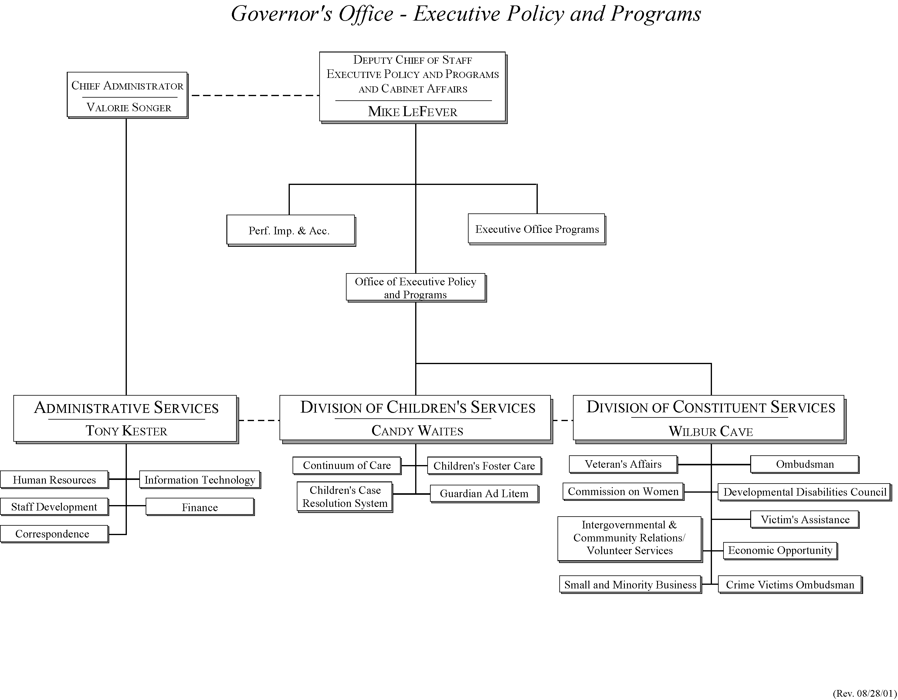

Section III – Malcolm Baldrige Criteria (Elements)

Category 1 – Leadership

1.1(a-f) How do senior leaders set, deploy and communicate: (a) short and long term direction; (b) performance expectations; (c) organizational values; (d) empowerment and innovation; (e) organizational and employee learning; and (f) ethical behavior?

(a) The diverse nature of the 13 programs (offices) that constitute the Division of Children Services and Division of Constituent Services of the Office of Executive Policy and Programs (OEPP) dictates special approaches for setting and communicating direction. Short-term direction is set by legislative and other customer needs and is communicated as needed to the Deputy Chief of Staff (DCS) for OEPP by the Governor, his Chief of Staff, or other government officials. The primary long term-direction for each of the functions is set by enabling legislation, applicable portions of the five primary goals of EnVision South Carolina and the business and operating philosophy articulated by the Governor. To insure compliance, understanding, and effective organizational communications, the DCS for OEPP conducts weekly staff meetings with the three Division Directors who in turn conduct follow-up meetings with their respective staffs. Weekly meetings are also conducted with Agency Directors representing the 13 Cabinet Agencies, and the Director of Performance Improvement and Accountability to insure sound communication and coordination. The telephone, e-mail, and open-door policies throughout the organization further facilitate rapid communications. These methods permit a quick response to issues or concerns of interest to all of OEPP’s internal and external customers.

(b,c) General and specific performance expectations and organizational values set by the Governor are communicated, modeled and reinforced by OEPP senior leadership. Within each OEPP function, employees and their supervisors include specific work objectives, performance expectations, and training goals in each employee’s Planning Stage for the coming year’s employee performance evaluation. Those employees serving OEPP at-will or with positions assigned by other agencies receive specific written or verbal instructions regarding performance expectations and values from the DCS. Any incident of nonconformance is addressed verbally, in writing, or through prescribed state government HR regulations as appropriate.

(d) Because of the wide variety of programs served by OEPP, reliance on empowerment and innovation are a necessity and are widely supported and encouraged. At the supervisory and managerial level, division directors and office managers are given maximum flexibility to serve their customers quickly, effectively, and efficiently. Managers are encouraged and expected to transfer empowerment to office staff so that they can work freely within broad guidelines appropriate to their function. Management training on supervisory skills and organizational development topics is routinely provided and encouraged, with all managers having completed select programs to further develop their supervisory and management skills. Innovation is encouraged at all levels with improvement suggestions frequently discussed and developed in office staff meetings, and if applicable, forwarded to the appropriate Division Manager or DCS for potential organization-wide implementation. Although not in place at this time, an internal organization-wide employee suggestion program is planned for next year.

(e) Organizational and employee learning is strongly supported by senior management whether through sponsorship of the EXCEL program, through attendance at in-house training classes, through programs offered by the Budget and Control Board, by participation in writing the Baldrige-based accountability report, or through training procured by other methods. For example, to significantly increase organizational learning and understanding of the Baldrige criteria for organizational performance excellence, each division within OEPP formed a management/employee team to prepare individual Divisional Accountability Reports. The respective Division’s Director chaired each of the three divisional teams. This process, modeled by senior leadership significantly increased learning, commitment to continuous improvement, and organizational understanding of the performance excellence criteria.

(f) Guidelines for ethical behavior are listed in the Employee Handbook which is given to new OEPP employees. Senior managers follow these guidelines and expect compliance by all employees. The State Government Ethics and Accountability Act provides clear procedures for investigating grievances and initiating any required disciplinary actions. The State Ethics Commission also requires specified officials and public employees to file Statements of Economic Interest, which also helps insure that ethical guidelines are followed. In addition, the OEPP Human Resources function conducts Exit Interviews in person or by follow-up survey with departing employees and results are reported to senior management. Training on ethics is routinely offered by the Ethics Commission. Employees are notified of these sessions as they are scheduled.

1.2 How do senior leaders establish and promote a focus on customers?
The goals and key areas of interest described in the Governor’s Business Plan provide the primary focus and direction for each of OEPP’s offices. In addition, senior leadership’s close coordination with the Governor’s Executive Control of State ensures that key customer needs and concerns, whether on legislative or quality of life issues, are identified and expeditiously addressed. A unique communication and information infrastructure consisting of the Governor’s Call Center, Ombudsman’s Office and Correspondence Office, backed by external state agencies, ensure that customer concerns and inquiries are addressed quickly and effectively. In addition, Internet web pages have been developed to provide accessibility to those customers with physical handicaps and other impairments. These are in compliance with Sections 504 and 508 of the Rehabilitation Act of 1997, and guidelines set forth by the Americans with Disabilities Act. Further customer service improvements are planned for the future by developing a “Seamless Constituent Response Network” (SCRN).

1.3 What key performance measures are regularly reviewed by your senior leaders?
Due to the diverse nature of OEPP offices, senior managers routinely review a wide variety of performance measures and reports regarding service efficiency and effectiveness. Examples include the following: 1) Office of Finance: appropriations versus allotments, cash status and cash by grant, the timeliness of vendor and employee payments; 2) Office of Correspondence: response time to received correspondence and correspondence received by type of customer issue (Table 7.1-5); 3) Victims Assistance: the number of Victim’s Assistance claims received, awarded, and monies paid (Table 7.6-3); and 4) Ombudsman’s Office: the number and type of telephone inquiries received per day and accurately responded to in a timely manner
(Table 7.2-17). Additional examples from the Division of Children’s Services include: scores received on customer satisfaction surveys; degree of parental involvement; degree of improvement in client’s functioning; number of volunteers trained in Guardian Ad Litem; case acceptance and rejection rate; and percent of employees satisfied with their job and work environment.

1.4 How do senior leaders use organizational performance review findings and employee feedback to improve their own leadership effectiveness and that of other managers?
The primary mechanism used for obtaining leadership effectiveness feedback is through the Employee Performance Management System (EPMS) process. At the senior level, performance feedback may be received directly by the Governor and through interaction with senior government officials. Additional feedback is obtained through employee satisfaction surveys, exit interviews, and individual dialogue with employees. OEPP directors and office managers also seek and provide leadership effectiveness feedback during normal office meetings.

1.5 How does the organization address the current and potential impact on the public of its products, programs, services, facilities and operations, including associated risks?
OEPP uses a variety of methods to insure that its programs and services are focused on addressing customer needs and minimizing risks. For example, public issues and concerns are tracked through press summaries of South Carolina newspapers and a compilation of issues and inquiries received by the Ombudsman’s Office and Correspondence Office. Additional methods for obtaining information on program impact include partnership and collaboration with other government entities, service providers, focus groups or meetings conducted with customers. The timeliness of responses to individual customer issues is tracked by a database maintained by the Correspondence and the Information Technology Offices. Financial information accuracy is validated through external audits with no significant findings reported during the last several years. OSHA and other regulatory requirements are met without any significant discrepancies noted.

1.6 How does senior leadership set and communicate key organizational priorities for improvement?
OEPP improvement priorities are set and communicated through the Governor’s Business Plan, legislative mandate, meetings between the Governor and senior staff, or customer service enhancement opportunities identified by the various office managers and staff and communicated to senior management for action requiring their assistance. Office managers meet with their staff to review these priorities and insure understanding and compliance. In addition, to continuously improve, each office has recently set two internal improvement priorities for this year to enhance customer services or improve office effectiveness and efficiency (2.1a-e).

1.7 How does senior leadership actively support and strengthen the community, and identify areas of emphasis?
Senior leaders and managers throughout OEPP actively support the community, with priorities either set by the Governor, OEPP senior leadership, or self-initiated participation. The following examples indicate the extent of community support provided:

DCS, OEPP: Board of Directors, Leadership South Carolina; Treasurer, South Carolina Chapter, American Society for Public Administration; Administrator, Technology Transition Team; Member, South Carolina Tobacco Community Development Board; Member’ Safe Schools Task Force; Member, Alston Wilkes Society; Member, Mental Health Association of the Midlands; Board of Associates, Planned Parenthood of South Carolina; Board of Trustees, Presbyterian College.
Director, Performance Improvement and Accountability: National Examiner, Malcolm Baldrige National Quality Award; Chairman, SC State Government Improvement Network; Executive Committee Member, SC Quality Forum; Member, American Society for Quality; Committee Member, SC Business One Stop (SCBOS) Team.
Division of Children’s Services (management participation): Co-Chair, Conference Committee to Prevent Child Abuse. Board Members on: Wachovia Bank, Nurturing Center, SC Children’s Center, Prevent Child Abuse SC, Community Mediation Center, SC Society for Certified Public Managers, Children’s Committee; Member, Children’s Justice Task Force; Standards Committee of NCASA and African Advisory Committee of NCASA; Member, Child Protection Advisory Committee and SC Bar.
Other methods of community support provided include strong participation by the Division of Constituent Services and Division of Administrative Services on various community service organizations and in charities including the United Way, the Good Health Appeal, First Ladies’ Walk for Life, Habitat for Humanity, United Black Fund of the Midlands and the Salvation Army Christmas Kettle program, SC State Fair, Riverfest, Family Connections of Hopes and Dreams and VWF Back to School Picnic.

Category 2 – Strategic Planning

2.1 What is your strategic planning process, including participants, and how does it account for: (a) customer needs and expectations; (b) financial, societal, and other risks; (c) human resource capabilities and needs; (d) operational capabilities and needs;
(e) suppliers/contractor/partner capabilities and needs?

2.1 (a-e) The Governor’s Business Plan and enabling legislation provide the primary focus for each office’s strategic direction. Additional input is provided by the Governor’s Executive Control of State and key legislative or customer service issues. As each office develops its goals and strategies, participation and review by the office staff, office manager, division director and the DCS for OEPP ensures organizational alignment, necessary financial and human resource allocations, and the minimizing of risk to OEPP’s customers. As goals and strategies are developed, any necessary coordination with suppliers or partners is assured prior to goals being finalized. An example of a few of the Division of Children’s Services key goals and planning methods is included below:

Table 2.2.1 Offices Planning Methods
Plan Component | Continuum of Care | Foster Care Review | Guardian Ad Litem | Children's Affairs
Defining customer needs and expectations | Family focus groups, parent advisory group, family survey, Program Oversight Council, interagency meetings, formal statewide service needs assessments, interviews with other stakeholders | County board action plans, data collection for "Foster Kids Count," involvement with SC Bar, advocacy and interagency groups, self-assessment survey of stakeholders, foster parent survey | Regular meetings with family court judges, volunteers, and DSS; a stakeholder survey is under development | Tracking of requests for assistance, and referrals of cases for mediation
Defining operational capacity and needs | Assessment of referral patterns, staffs’ capacity, and service expenditure patterns | Placements in foster care and staff capacity | Case load limited by number of volunteers | Referrals and staff capacity assessment.
Developing action and tracking action plans | Each of the 25+ objectives is assigned to a management team member to implement and report on quarterly | Distribution of plan to staff and determining each person's contribution to achieving objectives | Distribution of plan to staff and determining each person's contribution to achieving objectives | Routine staff meetings

Although OEPP offices use the Governor’s Business Plan as a primary planning document, OEPP plans to develop a supporting organization-wide strategic plan within the next year. Towards this goal, and to continue with further enhancements in the areas of customer services, effectiveness and efficiency, all OEPP offices have identified two key goals for next year. Key office goals include the following:
Division of Children’s Services: At least 90% of families will give the Continuum of Care a letter grade of A or B on the Family Satisfaction Survey; and the Office of Foster Care Review Board will design, administer and analyze a comprehensive survey of all foster parents in SC to determine key issues and problems with existing services. The Office of Children’s Affairs set goals to respond to 95% of all constituent telephone calls within the same business day and to respond to 95% of written correspondence within 4 business days. The Office of Guardian Ad Litem will provide at least 25 hours of training for each volunteer to increase volunteer knowledge and proficiency.

Division of Constituent Services: For the Disabilities Council, the goals are to increase the number of children with disabilities who remain in school; Victims Assistance: research model restitution programs of other states to acquire “best practices; Commission on Women: compile a comprehensive statewide report on the status of women in SC; Ombudsman’s Office: establish a Cabinet level Seamless Constituent Network; and Crime Victims’ Ombudsman’s Office: develop and implement a computerized database for case tracking purposes. Others include the Veteran’s Affairs Office which will work on developing and implementing a comprehensive eldercare system for veterans including nursing homes, adult daycare as well as in-home care; Small and Minority Business Assistance: add a broadcast system via the Internet to disseminate information to state agencies and vendors; and Office of Economic Opportunity: continue to improve services provided by the Results Oriented Management Accountability Task Force (ROMA) that currently represents 15 Community Action Program (CAP) agencies.

Division of Administrative Services: For the Office of Correspondence the goal is to design and implement a Governor’s Citizenship Awards Program; Office of Finance: reduce the number of days to process an invoice from 5 to 3 days; Office of Human Resources: develop and complete a Customer Satisfaction survey; and Office of Information Technology: to survey all office managers to ascertain technology needs and levels of customer satisfaction, and also service existing computers.

Many of the office goals described above will be incorporated into the OEPP strategic plan development process.

2.2 How do you develop and track action plans that address your key strategic objectives?
Due to the large variety of programs served by the offices of OEPP, each currently develops its own action plans to support their strategic goals. Action plan accomplishment is supported by the Employee Planning Stage which include specific tasks employees need to complete and expected performance levels needed to support office goals. Individual supervisors and office managers track action plan progress and manage human and financial resources needed to support plan attainment.

To insure that employees possess needed skills to achieve office action plans, employee training and development needs will be included on each employee’s Planning Stage, then aggregated and analyzed within OEPP to focus training needs analysis and delivery. This process will be implemented with the new EPMS cycle beginning November 2001.

  - How do you communicate and deploy your strategic objectives, action plans, and performance measures?
Since, at the present time, each office develops and maintains its own goals, action plans, and measurements, they are used and shared primarily within the respective office and division. For example, within the Continuum of Care, action plans are posted on the Intranet, discussed at staff meetings, and tracked by the Quality Council. Progress is updated quarterly. As OEPP develops its own strategic plan, supporting action plans and key measures will be shared throughout OEPP. Specific methods for sharing this information will also be developed within the next year.

Category 3 – Customer Focus

  - Identify key customers and stakeholders.
Key customers and stakeholders for the three divisions that constitute OEPP include the Governor, Executive Control of State, Legislators, State Government Agencies, and the citizens of South Carolina. Customers are more precisely segmented as related to the type of services provided by each office within OEPP (Table A.1).

  - How do you determine who your customers are and their key requirements?
Key customer segments are determined by the goals and strategies contained in the Governor’s Business Plan. Additional key issues are articulated by the Governor and Executive Control of State, enabling legislation, or by other means. Combined, these sources provide guidance and expectations regarding customer segments and services for each office within OEPP. For example, within the Division of Constituent Services timely, accurate, and effective service serves as a primary goal whether they are provided to the developmentally disabled, veterans and their families, or victims of crime. The same service expectations exist for the division’s stakeholders such as schools throughout the state, law enforcement agencies, or the US Department of Veterans Affairs.

Within the Division of Administrative Services, the Correspondence Office views written correspondence as requiring special attention and ensures that an accurate, well-researched and coordinated reply is returned to the sender within five business days. Any trends in areas of interest and/or concern including health and education initiatives, environmental concerns, legislative, or quality of life issues that may require senior leaderships’ attention are immediately forwarded to them. In addition, in the Division of Children’s Services, attention to key customers and their requirements is constant.

Table 3.2.1 Customers, Stakeholders, and Their Requirements
COC’s Customers | COC’s Customer Requirements
Clients (children served) | Well planned and delivered services.
Client's family | Quick response to child's needs. Useful services.
Public providers (e.g. schools) | Useful assistance in working with children with emotional and behavioral disorders.
Private providers | Fair reimbursements and oversight.
Public agencies | Support in the establishment of agreements with private providers. Oversight of providers.
FCR’s Customers | FCR’s Customer Requirements
Children in foster care | Well run foster care system.
DSS | Fair oversight.
Foster parents | Well run foster care system.
Birth parents | Well run foster care system.
GAL’s Customers | GAL’s Customer Requirements
Volunteers | Useful training and support, courts, children.
Children’s Affairs Customers | Children’s Affairs Customer Requirements
Families | Quick and useful responses to their concerns.
Governor's Office | Quick and useful responses to constituents concern.
Public agencies | Quick and fair resolution of interagency issues.

3.3 – 3.4 How do you keep your listening and learning methods current with changing customer/business needs, and how do you use information from customers /stakeholders to improve services or programs?
Due to the wide variety of services delivered by OEPP, each office has developed their own specific methods for identifying and trending customer needs, inquiries, concerns, and issues and also provides feedback on the effectiveness of their methods. These include meetings with customers, public hearings, advisory councils, customer satisfaction surveys, and written or other verbal communications. Significant trends or changes in customer service expectations and needs are discussed during management meetings, or by OEPP internal committees, with service delivery excellence as a primary goal. For example, the Continuum of Care (COC), listening to its customers concerns regarding parent’s difficulty to attend daytime meetings, now also schedules meetings during non-work hours, and works with families to provide childcare transportation, if needed. The Continuum also has a standing Evaluation Advisory Committee which reviews data collection methods, analysis, and sharing of results, to insure that best customer service methods are used and shared. Information regarding customer needs and issues is also collected, tracked and trended by the Office of Correspondence and Ombudsman’s Office and routinely reported to pertinent OEPP offices, the DCS, Executive Control of State, and/or the Governor. Depending on the customer’s needs, concern or issue, service improvements may be initiated by an individual office or at the other end of the spectrum, through new legislation. Table 3.4.1 depicts how the GAL uses customer information to improve services.

Table 3.4.1 How Information from Customers and Stakeholders Is Used to Improve Services
Office | Use of Information
Guardian Ad Litem | The GAL office has used feedback from Family Court Judges, DSS, and Foster Care Review Boards to improve its knowledge of judicial and child protective services systems and to increase its appearance at staffings with other agencies. One use of this feedback was to establish a goal to have more male and minority volunteers.

3.5 How do you measure customer/stakeholder satisfaction?
At present, primary methods for obtaining customer satisfaction information include direct feedback received from the Governor, Executive Control of State, legislators, agency directors and managers, the Governor’s Call Center, the Ombudsman’s Office and the Correspondence Office. In addition, several offices within OEPP conduct customer surveys, focus groups, community meetings, or participate in program oversight committees. Examples include the Disabilities Council which sends out an annual survey to over 3,000 families who have family members with disabilities, the Office of Foster Care Review which conducts stakeholders assessments and a Foster Care Parent Survey, and the COC which regularly conducts family surveys, customer focus groups, and maintains a standing Program Oversight Committee. In addition, to support the planned development of OEPP’s strategic plan, each office will develop key customer process and outcome measures to aid in process management and the continuous improvement of service delivery.

3.6 How do you build positive relationships with customers and stakeholders?
All offices within the Divisions of Children’s Services and Constituent Services believe that strong customer communication links, flexibility, and accurate and timely service delivery provide the primary keys for building positive relationships. Examples include the Veterans Advisory Council which includes all veterans organizations and meets regularly to discuss ways to improve the lifestyles of veterans, and the Disabilities Council which routinely meets to determine and select methods to better meet the needs of those with disabilities. In addition, within the Division of Children’s Services, building positive relationships is a necessary part of casework, as is the building of family support groups, in collaboration with advocacy groups, in each region throughout the state.

Category 4 - Information and Analysis

4.1 How do you decide which operations, processes and systems to measure?
In OEPP, the more immediate, day-to-day processes that are measured are in support of the Governor’s Business Plan or are set by the Division Leadership Team under direction from the Governor’s Executive Control of State staff, and the Governor’s priorities and needs. Because of the diversity in the offices, where one office’s focus may primarily be advocacy and another may be processing accounting/payroll information, data comes in a variety of quantitative or qualitative data measures which makes consistency a challenge. For instance, the operations, processes and systems measured in the Division of Children’s Services are based on each office's strategic issues, and annual goals and objectives, and information needed for managing the office’s processes. In all divisions, the requirements of state and federal laws mandate certain information be obtained and reported in compliance with those laws.

Once the strategic planning process for OEPP is completed for the 2001-2002 fiscal year, key processes and operations will be measured in order to give decision-makers and leaders additional tools for continuous improvement in OEPP.

4.2 How do you ensure data quality, reliability, completeness and availability for decision-making?
To measure accuracy, all information flows from employee to supervisor to director to ensure data quality in work product. The Office of Correspondence measures mail processing to ensure efficient and responsive service. For example, the logs and reports generated by the Office of Correspondence provide information to offices, functions, and staff on a weekly, quarterly and annual basis regarding the nature of the mail, assignment of research, turnaround time for response and follow-up. In Finance, reports have a high level of validity and comply with the Comptroller General and the State Treasurer’s Office systems. These reports are generated on a daily, weekly and monthly basis in order for the Division of Administrative Services staff to monitor financial transactions.

Checks and balances, cross-referencing with other agencies are two determining factors for quality and reliability in the Office of Veterans Affairs. Veterans Affairs staff verifies with the US Dept of Veterans Affairs the number of claims and dollars gained for the veterans of South Carolina. This benchmarking enables the Veterans Affairs office to compare data with other states to see how well federal dollars are used for South Carolina veterans (Table 7.6-5). The Division of Children’s Services collects data on clients, stakeholders, processes, and the children services environment. The data quality improvement efforts used are summarized in Table 4.2.1.

Table 4.2.1 Data Distribution and Quality Improvement Efforts
Office | How Data Made Available | Examples of Data Quality Improvement Efforts
Continuum of Care | - Quarterly goal attainment updates to management  - On line data reports  - Monthly monitoring reports called "pulse points" printed and posted online | - Use of statistical process control to improve reporting response time and data quality.
Foster Care Review | - Annual Report  - Foster Kids Count Report  - Periodic management reports of key indicators | - Use of electronic links to DSS to avoid reentry of data and ensure quick access to changes in data.
Guardian Ad Litem | - Periodic management reports of key indicators | - Use of data to track hearings, placements, and visits with children
Children’s Affairs | - Periodic management reports of key indicators | - Plans to include private providers in data collection
4.3 How do you use data/information analysis to provide effective support for decision-making?
Information analysis is used for decision-making in OEPP whether it is through quantitative or qualitative data. Often qualitative data such as written correspondence and verbal feedback from both internal and external customers of OEPP services is used in conjunction quantitative data in review of programs and procedures. For instance, at the direction of the Governor, a cross-functional committee was formed from staff of both the Constituent and Administrative Services divisions to study and recommend improvements to constituent service procedures. Utilizing quantitative data such as processing and turnaround time of e-mail, faxes and letters
(Table 7.1-5) and conducting a gap analysis using qualitative data such as observations of call screening, the committee developed recommendations to improve constituent services.

In the Division of Children’s Services, processes and progress are routinely monitored to implement strategies:

Table 4.3.1 Use of Data
Office | Examples of Monitoring Processes
Continuum of Care | - Determine how many additional clients can be served  - Determine the rate of employee turnover
Foster Care Review | - Determine problem rates by county to determine where advocacy with other agencies needs to occur.
Guardian Ad Litem | - Determine where volunteer recruitment is needed and where to emphasize public education efforts.
Children’s Affairs | - Plans to monitor data for agencies and private providers are forthcoming for FY’01-‘02

4.4 How do you select and use comparative data and information?
Offices use comparative data when and where available. While all other states do have Governor’s Offices, they may or may not have the same functions as the South Carolina Governor’s Office does. Even if they have the same functions, data may not be gathered or reported in the same manner. This inconsistency creates a challenge for OEPP to have functional comparative data to use in all of its divisions. However, OEPP does benchmark against other state agencies in several areas. For example, in the Office of Human Resources, Equal Employment Opportunity (EEO) and affirmative action requirements in the agency are tracked and compared to other agencies. OEPP has met the EEO requirements established by the SC Human Affairs Commission and has a 92.5% level of attainment which exceeds the state goal of 90%.

In the Division of Constituent Services, annual reports are generated and used to compare with other state entities. For example, the Developmental Disabilities Council is required by the Federal government to produce the “Annual Program Performance Report” - its annual report. Comparative data is used to adopt and adapt caseloads and systems, and guide process improvement. In the Division of Children’s Services, the use of comparative data and benchmarks is in its formative stage, but offices currently use data from the counties to compare against statewide averages.

Category 5. Human Resources

5.1 How do you and your managers/supervisors encourage and motivate employees to develop and utilize their full potential?
In OEPP, employees are provided opportunities to develop and exercise their full potential in support of the Governor's objectives through several formal and informal mechanisms. The formal method of developing and evaluating employees is through the Employee Performance Management System (EPMS). A planning stage for each employee is developed with input from both the employee and the supervisor/manager. This planning stage allows for individual development plans within the employee’s position. The agency will also establish a training development plan for each employee as part of the EPMS planning document by November 1, 2001.

Additionally, a less formal approach is through training opportunities offered by the Governor’s Office, the State Budget and Control Board, other state agencies and the private sector. The Office of Human Resources notifies employees quarterly through e-mail and board postings of training opportunities, and the Office of Finance staff ensures fiscal training needs are budgeted. Each year six Governor’s Office employees attend the prestigious Governor’s EXCEL Leadership Institute. Other methods of motivating and encouraging employees are: 1) staff retreats and annual meetings, 2) newsletters which recognize staff's work and personal achievements, 3) recognition from Governor through performance awards, 4) opportunity to participate in employee appreciation lunch with the Governor and other Governor's office staff, 5) allowing employees to implement cost saving ideas which creates a feeling of accomplishment, and 6) encouraging employees to work on team projects which cut across office and division lines.

5.2 How do you identify and address key developmental and training needs, including job skills, training, performance excellence training, diversity training, management/leadership development, new employee orientation and safety training?
The Governor's Office is committed to developing programs that foster individual growth for employees, identify staff for advancement, and assist in creating a diverse workforce. In regard to management and leadership development, the Governor’s Office and Budget and Control Board (B&CB) jointly sponsor the Governor's EXCEL Leadership Institute, a training program for mid-level managers. Other leadership development opportunities include sponsoring individuals to attend the Executive Institute, the Certified Public Manager (CPM) program and Leadership South Carolina. As for staff advancement, OEPP is committed to promoting from within and in order to alert employees of job openings, e-mails and job postings are sent out when there are vacancies.

Training needs are assessed through individual interactions between supervisors and employees. A training needs assessment and linking training through the EPMS process is being planned for the 2001-02 fiscal year. In addition, the Office of Human Resources provides human resource services for the Governor’s Office in partnership with the B&CB. Through this partnership, the Governor's Office shares in the wide variety of education, training and development opportunities offered by the B&CB and benefits from B&CB expertise in personnel issues. OEPP also participates in the Cabinet Agency Training Consortium where training is made available from Cabinet agencies at no or low cost. In Children’s Services, offices use staff training surveys to determine training needs, such as software skills and supervisory skills. In addition, other methods for offices in Children’s Services include using the Designing a Curriculum (DACUM) process to determine staff training needs and the fit of the employees job descriptions with their training needs, holding focus groups in each regional office with case managers to determine what case management skills need improving, and developing a management assessment process for all supervisors which will lead to a formal management training curriculum.

Regarding performance excellence training, Fourth Generation Management was offered to OEPP in April and provided exposure to quality and performance excellence practices for OEPP employees.

5.3 How does your employee performance management system, including feedback to and from employees, support high performance?
In OEPP, an open-door policy exists whereby each employee has a direct supervisor to whom they can go immediately with questions or suggestions, allowing everyone to contribute to the overall work system. Goals are included in the EPMS Planning Stage and the supervisor and/or director routinely work with the employee throughout the year to monitor the progress toward those goals. The EPMS provides a forum for ongoing feedback to employees. Objectives are also incorporated into the EPMS. Future plans are to incorporate training and development needs into the Planning Stage document of this system.

5.4 What formal and/or informal assessment methods and measures do you use to determine employee well-being, satisfaction and motivation?
Employee well-being and satisfaction are addressed in various ways. Health screenings at a minimal cost are offered to employees, including breast and prostate cancer screenings and flu shots. Free health workshops are available and health information is distributed from the B&CB’s Prevention Partners group. Tuition assistance and variable work schedules help employees balance personal and professional lives. Methods used to obtain employee feedback are informal meetings and exit interviews or an exit interview questionnaire with departing employees. The employee grievance policy detailed in the Employee Handbook provides for mediation and appeal to the State Human Resources Director.

In addition, during the past year, a confidential survey was used in the Correspondence Office to determine, among other things, feedback on employee personal satisfaction and motivation. Results of the survey are being used to improve organizational dynamics within the office. An OEPP-wide employee satisfaction survey will be conducted and completed by March 2002.

5.5 How do you maintain a safe and healthy work environment?
Hazard Communication policy is given to all employees at new hire orientation sessions. Human Resources staff members attend annual Workers' Compensation training meetings. Office buildings housing agency staff are inspected by the fire marshal in accordance with regulations established by the Department of Labor, Licensing and Regulation. Wellness information and training sessions are posted routinely for employees. Specific examples of how a safe and healthy work environment is preserved can be demonstrated by the Children’s Services Division. In the past year, COC has held a set of training events to teach staff how to prevent acting out behavior of clients, de-escalate problem behavior, and use physical personal safety techniques.

5.6 What is the extent of your involvement in the community?
Employees throughout the Division participate in a variety of charities, either through payroll deduction or on a personal basis. The Office of Information Technology provides resources to the state and its community via the web, including the Governor’s Page, Office of Executive Policy and Programs Page, State Office of Victim Assistance, Developmental Disabilities Council, and Client Assistance Program. In addition, the IT Office provides support for extended hours during emergency situations such as hurricanes and natural disasters.

Children’s Services offices are involved in the community through involvement with community projects including: participating in and contributing to the March of Dimes WalkAmerica, collaborate with SC Safe Kids to produce the Kids Safety Calendar, and contributing to United Way. Individuals in offices participate in activities of many organizations: Richland County Health and Safety Council, Prevent Child Abuse South Carolina, Red Cross, Richland I Lunch Buddies, PTAs, County Associations for Missing and Exploited Children, and Children's Health and Safety Councils.

In Constituent Services, the Office of Intergovernmental Relations and Community Services focuses primarily on the communities in South Carolina. Interactions with the community range widely, whether it is mediating interaction with Native American Indian Tribal Councils, providing input to improving the school systems, working with the Emergency Preparedness Response Team or working with the legislature to improve services to victims of crime and the disabled.

Category 6 – Process Management

6.1 What are your key design and delivery processes for products/services, and how do you incorporate new technology, changing customer and mission-related requirements, into these design and delivery processes and systems?
Process management begins with policy deployment. Units within OEPP communicate objectives, define measures, and inspect the progress and achievement of objectives through teamwork. Whether it is through attending meetings to discuss workflows such as the Constituent Services committee that examined the flow of services through Correspondence and the Ombudsman Office, reviewing reports that highlight day-to-day processes, or designing and maintaining forms, resources and actions are aligned to maximize achievement of the overall, but diverse, organizational objectives. Within the mandates of these diverse programs that constitute OEPP, a focus on quality service is the binding objective. The boundaries of State and Federal guidelines that specify program function and dictate the population to be served are reviewed within their mandates accordingly.

Many of the individual units utilize electronic tracking systems to monitor the efficiency of the intake and dispersal of program services process. For example, the Correspondence Unit tracks incoming letters, e-mails, and faxes as a means of ensuring timely responses. Veterans Affairs monitors the standing of various individual applications for resolution. Regardless of the methodology used, program processes are reviewed for accuracy and timeliness routinely by the program managers.

6.2 How do your day-to-day operation of key production/delivery processes ensure meeting key performance requirements?
Production and delivery processes vary by office. Day to day operations are directed to ensure performance requirements are met. Below, select offices highlight how day-to-day processes meet performance requirements.

Table 6.2.1 Ensuring Requirements Are Met
Office | Examples of Methods
Continuum of Care | - Regional offices and state office conduct case management and services audits to ensure compliance with standards.  - Program Oversight: conducts reviews of provider operations to ensure compliance with state's contract with provider.
Human Resources | - Recruitment - Post vacancy notices within 3 days. Collect applications and review qualifications. Send applications of those who are qualified to the hiring supervisor within 3 days of the vacancy closing date. The Office assists hiring supervisors in achieving diversity. The current percentage of annual goals met is 92.5%.  - Employee Evaluation – Supervisors are reminded of Employee Performance Management System reviews that are due 2 months prior to the due date. The universal review date is November 1 of each year.  - Training - Employees are informed of quarterly training sessions provided by the Budget and Control Board through e-mail postings.  - Employment Services – New employees receive new hire orientation sponsored by the Budget and Control Board within one week of hire. All benefits are explained at this time.  - Employee Records – Employee information is maintained in 3 databases, one for payroll, which automatically updates the second that is for the State Office of Human Resources, and the third in a Personnel database for internal uses. Employee personnel records are maintained with up-to-date information on employees and their position.
Finance | - Reports, including Appropriation vs. Allotment, Allotment vs. Expenditure, Cash Status, and Cash by Grant, are generated on a daily, weekly and monthly basis. These reports are reviewed and used as a management tool by the Director of the Office of Finance and by the Director of the Division of Administrative Services

6.3 What are your key support processes, and how do you improve and update these processes to achieve better performance?
Staff crucial to particular projects are a part of the process of developing goals and action plans for those projects and are included when changes are necessary. The Division of Administrative Services provides financial, human resources and procurement support to all functions of the Governor’s Office, including the Mansion, Executive Control of State and OEPP . One of the Office of Finance’s improvement goals is to reduce the time it takes to process an invoice from 5 to 3 days. In addition, the Office of Human Resources continuously reevaluates and updates processes to improve services through meetings with peers such as the Human Resource Advisory Committee. Human Resources staff members regularly attend training such as the annual Human Resource Conference and workshops provided by International Personnel Management Association.

6.4 How do you manage and support your key supplier/contractor/partner interactions and processes to improve performance?
OEPP manages relationships with suppliers through working with a list of qualified vendors maintained by the Procurement Office. Vendors are held to the standard required for the specific process and any disputes with vendors can be taken up through the Budget and Control Board’s Materials Management Office. Products and services are purchased from suppliers on an as-needed basis. Bids are received from outside sources and evaluated for large jobs. Often, clients from Vocational Rehabilitation are used to minimize costs in exchange for receiving work experience and training. For example, clients from Vocational Rehabilitation assisted in packaging Reading Honor Roll materials for distribution during October 2000.

Through working with suppliers, the Division of Children’s Services seeks to increase customer satisfaction, improve services, and improve efficiency. The following table demonstrates the interaction between suppliers and offices in Children’s Services Division. Suppliers include public and private service providers for wrap services (therapy, positive role model, activity therapy, transportation) and residential services (group homes, therapeutic foster care, residential treatment facility) and residential therapeutic services.

Table 6.4.1 Managing Suppliers
Office | Methods to Interact With Suppliers | Supplier Management
Continuum of Care | - Planning meetings with families and service providers every 6 month during the service planning meeting  - Program Oversight Council meetings  - Newsletters to agencies, families, and providers  - Providers participation in decision making as appropriate  - Continuum staff regularly participate in interagency meetings | - Changing client selection tool to reduce the amount of time it takes to select a client.  - Changing the request for proposal document to better meet the needs of stakeholders.  - Changing the provider review process so providers have fewer reviews but more comprehensive and useful reviews.  - Worked with providers and internal staff to streamline documentation process to reduce how long it takes to get providers paid.  - Adjust set of services Continuum purchases so clients are more likely to use less restrictive care.  - Works with the Department of Health and Human Services to change documentation methods to reduce staff time spent in paperwork to allow for more time for meaningful client services.

Category 7: Results
7.1 Customer Satisfaction

What are your performance levels and trends for the important measures of customer satisfaction?

Table 7.1-1 Continuum of Care Customer Satisfaction Results
Measure | FY ’98–‘99 | FY ’99–'00 | FY ’00–‘01
% of families giving COC an A or B rating | 87% | 88% | 86%
% of families who say they will refer other families to COC | 88% | 85% | 96%

Table 7.1-2 Foster Care Review Customer Satisfaction Results
Measure | FY ’99– 00
Number of Completed Customer Satisfaction Questionnaires Mailed to Stakeholders | 948
Number of Completed Customer Satisfaction Questionnaires Received from Stakeholders | 489
Average overall "grade" | A
Percent agree: provide quality tangible service | 88%
Percent agree: FCR is empathic | 79%
Percent agree: FCR is reliable | 77%
Percent agree: FCR offers assurance | 70%
Percent agree: FCR is responsive | 65%
Percent agree: FCR is effective in monitoring DSS | 60%
Customer satisfaction at Foster Care Review is measured through a biennial survey.

Table 7.1-3 Children's Affairs Customer Satisfaction Results
Measure | FY ’98 – ‘99 | FY ’99 – ‘00 | FY ’99 – ‘00
Percent of correspondence responded to within 5 days | Not measured | 97% | 98%

Table 7.1-4a Office of Correspondence: Total Correspondence Received
Input | 1999-2000 | 2000-01
Pieces of Correspondence Routed | 39,176 | 31,225
Photo Requests | 46 | 147
Proclamation Requests | 431 | 410

Table 7.1-4b Office of Correspondence: Total Correspondence Completed
Output | 1999-2000 | 2000-01
Written Responses | 24,256 | 19,571
Completed Photo Requests | 46 | 147
Completed Proclamations | 317 | 325
Table 7.1-4a-b depicts the Office of Correspondence Incoming Mail quantities for the 2000-01 fiscal year as compared to the 1999-2000 fiscal year. Operational effectiveness and efficiency have increased. Cutbacks in revenues have promoted careful use of resources. Outgoing correspondence to teacher and public schools contribute to the Governor’s focus on improving public education by fostering self-esteem and feelings of efficacy among students and educators throughout the State, as is evidenced by the many positive letters the Governor received in response to these programs. In addition, a team worked to improve information flow, with the Office of Correspondence now providing Issue Alerts for the Governor’s Executive Control of State and Office of Executive Policy and Programs staff members. This has improved response times and relevancy of responses to constituents since its implementation during the 3rd quarter of the 2000-01 fiscal year. For example, results for the Office of Correspondence for the 2000-01 fiscal year are as follows:

Table 7.1-5 Quarterly Correspondence Cycle Times
Quarter | Mail Received | % Responses in Compliance with Executive Control of State Requirement (5 days)
1st | 1,343 | 74.68
2nd | 974 | 75.15
3rd | 1,439 | 92.84
4th | 1,783 | 98.88

Table 7.1-6 Ombudsman Office
TOTAL INPUTS | FY ’99 – ‘00 | FY ’00 – ‘01
Number of telephone inquires | 15,806 | 15,644
Correspondence | 5,707 | 5,644
Community organization/forums | 39/23 | 48/33

Table 7.1-7 Ombudsman Office
TOTAL OUTPUTS | FY ’99 – ‘00 | FY ’00 – ‘01
Responses to telephone inquires | 15,806 | 15,644
Correspondence generated | 4,664 | 4,941
Presentations organizations/forums | 39/19 | 48/31
Cases successfully closed | 149 | 154
The Ombudsman Office customer satisfaction measures demonstrate the number of callers to the office and case resolution.

Figure 7.1.8 Subject of Complaint for Crime Victims’ Ombudsman
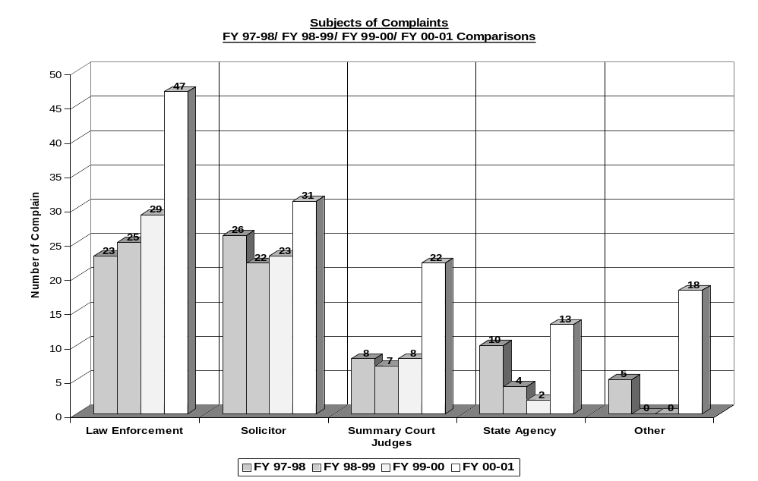
The Crime Victims’ Ombudsman acts as a liaison between the victims and collateral agencies in order to mediate complaints against criminal and juvenile justice agencies or victim assistance programs. The data in Figure 7.1-8 reflects the number of formal complaints (cases) filed against each of the entities involved in the criminal justice system for the last 4 fiscal years. The rise in complaints over the past fiscal year is due to renewed community outreach. The Office of Crime Victims Ombudsman has made a priority of getting information out to citizens. CVO has been present at Magistrate forums and public conferences in front of over 800 people this past year, distributing brochures, business cards, and other pieces of information.

7.2 Mission Accomplishment

What are your performance levels and trends for the key measures of mission accomplishment?

Table 7.2-1 Continuum of Care Client Services and Program Oversight Measures
Measure | FY ’98 – ‘99 | FY ’99 – ‘00 | FY ’00 – ‘01
Client Services Measures
Improved client behavior at school  Improved school performance  Parental involvement with child’s care  Client out of home (end of FY)  Client out of catchment area (end of FY) | 48%  55%  98%  42%  18% | 57%  54%  96%  40%  17% | 54%  56%  92%  48%  23%
Measure | FY ’98 – ‘99 | FY ’99 – ‘00 | FY ’00 – ‘01
Program Oversight Measures
Residential service contracts established  Medicaid certification of providers  Monitoring and technical assistance  Unannounced visits  Provider training | 23  16  290  54  4 | 22  10  246  54  10 | 98  9  241  54  13
Note: the drop in the parental involvement measure is due to the Continuum having a more stringent threshold for the involvement measure. The large change in the number of residential contracts is due to the procurement cycle requiring contracts be terminated and re-issued.
Table 7.2-2 Foster Care Review Program Measures
Measure | FY ’98–‘99 | FY ’99–‘00 | FY ’00–'01
Number of Reviews Conducted | 7,798 | 7,849 | 7,757
Number of Children Reviewed | 4,664 | 4,667 | 4,645
Number of Review Board Meetings | 414 | 410 | 417
Number of Areas of Concern Cited | 10,135 | 10,494 | 10,004
Number of Constituent-Related Communications Initiated |  | 75 | 45
Number of Advocacy Referrals Initiated | 1,929 | 1,390 | 1,397
Volunteer hours per child reviewed | 2.08 | 2.12 | 2.12
Reviews per coordinator | 866 | 1,121 | 1,108
Reviews continued or rescheduled | 242 | 298 | 258
Reviews not held timely* | 101 | 159 | 219
Advocacy referrals initiated per child | 0.4 | 0.3 | 0.3
Children reviewed per meeting | 11 | 11 | 11
*Note: To enhance the timeliness of reviews, DSS and FCR are working together to establish an online coordination and notification process for new clients.

Table 7.2-3 Guardian Ad Litem Program Measures
Measure | FY ’98–‘99 | FY ’99–‘00 | FY ’00–‘01
Total number of children served | 4,232 | 4,415 | 4,877
Total number of volunteers | 1,036 | 1,011 | 1,273
Total number of new cases |  | 1,644 | 1,701
Total number of closed cases |  | 1,399 | 1,394

Table 7.2-4 Children's Affairs Program Measures
Measure | FY ’98–‘99 | FY ’99–‘00 | FY ’00–‘01
Correspondence received | 130 | 340 | 683
Percent of correspondence responded within 5 days | Not measured | 97% | 98%
Number of CCRS Referrals Reviewed and Staffed | 15 | 12 | 12

Table 7.2-5 Foster Care Review Program Measures
INPUTS: | FY ’98–‘99 | FY ’99–‘00 | FY ’00–‘01
Number of Volunteers | 156 | 163 | 176
Number of Volunteer Hours | 9,707 | 9,918 | 9830
Number of Review Board Coordinators | 9 | 7 | 7
Number of Review Boards | 36 | 36 | 37
Number of Reviews Scheduled | 8,040 | 8,147 | 8015
Number of Incoming Constituent-Related Communication | -- | 76 | 45
Number of Children in Foster Care more than Four Months, Having at least One Review | 4,664 | 4,677 | 4645
Number of Completed Customer Satisfaction Questionnaires (biennial) Received from Stakeholders | -- | 489 | --

Table 7.2-6 Foster Care Review Child Placement Program Measures
OUTCOMES | FY ’98–‘99 | FY ’99–‘00 | FY ’00–‘01
Average Length of Time in Care (years) for Children Leaving Foster Care System | 2.9 | 2.9 | 3
Average Number of Placements Experienced by Children Leaving Care | 3.72 | 3.26 | 3.47
Percentage of Children Re-entering Care | 20% | 18% | 19%
Percentage of Children Placed in a Permanent Home After Leaving Foster Care System | 69% | 66% | 68%

Table 7.2-7 Correspondence Office Measures
Areas | FY ’00–‘01
Students | 55,728
Retirees | 3,916
School Administrators and Educators | 5,442
The Office of Correspondence assisted with 105,532 pieces of Outgoing Mail from the Governor to specific customer groups. In addition, 111 schools participated in the Governor’s Student Achievement Recognition Program, with 19,889 students recognized.

Table 7.2-8 Foster Care Review Medicaid Eligible Child Placement Program Measures
OUTCOMES: | FY ’98–‘99 | FY ’99–‘00 | FY ’00–‘01
Percent of Children with Inadequate Level of Communication Among Treatment Team | 18% | 15% | 30%
Percent of Children Placed at an Appropriate Level of Care | 80% | 73% | 83%
Percent of Children Whose Placement Meets Needs | 71% | 52% | 75%
Percent of Children Assessed Requiring Residential Treatment | 94% | 92% | 96%
Average Length of Time in Care (years) for Children Leaving Foster Care System | 4.1 | 4.2 | 4.0
Average Number of Placements Experienced by Children Leaving Care | 6.9 | 6.8 | 6.4
Percent of Children Re-entering Care | 23% | 23% | 26%
Percent of Children Placed in a Permanent Home After Leaving Foster Care System | 43% | 41% | 34%

Table 7.2-9 Small and Minority Business Affairs Measures
FY ’98–‘99 | FY ’99–‘00 | FY ’00–‘01
100 Certifications | 96 Certifications | 130 Certifications
93 Recertifications | 57 Recertifications | 38 Recertifications
66 Temporary Certifications | 102 Temporary Certifications | 207 Temporary Certifications
1 Trade Fair – 45 Businesses Attended | 1 Trade Fair – 39 Businesses Attended | 1 Trade Fair – 45 Businesses Attended
1 Minority Business Assistance Forum (MBAF): 200 Attendees | 2 MBAF -200 Attendees | 3 MBAF – 430 Attendees
OSMBA sends out certification applications based upon request. The re-certification application goes out to vendors whose certification is about to expire. OSMBA has found that the re-certification applications drop from year to year. Some vendors have simply gone out of business within the 5-year period and/or have not gotten the business they anticipated with the certification and as a result fail to reapply among other reasons. The temporary application is one (1) page and vendors are most apt to fill it out because there is no additional paperwork involved. Also, the Trade Fair is held annually and overall OSMBA has experienced the newly certified vendors coming to the Trade Fair more so than vendors that have been certified for a years. Over the past year, there has been an increase in the figures for the Minority Business Assistance Forum. This is a direct result of the involvement of the private sector.

Figure 7.2-10 SOVA Compensation Coordination: Claims Analysis
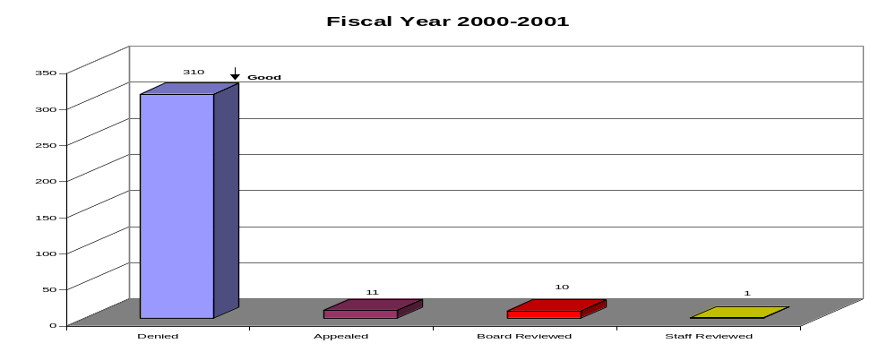

**Note:} Categories include the following: Denied Claims, Appealed Claims, Board Reviewed Claims, and Staff Reviewed Claims
The SOVA Compensation Coordinator performs daily duties of reviewing and presenting denied cases to the Crime Victims’ Advisory Board. Prior to the cases being presented to the Board, the Staffing Team staffs them and the necessary follow-up is provided. In Figure 7.2-10, data depicts the department’s statistics for the Fiscal Year 2000-2001. The chart relating to Compensation Coordinator indicates a decrease in the number of denied claims. This shows that advocates and service providers are being trained and able to do a better job in screening the applications prior to submitting them to the office.

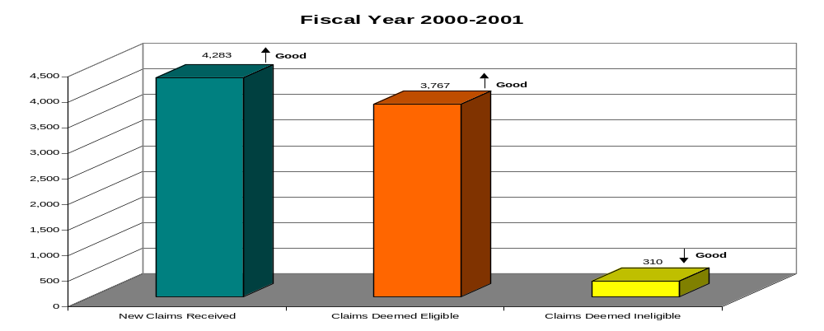
Figure 7.2-11 SOVA Eligibility Services: Claims Analysis

**Note: Categories include the following: New Claims Received, Claims Deemed Eligible, and Claims Deemed Ineligible
SOVA’s Eligibility Services section provides prompt courteous services to key customers, victims/claimants, advocates, law enforcement and service providers during their daily functions. The department’s daily duties consist of reviewing claims received from the Victim/Witness Assistance Services Department for eligibility determination. Claims are assigned and examined by staff, contacts are made via the telephone and written correspondence to victims/claimants, providers and advocates to establish that the criteria for eligibility has been met. Above, the data depicts the section’s statistics for the Fiscal Year 2000-2001. This Eligibility Services' chart indicates the number of new claims deemed eligible.

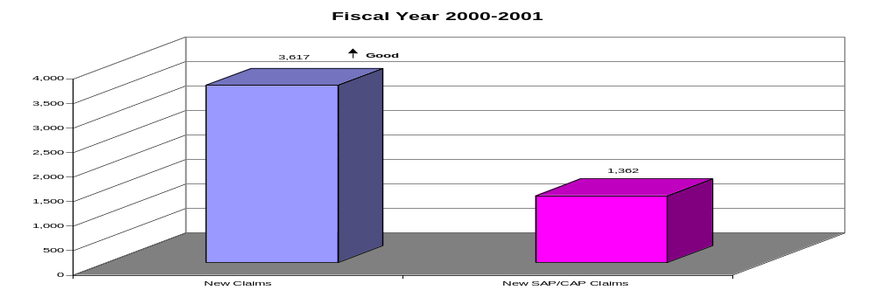
Figure 7.2-12 SOVA Processing Services: Claims Analysis

**Note:} Categories include the following: New Compensation Claims Received, New Sexual Assault Protocol and Child Abuse, Protocol Claims Received (SAP/CAP)
The Processing Services section works as a team with the goal of processing claims for payment to victims, claimants, and service providers in a timely manner. The section also provides information to victims, claimants, and service providers by telephone. Figure 7.2-12 shows data that depicts the department’s statistics for the Fiscal Year 2000-2001. This chart indicates the number of claims that have been paid. It demonstrates the funds used to reimburse victims or funds provided to the provider for services rendered. This number has increased thus far indicating that the needs of key stakeholders are being met (victims and service providers).

Figure 7.2-13 SOVA Program & Information Services: Claims Analysis
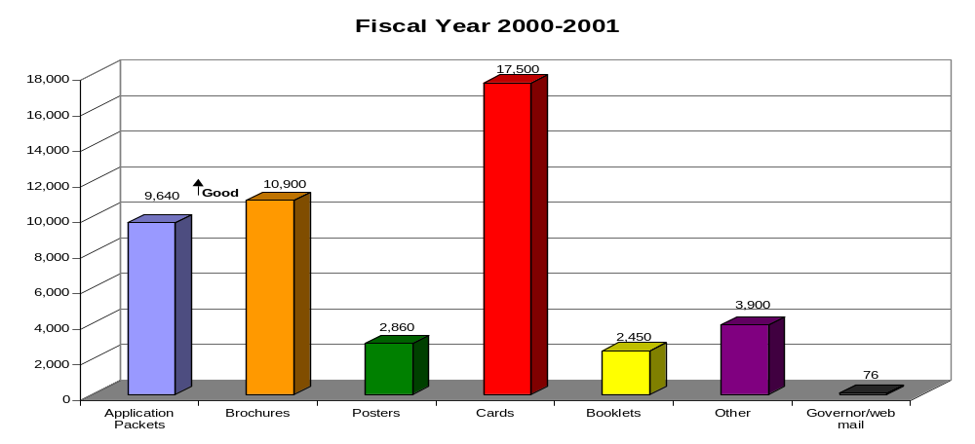

**Note:} Categories include the following: Application Packets, Brochures, Posters, Victims Rights & Resource Cards, Children’s Court Notebooks & Survivor Books, Other, Governor/SOVA/web mail

SOVA’s Program and Information Services supports the development and distribution of SOVA information pieces and production of materials for training events and public awareness. Training event brochures and handouts, internal forms, update handbooks, topical research packets and other items were prepared upon request. Information was provided to callers, visitors, and via e-mail and website communication. All materials included information on SOVA’s services and contact information. The results of these services during this fiscal year are compiled from inventory depletion figures, material order forms and training material inventory sheets.

Above, please find data that the department’s statistics for the Fiscal Year 2000-2001. This chart depicts an increase in the request of applications, brochures, booklets and other promotional items. Increase is due to the SOVA Training Team conducting statewide and regional training events regarding compensation and the rights of crime victims. The team was able to educate and train advocates and service providers; therefore, they (advocates and service providers) were able to pass documentation on to the key stakeholders (victims, claimants, law enforcement etc).

Figure 7.2-14 SOVA Victim/Witness Assistance Services: Claims Analysis
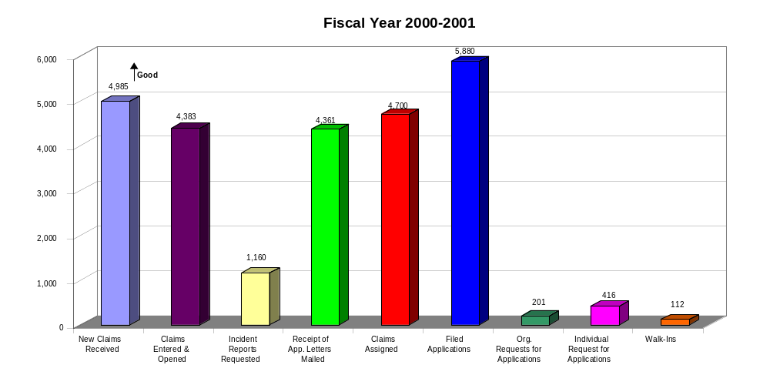

**Note:} Categories include the following: New Claims Received, Claims Entered & Opened, Incident Reports Requested, Receipt of Application Letters Mailed, Claims Assigned to Eligibility, Filed Applications, Organizations’ Requests for Applications, Individual Requests for Applications, and Walk-In Clients.

Victim/Witness Assistance Services (VWAS) contribution of providing direct services through support and advocacy to crime victims across the state has had tremendous impact on the clienteles’ experience throughout this process regardless of the outcome. VWAS receives feedback through evaluations and surveys provided at the end of training sessions as well as through an Appeal Exit Survey (optional) given at the end of the appeal process. These evaluations and surveys are reviewed and processed. The majority of the customer service comments made are excellent regarding the training/services provided to them. This enables VWAS to prepare for future training sessions or to evaluate services provided before, during and after the appeal process.

In addition, these services are beneficial in assisting other key customers such as service providers and advocates from the various circuits. Above, please find data that depicts the department’s statistics for the Fiscal Year 2000-2001. The Victim/Witness Assistance Services chart indicates the large number of direct services that is provided to crime victims. This is a new department in SOVA’s compensation program; therefore, the office is interested in seeing the difference that this department makes in providing support and advocacy to crime victims. SC is the fourth state nationally to have a direct victim service component in its compensation program.

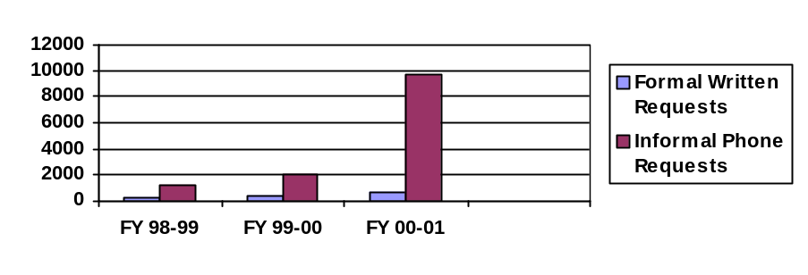Figure 7.2-15 Application Packet Totals by Year

Formal written vs. informal phone

Due to the increase in the number of SOVA training events, the number of applications mailed out have increased. During the training events, customers are provided contact information such as the SOVA number and address so that they can contact the office.

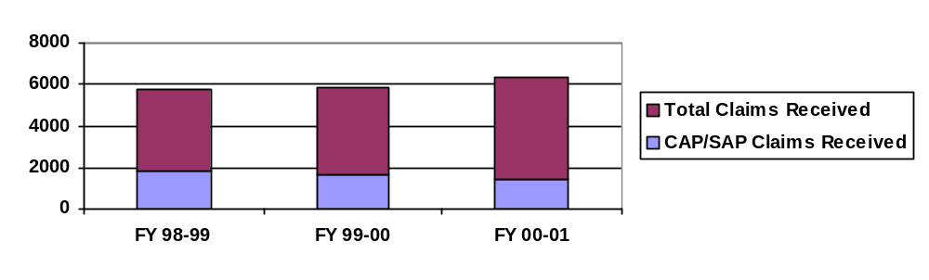Figure 7.2-16 SOVA Claim Totals
CAP = Child Abuse Protocol Claims; SAP = Sexual Abuse Protocol Claims

Figure 7.2-17 Ombudsman Office Telephone Inquiries 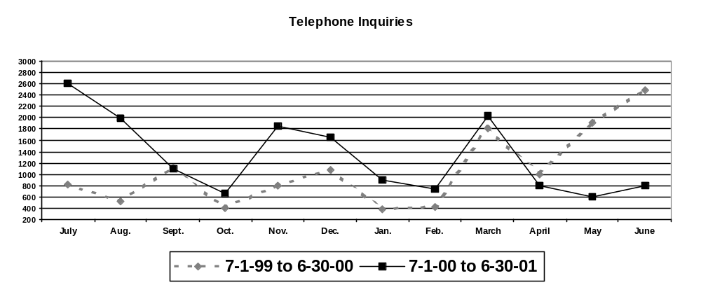Telephone inquiries tend to reflect “hot button” issues such as the Confederate Flag debate (June-July 2000). The Office of Ombudsman has fielded over twenty thousand (20,000) telephone inquiries and researched responses to approximately four thousand seven hundred (4,700) pieces of correspondence. Ninety-seven percent of correspondence was responded to in three days or less, and one hundred percent of telephone contacts were responded to in less than 24 hours. The Client Assistance Program (CAP) office has satisfactorily closed 152 cases while conducting 12 Administrative Reviews. As a standard procedure, each case closed by CAP is mailed a Satisfaction Survey for gathering consumer input into the CAP process.

The Ombudsman Office has been involved in 23 consumer forums and 14 outreach exercises to professional groups. These efforts are complimented by dozens of one-on-one interfaces with interested and/or concerned individuals.

The Office of Ombudsman plans to increase its activities in community outreach especially to the State's Hispanic population by early 2002. These efforts will be coordinated with the outreach efforts of other Governor's Office programs with similar customers. The staff of the Office of Ombudsman has completed over 400 hours of training. These training activities have included areas of customer service, state and local government processes, information assessment, software and computer use, and topics on infrastructure improvement.

Table 7.2-18 Developmental Disabilities Council Measures
OUTPUTS | FY 98-99 | FY 99-00 | 00-01
Employment Grants to persons with DD | 8 | 13 | 11
- Persons with Developmental Disabilities (DD) who have paid employment as a result of employment training | 105 | 62 | 91
- Others with DD who received training in employment | 514 | 1,065 | 685
Community Inclusion Grants | 4 | 6 | 3
- Persons with DD have greater opportunities for full inclusion into their communities | 184 | 1,384 | 708
Respite Care Grants | 3 | 5 | 3
- Number of families who have a family member with DD who have respite and sitter services | 110 | 162 | 221
Transition
- Number of students with DD receiving appropriate transition services | 3,298 | 3,511 | 4,326
- Number of educators trained |  | 600 | 260
Total Number of Grants Awarded | 30 | 28 | 28
OUTPUTS: Grant money given for NTD Research | $45,945 | $45,999 | $50,960
OUTCOME: The incidence rate of Neural Tube Defects (NTD) will remain or get lower than the national average (.9) (with assistance from other agencies) | .8% | .8% | .95%*
* Preliminary
The Council administers the Basic State Grant Program and assures the awards made through this program address the needs of persons with disabilities. Council grants are awarded in the federal Areas of Emphasis: Employment, Education/Early Intervention, Child Care, Health, Homes, Recreation, Transportation, Quality Assurance, Formal and Informal Community Supports and Prevention, the state priority.

Figure 7.2-19 Developmental Disabilities Council: % of Neural Tube Defects per 1000 Live Births in South Carolina (1992-2001)
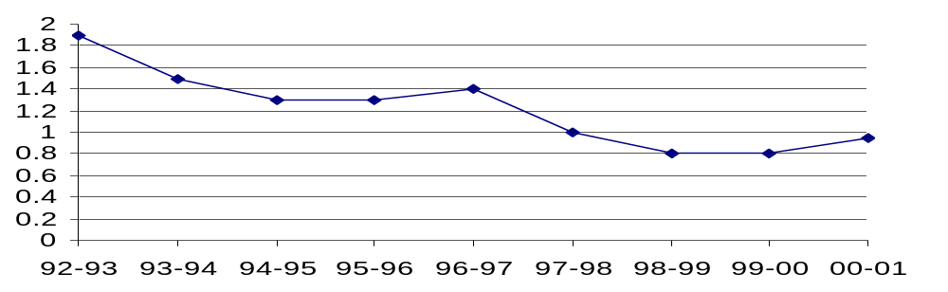
Neural Tube Defects per 1,000 live births have dropped from twice the national average to slightly below it. Following are some of the Council’s efforts on behalf of individuals with disabilities: 1) The incidence rate of neural tube defects in South Carolina will remain at the national average 2) To work to provide employment for persons with disabilities and 3) Students with developmental disabilities aging out of the school setting will actively participate in a coordinated set of transition services.

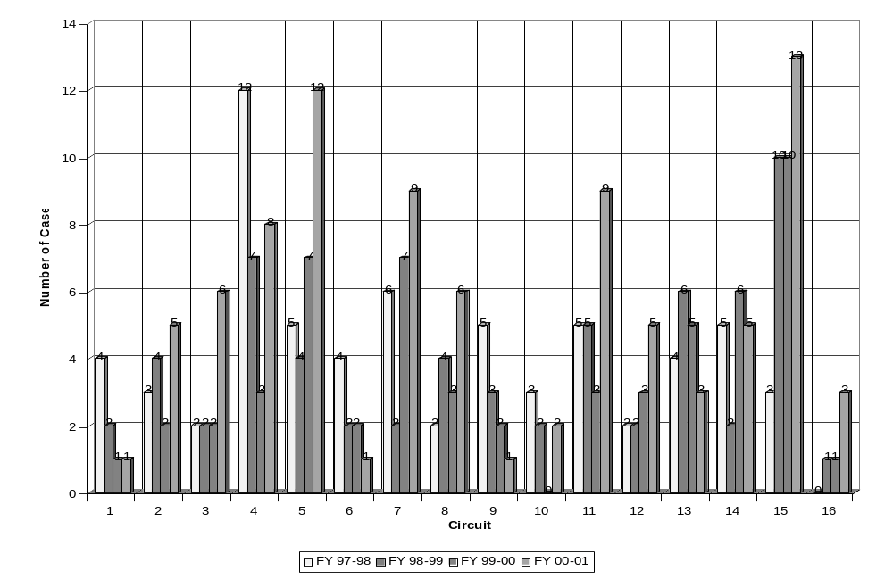Figure 7.2-20 Crime Victims’ Ombudsman Case Per Circuit Analysis
The data in the above figure reflects the number of formal complaints (cases) in each judicial circuit that were received and handled by the Office of the Crime Victims' Ombudsman for the last 4 fiscal years. It includes all entities in the circuit (law enforcement, solicitor, summary court, state agencies, and other).

7.3 Employee Satisfaction

What are your performance levels and trends for the important measures of employee satisfaction, involvement, and development?

A measure of employee satisfaction within Children’s Services is the turnover rate. As a whole, staff turnover was 17% during the fiscal year. In the Continuum of Care, employee satisfaction is not measured directly. However, in a survey addressing employee turnover, 95% of employees said working conditions were good or excellent. The survey had no other general assessment of satisfaction question. In the Foster Care Review Board, during FY00-01, the office director of Foster Care Review surveyed every employee regarding their satisfaction and met with each employee to help the employee develop and reach personal and organizational goals. In the Guardian Ad Litem, the Office Director met with all coordinators to determine needs of each office. All staff completed a written staff satisfaction survey. Due to the qualitative nature of this survey, no quantitative results are available in time for this report.

Table 7.3-1 Human Resource Measures Analysis
Measure | Result
Hire Above Minimum Delegation Audit | In Compliance
Classification Delegation Audit | In Compliance
% of Affirmative Action Goals Met | 92.5%
# of Employee Grievances | 0
Participation in Tuition Assistance | 32
Participation in Job Retention Services Program at Vocational Rehabilitation | 4
Percent of Employee Performance Management System Reviews Submitted on Time for Merit Increases | 100%
The lack of employee grievances in the past fiscal year is an indicator of a high degree of employee satisfaction. Participation in Tuition Assistance increased: 32 in 2001 up from 25 in 2000. The Office of Human Resources staff also worked with office directors to standardize the universal review date for all employees of OEPP as of November 1 of each year.

On direction of the Governor’s Office, the Office of Information Technology, working with the Office of Correspondence, placed Governor’s proclamations and Executive Orders on the Governor’s web site to facilitate interoffice and agency information flow, as well as customer/constituent access. The Office of Information Technology also updated portions of the Intranet site to make it more user friendly. In addition, the IT Office sponsored the following training sessions for Governor’s Office employees during the 2000-01 fiscal year:
Table 7.3-2 Information Technology Training Assistance
Type of Training | # of Sessions Offered | # of Employees in Attendance
Database Applications | 2 | 29
E-mail Software | 2 | 19
Office Productivity Software | 4 | 42
Office Productivity Software | 6 | 65
Database Applications | 2 | 10
E-mail Software | 2 | 8
Office Productivity Software | 2 | 6
Internal customer satisfaction is affected by the ability and ease with which staff can accomplish tasks through the use of technology and computer software and hardware. The training sessions offered by the Office of Information Technology cover every major software application used by Governor’s Office employees at least once annually. Sessions are planned on employee requests or identified need.

7.4 Supplier, Contractor, and Partner Performance

What are your performance levels and trends for the key measures of supplier/contractor/partner performance?

Table 7.4-1 Children’s Services Supplier, Contractor and Partner Management
Office | Supplier | Supplies | Management of Relationship | Performance Results
Continuum of Care | Public Providers such as schools, Mental Health, Social Services, Juvenile Justice | Public services such as education, mental health services, social services, and juvenile justice | Monitoring of quality of services, advocating for the development of services to meet unmet needs, improving interagency cooperation. | The Family Support Services unit of the Continuum has about 633 meetings with other child serving agencies a year. About 80% of meetings about a specific client. The other 20% involve state wide or systems change issues.
Continuum of Care | Private service providers--wrap and residential services | Wrap services such as positive role model, activity therapy, etc. Residential services such as group home care, residential treatment services, etc. | Contracts with providers, monitoring of quality, supports providers, develops new services when needed. Coordinates Program Oversight Council. | This data is shown in Table 7.2.1.
Continuum of Care | Families | Clients and support for their child | Involvement in treatment and treatment planning, training and skill development. | Treatment planning meetings: Family members attended over 500 of these meetings.
Foster Care Review | Review Board Volunteers | Recommendations to Family Court, DSS, and other interested parties relating to permanence for children in foster care. | Training and support of volunteers. | Review board volunteers provided over 11,000 hours of volunteer time.
 | Foster Parents | Foster care placements | Providing information regarding children in their homes to local review boards. | 2069 foster parents attended reviews.
 | Birth Parents | Children needing foster care placement | Providing information regarding their children to local review boards. | 2007 birth parents attended local review board meetings.
Guardian Ad Litem | Family Court Judges | Assignment of cases | Recruiting, training, and supervising volunteers who advocate for maltreated children. | Volunteers provided over 111,000 hours of time.
Guardian Ad Litem | DSS | Referral of cases | Recruiting, training, and supervising volunteers who advocate for maltreated children. | Volunteers provided over 111,000 hours of time.
Children's Affairs | Families | Concerns needing resolution | Gathering information on needs and seeking to find solutions to concerns. | This data is presented in Table 7.2.4.
Children's Affairs | Child serving state agencies | Inter-agency concerns needing mediation and resolution | As a member of the Program Oversight Council, helps agencies comply with terms of RFP. | Measurement being developed.
Children's Affairs | Private providers of children services | Concerns about the management of children's services contracts. | Mediates concerns between agency and provider. | This effort was developed in FY00-01 and started on July 1, 2001.

Administrative Services

The Office of Finance processed 100% of purchase orders on an average of 1.5 days and 100% of invoices in an average 5 days. The Office of Finance also expanded the use of the state procurement card from $0 to over $100,000 in purchases including purchases from the central supply warehouse and Jon-Ker (minority-owned business).

7.5 Regulatory and Legal Compliance

What are your performance levels and trends for the essential measures of regulatory/legal compliance and citizenship?

Table 7.5-1 Continuum of Care Medicaid Compliance
Measure | FY ’98 – ‘99 | FY ’99 – ‘00 | FY ‘00 – ’01
% of Wrap Medicaid funds recouped | 0.3% | 0% | 0%
% of Medicaid case management funds recouped | 0% | 0% | Audit pending
% of program oversight reviews not done according to standards | 0% | 0% | 0%
In FY98-99 the Continuum implemented a new method to bill for wrap services. Due to billing errors, the Continuum had to pay back to the Department of Health and Human Services 0.3% of the funds received as reimbursement. In FY99-00 and 00-01, no funds were recouped. A result of 0% indicates performance excellence, indicating that no funds had to be reimbursed to the funding source due to an improper distribution.

Table 7.5-2 Foster Care Review Case Review Compliance
Measure | FY ’98 – ‘99 | FY ’99 – ‘00 | FY ‘00 – ’01
% of reviews of new cases not completed on time | 1% | 4% | 3%
*DSS reports to FCR names of new foster care clients; however names are not always received on a timely basis. DSS and FCR are working together to resolve this issue via electronic notification.

Also, all OEPP offices are smoke-free in compliance with state law. The Edgar Brown building and other buildings that house OEPP offices also have fire escape routes posted that comply with state regulations.

7.6 Financial Performance

What are your current levels and trends of financial performance?

Administrative Services
The Division of Administrative Services operates on a fixed budget. In a tight fiscal year, this Division has maintained quality and streamlined costs by prioritizing needs and consolidating duties. In an effort to raise efficiency, the Division Leadership Team developed a plan to reduce supply costs by setting standards for uniform supply types of non-unique items throughout the Office of Executive Policy and Programs. For example, toner purchases were consolidated, resulting in savings in excess of $5000. Bar codes for mail costs were developed to ensure responsibility and accountability of staff members and accuracy of business-related correspondence. Vendors were paid in a timely manner (within 5 days), and all employees were paid on the designated dates. The expansion of the use of the state procurement card for some purchases increased efficiency in the Office of Finance by reducing the number of invoices that require processing. The Office of Human Resources implemented changes in the Employee Performance Management System to standardize the universal review date for more equitable merit increase distribution.

Table 7.6-1 Continuum of Care Case Management Efficiencies
EFFICIENCY MEASURES | FY 1998-1999 | FY1999-2000 | FY1999-2000
Case mgmt hours / case manager / month  Case mgmt hours / client / month  $ spent per client on case services | 46.0  5.3  $18,284 | 44.27  4.9  $16,559 | 46.49  5.2  $14,531
These numbers are decreasing because the number of clients served while the amount COC has to spend on client services has remained flat.

Figure 7.6-2 Continuum of Care Case Management Efficiencies
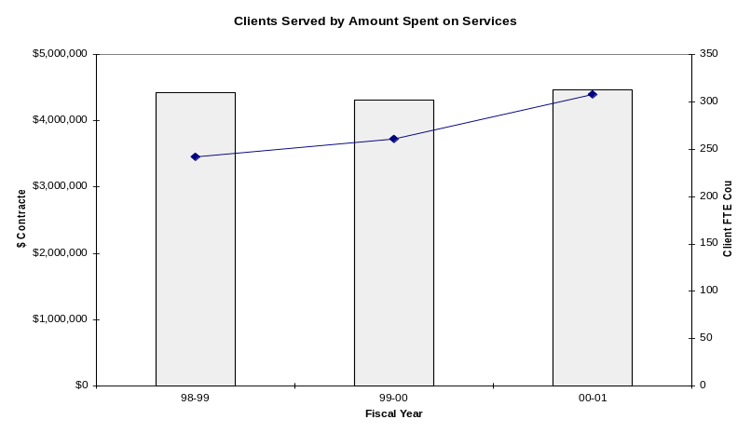
Figure 7.6-3 SOVA Financials – Claims Paid 2000-2001
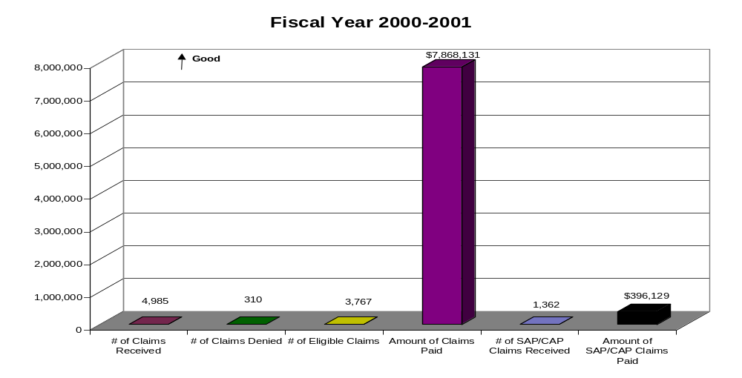

**Note:} Categories include the following: Claims Received, Claims Denied, Claims Deemed Eligible, Amount of Claims Paid, SAP/CAP Claims Received, Amount of SAP/CAP Claims Paid

SOVA Financial Services Department
Above, please find data that depicts the department’s statistics for the Fiscal Year 2000-2001. The Financial Services' chart indicates the amount of money that SOVA spent on claims. These funds enable SOVA to address to needs of key stakeholders. The Financial Services Department’s key customers are both internal (SOVA staff) and external (victims, providers, solicitors, state, federal and non-profit agencies). Internally, the Financial Services Department handles procurement and travel for SOVA staff members. Externally, the Department manages the financial, grant, and contractual obligations of the Crime Victim Compensation Fund. Internally, the section prepares and analyzes budgets, revenue and expenses to assure availability of funds for payments to all of SOVA’s monthly office expenses (phone bills, equipment maintenance and repairs, rent, etc.) The Financial Services Department coordinates with the Governor’s Office of Executive Policy and Programs accounting area daily to provide prompt payment for all SOVA customers in a timely manner.

Veterans Affairs

The Office of Veterans Affairs provides client assistance to all veterans, their dependents or survivors in developing, filing, presenting and prosecuting to final determination all claims for benefits under terms of federal and state legislation. The U.S. Department of Veterans Affairs expends millions of dollars in South Carolina.

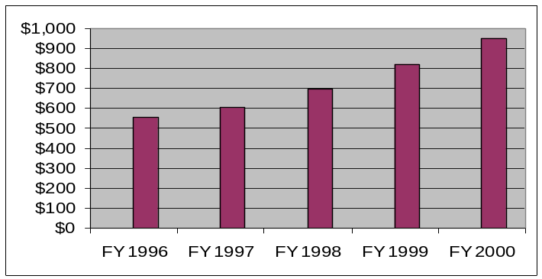Table 7.6-4 Veterans Affairs Dollars in Millions – VA Expenditures in S. Carolina

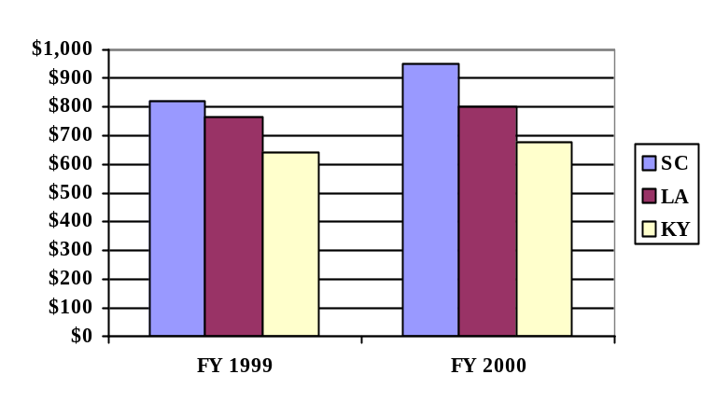Table 7.6-5 Veterans Affairs Dollars in Millions – VA Expenditures in S. Carolina Compared with Kentucky and Louisiana (states with comparable veteran populations) VA Expenditures in South Carolina have increased and exceeded comparison states’ expenditures.

Table 7.6-6 Office of Economic Opportunity Financial Breakdown
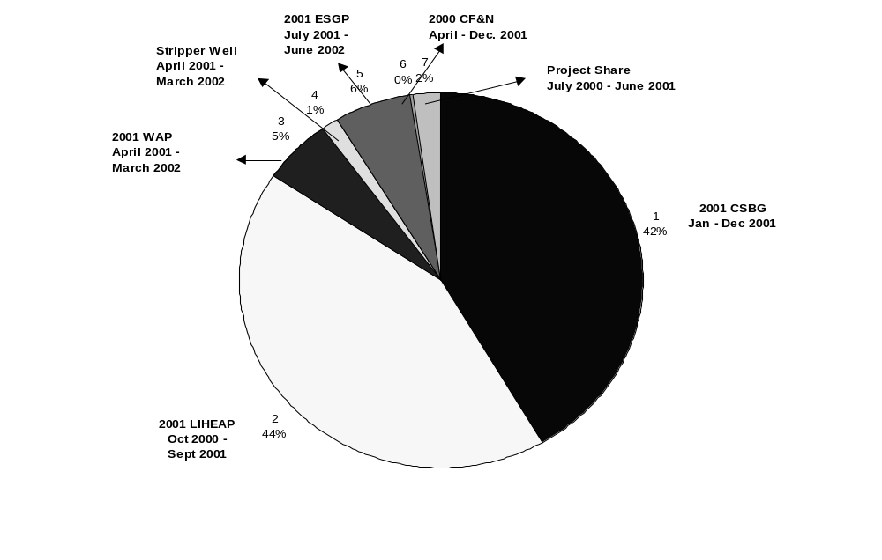
Office of Economic Opportunity Federal and Non-Federal Funds

$1,393,000 - Emergency Shelter Grant Program (ESGP) A competitive grant that is issued to non-profit organizations that provide housing and counseling assistance to the state's homeless population and those at risk of becoming homeless.
$55,902 - Community Food and Nutrition (CF&N) Monies are distributed to all community action agencies to provide food, health and nutrition assistance and awareness of eating healthier.
$467,489 - Project Share - Non-Federal Funds - The project is composed of three utility companies: South Carolina Electric and Gas (SCE&G), Duke Power and Carolina Power and Light (CP&L). Funds are used to provide energy assistance and to supplement the Low Income Home Energy Assistance Program (LIHEAP) and Weatherization Assistance Program (WAP).
$298,859 - State Energy Office - State Funds - These funds are used to assist in our Weatherization Program.
$1,195,436 - Weatherization Assistance Program (WAP) This program provides energy assistance in the form of home weatherization. This process includes the replacement/repair of windows, doors, caulking, and placing insulation and weatherization stripping in the home.
$9,360,132 - Low Income Home Energy Assistance Program (LIHEAP) This program provides energy assistance to eligible households throughout the year via a voucher system to the energy providers.
$9,173,174 - Community Service Block Grant (CSBG) These funds assist community action agencies across the state to develop community based programs using the needs assessment approach. These programs provide assistance in employment training and placement, housing and community services.

Table 7.6-7 Emergency Shelter Grants
INPUTS | FY 99 | FY 00
Number of Agencies Applying for Grants | 35 | 38
OUTPUTS | FY 99 | FY 00
Number of Agencies Awarded Grant | 25 | 26
Number of Clients Served | 17,865 | 19,075
Funding Disbursed | $1,392,000 | $1,395,000
Emergency Shelter Grants Program (ESGP)
ESGP is grant for the homeless that allows units of local government and non-profit social service agencies to provide housing and counseling assistance to the State’s homeless population via community based shelters and transitional housing programs.

Table 7.6-8 Weatherization Grants
INPUTS | FY 99 | FY 00
Number of households receiving assistance | 1,047 | 1,195
OUTPUTS | FY 99 | FY 00
Funds Disbursed | $973,975 | 1,056,507
* No Records kept on number of households applying for assistance
Weatherization Assistance Program (WAP)
The Weatherization Program (WAP) provides materials to make the home more efficient by way of energy assistance in the form of weatherizing the home. This process would include the replacement/repair of windows, doors and/or placing insulation, caulking and weather stripping in the home.

Low Income Home Energy Assistance Program (LIHEAP)

Table 7.6-9 LIHEAP Grants
OUTPUTS | FY 99/00 | FY 00/01
Number of Households issued vouchers for Direct Assistance  Funds Disbursed | 47,322  7,518,572 | 53,539 *  5,590,600
*As of May 25,2001

Table 7.6-10 Emergency Assistance Grants
INPUTS | FY 99/00 | FY 00/01
# of Households Applying for Emergency Assistance (Heating) | 12,652 | no report *
# of Households Applying for Emergency Assistance (Cooling) | 7,540 | no report
OUTPUTS  # of Households Receiving Emergency Assistance (Heating)  # of Households receiving Emergency Assistance (Cooling)  Funds Disbursed – Heating  Funds Disbursed - Cooling | FY99/00  12,304  7,202  383,359  2,159,853 | FY99/00  19,033  6,863  4,016,826  774,140
*Paper reporting has created no reporting, incomplete reporting and incorrect reporting on the number of households applying.
Direct Assistance provides winter heating and summer cooling assistance once a year by way of issuing vouchers (certificates) to eligible households. To assist with heating and cooling bills, funds are disbursed upon receipt, resulting in seasonal and annual fluctuations of total disbursements. Large disbursement total for heating during FY 00/01 is due to assistance provided by the media to collect extra funds for the those who needed extra assistance.

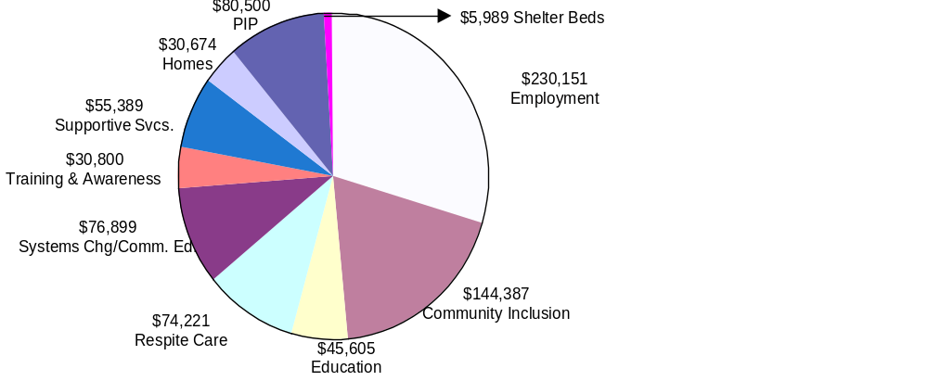Table 7.6-11 Developmental Disabilities Council Financial Breakdown
All funds received for the above service areas were generated through federal grants procured by the Developmental Disabilities Council.

