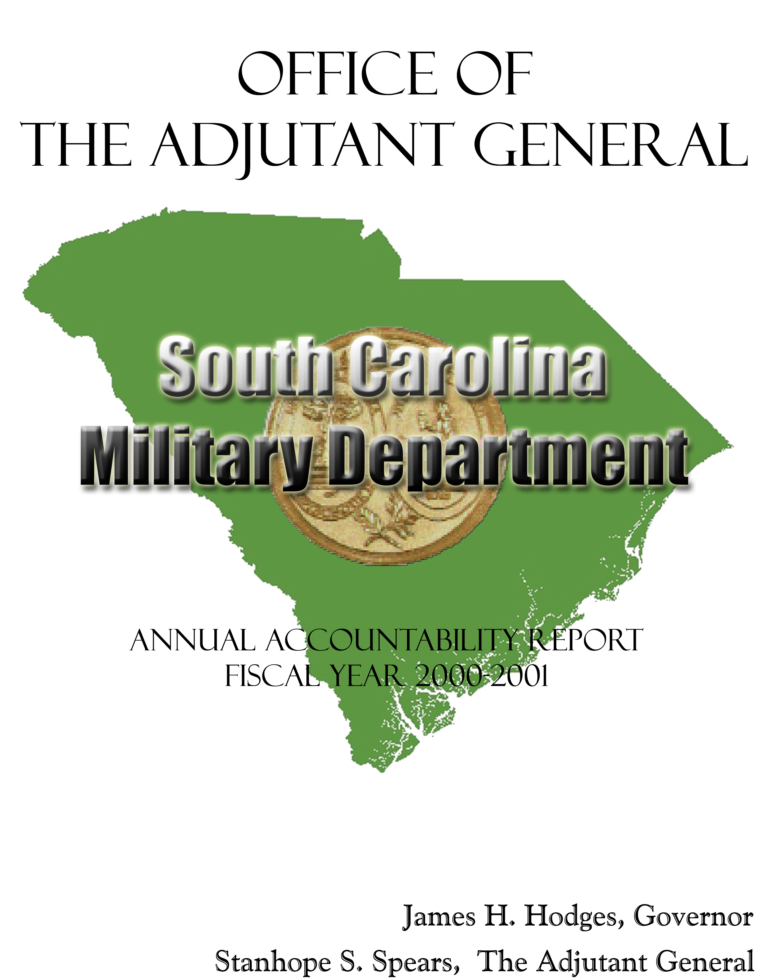
TABLE OF CONTENTS
TRANSMITTAL FORM 3
EXECUTIVE SUMMARY 4
BUSINESS OVERVIEW 8
Organzational Chart----------------------------------------------------------11
LEADERSHIP 12
sTRATEGIC pLANNING --------------------------------------------------------------14
CUSTOMER FOCUS AND SATISFACTION 16
Information and analysis ---------------------------------------------------18
HUMAN RESOURCES FOCUS 20
PROCESS MANAGEMENT 22
KEY BUSINESS RESULTS 24
Armory Operations 24
South Carolina Emergency Preparedness Division / South Carolina Disaster Relief Assistance 29
South Carolina Emergency Preparedness Division / Operations 31
South Carolina Disaster Relief Assistance------------------------------------------------------------------------------36
Youth ChalleNGe Academy 37
Tuition Assistance 39
Office of The Adjutant General 41
South Carolina State Guard 48
National Guard Pension Fund 50

TRANSMITTAL FORM

Agency Name…...………………………………..………South Carolina Military Department

Date of Submission………………..…………….................................................August 31, 2001

Agency Director……………..……………………………………………….Stanhope S. Spears
Major General, SCARNG
The Adjutant General

Agency Contact Person…………...…………………………………….Mr. W. Carson Raichle

Agency Contact’s Telephone Number….…………………………………………803-806-4445

EXECUTIVE SUMMARY

The South Carolina Military Department’s commitment to quality management lends itself to empowerment, innovation and entrepreneurship. It has promoted partnering with other State and Federal agencies and the private sector for mutual advantage. As we benchmark against others for best practices, others benchmark against this agency.

In this summary, please note the collateral value that this agency’s State dollars have in bringing Federal dollars to South Carolina.

Here are a few examples of Army Guard achievements from this past fiscal year: (1) The establishment of a Distance Learning Program (100% federally funded) in partnership with the Army Guard and South Carolina colleges and universities. This program’s marketing plan has been adopted by the National Guard Bureau as a model for the entire United States. (2) For the second year, an in-depth survey was conducted by the Budget and Control Board’s Dr. Hardy Merritt. This “Command Climate Survey” for the Army Guard has the potential of becoming a national benchmark in identifying the needs and expectations of young soldiers. No other State has undertaken a project of this magnitude with such statistical exactitude and depth. This survey was 100% federally funded. (3) In a continuing partnership with the South Carolina Department of Natural Resources, the Army Guard participated in two Reef-Exercises to establish artificial reefs with obsolete equipment off the State’s coast at Georgetown and Beaufort. This program is 100% federally funded by the Department of Defense. (4) In the past fiscal year, the Governor’s Counter Drug Task Force, 100% federally funded in the amount of $1.9 million, aided in the seizure of drugs worth over $40 million. In addition to supplying essential personnel to the Drug Enforcement Administration, the U.S. Customs Service, the U.S. Attorney’s Office, the U.S. Postal Inspection Service, the U.S. Marshals Service, the State Law Enforcement Division, the FBI, the Port of Charleston and the Greenville County Sheriff’s Office, this Task Force addressed nearly 40,000 K-12 students in South Carolina on the dangers of drug use.

The Air Guard continued with its high level of accomplishment. (1) The deployment of a security specialist team to provide security for the International Special Olympic Games in Alaska. Alaska’s Governor awarded the Alaska Community Service Medals to this team for its exemplary service. (2) The successful completion of yet another overseas deployment in Operation Southern Watch flying 160 sorties which were mostly combat patrol missions over the Iraqi southern no-fly zone. Not a single sortie was lost because of maintenance cancellation. Other Air Guard personnel supported Operation Northern Watch from locations in Turkey and Europe. (3) The deployment of the 169th Medical Squadron to Guatemala to provide the much needed services to the many towns and villages in that stricken country. (4) And receiving the 2001 National Park Partnership Award along with partners the Richland Legislative Delegation, Richland County and the River Alliance for the construction of the entrance road and visitors center at the Congaree Swamp National Monument. This partnership saved taxpayers more than $3 million and provided an outstanding facility to the State and the nation for visitors to better understand the significance of the Congaree Swamp and generate tourist revenue for South Carolina.

State Operations, the third element of the South Carolina Military Department, saw increased involvement with at-risk youth. (1) Groundwork was begun to establish a second Youth ChalleNGe Program in Allendale partnering with the South Carolina Department of Education. The current program in partnership with the Wil Lou Gray Opportunity School enjoys a post-graduation success rate of 88%.
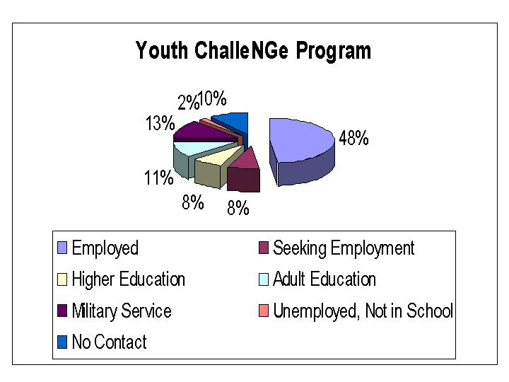
(2) A new program named Starbase, 100% federally funded through the Air Guard and the National Guard Bureau, is geared to at-risk primary school students. Starbase is designed to raise the interest and improve the knowledge and skills in math, science and aerospace technology by exposing youth to the technological environment and positive role models found in the military. Richland School District One is partnering in this effort. (3) Innovative technological advances made within the agency using the 100% federally funded RCAS system include an “Internet Facility Maintenance Work Request System” that will allow agency personnel throughout the State to electronically request work. The program will allow the requestor to complete the request on-line and track the status of the work order. Further, it will generate work orders, assign work crews and track work order costs. It will help save limited work time and improve both accountability and customer feedback. Additionally, this important tool was made possible by the work of a research assistant provided by a partnership with the University of South Carolina. (4) The Emergency Preparedness Division (EPD) greatly expanded training for emergency management personnel at all levels of government – 80 training courses for 2,247 personnel state-wide represented an increase of 170%. (5) The execution of 15 exercises for the State Emergency Response Team represented an increase of 300% over the previous year. (6) 16 stakeholder workshops, a 300% increase over the previous year, that included State, private and volunteer agencies were conducted to insure the Emergency Operations Plan was fully coordinated and responsibilities specifically assigned and understood. (7) EPD has been in the forefront of Terrorism/Weapons of Mass Destruction preparedness. South Carolina was the first State to submit and have approved a 3-year statewide domestic preparedness strategy. A team of 22 Army Guard Reservists (AGRs) with a Federal payroll in excess of $800,000 dollars currently man a special WMD unit which will be housed in a facility constructed with Federal dollars on State land.

Mission is the reason for an organization’s existence or what it does. The above achievements, in addition to the agency’s everyday operations, are proof that the South Carolina Military Department exceeds its mission statement:

• Provide combat-ready units to the US Army and US Air Force.

• Provide planning, coordination and military capabilities in response to State emergencies.

• Add value to State and Nation with community-based organizations, soldiers and airmen.

Mission is enhanced by the values adopted by the agency. These values, or guiding principles, express those things we care most about and drive behavior at all levels. They serve as guides to doing the right things as we carry out our mission. The agency values are:

• Communication - open, honest and timely dialogue with respectful exchange of views with everyone working together for a common purpose.

• Honesty – telling the unbiased truth with sincerity, compassion and without hidden agendas.

• Integrity – doing the right thing every time; loyal to the organization and to each other.

• Competence – qualified, capable, effective and dedicated professionals who meet the expectations of our members.

• Teamwork - working together as a team with cooperation, shared goals, mutual support and unity of purpose.

• Fairness – equal opportunity for everyone through consistent actions, equal recognition for equal accomplishments and treating everyone the same.

• Family – taking care of and supporting each other and our loved ones, keeping them informed, making them feel like they belong and putting them first.

• Patriotism – supportive of the United States and South Carolina constitutions and democracy.

Goals are long-range statements of purpose, aim and intent which, when accomplished, collectively will enable the organization to achieve its vision. Goals are not necessarily quantified or limited in time. The South Carolina Military Department’s goals are:

1. Safety
2. Strength
3. Training Readiness
4. Equipment Readiness
5. Quality of Life
6. Strengthen Support for State Missions

Opportunities and Barriers: The agency continues to makes strides in the use of innovative technology to better serve its customers’ needs, both internally and externally. However, personnel and facilities will continue to be the driving forces of this organization. Without trained and qualified employees, the citizens of South Carolina will not receive the quality support they require and deserve. Facilities must be properly maintained to provide acceptable conditions for continual military training. Unfortunately, most facilities do not meet minimum Federal guidelines for usability and safety.

BUSINESS OVERVIEW

Workforce. The Adjutant General’s staffing includes approximately 11,680 men and women of whom 10,486 are traditional National Guard members and 726 are Active Guard/Reservists. Fifty personnel are employed in the Emergency Preparedness Division. There are 1,040 unpaid volunteer members of the State Guard.

The South Carolina Military Department is considered one of the premier military departments in the United States. Army Guard and Air Guard units are tasked to be in a continuous state of readiness for deployment. During the past fiscal year, personnel and/or units were deployed to Japan, Korea, Germany, Kuwait, Bosnia, Yugoslavia, Guatemala, Italy and Turkey.

Locations. The agency is headquartered at 1 National Guard Road in Columbia and maintains 82 armories valued at $311 million, two Army National Guard training installations and an Air National Guard training station.

Accountability Report Appropriations/Expenditures
 | 99-00 Actual Expenditures |  | 00-01 Actual Expenditures |  |  | 01-02 Appropriations Act
Major Budget Categories | Total Funds | General Funds | Total Funds | General Funds |  | Total Funds | General Funds
Personal Service | $7,190,330 | $2,505,208 | $7,969,270 | $2,644,603 |  | $7,053,260 | $2,166,344
Other Operating | 10,281,558 | 1,961,864 | 11,151,826 | 1,545,688 |  | 10,184,467 | 2,070,041
Special Items | 5,189,756 | 3,196,248 | 3,942,016 | 1,724,474 |  | 5,146,459 | 1,586,459
Permanent Improvements | 8,121,418 | 44,871 | 1,942,197 | 39,887 |  | 1,625,000 | 10,000
Debt Service | 3,507 | 3,507 | 0 | 0 |  | 0 | 0
Case Services | 0 | 0 | 0 | 0 |  | 0 | 0
Distributions to Subdivisions | 956,328 | 0 | 1,359,251 | 0 |  | 1,276,754 | 0
Fringe Benefits | 4,364,759 | 3,174,484 | 4,637,615 | 3,211,202 |  | 4,394,700 | 3,293,035
Base Reduction |  |  |  |  |  | (889,521) | (889,521)
Total | $36,107,655 | $10,886,182 | $31,002,176 | $9,165,853 |  | $28,791,119 | $8,236,358

Other Expenditures
 | Sources of Funds |  | 99-00 Actual Expenditures |  | 00-01 Actual Expenditures
 | Disaster Assistance (Non-Recurring):
 | Supplemental Bill |  | $2,788,263 |  | $3,296,103
 | TOTAL FUNDS |  | 22,856,875 |  | 16,891,901
 | Spartanburg Armory Supplemental Bill |  | 0 |  | 1,000,000
 | Tuition Assistance Supplemental Bill |  | 150,000 |  | 0
 | Capital Reserve Funds |  | 0 |  | 250,000
 | Bonds |  | 0 |  | 0

Key Customers. Identification of customers and their needs is crucial to the strategic planning process of this agency. However, the South Carolina Military Department’s operations are of such a diverse nature that a complete list of customers exceeds the demands of this report. A primary list of customers includes: the President of the United States, the Governor of South Carolina and the citizens of this State; the Department of Defense, the U.S. Army and U.S. Air Force, the National Guard Bureau, the Federal Emergency Management Agency, the traditional National Guard men and women of our Army and Air Guard components, parents/guardians of at-risk youth, the Universities of South Carolina and Clemson, South Carolina Departments of Juvenile Justice, Social Services, Health and Environmental Control, Public Safety, Transportation, the U.S. Drug Enforcement Administration, the U.S. Customs Service, the U.S. Attorney’s Office, the U.S. Postal Inspection Service, the U.S. Marshals Service, State Law Enforcement Division, Greenville County Sheriff’s Office, the Port of Charleston, magistrates, county and municipal governments, the American Red Cross, and, of course, the agency’s staff.

All of these customers provide input and feedback on the agency’s processes. A variety of methods are employed to determine their market requirements and expectations. Please refer to the section on “Customer Focus and Satisfaction” for details.

Key Suppliers. Among the South Carolina Military Department’s suppliers are: U.S. Army, U.S. Air Force, National Guard Bureau, Universities of South Carolina and Clemson, S.C. Department of Vocational Rehabilitation, S.C. Department of Corrections, S.C. Law Enforcement Division, S.C. Budget and Control Board, S.C. General Services, S.C. Department of Labor, Licensing and Regulation, Comptroller General’s Office, State Treasurer’s Office, Department of Health and Environmental Control, S.C. Department of Corrections, S.C. Research, Pratt & Whitney, Tyler Construction, Monteray Construction, Bonitz Flooring, Amana Corporation, Hussey Gay Bell & DeYoung, Guy White & Associates, Law Gibb Engineering, SCANA/SCEGCO, City of Sumter, LTC Associates, Stern Two Notch Properties, John Deere, Grant Contracting, Post Buckley Schuh and Jernigan, Danka Business, URS, Mechanical Design, BES Incorporated, PYA Monarch and McMillan Smith.

Major Products/Services. Our mission statement correctly identifies those products and services provided by the South Carolina Military Department:

“Provide combat-ready units to the U.S. Army and U.S. Force…provide planning, coordination and military capabilities in response to State emergencies…add value to State and Nation with community-based organizations, soldiers and airmen.”
Organizational Chart

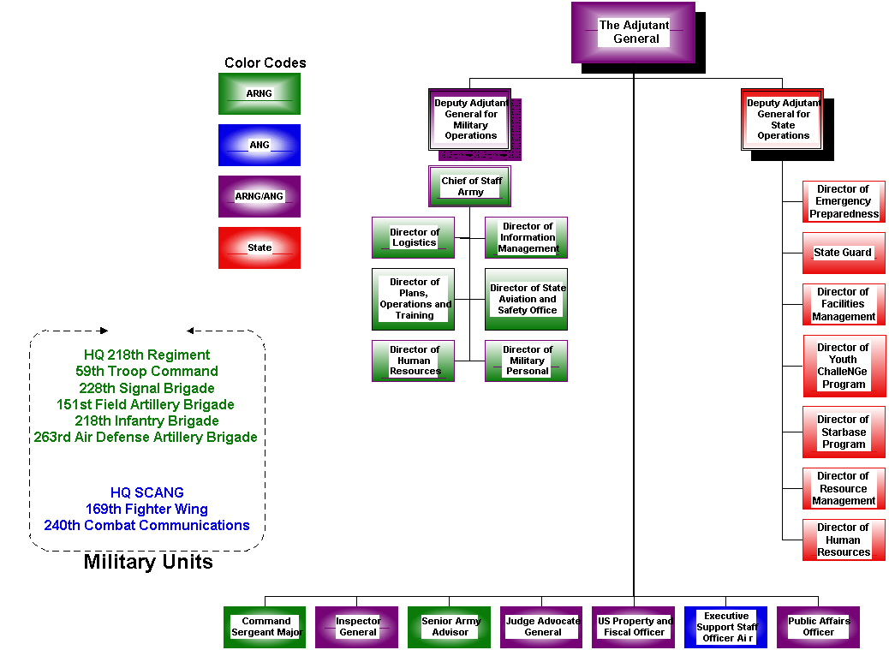

LEADERSHIP

Led by the Adjutant General, Major General Stanhope S. Spears, the senior leadership of the South Carolina Military Department, through its Executive Council, the Air Guard and State Operations Quality Councils and the Army Guard Command Readiness Council, is vitally involved in all aspects of the agency’s operations. These include guiding the agency’s long range strategic planning, development of the annual business plans, seeking innovative business-like practices, insuring that performance measures are monitored for excellence and serving as role models for all employees of the organization. It is the leadership’s responsibility to ensure that participation in these activities extends to all levels of the organization and is communicated throughout the organization. In turn, feedback from these organizational processes is used to improve the agency’s leadership.

Leading by example, the senior leadership provides the environment for innovation and improvement within the agency. The Adjutant General is currently a member of the Executive Council of the National Guard Association of the United States, a member of the Reserve Forces Policy Board and Chairman of the Safety and Occupational Health Committee of the National Guard Bureau. The senior leaders on the military side of the agency have been trained in management principles, team leadership and Malcolm Baldrige-type criteria, viz., Quality Air Force Assessment and Army Performance Improvement Criteria, all at federal expense. Leaders in State Operations receive Malcolm Baldrige training as an on-going project in addition to the courses available through the Budget and Control Board’s Human Resources Office, especially the Executive Institute. Their leadership abilities are recognized at all levels of government. For example, the past Director of the Emergency Preparedness Division, who served as Chairman of the National Emergency Management Association Terrorist Committee, now directs a Weapons of Mass Destruction Office at the U.S. Department of Justice. Additionally, the Deputy Adjutant General for State Operations presently serves as Chairman of the Communities in Schools-SC Board, a program dedicated to “helping kids to help themselves.” The current EPD Director chairs the State’s Hurricane Task Force that focuses on improving communities’ survival from the effects of hurricanes.

Senior leadership has also insured that all employees of the agency have an opportunity to receive training that will enhance their value to the agency and their own quality of life. Training of this nature ensures that future leaders have both the skills and experience to excel and continue a tradition of excellence in leadership. Of special note is the agency’s “Culture for Change” course, which not only serves to address the diversity of the agency, its mission and its customers but is a valuable tool for employee feed-back and communication of the organization’s strategic plan and action plans.

Performance measures are an important part of the process and help the agency track and measure its progress on issues directly tied to the goals of the strategic plan. These include: recruiting and retention, facility management and maintenance, response time to emergencies, error rates, cycle time reduction, customer satisfaction, employee expectations and needs, and employee and external customer training. The agency benchmarks with other States and like agencies to identify, translate and implement best practices.

The South Carolina Military Department demonstrates its public responsibilities and practices in many ways. In the past fiscal year, EPD published and distributed 500,000 public information brochures of the 2001 Hurricane Guide which advises the public on actions to take before, during and after hurricanes; increased the number of presentations and briefings to the mass media, citizen groups, municipal and county officials, private enterprises and volunteer organizations; produced and distributed a brochure outlining the organization and mission of the terrorism-oriented Critical Incident Management Group; produced and began marketing to the public its third generation web site which received nearly a half million visits during the 1999 approach of Hurricane Floyd; and conducted Terrorism/WMD training for local, state and federal Senior officials to include mayors, county councils, military leaders, state agency directors, private and volunteer organization representatives, the FBI, universities and hospitals.

Information technology has a direct impact on the public. The South Carolina Military Department’s goal of a 20% increase in web traffic was exceeded in FY 2001 by over 1,000%. Additionally, the partnership with the University of South Carolina to provide work study (WS) and research (RA) opportunities has been highly beneficial to the agency, the University and the citizens of South Carolina. Last year, this agency reported on a technological advance for SABAR access that improved remote accessibility by as much as 50%. This year, the agency developed an online Internet Facility Management Work Request program for its customers that will automatically generate work requests, track work requests, assign work crews and track work order costs. This will help save the extremely limited work time available and improve both accountability and customer feedback.

The agency’s commitment to education and the youth of South Carolina is already evidenced by its successful partnership of a Youth ChalleNGe Program with the Wil Lou Gray Opportunity School. The program post-graduate success rate of 88% has already been mentioned. A second Youth ChalleNGe Program to serve at-risk youth has been established in Allendale County in partnership with the South Carolina Department of Education. Yet another program for at-risk students has been established in Columbia at Owens Field. In conjunction with Richland School District One and federal funding through the Air Guard and the National Guard Bureau, Starbase will provide at-risk primary grade youth the opportunity to gain exposure to math, science and aerospace technology.

These are just a few examples of this agency’s commitment to actively support and strengthen our State and community. The Malcolm Baldrige Criteria include citizenship as a primary element of leadership. This agency is proof of that citizenship with over 11,000 Army and Air Guard men and women selflessly and proudly serving their State and the Nation. This is citizenship at its very best!

STRATEGIC PLANNING

The South Carolina Military Department’s strategic plan is the basis for both its long-range and short-term planning. The agency is now in its eighth year of strategic planning as mandated by Presidential Executive Order. The original strategic plan began with an analysis of our strengths, weaknesses, opportunities and threats or SWOT. The process involved intense study of both internal and external customers. The internal scan covered opportunities for improvement in our culture, human resources, structure, systems and processes and technology. Covered externally were Federal and State mandates that affect our vision and mission, demographic trends, technology trends and other relevant topics.

Using input from all sources, leadership formulated statements of mission, vision and values to reflect the agency’s strategic direction. Goals were developed that are key issues for the agency: Safety, Strength, Training Readiness, Equipment Readiness, Quality of Life and Support of State Missions.

In doing business, the South Carolina Military Department is committed to process improvement by: (1) strategic and annual business planning; (2) quality management; and (3) measurement of key performance indicators. All three of these components are “in line of sight” with the agency’s goals as expressed in the strategic plan.

The strategic plan sets the agency’s direction long-term, while the annual business/action plan represents short-term initiatives backed-up by measurable action plans. All major work groups participate in this important annual planning process. With the identification and tracking of key performance indicators, the agency is able to gauge its effectiveness and efficiency. When analyzed, these same key performance indicators give management the tools necessary to make sound and business-like decisions.

To accomplish the strategic plan, an Executive Council, comprised of senior leadership from the South Carolina Military Department’s three major elements, was established. This Council not only develops long-term policies based on the strategic plan but also serves as a catalyst for process improvement throughout the organization. This has resulted in the formation of Quality Councils for the Army National Guard (known as the Command Readiness Council), the Air National Guard and State Operations. These Councils ensure that the strategic plan, goals and objectives are communicated to every employee though meetings, newsletters and employee courses, such as “Culture for Change.” The strategic plan is reviewed annually and updated as necessary in order to remain a viable plan of action for the agency. An understanding of the strategic plan’s linkages to the Malcolm Baldrige Criteria is critical for the plan to be a success.

The deployment of the strategic plan involves all employees of the South Carolina Military Department. The agency’s annual Strategic Planning Conference addresses improvement opportunities in each agency division and sets objectives and initiatives that are then formulated in the annual business plan. This allows alignment of employee efforts with the issues of most importance to the agency and helps leadership in monitoring programs and the wise use of resources. Progress updates are reported on a regularly scheduled basis throughout the year by the Quality Councils directly to the Executive Council.

Performance measures are an important part of the process and help the agency track and measure progress on issues directly tied to the goals of the strategic plan. These include: recruiting and retention, facility management and maintenance, response times to emergencies, error rates, cycle time reduction, customer satisfaction, employee expectations and needs, and employee and external customer training. The agency benchmarks with other States and like agencies to identify, translate and implement best practices.

Strategic planning, initiatives for quality improvement and key performance measures are the agency’s tools in determining how successful it is in achieving its goals and accomplishing the mission set forth in the strategic plan.

CUSTOMER FOCUS AND SATISFACTION

As stated earlier, identification of customers and their needs is crucial to the strategic planning process. The very diversity of the South Carolina Military Department’s operations precludes a complete list of external customers. Primary external customers were provided earlier in this document in the section entitled: Business Overview. Many of these external customers are mandated by State and Federal mandates.

All of these customer groups provide input and feedback on the agency’s processes. A variety of methods are employed to determine their market requirements and expectations. These include but are not limited to:

- Workshops

- Command Climate Surveys (Army and Air National Guard)

- Recruiting and Retention Surveys (Army and Air National Guard)

- Participation in State and National Conferences

- After Action Reports and Debriefings

- Vendor Surveys

- One-on-One Customer Surveys

- Hurricane Season Assessment (Emergency Preparedness Division)

- Training Needs Assessment for Local and State Officials (EPD)

- Customer Satisfaction Surveys

- Utilization of the South Carolina Military Department’s Website

Information gained from the above processes is analyzed and tracked in order for the agency to improve practices that enhance customer satisfaction. In our recent Malcolm Baldrige-type assessment, the area of customer focus and satisfaction indicated an area of opportunity for the agency. In an effort to overcome this deficiency, several innovative programs have been established during the past year:

- An electronic feedback via the Internet that measures customer satisfaction. A sample chart is included in the “Business Results” section of this report.

- Established a more secure, reliable and significantly faster server access for remote SABAR users. This agency is the first of 21 State agencies using SABAR to implement Citrix technology and improving access by up to 50%.

- Developed an Internet program that allows remote users to initiate work order requests, follow the status of the requests, assign work crews and track work order costs, thereby saving on work time available and improving both accountability and customer feedback.

- An improved agency website for the dissemination of information to customers and the general public that has increased by over 1,000% in the number of main page “hits” over the previous fiscal year.

- The Emergency Preparedness Division (EPD) has spearheaded the formation of 11 jurisdictional, three regional and one State Terrorism/WMD rapid response teams.

- EPD enhanced its “Public Information Phone System” to provide disaster related information to evacuating citizens. Additionally, a partnership was formed with the South Carolina Public Radio system to provide real-time hurricane updates/route information to evacuees.

- In conjunction with the FBI, EPD sponsored a Terrorism Conference of Federal, State and local representatives with over 500 in attendance.

- Based on monthly meetings and conversations, the agency’s Budget and Finance Section determined that vendors required a fast turnaround on invoice payments. A goal of six days was established in order to process payments in a timely fashion. This past year’s turnaround time was 6.7 days.

The South Carolina Military Department is continually exploring ways to correct weaknesses in existing processes that hinder our progress in achieving operational excellence. We must ensure that our customers’ needs and expectations are being met.

INFORMATION AND ANALYSIS

The agency’s divisions have developed performance measures to either monitor system inputs, outputs and outcomes or to improve the systems by eliminating special and common cause variations. These measures reflect the information necessary for quality management to make data-based decisions that are wise, business-like and in the best interests of the customer. These measures also insure that the systems are operating properly to achieve the strategic plan’s goals in the delivery of products or services to our customers.

The agency’s strategic plan calls for action plans that are in “line of sight” with the goals of the South Carolina Military Department. Action plans are the direct result of collective input from senior leadership, directorates, staff and, of course, the customers. Action plans assign responsibility either to an individual or group. They have established deadlines and designated metrics for the measurement of progress. These measurements are analyzed and interpreted on a regular basis by senior leadership through staff meetings held monthly, quarterly or annually, e.g., Quality Council meetings for Army and Air Guard and State Operations, the Executive Council and the annual Strategic Conference. Since the action plans are “works in progress,” they are modified as deemed necessary by senior leadership in order to meet the needs of the State and Federal governments and other key customers.

Both Army and Air National Guard have in place measurable key performance indicators tied directly to the agency’s goals: Safety – Regularly scheduled accident reports with appropriate follow-up action as necessary; Strength – Recruiting and retention reports that are briefed on a regular basis to commanders for their immediate action; Training Readiness – Unit status reports that reflect the readiness of Guard personnel in the event of Federal deployment or State emergencies; Equipment Readiness – Regular and frequent equipment readiness reports in support of soldiers and airmen; Quality of Life – Quarterly meetings of facility personnel to address maintenance, future needs and training requirements; and Support State Missions – Regularly scheduled meetings and daily liaison with the Emergency Preparedness Division.

Similarly, State Operations has key performance indicators in “line of sight” with the agency goals. These key performance indicators are considered so important to the day-to-day operations of the agency that they are reported on and analyzed monthly as well as at quarterly meetings.

Here are some examples of activities within State Operations with respect to information gathering and analyses:

- Comparative data is gathered from like events such as hurricane to hurricane or winter storm to winter storm. This is necessary since the personnel and equipment mix is different each time. Logistical analysis is used to select the right mix and avoid over expenditure and waste.

- Youth ChalleNGe collects data from monthly reports to track performance levels of the residential and post-residential departments. This data is transferred for validation to the program’s contractor, the National Guard Bureau.

- The Facilities Management Office maintains historical data, reviewing results and lessons learned. Maintains an open dialogue for constructive criticism among employees, leaders and contractors. Maintains maximum information management standards while setting realistic priorities within human resource constraints.

- The Human Resource Officer maintains trend charts on state FTEs, number of vacancies, individual employee training, grant/agreement employees and temporary hires. The HRO maintains open lines of communication through meetings, conferences and seminars with supervisors and program managers within the agency as well as the Office of Human Resources. Monitoring these key performance indicators is critical during this time of budget downsizing and personnel cutbacks.

- EPD develops an annual work plan that defines priorities, milestones and end products within 13 separate functions in order to apply for Emergency Management Performance Grant funding through FEMA. This funding allows South Carolina to structure programs based on identified needs and priorities in the event of emergencies.

- Additionally, EPD conducts a “Joint Assessment” with each county to review every aspect of their emergency management program. Information and customer feedback is collected in order to “fine tune” programs and establish priorities.

- The State’s EPD program is evaluated every three years using the Capability Assessment for Readiness instrument provided by FEMA. National results are published which allows EPD to benchmark against other programs across the country.

- In the accountability area, EPD and the contractor for SABAR developed a module to track disaster payments and balances in the SABAR accounting system that will save taxpayers dollars and speed up delivery of services and products.

These are just a few instances on how the South Carolina Military Department utilizes information gathering techniques and their analyses to become more accountable to the citizens of our State and provide services in a timely and efficient manner.

HUMAN RESOURCES FOCUS

The Adjutant General’s staff consists of 1,698 technicians and Army Guard Reserve (AGR) personnel (100% Federally funded) and 468 State employees who are FTEs or occupy grant/agreement positions (grant employees can be funded up to 100% Federally). This staff operates from the Columbia headquarters, 82 armories throughout the State, two Army National Guard training sites and one Air National Guard training station. The South Carolina Military Department is committed to attract South Carolina’s best and brightest, retain them and develop them to their fullest potential. In order to succeed, employees are empowered to cross team and/or division lines to communicate issues and collaborate to optimize service delivery.

Leadership’s responsibility does not end with internal staffing but extends to 10,486 citizen-soldiers of the State’s Army and Air National Guard, one of the agency’s largest customer groups. For the first time in a decade, there is a significant downward trend in strength. Analysts claim a strong State and National economy make a commitment to Guard and Active Duty service less and less attractive. This agency is using every possible means to reverse this trend since it affects our ability to accomplish both Federal and State missions. A survey conducted for the South Carolina National Guard by Dr. Hardy Merritt identified the influence of a civilian job as one of the major reasons for leaving the Guard. Because of this finding, the agency has supported a stronger Employer Support for Guard and Reserve Program and Family Support Group. This is evidenced by their inclusion in the Command Readiness Council’s (Army Guard) business plan and the strategic plan’s strength goal. The South Carolina Air National Guard has made these strength issues part of their business plan as well.

As traditional National Guard men and women, these customers come to us one weekend a month and two weeks a year. Part of customer satisfaction for our citizen-soldiers is receiving the quality training they expect in a timely and efficient manner. Thus, the agency’s responsibility extends not only to providing training of the highest caliber available but providing facilities that are mission capable, free of health and environmental hazards and generally pleasing in which to work. As stated earlier, “Personnel and facilities continue to be the driving force of our organization.”

State employment recruitment and retention face problems, as well. Every effort is made to hire the best qualified person for the job, train them, provide them with the right tools and technology and provide a work environment that is safe, healthy and pleasing to work in. Processes are in place to reward exceptional performance with pay increases when possible and recognition through an awards program. However, budget downsizing will affect every employee at the agency. Our recruitment efforts are hamstrung and key personnel will leave for a more secure workplace at other agencies or in the private sector. Leadership will suffer for a lack of continuity with the loss of experienced staffers.

Employees perform better when they are kept fully informed. Last year, a newsletter entitled “All About Us” was started that keeps employees up-to-date on policy changes, upcoming agency seminars and courses, employee recognition and other pertinent data. Also, a “Culture for Change” course was introduced for all new employees and for all those employees who had not received quality awareness training. The course offers an overview of the agency and its different components, tours of the Air National Guard’s McEntire Air Station and the Army National Guard’s McCrady Training Center, a core of instruction on customer service and a briefing on the agency’s strategic planning process and business plan. At commencement, a member of the senior leadership addresses the class and answers questions. Courses of this type help employees gain the skills and knowledge to become future leaders of the agency. Attendance at these classes is monitored by a secure database.

A flexible work schedule also allows employees time to pursue undergraduate and post-graduate courses. While additional education contributes to the individual’s quality of life, it also enhances the individual’s value to the agency. Human Resources is currently working on a survey to determine individual needs, e.g., supervisory training, computer skills, accounting techniques and other relevant areas. Professional training of this nature is critical in preventing the loss of skilled personnel.

Information technology plays an important role in today’s marketplace by increasing the speed of internal processes and the faster delivery of services to our customers. The dramatic network speed upgrade from a 10MB/sec to a 100MB/sec network has greatly enhanced our ability to serve our customers and supply our employees with state-of-the-art technology. Unfortunately, a four-year program of workstation replacements to keep current with technology has been cancelled because of budget shortfalls.

The agency has sponsored two credit unions for its employees and customers: McEntire Air National Guard Federal Credit Union and the South Carolina Army National Credit Union. These credit unions have combined assets in excess of $35 million and provide valuable financial counseling and services to over 8,000 members.

Employee well-being and satisfaction is a significant indicator of our return on investment. Agency measurements include customer surveys, focus groups, feedback, “Town Hall” meetings, exit interviews, turnover rate and absenteeism.

PROCESS MANAGEMENT

A responsibility of quality management is the identification and monitoring of key organizational processes that affect customer needs and business results. These processes need to be under constant review for improvement, elimination and/or additions. These processes and their measurements are the key to the agency’s strategic plan in delivering a timely and quality product/service to our customers.

The South Army National Guard and the South Carolina Air National Guard have Federal mandates that require regular reports on a number of mission essential processes along with appropriate metrics. These include recruiting and retention, strength, training and equipment readiness. Additional requirements, but of high customer importance, are pay and leave records, officer and enlisted evaluations, promotions, benefits and retirement. All processes support the goals of the agency’s strategic plan.

This past year, the Emergency Preparedness Division (EPD) developed a plan in coordination with the State Budget and Control Board, the Governor’s Office and the Seventh Day Adventists to manage the South Carolina Donated Goods and Volunteer Services Management System and to meet the needs of citizens during a disaster; completed and issued a major revision based on customer feedback of the South Carolina Hazards Assessment to all county emergency preparedness directors; if cable television fails, a back-up satellite downlink capability was established to ensure the flow of vital information from FEMA and other agencies; and the division’s two response vehicles have been equipped with mobile satellite radio systems that provide access to the existing state satellite talk group and dial tone. These advances were made possible through the feedback supplied by customers and the inputs, outputs and outcomes of exercises conducted throughout the year at all levels of government. Internally, a system has been established to ensure information sharing and efficient day-to-day operations: a weekly supervisors’ meeting with the director, a monthly meeting with all personnel to receive briefings from project managers and a quarterly meeting of senior leadership to review goals and progress on the annual work plan.

State Budget and Finance instituted an informal study of personnel strength and reassigned duties to enhance overall office productivity; issued a Standard Operating Procedure manual to serve as a reference to proper office procedures; conducted training classes in the basic utilization of SABAR and provided program manager access to their accounting data in order to eliminate interruptions of the primary accounting staff and the spotting of errors prior to the end of the accounting period; and individual meetings with the offices of the Treasurer and Comptroller in order to streamline the flow of data electronically.
The Facilities Management Office is accountable for a number of processes which tie-in directly with all six of the agency’s goals. In the area of construction, both major and minor, elaborate “information loops” are formed with customers, architects, contractors, sub-contractors and an FMO project manager. Documented planning sessions, a construction timetable, in process reviews and participants’ input and feedback are crucial in delivering a product that meets or exceeds the customer’s specifications and expectations. Additionally, the project manager is responsible for compliance with State and Federal law and keeping the project within budget and on time. FMO teams regularly visit agency facilities for on-site inspections and customer feedback. The results are tabulated from a standardized checklist for later evaluation and inspections. This office’s environmental section insures the safety of employees/customers by regular on-site inspections of facilities for health and environmental hazards. Interviews are conducted with both staff and customers to determine compliance with State and Federal laws. Reports are evaluated and analyzed. Appropriate action, where applicable, is initiated and followed-up. The environmental section, through partnerships with the Universities of South Carolina and Clemson, conducts rigid and thoroughgoing scientific studies, e.g., a fire ant study in conjunction with Clemson. These studies will result in long-term benefits to the citizens of South Carolina. An energy section is the agency’s driving force to reduce energy consumption. Monthly statistics are collected and analyzed for further actions such as lighting retrofits, etc. Customer suggestions, seminars, interview and facility manager input on how to save energy are important to this process. As a result of this dialogue, an Internet website has been established where callers can obtain exact information on how much energy was consumed by their particular facility and in what areas.

Human Resources is tasked with providing agency managers with the information and the needed employees to accomplish all of the agency’s goals. HRO insures that that a hiring process is in place that is compliant with State and Federal law. All staff will receive training in this area by the HRO director or outside seminars and State HRO sponsored conferences. This section benchmarks with other State agencies in identifying best practices that can serve our customer: improved interviewing techniques, fully delineated job descriptions, improved new employee orientations, etc. HRO regularly reviews its key performance indicators to better serve its customers by improving on its processes.

As good as this may sound, our Malcolm Baldrige-based assessment clearly indicates a need for improvement in the area of process management, with the exception of the Air Guard component. This agency needs to take a long and hard look at information flow and follow-up actions, revisit the processes to correct weaknesses, better tracking and trending mechanisms, and, of course, improved measurements.

The South Carolina Military Department is committed to make these improvements for increased customer satisfaction through excellence in our performance. Our customers expect and deserve the best; they should receive no less.

KEY BUSINESS RESULTS

Name: |  | Armory Operations
Cost: | $1,521,380 |  | State
 | $460,995 |  | Earmarked
 | $569,954 |  | Federal
 | $2,552,329 |  | Total

Goal:

Manage facility programs in accordance with Section 25-1-1620, South Carolina Code of Laws, 1976, as amended. Provide quality facilities for use by the South Carolina Army National Guard in support of Federal training missions as mandated by the United States Army and the National Guard Bureau and support to the local communities. Program considers adequacy of facility relative to providing needed space for meeting strength requirements and fielding military equipment.

Objectives:

- Conduct comprehensive inspections of all supported facilities to identify and prioritize maintenance/construction requirements.
- Develop long-range plans for maintenance, repair, and construction of facilities to meet program goal.
- Improve the physical condition of the facilities and to ensure that they provide a safe and clean environment for employees and the general public at the lowest possible cost.
- Safely and effectively manage hazardous materials, to protect and preserve natural and cultural resources, to protect endangered species, to manage erosion control to manage land-disturbing activities, to manage the underground storage tank program, and to facilitate the removal and disposal of asbestos containing materials at existing locations.
- Effectively and efficiently manage the military construction program.

Program Results:

- During FY 00-01, we conducted inspections to determine the status of each armory. These inspections included evaluation criteria provided by the Federal Government for the purpose of determining whether the facility provided adequate space for mission accomplishment as well as whether the facility met appropriate building standards.
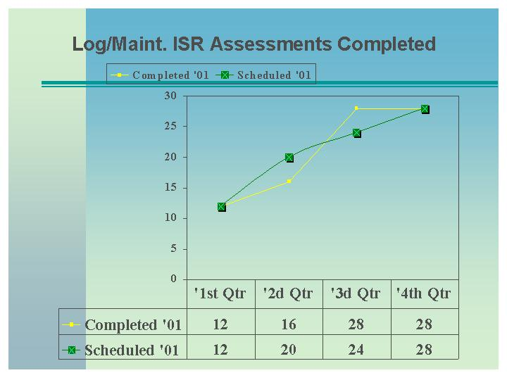

Goal
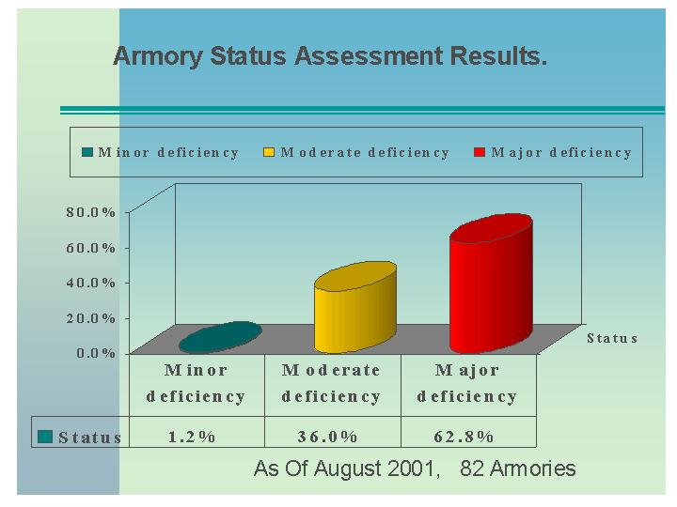

- During the evaluation process, we identified the estimated maintenance and repair and minor constructions costs associated with upgrades to meet mission requirements.

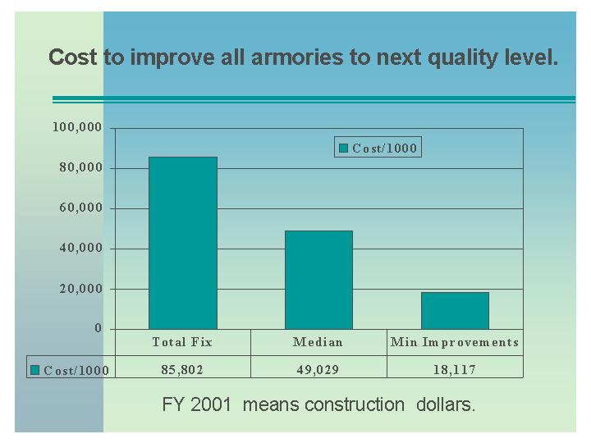

- State appropriations for FY 00-01 totaled $1,521,380 with utility costs, i.e. electricity, sitter salaries, natural gas, water, propane, etc., totaling approximately $1,376,639. Maintenance and supplies costs during FY 00-01 totaled $1,175,690. The total annual operating cost for FY 00-01 was $2,552,329.
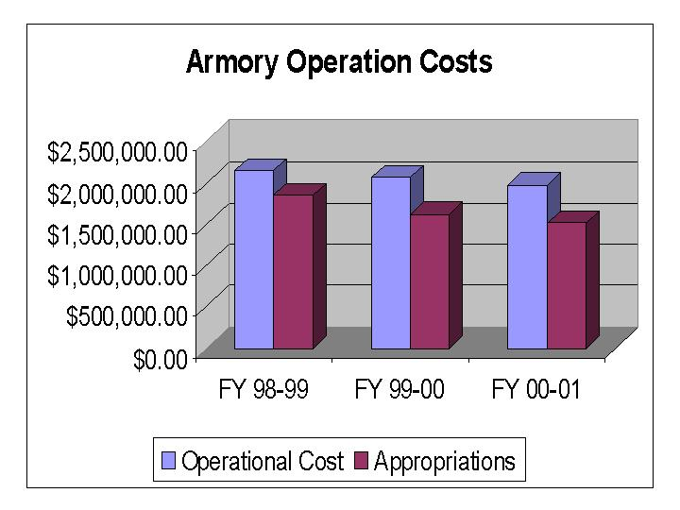

- Funding shortfalls required to offset operating costs and make emergency repairs were derived from carry-forward funds from the previous year as well as an active rental program. Proceeds derived from the rental of armories, authorized through the annual Appropriations Act totaled $245,952 net.

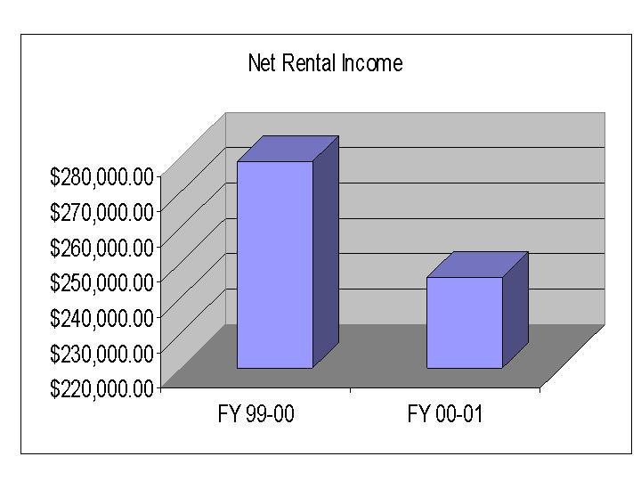

Name: |  | South Carolina Emergency Preparedness Division / South Carolina Disaster Relief Assistance
Cost: | $13,599,348 |  | State
 | $65,519,392 |  | Federal
 | $1,863,881 |  | Earmarked
 | $80,982,621 |  | Total

Goals: Reduce human suffering and enhance the State’s capability to recover from a disaster.

Objectives: Provide State and Federal assistance to respond and recover from disasters.

Key Results:
- FY 01 was a relatively calm year and this is reflected in the total number of workdays devoted to disaster response. This allowed the division to refine plans and processes and to execute an unprecedented schedule of training and exercises as depicted in previous sections of this report.

- SCEPD responded to and managed disaster response for Hurricane Florence, Tropical Storm Gordon, Tropical Storm Helene as well as ten other local emergency situations such as train derailment, tornado touchdown, wildfire, power failures and water supply problems.

    - During FY01, 16.5 workdays were devoted to disaster response as compared to 145 in FY00.
    - Additionally in FY01, the State Emergency Operations Center processed 849 emergency messages and 11 requests for emergency assistance as opposed to 1683 emergency messages and 328 requests in FY00. (These FY 00 numbers include the Conway Flood and the Winter Storm).

- SCEPD has enhanced the division’s emergency management automation system to assist local government in documentation and tracking of requests for assistance as well as situation messages and reports. A county specific view has been developed that will greatly simplify the data collection process for local emergency managers and operations center personnel.

Name: |  | South Carolina Emergency Preparedness Division / Operations
Cost: | $1,245,588 |  | State
 | $3,293,221 |  | Federal
 | $945,558 |  | Earmarked
 | $5,484,337 |  | Total

Goal: Prevent the loss of life and property attributable to disasters.

Objective: Reduce the risk of loss of life from hazards and improve the state's capability to
respond to disasters.

Key Results:

- The SC Emergency Operations Plan for disaster response and recovery was revised with input from numerous state agencies and volunteer organizations.
    - Sixteen workshops were conducted to enhance the quality of inputs, which were eleven more than in the previous reporting period.
    - Twelve of 17 support agencies operating procedures were reviewed and 2.5 were certified during this reporting period for a total of 4.5 certified.

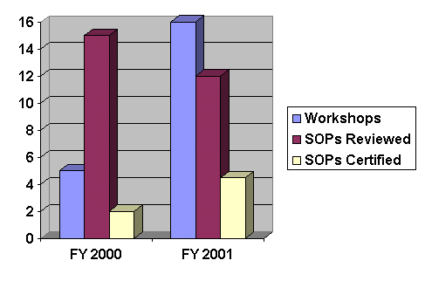

- The SC Hurricane Plan was revised with input from state and local agencies.
    - Data for over 230 hurricane shelters and 450 individual traffic control points was reviewed for accuracy.
    - 43 shelters with total capacity of 19,839 spaces were added to the plan. This represents a 22% increase in total shelters and a 17 % increase in total shelter capacity statewide from previous years.
    - Significant refinements concerning evacuation traffic monitoring, and re-entry guidance were developed.
    - Estimated clearance times for the Myrtle Beach area was significantly reduced by including the Conway Bypass as a hurricane evacuation route and diverting traffic around lower capacity routes.

Percentage of Clearance Time Reduction
Hurricane Category | Low Tourist Occupancy | High Tourist Occupancy
1-2 | 32% | 31%
3-4 | 20.1% | 22.9%
5 | 22.6% | 23.8%

- The SCEPD Earthquake Program continued to develop during this reporting period.
    - A comprehensive Seismic Risk and Vulnerability Study was contracted to provide officials at all levels detailed data for plan development.
    - In partnership with Earthquake Education Center (EEC), located at Charleston Southern University, 6 earthquake awareness and preparedness workshops were presented to 275 nurses, hospital employees, news media, educators, schools, civic groups and insurance agents.

- A joint emergency management assessment program began in 1997 to assist county officials in developing highly efficient and effective programs. One-third of the 46 counties are scheduled each year. As of FY00, a baseline has been established. The chart below indicates the average score for each functional area for both FY 2000 and 2001. FY 2001 results indicated improvement in almost all areas.
1- Hazard analysis 11 - Warning
2 - Mitigation 12 - Emergency Operations Center
3 - Planning 13 - Direction and Control
4 - Resource Identification 14 - Disaster Declaration
5 - Training and Education 15 - Disaster Records and Documents
6 - Tests and Exercises 16 - Evacuation Strategies
7 - External coordination 17 - Shelter Strategies
8 - Public Education and Awareness 18 - On-Site Management of Incidents
9 - Public Information 19 - Recovery
10 - Communications 20 - Post-Incident Activities

- SCEPD provides numerous emergency management-training programs and conducts exercises to test the state’s capability to respond to emergencies. In the absence of any major emergencies, the training and exercise programs are increased tremendously.

- For FY01, the goal was to increase by 10% the number of courses presented and the personnel trained. Courses offered were increased by 167% and personnel trained increased by 173%.

- Two federally evaluated exercises involving a fixed nuclear facility were successfully completed without any deviations.
- Two 2-day, full-scale, statewide exercises were conducted to validate the State Emergency Operations Plan, State Hurricane Plan, and other supporting plans.

- Five tabletop exercises were held for primary members of the State Emergency Response Team to test their procedures when responding to an earthquake scenario and a hurricane scenario.

- A tabletop exercise was conducted for the Governor and cabinet agency directors to provide a review of hurricane procedures and an introduction for new directors.

- Three federally evaluated exercises involving Federal Energy commission regulated dams were successfully completed without any deviations.

- Two tabletop exercises were conducted for other state agencies to validate their hurricane response plans.

- Forty-six (46) staff positions per each 12-hour shift are required to effectively coordinate disaster response in the State Emergency Operations Center. Presently, SCEPD can only fill 23 positions on the day shift and 19 positions on the night shift. The shortfall of 23 positions (day) and 27 positions (night) are filled by volunteers from other state agencies or are left vacant. Although these personnel do an admirable job they are not experienced emergency managers. Additionally, this staffing shortfall precludes sending an experienced SCEPD employee to a county operations center as liaison to avoid leaving a critical position in the SEOC vacant.

Name: South Carolina Disaster Relief Assistance

Cost: State: $ 3,296,103
Federal: $12,650,857
Earmarked: $ 1,001,269
Total: $16,948,229

Goals: Reduce human suffering and enhance the state’s capability to recover from a
disaster.

Objectives: Provide state and federal assistance to respond and recover from disasters.

Key Results:

- FY 01 was a relatively calm year and this is reflected in the total number of workdays devoted to disaster response. This allowed the division to refine plans and processes and to execute an unprecedented schedule of training and exercises as depicted in previous sections of this report.

- SCEPD responded to and managed disaster response for Hurricane Florence, Tropical Storm Gordon, Tropical Storm Helene as well as ten other local emergency situations such as train derailment, tornado touchdown, wildfire, power failures and water supply problems.
    - During FY01, 16.5 workdays were devoted to disaster response as compared to 145 in FY00.
    - Additionally in FY01, the State Emergency Operations Center processed 849 emergency messages and 11 requests for emergency assistance as opposed to 1683 emergency messages and 328 requests in FY00. (These FY 00 numbers include the Conway Flood and the Winter Storm).

- SCEPD has enhanced the division’s emergency management automation system to assist local government in documentation and tracking of requests for assistance as well as situation messages and reports. A county specific view has been developed that will greatly simplify the data collection process for local emergency managers and operations center personnel.

Name: | Youth ChalleNGe Academy

The South Carolina National Guard Youth ChalleNGe Program is a 17-month program (5 months in residence with a 12-month follow-on program) designed to assist at-risk youth (16-18) in acquiring the basic skills and education necessary to succeed in life. This youth group is no longer able to attend public schools.

Cost: | $1,820,000 | Federal

Goal: Attain maximum enrollment number (200) per year and maintain 85% of enrolled students who either: complete the program and return successfully to the public school system; become gainfully employed; or pursue higher education.

Objectives:

- Graduate at least 50% of enrollment with GED.
- Secure or assist in securing gainful employment or higher education opportunities for at least 50% of graduates.

Key Results:

- The South Carolina National Guard Youth ChalleNGe completed its third year of operation during State fiscal year 2000-2001. In total, since its inception the program has graduated four residential classes. Three classes have completed the entire seventeen (17) month program. The remaining three classes are currently undergoing the post-residential monitoring phase through the mentoring program.

- An important phase of the Youth ChalleNGe Program involves a 12-month post residential period in which an assigned mentor monitors the progress of the graduate.

  - Monthly contact is maintained with the individual and a monthly stipend in the amount of $100.00 is awarded to those graduates who are employed or enrolled in school during this follow-on period.
  - The post residential phase is considered one of the most critical indicators of the long-term success of the program.

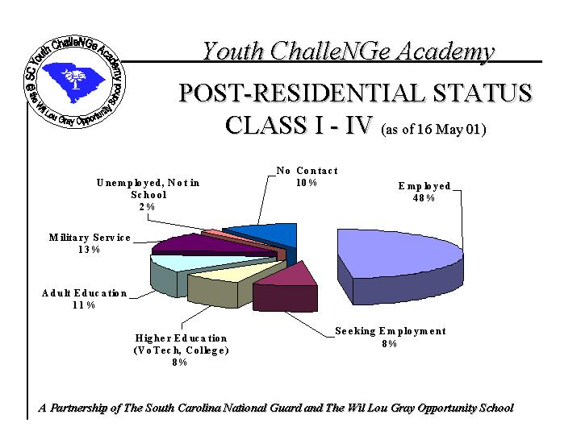

Name: |  | Tuition Assistance
Cost: | $218,000 |  | State

Goal: Manage and administer the program in accordance with Section 59-114-40, South Carolina Code of Laws, 1976, as amended and applicable Adjutant General Regulations. Increase number of personnel enlisting in the South Carolina National Guard and encourage retention of personnel in the National Guard.

Objectives: At least fifty percent of total appropriation targeted for use of recruiting new personnel and first term (enlistment) soldiers and airmen.

Key Results:
- The South Carolina National Guard is currently at 83% of its authorized strength.
- The Tuition Assistance program has become a valuable tool in attracting new personnel into the National Guard, retaining our quality personnel and providing viable continuing education for career members.

  - During FY 00-01, 214 qualified applicants received tuition assistance; of these 204 were considered new recruits or 1st term soldiers or airmen and 10 are in their second, or higher, enlistment.
  - The Goal of 50% recruiting 1st term was exceeded in FY 00-01. 95% of personnel were first term enlistments.
  - Due to funding shortfall from the previous year, at least 100 qualified 1st term applicants did not receive tuition assistance. The shortfall was approximately $250,000.

Name: |  | Office of The Adjutant General
Cost: | $1,796,557 |  | State
 | $746,918 |  | State (Employer Cont)
 | $147,985 |  | State (Mil Personnel)
 | $28,749 |  | State (POTO)
 | $180,157 |  | State (Army Contract)
 | $303,018 |  | State (Air Contract)
 | $3,221,384 |  | Total

Goals: Manage the Agency and the South Carolina National Guard in accordance with Section 25-1-350, South Carolina Code of Laws, 1976, as amended.

Objectives: Provide direct support of the organizational goals, which enable us to achieve our mission and vision. The six goals for the South Carolina Military Department are:

- Safety
- Strength
- Training Readiness
- Equipment Readiness
- Quality of Life
- Support State Missions

Key Results:

- In “Promoting the South Carolina Military Department” goal, the agency has developed a web site to provide customers with additional information concerning the South Carolina Army and Air National Guard, the Youth ChalleNGe Academy, the South Carolina State Guard and the Emergency Preparedness Division. Tracking the number of “hits” to this site will monitor the effectiveness of this promotion. This past year resulted in a 1,000% traffic increase from the previous year.
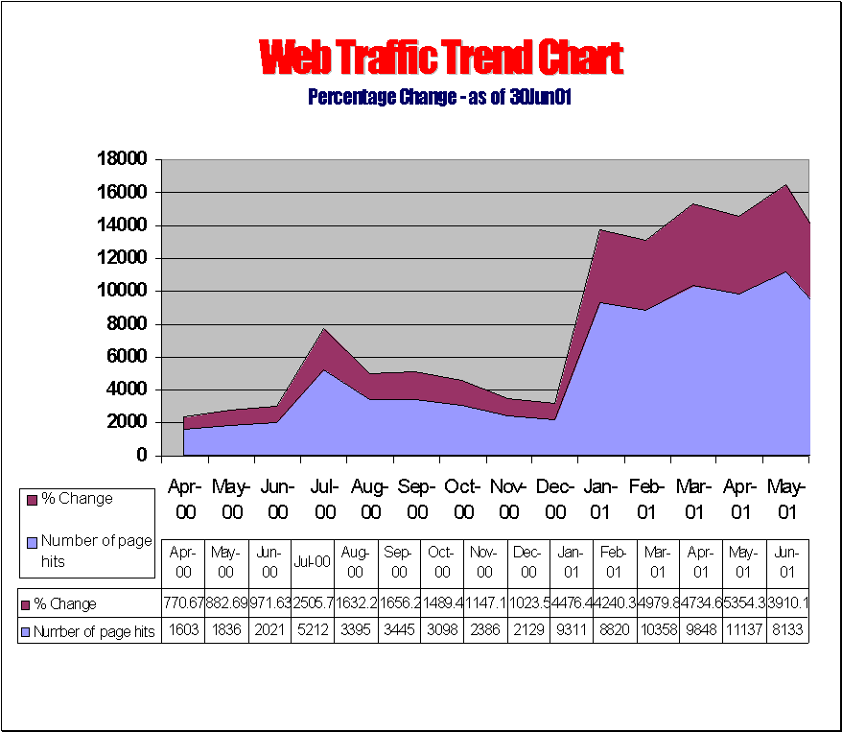

- In support of the strategic plan’s goal of “Support State Missions,” the agency entered into a Federal cooperative agreement: The Youth ChalleNGe Program for at-risk youth, which after its second year enjoys an 88% success rate.

- Responding to State and Federal mandates, the South Carolina Military Department has initiated energy conservation efforts. The agency’s goal was to reduce energy consumption by 5% by 30 Jun 01. Historically, the South Carolina Military Department ranks as one of the lowest energy consumers among the State agencies.
Energy Usage Reduction
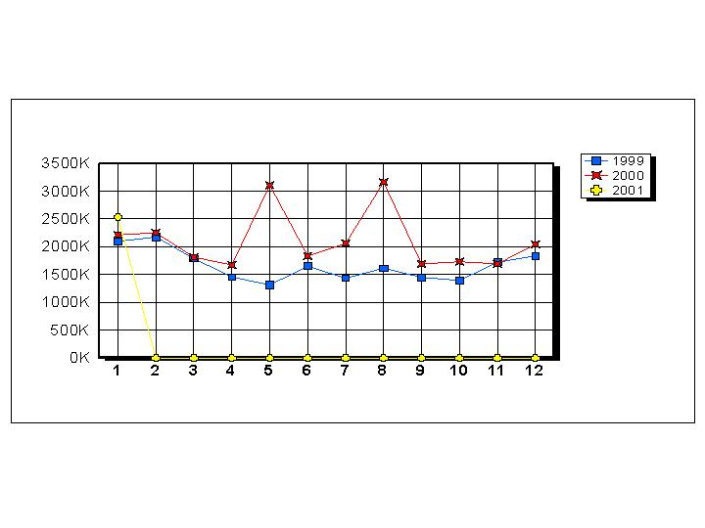

Goal

- The heart of operation for the South Carolina Military Department is information technology. It is crucial that customers, both internal and external have access to data that is accurate and delivered in a timely fashion. Server on-line readiness and virus protection are two important measurements. In the first chart, the server on-line goal was 95 %. The year-end result for FY 00-01 was over 99%. The goal of a less than two week virus protection was exceeded as well.
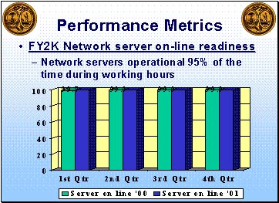
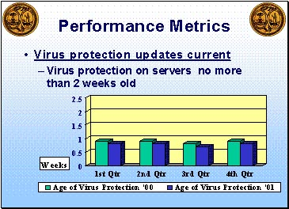

- The Accounting and Finance division charts and trends several key performances indicators. These include the number of vouchers processed against an average standard from previous years, the number of voucher errors against an average standard, the number of vouchers returned against an average standard and the average process time to and from the Comptroller General’s office against set goals. The last two charts reflect that goals were being met and that processing time had been greatly reduced.

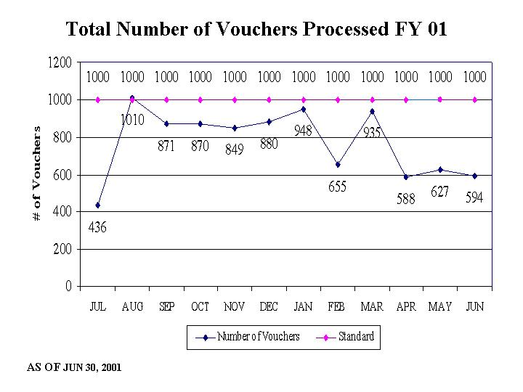
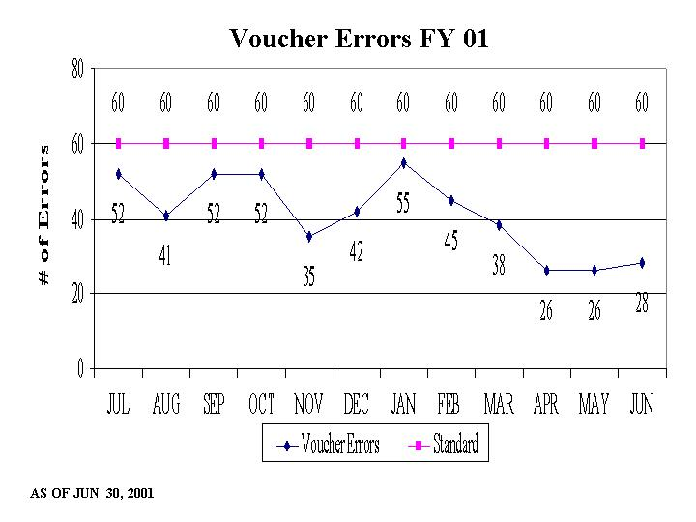

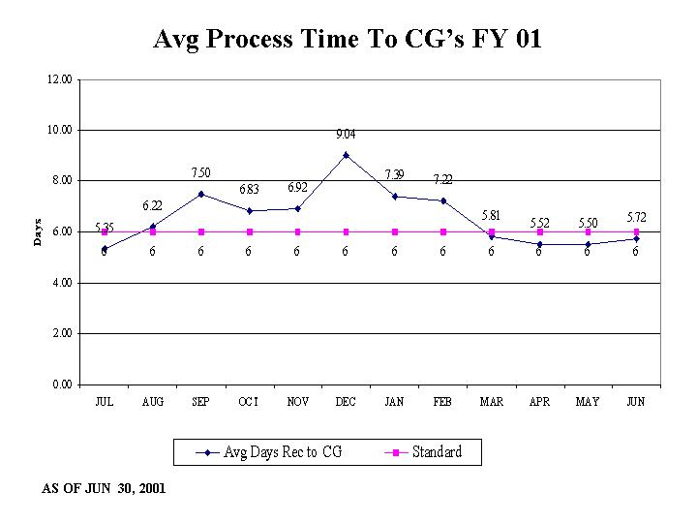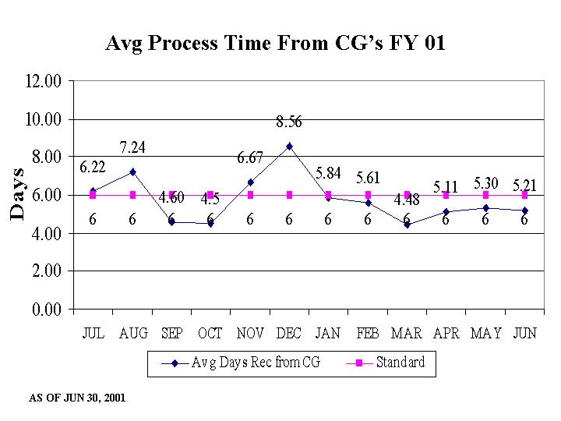

Name: |  | South Carolina State Guard
Cost: | $126,381 |  | State
 | $4,500 |  | State (Funeral Flags)
 | $130,881 |  | Total

Goal: Support the Military Department in State missions consisting of maintaining public safety; supporting local civil authorities to provide essential service; protecting local resources and services; assisting local law-enforcement agencies; supporting disaster assistance requests from the Red Cross and other humanitarian agencies; conducting state and community service projects at minimal cost to the state.

Objectives: Provide continuous support to the Budget and Control Board during contingency operations. Provide support to State/Local Law Enforcement Agencies; Provide chaplain support to the National Guard Youth ChalleNGe program; conduct honor guard for military funerals when requested; Conduct annual training in drill, ceremonies, and continuing education.

Results:
- During FY 00-01, the South Carolina State Guard exceeded 30,000 hours of volunteer hours to various State and local authorities.

VOLUNTEER SERVICE HOURS
VOLUNTEER HOURS SAVINGS

- The State Guard provided honor guards for 58 military funerals. This tradition, generally requested by family members, is being provided when the active component cannot provide such services.

FUNERAL PARTICIPATION

Name: |  | National Guard Pension Fund
Cost: | $2,499,865 |  | State

Goal: Program is managed in accordance with Sections 25-1-3210 through 25-1-3240 of the South Carolina Code of Laws, 1976 as amended.

Objectives: To accurately identify authorized recipients and distribute entitlements in a timely manner. To maintain the fund at the prescribed actuarial funding level.

Key Results: During FY 00-01, Army and Air National Guard State Pensions had an annual economic benefit to the South Carolina economy of $2.0 million.

- Section 25-1-3235 requires the General Assembly to appropriate sums “sufficient over time to establish and maintain (National Guard Pension) fund on an actuarial basis” As depicted below, the fund begins declining in 2015, becomes insufficient to meet outlays in 2028 and will not meet projected outlay in 2029, given the current appropriation status.

- The South Carolina National Guard soldier also qualifies for a Federal Military Pension upon retirement from the Guard with 20 years of service. Shown below are pension totals for FY 00-01. These federal pensions had an annual economic benefit to the South Carolina economy of $1.1 million.

