EXECUTIVE SUMMARY

- Major Achievements from past year.
Perhaps the most significant achievement for the past year has been the agency’s ongoing work with the South Carolina Education Accountability Act (EAA). In addition, to extensive data collection on essential agency indicators, SCSDB also implemented year 2 of a comprehensive SCSDB District Strategic Plan to improve student and staff performance and school programs.

Several major new program accomplishments have been achieved at SCSDB during the past year. These initiatives have involved program improvements/expansions; facility upgrades, and changes within programs in order to offer more effective student/client services. Changes were made to meet identified critical needs such as: well-trained residential and education staff, the provision of sign language classes and Braille production, new assistive technology, expanded medical care, and quality after-school programs for our student and clients.

Many of the SCSDB improvements made during the 2000-01 fiscal year can be directly attributed to growing collaboration between SCSDB and other state agencies and private organizations. These collaborations created new opportunities for training and other essential factors for success of SCSDB staff and students even with current economic conditions. These linkages have provided access to quality staff and volunteers from the community and higher education systems.

Among the major programmatic accomplishments based on professional partnerships, SCSDB can include the following collaborations to improve educational services for students who are blind or visually impaired:
- Vision Partnership – SCSDB, USC-Spartanburg, South Carolina Commission for the Blind, and the South Carolina Department of Education working together to create a new master’s degree program at USC-Spartanburg in the area of visual impairments with SCSDB as the clinical training site;
- Vision Summit - South Carolina’s first Vision Summit with 200 professionals and parents working together on behalf of children with visual impairments;
- IMRC - South Carolina’s first Instructional Materials Resource Center (IMRC) on the SCSDB campus for the distribution of Braille textbooks and other instructional materials;
- Braille Prison Project - South Carolina’s first prison Braille production project (along with the Department of Corrections) for inmates to be trained to produce books and other instructional materials in Braille;
- NASA Project - NASA support project (along with College of Charleston) to adapt space science materials in Braille;
- Assistive Technology - South Carolina’s first assistive technology site (with Office of Information Resources, Public Service Commission) to provide full access to governmental public information to citizens with disabilities through a pilot program directed by the South Carolina General Assembly.
- Pan American Games for the Blind – SCSDB served as host site for nearly 300 athletes and staff from 17 countries for the Games’ first US visit; coordinated thousands of volunteer hours from hundreds of community organizations and individuals for this four-day event;
- Special Schools Consortium - SCSDB continued in its leadership role among South Carolina’s seven special public schools, serving as the lead agency for the Special Schools Consortium (which meets on a bi-monthly basis);
- “Working Wheels - Special Students Service Organizations: Implementation of “Working Wheels,” (first community volunteer program for children with multiple disabilities in wheelchairs), and junior Lion’s and Civitan Clubs.
- Post Secondary Education Agreement - Expansion of Postsecondary Cooperative Education agreements (with Spartanburg Technical College, Clemson University, USC-Spartanburg, Converse College, and Presbyterian College).

Program effectiveness has also been enhanced through expansion of private/public partnerships for new resources and funds. There have been extensive efforts to increase community collaboration in the areas of fund-raising with several private foundations and donors.

These major achievements have been accomplished with significant cost effectiveness. Many were achieved by creating partnerships with other state agencies or private entities. Some were supported through donations of funds or staff resources from the private sector (e.g., athletic/recreational facilities improvements, staff training and workshops, etc.). Other achievements were supported by redirecting existing resources to other higher priorities identified by staff, such as the implementation of the agency’s District Strategic Plan and Master Safety/Facility Plan.

- Mission and Values
Mission Statement:
The mission of the South Carolina School for the Deaf and the Blind, in partnership with families, is to ensure our students reach their greatest potential by providing challenging individualized programs in a safe and accessible environment and to serve as a resource center providing leadership, information and technical assistance to organizations and individuals concerned with services to people with sensory disabilities.

Agency Values:
Human potential is unlimited.
All creation has worth.
Higher expectations lead to higher results.
Learning is a lifelong process.
The family is the most important element in the life of a human being.
A healthy society balances rights with responsibilities.
Embracing diversity strengthens organizations.

Agency Parameters:
- We will always make decisions based on the best interest of our students.
- We will not sacrifice the safety and security of our students and staff.
- We will practice participatory decision-making at all levels of the organization.

3) Key Strategic Goals:
- We will develop and implement a plan that will envision and embrace
programmatic changes while focusing on our primary mission.
- We will ensure that staff has the support and training to teach to learner standards and develop student outcomes that are measurable and clear.
- We will develop and implement a plan that will enhance relationships with families and agencies and improve public image.

Objectives:
- All students will successfully complete their individualized program.
- All students will be successfully placed within one year of graduation of the school.

4) Opportunities and Barriers:
Opportunities that will help SCSDB achieve its goal of attaining highest educational standards include:
- providing a safe and attractive environment in which students and staff can learn in improved and modern school furnishings facilities/campus;
- providing training to empower dedicated staff to perform job duties in exemplary manner;
- supporting students to achieve their highest potential by extending the school year and school day – and by providing them with access to assistive technology and other instructional materials to meet their learning needs;
- funding competitive pay scale and career ladders, especially to lower paid staff (e.g., teacher assistants) in order to recruit and retain quality staff;
- assisting with tuition support for low-income post-secondary students;
- Addressing the complex needs of students who have sensory disabilities and emotional/behavioral problems.

Barriers:
SCSDB faces serious challenges and barriers as staff strives to achieve success for students and programs, including:
- 150+ year old campus with antiquated facilities and furnishings;
- inadequate funds (from both state and private sources) to address facility and program needs that require monetary support;
- accountability challenges in developing and maintaining high learning standards for school with 100% special education population;
- identifying/securing support (dollars and people) to address staff learning/training needs;
- Recruiting and retaining high quality staff – especially critical with nation-wide teacher shortages and high attrition rates.

BUSINESS OVERVIEW

Staff

The South Carolina School for the Deaf and Blind currently employs 396 full-time staff members. Of the faculty and staff 21% have advanced degrees in their fields, at the master’s or doctorate level. Many are professional leaders in our community, who speak at conferences, teach classes and publish in educational journals. This includes the 20% of our employees who have disabilities.

Operation Locations

The main campus is located on the original founding site in Spartanburg County, and consists of 160 acres with 38 buildings. The campus is identified by its signature building, Walker Hall, which was placed on the National Historic Registry in 1977. Walker Hall is currently undergoing major renovations. The South Carolina School for the Deaf and the Blind has been recognized as the cultural, athletic and educational center for South Carolina’s deaf and blind communities. It currently serves as the home of the South Carolina Museum of the Deaf and is the future site of the State Museum of the Blind.

The main facilities are proudly shared with outside groups for community educational, social and athletic activities, and serve as home to a myriad of educational and administrative programs. Preparations have been made to convert warehouse space which will house the South Carolina Braille Library and serve as the central depository of Braille textbooks as well as other materials used in educating the blind within the state.

Campus Outreach Centers are strategically placed throughout South Carolina to better serve communities in other areas of the state. There are currently Outreach Centers located in Conway, Rock Hill, Florence, Columbia and Charleston, South Carolina in addition to Spartanburg. These centers serve as a resource for deaf and blind clients in other parts of the state and provide interpreting services in these areas as well.

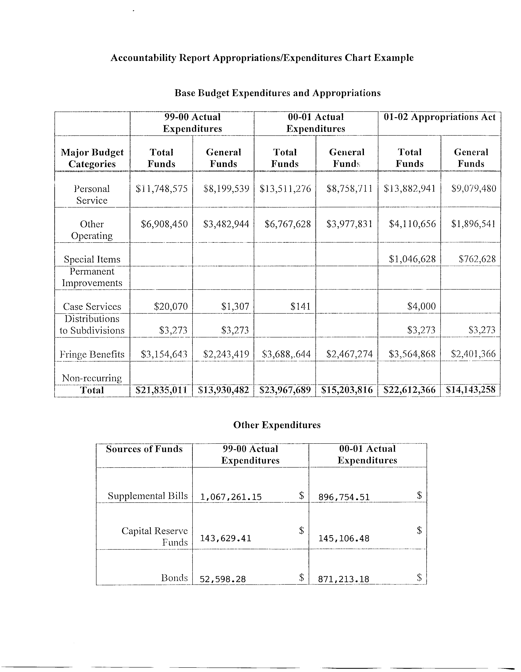

Key Customers

The South Carolina School for the Deaf and the Blind’s Spartanburg Campus serves more than 350 students including early intervention, pre-school through post-secondary, from throughout the state of South Carolina. Buses transport day students, Monday through Friday, within the upstate. Dormitory students are bused home on Fridays and are returned on Sunday evening. Weekly routes include Myrtle Beach, Georgetown, Charleston, Beaufort and points between.

The school serves an increasingly complex student population, including 100 students on campus using wheelchairs or other orthopedic devices for travel. SCSDB also has 160 students on campus with chronic health problems, such as seizures and Attention Deficit Disorder (ADD). Approximately 85% of the student population are Medicaid eligible.

Nearly 700 additional preschool children and their families are served annually through Early Intervention Programs stationed within the six regional South Carolina School for the Deaf and the Blind Resource Centers located throughout the state. The school serves more than 160 blind and visually impaired individuals across the state. The Deaf and Blind Orientation and Mobility Specialists, and the campus serves as an operational center for statewide services to citizens of all ages with sensory disabilities.

Key Suppliers

The South Carolina School for the Deaf and the Blind strives to practice the most cost efficient methods of obtaining supplies and services without compromising quality. The campus does not discriminate based on race, sex, religion, disability, ownership or company size when choosing a prospective vendor. The school makes every effort to obtain the services of Women / Minority Owned Businesses if available. The retention of goods and services is at the discretion of the Procurement Specialist, unless the goods and services are submitted for bid. At that time, the vendor is chosen by the lowest bid submitted. All efforts are made to secure the services of the most responsive and responsible vendors at all times.

Major Products and Services

The South Carolina School for the Deaf and the Blind offers services statewide to deaf, hard-of-hearing, blind and visually impaired individuals of all ages, their families and the professionals who work with them. These services are conducted on the Spartanburg Campus, as well as five other regional resource centers, which are located in Columbia, Charleston, Conway, Florence and Rock Hill. The school serves as the hub of services in South Carolina for professionals and families in the field of sensory disabilities, including Brailling Services, Braille Classes and Sign Language Classes.

The South Carolina School for the Deaf and the Blind is recognized for its innovative services, such as summer leadership and arts camps for South Carolina students with sensory disabilities including those in the Public School System. The Mainstream Program works in conjunction with local public school districts to provide students the benefit of the specialized services and resources available at the South Carolina School for the Deaf and the Blind, while taking some courses within the public school system.

The campus also provides services to post-secondary students, through collaboration with the South Carolina Department of Vocational Rehabilitation, South Carolina Commission for the Blind, Spartanburg Technical College and local businesses.

Organizational Structure

See South Carolina School for the Deaf and the Blind Organizational Chart

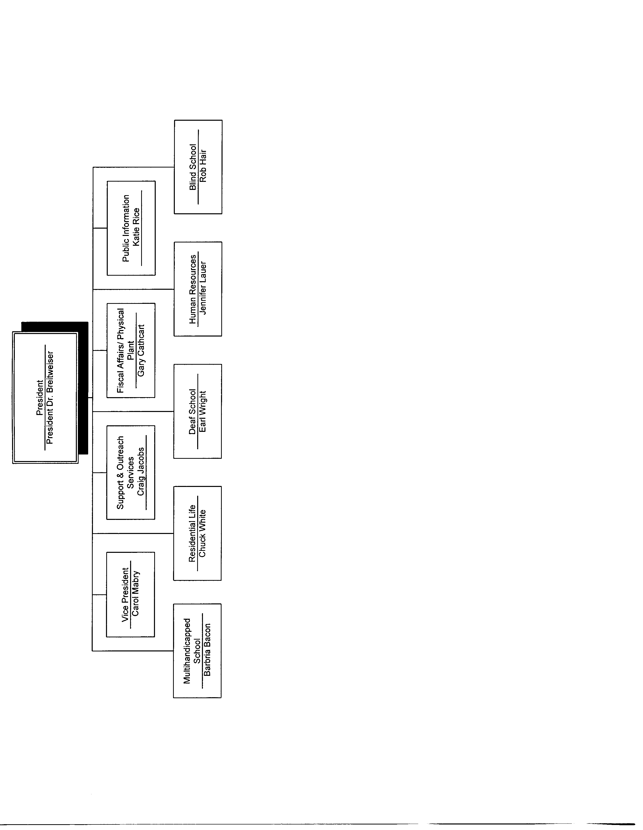

Category 1 – Leadership
1a. Senior leaders set, deploy, and communicate short and long-term directions through regular and special meetings and various communication strategies, including:

Meetings:
- Annual retreat of Administrative Team;
- Weekly meetings of key directors;
- Monthly management meetings;
- Division meetings beginning and mid-point of school year.
- Quality groups including School Improvement Councils, Quality Councils, and Invitational Meetings.

Communication tools, including:
- President’s Weekly News;
- President’s monthly newsletter;
- Other tools such as e-mails, memos, flyers, agency newsletter, Parent Press;
- Special planning initiatives, with written follow-up reports, including development of agency-wide and division specific mission, goals, and values.

1b. Performance Expectations:
- Compliance reports for both state and federal requirements (e.g., BEDS report on staff certification standards);
- Defined Minimum Program (DMP) and state requirements updates;
- Establishment of EAA committee standards used to judge our school
- Training in improved focus for students’ education program standards;
- Training for SC student standards;
- Staff evaluations using new program of Strategic plans;
- National teacher’s certification class;
- Tuition reimbursement for staff training;
- Recognition of staff awards and ratings in all departments.

1c. Organizational values are shared through surveys, communication and involvement by SCSDB:
- Students;
- Parents/families;
- Board of Commissioners;
- Staff;
- Alumni;
- Other constituencies.

1d. Empowerment and innovation, including SCSDB leadership role with:
- Special Schools Consortium;
- State Task Force on Assistive Technology;
- Invitational meetings for staff and suggestion boxes;
- Staff suggestions through educational programs and team meetings for every division;
- Staff leadership roles, such as Team Leader initiatives;
- Campus-wide committees;
- Curriculum teams;
- Annual review of agency strategic plan, including the agency mission statement;
- End-of-year reports and audits;
- Staff Training and Development Committee meetings with goals for improvement of staff;
- Meetings of Teacher Association and other special interest groups;
- Team grants writing support for special projects.

1e. Organizational and employee learning is achieved through:
- Monthly New Employee Orientation;
- Classes on disabilities training;
- Campus computer classes for students and staff;
- Opportunities for new learning at conventions and conferences;
- Exit interviews;
- “Train the trainer” projects to develop staff training cadre;
- Invitational meetings;
- Consultants come to campus to train key staff;
- Tuition reimbursement for classes;
- State management training programs (through state OHR).

1f. Ethical Behavior presented and supported through the following groups and activities:
- SCSDB safety committee;
- Student/staff/parent participation on agency committees;
- Role models with staff and volunteers who are disabled or represent other minority groups;
- Values stated on strategic plan, shared, and implemented;
- Ethics statements from key organizations posted in key campus locations;
- High attention to state ethical standards in all departments.

2. Establish and promote a focus on customers:
- Changes are based on input and feedback from customers;
- Students participate in decision making in SIC, Student Council, Safety, Strategic Planning, Student Code of Conduct project, and
- IEP meetings create Individual Education Program for each student with parental and student involvement;
- Individualized transition meetings and planning with parents, students, and representatives from other agencies;
- Behavior plans for individual treatment of each student;
- Surveys to gather input from students and families;
- Suggestion boxes and invitational meetings result in improvements;
- Feedback gathered from employees on quality of graduates and training;
- Tracking system for job placement of graduates.

3. Key performance measures to be regularly reviewed:
- Key performance measures are regularly reviewed at management, division, and agency-wide meetings;
- Mastery if IEP objectives for each student;
- Ratings criteria for state and federal compliance reports;
- Agency financial reports;
- Audit reports and their corrections;
- Numbers of students/clients served;
- Numbers of students employed in work programs;
- Number of graduates employed in Postsecondary status;
- Exit interview data;
- Safety reports, including incident and accident reports.

4. Organization performance and employee feedback to improve leadership effectiveness and effectiveness of management:
- Annual audits of agency programs and special audits, as required;
- Staff survey data used to improve services to other service components;
- Topics for agency meetings based on staff needs as expressed by staff;
- Identification of training opportunities in leadership areas;
- Internal promotional opportunities;
- Efforts to gather employee feedback;
- Need assessments with essential constituents to identify community and client needs.

5. Senior leadership addresses the current and potential impact on public by:
- Informing the public of products, programs, services, etc., through staff members or activities of its Public Information Department and press conferences and releases
- Review of its annual accountability reports
- Study of community safety involving neighborhood communities, local fire department and nursing home, public works, area businesses
- Board of Directors share information in their work and circle of influence
- Public presentations
- Stewardship and use of state resources to legislators in various areas
- Outreach efforts throughout state on the agency services

6. Senior Leadership sets and communicates key organizational priorities for improvement by:
- Development and distribution of Agency Strategic Plan, with priorities and regular review and updates;
- Reassignment of staff with attention to key improvement areas;
- Continuous improvement as top goal for the agency;
- Agency newsletters, other publications;
- Community meetings and presentations;
- Board meetings with discussion of needs for improvements and how we plan to accomplish those.

7. Senior leadership and the agency actively support and strengthen the community through leadership in the following activities:
- Employment of many persons, including those with disabilities, from the community;
- Leaders are members of Lions Club, Civitans, Rotary and other civic clubs;
- Hosts for special events (Very Special Arts, Special Olympics, Pan American Games for the Blind);
- Disability Awareness events leaders;
- Community classes;
- Chamber of Commerce programs related to employment of individuals with disabilities;
- Placing job coaches in community;
- Business Advisory Committee;
Community use of facilities (track, buildings, etc.).

Category 2 – Strategic Planning

- What is the strategic planning process?
The SCSDB Strategic Planning process is conducted through the agency District Strategic Plan. This plan is a required component of the 1998 Education Accountability Act (EAA). The SCSDB District Strategic Plan has been submitted to and approved by the SC Department of Education.

- Customer needs and expectations:
The SCSDB strategic planning process is an annual process that involves several groups of constituents to assist with the following:
- Identification of a District Strategic Planning Team composed of parent/family, student, staff, alumni, and community representatives whose task is to develop, review, and/or revise the mission, values, vision, and goals of the agency;
- Designation of Action Teams (also with representative membership) who have the task of developing action plans (with timelines and strategies) for achieving goals. These groups, through representative membership, access to agency reports (such as customer surveys) and communication strategies (such as focus groups), gather information on customer needs and expectations.

- Financial, Societal, and other risks:
Are studied in the strategic planning process through the development of impact statements that reflect direct and indirect costs to the agency. The impact statements and related data are included in the Action Team planning process for consideration prior to action commitment. Risk factors are explored and resolved at both the agency and division levels by the SCSDB Administrative Team, Board of Commissioners, and key staff – using internal and external expertise for planning and operational activities. This process is also an integral part of the District Strategic Planning process that is studied through the full strategic planning team and also by the specific action teams, as appropriate.

- Supplies/contractor/partner capabilities and needs are accounted for by coordinating the district strategic plan and subsequent action plans with the division planning process – including human and fiscal resources.

- Operation capabilities and needs:
SCSDB’s mission is two-pronged:
- To work in partnership with students’ families to help each student reach his/her potential;
- To serve as a statewide resource center for individuals with sensory disabilities, their families and the professionals who serve them.

SCSDB’s challenges in achieving its mission are significant: agency responsibility for statewide services, complex client populations (persons with disabilities spanning all ages), critical personnel shortages, increasing demands for new resources, and antiquated facilities and equipment. All of these challenges are cited in two (2) key documents that have been completed at SCSDB and approved by its Board of Commissioners: the SCSDB updated Strategic Plan (as mandated by the EAA) and the SCSDB Campus Master Plan (the agency’s first comprehensive facility/safety/accessibility plan in its 151 years of existence).

These two documents provide strategic plans (one for programs and the other for facilities). They include strategies, action plans, and measurement processes to support and assess the work of trans-disciplinary groups within the agency (staff, parents/families, customers, and other constituents). Measurements include substantiated improvements to agency programs and facilities, as well as the groups’ successes in identifying innovative solutions to agency problems. Program effectiveness has been enhanced by utilizing skills and ideas of those most invested in and knowledgeable of the agency in order to achieve best practices. Cost efficiency will be greatly enhanced by the incorporation of existing staff and constituencies into the continuous improvement cycle.

- Action plans are developed and tracked as an integral part of the District Strategic Planning process. For each major agency goal that is defined, an action team is convened. This action team, comprised of staff, parents/families, students (as appropriate), alumni, and other community representatives take each goal through the following steps of identifying:
- Strategies Definition
- Specific results to be achieved
- Action Steps
- Responsible agents
- Projected starting and completion dates
The action teams meet on a regular basis (determined by their schedule with two key reporting times to the District Strategic Planning Committee: mid-point and year-end). However, periodic updates are also provided.

- SCSDB communicates and deploys performance measures through a series of activities:
- Newsletters
- E-mails
- Celebrations
- Special reports
- Annual and mid-year meetings and reports at agency-wide, divisional, Board, and parent meetings
- EAA requirements, notably the SCSDB Report Card

Category 3 – Customer Focus

- Identify key customers and stakeholders through:

- Annual surveys
- Regular reviews of suggestions, complaints, and comments
- Reports from disability groups
- District Strategic Planning Process
- Students’ Educational Programming
- Contact with sister agencies

- How do you determine who your customers are and what are their essential requirements?

Through activities including brainstorming, focus groups, surveys, meetings and retreats, interactions with disability groups, other schools and agencies.

- How do you keep your listening and learning methods current with changing
customer/business needs?

Listening and Learning Methods: SCSDB uses listening and learning methods to keep up with current and changing customer/business needs by:
- Utilizing community and customer feedback for improved program effectiveness
- Gathering feedback from such sources as parent and community focus groups, meetings and surveys related to the agency’s Education Accountability Act (EAA) planning process
- Involving parents/families in the development of essential goals and activities with agency staff. Parent/family involvement was also encouraged and increased by active roles of parents/families, students, and community representatives in:
- School Improvement Council (SIC)
- Agency-wide councils held for program-specific activities and topics such as safety/security meetings
- Staff/family meetings held for individuals and groups within SCSDB to offer parents/families an opportunity to work with key staff on their specific questions, concerns and suggestions
- Quality Council meetings (parent/family and staff groups at each SCSDB education program) to discuss concerns unique to each school program.
- Implementation of SCSDB facility design teams (including alumni, parents, community members, and students)
- Parent conferences re IEPs, grades, progress reports, etc.
- Use of customer phone calls, letters, notes to make changes for other students and parents

- Vision Summit meeting example of keeping current
- Leadership Conference Center for Creative Leadership
- Agency Directors Organization Meetings (twice yearly)
- Distribution of articles from magazines and journals and books on management to managers
- Survey results sent to managers
- National newsletters and national conventions allow for networking
- Consumer advocate interaction with managers

Use information for improvements:
- Establish new positions
- Make ideas a part of strategic plans for coming years
- Consistent coordination program is an example of the feedback being put into use
- EAA Committee and Sasipx uses group interactions puts this into use weekly
- Make program improvements and innovations
- Develop budget requests
- Identify and develop grant proposals

Category 4: Information and Analysis

1. Operations, processes, and systems to measure are determined through mandates from state and federal entities and agency governance, including:

- Agency Strategic Plan, particularly sections with goals and objectives;
- Board of Commissioners' List of Commitments;
- Measurements required by state and feral laws and regulations, including
Health and safety regulations (e.g., vehicle regulations, food standards, OSHA, etc.
- IDEA (special education regulations);
- Section 504 regulations;
- Staff regulations (criminal record check, drug and health tests, etc.);
- Facility Mandates, including ADA, life safety checks, etc.;
- State education regulations;
- State Defined Minimum Program;
- SC State Standards for students;
- Teacher certification (BEDS Report);
- EAA Data (report card, including student and staff performance measures and student demographics);
- Development of report card data from Special Schools Consortium for EAA.

2. Data quality, reliability, completeness, and availability for decision-making is ensured through:

- Use of state and federal standards for comparison and decision making;
- Availability of similar special schools' data for accurate comparisons of like student populations and programs;
- Submission of data to state and federal agencies for compilation and reporting;
- Audits and site visits (including records reviews) made by external entities and staff members;
- State and federal compliance reviews;
- Submission of plans (e.g., District Strategy Plan) for approval prior to implementation of data collection;
- Use of information technology processes and staff (both internal and external to agency) for data review.

3. Use of data/information analysis to provide effective support for decision-making is utilized by:
- Application of data analysis to identify trends and offer projections in critical decision-making areas, such as staff turnover, enrollment trends, and demographic changes, facility systems' needs, etc.;
- Review of surveys and reports to determine concerns and suggestions of key constituencies and consideration of mechanisms for improvements (e.g., additional security support to address growing safety concerns.

4. Comparative data and information are selected and used, based upon:

- State and federal education mandates, such as IDEA and other education/special education regulations;
- EAA applications, such as percentage of students on free and reduced lunches, Medicaid eligibility, etc.;
- Historical agency data;
- Comparative analysis of data across systems, such as an analysis of IT capability in comparison to students' and staff's instructional technology needs or fiscal capability compared to innovative program opportunities;
- Indicators for key agency planning processes, such as agency Strategic Plan;
- Federal, state, and local requirements for reporting indicators (such as comparative analysis related to health and safety standards, noting comparative deficits or improvements);
- Fiscal reports to other state entities, foundations, or private donors';
- Grant evaluations.

Category 5 – Human Resources

- Motivation and Encouragement for Employees:
- SCSDB works to develop and implement strategies to support and utilize the full potential of its work force, focusing on recruitment, training, and retention of high quality staff members who are matched to job assignments that are both appropriate and challenging.
- Staff is encouraged and motivated through individual and departmental staff recognition plans; staff is empowered to express opinions and recommend changes through various annual quality circles, staff meetings, and individual meetings.

- Identify and Address key needs:
- SCSDB’s efforts toward improved staff training and development were top priorities for virtually every department within the agency. The SCSDB Administrative Team led the agency in improved staff training and development (ST&D) for agency staff. Staff Training and Development has again been included as a top goal in the agency’s revised strategic plan, as well as being noted as a major commitment in the Board of Commissioners’ agency improvement plan.
- Training needs are identified through surveys, observations, evaluation process, credentials review, state or federal requirements.
- During the 2000-01 fiscal year, SCSDB continued several existing programs and added new programs for staff training and development, primarily through the oversight of the SCSDB Staff Training and Development (ST&D) Committee composed of key staff from all departments within the agency. This group meets monthly to review the current training programs, to identify other program areas needing training, and to plan for new training programs. Many improvements have been made to strengthen staff training programs. We are now able to correlate many positive results (such as improved safety reports, improved student behavior reports, reduced numbers of student suspensions, improved staff recruitment/retention rates, and improvements in student/program performance measures) with specific ST&D initiatives.
- SCSDB can verify substantial cost effectiveness of its staff training and development program throughout the 2000-01 fiscal year.
- Grants and stipends: Over one-half of training provided to SCSDB teachers was funded through grants secured by the agency including School Improvement funds and university/higher education projects.
- Staff assignments: Two major areas of staff training and development were coordinated by existing staff positions: teacher professional development and safety/risk management. By realigning duties, SCSDB was able to identify and utilize the expertise of current staff to coordinate all areas of teacher professional development and safety/risk management.
- Train the trainers: Through this initiative, SCSDB is able to expand its own in-house cadre of qualified trainers for several ongoing training programs. Over two dozen staff members have been identified and trained as trainers for various specialized programs, particularly in areas related to state and federal requirements such as Education Accountability Act (EAA) and IDEA. These “train the trainers” programs included:
- Improved teaching and assessment skills for education staff;
- Assistive technology training for all education, residential, and related services staff;
- Student IDEA requirements for education staff;
- Student behavior management programs for all education and residential staff;
- Technology services for all staff;
- Life Safety skills for all staff;
- Team Leaders in each school program (SCSDB also successfully piloted a team leader model among teachers to provide peer support and leadership at the classroom level.)
- Work with other agencies: SCSDB is continuing its work with other agencies and the private sector to participate in their staff training with minimal charge to the agency. The following list is a sample of “free” training opportunities made available to SCSDB (and the companies/agencies that provided them):
- Website Training – ETV;
- Sign Language Proficiency – National Technical Institute for the Deaf (NTID);
- ADEPT Training – Spartanburg School District 7 and SCDOE;
- Assistive Technology Training – American Printing House for the Blind (APH) and USC-Assistive Technology Center;
- Parent Advisory Training – SKI*HI Institute of Utah;
- Behavior Management Skills – Charles Lea Center, Department of Mental Health;
- Training for work with Multihandicapped students – Spartanburg Regional
Medical Center and USC-Spartanburg.
- In particular, SCSDB teachers and therapists had excellent staff development opportunities through the state’s higher education system, including:
- Strategies in Visual Impairments – USC Spartanburg;
- Science Education – College of Charleston;
- Positive Behavior Management – USC;
- Communication Skills – Spartanburg Technical College;
- Orientation and Mobility – SC State University.
- SCSDB also served as the host site for a regional therapeutic training session for occupational and physical therapists. The funds provided for hosting this program allowed SCSDB therapists to participate in this required training without charge.
- The agency continues to measure and assess ST&D activities and to use these data to plan for future goals and training. Finally, SCSDB continues to work on staff classification and compensation improvements (which we continue to study with the guidance of the State Office of Human Resources) to assist SCSDB in the implementation of career opportunities related to staff training, increased/revised duties and staff performance. Because this was found to be an effective strategy for much needed improvements in the agency’s residential program in the past, the same model is under review for the teacher assistant and sign language interpreter programs.

- Feedback from EPMS system through:
- Human Resource Training – State Office of Human Resources;
- ADEPT Training – provided by the SC Department of Education;
- Performance is measured by the following reviews: monthly staff reviews, state evaluation systems (EPMS and ADEPT), exit interviews and tests.

- Assessment of Employee Issues through:
- Staff Invitational Meetings;
- Quality Councils and School Improvement Council;
- Staff meetings at program, school, division, and agency levels;
- Suggestion boxes;
- Regular and special meetings with special interest groups (such as education staff/teachers, etc.);
- Surveys;
- Focus groups;
- Availability and visibility of Administrative Team.

- Safe and Healthy Environment:
- Comparisons of 2000-01 data with base line statistics indicate continued reductions in staff turnover rates, student incident reports, work-related accidents. Other outcome measures show positive gains such as student, parent and staff surveys.
- Safe and healthy environment is maintained through: School Resource Officers; response to staff, student and family safety concerns; the observation and input of all campus residents and guests; mandated safety tests and checks; identification of key staff members/positions with safety responsibilities; proper direction of resources; development and distribution of safety materials; regular safety-related drills and practices.

- Community involvement:
- Participation in several community and state initiatives;
- Collaboration with community agencies that can assist with human resources needs;
- Recognition of special celebrations/events (e.g., Red Ribbon Week);
- Community access to facilities;
- Community partnerships to enhance programs, services and facilities.

Category 6 – Process Management

SCSDB’s process management, including customer-focused design, product and service delivery, support, and supplier/contractor/partnering process involving all work units.

- What are your key design and delivery processes for products/services, and how do you incorporate new technology, changing customer and mission-related requirements, into these design and delivery processes and systems?

1a. Key design and delivery processes for products and services:
- Information Technology Plan;
- IEP committee plans, develops, and directs the students’ learning;
- Support Service staff aligned to the IEPs;
- Progress reports before sending home, will be reviewed by team leader;
- Use of the test data to be provided for the IEP goals and objectives and will be used for EAA;
- Monitoring of such data as teacher absences, use of substitute teachers, alternative student services;
- Assistive Technology Projects.

1b. Incorporated into design and delivery processes and systems through:
- strategic planning;
- action teams;
- School Improvement and Quality Councils.

- How does your day-to-day operation of key production/delivery processes ensure meeting key performance requirements?

Participation in state and federally mandated systems that tie back to performance requirements, such as:
- IDEA;
- EAA (notably report card);
- HUD and USDA grants;
- audits;
- staff training requirements;
- facility tests and standards;
- state and federal compliance reports.

3. What are your key support processes, and how do you improve and update these processes to achieve better performance?

Key support processes:
- development of quality staff (through recruitment, training and retention of talented staff);
- provision of a safe, secure environment through facilities management Master Facility Plan; Agency Emergency Plan; health and facility inspections and drills; security staff;
- Public Affairs – through regular publications, agency presentations, and media contacts coverage.

4. How do you manage and support your key supplier/contractor/partner interactions and processes to improve performance?

Work with other partners: SCSDB is continuing its work with other agencies and the private sector to partner in expanding resources for the agency. The following list is a sample of partnerships:
- ETV;
- National Technical Institute for the Deaf (NTID);
- Spartanburg School District 7 and SCDOE;
- American Printing House for the Blind (APH);
- USC-Assistive Technology Center;
- SKI*HI Institute of Utah;
- Charles Lea Center;
- Department of Mental Health;
- Spartanburg Regional Medical Center;
- Spartanburg Technical College;
- USC-Spartanburg;
- Clemson University;
- Converse College;
- College of Charleston.

SCSDB has also worked with public and private partners to undertake facility and campus improvement projects.

Another key partner interaction that relates to improved performance is the EAA process, notably the report card. SCSDB uses the report card data (in collaboration with key constituencies) to improve such performance measures as student performance and achievements, staff training and credentials, and student demographic data.

Business Results

Customer Satisfaction Results
Our students have made several accomplishments to assist our school in making strides to meet our mission. Throughout the 2000-2001 school year, we continued our legacy of educational excellence and service to the state of South Carolina. We have developed new programs and continued programs that help our school better meet our students needs.
Our School Improvement Council (SIC) which, consist of parents, students and staff has met 85% of their goals.
- The first student service club was chartered.
- Four or our students were recognized with national awards in the performing or visual arts.
- We also have four students who were winners in the national Braille reading contest
- Seven received international honors for their athletic achievements.
Additional, 13 new school buses and an activity bus have been added to our fleet to ensure safety while traveling with students. South Carolina School for the Deaf and the Blind strives to maintain a standard of being an effective and inviting place to learn.
SCSDB measures performance levels and trends for the key measures of customer satisfaction by our student drop out rate, our student safety awareness, student gains in mathematics / language arts, and student mastery of IEP goals. Our agency statistical data includes of the following statistics:

- 85% of SCSDB student population are Medicaid eligible
- 71.9% of our students are residential students (28.1% day students)
- 82.7% receive free / reduced lunch
- 96% of our students believe their best efforts are important to SCSDB teachers and staff.
- 93% of our students feel safe on our residential campus
- 12.6% of SCSDB students are mainstreamed
- 33.9% are enrolled in after-school tutorial programs
- 100% of SCSDB students receive related services
- Our average daily attendance rate is 295.18 (94%)
- 24.5% of students participate in work based learning programs
- 86.4% of SCSDB graduates are employed or enrolled in SCSDB Post Secondary Program
- We continue to maintain an annual drop out rate of .3%

All the information listed above represents our efforts in carrying out our mission as well as our abilities to assist our students with educational and social growth.

Financial Results

South Carolina School for the Deaf and the Blind continues to be financially efficient with all state, federal and other funds received. Our internal budget review system allow divisional input and aid our school in maintaining our state appropriations. The financial information is included in the management decision making process. Our participatory budget process maximized divisional/ departmental participation.

SCSDB has utilized all available funds to provide an effective environment conducive to learning. We will always provide the most effective learning environment possible.
People are the primary resource at South Carolina School for the Deaf and the Blind with over 80% of the SCSDB budget expended on labor intensive services the agency provides to students and clients. Cost efficiency in the agency can be readily documented by successful efforts to recruit, train, and retain quality staff, thus enhancing the agencies ability to achieve its goals.

Implementation of the continued facility / program planning process has helped the agency staff direct their time and resources with greater efficiency. Additional resources were sought for specific facility and program projects once they are identified and prioritized.

Stakeholders were used economically as audiences to provide relevant input that can improve programs, services and public relations. In addition, we will identify resources in-house to support customer response activities within the agency as a whole, and within specific SCSDB programs.

Increased access to new collaborative partners enabled SCSDB to maximize agency resources, encourage new funding for innovative programs, and ensure support for critical agency services (such as student programs, campus facilities, and information technology). Improved interagency collaborations also helped to ensure that adequate resources are made available for programs and facilities priorities.

Current Funding Sources

Budget Expenditure Analysis

- 76% of SCSDB Budget is student and client services

Budget Expenditure Analysis

The information above represents the utilization of appropriated funding. The personal service increase is a result of increased staffing of teachers. Teacher staffing was necessary to maintain the educational levels our students require.

Human Resources Results

South Carolina School for the Deaf and the Blind has developed and implemented strategies to support and utilize the potential of its work force, focused on recruitment, training, and retention of high quality staff members who are matched to job assignments that are both appropriate and challenging. SCSDB’s efforts toward improved staff training and development has been a top priority for every department within the agency. The SCSDB Administrative Team led the agency in improved staff training and development (ST&D) Committee composed of essential staff from all departments within the agency. We are now reaping the benefits of positive results (such as improved safety reports, improved student behavior reports, reduced numbers of student suspension, improved staff recruitment/ retention rates, and improvements in student / program performance measures with specific ST&D initiatives.
SCSDB continues to work on issues such as school reports and other requirements of the Education Accountability Act, EAA, and staff training/ development needs. Through inter-agency collaboration, SCSDB has been able to identify training coordinate costs for the development of Braille production and distribution areas in the state. We will continue our successful practice of expanding the pool of qualified and trained staff and surveying new SCSDB staff to determine skills of staff who can serve the agency. SCSDB is continuing its work in the private sector to participate in their staff training with minimal charge to the school. We have also been measuring and assessing ST&D activities to use the data to plan for future goals and training. Also, staff classification and compensation improvements (which we continue to study with the guidance of the State office of Human Resources) are assisting SCSDB in the implementation of career opportunities related to staff training, increased/ revised duties and staff performance. This has been found to be an effective strategy for much needed improvements in the residential program of the schools in the past the same model is under review for the teacher assistant and sign language interpreter programs.

The school has participated in the development of a new teacher training initiative at USC -Spartanburg. Through this cooperative effort, SCSDB and USC-S will jointly develop a teacher training program in the field of visual impairments that is predicted to reduce the number of vacancies. It should also reduce the need for on-the-job training for teachers already in the classrooms in such essential areas as Braille instruction (essential for teaching reading, mathematics, etc. to children who are blind).

SCSDB continues to utilize community and customer comments for improved program effectiveness. Information feedback gathered from such sources as parent and staff focus groups, meetings and surveys has been incorporated into the agency’s Education Accountability Act (EAA) planning process. The staff’s goals are to involve parent/ families in the development of essential goals and activities with agency staff. Parent/ family involvement was also encouraged and increased by:

- Active role of the School Improvement Council (SIC), composed of parent, families and staff, in quarterly meetings to discuss and strategies on school issues.
- Agency-wide councils held for program-specific activities and topics such as Security / Safety meetings
- Staff/ family meetings held for individual and groups within SCSDB to offer parents/ families an opportunity to work with key school staff on their specific questions, concerns, and suggestions
- Quality Council meetings (parent/ family and staff groups at each SCSDB education program) to discuss concerns unique to each school program. These meetings related to essential topics of interest identified by parents – including safety accessibility, program, staffing/ personnel, and program resources.
- Implementation of an SCSDB facility design team (including staff, alumni, parents, and students) whose purpose is to assess program needs and work with architects/ construction teams to match facility designs to those needs.
- Twelve Staff TQM/ Invitational meetings conducted during the school year by the agency head with random groups of staff invited to discuss their topics of interest.
- Opportunities for staff input through various surveys
- Access to “ Suggestion Boxes” to share their concerns and suggestions
- Students have been invited to provide their comments to staff using surveys as evidenced by the sample safety survey recently completed.

SCSDB enhanced effective staff use of relevant data and information related to key organizational processes that will improve the performance of the school. The technology staff members have been leading the agency with numbers of activities- all related to the agency’s District Strategic Plan. Through these activities, SCSDB is ensured a leadership role in using technology to improve program effectiveness- both internal and external to the agency.

Supplier Results

South Carolina School for the Deaf and the Blind has worked cooperatively with all suppliers. We have complied with State requirements for procurement procedures. The minority business percentage has been monitored and evaluated throughout the year. We strive to meet the 5% minority business utilization each year. Our food service and security contracts have been evaluated to ensure the most efficient and effective services possible for our students to utilize. We will continue to utilize our supplier resources to meet the needs of our students and ensure a safe and productive learning environment.

Organizational Effectiveness Results

Comparisons of 2000-2001 data with base line statistics indicate continued reductions in staff turnover rates, student incident reports, and work-related accidents. Other outcome measures show positive gains such as student, parent and staff surveys.

Facility Improvements have been made with the Walker Hall continued renovation as well as the new developing front entrance, and HUD dorm. This is a critical area of consideration in both the SCSDB District Strategic and Annual Improvement Plans and in various SCSDB parent, student, and staff surveys. The SCSDB Physical Plant/ Maintenance Department has successfully completed (or overseen the completion of) more than two dozen building improvement projects during FY 2000-2001. However, given the age and needs of the campus facilities at SCSDB, the need for continued repair and renovation is overwhelming and is likely to be a major source of funding and program needs for many years to come. The past fiscal year (2000-2001 was a difficult year for funding but the slow down on new funds provided us with time to complete several projects and to implement the Master Plan, with an eye toward future campus facility needs. Facility and technology plans have been developed with special consideration to setting priorities based on program needs, staff input and technology and facility requirements.

The increased family participation in various meetings and activities was the result of the efforts of interested parents to become more involved in their students’ programs (such as the work of the SCSDB School Improvement Council (SIC) and program specific Quality Councils). Focus groups were conducted throughout the year to increase constituent’s involvement and input.
- Staff TQM/ Invitational meetings hosted by SCSDB agency president
- Student representative meetings (held monthly)
- Annual retreat meetings for various SCSDB department and constituents
- Specially scheduled meetings assembled for various topics of interest.

The school’s Information Technology (IT) Committee has continued in the major role in planning and prioritizing technology plans (with representatives of all agency programs) including feedback on customer satisfaction and agency needs. Technology grant applications of over $3 million have been prepared and submitted to a variety of public and private agencies. Interactive technology training has been provided for virtually all education staff and students.

Throughout the year, SCSDB has reviewed data on the program effectiveness and cost efficiency of these agency accomplishments. Measures utilized include satisfaction of students, staff and constituents, higher rates of staff recruitment and retention, more positive media coverage and public relations, and greater interest and knowledge of SCSDB programs and services (at the local, state, regional, and national levels). Responses from constituents, community support, and media coverage have all shown significant, positive growth (demonstrated by the many favorable reports on SCSDB that appeared in various state and local media during the year). In addition, this has been an excellent time for collecting and reviewing data in order to determine the agency’s ability to achieve and sustain success.

