State of South Carolina

Department of Probation, Parole and Pardon Services

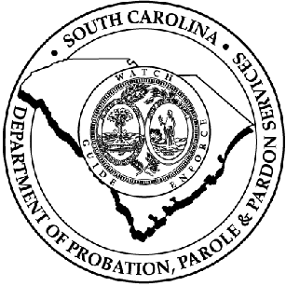

Agency Accountability Report

Fiscal Year 2000-01

August 31, 2001

Table of Contents

Transmittal Letter Page 1

Financial Overview Page 2

Organizational Chart Page 3

Business Overview Page 4

Leadership Page 7

Strategic Planning Page 10

Customer Focus Page 12

Information and Analysis Page 13

Human Resources Page 14

Process Management Page 16

Results Page 19

State of South Carolina
Department of Probation, Parole and Pardon Services

JIM HODGES STEPHEN K. BENJAMIN
Governor Director

2221 DEVINE STREET, SUITE 600
POST OFFICE BOX 50666
COLUMBIA, SOUTH CAROLINA 29250
Telephone: (803) 734-9220
Facsimile: (803) 734-9440

August 31, 2001

Mr. R. Lester Boles, Jr., Director
Budget and Control Board
Office of the State Budget
1122 Lady Street
Columbia, South Carolina 29201

Dear Mr. Boles,

I am pleased to present The South Carolina Department of Probation, Parole, and Pardon Services Accountability Report for fiscal year 2000-01. Again this year, our vision in approaching the report, was to create a practical, consistent and systematic process to measure and report compliance with laws, policies, and procedures, in all areas of the Department, and to ensure this is being done in a positive environment fostering continuous improvement and innovation.

Using the Department’s Strategic Plan and the Malcolm Baldridge National Quality Award Criteria as a foundation, each division began to complete a comprehensive and systematic self assessment of its performance during FY 00-01. The Department’s Quality Office, Office of Internal Audit, and Administrative Services Division provided technical assistance and consultation services to staff and managers throughout the process. The final product is a consensus of our organization’s performance on meeting our legislative mandates and progress on our strategic plan.

For information or assistance regarding this report, please contact Mr. William Bray, Budget Office, at (803) 734-9336.

Sincerely,

Stephen K. Benjamin

Financial Overview

Base Budget Expenditures and Appropriations

 | 99-00 Actual Expenditures |  | 00-01 Actual Expenditures |  | 01-02 Appropriations Act
Major Budget Categories | Total Funds | General Funds | Total Funds | General Funds | Total Funds | General Funds
Personal Service | 27,156,178.37 | 18,116,881.84 | 28,535,098.64 | 19,083,455.26 | 28,945,187.00 | 19,434,604.00
Other Operating | 7,163,638.32 | 885,284.45 | 7,714,642.15 | 658,848.88 | 8,804,672.00 | 1,545,194.00
Special Items | 861,849.07 | 622,140.37 | 133,910.40 | 94,161.47 | (3,200,000.00) | (3,200,000.00)
Permanent Improvements | 296,158.00 | 146,158.00 | 0.00 | 0.00 | 0.00 | 0.00
Case Services | 536,343.72 | 47,990.25 | 515,024.46 | 159,844.25 | 492,337.00 | 172,500.00
Distributions to Subdivisions | 0.00 | 0.00 | 0.00 | 0.00 | 0.00 | 0.00
Fringe Benefits | 7,988,345.45 | 5,335,097.48 | 8,788,026.68 | 5,874,394.15 | 8,584,129.00 | 5,679,859.00
Non-recurring | 0.00 | 0.00 | 0.00 | 0.00 | 0.00 | 0.00
Totals | 44,002,512.93 | 25,153,552.39 | 45,686,702.33 | 25,870,704.01 | 43,626,325.00 | 23,632,157.00

Other Expenditures

Sources of Funds | 99-00 Actual Expenditures | 00-01 Actual Expenditures
Supplemental Bills | 621,640.37 | 94,161.47
Capital Reserve Funds | 208,158.07 | 0.00
Bonds | 0.00 | 0.00

Organizational Chart

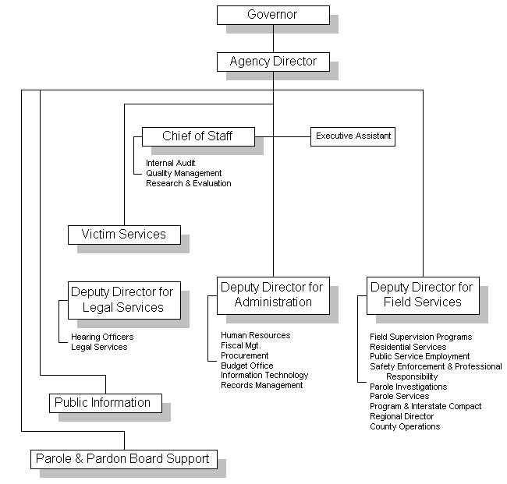

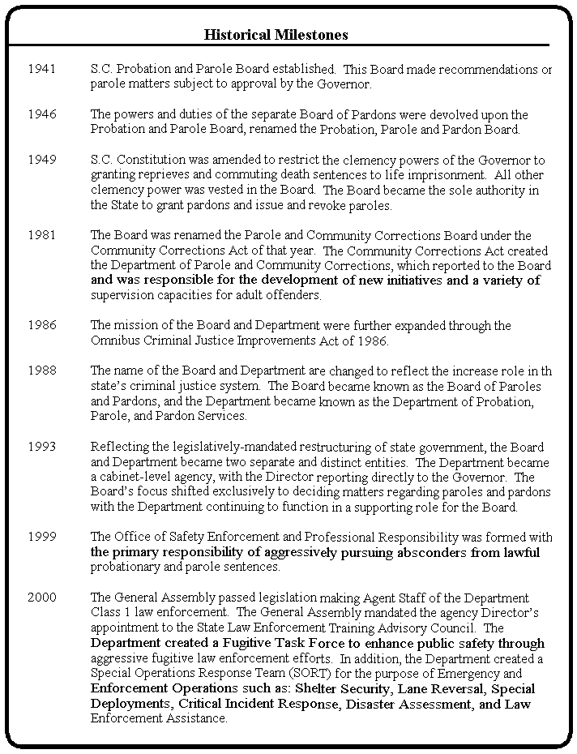
Business Overview

Historical Overview

The use of parole in South Carolina began in 1941 with the establishment of the South Carolina Probation and Parole Board. At the time of its creation, this Board made recommendations on parole matters subject to approval by the Governor.

In 1946, the duties of the Board grew to include recommending pardons as well as paroles for the Governor’s approval, and the Board was re-titled the Probation, Parole and Pardon Board.

Three years later, the South Carolina Constitution was amended to restrict the clemency powers of the Governor to granting reprieves and commuting death sentences to life imprisonment. All other clemency power was vested in the Board, which then became, and still remains, the sole authority in the state to grant pardons, and to issue and revoke paroles.

The Community Corrections Act of 1981 mandated an internal reorganization, new community corrections initiatives, and in general expanded the agency’s mission to include the development of a variety of supervision capacities, some to serve as viable alternatives to incarceration. The Omnibus Criminal Justice Improvements Act, passed in June 1986, further expanded our mission to develop a continuum of judicial options, which could be individually applied to fit both the offender and the offense.

The basic purpose of any government agency, to justify its existence, should be to improve the moral and economic character of all its people. This agency has sought diligently to educate the community of its responsibilities and the inherent rewards that come from a successful reformation of an individual who might have deviated from the acceptable norm of good citizenship. We have provided an opportunity for those under Probation or Parole to modify or alter their attitudes to properly adjust to complete reformation, acceptance of their responsibilities and develop into an asset to the community and their immediate family. Restoring a person to a reproductive life and prevent his recidivism is a rewarding process and a true goal to which this department has dedicated its efforts.

The Parole Board

The S.C. Board of Paroles and Pardons is composed of seven part-time members - one member from each of the state’s six U.S. congressional districts, and one member at large. Appointed by the Governor and confirmed by the South Carolina State Senate, members serve staggered, renewable six-year terms. Members represent diverse backgrounds, experience and occupations.

The Board elects its own chairman, vice-chairman and secretary from its membership. Elected in January, these officers serve in their respective posts for two years, and may be reelected.

Probation statutorily permits the Courts to prescribe and control the treatment program of each offender under supervision in community surroundings by Probation Agents under conditions imposed by the Court for a specified period during which the imposition of sentence is suspended. Probation is not a release from jurisdiction but a method to provide the greatest degree of protection to the community and maximum possibilities for rehabilitation to each offender.

Parole is not clemency, not a right, nor a reduction of sentence. Parole is a means of release of a prisoner from imprisonment but not from the legal custody of the State for adjustment outside of prison walls under such conditions and provisions acceptable to society. Any Parolee who fails to respond can be reimprisoned promptly, while the Parolee who is making a sincere effort to conform can be encouraged, counseled and motivated to become a productive citizen.

Current Business Overview

The Department is unique in the law enforcement arena in that we supervise adjudicated offenders in their communities. In doing so, it is the responsibility of the Department to promote a feeling of safety among the citizens within their own communities as described in the Governor’s Business Plan. To accomplish this mission the Department is divided into three Divisions as represented in the organization chart on page 3. The Field Services Division has 648 commissioned law enforcement personnel and 125 support personnel divided into five regions with offices in each county. As of June 30, 2001, the Department was responsible for the supervision of 51,225 jurisdictional offenders.

Our major objectives over the last year have been:

- To promote public safety through increased offender accountability ensuring that citizens are confident in the safety of their surroundings.

- To increase the visibility of Agents in community policing efforts, and emergency response situations as requested by the Governor.

- To improve the Department’s information technology infrastructure in order to provide Agents with the technology to efficiently and effectively manage their caseloads.

- To employ sound fiscal practices in the compensation of agents in order to retain quality, well trained agents.

FY 2000-01 Accomplishments:

- The General Assembly passed legislation making Agent Staff of the Department general law enforcement.

- The Department met 93% of its affirmative action goals for the second year in a row.

- All staff participated in training from the Stop the Violence Against Women Program.

- The Department disbursed 99.13% of the Department Administered Court Ordered Restitution (DACOR) funds collected during the fiscal year, dispersing 42,889 checks totaling $4,716,804.44.

- The Director established a Victims Advisory Council made up of twenty members of victims and victim service providers from across the state. The purpose of the Council is to increase the community’s awareness and knowledge about the Department and to enhance the Department’s partnership with the victims community.

- The Department obtained DNA samples from 5,239 offenders to meet statutory requirements to establish a DNA database. $206,162.16 was collected as part of this sampling program and remitted to SLED. Additionally, the Department assisted the Department of Juvenile Justice to obtain over 368 DNA samples from their offenders at no cost to DJJ.

- The Department initiated a new policy in regards to dealing with Hispanic offenders and victims. Translation services were established with Department staff as well as private vendors. Cultural training has been initiated and will be completed during 2001.

- The Department Quality Council was redesigned to increase efficiency and effectiveness. The Quality Bulletin Board was electronically placed on all computers allowing access for all staff to see what is being done in regards to quality oriented initiatives as well as other teams and committees.

- A sex offender committee was established to develop and plan implementation of sex offender specific policies and training. Information from national sources has been gathered. This committee expects to complete the planning by January 2002.

- The offender information staff developed and installed an innovative and responsive automated support system that enhanced the interstate compact sections ability to provide responsive service to all county offices and states within the compact.

- The Department established the first statewide Fugitive Investigation Team of any Probation & Parole Agency in the nation. The efforts of the team resulted in the arrest of more than 2,000 fugitives. Since the team’s inception, more than 8,000 warrants were cleared. This incredibly successful effort has been presented to a national audience and lauded by the National Institute of Corrections (NIC), network of Probation and Parole Executives.

- The Department launched on-going statewide warrant sweeps. In Operation Clean Sweep in July 2001, nearly 200 fugitive, criminal offenders were arrested and taken out of South Carolina Communities. The first-ever statewide fugitive roundup by the Department, the intensive, week-long effort involving hundreds of agents meant the arrests of criminal offenders who had violated the conditions of their probation or parole.

- The Department launched a statewide Top Ten Most Wanted effort during the fiscal year. The Department has captured over 16 of these fugitives since the inception of the list.

- The General Assembly mandated the agency Director’s appointment to the State Law Enforcement Training Advisory Council.

- The Department published its first tribute to victims “Gone Too Soon”. The book contained more than 100 submissions of poems, letters, and thoughts in memory of those whose lives were tragically cut short because of a terrible crime.

- The Department developed and implemented policy changes along with introducing the automated Parole Information Center (PIC); reducing paperwork involved in processing parole cases, reducing overall required resources in parole case preparation, and reduced case processing time by 6 months.

- The Procurement Office established a Law Enforcement Warehouse which exists to receive, issue and safeguard all Department safety and law enforcement related equipment, supplies and materials.

This fiscal year marks the second full year under the current Executive Staff. A renewed vision and commitment to the community was communicated by Mr. Benjamin and his Executive Staff as the department began an earnest process of top down review of management and operational systems in striving to be the best community oriented law enforcement agency in the State.

Leadership

In early 2000, the Department deployed a comprehensive and bold step towards complete organizational accountability management and continuous improvement planning. This bottom up approach to accountability management and improvement planning was innovative in its inception and challenging in its deployment. By late 2000 and early 2001 the department realized significant return on investment by emerging from significant budget reductions totaling over 13% without disruption of services or implementing a reduction in force. The basic approaches to planning and accountability are depicted in figure 1.1.
The Leadership model for the Department, as depicted in figure 1.2, is an integrated approach of bidirectional communications between all levels of the organization that places a premium on Values, Planning, and Feedback. The Leadership System (figure 1.4) for the Department is key to the organizational success achieved this fiscal year. The foundation for our leadership model is built upon our values.
Figure 1.2

Our values reflect who we are and the things for which we stand. It is the culture of our way of doing business. We are committed to demonstrate these values to each other and those we serve.

Integrity:
- Creating trust;
- Doing what is right
- Being honest and maintaining the highest standards of ethical conduct.

Fairness:
- Treating people fairly, with dignity and respect;
- Advocating and demonstrating equal opportunity;
- Balancing organizational needs with individual needs and interests.
Figure 1.3 - SCDPPPS Community Policing Project - Probation & Parole Agents worked with the State Highway Patrol at traffic check points.

Teamwork:
- Being a team player;
- Communicating openly and effectively;
- Empowering people and demonstrating leadership.

Quality:
- Doing things right the first time;
- Exceeding expectations;
- Commitment to continuously improving our processes.

Accountability:
- Faithful in protecting the public’s trust;
- Being responsible for our actions;
- Making decisions based on facts and data.

The second dimension of our model is planning. With our values serving as the foundation and driving force for our business culture, it follows that we consider all of the inputs and opportunities for our organization and incorporate those into our operational and long range plans. Planning incorporates all levels of the organization and is characterized by our formal process of accountability management and improvement planning. All assessments and plans are evaluated and updated on an annual basis and status of action plans and activities are reviewed monthly.

The third dimension of our leadership model is feedback. More than any other component, feedback is vital to our ability to assure continued and sustained organizational success. Our values of teamwork and quality require us to constantly evaluate and assess the vitality or our communications. One of our most effective vehicles for assessing our communications is through our Department’s Quality Structure. This fiscal year, we revitalized our Quality Councils and established a permanent linkage to and with the senior leadership system for the department.
The new quality council for the department is responsible for assuring the development and sustainment of our system for the coordination of the Department’s quality related initiatives. Which fosters quality as a way of life for all SCDPPPS employees. This includes the employee suggestion program as well as oversight of the department’s policy and procedures committee. At each meeting of the senior leadership of the department, updates on the status of quality initiatives for the department are briefed and actions assigned to address improvement opportunities identified.

Commitments to Employee Satisfaction:

Senior leadership’s commitment to insuring a quality work force and employee satisfaction is exemplified by the following initiatives:

- Provided Agent Uniforms.
- Developed a Body Armor Vest Rotation Schedule.
- Provided Arrest Scenario Training.
- Increased the size of vehicles to insure that a large vehicle is in each County.
- Increased communications equipment available in Field Offices.
- Increased the number of computers in Field Offices.
- Develop conversion to 32-bit Offender Information System.

Giving back to the Community:

Senior leadership’s commitment to the quality of life in South Carolina is exemplified by the following:

- The Director participated in the Mark Harmon Celebrity Baseball Game supporting the South Carolina Victim Assistance Network during Victims Rights Week 2001.
- The Director lead staff participants in the annual Walk For Diabetes.
- The Director is on the Board of Directors for the Columbia Action Council and the World Affairs Council.
- The Director is a member of the Community Advisory Board for WOLO-TV Channel 25.
- The Chief of Staff is a Court Appointed Special Advocate (CASA)
- The Deputy Director for Administration is the Chairperson for the Health and Safety Awareness Committee and a member of the Community Council for the Junior League of Columbia.
- The Deputy Director for Administration is the Chairperson for the Multi-Cultural Committee for EdVenture children’s museum.
- The Deputy Director for Field Services was Chairperson for the Community Health Charities.
- The Deputy Director for Field Services is on the board of director’s for the Deputy Director’s Organization.
- The Deputy Director for Legal Services was the Department Campaign Coordinator for United Way in 2001.
- The Deputy Director for Legal Services volunteers for Sister Care, a shelter for battered women and children.

In addition, executive leadership has encouraged each office to reach out to the community, schools and businesses to help educate them on the Department, safety issues and offender supervision. All offices across the state are actively involved in community service. Some examples of office involvement include:

- The Department participated again in the Summer Work Experience Leadership Program (SWELP) with the Columbia Urban League.
- York County is conducted a month-long food and school supply drive donating proceeds to PATH in York and to Pilgrim’s Inn in Rock Hill.
- The Greenwood County office participates in the Adopt-a-Highway Program winning Greenwoods County’s “Most Outstanding Litter Clean Up Group of the Year”.
- Barnwell County has worked with the Williston Literacy Council in the establishment of an adult literacy program geared toward working with young offenders.
- The Horry County office participates in the Coastal Regional Intelligence Sharing Program. This program is a network of law enforcement officers who meet to share information about pending investigations and warrants.
- The Allendale Office participated in the organization and sponsorship of the Relay for Life Program, which is a national fund raising program to educate people on the prevention and cure of cancer.
- A Greenville County Agent hosted reading events for elementary school students.
- For the past five years, SCDPPPS staff from Central Office and Richland County have volunteered with the Lunch Buddy Program in Richland School District One and Richland School District’s II’s Table Talkers.
- The Kershaw County Office provided lunch for young people participating in Camp SOAR which is a week long camp for at risk youth.

Strategic Planning

The Department of Probation, Parole and Pardon Service’s Planning approach integrates and links all department planning and improvement efforts for senior leadership. The Department sets 1 to 5 year strategic objectives and selects improvement initiatives and action plans to achieve the strategy. Charters for improvement initiatives designate team members including managers and staff from all levels within the organization who implement action plans. Quarterly, the Executive Management Team “EMT” reviews the strategic direction, improvement initiatives, financial and performance data and makes adjustments as conditions warrant.

The Executive Management Team reviews inputs for planning (Figure 2.1) analyzes the results, and develops strategic themes annually. This information is communicated to the divisions and through regional management around the state. Alignment is assured through regular and systematic scheduled feedback meetings conducted weekly, monthly, quarterly and annually at all levels of the organization. Additionally, each region has fully established and operational quality councils that provide additional data inputs to the process to assure strategic alignment.
Additionally, the “EMT” has established 14 teams (Figure 2.2) to address significant priority improvement areas impacting the department and employees.

These teams work throughout the organization and across the state of South Carolina.
Team | Purpose
Policy Committee | Review, Implement, Facilitate communication of changes to Department Policy and Procedure Manual
Department Quality Council | Review issues received from individuals that have statewide impact.
Regional Quality Council | Reviews issues received from individuals that have regional impact.
Sex Offender Team | Developing statewide policy and training regarding sex offender supervision.
Drug Treatment Court Management Team | Developing and implementing Drug Court in 3rd Judicial Circuit.
Vehicle Advisory Group | To discuss issues associated with the department fleet and to plan for future utilization and to promote vehicle safety, regulations and procedures.
Scheduler Committee | Monitoring and making recommended changes to the scheduler program.
Court Presentation Committee | Inter-office committee reviewing presentation of violation cases by limited staff.
Horry County Quality Council | To address issues and concerns on the county level.
Communications Committee | To generate ideas, conduct research and propose solutions addressing a wide array of communications concerns. Reviewing policies and practices. Developing communication related training.
Annual Meeting Planning Group | To plan and implement the Department’s Annual Meeting
Violations Group | To review and improve the violations process.
Risk Management Group | To review and develop new risk assessment strategies.
Basic Training Group | To review and revise agent basic training.

Figure 2.2
The Department linked its FY 2000-01 Budget Request to the Governor’s Business Plan. This marked the first time the agency strategically aligned its operational and strategic plans with the Governor’s long ranges plans for the state of South Carolina. Those strategic linkages included:

- To promote public safety through increased offender accountability ensuring that citizens are confident in the safety of their surroundings.

- To employ sound fiscal practices in the compensation of agents in order to retain quality, well trained agents.

- To increase the visibility of Agents in community policing efforts, and emergency response situations as requested by the Governor.

- To improve the Department’s information technology infrastructure in order to provide Agents with the technology to efficiently and effectively manage their caseloads.

These strategic linkages were communicated through the organization in the form of action plans by each responsible functional area. Assurances in obtaining these goals was achieved through each functional areas self assessment. The Field Services Division, the largest division, has worked this year to develop and implement Strategic Measurements that implement the Department’s goals. These strategic objectives represent many hours of dedicated service by the staff of SCDPPPS. In the coming year, these measures will be used to establish baseline data and develop targets for our staff to work towards. By focusing on these objectives, our department has implemented a system that is easily communicated to all staff and provides for accountability from agent to county to regional and statewide level. The department has empowered 1st line managers and leadership to have access and information on performance at their disposal.

Overall the department includes a wide array of inputs into its planning process and assures a systematic deployment of guidance for offices to act upon in deploying resources to address strategic objectives. See figure 2.3.
Customer Focus
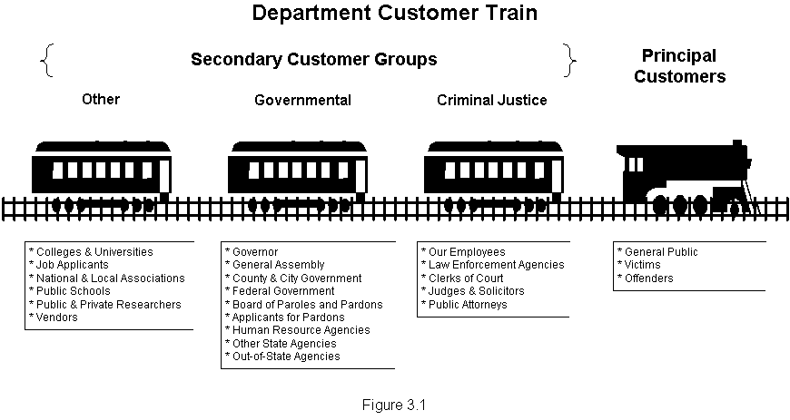
The Department’s customers can be divided into four categories (figure 3.1). These categories include Principle, Criminal Justice, Governmental, and Other. The Principle customers for the Department are those who are the prime recipients of the services from the Department. These include the General Public, Victims, and Offenders. The Department’s secondary customer groups include Criminal Justice, Governmental, and Other.

As a governmental agency our customers serve more as stakeholders in our mission. As a Law Enforcement Agency, the goals of the Department are developed to insure the safety of the general public, our number one customer and stakeholder. In order to determine the Department’s effectiveness in supporting our customers needs, we rely on surveys and internal self assessments of functional areas in supporting the Department’s mission.

Listening & Learning
Agency Web Site
Agency Annual Conference
Solicitor’s Association
General Sessions Court Judges
Summary Court Judges
Municipal Association
Association of Counties
Victims Association
General Assembly
Faith Community
Senior Management & Line Staff
Direct Calls
Complaints

Approach & Processes
Internal Investigations
Focus Groups
Quality Councils
Policy & Suggestion Process
Figure 3.2

Opportunities to listen to our customer and learn from their experience are found in figure 3.2

An example of staying in touch with our customers has been the development of services for Hispanic citizens. These have included entering into a relationship with the Hispanic Outreach to conduct cultural training to all Department staff. To contract with service providers to provide translation services to agents, victims, and offenders over the phone and, if needed, in person.

Figure 3.3

Department Senior Leadership strongly supports and encourages employees at every level to take advantage of every contact with constituent groups to understand their concerns and expectations and to address those concerns. Through the departments assessment and improvement planning system, mission accomplishments and strengths and areas for improvement are addressed to include incorporation of key customer expectations.

The Department affords customers many avenues to gain access to enable their voices to be heard. These are illustrated in figure 3.3.
Information and Analysis
In order for managers to make sound decisions and maintain focus on the Department’s mission, information must be timely, accurate, and obtainable to all managers. Figure 4.1 illustrates the types and frequency of information reviewed by managers. This data is categorized in three groupings: Operational Performance, Financial Data, and Employee Satisfaction/Performance. In order to keep all employees informed the Department utilizes email and “The Informer”, the Department’s newsletter, to share results, announcements, community involvement, and policy changes.

The department implements measurements for each organizational level. At the department level, executive management tracks overall progress towards the department’s key strategic objectives. The primary and fundamental source of information flows annually to the EMT through the divisions from offices and sections of the organization through the self assessment and improvement planning process. That brings together, a comprehensive and thorough analysis of operational achievements and improvement opportunities to enhance organizational effectiveness and involves all employees of the organization. The basic flow is depicted in figure 4.2.
Figure 4.1
Figure 4.2
Human Resources

All senior managers establish and reinforce an environment for empowerment, innovation and organizational and employee learning through a variety of approaches. Each is intended to encourage learning, and improve quality, customer satisfaction, and performance levels. The successful implementation of ideas and projects are recognized in a variety of ways, including the rewards of money, statewide certificates and recognition at public meetings to include region-wide functions, luncheons and scholarships to national conferences.

In order to find quality people the Department maintains an open continuous recruitment process that allows for applicants to apply for the entry level agent position at any time. A brochure is provided during the recruiting opportunities which describes what the employment experience as a Agent is like. The Department extends itself to institutions of higher learning when recruiting for qualified applicants. Once the application is submitted the Department administers a series of tests that include a reading comprehension exam, a psychological test, a drug screening and a credit check.

The department retains good people by having a career track in place that they can progress through over a number of years. When an employee reaches a benchmark in the career track a pay increase occurs. The department also provides professional development and training opportunities for employees. Employees efforts and achievements are recognized and good performance is reinforced through various appreciation methods.

To insure diversity, the department has an Affirmative Action plan in place and the areas of underutilization are carefully monitored. This ensures that the department’s employee workforce is representative of the population that it serves. The department has extended recruiting efforts that are aimed at generating a diverse workforce. Specified minority recruiting is accomplished by contacting Historically Black Colleges and Universities.

In order to keep employees motivated, the department provides opportunities for employees to attend various training and to participate in state, local and national conferences. Employees are motivated by programs the department offers such as merit pay, pay for performance, bonus pay, and employee recognition activities. The department has also established regionalized Quality Councils to ensure that employees are empowered to have input into the department’s administrative processes.

The Department’s Quality Council provides a blueprint for our direction in addressing quality of life issues within the organization and for identifying opportunities for enhancing organizational effectiveness and efficiency through supporting ideas for change and improvement.

The Quality Councils, state, and local, in concert with the department’s accountability management, reporting and improvement planning system affords a wide array of mechanisms, systematically deployed, to address all facets of the organization’s mission, employee and customer needs and expectations. Significant and sustained improvements are recent products of the combined efforts of these processes.

In order to achieve high performance of our employees, the Department offers programs such as merit pay, pay for performance, bonus pay and employee recognition activities encourage employees to perform at their best. An employee recognition activity that encourages employees to perform at their best is the Employee of the Year Award. Also supervisors are trained to reward good performance through positive feedback. The department also ensures that employees are equipped with the necessary training to fulfill their job duties and responsibilities.

In order to maintain a highly trained workforce, training is conducted for all levels of employees within the department from entry to divisional manager. Employees must be approved to attend all training. When approved, employees are also allowed to attend training offered by other state agencies and other entities outside of the department. Also on the job training occurs for the fulfillment of the primary responsibilities along with cross training for other job duties and responsibilities. The Staff Development and Training section coordinates all training offered within the department and maintains a database of all employee training activity.

The department provides training to line level employees as well as managerial level employees. Senior level employees are equipped with the job knowledge to pass along to the newer employees. The department also provides summer jobs to high school students in coordination with the Columbia Urban League. Internships at the department have also been made available to college students.

Safety of our workforce is a major concern of the Executive leadership. The department has employees tested for HBV, TB and for illegal drug use. There is also an employee assistance program in place known as Job Retention Services. Each department location has a Materials Safety and Data Sheet Manual in place. There are safety guidelines in place and there is a move towards developing a Workplace Safety Policy. The department also has an Office of Safety, Enforcement and Professional Responsibility (OSEPR).

Services made available to employees to assist well-being and satisfaction include:

- Law Enforcement safety equipment
- Tuition Assistance Program
- Medical service for Agents
- Chaplaincy Program (SC LEAP)
- Employee Assistance Program
- Wellness Committee
- Employee/Volunteer Recognition

Figure 5.1

Process Management

Evaluation and improvement approaches are integral to all of the Department’s design processes. Process improvement efforts use charters to ensure initiatives are well defined and well linked to the organization’s strategic direction. Process owners are designated for each of the department’s key mission processes. They are responsible for defining process purposes: identifying customers; understanding customer requirements; flowcharting or documenting the process; developing the appropriate measures and controls as well as assuring that the controls are properly used. Additionally, they are responsible for identifying and prioritizing process improvement opportunities, chartering improvement teams and approving process improvement.
Figure 6.1

The Administrative Services Division’s key support processes are an integral and integrated part of the department and vital to mission success. These are illustrated in figure 6.1. During FY 2000-01, the Division performed a comprehensive review of their support goals. Each support process is defined in figure 6.2. The Departments core mission process is defined in figure 6.3.

In general, the requirements for support processes are to meet internal customer standards for accuracy, reliability, effectiveness and cost. Support process requirements are determined through knowledge of the customer needs, using first hand knowledge, customer interviews, surveys, and internal experts.
Support Processes:
Requirements and Measurers

Support Process | Process Requirements | Measurements
Accounting | - Accurate Information | - Audit free  - Timely processing
Budget | - Accurate Information | - Timely accurate information  - Audit free
Procurement | - Customer Requirements  - Compliance | - Customer responsiveness  - Audit free  - Best costs
Human Resources | - Requirements of internal customers  - Timely and accurate data | - Employee Satisfaction  - Turnover
Records | - Timely access  - External customer requirements | - Customer responsiveness  - Timely processing
Information Technology | - Technology trends  - Hardware  - Software  - Customer requirements | - System availability  - Customer responsiveness
Offender Information System | - Customer requirements | - Customer responsiveness  - System availability

Figure 6.2
We have been committed to establishing and maintaining comprehensive support systems which serve as the foundation for our ability to meet our mission and the expectations of the citizenry of the state. As the Executive Management Team worked to assess progress the Department has made over past years, one area that continues to be of concern involves the technology and systems our Department has in place for "radio communication". To address the challenges that the Department faces in the immediate future to fine-tune our Department's communication efforts, the Department established a standing Communications Committee in the fall of 2000 to generate ideas, conduct research and propose solutions addressing a wide array of communication system concerns.

During FY 2000/2001, the Department established a Law Enforcement Warehouse which exists to receive, issue, and safeguard all Department safety and law enforcement related equipment, supplies and materials. The Law Enforcement Warehouse is comprised of a perpetual inventory of approximately 100 law enforcement commodities. Warehouse activities include a central receiving, distribution and storage warehouse. The Law Enforcement Warehouse Manager administers a stock rotation schedule, prepares stock requisitions, manages stock-outs or low stock levels, conducts yearly warehouse inventory, maintains security and safety practices and inspects, maintains and organizes warehouse area. The Law Enforcement Warehouse Manager is responsible for issuing, receiving and safeguarding Department issued weapons and maintains proper paperwork for tracking of same, ensuring the appropriate tracking and reconciliation of all Department issued weapons. Planning and implementation activities regarding the Law Enforcement Warehouse were closely coordinated with the Field Services Division staff to ensure the highest level of material management support for the Department's primary mission and special law enforcement initiatives.
Field Services Core Mission Processes
Requirements and Measures

Mission Process | Process Requirements | Measurements
Offender Home Visits | - Conduct home visits to verify residence and to assist in monitoring and enforcing offender’s compliance with general and special conditions. | - Monthly Trend Charts  - Internally Benchmarked
Fines | - Monitor, track and enforce payments. | - Monthly Trend Charts  - Internally Benchmarked
Restitution | - Monitor, track and enforce payments. | - Monthly Trend Charts  - Internally Benchmarked
Fees | - Monitor, track and enforce payments. | - Monthly Trend Charts  - Internally Benchmarked
Public Service Employment | - Monitor enforcement of successful completion of hours. | - Monthly Trend Charts  - Internally Benchmarked
Offender Drug Testing | - Respond to each positive drug test. | - Monthly Trend Charts  - Internally Benchmarked
Warrant Service | - Serve warrants within 30 days  - Total warrants served. | - Monthly Trend Charts  - Internally Benchmarked

Figure 6.3

During FY 2000/2001, the Department's Law Enforcement Warehouse was assigned the responsibility of working with programmers to plan and develop an automated system to closely track certain safety equipment including Department weapons, body armor, and radios. The Department's programming staff provided tremendous support in writing a system to track the nuances of a responsive automated system, including identifying information for all equipment and critical information specific to the various types of equipment such as expiration dates for body armor. Data entry began at the end of FY 2000/2001 and the system will be fully implemented in FY 2001/2002.

Incorporating Feedback and Improvements

Customer and employee input is continually solicited at all levels of the organization. Part of our process improvement cycle includes the evaluation of the effectiveness of our business processes and their implementation. We receive information through various means including:

- Self Assessments
- Audit Opinions
- Customer Feedback
- Employee Suggestions
- Quality Council Recommendation

Our processes are systematically reviewed and evaluated for opportunities for improved performance. Evaluation is accomplished through our quality assurances mechanisms, self assessments. Improvement is accomplished through a variety of activities. Some of these include:

- Process Improvement Teams
- Natural Work Groups
- Process Analysis
- Bench-marking

Some examples of significant improvements achieved in key results areas of the department are:

- Agent Safety Advisory Group developed and deployed physical fitness program;

- Established partnership with the Hispanic Outreach to conduct cultural training for all department staff during 2001.

- Offender Information System Team developed and deployed the following system enhancements to aid in operational performance management: (figure 6.4)
- Monthly Collections Activity Report
- Warrant & Citation Activity Report
- DNA Activity Report
- Drug Testing Activity Report
- Gang Alert

Figure 6.4
The Offender Information System (OIS) is the computerized system that maintains a multitude of reports and records that can be used by all staff. There are two primary ways in which modifications are made to the system. The first method is by periodic meetings between the OIS staff and the OIS liaison for the Regional Directors. During these meetings the liaison makes recommendations that would enhance the OIS system for both the user providing input as well as the user who needs the information the system can generate. One of the most user friendly reports that was recently generated by the OIS is the caseload management report. Field staff can easily generate this report and can instantly tell when their last home visit progress report was completed as well as several other key supervision events. The second method used to enhance the OIS is by the scheduler committee. This committee receives input from users of the scheduler system and meets to discuss these suggestions at least quarterly. During 2001 the Department had 30 counties using the scheduler. Should additional appropriations be made available, computers will be distributed to the remaining counties. It is anticipated that by July 2002 every county will be using the scheduler program to document and manage cases.

Additional enhancements that impact the employees at all levels of the organization was the development and full deployment of the “Career Data System” (CDS) administered by the department’s Office of Human Resources. That system enables employees, supervisors and managers real time access to:

- Leave Balance, and history
- Benefits
- Training
Office Self Assessment and Improvement Planning

The office self-assessment process allows for the measurement of improvement activities. This basic approach of planning, action, results and improvements is fundamental to our continuous improvement efforts within the department.
The basic approach and process is depicted in figure 6.5. Each office assesses their accomplishments in each core mission activity using basic questions as an initial point of departure in their assessments of each core mission activity. Those initial questions are outlined in figure6.6.
Assessment
Questions

Did we improve, stay the same or did the condition worsen?
How do we know these results?
Do we know the root cause(s)?
What will we do to sustain or improve these results?
What is our target for the next 12-18 months?
How will we know we are achieving the “right” results?
Who is responsible for assuring accountability?

Figure 6.6

Results

Financial Data:
Total Costs by Program Area
(Appropriations Act)

 | FY 1998-99 | FY 1999-00 | FY 2000-01
Administration | 3,695,854.27 | 5,385,617.51 | 5,861,584.48
Offender Supervision | 24,681,786.92 | 25,800,975.05 | 28,190,725.00
Paroles & Pardons | 1,316,277.55 | 914,416.37 | N/A
Residential Services | 2,423,728.79 | 2,669,108.97 | 2,489,989.84
Parole Board | 244,821.69 | 232,700.51 | 222,465.93
Employer Contributions | 7,088,715.86 | 7,988,345.45 | 8,788,026.68
Supplemental Appropriations | 895,903.91 | 861,349.07 | 133,910.40
Total | 40,347,088.99 | 44,002,512.93 | 45,686,702.33

Figure 7.1

In fiscal year 2000-01, the major source of funding for the Department is from State General Funds (56.8%) and Earmarked Revenue (40.3%). The remaining 2.9% is from Supplemental Appropriations (1.0%), Federal Funds (0.4%), and General Fund Carryforward (1.5%). The two major sources of Earmarked Funds are from Omnibus Revenue (80.1%) and Supervision Fees (16.6%). Figure 7.1 illustrates the program costs by major program area. All figures are Total Funds. Beginning in fiscal year 1999-00 the Parole & Pardons program was realigned within the Administration and Offender Supervision programs in order to improve operational efficiencies. This realignment was completed in fiscal year 2000-01. The Offender Supervision program is the main area of the Department responsible for all law enforcement activities.

In fiscal year 2000-01 81.69% of Total Fund expenditures were for personal services. The Department is authorized 990 Full Time Equivalents, FTE’s. Figure 7.2 illustrates the program costs by type.

Total Costs by Type

 | FY 1998-99 | FY 1999-00 | FY 2000-01
Personal Service | 32,704,975.66  81.06% | 35,155,148.23  79.89% | 37,323,125.32  81.69%
Other Operating | 7,267,563.18  18.01% | 8,311,020.98  18.89% | 7,848,552.55  17.18%
Case Services | 374,550.15  0.93% | 536,343.72  1.22% | 515,024.46  1.13%
Total | 40,347,088.99 | 44,002,512.93 | 45,686,702.33

Figure 7.2

Personal Services is all salary and contributions costs for the Department.

Other Operating is all contractual service, supply, fixed changes, travel, and equipment expenditures for the Department.

Case Services is all expenditures on behalf of the State where such assistance is maintained on each case or where direct public assistance payments are made to individuals based on a legal formula for special determination.

Figure 7.3 compares the cost of supervision from FY 1997-98 through FY 2000-01.

Cost of Supervision

 | FY 1997-98 | FY 1998-99 | FY 1999-00 | FY 2000-01
Regular Supervision Costs | $1.83 | $1.95 | $2.17 | $2.80
Cost Per Day – All Levels | $2.58 | $2.82 | $3.10 | $3.56
Intensive Supervision Costs | $9.20 | $9.95 | $10.65 | $9.87
Home Detention without Electronic Monitoring | $12.24 | $13.23 | $14.17 | $13.12
Home Detention with Electronic Monitoring | $17.58 | $17.03 | $17.51 | $16.77
Residential Services Per Bed Day Costs | $43.57 | $37.41 | $41.25 | $41.17

SCDC Total Fund Inmate Cost Per Day | $39.23 | $42.02 | $43.78 | Not Available

Source: Inmate Cost Per Day from SCDC

Figure 7.3

Input / Output Data:
Figure 7.4 illustrates the number of disbursement checks issued during the fiscal year by the Department.

Figure 7.4

In FY 2000-01 Victims Services received 5,156 telephone calls and 16,131 letters of opposition from victims. (Figure 7.5)

In FY 2000-01 Victims Services received 2,026 victim impact statements from victims. (Figure 7.6)

The Department had 51,225 jurisdictional offenders under supervision on June 30, 2001. (Figure 7.7)

For active accounts during FY 2000-01, 816,483 hours of public service employment were performed by offenders. (Figure 7.8)

During FY 2000-01, the Department operated three restitution centers and one community control center with a combined total capacity of 220 beds. (Figure 7.9)

Efficiency / Effectiveness Data:
The Office of Internal Audit, in consultation with the Quality Management/Staff Development and Training Department, addressed training and relevance to core mission tasks performed by Field Services Division employees.

Figure 7.10 revealed that approximately 40% of those employees surveyed expressed concern about the imbalance between professional development and law enforcement training. As a result the SDT Section in conjunction with the Field Services Division revamped its core curriculum for Probation and Parole Agents to add arrest scenario, cover drill, and criminal domestic violence training.
Figure 7.10

The Department disbursed 99.13% of the Department Administered Court Ordered Restitution (DACOR) funds collected during the fiscal year, disbursing 42,889 checks totaling $4,716,804.44. (Figure 7.11)

Restitution Centers are community-based residential facilities providing an intermediate sanction for nonviolent offenders. The program emphasizes victim restoration through offender paid restitution. Offenders must maintain employment and perform unpaid public service. Individual assessments are completed on each offender. Figure 7.12 illustrates the total amount paid ($1,550,937) by offenders in the program for victim restitution and other monetary obligations.

Figure 7.13 illustrates the percent of bed day utilization for residential programs administered by the Department.

Figure 7.14 illustrates the number of offenders tested for drugs over the past four years.

Figure 7.15 illustrates that the rate of warrants served is increasing while the number of warrants over 30 days is decreasing.

Figure 7.15

Figure 7.16 illustrates the decline in the number of absconded offenders. Since the inception of the Fugitive Task Force, the number of absconded offenders has decreased on average 12.07% for the last two fiscal years.

During the period FY 1999 - FY 2001, the department experienced an average rate of change in the department’s admissions of probationers to supervision of 3%, while experiencing an overall drop in full revocations of about 1%. The net in successful closures, those offenders ending supervision satisfactorily reflected an increase of 2.48%. (Figures 7.17 & 7.18)
This is noteworthy, when compared to the irregular trend in the percent of change in admissions and revocations. With regards to supervision, and successful outcomes those process and outcomes remained fairly stable during the three year period measured.
Successful closing means that the offender met all of the required conditions of supervision.
Figure 7.17

Figure 7.18
Benchmark research yielded one state with a standard addressing full revocation. A full revocation means that the offender violated the conditions of probation resulting in the judicial imposition of the suspended sentence. As seen in figure 7.19, South Carolina compares favorably with both the state of Florida’s standard and their FY01 results.

Figure 7.19

The Field Services Division increased focus upon increased interaction with offenders during FY 2001. Significant increases in both office contacts and field contacts with offenders was noted. (Figure 7.20)

Figure 7.20
The Field Services Division during FY 2000-01 focused resources to enhance it visibility and activity within the communities throughout South Carolina. One of the results of this increased focus occurred in the area of improved compliance with home visit supervision standards.

Offices focused more upon seeing offenders in their homes and communities. The figure 7.21 reflects data collected from the statewide automated system (65% of all offices) indicating an overall increasing trend in supervision of offenders in their communities. This trend reflects overall success in meeting the divisions strategic objective of community based probation and increased home visits.
.
Figure 7.21

South Carolina compares favorably with the Florida Department of Corrections Division of Community Supervision. During the preceding 12 months, Florida reported an overall 70% average compliance with community supervision standards.

