
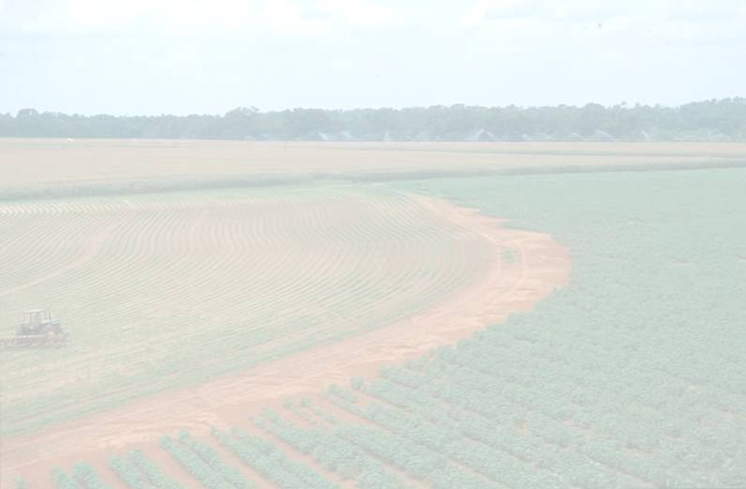
South Carolina Department of Agriculture

2002-2003 Accountability Report

Accountability Report Transmittal Form

Agency Name: South Carolina Department of Agriculture

Date of Submission: September 15, 2003

Agency Director: Commissioner Charles Sharpe

Agency Contact Person: Clarissa Adams

Agency Contact’s Telephone Number: 803-734-2196

South Carolina Department of Agriculture
I. Executive Summary

The South Carolina Department of Agriculture (SCDA) is charged with overseeing the state’s second largest industry: agriculture. While the SCDA serves all the people of the state, the agency also serves approximately 24,500 farms with cash receipts for crops and livestock totaling $1.7 billion. That agricultural base creates a ripple effect of about $7 billion in addition to generating revenue, taxes, and jobs, particularly for the rural communities of the state. Add to that the food and fiber agribusiness sector, and the industry of agriculture in South Carolina is a valuable part of the state’s economy. Nationally, South Carolina ranks near the top in the production of several agricultural products.

The SCDA, a relatively small agency with a $5.2 million budget, has very large responsibilities to both producers and consumers regarding agricultural products, both fresh and processed. The SCDA is dedicated to promoting and heightening the public’s awareness of South Carolina’s agriculture commodities and the farmers who produce them.
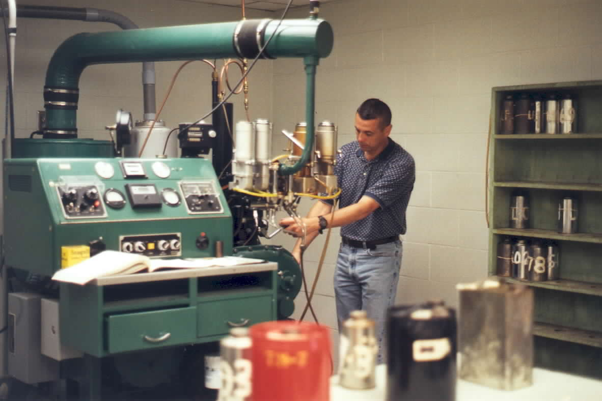
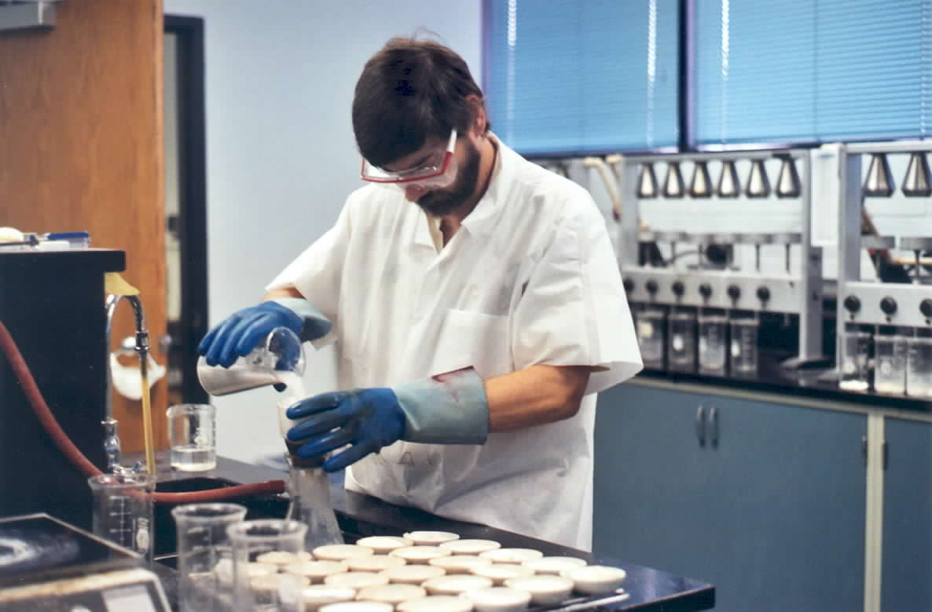
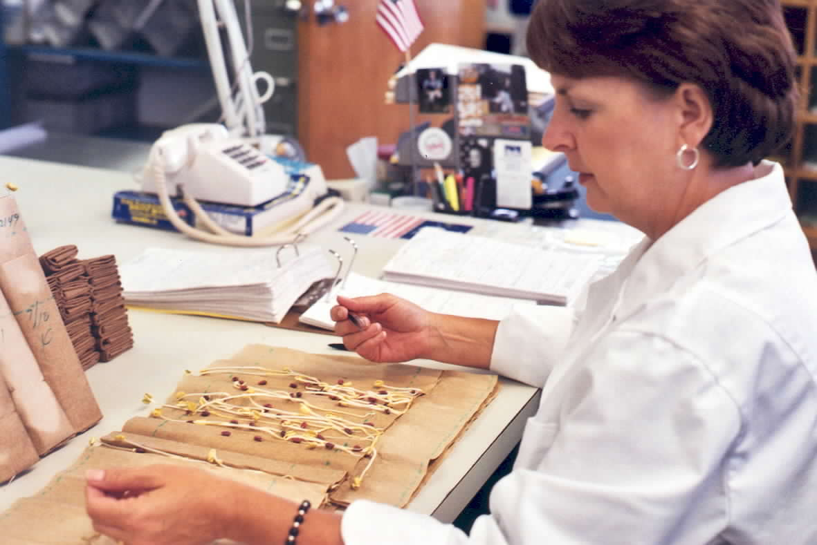

I.1 Mission and Values

The department’s mission is to promote and regulate the growth and development of the state’s agriculture industry and its related businesses while assuring the safety and security of the buying public. Our shared vision is for the state’s economy to grow and prosper providing everyone, producers and consumers, opportunities to enjoy the fruits of agriculture.

1.2 Strategic Goals

The agency’s key strategic goals include:
- Promoting agriculture and agribusiness in the state by providing agricultural marketing assistance
- Maximizing protection of producers and consumers
- Providing public awareness, promotion, and publicity of South Carolina agricultural products
- Effectively managing agency operations and a diverse work force

This year, an emphasis was placed on the development of a new strategic plan. Strategies were also developed for each key goal.

I.3 Opportunities and Barriers

The agency’s opportunities have been abundant despite significant barriers. Under the leadership of the new Commissioner of Agriculture, Charles Sharpe, all areas of the department were examined for efficiency and effectiveness. As a result, a new mission statement, vision, and strategic plan were developed to meet the agency’s new goals and objectives. After program evaluation, the agency was ultimately reorganized.

Agriculture is the state’s second largest industry. Marketing funds could significantly improve the state’s economy; however, lack of funding has prohibited developing the industry to its fullest potential. The most significant barrier has been that the agency sustained three significant budget reductions. The SCDA is currently operating at funding levels that date back to 1985.

- FY1985 State Budget $5,434,498
- FY2003 State Budget $5,200,870

Voluntary Retirement Incentive and Voluntary Separation Incentive Programs were implemented during the fiscal year. In addition, employees throughout the agency voluntarily furloughed a total of approximately 76 days. While the incentives and furloughs resulted in savings to the agency, work requirements remained at the same level of demand.
Although authorized, the SCDA has been unable to fill 21% of its work force due to severe budget limitations. Despite funding levels that date back almost twenty years, the agency has managed to continue to offer quality services to producers and consumers. While the level of service has remained high, staffing shortages and budget reductions have forced reductions in service.

The loss of key personnel and funds has forced employees throughout the department to assume additional responsibilities. Many employees work overtime. Employees however, continuously strive to perform at a high competency rate. As a result, the Commissioner has placed an emphasis on morale in the workforce.

I.4 Major Achievements

Major Accomplishments include:

- Complete review of the agency’s operations

- New mission statement, vision, and strategic plan

- Use of zero base budget methodology to review program expenses and projection of program needs

- Increase in agribusiness; such as assisting in recruiting of biotech companies and recent reopening of soybean plant

- Special emphasis in promotion and development of specialty crops

- Revamped agency website to offer additional information to producers and consumers

- Registration and licensing forms available online for consumers

- New electronic leave system at no cost to the agency

- Review of personnel and succession planning

I.5 Accountability Report

The accountability report is an important tool in dealing with today’s challenges and in preparing for the future. A systematic approach is being developed for customer surveys in order to gather reliable measures.
II Business Overview

II.1 Number of Employees: 139.56 Filled FTE’s
37.69 Vacant FTE’s
177.25 Total FTE’s

II.2 Operation Locations

Capitol Complex, Wade Hampton Building
Metrology Laboratory, 237 Catawba Street, Columbia
Consumer Services Laboratory, 1101 Williams Street, Columbia
Columbia State Farmers Market
Greenville State Farmers Market
Pee Dee State Farmers Market

II.3 Appropriations/Expenditures Chart

Base Budget Expenditures and Appropriations

 | 01-02 Actual Expenditures |  | 02-03 Actual Expenditures |  | 03-04 Appropriations Act
Major Budget Categories | Total Funds | General Funds | Total Funds | General Funds | Total Funds | General Funds
Personal Service | $5,242,201 | $3,710,031 | $5,331,487 | $,3365,561 | $5,188,203 | $3,273,971
Other Operating | $3,726,311 | $1,286,316 | $3,464,374 | $1,157,345 | $5,095,501 | $782,742
Special Items | -0- | -0- | $ | $ | $ | $
Permanent Improvements | -0- | -0- | $ | $ | $ | $
Case Services | -0- | -0- | $ | $ | $ | $
Distrib.to Subdivisions | -0- | -0- | $ | $ | $ | $
Fringe Benefits | $1,542,905 | $1,096,601 | $1,594,831 | $1,057,272 | $1,664,264 | $1,144,157
Non-recurring | -0- | -0- | $ | $ | $ | $
Total | $10,511,417 | $6,092,948 | $10,390,692 | $5,580,178 | $11,947,968 | $5,200,870

Other Expenditures

Sources of Funds | 01-02 Actual Expenditures | 02-03 Actual Expenditures
Supplemental Bills | $ | $
Capital Reserve Funds | $ | $
Bonds | $ | $

Interim Budget Reductions

Total 01-02 Interim Budget Reduction | Total 02-03 Interim Budget Reduction
$276,874 | $866,281

II.4 Key Customer Segments

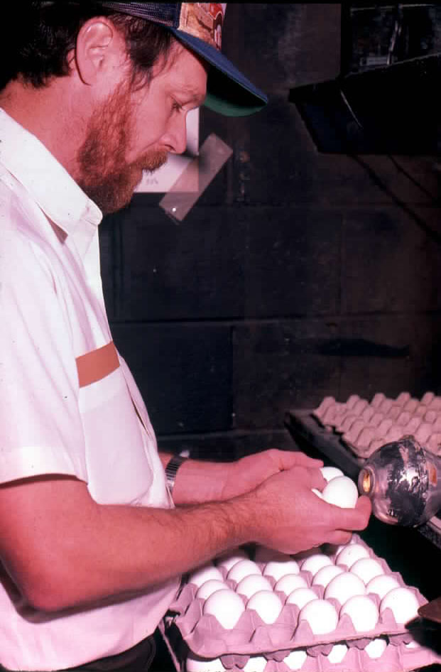
Key Customers include consumers, producers, farmers, processors, the General Assembly, the Governor’s Office, Agriculture Commission, Commodity Boards and Associations, existing agribusiness in the state, Government leaders in the state, agriculture community.

II.5 Key Stakeholders

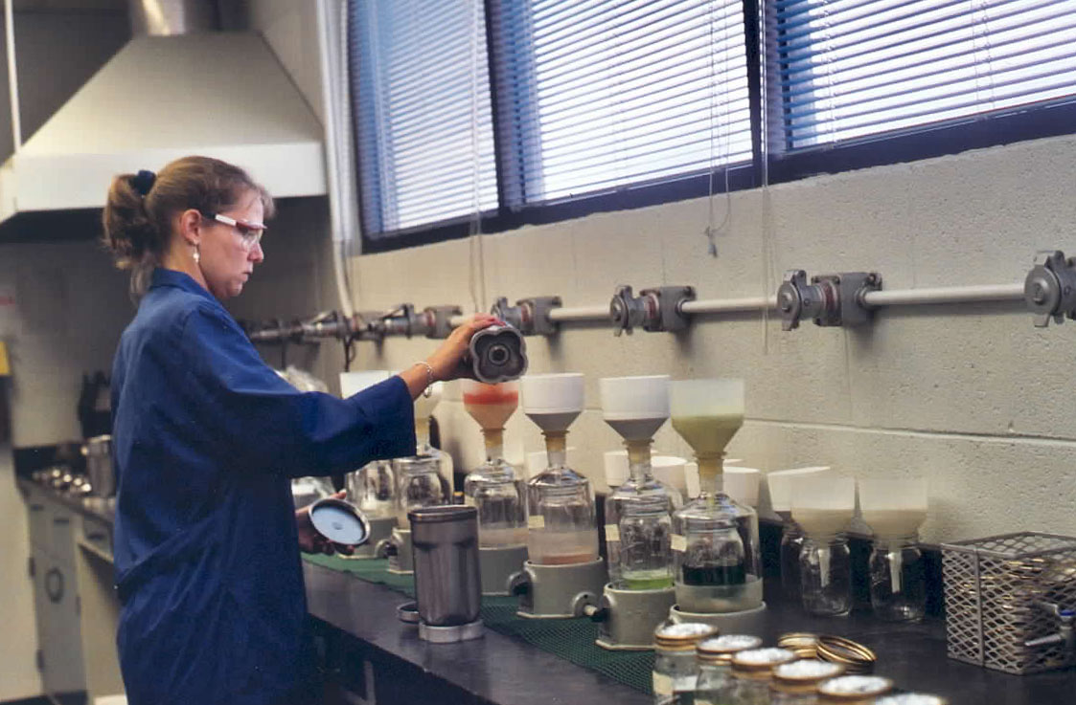
Consumers of South Carolina agriculture products are ultimately the key stakeholders.

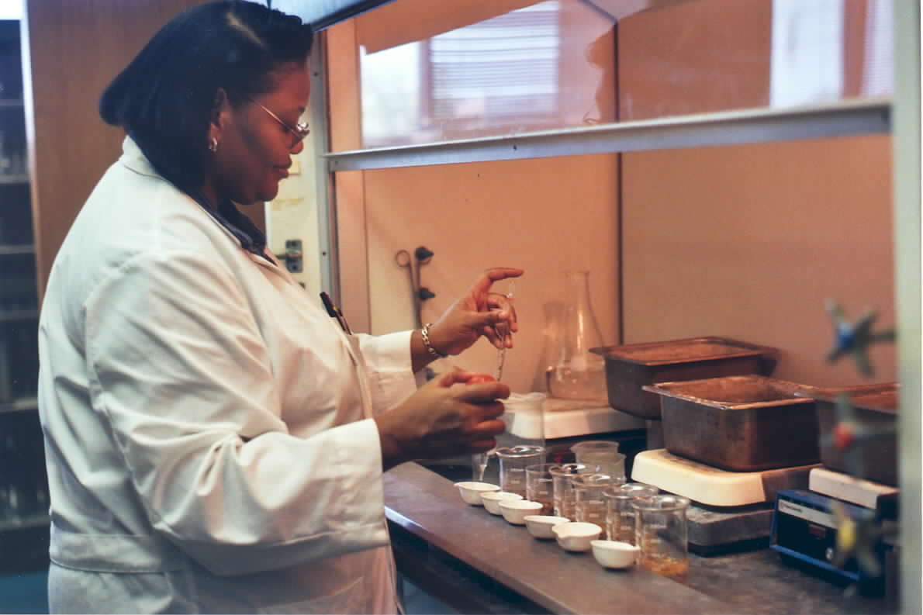

II.6 Key Suppliers

Producers, vendors eligible to bid on state contracts, technology vendors, Federal grant users, and the Federal government which supplies specialty crop grants and USDA cooperative agreements.

II.7 Organizational Structure

South Carolina Department of Agriculture

Organizational Chart

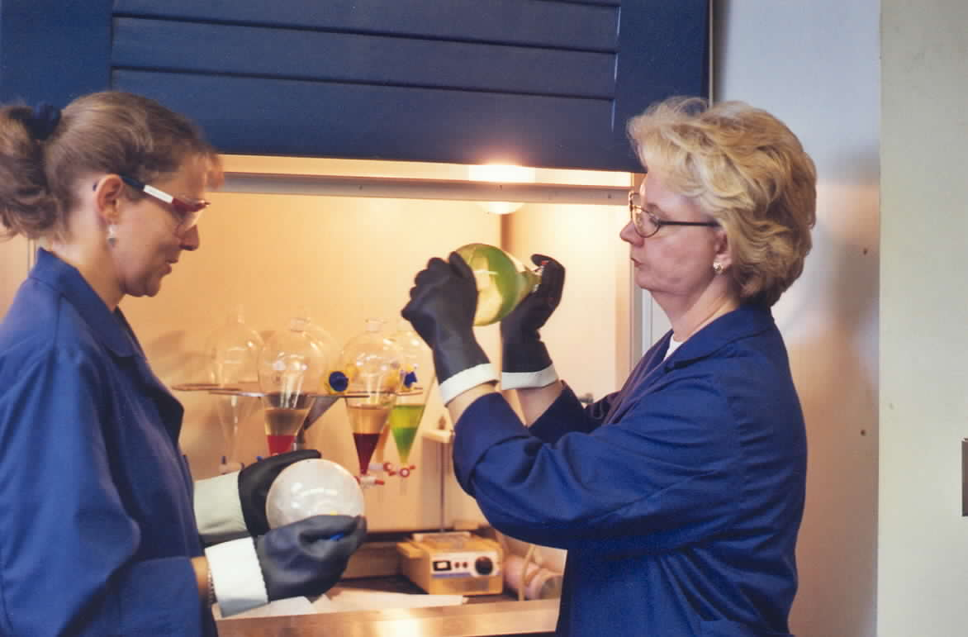

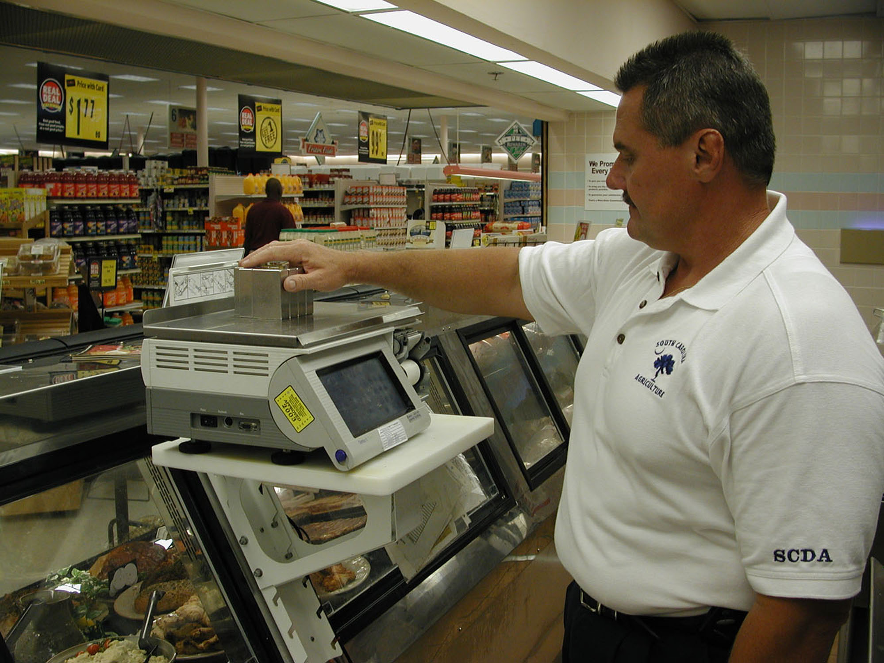

Elements of Malcolm Baldrige Award Criteria

III Category 1 – Leadership

1. 1. How do senior leaders set, deploy and communicate: a) short and long term direction, b) performance expectations, c) organizational values, d) empowerment and innovation, e) organizational and employee learning, and f) ethical behavior?

Senior Leadership at the Department of Agriculture begins with the Commissioner of Agriculture, Charles Sharpe. As a Constitutional Officer, taking office in January of 2003, many changes have taken place in an extremely short period of time.

A strategic plan was recently developed to assist with long-term direction for the agency. The new strategic plan will be communicated and will serve as a useful planning tool for the agency.

Since assuming office at the beginning of the calendar year, the Commissioner began meeting monthly with Division Directors to discuss short-term issues. The monthly senior staff meetings are very informative and provide an opportunity for the Department to continually assess progress. In addition, regular and frequent communication between senior leaders serves as an important part of senior leadership in this Department. Division Directors meet regularly with staff to keep employees apprised of agency issues.

The agency had its first electronic employee newsletter late in the fiscal year. The electronic newsletter includes a message from the Commissioner pertaining to agency issues and performance expectations. Additionally, the Commissioner has met with the entire staff on several occasions to discuss short and long term goals.

Performance expectations are relayed through annual evaluations. In addition, less formal communication occurs regularly between workers and their supervisors.

Senior leadership understands the importance of innovation with regards to the State’s second largest industry. Employees are empowered and encouraged to use initiative when performing their jobs. Additionally, professional development for staff is offered whenever feasible. Division managers and supervisors are active in professional organizations that foster their continued growth in knowledge and expertise in their fields of specialty. Lab scientists and supervisors and technicians are likewise encouraged and supported in outside professional activities that contribute to their growth and professional competence.

1. 2. How do senior leaders establish and promote a focus on customers?

Customer focus is a key component of the agency’s strategic plan. Every South Carolinian is, in some way, a customer and stakeholder of agriculture. With such a broad spectrum of customers and stakeholders, the agency’s daily operations result in a focus on our ultimate customer. Senior leadership and staff continuously assist consumers with agribusiness, product testing, and inspections to provide reasonable assurances for the consumer.

1. 3. What key performance measures are regularly reviewed by your senior leaders?

- Tests on feeds, seeds, foods, cosmetic and petroleum products to assure product safety

- Partnerships with stakeholders to promote agriculture in South Carolina

- Buying and selling of the State’s agricultural commodities both fresh and processed

- Food sanitation inspections at locations under SCDA regulatory authority

- Growth and development of the State Farmers Markets

1. 4. How do senior leaders use organizational performance review findings and employee feedback to improve their own leadership effectiveness and the effectiveness of management throughout the organization?

Senior staff meetings and division staff meetings provide a forum for informal, yet meaningful employee feedback. This information is useful in identifying areas for organizational improvement.

1. 5. How does the organization address the current and potential impact on the public of its products, programs, services, facilities and operations, including associated risks?

The agency receives excellent feedback on programs and services from the agriculture community and Commodity Boards and Associations. Testing and inspection error rates provide vital information concerning safety and risk to consumers.

1. 6. How does senior leadership set and communicate key organizational priorities for improvement?

Senior leaders set short-term priorities based on the agency’s strategic plan. Organizational priorities are communicated regularly from the Commissioner to senior staff throughout the year during regular scheduled meetings.

1. 7. How does senior leadership and the agency actively support and strengthen the community? Include how you identify and determine areas of emphasis.

Community volunteerism and giving back to the community is encouraged at the Department of Agriculture. The agency participates in charitable giving primarily through fund raising events such as the United Way. The agency has great interest in Harvest Hope and the Red Cross. The agency had a food drive and also routinely coordinates blood drives at two locations. Educational tours are also available at the State Farmers Markets. Senior leadership serves on many Boards for various organizations throughout the community. Additionally, the Commodity Boards sponsor programs with organizations such as the Girl Scouts.

III Category 2 – Strategic Planning

2. 1. What is your Strategic Planning process, including participants, and how does it account for:
* Customer needs and expectations
* Financial, societal and other risks
* Human resource capabilities and needs
* Operational capabilities and needs
* Supplies/contractor/partner capabilities and needs

Senior Leaders began to develop a new strategic plan. Division directors met to discuss the future, to identify the agency’s customers, to determine the purpose and goal of strategic planning, and to develop measurements for success.

Department budgets are submitted outlining the divisions’ needs to meet agency goals. Budgets, including human resource and operational needs, are summarized for the Commissioner. Items are prioritized due to budget limitations and the budget is implemented for the year.

2. 2. How do you develop and track action plans that address your key strategic objectives?

The new strategic plan will be monitored to ensure programs and activities are aligned with long-term and short-term goals. Progress will be tracked to measure success.

2. 3. How do you communicate and deploy your strategic objectives, action plans and performance measures?

The strategic plan is communicated from senior leadership.

2. 4. What are your key strategic objectives?

- Promoting agriculture and agribusiness in the state by providing agricultural marketing assistance
- Maximizing protection of producers and consumers
- Providing public awareness, promotion, and publicity of South Carolina agricultural products
- Effectively managing agency operations and a diverse work force

2. 5. If the agency’s strategic plan is available to the public through the agency’s internet homepage, please provide an address for that plan on the website.

III Category 3 – Customer Focus

3. 1. How do you determine who your customers are and what their key requirements are?

State laws and regulations help determine the agency’s customers. In South Carolina there are approximately 24,500 farms, and numerous producers and processors. Consumers of South Carolina agriculture products are ultimately the key customers.

Other key customers include the General Assembly, the Governors Office, Agriculture Commission, Commodity Boards and Associations, existing agribusiness in the state, Government leaders in the state, and the agriculture community.

Requirements from customers include:
- Assurance that agricultural products offered for sale to the public are honestly represented and meet quality standards.
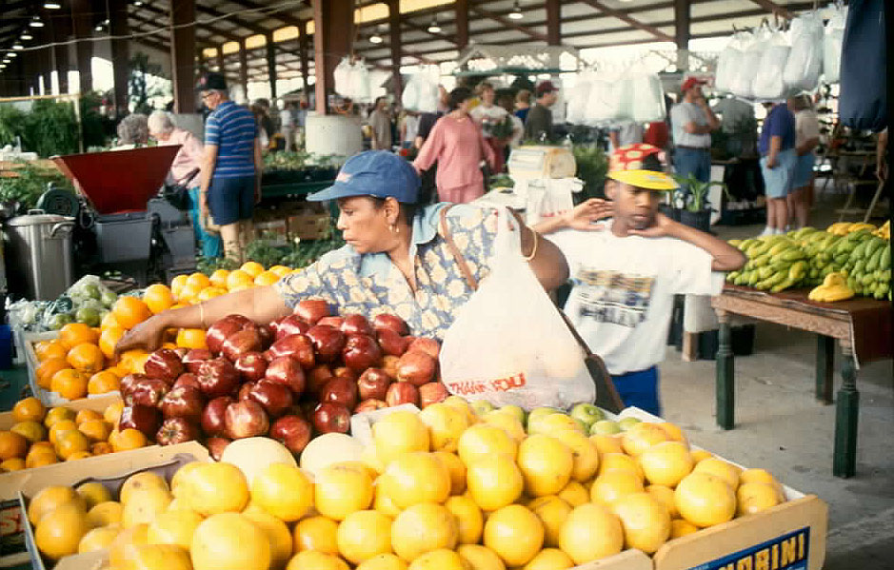
- Assurance of a fair and honest market place where consumers are afforded protection from fraud or unsafe products
- Accurate measurement affects where some commodity is bought or sold.

3. 2. How do you keep your listening and learning methods current with changing customer/business needs?

The agency continually seeks input from farmers and processors on how to improve processes. The agency’s website was redesigned to provide current
information about agriculture and is monitored to determine number of visits to the site. Legislative issues are currently being reviewed and updated to address current and future agricultural concerns.
3. 3. How do you use information from customers/stakeholders to improve services or programs?

A high priority is placed on complaints and requests received from consumers regarding product quality. Complaints are used as one source of data to determine customer satisfaction.

3. 4. How do you measure customer/stakeholder satisfaction?

Customer satisfaction is measured or inferred through meetings/feedback with customers, and through complaint resolution efforts. Ongoing communication provides feedback on how customers’ requirements and expectations can best be filled.

3. 5. How do you build positive relationships with customers and stakeholders? Indicate any key distinctions between different customer groups.

Positive relationships are built with production customers dealing with their programs of interest. Trade show participation, certified Road-Side Markets, shippers’ guide participation, and other general marketing program numbers help gauge success.

Consumer customers recognize “Quality” label and the utilization of local product signage. Employees attend various functions at all levels of participation to assist with building positive relationships. Continuity of employees in key positions also builds a feeling of confidence as we promote South Carolina products.

Production customers travel with employees and make marketing visits to increase marketing presence. Assisting with Boards and Associations in developing programs designed especially for production activities builds positive relationships. Factual information is also supplied for decision processes that affect the survival of individual operations.

The Market Bulletin is published twice a month for producers and consumers as a resource for buying and selling agricultural and agricultural-related items as well as a resource for valuable information.

III Category 4 – Information and Analysis

4. 1. How do you decide which operations, processes and systems to measure?

In developing the strategic plan, measurement criteria was evaluated for the entire agency. Each major program area within the agency is developing performance measures. Senior leadership and staff recognize the importance of service and customer satisfaction.

4. 2. How do you ensure data quality, reliability, completeness and availability for decision making?

The agency benchmarks to the private sector and other State Agriculture Departments whenever possible. Many programs are subject to audit to ensure financial effectiveness and procedure compliance.

4. 3. How do you use data/information analysis to provide effective support for decision making?

Data analysis is used in a number of ways to support effective decision making and assess performance.

- Comparative data and trends are evaluated to determine demand levels, cost returns and operational effectiveness.
- The volatile market can utilize data information while staying abreast of immediate situations.
- Volume pricing, demand trends, and historical weather information relating to local seasonal applications is vital for decision making.
- Negative trends are reviewed by senior management on a regular basis for corrective action.

4. 4. How do you select and use comparative data and information?

Comparative data is selected based on benchmarks relevant to the agency’s mission. Participation in national organizations such as the National Association of State Departments of Agriculture, Southern Association of State Departments of Agriculture and Southern United States Trade Association also provide information for comparison purposes.

III Category 5 – Human Resources

5. 1. How do you and your managers/supervisors encourage and motivate employees (formally and/or informally) to develop and utilize their full potential?

Despite severe budget limitations, the Commissioner has placed great emphasis on motivating employees. Programs were reviewed and the agency underwent a reorganization to maximize employees’ full potential.

The agency also accommodated employee requests to participate in the Voluntary Furlough program in order to attend to personal needs. The employees took a total of 76 days for the fiscal year.

Employees were also recognized several times during the fiscal year. The agency had an employee luncheon at the beginning of the calendar year and an ice cream social during Employee Appreciation Week. In late spring, the agency had its first family picnic. Service pins and awards were presented to employees at this time.

The agency also routinely publishes an electronic newsletter and posts information via E-mail regarding agency issues.

5. 2. How do you identify and address key developmental and training needs, including job skills training, performance excellence training, diversity training, management/leadership development, new employee orientation and safety training?

The agency attempts to coordinate quality training within the varying technical fields of expertise. Staff is active in professional and scientific organizations that foster continued growth and expertise in their fields of specialty. Staff are also encouraged and supported in outside professional activities that contribute to their growth and professional competence

5. 3. How does your employee performance management system, including feedback to and from employees, support high performance?

The agency’s EPMS system is based on annual reviews. Currently employee’s position descriptions are being reviewed for changes and plans include new planning stages for the December 1st Universal Review Date. Throughout the evaluation period, employees are encouraged to communicate issues, solve problems and make continuous improvements. Communication is the most vital form of feedback in improving performance.

5. 4. What formal and/or informal assessment methods and measures do you use to determine employee well being, satisfaction, and motivation?

Performance evaluations and staff meetings provide excellent opportunities to discuss employee needs and help determine employee well being and satisfaction.

The agency adopted an electronic leave system eliminating paperwork and thereby providing a wealth of information to assist supervisors.

The Commissioner began informal quarterly sessions with staff at the agency’s various locations to gather feedback from employees and garner camaraderie within staff. The Commissioner’s most recent session included hosting a hot dog cookout.

5. 5. How do you maintain a safe and healthy work environment?

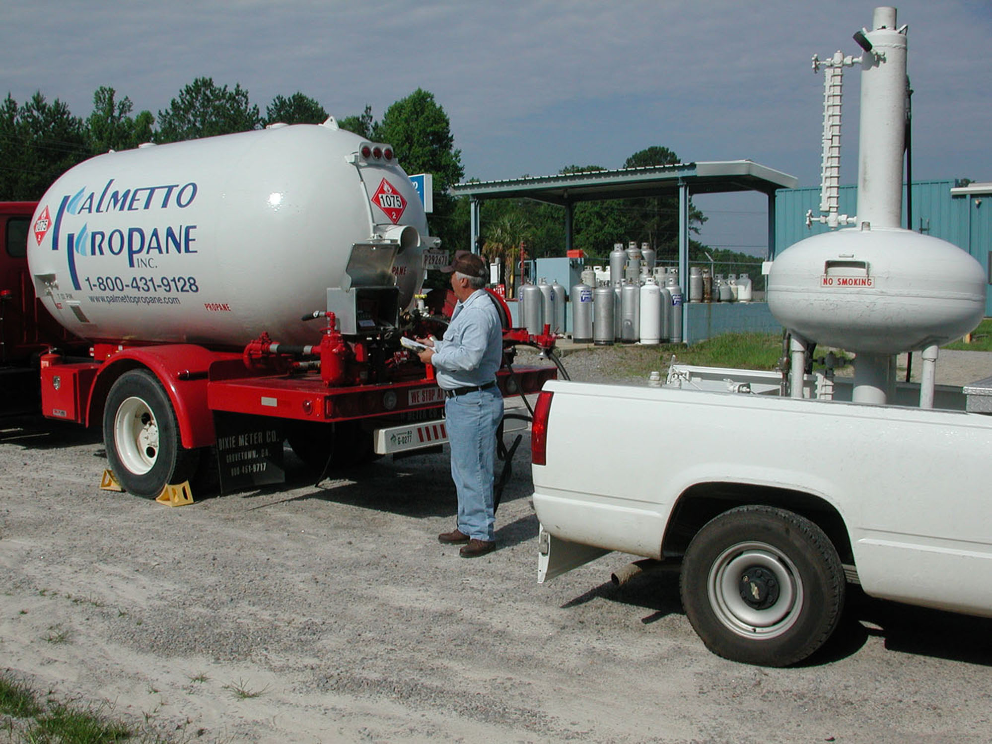
Safety is a high priority to the Department of Agriculture. The laboratories conduct regular safety meetings and training sessions. As a result of the September 11, 2001 terrorist attack, the agency is also an active participant in the Bioterrorism Advisory Committee, and Agroterrorrism Subcommittee. The agency also participates in the evacuation plan spearheaded by the Budget and Control Board.

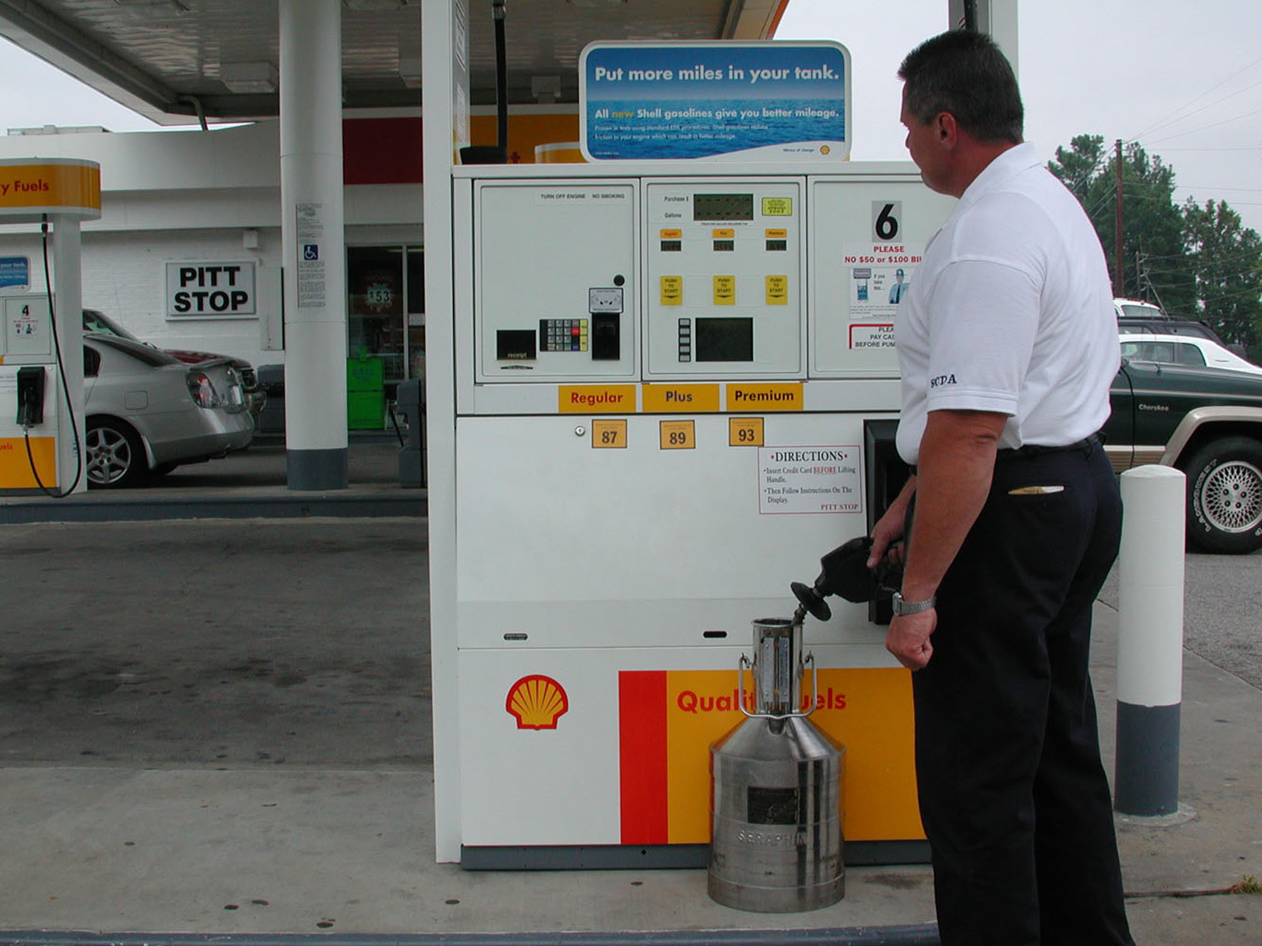

Information regarding health issues is distributed electronically on a regular basis to staff. Employees frequently participate in programs offered by Prevention Partners such as diabetes education and health screening.

5. 6. What is the extent of your involvement in the community?

Staff participates in a number of fund-raising activities such as United Way and Community Health Charities.

The agency also has a plethora of involvement in the community. The agency is filled with Sunday school teachers and leaders, coaches for youth sports, contributors for food drives, counselors, Board members, volunteers at the Town Theater, and many other organizations.

III Category 6 – Process Management

6. 1. What are your key design and delivery processes (including such activities as needs assessments and efforts at continuous improvement) for products/services, and how do you incorporate new technology, changing customer and mission-related requirements, into these design and delivery processes and systems?

As policies and procedures are developed, standardization and communication have become of utmost importance. Technology has also become an integral part in meeting the agency’s mission.

When developing a program or service, problems are identified and solutions are weighed to identify the best solution. If necessary, a small test is conducted prior to putting the plan into action. Development as outlined, often take place during meetings with senior leadership.

Follow up evaluation is conducted to make any necessary adjustments.

6. 2. How does your day-to-day operation of key production/delivery processes ensure meeting key performance requirements?

Communication is essential to stay abreast of new developments and to ensure information needs are met.

6. 3. What are your key support processes, and how do you improve and update these processes to achieve better performance?

Key support processes include Administration, Information Technology, Human Resources, Procurement, Finance, Budget, Legislative Services, and Legal Counsel. These areas are designed to assist the agency’s major programs by providing a qualified work force, funding to support the mission, timely technology, and input regarding legislation and regulations.

With a shrinking work force, technology is a critical component in improving agency performance.

6. 4. How do you manage and support your key supplier/contractor/partner interactions and processes to improve performance?

The agency works collaboratively with producers and processors to help ensure consumers receive the best possible product. While regulatory requirements are designed to help protect the consumer, the agency works closely with agribusiness and other State and Federal agencies not only to enhance partnerships but to maximize South Carolina quality products.

III Category 7 – Business Results

The SCDA is comprised of three major areas and one minor area of programs and services:

Program: Laboratory Services

The SCDA is charged with a broad range of consumer protection regulatory responsibilities regarding production, storage, handling, transport and sale of food for human consumption. Assurance of quality and safety of food products from process facilities to marketplace involves chemical, physical, and biological testing of products.

Responsibilities extend beyond food products, to include regulating animal feeds and seeds sold for agriculture and gardening, inspecting commercial weighing and measuring devices, and testing petroleum products sold for heating and automotive uses across the state. In addition, the SCDA administers product registration and conducts routine inspections for items such as animal and pet foods, antifreeze, frozen desserts, and cosmetic products. Permits are also issued for special services and businesses.

The objectives of Laboratory Division programs are:

To receive samples and analyze products from the public food supply to detect adulteration, confirm conformance to standards of identity and quality and assure consumers are protected from fraudulent or unsafe food products.

To regularly sample commercial animal feed and pet foods from the state’s markets for analysis of nutritional and medicinal ingredients for conformance to label guarantees and standards of quality.

To provide seed analysis services to consumers, certifying agencies, seed companies, seed producers, and in support of regulatory surveillance and enforcement under the state’s Seed and Noxious Weed Law.

To regularly receive samples of gasoline, diesel fuel, kerosene, and heating fuel from channels of commerce and test them for conformance to quality standards, label representations and safety.

To administer product registrations required by law including animal and pet foods, frozen desserts, gasoline, antifreeze, and to issue licenses and permits to certain special services and businesses. Licenses or permits are issued for frozen desserts, butterfat testers, samplers and weighers and salvagers.

Laboratory Services division includes:

- Seed
- Pesticide
- Food
- Feed
- Petroleum
- Seed Licensing
- Food & Safety Council
- Product Registration

Enabling Legislation: Seed and Noxious Weed Law
Commercial Feed Act

Meeting the objectives represents a considerable volume of laboratory effort as is reflected below in Tables I and II.

TABLE I. DIVISION WORKLOAD BY YEAR

98/99 99/00 00/01 01/02 02/03

Food Samples 3,627 3,644 3,526 3,654 4,143
Animal Feed Samples 1,710 1,406 1,694 1,953 1,993
Seed Samples 15,600 18,691 14,252 14,413 16,423
Petroleum Samples 2,720 2,137 1,518 2,918 2,854
Registration Transactions 3,627 3,096 2,765 3,654 2,681

TABLE II. NUMBER OF ANALYSES PERFORMED BY YEAR

98/99 99/00 00/01 01/02 02/03

Food Analyses 12,429 13,382 12,623 11,029 10,383
Feed Analyses 5,714 4,767 4,405 5,804 5,445
Seed Analyses 24,009 26,709 23,695 23,199 22,824
Petroleum Analyses 9,780 12,710 9,976 19,869 16,647

Year to year fluctuations in samples analyzed and numbers of analyses performed are more or less random for foods, feeds and seeds. Petroleum product samples and analyses were down some from a year earlier. Factors contributing to this were a month of down time with instrument problems, introduction of a new octane analyzer which had to be calibrated against the existing octane measuring machines and the loss of a technician which left only one person to keep the Petroleum Lab up and running. In spite of these problems the Petroleum Lab maintained a remarkable level of productivity.

The efficiency of the Laboratory Division’s testing and analytical effort is reflected in the per sample and per analysis cost to produce work results. These costs have been computed for each section of the laboratory and are elaborated on below:

Registration Office
Registration Office transactions averaged a cost of $23.23 per transaction. This is a 23% increase over the prior year. The increase occurred because transactions were down in number by 36% spreading the costs over a smaller volume of work.

Food and Pesticide Residue Lab
Food sample costs in FY 03 were $110.81 per sample and $30.84 per analysis. These figures are down by 1% per sample and 3% per analysis respectively from FY 02.

Feed Laboratory
Feed sample work was performed in FY 03 at a cost of $166.31 per sample and $54.17 per analysis. These figures improved by 15% on a per sample basis and 19% per analyses over a year earlier.

Seed Lab
Seed analyses were performed in FY 03 for a cost of $31.60 per sample and $22.74 per analysis. These figures are down from a year earlier by 24% per sample and 7% per analysis respectively. The decreases are at least partly attributable to Seed Lab staff reductions spreading the workload over a smaller workforce.

Petroleum Lab
Petroleum Lab work was performed in FY 03 at a per sample cost of $40.04 and per analysis cost of $6.18. These numbers represent cost efficiency improvements of 92% per sample and 38% per analysis. The lower costs reflect a relatively constant workload being managed by a 50% smaller staff. This is probably not sustainable in the future since understaffing the Petroleum Lab raises concerns over safety.

The outcome of the Laboratory Division’s work can be assessed by reviewing the record of compliance in each of the program areas. Table III presents such information in violation rates recorded by year.

TABLE III. VIOLATION RATES FOUND BY PROGRAM OVER 5 YEARS

PROGRAM FY 99 FY 00 FY 01 FY 02 FY 03

Food 11.6% 12.0% 10.7% 5.2% 7.7%
Pesticide Residue 1.8 1.6 2.4 3.2 1.2
Feed 27.0 21.0 20.8 10.8 15.3
Seed 14.3 13.6 7.9 4.5 6.0
Petroleum 2.4 6.2 5.2 2.5 1.9

The food program violation rate, at 7.7%, continued the trend started last year of moderately lower violations detected. This may reflect the better record of ground meat products avoiding excess fat values. It will be worth continuing to watch this particular violation frequency.

Pesticide residue violations are mostly technical in nature and do not represent a significant food safety threat. It is rare that these technical violations necessitate any enforcement action. The pattern of pesticide residue violations observed in our laboratory mirrors the pattern of violations found nationwide in USDA’s “Pesticide Data Program”.

Animal feed violations run around 20% fairly consistently over the years. Last year’s rate of 15.3% shows a return to numbers closer to historical figures of around 20%. The slightly lower figures of 10.8 and 15.3% in the past two years are simple random variations within the normal range of 15 to 25% seen over many years.

Seed Law violations were down for a second straight year at 6% compared to the five year average of 9.3%. This is possibly a continuing reflection of improved quality assurance by seed merchants as more marginal operations leave the business and the tightly controlled genetically modified seeds continue to capture more market.

Petroleum violations were again low for FY 03 at 1.9% or about the average for the past five years. This is consistent with petroleum law compliance rates observed nationally. Only in jurisdictions which still do not have a petroleum law covering engine fuels are products frequently found out of compliance with the ASTM standards usually adopted by state petroleum laws. Based on compliance rates found here in South Carolina consumers can be confident that petroleum products they purchase in the state are of good quality and truthfully labeled.

Program: Consumer Services

Consumer Services division includes:

- Petroleum
- Food
- Feed
- Scale Inspectors
- Grain Inspectors
- Food & Cosmetology
- Audit
- Heavy Duty Scales
- Metrology Laboratory

Enabling Legislation: Weights and Measures Law
Dealers and Handlers of Agricultural Products Law
Grain Producers Guaranty Fund Law
Dealers and Handlers Guaranty Fund Law
State Warehouse System Law
Food and Cosmetic Act
Gasoline, Lubricating Oils, & Other Petroleum Products Act

Number of Firms and Devices Inspected under Weights and Measures Law
Number of Official Samples Drawn for Laboratory Division
Number of Standards Calibrated by Metrology Lab
Per Fiscal Year

Percentage of Weighing and Measuring Devices Found Incorrect
Percentage of Packages Incorrectly Labeled as to Net Content
Per Fiscal Year

Number of Food Manufacturers and Food Warehouses Inspected
Number of Licensed Public Weighmasters
Per Fiscal Year

Number of Licensed Dealers and Handlers of Agricultural Products
Number of Licensed Warehouses for the Storage of Cotton or Grain
Number of Audits of Licensed Dealers and Handlers and Warehouses
Per Fiscal Year

Program: Marketing and Promotions

The South Carolina Department of Agriculture is charged with the responsibility of maintaining and developing broad based marketing programs to increase consumer awareness and product demand for quality South Carolina agricultural commodities at local, national and international levels. The South Carolina Department of Agriculture also encourages expansion and development of existing industries that utilize South Carolina agricultural commodities, both fresh and processed, thereby increasing the marketability of locally grown products. In support of our marketing program, our inspection and market news programs provide quality grade standards and up-to-date firsthand market news through a cooperative status with USDA to the allied industry.

Market Service divisions include

- State Farmers Markets
- Export or International Products
- National Products
- Fruit & Vegetable Grading & Inspection
- Grain Grading & Inspection
- Poultry & Egg Grading & Inspections
- SC Quality Program
- Commodity Boards
- Roadside Markets
- Livestock Market News
- Fruit & Vegetable Market News
- Home Economics
- Horticulture
- Aquaculture
- Equine

Enabling Legislation: Agricultural Commodities Marketing Act
General Agricultural Marketing Law
Local Marketing and Roadside Law

State Farmers Markets

The SCDA operates State Farmers Markets in Columbia, Greenville and Florence. The Markets provide facilities for farmers to conduct direct sales of fresh produce to both consumers and major food distributors. The Markets serve as food distribution hubs. In addition, produce is shipped directly to grocery chains, restaurants, and industrial food handlers. The service area of the Markets extends beyond the boundary of the state, supplying produce throughout the eastern United States and Canada.

The Columbia and Greenville State Farmers Markets operate 24 hours a day, closing only on Thanksgiving and Christmas days. The Columbia Market is the second largest Farmers Market in the Southeast in volume of produce, next only to Atlanta. A source of fresh, locally produced fruits and vegetables, the markets are also major venues for the sale and distribution of horticultural products that draw consumers from a broad geographic area.

Columbia State Farmers Market:

This facility is the largest and most complex of the three markets. Of the eighteen people employed at this market, six are part-time. It operates 24-hours a day for wholesale operations. The only days it is closed are Christmas Day and Thanksgiving Day.

The market provides facilities for daily sales by farmers; monthly or seasonal leases to farmers, wholesalers and retailers; and long-term leases to farmers, wholesalers, retailers, restaurants, and food processors. Numerous private sector jobs are supplied at the facility, though many are seasonal in nature.

Market revenue is generated by long and short-term leases, gate fees, and daily stall rental. Additional revenue is received from parking for football games. Revenue has been increased by raising rates. All facilities that are suitable for year-round operations are leased. Seasonal income is dependent on the size of the state’s agricultural production of produce.

The Columbia Market is in need of significant repairs and improvement. Most of the buildings and sheds were constructed in the 1950’s, and are in dire need of replacement. Major structural repairs are needed; however, revenues are not sufficient to cover projected costs. Additionally, the uncertainty of whether or not the market will be relocated makes it difficult to justify long-term investments. Tenants are also unwilling to make investments due to the uncertainty.

Columbia:

 | Revenues | Disbursements
FY 00-01 | $ 981,945.39 | $1,106,610.57
FY 01-02 | $1,262,761.85 | $1,093,575.41
FY 02-03 | $1,278,688.30 | $1,225,865.54

Greenville State Farmers Market:

Wholesale operations predominate at the Greenville Farmers Market. The facility provides the same services as the Columbia market, but on a smaller scale. This market also operates seven days a week on a year-round basis. It closes on Christmas and Thanksgiving days. A staff of six people operate the market; three are part-time and needed to control access during nights and weekends.

A private poultry processing plant is located within the facility, but not on market property. Access to the plant is through the market. There are several problems associated with having this facility in such close proximity to a produce market.

Many of the structures are old and in need of substantial investments to bring up to present day standards. Numerous repairs have been deferred due to insufficient revenue. Improvements are needed to ensure present day standards are being met by food handlers.

Greenville:

 | Revenues | Disbursements
FY 00-01 | $138,350.18 | $126,456.44
FY 01-02 | $148,162.18 | $133,263.55
FY 02-03 | $151,117.00 | $142,411.92

Pee Dee Farmers Market (located at Florence):

This market provides space for daily sales by farmers and long-term leases to wholesale and retail operations. It has become a major venue of the sale of horticultural products and draws consumers from a broad geographic area. Spring and fall plant and flower festivals are a main draw for the market, and help promote year-round business at the market. It is operated by a staff of five, with only one being part-time. The market is closed on Sundays and at night.

The only warehouse building at the market is leased to the Harvest Hope Food Bank. They operate a regional distribution center from the building. It provides a needed service that provides surplus food products to people in need.

During the spring and summer months the stall space at the market is fully utilized. There is a waiting list for space in the event it becomes available. There is a definite need for an additional farmer shed at the market. Market revenues are stable, but the lack of additional space limits the possibilities of increasing revenues. Adequate space for expansion exists on this market.

Pee Dee:

 | Revenues | Disbursements
FY 00-01 | $164,382.55 | $173,801.96
FY 01-02 | $173,971.67 | $170,948.11
FY 02-03 | $179,488.62 | $193,998.76

The performance level of the Marketing and Promotion Division is controlled by factors far beyond the realm of our state. Weather conditions, volume harvest, supply and demand are just a sample of factors that influence the performance of this Division.

It is true that all services offered are available in “bad” crop years as well as “good” crop years. Participation by the industry affects our ability to perform at a maximum level.

The Division suffered budget reductions last year thereby restricting activities in continuing consumer awareness campaigns regarding local products. We utilize various joint cooperatives and brokers to maintain as much awareness of local products as possible.

Listed below are the results and major programs.

Utilization and orderly marketing of 400 million plus pounds of South Carolina’s major fresh fruit and vegetable crops.

Maintained the level of awareness at consumer level in South Carolina retail and food service establishments.

Maintained consumer confidence in food channels, supporting healthy nutritional diets while removing fear of contaminated products, thereby increasing fresh and processed product consumption.

Continued exposure and high visibility of South Carolina specialty products, both fresh and processed, at all levels of retail and wholesale trade.

Established and maintained South Carolina growers as number two in peach production, number two in flue-cured tobacco production, number seven in tomato production, number eight in watermelon production, number eight in turkey production, number nine in peanut production, number twelve in cotton production, and number ten in pecan production.

Worked to stabilize decreasing numbers in fresh fruit and vegetable production industry with cooperative cost effective marketing plans, programs, and promotions.

International Market Development – Agricultural exports from South Carolina for 2001 estimated at 262.2 million dollars.

Certified Roadside/Direct Marketing – Serving 100 plus markets and direct sales outlets.

Domestic Market Development – Participated in seven National Exhibitions, various regional promotional exhibitions, contacted over 500 chain and food service buyer/establishments. Coordinated in-state visits for chain and food\service buyers with outlets numbering over 5,000.

Specialty Products – Assisted the 60 plus specialty product manufacturers and distributors through South Carolina trade shows and supplying trade leads.

Sheep, Goat, and Ratite Development and Expansion – Worked with individuals and groups to further develop and expand this industry to its maximum potential for South Carolina producers. Assisted with meetings that included producers, processors and food brokers to establish markets and market demand with profit potential.

S. C. Quality Program – A program to increase overall awareness of South Carolina products, working with 75 plus members and most chain food stores operating in South Carolina.

Equine Program – Served 50,000 owners with 100,000 plus animals that have an estimated economical impact on our economy of 350 million dollars. Also worked with the Horse Council’s membership of 1,500 plus.

Aquaculture – Coordinated activities of aquaculture and striped bass association with membership of 60 plus. Worked closely with legislative issues and national associations.

Home Economist/Nutritional Program – Worked with national 5 A Day Program, S. C. School Lunch Challenge, Farm City Week, DHEC and Harvest Hope Food Bank. Also through 125 plus television and radio spots promoted nutritional and healthy diet and lifestyles to all of South Carolina with over-laps into neighboring states.

Ornamental Horticulture Program – Worked with 800 plus members of the Nurserymen’s Association, green house growers, landscape, and turf and sod producers. This industry has sales at over 450 million dollars wholesale on an annual basis.

Agribusiness Support Services – Assisted over 100 established agri-business firms with marketing and production assistance. Also with packaging, transportation, and other aspects of business for profit and expansion within South Carolina.

Pecan Producers and Processors – Worked with three commercial processors and with South Carolina production of 1 million lbs.

S. C. Commodity Board Program – Assisted the present S. C. Commodity Boards with their collections, marketing, administrative, and other related duties to promote sales, usage and research for each.

Cotton Board: 130,000 bales on 190,000 harvested acres
Soybean Board: 7.1 million bushels harvested on 415,000 acres
Peanut Board: 19.1 million pounds harvested on 8,700 acres
Watermelon Board: 130 million pounds harvested on 9,300 acres
Pork Board: 250,000 hogs and pigs
Cattle and Beef Board: 430,000 cattle and calves
Tobacco Board: 59.5 million pounds on 30,500 acres

Major Agricultural Associations – Coordinated and worked closely with Chairmen and Association Boards with their administrative, marketing, financial guidance, and other related items.

S. C. Peach Council: Weather condition limited production to 130 million pounds on
16,000 harvested acres
S. C. Tomato Association: 84 million pounds on 3000 harvested acres
S. C. Watermelon Association: 130 million pounds on 9300 harvested acres
S. C. Corn Growers Association: 12.0 million bushels on 260,000 harvest acres
S. C. Soybean Association: 7.1 million bushels harvested on 415,000 harvested
acres
S. C. Horsemen’s Council: Worked with 1500 memberships and over 100,000
animals

Program: Administration

The Administration division includes:

- Executive Office
- Public Information
- Finance
- Information Technology
- Human Resources
- Budget
- Procurement
- Payroll
- Agribusiness
- WIC
- Senior Farmers Market Nutrition Program
- Small Farms
- Legal
- Market Bulletin
- Print Shop
- Media Relations

Agribusiness Development and Small Farms

The Department has expanded its role in rural development by utilizing the Commissioner’s position as a member of the Coordinating Council for Economic Development. Department staff take advantage of past working relationships with
the Department of Commerce to help attract and coordinate agribusiness related projects. The small farms program is improving relationships with DSS and DHEC to help coordinate nutrition programs. Results can be measured by the number of projects considered and the number of consumers served.

Enabling Legislation: General Duties & Authority of Commissioner & Department

$0
$1,000,000
$2,000,000
$3,000,000
$4,000,000
$5,000,000
$6,000,000
$7,000,000
FY 2000
FY 2001
FY 2002
FY 2003
FY 2004
Department of Agriculture

5 Year State Budget History

