Accountability Report Transmittal Form

Agency Name: Public Service Activities – Clemson University

Date of Submission: September 15, 2003

Agency Director: Dr. John W. Kelly

Agency Contact Person: Gary McMahan

Agency Contact’s Telephone Number: 864-646-0681

Accountability Report

Clemson University
Public Service Activities

2002-2003

Section I – Executive Summary
Section I-1 Mission and Values 1
Section I-2 Key Strategic Goals for Present and Future Years 1
Section I-3 Opportunities and barriers … 6
Section I-4 Major Achievements from Past Year … 8
Section I-5 How the Accountability Report is Used to Improve Organizational Performance 13
Section II – Business Overview
Section II-1 Number of Employees: 14
Section II-2 Operation Location: 14
(Figure II-1) 14
Section II-3 Expenditure/Appropriations Chart 15
(Chart Series II-1) 15
Section II-4 Key Customers 16
Section II-5 Key Suppliers 16
Section II-6 Major Products and Services 16
Section II-7 Organizational Structure 17
(Figure II-3) 17
Section III Elements of Malcolm Baldrige Award Criteria
Section III-1 Leadership 18
Section III-1-1 How do senior leaders set, deploy and communicate? 18
Section III-1-2 How do senior leaders establish and promote a focus on customers? 19
Section III-1-3 What key performance measures are regularly reviewed by your senior leaders? (Actual results are to be reported in Category 7). 19
Section III-1-4 How do senior leaders use organizational performance review findings and employee feedback to improve their own leadership effectiveness and the effectiveness of management throughout the organization? 19
(Graph III-1) 20
(Table III-1) 20
Section III-1-5 How does organization address the current and potential impact on the public of its products, programs, services, facilities and operations, including associated risks? 21
Section III-1-6 How does senior leadership set and communicate key organizational priorities for improvement? 21
Section III-1-7 How does senior leadership and the agency actively support and strengthen the community? . 21
Section III-2 Strategic Planning 22
Section III-3 Customer Focus 22
Section III-3-1 How do you determine who your customers are and what their key requirements are?. 22
Section III-3-2 How do you keep your listening and learning methods current with changing customer/busines needs? 23
Section III-3-3 How do you use information from customers/stakeholders to improve services or programs? 23
Section III-3-4 How do you measure customer/stakeholder satisfaction? 24
Section III-3-5 How do you build positive relationships with customers and stakeholders? Indicate any key distinctions between different customer groups. 24
Section III-4 Information and Analysis 25
Section III-4-1 How do you decide operations, processes and systems to measure? 25
Section III-4-2 How do you ensure data quality, reliability, completeness and availability for decision-making? 25
Section III-4-3 How do you use data/information analysis to provide effective support for decision-making? 26
Section III-4-4 How do you select and use comparative data and information? 26
Section III-5 Human Resources 26
Section III-5-1. How do you and your managers/supervisors encourage and motivate employees (formally and/or informally) to develop and utilize their full potential? 27
Section III-5-2. How do you identify and address key developmental and training needs, including job skills training, performance excellence training, diversity training, management/leadership development, new employee orientation and safety training? 27
Section III-5-3 How does your employee performance management system, including feedback to and from employees, support high performance? 28
Section III-5-4 What formal and/or informal assessment methods and measures do you use to determine employee well being, satisfaction, and motivation? 28
Section III-5-5. How do you maintain a safe and healthy work environment? 28
Section III-5-6. What is the extent of your involvement in the community? 29
Section III-6 Process Management 29
Section III-6-1 What are your key design and delivery processes for products/services, and how do you incorporate new technology, changing customer and mission-related requirements, into these design and delivery processes and systems? 29
Section III-6-2. How does your day-to-day operation of key production/delivery processes ensure meeting key performance requirements? 30
Section III-6-3. What are your key support processes, and how do you improve and update these processes to achieve better performance? 30
Section III-6-4. How do you manage and support your key supplier/contractor/partner interactions and processes to improve performance? 30
Section III-7 Business Results 31
Section III-7-1 What are your performance levels and trends for the key measures of customer satisfaction? 31
Section III-7-2 What are your performance levels and trends for the key measures of mission accomplishment? 31
Section III-7-3 What are your performance levels and trends for the key measures of employee satisfaction, involvement and development? 31
Section III-7-4 What are your performance levels and trends for the key measures of supplier/contractor/partner performance? 32
Section III-7-5 What are your performance levels and trends for the key measures of regulatory/legal compliance and citizenship? 32
Section III-7-6 What are your current levels and trends of financial performance? 32
Additional Accomplishments 33

Section
I-1

Mission and Values
Clemson University was founded in 1889 on one person's belief that education would create a better way of life for the people of South Carolina. Since its opening the institution has provided public service programs that help citizens, private enterprises and public agencies resolve their problems from day to day. As our state's education, research and information needs change over the years, the university welcomes the opportunity to address these changing needs. Exciting, new solutions are being developed to help South Carolinians face the challenges of today and prepare for the future. Within the divisions, departments, institutes, centers of our university and in every county of our state and across the world, Clemson's Public Service is fulfilling the founding mission through outreach efforts.
Section
I-2

Key Strategic Goals for Present and Future Years
For several years, the mission of Public Service Activities at Clemson is to focus our efforts around the following five goal areas: (1) Agrisystems Productivity and Accountability; (2) Economic and Community Development; (3) Environmental Conservation; (4) Food Safety and Nutrition; (5) Youth Development. These goal areas complement the university’s ten-year goals in the Southern Association of Colleges and Schools (SACS) assessment procedures and in the five-year plan of work, which is negotiated with the U.S. Department of Agriculture. All of the units within PSA have aligned their programming, funding, evaluation, and accountability functions around these five goal areas which are then aligned with the following goals of Clemson University, in the spirit of “One Clemson.”

Clemson University goals:
Academics, research and service
- Excel in teaching, at both the undergraduate and graduate levels.
- Increase research and sponsored programs to exceed $100 million a year in research support.
- Set the standard in public service for land-grant universities by engaging the whole campus in service and outreach, including a focus on strategic emphasis areas.
- Foster Clemson's academic reputation through strong academic programs, mission-oriented research and academic centers of excellence, relevant public service and highly regarded faculty and staff.
- Seek and cultivate areas where teaching, research and service overlap.

Campus life
- Strengthen our sense of community and increase our diversity.
- Recognize and appreciate Clemson's distinctiveness.
- Create greater awareness of international programs and increase activity in this area.
- Increase our focus on collaboration.
- Maintain an environment that is healthy, safe and attractive.

Student performance
- Attract more students who are ranked in the top 10 percent of their high school classes and who perform exceptionally well on the SAT/ACT.
- Promote high graduation rates through increasing freshman retention, meeting expectations of high achievers and providing support systems for all students.
- Promote excellence in advising.
- Increase the annual number of doctoral graduates to the level of a top-20 public research university.
- Improve the national competitiveness of graduate student admissions and financial aid.

Educational resources
- Campaign goal surpassed by 40 percent.
- Rededicate our energy and resources to improving the library.
- Increase faculty compensation to a level competitive with top-20 public universities.
- Increase academic expenditures per student to a level competitive with top-20 public universities.
- Manage enrollment to ensure the highest quality classroom experiences.
Clemson's national reputation
- Promote high integrity and professional demeanor among all members of the University community.
- Establish a Phi Beta Kappa chapter.
- Have at least two Clemson students win Rhodes Scholarships.
- Send student ensembles to perform at Carnegie Hall.
- Have at least two Clemson faculty win recognition by national academies.
- Publicize both national and international accomplishments of faculty, staff and students.
- While maintaining full compliance, achieve notable recognition with another national football championship, two championships in Olympic sports and two Final Four appearances in basketball.

A new initiative at Clemson University has just been implemented that will directly affect PSA. This new initiative is called Academic Plan. The foundation for Clemson’s Academic Plan is a call to focus our talents, energies, and resources on eight broad “emphasis areas” that foster collaboration and promote the integration of teaching, research, and service. Instead of marshalling all of our resources to departments and colleges, we will focus on programs that provide interdisciplinary research and service venues, unique platforms for enhanced scholarship, and increased opportunities for graduate and undergraduate students.
These new emphasis areas are as follows:
- Leadership and Entrepreneurship | - Automotive and Transportation Technology
- Information and Communication Technology | - General Education
- Family and Community Living | - Biotechnology and Biomedical Sciences
- Advanced Materials | - Sustainable Environment

Goal 1 – Agrisystems Productivity and Profitability
Program focuses for this year and future years will include:
- Agriculture and human health and nutrition
- Bio-based economy
- Biotechnology
- Animal genetics/nutrition/reproduction
- Integrated pest management/biodiversity
- Value added strategic crops and markets
- Plant and animal production systems
In Addition:
- The state-wide agroterrorism risk assessment to formulate comprehensive State Homeland Security Strategies to target federal government resources and refine existing programs will be completed
- Terrorism prevention efforts will be expanded by completing a database containing GPS coordinates and physical addresses of large pesticide storage facilities in SC.
- Response plans will be developed for potential terrorist introduction of crop pests, emerging infectious zoonotic diseases such as West Nile Virus, Monkeypox, and foreign animal diseases such as Exotic New Castle Disease, Rinderpest, Mad Cow Disease and Foot and Mouth Disease.
- New regulations requiring permits to sell fertilizers in SC and monitoring of restricted fertilizer sales will be implemented.
- The SC Meat-Poultry Inspection Department will successfully complete the first USDA/FSIS Comprehensive Review
- The American Association of Veterinary Laboratory Diagnosticians (AAVLD) accreditation will be maintained to minimize the impact of disease testing on export markets and enhance Clemson University's academic reputation.
- Work will continue to eradicate all Tropical Soda Apple in the state and identify non-infested sites that are at risk for potential spread of TSA.
- The departments of Plant Industry and Fertilizer and Seed Certification Services will be restructured and combined to continue present level of response and productivity, while operating more economically.
- An innovative sod based cropping systems program will be initiated that integrates all facets of crop and pasture management with crop and beef production.
- The organic production and certification proficiency of Extension Agents, NRCS and DNR staff, other agricultural educators and professionals will be enhanced
- New programs leading to the increased adoption and utilization of environmentally sound integrated pest management practices among agricultural producers and among producers of landscape and ornamental plants will be developed.
- PSA will capitalize on the graduate education potential of the research and education centers by increasing on-site students, utilizing existing distance learning technologies and encouraging greater participation of resident faculty in graduate education
- The graduate student housing capacities at the research and education centers will be expanded.
- Plans will be developed for a Sandhill REC Master Plan and a new office/conference center.
- The partnership with the Ag. Heritage Center in Blackville will continue in developing the Ag. Museum and the Region III Discovery Center.
- The PSA Infrastructure Plan to systematically replace worn and outdated equipment at research facilities using alternative sources of revenues will continue

Goal 2 –Economic and Community Development
- The scope of the "Bridging the Digital Divide" program will be expanded to serve more individuals in rural South Carolina counties.
- Groups of stakeholders will be convened to discuss and identify strategies for community and economic development in South Carolina.
- Community and economic growth, leadership and volunteer development will be enhanced through educational programs and by providing sound information to voters and decision-makers on public policy alternatives and social issues.
- Research and service programs will be designed to strengthen institutions supportive of family life.
- Research and public service programs will be initiated to enhance awareness of public policy issues and improve the quality of national, state and local government

Goal 3 –Environmental Conservation
- Increase the adoption of environmentally sound animal waste handling and utilization systems.
- Partner with solid waste management entities for research and education on new processes.
- Determine the impacts of increasing population on water quality and quantity, wildlife habitat and use of currently accepted land management practices
- Initiate short-courses and workshops for prescribed fire education for the general public and specialized audiences
- Continue infrastructure improvements at Baruch with efforts to secure a building addition/renovation
- Expand research into specific impacts of residential development on wildlife habitat, water quality, and plant community diversity and quality.
- Develop strategies and management practices in cooperation with USDA Agricultural Research Service to make greenhouse and nursery operations more environmentally sound
- Provide educational programs to landowners on impacts of land management on water quality and on fish and wildlife resources. Provide educational programs to private land owners on wildlife damage management.
- Teach sustainable forest management concepts and practices to private landowners and industry in order to broaden these practices on all forest lands.
- Develop and conduct training programs that improve the professionalism of logging and other timber operations businesses, and that promote sustainable forestry principles.
Goal 4 –Food Safety and Nutrition
Program focuses for this year and future years will include:
- Food Industries will be a major focus area this year and in future years
In Addition:
- Assess and plan strategies to address agroterrorism and food safety risks in the state, and increase emphasis on food safety and bio-security
- Reduce food borne-illnesses by providing a program of environmental microbiological sampling of fully cooked products and food contact surfaces for Listeria species and other potential organisms such as E. coli 0157:H7, and Salmonella.
- Conduct research on nutrition and how it affects the health of South Carolinians as a partner in the newly formed SC Nutrition Research Consortium, in collaboration with the Medical University of SC and the University of South Carolina.
- Provide food and nutrition educational programs for preschoolers and youth ages 5 to 19 that will improve their nutritional status.
- Provide educational programs to young adults/families which will improve their skills in choosing, preparing, and consuming a nutritionally adequate diet.
- Coordinate food and nutrition educational efforts with food and nutrition related agencies and organizations.
- Provide effective educational programs and training to South Carolina citizens and industries which increase knowledge and behavior toward safe food handling practices.
Goal 5 –Families and Youth Development
- Foster good decision making, knowledge acquisition, and positive attitudes through a diversity of 4-H & Youth programs for 4-H clubs, public schools, and home schoolers through curriculum such as Cruisers (a life skills development program that addresses pedestrian and driver safety) and Character Education.
- There are plans to form the S.C. Nutrition Research Consortium, composed of the three research universities to conduct research on nutrition and how it affects the health of South Carolinians
- Generate, share and apply knowledge needed to strength ties between families and communities
- Develop and deliver innovative experiential learning programs that use outdoor settings and/or residential environments to educate young people in a variety of subject areas.
- To continue to develop programs that increase involvement of entire University with new initiatives that engage participation of faculty, staff and students from outside the Youth Learning Institute network.
- To continue to develop strategies that offer research opportunities and seek grant opportunities for research of youth development programs

Opportunities and barriers that may affect the agency’s success in fulfilling its mission and achieving it strategic goals.
Section
I-3
Opportunities
The new Bio-systems Research Center and greenhouse complex are coming on line with state of the art equipment and a concentration of faculty expertise in biotechnology, blending disciplines of chemistry, agriculture, life sciences and engineering. With available state support and aggressive efforts to secure outside funding, the center will serve as a focus for creativity and idea generation in biotechnology and an incentive for high tech/biotech industries to locate in the region.

The array of research, extension and regulatory activities and facilities related to animal agriculture at Clemson and at the Edisto Research and Education Center will be systematically re-configured into an animal industries program. This will help define specific goals, attract expertise, share available resources and take full advantage of available outside funding.

PSA plans to develop, demonstrate and implement initiatives which can benefit children and families in the current reduced resource environment which presents a weakened community safety net for children and families.

PSA is committed to reconfigure available resources and generate new resources to meet the need for community development in rural areas of the state. The Institute for Community and Economic Development at the Sandhill Research and Education Center in Columbia will serve as the catalyst to set this process in motion.

There will be efforts to develop models for reconstructing formal and informal systems of social support to provide healthy and safe environments for youth development in the state.

Legislative initiatives for 2004 include:
- Palmetto 2030: (Recurring) A campus-wide collaborative research and educational effort initiative that will quickly and efficiently transfer information and technology developed at Clemson and other locations to civic and business leaders.
- Invasive Species and Threatening Pests and Diseases: (Recurring) An expansion of research, Extension and regulatory programs in profitable agriculture, environmental conservation and rural economic development to deal with ever increasing populations and outbreaks of pests and diseases in the state.
- Replace Telecommunication Systems in County Extension Offices: (Non-recurring) The current equipment is obsolete and beyond repair or upgrade. New systems would be compatible with enhanced data communication equipment which will carry voice traffic between the Clemson campus and county offices without incurring long distance charges.

- Fire Ant Research and Education: (Non-recurring) Clemson will investigate new management strategies that are environmentally and socially acceptable to control the rapid spread of the imported fire ant.

Barriers
The loss of research capability due to the funding base reductions has a negative impact on PSA’s ability to solve problems in the state identified by stakeholders as well as the organization's capability to respond rapidly and geographically to 56 state and federal mandates in the following areas:
- Regulation of pesticide/fertilizer sales and use
- The seed certification program
- Introduction of invasive species (insects, weeds, and crop diseases) into SC
- Homeland security efforts to prevent agro-terrorism
- Regulation of structural pest control operators

The security of food and agriculture in South Carolina becomes an increasingly important concern as PSA's capacity to offer critical educational programs, conduct inspections and provide services is diminished.

The Extension Service has a reduced delivery capacity as a result of the continuing decline in state support. Extension experienced almost a 24% decrease in FTE's and employees from FY 2001-02 to July 1, 2003, while the demand for educational programs and services from citizens, communities and the business sector increased. Budget constraints impact the ability to produce and distribute publications.

Operating funds are not available to support critical research, Extension and regulatory efforts of faculty and staff, and they, in turn, are relying increasingly on outside grant funding to support their efforts. This occasionally creates an environment where it is increasingly difficult to focus on specific state needs identified by stakeholders while meeting the specific demands of the outside research sponsor.

Budgetary constraints have prohibited the organization from staffing critical vacant positions. Understaffed units in the organization affect the numbers, quality and timeliness of programs delivered and the number of citizens and businesses that can be served. In addition, it is exceptionally difficult to compensate for the loss of the knowledge and experience by the retirement of many of professionals on campus and in the counties and at the research and education centers.

The inability to replace seasoned and knowledgeable faculty and staff in an environment of increased client demand is intensifying efforts to regionalize research, Extension and regulatory delivery. There are opportunities to expand existing multi-state cooperative agreements and initiate new ones, but since these are reciprocal, there is no net increase in service delivery, only an increase in the diversity of the information available to clients.

The need for educational programs that provide meaningful experiences for youth continues to grow. As major state agencies and school districts are unable to provide services due to reduced budgets, the need to develop collaborative efforts increases.
Cuts to the Department of Social Services resulted in the elimination of three significant programs, Family and Youth Strengthening, Project Teen, and the Summer Youth Program. In response, the Youth Learning Institute was able to solicit gifts and find alternative grants to provide summer camp opportunities for young people in DSS custody or foster care.

Major Achievements from Past Year
Section
I-4

Identifying Outside Resources
- $24,900,000 in grant funding was secured to leverage, support and expand PSA activities. This represents a 25% increase over the previous year's level, and includes a record grant of $5.6 million to assist the South Carolina shrimping industry, and $3.9 million grant from the Boys and Girls Clubs of America, Inc.

Education and Outreach
- More than 735,000 contacts were made with citizens of the state through 10,296 educational programs, day and specialty camps, farm, home and industry visits, industry field days and special programs devoted to community and economic development, food safety, health and the environment.
- Examples of the programs and activities include:
  - 12 Master Tree Farmer/Master Woodland Owner Programs
  - 107 forest resource management programs
  - 51 Teaching SMART Programs
  - 68 Teaching Kids about the Environment (Teaching KATE)
  - Youth Learning Institute Camping programs.
  - Master Wildlifer telecourse presented in 12 states at 140 sites.
  - 12 Pontoon Classroom day camps about water quality and non point source pollution.
  - 383 water quality and quantity programs
  - 156 pesticide safety education and training programs. Over 2,500 pesticide applicators were recertified
  - 91 federally funded Integrated Pest Management programs
  - 48 confined Animal Manure Managers Program
  - 508 Master Gardener programs and projects
  - 804 Educational programs in community, leadership, and economic development, including Palmetto Leadership
  - 83 Financial Security and Stability educational programs.
  - 586 Citizenship/Civic Education programs
  - 804 Capacity-building for non-profit organizations
  - 482 general food and nutrition programs
  - 3,886 Federally funded Expanded Food and Nutrition Education Programs, with over 90% of the participants reporting improved nutritional practices
  - 50 programs in food safety from farm to processing
  - 8,572 Lifelong Improvement in Nutrition and Community (LINC) programs
  - 3,500 4-H and Youth educational programs
  - 122 First Steps programs
- More than 100 youth and adults from Williamsburg county were served in a new federally funded program, “Bridging the Digital Divide,” which implements an infrastructure for bridging the computer technology and achievement gap among high school students in the rural areas of South Carolina. A recreation vehicle was converted into a mobile computer laboratory
- 33 Children in Williamsburg County participated in the SAT/Career Workshop and Emerging Scholars program which was initiated as a pilot this year. There was a 60% increase in the SAT practice math scores and 25% in verbal.
- Launched E-Tech program with Clarendon County School District 1 to provide program that teaches teachers and students technology skills in the context of natural resource education.
- Federal funding was awarded to assist in the development of a national media campaign to prevent bullying among children.
- Southern Greenville County implemented a foundation funded multi-year, multi-million dollar project to reduce child maltreatment Through the Strong Communities for Children in the Golden Strip Project.
- 11 different community-based organizations across the state were awarded $30,000 each from grant funds to build capacity to address community issues related to hunger, homelessness, at-risk children, people transitioning from welfare to work and those in need of intense rehabilitation such as addicts and prisoners.
- Lead in the development of agency level agreement between Clemson University and the Department of Juvenile Justice in an effort to promote and sustain delinquency prevention efforts and juvenile aftercare at the community level.
- Partnered with the SC National Guard to provide services and expertise to enable the continuation of their Youth ChalleNGe Academy program.
- PSA website traffic exceeded 2.7 million requests during the year, resulting in distribution of over four million copies of reports, courseware, newsletters and books. Many of these reports would have been prohibitively expensive to produce in conventional form.
- 12 field days were held across the state to present the latest research findings and current techniques for field and vegetable crops.
- 140,074 informational bulletins were delivered by request to customers across the state.
- The “Your Day” radio program attracted 25,000 listeners each day, four days a week.
- 47,500 copies of the publication "Extension Answers" were distributed statewide.
- PSA issued 324 news releases, 107 publications and related projects, and
- 63 SC newspapers along with the Charlotte Observer, carried the "Buds and Blooms" horticulture column.
- The NOAA Land Use in Coastal Ecosystems Study (LUCES) continues with the SC Water Resources Center urban growth model as one of the featured products.
- A collaborative colloquium involving a group of 60 state agencies was convened to discuss and identify strategies for community and economic development in the state. This is an ongoing process.

Home-Land Security, Food and Public Safety

13,857 Homeland Security contacts were made with the regulated community, pesticide dealers and applicators, fertilizer retailers, aerial applicators, nurseries, and greenhouses to implement new legislation regulating fertilizer that could be misused as an explosive, prevent the misuse of pesticides and aerial application aircraft, and prevent the intentional introduction of plant pests into SC agriculture by terrorists.
- More than 20 PSA staff served on the state Agro-terrorism subcommittee for state homeland security. PSA is the lead agency in SC for Agro-terrorism
- Clemson became a member of the Extension Disaster Education Network (EDEN), an affiliation of the Land Grant & Sea Grant university professionals dealing with disaster education. PSA continuously disseminates information related to homeland security and natural disasters across the state
- Development began on a geo-reference database in cooperation with the University of South Carolina to protect the state’s meat supply from bio-terrorism or a disease outbreak
- A statewide summit was convened of health and community leaders to address health issues of childhood obesity.
- A total of 623 food handlers participated in a 10-hour certification course in food handling to assist industry with food safety issues. Each participant passed an exam to receive a certificate. A total of 143 food service managers passed a national ServSafe exam and were certified.
- Clemson was the only land grant university in the nation accredited by the USDA National Organic Program to certify producers and handlers of organic foods.
- PSA dealt on a statewide basis with emerging diseases that can be transmitted from animals to humans, such as West Nile Virus, monkey pox and Mad Cow Disease. Relative to Mad Cow Disease, PSA confirmed 100% compliance of state commercial feed mills with the 1997 FDA ban on feeding ruminant protein to ruminants
- PSA successfully managed the largest outbreak of Eastern Equine Encephalomyelitis (EEE) in the state's history.
- More than 11,000 Tropical Soda Apple plants were located destroyed through inspections and surveys at 51 sites totaling 10,000 acres in 18 counties
- The Plant Problem Clinic analyzed and reported on 1,010 samples, the Nematode Assay Lab processed 1,508 samples, and 32,932 soil samples were analyzed
- Consumers were saved over two million dollars as a result of investigations of structural pest control activities in the state.
Discovery
- Six new US patents were issued; one new license agreement was signed; there were seven new disclosures.
Patents:
  - Apparatus & Method for Propagating Plants
  - Method for Promoting Ovulation, Parturition & Lactation in Mammals
  - System & Process for Treating Waste Water
  - Jointless Gene of Tomato
  - Laminitis in Horses
  - Apparatus & Method for Propagating Plants
Disclosures:
  - "Controlled Eutrophication Process"
  - "Carbon Dioxide Gas into Ground Meat"
  - "Protein Films as Blockers of Ultra-Violet Wavelength"
  - "Antibody-linked nanoparticles to detect & eliminate bacteria"
  - "Thermally extruded/pressed soy flour films"
  - "Sequencing & PCT Method for GC-rich & Difficult to sequence region by adding Oligonucleotide"
  - "Novel Immunotherapy for Breast Cancer"
License:
  - Southern Sun Biosystems, Inc. - Natural Light Climate Control Chamber for Plant Production"
In addition:
- A natural process was discovered to lower blood pressure and work began searching for the biochemical process that makes it effective.
- Chemicals were discovered in raspberries that prevent cancer and protect skin from sun damage and aging.
- A “bioreactor” was designed to produce medicinal plants in a controlled environment to standardize the medicinal content and raise production capacity
- Harvesting and post-harvest handling techniques have been developed to optimize active compounds in medicinal plants
- A Food packaging film has been developed from soy protein and acid whey
- Established a comprehensive network of water quality sampling stations within the Saluda-Reedy River watershed, including satellite linked real-time monitoring stations to chart the impact of urbanization in Greenville County on the Reedy River.
- Developed public-private partnership to provide policy decision makers with scientific information on the environmental, social, and economic impact development in the Saluda-Reedy River watershed.
- Provided baseline analysis of copper content in states surface waters to help SCDHEC (Dept. of Health and Environmental Control) establish permissible discharge levels.
- Assessed the impact of recent hardwood timber harvesting on the health and number of migrating songbirds in the Southern Appalachian mountains, compared to mature hardwood stands
- Discovered that the wetlands in the new Waccamaw National Wildlife Refuge were able to reduce the phosphorous and nitrogen content of water moving from agricultural fields in the Waccamaw and Pee Dee River watershed across Bull Island in spite of a year (2002) with the lowest rainfall since 1895.
- A coordinated strategy has been developed by the SC Task Group on Toxic Algae to cope with toxic algal blooms in South Carolina waters.
- Harvesting and post-harvest handling techniques were designed for feverfew as an alternative crop for tobacco growers
- The major sources of a widespread fungus that attacks nursery and greenhouse plants were identified.
- The genes that control plants response to drought, salinity, and cold temperatures, were discovered and characterized using sunflower and turfgrass as models
- Work began to isolate the genes that control nodulation as a first step to increasing crop yields of pea, soybean and alfalfa
- Work began on an inexpensive optical sensor system to determine the optimum fertilizer rates for turfgrass and field crops
- A pilot plant was set up (in conjunction with a commercial operation in Williamsburg County) to produce and process flax as a new agricultural crop and as a new fiber for manufacturing automotive components
- The impact of nematodes on cotton and soybean crops was reduced by targeting nematicide applications using soil electrical conductivity technology
- The patented “partitioned aquaculture system” was expanded and adapted to include marine shrimp production
- A method was patented to reduce the bacteria and odor in animal waste manure by injecting ozone into the water
- 96 refereed journal articles were published.
Increasing Capacity
- Received full accreditation from the Association for Assessment and Accreditation of Laboratory Animal Care. Clemson is one of very few land grant universities that are accredited, including the animal farms.
- PSA acquired, at no cost, more than $400,000 in surplus federal vehicles, office supplies, and lab and farm equipment to support ongoing programs.
- Clemson is now sharing space at the new USDA laboratory at the Coastal Research and Education Center in Charleston.
- A new research facility was completed at the Edisto Research and Education Center in Blackville including two state of the art greenhouses, a 3,000 sq ft plant research support lab and a 250 seat auditorium for educational programs and conferences.
- 40 additional acres of irrigation has been added to support all crop research at the Edisto REC and an advanced farming technology field laboratory was established.
- A new golf green research site and a new lawn turf demonstration area were installed to support research and extension information requests from golf course operators and the turf grass industry.
- Opened YLI Headquarters and Education Center in Pickens, SC on the site of a former SC National Guard training facility. The 32 acre site was made available by the National Guard for YLI use at no cost.
- All research farms in the Clemson area were brought under central management to increase resource efficiency, effectiveness and accountability.
- Systematically improved the physical facilities and the research infrastructure at all of the research farms.
- A new grant pre-award unit was established to support PSA and the College of Agriculture, Forestry, and Life Sciences and assisted with or reviewed over 90 proposals, totaling over $30 million.

How the accountability report is used to improve organizational performance
Section
I-5

Each section of the accountability report is reviewed by the PSA Leadership Council to identify and prioritize specific areas where improvements and enhancements can be made before the submission of the plan for the following year. The implementation of identified recommendations to improve organizational performance begins immediately.

In addition, the performance excellence criteria in the accountability report are reviewed in relation to the plans and reports submitted both to USDA (South Carolina Plan of Work for Research and Extension) and to the Clemson University Office of Assessment

PSA has established means of assessment and criteria for success for all programs. These are reported to the university on a time line which parallels the reporting timeline of the Budget and Control Board Accountability Report, and while the two plans are formatted differently, the means of assessment are essentially the same.

Each year the annual report to the Office of University Assessment contains a description of the planned activities by PSA goal, the actual performance and a description of how the analysis of the reasons for discrepancies between planned verses actual performance is used to improve planning, programs and performance.

Due to space limitations in the BCB annual report, only the actual outputs and outcomes of the previous year's activities are reported in Section I-4. The planned goals, the relationship of the planned activities to actual performance and how the results of analyzing the planned vs. actual are used to improve programs are not included, once again, because of space limitations. A more generalized set of strategic goals is presented in Section I-2.

The annual report to the USDA is submitted in April of each year to accommodate research and Extension activities which are planned and reported in the plan of work run on the federal fiscal year (October 1-September 30). Reporting is more heavily focused on outcomes or impact than on the shorter term outcomes. PSA is moving to develop and find resources to support the development of sophisticated impact and performance analysis for use in all three of the major accountability reports.

Number of Employees
Section
II-1
804 PSA employees in 670 FTE’s. 86 of these employees are paid in part or totally on grant funds.
In addition, there are 104 positions funded solely by grant funds.

Operation Locations
Section
II-2

Public Service Activities has at least one operation in every county in the state, in Extension offices, which are provided by the respective county government through a cooperative agreement. Operations are also carried out on Clemson University campus as well as on locations in the immediate vicinity and the following sites:
Aiken County……………..Long Leadership Center
Barnwell County………….Edisto Research and Education Center
Charleston County..............Coastal Research and Education Center
Clarendon County………...R.M. Cooper Leadership Center
Florence County…………..Pee Dee Research and Education Center
Georgetown County………Belle W. Baruch Institute of Coastal Ecology and Forest Science
Pickens County...................Clemson Experimental Forest
Richland County………….Sandhill Research and Education Center
Institute for Community and Economic Development
Livestock and Poultry Health
York County……………...Matthews Environmental Center
Dominica, West Indies…....Archbold Tropical Research and Education Center
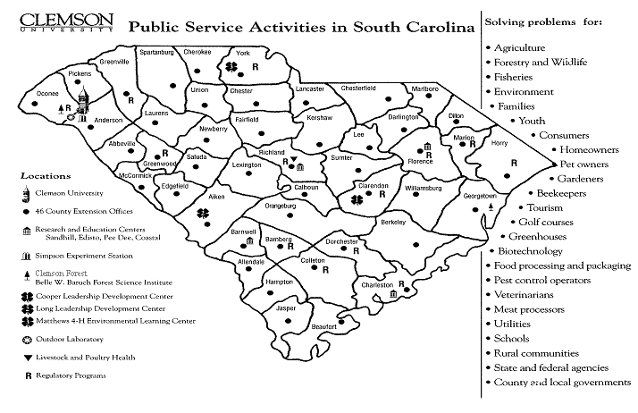

Figure II-1

Expenditure/Appropriations Chart
Section
II-3
See figure below -- for expenditures/appropriations chart for PSA. It should be noted that PSA received 10.9% funding cut from appropriations in FY 2002-03. This resulted in the loss of the ability to fund 96 PSA FTEs. The individuals in these positions took advantage of retirement incentive packages. The loss of these hundreds of years of experience and programmatic and institutional knowledge has left critical voids in service areas

PSA leadership has reorganized, eliminated numerous administrative positions, broadened areas of oversight and geographic coverage and is still focused on meeting the vision of Clemson University. PSA will continue to increase its quest for new resources and collaborators. No other way exists to meet Clemson University's vision, mission, and goals.

 | 01-02 Actual Expenditures |  | 02-03 Actual Expenditures |  | 03-04 Appropriations Act
Major Budget Categories | Total  Funds | General  Funds | Total  Funds | General  Funds | Total  Funds | General  Funds
Personal Services | 41,570,925 | 31,474,171 | 38,631,497 | 29,197,203 | 35,577,522 | 28,883,194
Other Operating | 19,374,043 | 6,898,913 | 19,105,388 | 7,259,187 | 12,185,456 | 2,000,063
Special Items | 134,974 | 134,974 | 134,974 | 134,974, | 134,974 | 134,974
Permanent Improvements | 0 | 0 | 0 | 0 | 0 | 0
Case Studies | 0 | 0 | 0 | 0 | 0 | 0
Distributions to Sub-Divisions | -264,196 | -264,196 | -257,995 | -257,995 | -210,567 | -210,567
Fringe Benefits | 12,856,773 | 8,822,693 | 11,072,703 | 8,079,258 | 10,660,068 | 8,067,075
Non-recurring | 0 | 0 | 0 | 0 | 0 | 0
Total | 73,672,519 | 47,066,555 | 68,686,567 | 44,412,627 | 58,347,453 | 38,874,739

Other Expenditures

Sources of Funds 00-01 Actual Expenditures 01-02 Actual Expenditures
Supplemental Bills | 0 | 0
Capital Reserve Funds | 0 | 0
Bonds | 0 | 0

Interim Budget Reductions
Total 01-02 Interim Budget Reduction | Total 02-03 Interim Budget Reduction
3,227,667 | 4,043,222
Chart Series II-1
Section
II-4

Key customers segments linked to key products/services
Although our key customers are and continue to be the citizens of South Carolina, we reaching out into many new areas across the country and in other nations. The programs conducted by PSA are accessible to all people. The mission and goals of the organization lend themselves to people who are associated with agriculture, agricultural and forest products, business and industry, landowners and managers of natural resources, families and youth, limited resource families and rural and community leaders.

Customers also include pesticide and fertilizer sales and users, those who produce certified and enhanced seeds and plants, practicing veterinarians, county and local governments, business and industry, agencies who work in the areas of economic development, health, conservation, the environment, wildlife, water resources, technical education and youth and families.

Key stakeholders (other than customers)
Section
II-5
Other than our customers, and of no less importance to our mission and values, are our own employees. We take pride in being a “family” at Clemson University and that is certainly true in PSA. If it were not for our employees, we would not be able to serve our customers well. That is why these past few years have been troubling times for PSA administration. We have pursued, and will continue to pursue, every possible way to balance our budget without having to lose any of our employees. Hopefully, we will be able to accomplish this.

Key Suppliers
Section
II-6
The term “suppliers” is being used to describe agencies, organizations, groups of individuals and classifications of individuals who support PSA programs with funding, matching or in-kind support. Advisory boards provide invaluable support that is used to “build” program initiatives so they are included here as well.

- Federal, State, and Local Government  - Agriculture Council  - Cooperatives – SC Cooperative Council  - 4-H Donors  - Farm Bureau  - Green Industries  - Livestock Breed Associations | - Private Industry  - Foundations  - Private Non Profit Corporations.  - SC Poultry Federation  - State and Local Fairs  - County Advisory Boards  - Public Service Activities Advisory Board
- Agriculture Industry Associations – i.e. Soybean, Corn, Cotton Growers Associations

Organizational Structure
Section
II-7
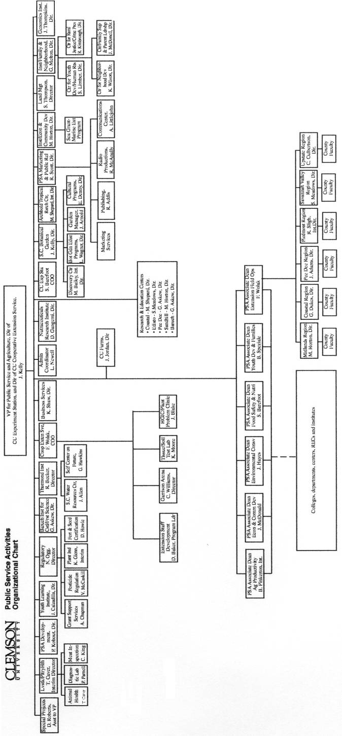

Figure II-3
Section
III-1

Leadership
Clemson University, under the leadership of President James Barker, has established new Vision, Mission, and 10-Year Goals. The vision is for Clemson University is to become a nationally ranked top 20 public institution. Public Service Activities, under the leadership of Vice President John Kelly, embraces the vision, mission, and goals. The President, Vice Presidents, Deans, Directors and every faculty and staff member will be evaluated by their contribution to those goals.

The new 10-year goals of Clemson University that most closely relate to PSA are: setting the standard for relevant public service; increasing research programs to exceed $100 million per year, which has now been achieved, and fostering Clemson's academic reputation through strong academic programs, mission-driven research, relevant public service and highly regarded faculty and staff. Performance measures to accomplish these, and other appropriate, 10-Year Goals have been incorporated into the performance review criteria for PSA’s employees.

PSA Goal areas are:
- Agrisystems Productivity and Profitability, PSA Goal 1
- Economic and Community Development, PSA Goal 2
- Environmental Conservation, PSA Goal 3
- Food Safety and Nutrition, PSA Goal 4
- Youth Development, PSA Goal 5.

The Public Service Council is responsible for implementing programs, initiatives and activities under the five goals. The team consists of the following key leaders:
- Vice President of Public Service and Agriculture
- Chief Operating Officers for the Experiment Station and the Cooperative Extension
- Service
- Associate Deans for Agri-Systems and Productivity, Economic and Community Development, Environmental Conservation, Food Safety and Nutrition and Youth Development and Families.
- Director, Clemson University Activities Information Management System
- Chief Financial Officer for PSA
- Associate Dean for Extension

These leaders regularly receive input from advisory groups, industry leaders and vice presidents and deans at Clemson, which is applied to guide PSA in setting organizational values, directions, and performance expectations and accomplishing the vision and mission of PSA.

How do senior leaders set, deploy and communicate?
Section
III-1-1
Senior leaders empower employees in a university setting and through feedback mechanisms in staff meetings and reverse evaluations of supervisors. Professional development is offered formally in retreats or structured learning professional programs and in attendance in professional meetings, where funding allows. Meetings and training are often conducted with the advantage of distance communications systems which allow two way video and audio and avoid travel expenses and lost travel time. Ethical behavior for all Clemson employees is identified in the University's Fiscal Policies and Procedures and Personnel Policies and Procedures Manual.
Section
III-1-2

How do senior leaders establish and promote a focus on customers?
The commitment to customer service is reflected in the mission and goals of PSA, and is supported by a sophisticated and long-standing network of advisory boards and committees at the county, regional and state levels. The focus on customer service is an element of each leadership team meeting. The President and Vice President meet with constituency groups on campus, at the Research and Education Centers and at Extension Service offices.
Section
III-1-3

What key performance measures are regularly reviewed by your senior leaders?
The key performance measures, which are regularly reviewed by senior leaders include the numbers of individuals, groups, companies and agencies served, numbers of regulatory inspections and other services provided, the number of educational and public service events held, the number of patents, licenses, publications issued, resources leveraged, communication effectiveness and cost benefit analysis and other statistical measures of impact on the state and the nation. Performance measures are tailored to reflect performance in the five PSA goal areas and in the Clemson University goals and emphasis areas which were described in Section 1-2 above. There are additional measures which are cumulatively reflected as accomplishments in Section I.

How do senior leaders use organizational performance review findings and employee feedback to improve their own leadership effectiveness and the effectiveness of management throughout the organization?
Section
III-1-4
An ongoing review of key performance and employee feedback is used to improve leadership and management effectiveness. Last year, PSA employees were asked to rank the effectiveness of PSA senior leaders. The ranking options were given from very poor, poor, neutral, good, to very good. The following chart demonstrates the confidence in PSA leadership.

Section: Leadership in PSA
A13=PSA leadership at the VP level is . . .
A14=The Director of Cooperative Extension Service's leadership is . . .
A15= The Director of The Experiment Station’s leadership is . . .
A16= The Director of Livestock and Poultry Health's leadership is . . .
A17= The Director of Regulatory and Public Service Program's leadership is . . .
(Graph III-1)

 | SD/VP | D/P | Neutral | A/G | SA/VG
 | % | % | % | % | %
A13='PSA LEADERSHIP AT VP LEVEL' | 5.19 | 9.09 | 15.58 | 37.66 | 32.47
A14='LEADERSHIP-DIR COOP EXTENSION SERV' | 2.99 | 8.96 | 13.43 | 44.78 | 29.85
A15='LEADERSHIP-DIR EXPERIMENT STATION' | 7.55 | 7.55 | 18.87 | 32.08 | 33.96
A16='LEADERSHIP-DIR LIVEST POULT HEALTH' | 0.00 | 2.50 | 17.50 | 42.50 | 37.50
A17='LEADERSHIP-DIR REG & PUBLIC SERV' | 0.00 | 0.00 | 13.21 | 37.74 | 49.05

(Table III-1)
Note: Leadership at the Vice President’s level was perceived as very favorable with a 85.71% approval rating. Similar high ratings were given to the other PSA Directors. (Note: The Deans of SCAFRS and CES were rated as “Directors” in this Self-Study from FY 2002.)

The performance of the organization is evaluated monthly by both the PSA Associate Deans and Directors and The PSA Council, based on the availability of on-line accountability information on CU-AIMS, budget analysis and reports by the Chief Financial Officer, and other custom reports at the request of the members. The Vice President of Public Service and Agriculture makes specific assignments where corrective action is needed in specific program areas, and the PSA Associate Deans and Directors and the PSA Council review particularly successful performance in an effort to increase performance across the organization.

How does the organization address the current and potential impact on the public of its products, programs, services, facilities and operations, including associated risks?
Section
III-1-5
PSA depends on feedback from its advisory system, a close working relationship with local and state elected officials and state and federal agency heads to monitor the impact of programs. Consensus building and broad based public relations activities precede the introduction of new programs in the state, in addition to the more formal review of new programs by the Merit review committee and the peer review of new research projects.

In addition, customer satisfaction surveys are conducted regularly and are detailed in Category 3-Customer Focus. These surveys along with more informal information gathering techniques provide a continual source of feedback. This feedback is used to address the current and potential impact of PSA activities on the public.
Section
III-1-6

How does senior leadership set and communicate key organizational priorities for improvement?
The assessment process which is reported in the USDA Plan of Work, the Annual Report to the SC Budget and Control Board and the Annual report to the Southern Association of Colleges and Schools (SACS) assist the PSA Associate Deans and Directors and the PSA Council to gauge areas which merit the most effort for improvement. Unfortunately, recent budget reductions have complicated efforts to systematically improve program activities to enhance performance and cost effectiveness.

Priorities are communicated throughout the organization through the PSA Associate Deans, Directors and the PSA Council to their respective faculty and staff. Priorities are communicated to Clemson University thought the Vice President’s participation in the university Administrative Council, vice presidential meetings and in exchanges with the President and key members of the President’s staff and the staff of the vice presidents. The latest technologies are also employed to enhance communications capabilities, to include e-mail, teleconferencing via satellite and the internet and on the PSA web sites. Legislators are advised of priorities by the staff in the University’s Columbia office.

How does senior leadership and the agency actively support and strengthen the community?
Section
III-1-7
The intent of the mission of PSA is to help people in South Carolina make informed decisions which will improve their lives and the communities where they live. PSA accomplishes this mission by developing new knowledge through research and transferring this knowledge to the citizens of the state through a range of educational techniques.

Strategic Planning
Section
III-2
PSA is committed to taking a leadership role in addressing challenges and realizing opportunities in South Carolina. PSA is poised for the future with its five strategic goals aimed at meeting the needs of South Carolina citizens and achieving the highest levels of scholarly excellence in research, outreach, and service. These goals are compatible with the Clemson University goals and emphasis areas..

The PSA units collectively provide input to the strategic planning process. In addition, the strategic planning takes place within these units with a focus on what is best for PSA, Clemson University and the state of South Carolina. Key issues addressed include: recognition and clarification of mission, environmental scanning, identification and selection of issues, development of goals, and strategies, implementation of plans and monitoring and assessment of results.

Stakeholder input remains critical to the strategic planning process and, as such, input is sought from a variety of stakeholders. The information team collected relevant data via interviews, surveys, and personal contacts. Nominal group technique was also used at the county level to garner stakeholder input. Demographic data from all the counties through an environmental scan was also conducted. Customer needs, financial, societal and other risks, human resource capabilities and needs, operational capabilities and needs, and suppliers, contractors, partners’ capabilities and needs, were all considered in the planning process.

The success of programs, projects, and services, to a great extent, depends on the ability of employees to do the job and the extent to which they are up-to-date on the subject matter. PSA’s goal is to enhance the human resources by aggressively hiring outstanding faculty, researchers, agents, and support staff; invest in their professional development, and provide a supportive work environment. Several training and professional development opportunities are available to employees to improve their skills. The heads of PSA’s seven units annually review the needs of each employee and then identify professional development opportunities for them.

Customer Focus
Section
III-3
PSA’s key customers and stakeholders are the citizens of South Carolina. Included among them are South Carolina growers or any plant or animal commodity, citizens, consumers, government agencies, other universities, gardeners, youth, agribusiness, businesses and persons relating to any context of our research education and regulatory functions to include, commodity groups, residents of communities, cities, and rural areas. Included also are legislators, alumni, families, meat packing establishments, agri-chemical users, unidentified users of PSA electronic printed, and broadcast information, and people who support the wide range of PSA units and their program activities.

How do you determine who your customers are and what are their key requirements?
Section
III-3-1
Contact data identifies customers and their needs. In FY 2001-02, more than 684,000 people in South Carolina were contacted by the PSA units to determine their requirements. They represent a variety of people from all walks of life. These people are integral to programs and initiatives and provide valuable feedback performance. A majority of these contacts were programmatic, meaning that customers came to programs or submitted requests to receive information based on an identified need. Telephone calls, office visits, farm and home visits, participation in workshops, demonstrations, and seminars are some of the methods employed to provide information and at the same time determine customer’s needs and wants. In addition, print media such as brochures, pamphlets and, how-to-do guide books have also been published and distributed to the customers. Many needs are defined by mandated health requirements.

When a research need is identified, such as the appearance of a new pest or disease, a critical social or environmental phenomena or a production concern, the customers that have the information need are contacted and the problems are discussed along with potential methods of obtaining the information that is needed to solve them. Proposals show them our capacity and how we are able to meet their needs.
Section
III-3-2

How do you keep your listening and learning methods current with changing customer/business needs?
The annual nature of surveys and contact data gathering, coupled with the fact PSA has at least one service unit in each county of the state makes it possible to constantly assess the validity and strength of listening and learning methods. The staff at the local level is in constant contact with state legislators, local elected officials and citizens who are served daily, which reinforces the annual approaches. The unanticipated occurrence of new diseases such as West Nile Virus which impacts birds, animals and humans, plant pests, such as Tropical Soda apple which impacts pasture land and the environment or Plum Pox disease, which impacts peach production, keys the various units in PSA to respond in a coordinated fashion with customers. The recent drought effects all South Carolina residents but in different ways, and calls for regional responses to special needs from PSA.

The potential threat of bio-terrorism sets a different series of processes in motion which mobilizes elements of all PSA units into a coordinated effort with the relevant agencies in state and federal governments.

How do you use information from customers/ stakeholders to improve services or programs?
Periodic meetings with advisory boards, local leaders, and other stakeholders along with focus groups, provide feedback on how programs and initiatives are meeting their needs. Information gathered from meetings and from periodic survey instruments is conveyed to the PSA Directors and the PSA Council members for review and recommendations for faculty and staff in the various PSA units. Advisory Boards have played a significant role in providing input and feedback which has been used to improve both services and programs.
Section
III-3-3

How do you measure customer/stakeholder satisfaction?
Section
III-3-4
PSA has a plan to measure the quality of services provided in all the 46 counties of the state. Part of this plan involves a customer satisfaction survey (CSS) which has been developed to collect data from the customers. The goal of CSS is to find ways to improve program quality, information delivery, and more important, to assist in the accountability process. Four indicators were identified to assess the quality and satisfaction of services provided. These include: 1) up-to-date, useful, relevant and easy to understand information, 2) the extent to which recipients had the opportunity to use the information, 3) the extent to which they have shared the information with others, and 4) the extent to which they are satisfied with the services provided. The following success criteria was also established: 1) 80% of the survey participants will report positively to all the questions, 2) 50% will report that they have used information, 3) 70% will report that they have shared extension information with their friends and neighbors, and 4) 80% will report that they are satisfied with the services provided.

Forty-one of the 46 counties participated in the survey. A team comprised of extension agents, county extension directors, and secretarial staff conducted over 1,142 interviews with customers to collect data. These 1,142 responded to 14 questions covering the four criteria indicated above. The results of the survey are provided in the business results Section III-7, Results.

The results of CSS have been used by county staff in budget decisions, in showcasing program accomplishments and in meetings with legislative officials. Such use has shown that Extension can make a difference.

How do you build positive relationships with customers and stakeholders? Indicate any key distinctions between different customer groups.
Section
III-3-5
Daily interaction, made possible by the location of PSA resources and personnel in every county, coupled with the delivery of information that is accurate, timely and usable are the keys to positive relationships with customers and stakeholders. Industries, large business operations and local governments require different levels of assistance than many citizens who have a very specific need.
Section
III-4

Information and Analysis
PSA has one of the best information systems of the land-grant colleges in CU-AIMS – Clemson University Activity Information Management Systems. CU-AIMS collects data from many sources and summarizes the data in such a way that allows the administration to be understand the complexities of the organization. Although the system is still evolving, CU-AIMS is able to collect all financial data from the University’s financial systems, performance data from PSA’s own performance tracking system for Extension Activities and from the system for tracking faculty performance, and data from several federal data sources which track research activities.
Section
III-4-1

How do you decide operations, processes and systems to measure?
All programming must fit within the five PSA goals as well as meet the goals/objectives of the individual units within PSA and the university goals/emphasis areas. These units have their own established process to determine their success in addressing the needs of their customers/stakeholders. This process could be peer review committees, focus groups, surveys, and personal contacts. Decisions are made that guide the units in directions that focus their programming on relevance, capacity and impact.

The PSA Directors and the PSA Council determine activities which will be measured. PSA has implemented a system-wide accountability system called CU-AIMS (Clemson University Activity Information System) that looks at all aspects of the organization. This system measures program activities and provides information to the various units in the organization for assessment and management purposes.

How do you ensure data quality, reliability, completeness and availability for decision-making?
Section
III-4-2
CUAIMS takes data from numerous sources and delivers it to three levels of PSA: the stakeholders, the users, and the decision makers. The stakeholders are informed of activities within PSA through the web-based system called “South Carolina Growing”. This system shows the general public, legislature, media, scientists, and other interested parties the current problem-areas being addressed by PSA, the solutions being discovered the information being disseminated from these discoveries, and the areas that PSA will be targeting in the future. By informing the public PSA encourages feedback from stakeholders to insure that working is underway in the correct areas and addressing the critical needs and delivering the proper information.

The Professional Home Page (PHP) component of CU-AIMS is the connection to the expertise within PSA i.e. the scientists, the technicians, the staff, and other professionals that make it possible to solve the problems and deliver the information to stakeholders. By keeping them informed PSA can further insure that they know what is being asked of them (through performance measurement subsystems), and showing them what their colleagues are doing (encouraging collaborative efforts), and giving them a process to communicate with the administration any discrepancies or misrepresentation of the data (electronic report transfer).

The final component of CU-AIMS is the Information Management System. It is the umbrella or the “core” of CU-AIMS. This is where all the data is stored and delivered to the administration. This system does high-level analysis of how the organization is working. It looks at spending trends, performance measurement, time analysis, account discrepancies, goal progress, and market analysis. This is the true decision making tool for the administration.

How do you use data/information analysis to provide effective support for decision-making?
Section
III-4-3
Data gathered by CUMIS (Clemson University Management Information System) is combined with data received from various survey instruments, advisory board sessions and CUAIMS is available to the PSA Directors, the PSA Council and to unit directors.
Special reports are developed from CUMIS and CUAIMS on request from the Directors and the Council. The Chief Financial Officer also prepares special reports at the request of the Directors and the Council

How do you select and use comparative data and information?
Section
III-4-4
CUAIMS brings in information from all aspects of PSA. Much of this data is grouped into predefined areas that allows for comparing performance between departments, or stations, or problem areas (programs) or between individuals. These predefined areas have certain criteria or performance measures that can allow for these comparisons to be made.

Because CU-AIMS connect to numerous data sources, comparisons can be made between Clemson and with other “like” institutions across the country. This not only makes it possible to gauge performance (performance measures) but also presents opportunities to collaborate efforts with other institutions. Once CUAIMS connects to commodity databases within the state, it will be possible to compare PSA efforts to those of industry.

Human Resources
Section
III-5
Public Service Activities Business Services works together with Clemson University Human Resources for all PSA employees. Many human resource activities which once were administered by PSA are now transferred to the university’s central office of Human Resources. The university’s office is much better qualified to work with our employees on personnel issues. PSA still maintains an office of Staff Development that insures personnel are better trained to meet the needs of their profession.

How do you and your managers/supervisors encourage and motivate employees (formally and/or informally) to develop and utilize their full potential?
Section
III-5-1
Employees are encouraged and motivated to develop and utilize their full potential through the following:

Effective planning using the Employee Personnel Management System can encourage employees to develop their skills and abilities and by providing opportunities for employees to continue their education, at little or no cost.

PSA has a number of incentive and awards programs to support the employees within the system. The organization has the standard performance incentive raises. However, an innovative Distinguished Agent position was created which is reserved only for those agents who perform at the highest level. Each professional organization that is tied to Extension, such as: the County Agricultural Agents, Family and Consumer Sciences Agents, 4-H Agents, Extension Secretaries, and Epsilon Sigma Phi, have awards programs to promote excellence in programming efforts. Three Superior Performance Awards are sponsored for agents and faculty as is an Outstanding Service Award for classified staff. In addition, the Clemson University Alumni Association sponsors the Distinguished Service Award each year for excellence in Public Service.

How do you identify and address key developmental and training needs, including job skills training, performance excellence training, diversity training, management/leadership development, new employee orientation and safety training?
Section
III-5-2
The Office of Human Resources conducts a training needs-assessment survey designed for each University unit. From the information gathered, sessions are scheduled to meet the needs of the unit. OSHA training is done in accordance with regulations. New employee orientation is not mandatory at Clemson; however, each new staff member is invited to attend. All day sessions are held on the 1st and 2nd payday of each month.
PSA provides an in-service training program for all employees. The training is divided into three categories: Subject Matter; Professional Development (which includes Orientation); and Technology. Extension specialists and initiative teams develop subject matter trainings each year and provide to agents to keep them up-to-date in the various program areas. A variety of Professional Development trainings are offered each year covering such topics as Grant Writing, Diversity, Developing Partnerships, Developing Survey Instruments, etc. An orientation program is in place which includes an introduction to the Cooperative Extension Service and additional trainings in Civil Rights and Program Development. Technology trainings are offered which cover the use of several computer programs. In addition, the Professional Associations associated with PSA also offer trainings and updates both at the state and national levels.

How does your employee performance management system, including feedback to and from employees, support high performance?
Section
III-5-3
The Office of Human Resources communicates expectations during the planning phase of the process - employees are allowed input into formulating the planning stage. The ratings allowed by policy in the evaluation phase include not only one for meeting the expectations, but also one for exceeding and one for substantially exceeding. The possibility of achieving a higher rating for work that is accomplished encourages performing at a higher level. Performance pay is also tied to the EPMS - can be an incentive for higher level performance; and support of the President's University Goals as a way in part of becoming one of the Nation's top twenty public universities increases awareness of a Mission above an individual's daily duties - supporting higher performance than usual. Each employee chooses one of the Goals to be included as part of their evaluation document.
Formal written performance evaluations and interviews conducted with each faculty member to review accomplishments, weaknesses, and areas needing improvement. This information is utilized in determining the annual goals and objectives for the plan of work developed by each faculty member.

What formal and/or informal assessment methods and measures do you use to determine employee well being, satisfaction, and motivation?
Units periodically review well being, to include work level and schedule, satisfaction and expectations with personnel. Efforts are made to insure that supervisors are available to discuss issues with subordinates. Employees are encouraged to make suggestions for improvements
Section
III-5-4
Section
III-5-5

How do you maintain a safe and healthy work environment?
The Office of Human Resources ensures compliance with the Drug Free Work Force Act by annual distribution and enforcement of the Employee Drug and Alcohol policy; compliance with the DOT regulations governing training and drug testing of employees who are required to have a commercial driver's license (CDL). (Partnership stated under the first question of the assistance provided to employees in obtaining a license after requirement has been added to an existing position.) The University Smoking Policy is in compliance with the SC Clean Indoor Air Act; Training provided annually on causes and symptoms of violence in the workplace; Employee Assistance Program provides confidential assistance/referral for employees experiencing difficulties in coping in a variety of life/work situations. (The intent of the program is to enable them to return to a more productive employee).

The University and PSA focus on encouraging safe work environment/habits. Ergonomics specialists on staff will provide recommendations for improving workstations, etc; and the University Wellness Center provides health programs and services at little or no cost to employees. These programs include in part recommendations for weight loss, improving diet and lifestyle changes.
Individual PSA units have a variety of complementary approaches in the safety area to include training in pesticide management for employees, safety compliance officers who stress safety in laboratory areas and regular inspections of facilities and equipment.
Employees are monitored to insure that all safety measures are followed. Employees that become aware of a potential safety problem or area in need of attention are encouraged to report the need to their supervisor.

What is the extent of your involvement in the community?
Section
III-5-6
PSA engages the community through partnerships, collaborations, and through many outreach efforts. Off campus and university faculty and staff are encouraged to involve themselves in community activities. Personnel serve as members and officers in numerous leadership and civic organizations. Several employees are involved in their local school system, serving as members of the school board. Participation in these type activities shows the commitment of PSA personnel to their community. PSA has projects address: community volunteerism, educational improvement, civic engagement and environmental quality. PSA has developed formal networks with civic associations, volunteer training initiatives, private companies and governmental organizations.
Section
III-6

Process Management
Because of the complexity of our mission, PSA utilizes many instruments to insure that our divisions and representatives are working together to deliver our services. Our reliance on our own mission and objectives, our close contact with our customers and stakeholders and the commitment of our employees insures that we work together to accomplish this.

What are your key design and delivery processes for products/services, and how do you incorporate new technology, changing customer and mission-related requirements, into these design and delivery processes and systems?
Section
III-6-1
The design of program initiatives is built around three primary criteria, relevance, capacity and impact. Needs assessments are targeted towards the customer base and systematically updated. Advisory boards with a broad cross section of members are asked to assess and provide input to the PSA Associate Deans, Directors and PSA Council on the design of program initiatives and the delivery of services. Each unit within PSA is directly involved in service delivery unique to its own specific mission. The design of the delivery systems is constantly being impacted by increased demand for services, new types of services, and new means of service delivery. Budgetary constraints directly impact the ability of PSA to respond to changing customer needs. Remote delivery of service using Internet technology, satellite, two-way video, and radio are examples of innovative approaches to service delivery.

How does your day-to-day operation of key production/delivery processes ensure meeting key performance requirements?
Section
III-6-2
The design and delivery of all PSA programs is built around achieving the objectives in the five PSA goals. Decisions are made in the design stage to focus research initiatives on the established goals. Spontaneous demand for service from customers is assessed in terms of PSA’s ability to deliver the service within the context of the five PSA goals. In instances where the service request is beyond PSA’s capabilities, mission or outside a goal area, efforts are made to refer the customer to other agencies, state or federal or two other land grant universities, with different specialties.
Section
III-6-3

What are your key support processes, and how do you improve and update these processes to achieve better performance?
Communications is a key support process in the design, production and delivery of products to customers. PSA has a communications center, web page authoring and management staff, radio station, publications and graphics capabilities two-way video and satellite facilities, a broad base of computer support, and access on a reimbursement basis to a range of communications support from Clemson University. Facilities adjacent to the university and at strategic locations across the state (at least one facility in each county (see Section II, item 2) are maintained and supported by the Farm Research Services unit adjacent to the campus with specific support functions housed at each installation. PSA staff are responsible for the maintenance of computers, diagnostic and research equipment as well as vehicles, buildings and grounds. Maintenance can also be done either on a contractual basis with the university or an outside vendor. Personnel and property management are conducted internally. Legal, land management, computer, janitorial and legislative support services are shared with the university, funded by PSA at negotiated levels.

How do you manage and support your key supplier/contractor/partner interactions and processes to improve performance?
Section
III-6-4
The primary suppliers for PSA are the federal and state government, companies, organizations, foundations and communities that invest funds in PSA. Interactions with suppliers, contractors and partners are carried out though visits, correspondence, periodic reporting and annual reporting as represented by this document. Quality outputs and outcomes, coupled with documented customer satisfaction that are shared with suppliers, contractors and partners on a timely basis, generates valuable inputs that are used to improve performance. Advisory boards and groups are also apprised of comments from these interactions and suggestions for improving performance are generated.

Business Results
Section
III-7
PSA is all about “service”. We generate and transfer knowledge through research and education. If we are not serving our customers and stakeholders well, we are not doing our job. Our primary deliverable is information. Whether the need is for a farmer in a rural county, the housewife, the researcher, an industry leader in the state, a member of the legislature, or a colleague in another state or across the world, PSA should be able to help them.
Section
III-7-1

What are your performance levels and trends for the key measures of customer satisfaction?
PSA is interested in enhancing the quality of the information and services it provides to customers, while expanding or at least maintaining the numbers of customers served and enhancing the quality at the same time. Performance levels to date indicate that PSA is successful in providing educational programs, research initiatives and regulatory services which benefit the citizens of South Carolina and leaves with the recipient the view that they have benefited. Continuing to achieve this goal is becoming increasingly problematic in an era of decreasing budgets. PSA plans to increase customer satisfaction by achieving even more desirable performance levels through an expansion of a trend towards electronic mediums to meet customer needs and achieve customer satisfaction, and through a restructuring of primary components of the PSA delivery system.

PSA has developed a sophisticated, multi-part model for measuring customer satisfaction and this is described in Section III-3 Customer Focus. .
Section
III-7-2

What are your performance levels and trends for the key measures of mission accomplishment?
PSA has restructured to increase the focus on the five PSA goal areas, assigning an Associate Dean to focus on each goal area which in turn works with the university and within emphasis areas. This has had the effect of increasing performance in the areas and improving reporting. As the Associate Deans continue with their efforts and as PSA moves towards programs it is anticipated that the trend will be towards increased performance in each goal area.
Section
III-7-3

What are your performance levels and trends for the key measures of employee satisfaction, involvement and development?
The impact of budget reductions and retirements and subsequent restructuring has challenged PSA employees to take on additional and often time more complex responsibilities. PSA employees have responded positively in this rapidly changing environment and PSA will increase opportunities for employee involvement and is refocusing efforts to provide professional development and training opportunities.

What are your performance levels and trends for the key measures of supplier/contractor/partner performance?
Section
III-7-4
Outside funding for PSA activities have increased dramatically over the last year. This reflects increasing confidence on the part of federal, state and private partners in PSA’s ability to provide research, education and regulatory programs. Increased partnering with outside funding agencies, organizations and companies is necessitated by the declining state budget situation and the university goal of increasing overall research funding. The trend towards increasing collaboration with partners is expected to increase.

What are your performance levels and trends for the key measures of regulatory/legal compliance and citizenship?
Section
III-7-5
There has been a dramatic increase in activity on the regulatory side of PSA in response in the areas of bio security, food safety and security and the threat of diseases resulting from the increasing terrorist activities. There has been increased coordination with state and federal agencies to coordinate response scenarios and these close working relationships are anticipated to continue and become more sophisticated. The security of the food supply and the ability to respond to threats to human life, livestock, air and water quality will become increasing important elements of the overall PSA thrust in South Carolina.

What are your current levels and trends of financial performance?
Section
III-7-6
PSA has systematically undergone a series of funding reallocations, budget reductions and faculty and staff reassignments with the long-term goal of capitalizing on state and federal funding and leveraging private funds to achieve the organizations five goals and complement the university’s goals and emphasis areas. Increasing the return on the dollar while not compromising the unbiased nature of the information and services which are provided, is a top financial priority. PSA employees and those in leadership positions are going to extraordinary lengths to maintain, refine, and when possible expand the levels and quality of activities provided across the state. Budget reductions which cannot be offset by outside funding are requiring shifts in program emphasis, the elimination of some activities and new approaches to program delivery. The trend of positive, innovative responses and the concern of PSA staff and leadership to meet needs in the state and meet both the PSA and university goals are anticipated to continue.

Additional Accomplishments
Education and Outreach
- Pesticide applicators for three states received five to eight hours of CCH.
- 100 enterprise budgets were developed and distributed to County Ag Agents
- 360 participated in the grazing animal systems project. Over 127 producers participate in managed marketing programs. All reported implementing recommended grazing management systems to improve profitability and decrease detrimental environmental impacts of livestock
- Over 48,000 acres of horticultural crops and 12,000 acres of agronomic crops were affected by integrated crop management. Over 5,000 acres were planted to new alternative crops.
- Over $247,404 was raised to support local Community Enhancement and Improvement programs and collaborative efforts.
- 1000 individuals participated in 32 programs dealing with Silvicultural Systems.
- 1,246 producers participated in 48 activities conducted to teach best management practices in manure management.
- 1,767 residents were trau\ined ti become Master Gardners. These volunteers contacted 37,011 people and contributed 33,918 hours of service.
- 32,690 consumers received plant health management information. Plant health demonstration sites were visited by 10,755 consumers.

Examination of customer satisfaction data (Table 1) reveals that over 97% of the customers (participants) were very satisfied with the service they received from Clemson Extension Service. Customers also indicated that the information they received was up-to-date, accurate, easy to understand, and relevant to their situations. Data from CSS can be linked to not only knowledge and skills acquisition, but also inclination toward adopting a recommended practice. Almost 80% of them reported that they used the information. Over 77% indicated that they shared information with their friends and neighbors indicating the confidence and trust they have for Extension programs and the information received. Collectively, these indicators enhance the credibility and quality of extension programs and services provided by county Extension staff

CUSTOMER SATISFACTION SURVEY (CSS)
Extension Information: | Frequency | % of Total Respondents
Relevant | 1086 | 95.35
Useful | 1101 | 96.66
Up-to-Date and Accurate | 1114 | 97.38
Easy to Understand | 1095 | 96.39
Extension Clientele:
Used Information | 906 | 79.61
Changed Behavior | 719 | 63.85
Shared Information w/ Others | 877 | 77.68
Satisfied w/ Service Provided | 1112 | 97.46
Table III-2
As indicated earlier, the mission of extension is education—to help people help themselves by providing unbiased research-based information to our customers. The graph series in Section III show trends in the number of people completing programs from 1998-2003, the trends in total contacts and programmatic contacts for 1998-2003 followed by four graphs showing performance indicators by PSA goals, including number of programs/activities conducted, number of people completing Extension programs, number reporting increased knowledge as a result of participation, and the number reporting adoption of a practice.

The total number of contacts (graph 2) has increased from last reporting period. The number of contacts increased from 1997-98 from 653,599 to 756,994 in 2000-01. There was a slight decline in the number of contacts in 2001-02 to 658,522. A total of 734,898 contacts were made in 2002-03.

The number of programs/activities conducted by staff is represented in Graph 3 by the five PSA Goals. During the four-year period, the number of programs conducted decreased from a high of 18,987 in 1997-98, to 10,296 in 2002-03. There has been a reduction in the number of staff to deliver programs due to retirements during the last two years. Many staff are working together and presenting programs to minimize travel and cost. In addition, several programs have become increasingly interdisciplinary, resulting in team efforts. Despite a decline in number of programs conducted, the average number of people per program/activity has increased—11 persons per program in 1997-98 to almost 21 persons per program in 2002-03.

In addition to total number of contacts made and number of activities conducted, two other performance indicators—total number of people completing programs by PSA goal (graph 4) and number of people reporting increased knowledge by PSA goal (graph 5) as a result of participation in extension programs—are critically important to our mission. Overall, however, the total number of people completing programs reveals a slight decline in 2003. For FY 2002-03, the total number of participants completing programs were 216,192. Of those individuals participating, 157,675 reported an increase in knowledge.

The final indicator relates to the number of people adopting a practice (graph 6). For FY 2002-03, of the 157,675 individuals who reported an increase in knowledge, 17,865 indicated that they had adopted or increased the use of practices taught as a result of programs. The ratio of knowledge gain to adoption in 2002-03 was 11.

The reported drop in the adoption of practice by Extension clientele is linked to the fact that we included an indicator of planning to adopt to our accomplishment indicators for all projects. This gives agents the opportunity to receive immediate feedback from clientele that they are planning to adopt the practices taught in the program. To determine the adoption of practices requires agents to follow-up with clientele weeks after the program to see if they are in fact adopting the practices taught in the program.

CU Extension Service Graphs
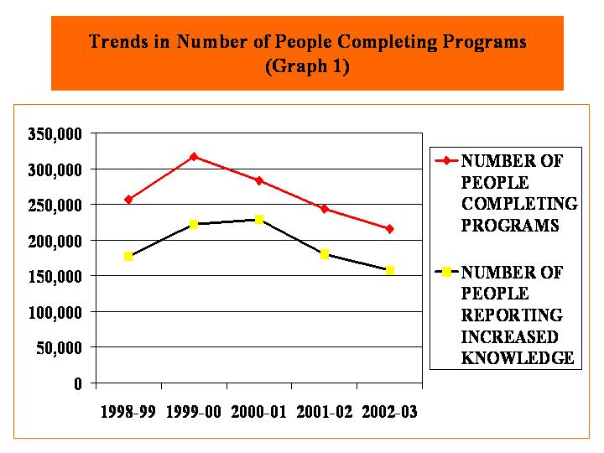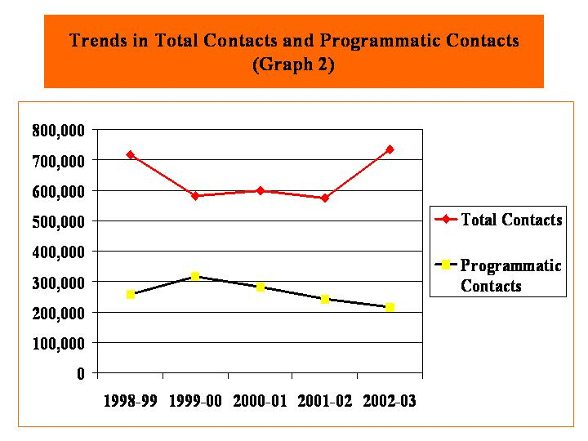

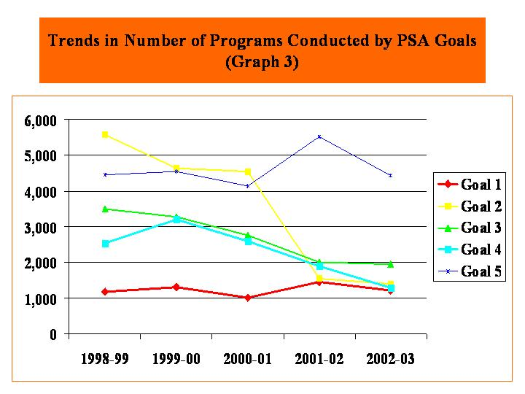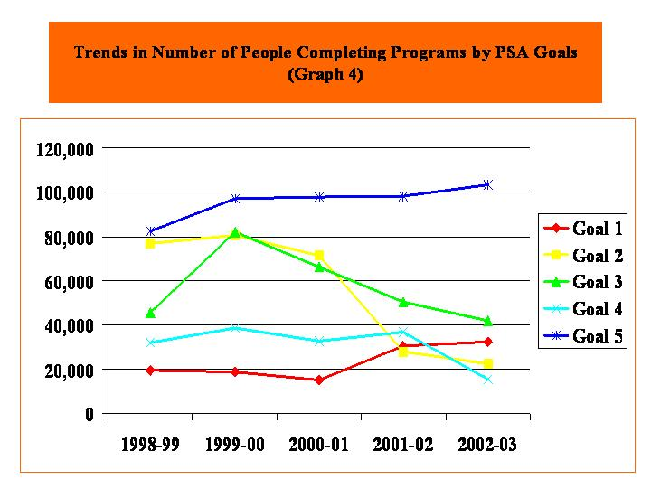

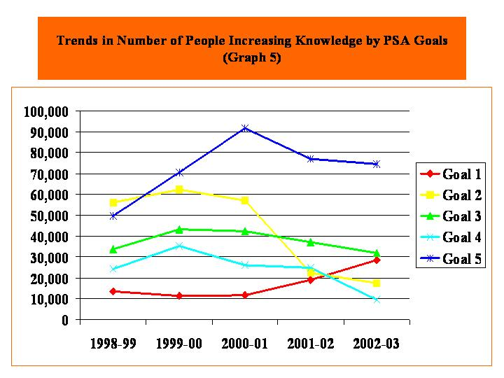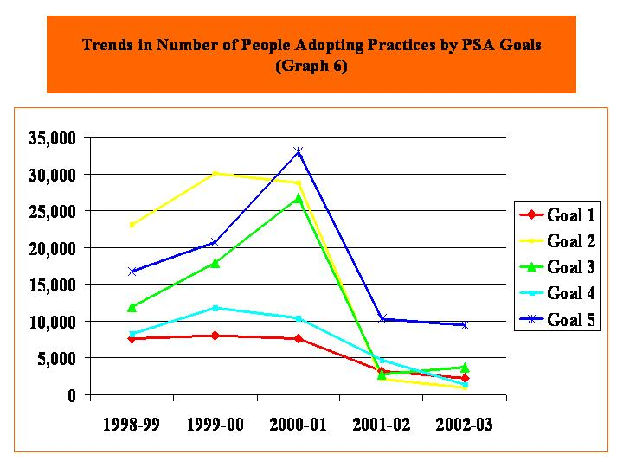

(Graph Series III-2)
- The Strom Thurmond Institute personnel served on two government reorganization task forces for South Carolina; testified on tax reform, school financing, and state water law revision.
- The Director of STI was elected president of the Southern Consortium of Public Service Organizations at the Southern Growth Policies Board.
- PSA concluded a NSF effort in FY03, spun that work-product into a collaborative agreement with SUNY-Albany and Reg 1 EPA for a Hudson River assessment.
- PSA developed a 501c(3) partnership with a number of conservation groups, private sector businesses and regional universities for the Saluda-Reedy Watershed Consortium.
- The Jim Self Center on the Future developed a $3.9 million project for network development and training with the Boys & Girls Clubs of America, Inc. This is a five-year effort.
- A private sector partnership with SpectroTec, Inc. resulted in a project with the Umatilla Indian Tribe, preliminary discussions with PEMEX Oil and a proposal for shipping traffic monitoring.
- A statewide committee commissioned by SLED was established for Agroterrorism Prevention and Food Safety to assess and address vulnerabilities.

During the last fiscal year, The Institute of Family and Neighborhood life worked to develop research, service and evaluation programs that touched every county in the state. These programs related to: violence prevention, including bullying prevention among school children, teen pregnancy prevention, child care capacity building of grassroots and faith-based organizations, parenting, child maltreatment prevention, drug courts; and poverty reduction.

To implement these programs, IFNL partnered with schools, courts, social service agencies and grassroots and non-profit organizations at the local, state, national and international levels. To fund these activities, IFNL generated external contracts and grants from private foundations and state and federal agencies totaling $2,770,499.

To diffuse knowledge, IFNL faculty and staff:
- produced approximately 60 publications (articles, chapters, books, op-ed pieces) either in print or in press;
- maintained its own website as well as websites for the National Center for Rural Justice and Crime Prevention and the South Carolina Center for Grassroots Leadership and Non-profit Organizations;
- produced weekly radio broadcasts of A Community Matters, a segment that runs on Monday broadcasts of public radio's A Your Day program;
- conducted eight distance learning events, broadcast to eight different counties and drawing 1200 participants from across the state. Corresponding videos were mailed to state libraries and all United Way agencies.

A primary role for the Clemson Institute for Economic and Community Development (CIECD) is to convene groups of stakeholders to discuss and identify strategies for community and economic development in South Carolina. One of the groups convened on a regular basis is a group representing 60 state agencies, non-profits and other Non-Government Organizations (NGO’s) that provide service to communities in one way or another. The CIECD invited these representatives to discuss avoiding duplication, leveraging resources and coordinating service delivery wherever possible. The impacts of this effort to date have included: 1) Enhanced communication between service providers, 2) establishment of Allendale County as a pilot for coordination, and 3) re-direction of some funding that would have been lost to Allendale County.

The Renaissance Communities Program has been established to connect the knowledge and expertise of Clemson University to the needs of South Carolina Communities. This program helps communities implement their strategic plans by connecting them with CU. Examples include: 1) Development of comprehensive recreational plan for Allendale County by the PRTM Department at Clemson, 2) Involvement by the Clemson School of Public Health in Allendale County, 3) the Palmetto Leadership Program in Dillon and Union Counties, and 4) Land use planning in Kershaw County.

Palmetto Leadership is delivered through the CIECD. This program was conducted in Union, Dillon and Chester counties during FY 02. In addition to Palmetto Leadership, the CIECD has been working to pull together a consortium to coordinate an effort to build capacity of community groups to address their issues and opportunities. The result has been the formation of a collaborative including SC Association of Non-Profit Organizations (SCANPO), Fair Share, the SC Association of Community Development Corporations (SCACDC), The Center for Non-Profit and Grassroots Leadership at Clemson and the CIECD to work together in a new initiative. The Sandhill REC Youth environmental stewardship programs reached 3138 students for this period. Programs held at the Conservation Station, the outdoor learning laboratory at Sandhill REC, all correlated with the SC Science Standards for respective age/grades. Experiential learning in six natural resource field areas expose students to key biological concepts and teach children how to respond responsibly to environmental questions and situations.

A chief accomplishment during the year was the establishment of the Focus on the Future Colloquia, an ongoing series of events, addresses, and presentations over the next few years that will cover a myriad of issues facing South Carolinians. To inaugurate the series, Steve Forbes, nationally renowned business leader and former Presidential candidate, presented the first Focus on the Future address in May, 2003.

The CIECD/Sandhill Funding Initiative has resulted in meetings with the Ford Foundation, the Carnegie Corporation, the Sloan Foundation in New York. Proposals are in progress for all three foundations. CIECD currently has fourteen proposals in various stages of completion, seven of these for the Institute itself, the other seven in partnership with various agencies and non-profit organizations for community development initiatives around the state.
The Youth Learning Institute has been tracking several measures that are considered productivity measures. Of these, revenues and number of participants are the two that primarily used as quantitative measures. Qualitative measures have yet to be established.

Homeland Security, Food and Public Safety
Regulatory and Public Service Programs maintains exceptional programs by emphasizing educational enforcement of legislative mandates in pesticide, fertilizer, lime, chemigation, and plant industry, while also setting a national standard for cooperative programs with federal partners in groundwater monitoring; worker protection; pesticide container recycling; integrated pest management in public schools; witchweed and boll weevil eradication; and other invasive species programs.
- Administer genetic and quality standards for certification of seed and vegetatively propagated materials.
- Enforce detailed standards that help protect structures from wood destroying organisms, and help protect property and people from pesticide misuse.
- Inspect and certify the national and global movement of plant industry products meeting the requirements of states and most foreign countries' pest-free certification before nursery stock can be imported or exported.

(Graph Series III-3)

Obj. | FY 2003 Type of Measure | FY 2003Output
1 | The percentage of fertilizer lots sampled that are found to be deficient in nutrient content. Benchmark: Maintain deficiency rate of less than 20% . Result: 1386% = higher quality. | 13.86%
2 | The amount of fertilizer sampled as a percentage of the total fertilizer sold in SC. Benchmark: Sample at least 5% of the total tonnage sold. Result: 3.51% | 3.51%
3 | Seed lots (500 bushels or less) of seed production inspected for certification and percentage of seed lots inspected that meet purity standards in laboratory tests. Benchmark: Maintain a minimum of 95 % of all seed lots inspected meeting SC Certification standards for purity. Result: 96.06% compliance indicates effectiveness of inspections in ensuring that SC Certified seed meets high quality standards. | 482 seed lots  96.06%
4 | The number of inspections required in addition to certification inspections conducted to certify plant/commodity shipments (transplants, nursery stock, seed, lumber) intrastate, interstate, and globally. Benchmark: Respond to phytosanitary requests within a weeks’ timeframe and maintain an acceptance rate above 94%. Result: This certification fulfills certification requirements for shipment of these materials. Shipments enhance the marketing and profitability of SC agricultural business. No rejections from foreign countries of 197 federal phytosanitary certificates issued in FY 2003. | 1392 inspections  compliance rate  100%
5 | The number of inspections conducted of commercial greenhouses, nurseries, dealers, turf/sod farms and vegetable transplant producers for insect and disease detection. Benchmark: Conduct one inspection annually of each licensed nursery. Achieve a 95% compliance rate of nurseries meeting inspection criteria. Result: Plant material shipped and sold in SC and nationally is free of insects and disease. This enhances the horticultural industries (2nd in cash receipts in SC) productivity and provides credibility to the industry and other states of our program. | 1215 inspections  compliance rate  100%
6 | Invasive species surveys were conducted to detect/determine the presence of the invasive weeds Giant Salvinia in SC ponds and natural areas and Tropical Soda Apple in the state. Benchmark: Survey lower-state aquatic areas for Giant Salvinia, and survey TSA infested sites every six weeks from June 15th to killing frost to prevent mature fruit production. Result: No Giant Salvinia found in SC’s lower-state aquatic areas. Survey allows early detection and mitigation of new infestations. No TSA plants produced mature fruit at current infested sites. TSA populations are being reduced saving cattlemen and landowners thousands of dollars in production losses and control costs. | 599 aquatic sites surveyed  11,127 TSA plants found and destroyed 2002
7 | The number of inspections conducted to assure proper pesticide use. Benchmark: There will be over 2,000 inspections to ensure safe pesticide use and structural pest control compliance with pesticide labels, state and federal law. Result: These inspections protect the environmental resources of South Carolina from the effects of pesticide misuse. They also protect consumers and their property from harm due to fraud and incompetence in the pesticide-application industry. | 2,834 complaint and compliance-assistance inspections by DPR.
8 | The number of pounds of pesticide containers recycled. Benchmark: Over 100,000 pounds of pesticide container plastic will be recycled. Result: The number of containers available for recycling has been declining steadily for the last few years. Part of this is due to the increasing dominance of “mini-bulk “ and other returnable containers in agriculture. Part of the explanation is also the overall decline of agriculture in South Carolina due to the combined effects of the decade-long and the conversion of farmland to other uses. Pesticide use, and the amount of pesticide containers available for recycling, can reasonably be expected to follow this overall trend. | 148,000 lbs of pesticide containers recycled.
9 | The number of groundwater samples procured and analyzed for pesticide and nitrite contamination. Benchmark: Over 150 groundwater samples will be taken and analyzed. Result: Two hundred and thirty-two (232) groundwater samples were obtained from privately-owned wells and from the DPR’s in-field study sites. Approximately 3.8% of the private wells sampled yielded detectable levels of pesticide residues, and about 80% of the wells sampled contained detectable residues of nitrate. The presence of a groundwater-monitoring program increases compliance with groundwater-protection measures in the applicator community. This program also serves to set the baseline for South Carolina’s groundwater protection efforts. | 232 wells sampled.
10 | Monetary savings of consumers where the Department of Pesticide Regulation investigated structural pest control activities. Benchmark: Over a million dollars of monetary savings will occur in 2001-2002. Result: This figure is a conservative estimate of the money refunded directly to consumers as a result of the DPR’s activities. It includes legal settlements, refunds, and the value of repairs that would not otherwise have been made, but does not include the value of treatments already paid for but properly completed because of the DPR’s involvement. | $2,024,870
11 | Homeland Security prevention measures. Benchmark: The threat of terrorism will be reduced concerning agrochemicals or aerial application equipment. This will be measured by the actions taken to reduce terrorism and the success of those efforts. Result: Measures are in place to prevent and/or mitigate agroterrorism.. | 13,857 inspections/  contacts

(Table III-3)

- Live Stock and Poultry Health obtained over $190,000 in grants for biosecurity, homeland defense and food safety.
- Increased the number of veterinarians trained in foreign animal disease (FAD) investigation from 2 to 3
- Achieved 100% compliance with national laboratory accreditation, qualified and certified disease free status and “equal to” status with the USDA/FSIS
- Meat Poultry Inspection Department - “equal to” status with the USDA/FSIS
- USDA Qualified Pseudorabies-Free status and Validated Brucellosis-Free status in swine
- USDA Certification for Brucellosis and Accreditation for Tuberculosis in Cattle
- Veterinary Diagnostic Center was re-accredited with the American Association of Veterinary Laboratory Diagnosticians (AAVLD) and National Veterinary Service Laboratory (NVSL)

The Veterinary Diagnostic Center enhanced laboratory capabilities of surveillance for emerging and foreign animal diseases through obtaining essential diagnostic instruments/ equipment and hiring and/or training laboratory personnel to become proficient in these technologies. Capabilities to be attained include routine polymerase chain reaction (PCR) and direct fluorescent antibody testing for the identification of pathogenic organisms in tissues.
Assessment Results: Two new instruments were purchased from funds derived from federal grants and cooperative agreements that are or will be used to enhance detection capabilities of the laboratory for such diseases as avian influenza (AI) and exotic Newcastle virus (END) for commercial poultry, and classical swine fever (CSF) for pigs, and eastern equine encephalitis virus for horses through the use of polymerase chain reaction technologies. The goal is incomplete, due to significant losses in laboratory staff and marked reduction in travel/training funds.
Use of Results: The implementation of these technologies will greatly enhance laboratory capabilities and shorten the time to diagnosis for many endemic diseases, and in conjunction with guidelines and reagents to be distributed through USDA-APHIS-VS laboratories, should facilitate surveillance for foreign animal diseases. The acquisition of new equipment will be instrumental in hiring and/or training personnel to perform the testing, however, at this time, the lack of sufficient laboratory personnel who are proficient in these testing methodologies is impeding complete fulfillment of this goal.

Animal Health Cooperative Programs - To maintain the livestock-poultry disease free status for cattle brucellosis, swine brucellosis, classical swine fever, pseudorabies, tuberculosis and pullorum-typhoid.
Assessment Results: To maintain the livestock-poultry disease free status for cattle brucellosis, swine brucellosis, classical swine fever, pseudorabies, tuberculosis and pullorum-typhoid (see data in chart below).

Test Type | Total Tested | Total Positive | Animal Type
Cattle Brucellosis (farm & slaughter testing) | 5,325 | 0 | 0
Swine Brucellosis (farm & slaughter testing) | 16,088 | 2 | Feral swine
Other Brucellosis Testing | 238 | 0 | 0
Classical Swine Fever | 240 | 0 | 0
Swine Pseudorabies | 14,906 | 7 | Feral swine
Cattle Tuberculosis | 2,118 | 0 | 0
Other Tuberculosis | 187 | 0 | 0
Poultry Pullorum-Typhoid | 8,794 | 0 | 0
Note: Feral swine and backyard poultry pose a significant risk of swine Pseudorabies and poultry Pullorum-Typhoid to the commercial swine and poultry industries and jeopardizing our State-Free status. Hunted feral swine are a significant public health risk due to the transmission of brucellosis, which causes undulant fever in humans.

Equine Programs:
- Enforce EIA and other required equine health regulation in SC
- Develop and carry out CULPH disease surveillance/response programs.
- Develop GIS Database of equine facilities and premises
Assessment Results:
- 23 Equine Sales Facilities Records checks, 10 EIA violation court cases, 3 Incomplete CVI EIA information investigations, No positive Equine Infectious Anemia (EIA) cases in SC for fiscal year 2002-2003 out of total 35,414 (16,800 at CU Diagnostic Lab) samples tested for EIA on SC horses.
- Reported 28 positive WNV cases in horses in 2002
- Reported 1 equine case of Eastern Equine Encephalitis for 2002 season
- Carried out no CEM quarantines
- Reported 4 equine cases of Eastern Equine Encephalitis in June 2003 (utilizing newly developed Arboviral Reporting System).
- 138 Equine Event Permits issued for fiscal year.
- Obtained $14,000 Grant to develop applications for Livestock GIS data.

State Level Animal Emergency Management Program: Efficiently integrate all support agency actions into the State Emergency Operations Plan, including Federal involvement. Raise awareness of state government and administrators as to importance/perspectives of livestock, poultry, horses, wildlife and pets in the overall issues of emergency management.
Use of Results:
- Carry out $15,000 training grant projects: Two Veterinary Training Days, and Border Control Check-point Tabletop and Field Exercises. Added 4 new SERT members and provided training at SCEMD.Amend ESF-17 Annex (2003) with additional language addressing bioterrorism and FAD or ED.Complete MOU with USDA and obtain three FEMA 8’X 30’ Travel Trailers for future use in emergency response. Partially equip one trailer and provide it for 3 educational displays during the year.

Meat-Poultry Inspection Service: Identify all feed mills/protein blenders in South Carolina and determine if they process prohibited ruminant proteins. If prohibited protein is used, determine if the product and/or shipping documents are labeled in compliance with FDA regulations.

Assessment Results: Livestock-Poultry Health Law Enforcement Officers conducted on site surveys at all known feed mills and protein blenders in South Carolina to determine what type protein was being used in feeds. Of the 39 facilities identified, only eight (8) were using protein of ruminant origin. All facilities using ruminant protein were labeling shipping document in compliance with FDA regulations.

Use of Results: For the first time ever, a comprehensive listing of all feed mills and protein blenders in the state has been developed. Especially important is verification that all facilities handling ruminant protein are properly identifying the feed which will preclude ruminant to ruminant feeding and prevent the transmission of bovine spongiform encephalopathy if it was ever introduced into the United States.

Discovery
- In the area of Research, 32 research projects concluded and 36 new projects were begun.
- 40 varieties of cotton and 65 varieties of tobacco were tested at the Pee Dee REC
- Six new US patents were issued; one new license agreement was signed; there were seven new disclosures.
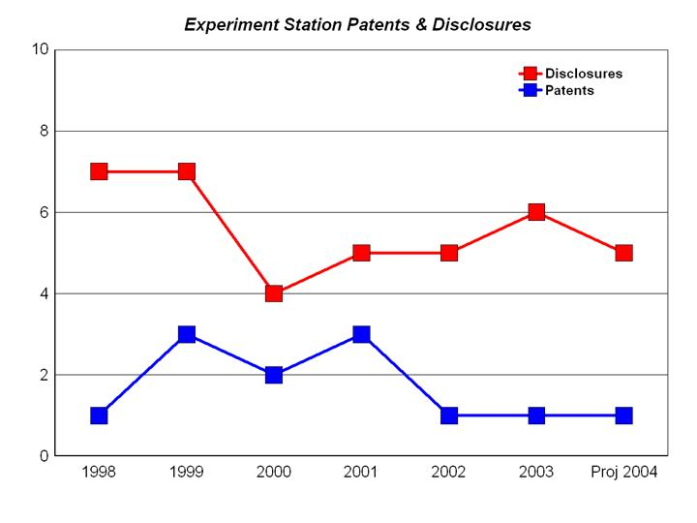

(Table/Graph Series III-1)

- The genetic role of glucose in crop plant development was identified, and implications for human health and development are now being considered.
- Progress continued in the development of the peach genetic map as a model to improve fruit crops
- Agroecology farming practices were identified which can protect the state’s declining quail population and preserve the environment
- Methodologies were developed to incorporate Nano-technology as a part of "smart packaging" initiatives to protect food safety
- Growth regulators and reflective film were shown to produce bigger fruit crops which have the potential to generate higher profits for growers in the state.
- 200 faculty, staff and students are now utilizing the Biosystems Research Complex, including 14 PI’s from 6 different Departments in 2 Colleges. The building is 2/3 occupied with the remaining space allocated for new faculty hires or endowed chair positions
- 21 PI’s from 7 different departments are assigned to Greenhouse Complex which is now at 90% occupancy, and additional infrastructure to support pesticide application and specialized growing conditions has been installed
- New Integrated pest management strategies and sustainable farming practices have been developed.

The Baruch Institute of Coastal Ecology and Forest Science expanded partnership work for endangered species projects involving mapping and estimation of Red-cockaded Woodpecker foraging habitat
- 95% of all wood harvested and delivered in the state was done so by loggers trained in the Timber Operations Professionals Program
- Expanded research in forest ecology by increasing emphasis on modeling and visualization of forest growth.
- Completed the third portion of a 4 part project on prescribed fire public education
- Collaborated with numerous partners on a South-wide water quality project
- Continued work on stream-side stabilization project with the US Army Corps of Engineers
- Partnered with several external institutions for a multi-million dollar coastal forest conservation project to be funded by a grant from a private foundation

