
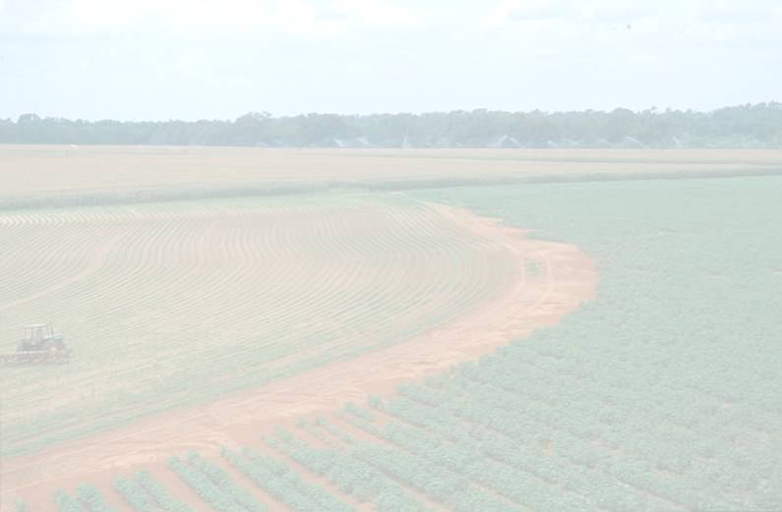
South Carolina
Department of Agriculture

2003-2004 Accountability Report

125 Years of Service,
Protection and Quality

Accountability Report Transmittal Form

Agency Name: South Carolina Department of Agriculture

Date of Submission: September 15, 2004

Agency Director: Hugh E. Weathers, Interim Commissioner

Agency Contact Person: Clarissa Adams

Agency Contact’s Telephone Number: 803-734-2196

South Carolina Department of Agriculture
I. Executive Summary

The South Carolina Department of Agriculture (SCDA) is charged with overseeing the state’s second largest industry: agriculture. While the SCDA serves every citizen of the state, the agency also serves approximately 24,500 farms with cash receipts for crops and livestock totaling $1.7 billion. That agricultural base creates a ripple effect of approximately $7 billion in addition to generating revenue, taxes, and jobs, particularly for the rural communities of the state. Add to that the food and fiber agribusiness sector, and the industry of agriculture in South Carolina is a valuable part of the state’s economy. Nationally, South Carolina ranks near the top in the production of several agricultural products.

The SCDA, a relatively small agency with a $5.1 million budget, has very large responsibilities to both producers and consumers regarding agricultural products, both fresh and processed. The 125 year old agency is dedicated to promoting and heightening the public’s awareness of South Carolina’s agriculture commodities and the farmers who produce them.

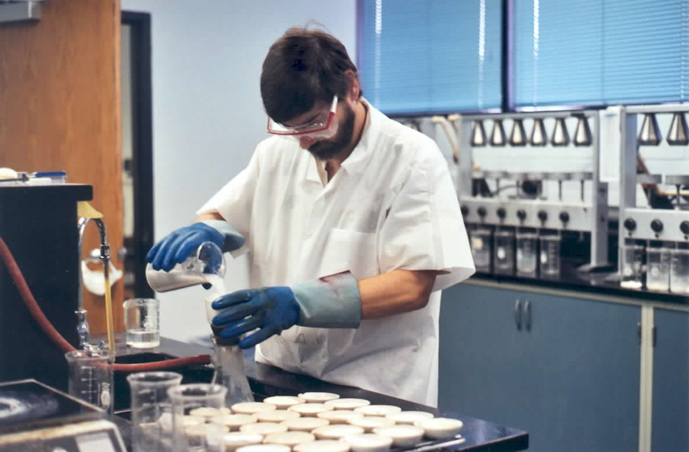
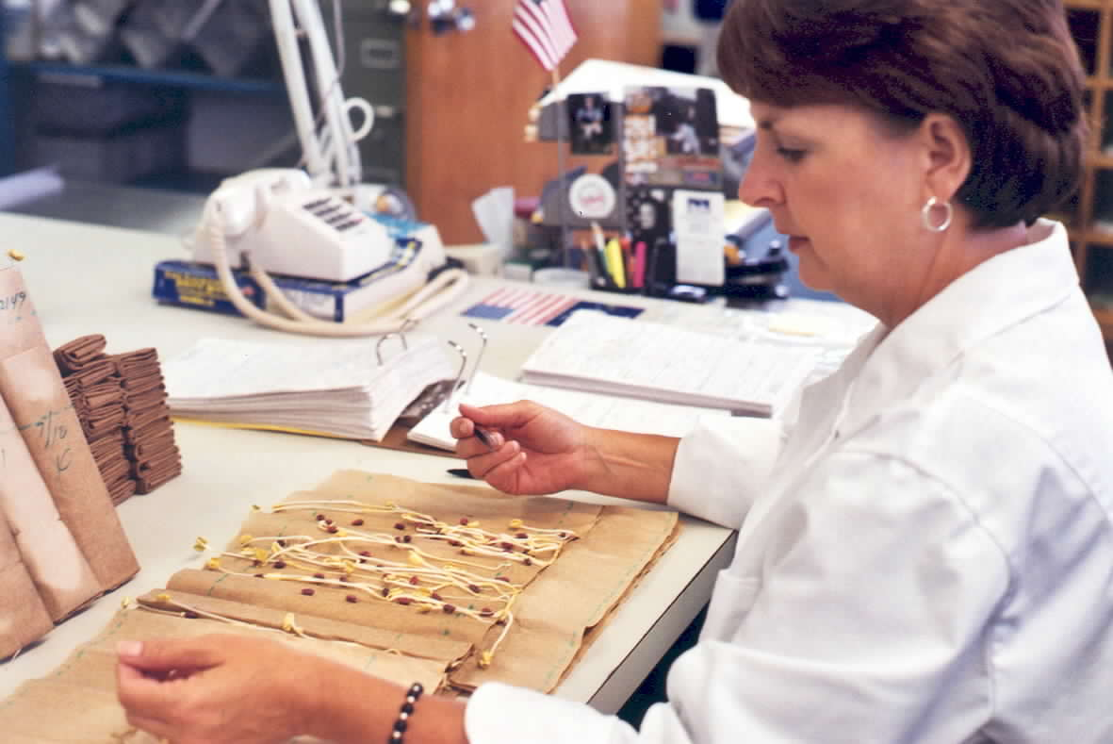

I.1 Mission and Values

The department’s mission is to promote the growth and development of the state’s agriculture industry and its related businesses while regulating the safety and security of the buying public. Our shared vision is for the state’s economy to grow and prosper providing everyone, producers and consumers, opportunities to enjoy the fruits of agriculture.

I.2 Major Achievements

Major Accomplishments include:

- Annual review of the agency’s programs for maximum efficiency of operations
- Use of zero base budget methodology to review program expenses and projection of program needs
- Continued progress on the Columbia Farmers Market relocation/renovation project
- Continued success with the recently developed Agriculture Commissioners Advisory Board of SC – representing each commodity board.
- Special emphasis with small farms programs and organic certification
- Redesigned agency website to offer additional information to producers and consumers
- Registration and licensing forms available online for consumers
- Annual review of personnel and succession planning for the agency’s potential 31% turnover rate
- Homeland Security grant for pesticide residue analysis

1.3 Strategic Goals

The agency’s key strategic goals include:
- Promoting agriculture and agribusiness in the state by providing agricultural marketing assistance
- Maximizing protection of producers and consumers
- Providing public awareness, promotion, and publicity of South Carolina agricultural products
- Effectively managing agency operations and a diverse work force

I.4 Opportunities and Barriers

The agency’s opportunities have been abundant despite significant budget reductions. The most significant barrier has been that the agency sustained a 34.4% budget cut over the last five years.
The SCDA is currently operating at funding levels less than the budget that dates back to 1985.

- FY1985 State Budget $5,434,498
- FY2005 State Budget $4,465,715

Although authorized, the SCDA has been unable to fill 25% of its work force due to severe budget limitations. In the past two years, the vacancy rate has almost doubled. Despite funding levels that date back twenty years and a high vacancy rate, the agency has managed to continue to offer quality services to producers and consumers. While the level of service has remained high, staffing shortages and budget reductions have forced reductions in service.

The loss of key personnel and funds has forced employees throughout the department to assume additional responsibilities. Many employees work overtime. Employees however, continuously strive to perform at a high competency rate. As a result, the agency has placed an emphasis on morale in the workforce.

Agriculture is the state’s second largest industry. Marketing funds could significantly improve the state’s economy; however, lack of funding has prohibited developing the industry to its fullest potential.

Employees throughout the agency voluntarily furloughed a total of approximately 239 days. While the furloughs resulted in savings to the agency, work requirements remained at the same level of demand.

I.5 Accountability Report

The accountability report is an important tool in dealing with today’s challenges and in preparing for the future. A systematic approach is being developed for customer surveys in order to gather reliable measures.

II Business Overview

II.1 Number of Employees: 133.56 Filled FTE’s
43.69 Vacant FTE’s
177.25 Total FTE’s

Agency Vacancy rate of 25%

II.2 Operation Locations

Capitol Complex, Wade Hampton Building
Metrology Laboratory, 237 Catawba Street, Columbia
Consumer Services Laboratory, 1101 Williams Street, Columbia
Columbia State Farmers Market
Greenville State Farmers Market
Pee Dee State Farmers Market

II.3 Appropriations/Expenditures Chart

Base Budget Expenditures and Appropriations

 | 02-03 Actual Expenditures |  | 03-04 Actual Expenditures |  | 04-05 Appropriations Act
Major Budget Categories | Total Funds | General Funds | Total Funds | General Funds | Total Funds | General Funds
Personal Service | $5,331,487 | $3,365,561 | $4,815,053 | $3,268,955 | $4,786,386 | $2,369,476
Other Operating | $3,464,374 | $1,157,345 | $3,731,556 | $919,791 | $4,317,362 | $1,091,362
Special Items | $ | $ | $ | $ | $ | $
Permanent Improvements | $ | $ | $ | $ | $ | $
Case Services | $ | $ | $ | $ | $ | $
Distributions  to Subdivisions | $ | $ | $ | $ | $ | $
Fringe Benefits | $1,594,831 | $1,057,272 | $1,456,754 | $960,115 | $1,596,605 | $1,004,877
Non-recurring | $ | $ | $ | $ | $ | $
Total | $10,390,692 | $5,580,178 | $10,003,363 | $5,148,861 | $10,700,353 | $4,465,715

Other Expenditures

Sources of Funds | 02-03 Actual Expenditures | 03-04 Actual Expenditures
Supplemental Bills | $ N/A | $ N/A
Capital Reserve Funds | $ N/A | $ N/A
Bonds | $ N/A | $ N/A

Interim Budget Reductions

Total 02-03 Interim Budget Reduction | Total 03-04 Interim Budget Reduction
$866,281 | $735,154

II.4

Major Program Areas
Program | Major Program Area | FY 02-03 |  |  | FY 03-04 |  |  | Key Cross
Number | Purpose | Budget Expenditures |  |  | Budget Expenditures |  |  | References for
and Title | (Brief) |  |  |  |  |  |  | Financial Results*
I Administrative Services | Administrative Services -provides executive leadership, support, policy development and review, financial services, computer and information technology, facilities management, personnel services, legal services, and administrative services. | State: | 1,292,084.34 |  | State: | 1,242,903.19
I Administrative Services |  | Federal: | 495,962.76 |  | Federal: | 167,695.79
I Administrative Services |  | Other: | 221,245.73 |  | Other: | 238,355.93
I Administrative Services |  | Total: | 2,009,292.83 |  | Total: | 1,648,954.91
I Administrative Services |  | % of Total Budget: |  | 16% | % of Total Budget: |  | 14%
II Laboratory | Improve the health of South Carolina citizens. Consumer protection regulatory responsibilities include production, storage, handling, transport and sale of food for human consumption. Pesticide residue levels, commercial feed, seed, and petroleum are tested and monitored to ensure levels do not exceed standards. Testing samples are collected throughout the state by Consumer Services inspectors. The program administers product registration and conducts routine inspections for items such as animal feed and pet foods, antifreeze, frozen desserts, cosmetic products, and export certification. Permits are also issued for special services and businesses. The program also provides assistance in the event of an emergency regarding Homeland Security and Bio-terrorism with regards to food safety. | State: | 1,227,238.24 |  | State: | 1,065,886.39 |  | Pages 21-24
II Laboratory |  | Federal: | 4,245.75 |  | Federal: | 997.06
II Laboratory |  | Other: | 0.00 |  | Other: | 55.16
II Laboratory |  | Total: | 1,231,483.99 |  | Total: | 1,066,938.61
II Laboratory |  | % of Total Budget: |  | 10% | % of Total Budget: |  | 9%
III Consumer Services | Provide inspection and analytical weighing services to ensure the accuracy of commercial weighing, measuring and counting devices. Inspection analysis includes gas pumps, grocery store scales, price scanners, vehicle tank meters, and liquid petroleum gas measuring devices. Collect official petroleum, produce, meat, and feed samples for the Laboratory function. Protect grain producers from undue losses by licensing, bonding and auditing warehouses and dealers. Inspect storage industries and facilities for sanitary conditions. | State: | 1,047,663.48 |  | State: | 1,073,349.62 |  | Pages 24-26
III Consumer Services |  | Federal: | 0.00 |  | Federal: | 0.00
III Consumer Services |  | Other: | 153,333.84 |  | Other: | 82,245.97
III Consumer Services |  | Total: | 1,200,997.32 |  | Total: | 1,155,595.59
III Consumer Services |  | % of Total Budget: |  | 10% | % of Total Budget: |  | 10%

II.4 Major Program Areas (Continued)

IV Marketing & Promotions | Improve the economic vitality of businesses and individuals. Maintain and develop broad based marketing programs to increase consumer awareness and product demand for quality SC agricultural commodities at local, national and international levels. Agricultural promotion programs include assisting state producers and processors in exporting commodities to national and international markets, assistance with roadside and community markets, promoting specialty products in international and national trade shows, assisting small farmers and the organic food industry, promoting horticulture, and assisting with rural rehabilitation for the state Woman-Infant Children Farmers Market program and Senior Program. Assistance is provided in markets such as the equine industry, aquaculture industry, etc. Provide assistance to the Commodity Boards related to the specific commodity. | State: | 955,920.43 |  | State: | 806,606.36 |  | Pages 26-31
IV Marketing & Promotions |  | Federal: | 12,834.94 |  | Federal: | 36,316.12
IV Marketing & Promotions |  | Other: | 3,385,330.87 |  | Other: | 3,832,196.31
IV Marketing & Promotions |  | Total: | 4,354,086.24 |  | Total: | 4,675,118.79
IV Marketing & Promotions |  | % of Total Budget: |  | 35% | % of Total Budget: |  | 39%
V | Employer Contributions | State: | 1,057,271.64 |  | State: | 960,115.44
V | Employer Contributions | Federal: | 0.00 |  | Federal: | 3,624.18
V | Employer Contributions | Other: | 537,559.61 |  | Other: | 493,015.16 |  | N/A
V | Employer Contributions | Total: | 1,594,831.25 |  | Total: | 1,456,754.78
V | Employer Contributions | % of Total Budget: |  | 13% | % of Total Budget: |  | 12%
Below: List any programs not included above and show the remainder of expenditures by source of funds.
N/A
 | Remainder of Expenditures: | State: |  |  | State:
 |  | Federal: |  |  | Federal:
 |  | Other: |  |  | Other:
 |  | Total: |  |  | Total:
 |  | % of Total Budget: |  |  | % of Total Budget:
* Key Cross-References are a link to the Category 7 - Business results.
These References provide a Page number that is included in the 7th section of this document.

II.5 Key Customer Segments

The department’s mission is to promote the growth and development of the state’s agriculture industry and its related businesses while regulating the safety and security of the buying public.

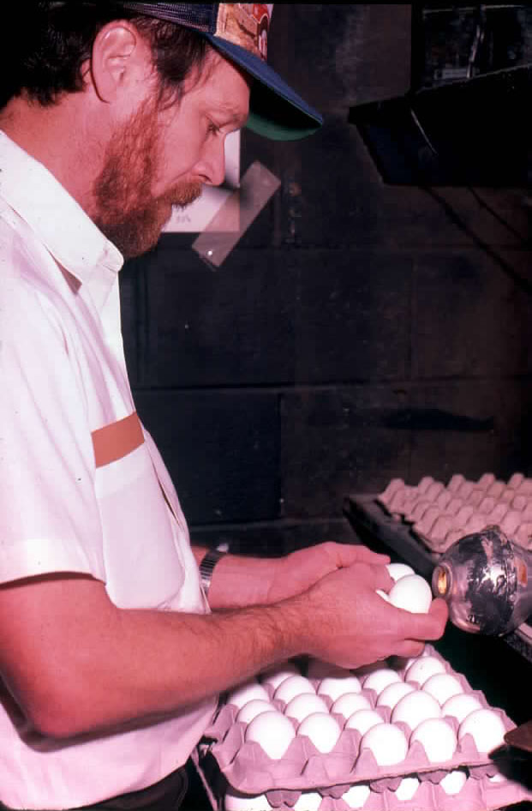
Key Customers include
- Consumers – this includes citizens of South Carolina in addition to citizens that consume SC agriculture products
- Producers - large production farmers as well as small farmers in rural communities
- Processors
- Government Leaders of the state
- Agriculture Commission
- Commodity Boards and Associations
- Existing agribusiness in the state as well as potential agribusiness for the state
- Government leaders in the state, agriculture community.

II.6 Key Stakeholders

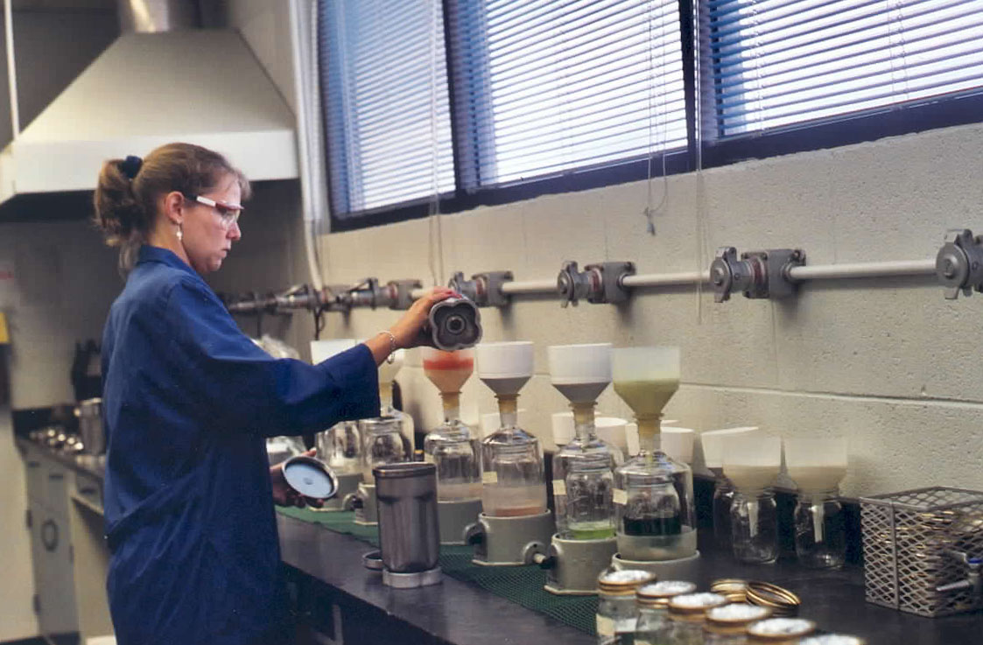
Consumers of South Carolina agriculture products are ultimately the key stakeholders.

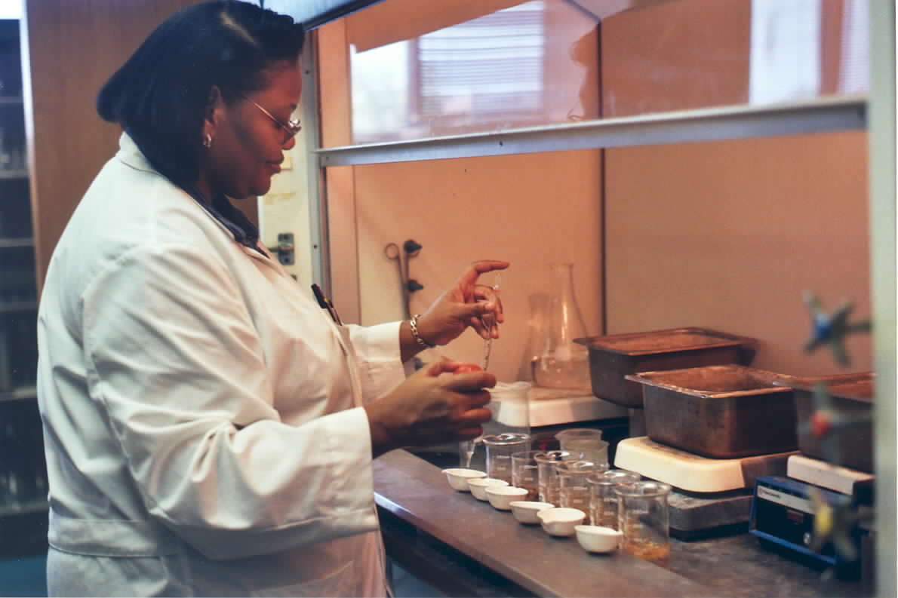

II.7 Key Suppliers

Producers, vendors eligible to bid on state contracts, technology vendors, Federal grant users, and the Federal government which supplies specialty crop grants and USDA cooperative agreements.

II.8 Organizational Structure

S. C. Department of Agriculture
Organizational Chart

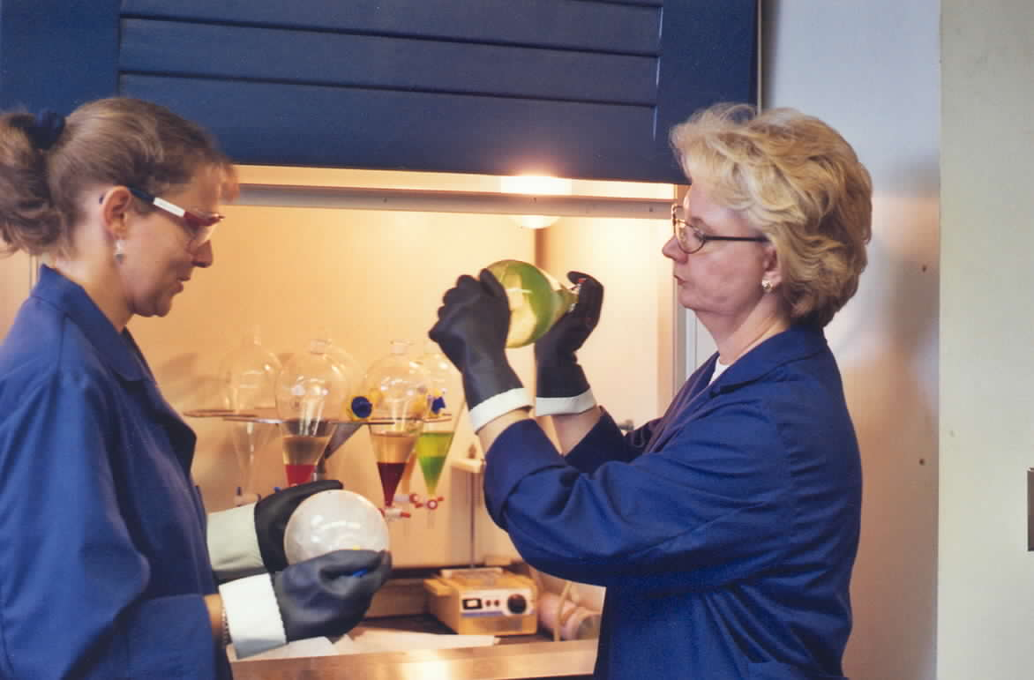

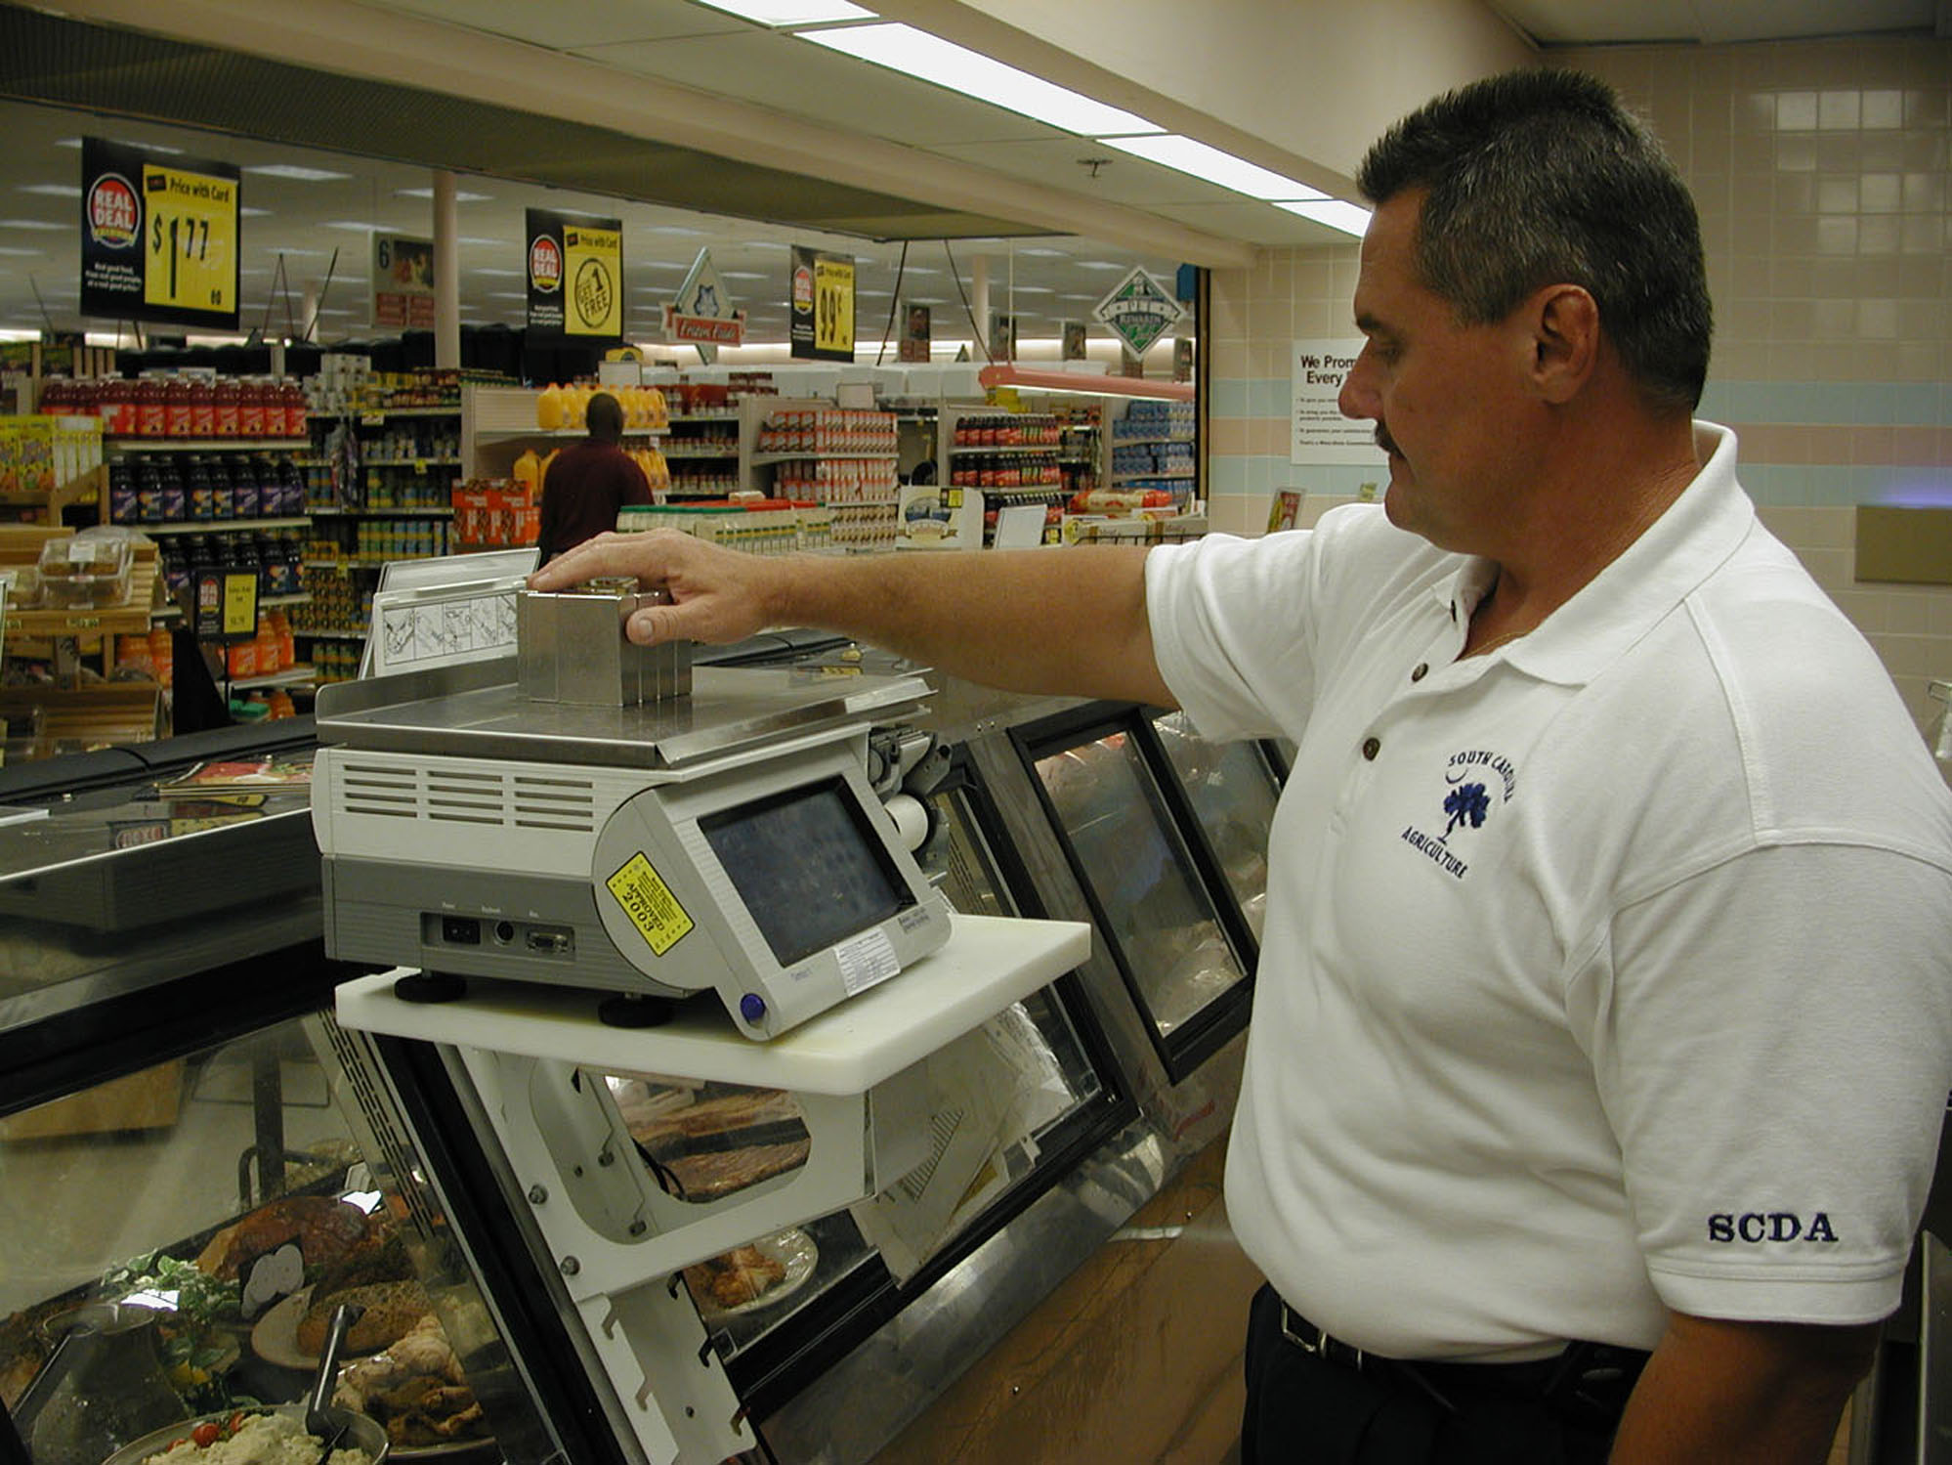

Elements of Malcolm Baldrige Award Criteria

III Category 1 – Leadership

1. 1. How do senior leaders set, deploy and communicate: a) short and long term direction, b) performance expectations, c) organizational values, d) empowerment and innovation, e) organizational and employee learning, and f) ethical behavior?

Senior Leadership at the Department of Agriculture began with the Commissioner of Agriculture, Charles Sharpe. Senior Staff meetings are conducted to discuss short-term issues. The senior staff meetings are very informative and provide an opportunity for the Department to continually assess progress and resolve short term issues. In addition, regular and frequent communication between senior leaders serves as an important part of senior leadership in this Department. Division Directors meet regularly with staff to keep employees apprised of agency issues.

A strategic plan was developed last year to assist with long-term direction for the agency. The strategic plan serves as a useful planning tool for the agency.

The agency has continued the new electronic employee newsletter this past fiscal year. The electronic newsletter includes a message from the Commissioner pertaining to agency issues and performance expectations. Additionally, the Commissioner has met with the entire staff on several occasions to discuss short and long term goals.

Performance expectations are relayed through annual evaluations. In addition, less formal communication occurs regularly between workers and their supervisors.

Senior leadership understands the importance of innovation with regards to the state’s second largest industry. Employees are empowered and encouraged to use initiative when performing their jobs. Additionally, professional development for staff is offered whenever feasible. Division managers and supervisors are active in professional organizations that foster their continued growth in knowledge and expertise in their fields of specialty. Lab scientists and supervisors and technicians are likewise encouraged and supported in outside professional activities that contribute to their growth and professional competence.

In addition, the Agriculture Commissioners Advisory Board of SC, comprised of approximately thirty agricultural commodity organizations, was created in an effort to facilitate a common platform for issues and problems within the industry of agriculture.

1. 2. How do senior leaders establish and promote a focus on customers and other stakeholders?

Customer focus is a key component of the agency’s strategic plan. Every South Carolinian is, in some way, a customer and stakeholder of agriculture. With such a broad spectrum of customers and stakeholders, the agency’s daily operations result in a focus on our ultimate customer. Senior leadership and staff continuously assist consumers with agribusiness, product testing, and inspections to provide reasonable assurances for the consumer.

1.3 How do senior leaders maintain fiscal, legal, and regulatory accountability?

Each major program is responsible for the budget within the division. Monthly fiscal reports are generated and distributed and monitored to ensure fiscal responsibility. The agency’s administrative division and general counsel also provide guidance and advice to senior staff regarding financial and regulatory issues.

1. 4. What key performance measures are regularly reviewed by your senior leaders?

- Tests on feeds, seeds, foods, cosmetic and petroleum products to assure product safety

- Partnerships with stakeholders to promote agriculture in South Carolina

- Buying and selling of the State’s agricultural commodities both fresh and processed

- Food sanitation inspections at locations under SCDA regulatory authority

- Growth and development of the State Farmers Markets

1. 5. How do senior leaders use organizational performance review findings and employee feedback to improve their own leadership effectiveness and the effectiveness of management throughout the organization?

Senior staff meetings and division staff meetings provide a forum for informal, yet meaningful employee feedback. This information is useful in identifying areas for organizational improvement.

1. 6. How does the organization address the current and potential impact on the public of its products, programs, services, facilities and operations, including associated risks?

The agency receives excellent feedback on programs and services from the agriculture community and Commodity Boards and Associations. Testing and inspection error rates provide vital information concerning safety and risk to consumers.

1. 7. How does senior leadership set and communicate key organizational priorities for improvement?

Senior leaders set short-term priorities based on the agency’s strategic plan. Organizational priorities are communicated regularly from the Commissioner to senior staff throughout the year during regular scheduled meetings.
1. 8. How does senior leadership and the agency actively support and strengthen the community? Include how you identify and determine areas of emphasis.

Community volunteerism and giving back to the community is encouraged at the Department of Agriculture. The agency participates in charitable giving primarily through fund raising events such as the United Way. The agency has great interest in Harvest Hope and the Red Cross. The agency had a food drive and also routinely coordinates blood drives at two locations. Educational tours are also available at the State Farmers Markets. Senior leadership serves on many Boards for various organizations throughout the community. Additionally, the Commodity Boards sponsor programs with organizations such as the Girl Scouts.

III Category 2 – Strategic Planning

2. 1. What is your Strategic Planning process, including participants, and how does it account for: a. Customer needs and expectations, b. Financial, societal and other risks, c. Human resource capabilities and needs, d. Operational capabilities and needs, e. Supplies/contractor/partner capabilities and needs

Last year, senior leaders assisted in developing a new strategic plan. Division directors met to discuss the future, to identify the agency’s customers, to determine the purpose and goal of strategic planning, and to develop measurements for success.

Division budgets are submitted outlining the divisions’ needs to meet agency goals. Budgets, including human resource and operational needs, are summarized for the Commissioner. Items are prioritized due to budget limitations and the budget is implemented for the year.

2. 2. What are your key strategic objectives?

- Promoting agriculture and agribusiness in the state by providing agricultural marketing assistance
- Maximizing protection of producers and consumers
- Providing public awareness, promotion, and publicity of South Carolina agricultural products
- Effectively managing agency operations and a diverse work force

2. 3. How do you develop and track action plans that address your key strategic objectives?

The strategic plan was reviewed throughout the year to ensure programs and activities are aligned with long-term and short-term goals. Progress is monitored to ensure and measure success.

2.4 What are your key action plans/initiatives?
Strategic Planning
Program | Supported Agency | Related FY 03-04 | Key Cross
Number | Strategic Planning | Key Agency | References for
and Title | Goal/Objective | Action Plan/Initiative(s) | Perf. Measures*
IVA. Marketing and Promotions IVB. Commodity Boards, IVC. Market Services | Promote agriculture and agribusiness | 1.1 Encourage new and existing businesses to the state which use traditional and non-traditional agricultural products or which service and supply agriculture. | Pages 26-31
 | Promote agriculture and agribusiness | 1.2 Search for new products and look for new value-added ways to use the state's products. | Pages 26-31
 | Promote agriculture and agribusiness | 1.3 Provide assistance to small farmers. | Pages 26-31
 | Promote agriculture and agribusiness | 1.4 Support the growth and development of local farmers markets. | Pages 26-31
 | Promote agriculture and agribusiness | 1.5 Manage three regional State Farmers Markets in Columbia, Greenville, and Florence efficiently and effectively. | Pages 26-31
 | Promote agriculture and agribusiness | 1.6 Market local farm products to consumers and assist farmers through the Certified Roadside Market Program | Pages 26-31
 | Promote agriculture and agribusiness | 1.7 Support expansion and development of local, regional, national, and international markets for South Carolina agricultural products | Pages 26-31
 | Promote agriculture and agribusiness | 1.8 Encourage buying and selling of the state’s agriculture products both fresh and processed through the “South Carolina Quality” Produce Marketing Program | Pages 26-31
II Laboratory Services, III Consumer Services, IVD Inspection Services | Protect producers and consumers | 2.1 Enforce all applicable laws regarding proper warehouse receipting, storage and payment for agricultural commodities. | Pages 21-26
 | Protect producers and consumers | 2.2 Ensure the accuracy of weights and other measurements. | Pages 21-26
 | Protect producers and consumers | 2.3 Work with public and private organizations to solve problems and issues related to agri-safety and agri-security. | Pages 21-26
 | Protect producers and consumers | 2.4 Perform food sanitation inspections at all locations under SCDA regulatory authority. | Pages 21-26
 | Protect producers and consumers | 2.5 Perform tests on feeds, seeds, foods, cosmetics, and petroleum products to assure acceptable quality. | Pages 21-26
 | Protect producers and consumers | 2.6 Grant permits to salvage food operations. | Pages 21-26
 | Protect producers and consumers | 2.7 Inspect and grade appropriate agriculture products for domestic and international markets | Pages 21-26
IVA. Marketing Promotions, IVB. Commodity Boards, IVE Market Bulletin | Provide public awareness, promotion, and publicity of South Carolina agriculture | 3.1 Create promotional campaign that includes publicity items, exhibits, and events designed to increase public awareness of agriculture in South Carolina. | Pages 26-31
 |  | 3.2 Encourage buying and selling of the state’s agricultural commodities both fresh and processed through the “South Carolina Quality” Program.

IVA. Marketing and Promotions, IVB. Commodity Boards, IVE Market Bulletin | Provide public awareness, promotion, and publicity of South Carolina agriculture | 3.3 Develop partnerships with stakeholders to promote agriculture in South Carolina
 |  | 3.4 Provide consumers with information on selection, preparation, and nutrition of South Carolina agricultural products through electronic and print media. | Pages 26-31
 |  | 3.5 Provide an agency publication that allows farmers and non-farmers to buy or sell farm-related items and that features timely information regarding agricultural issues and events.
 |  | 3.6 Collect and disseminate market news information to all segments of the produce and livestock industries and to consumers through various print and electronic means.
I Administrative Services | Effectively manage agency operations and work force | 4.1 Effectively manage financial resources to ensure financial well being.
I Administrative Services | Effectively manage agency operations and work force | 4.2 Create a work environment that promotes performance and employee satisfaction
I Administrative Services | Effectively manage agency operations and work force | 4.3 Evaluate programs and services to ensure customer needs are met.
I Administrative Services | Effectively manage agency operations and work force | 4.4 Evaluate employee performance and provide materials and technological needs to be successful.
I Administrative Services | Effectively manage agency operations and work force | 4.5 Use available technology and aggressively seek new technology to improve office operations
I Administrative Services | Effectively manage agency operations and work force | 4.6 Provide progressive leadership with a clear focus that actively guides the agency.
I Administrative Services | Effectively manage agency operations and work force | 4.7 Provide recognition to those employees for their effort.
I Administrative Services | Effectively manage agency operations and work force | 4.8 Develop a well trained and diverse work force.
I Administrative Services | Effectively manage agency operations and work force | 4.9 Encourage staff to contribute ideas to means and methods of improving the workplace and the operation of the agency.

2. 5. How do you communicate and deploy your strategic objectives, action plans and performance measures?

The strategic plan is communicated from senior leadership.

2. 6. If the agency’s strategic plan is available to the public through the agency’s internet homepage, please provide an address for that plan on the website.

III Category 3 – Customer Focus

3. 1. How do you determine who your customers are and what their key requirements are?

State laws and regulations help determine the agency’s customers. In South Carolina there are approximately 24,500 farms, and numerous producers and processors. Consumers of South Carolina agriculture products are ultimately the key customers.

Other key customers include the General Assembly, the Governors Office, Agriculture Commission, Commodity Boards and Associations, existing agribusiness in the state, Government leaders in the state, and the agriculture community.

Requirements from customers include:
- Assurance that agricultural products offered for sale to the public are honestly represented and meet quality standards.
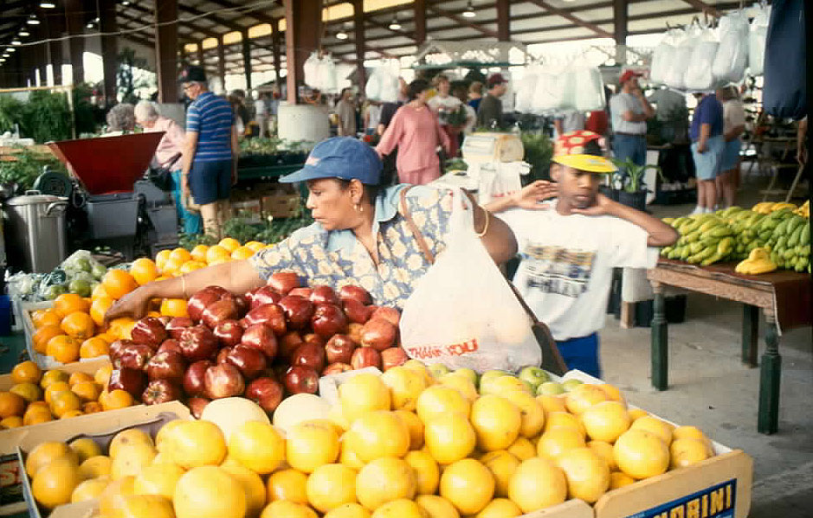
- Assurance of a fair and honest market place where consumers are afforded protection from fraud or unsafe products
- Accurate measurements where commodities are bought or sold.

3. 2. How do you keep your listening and learning methods current with changing customer/business needs?

The agency continually seeks input from farmers and processors on how to improve processes. The agency’s website was redesigned to provide current
information about agriculture and is monitored to determine number of visits to the site. Legislative issues are currently being reviewed and updated to address current and future agricultural concerns.

3. 3. How do you use information from customers/stakeholders to improve services or programs?

A high priority is placed on complaints and requests received from consumers regarding product quality. Complaints are used as one source of data to determine customer satisfaction.

3. 4. How do you measure customer/stakeholder satisfaction?

Customer satisfaction is measured or inferred through meetings/feedback with customers, and through complaint resolution efforts. Ongoing communication provides feedback on how customers’ requirements and expectations can best be filled.

3. 5. How do you build positive relationships with customers and stakeholders? Indicate any key distinctions between different customer groups.

Positive relationships are built with production customers dealing with their programs of interest. Trade show participation, certified Road-Side Markets, shippers’ guide participation, and other general marketing program numbers help gauge success.

Consumer customers recognize “Quality” label and the utilization of local product signage. Employees attend various functions at all levels of participation to assist with building positive relationships. Continuity of employees in key positions also builds a feeling of confidence as we promote South Carolina products.

Production customers travel with employees and make marketing visits to increase marketing presence. Assisting with Boards and Associations in developing programs designed especially for production activities builds positive relationships. Factual information is also supplied for decision processes that affect the survival of individual operations.

The 91 year old Market Bulletin is published twice a month for producers and consumers as a resource for buying and selling agricultural and agricultural-related items as well as a resource for valuable information.

III Category 4 – Information and Analysis

4. 1. How do you decide which operations, processes and systems to measure?

In developing the strategic plan, measurement criteria was evaluated for the entire agency. Performance measures are determined for each major program area within the agency. Senior leadership and staff recognize the importance of service and customer satisfaction.

4.2. What are your key measures?

Key measures include customer satisfaction, employee well-being, and comparison of costs against comparable products and services.

4. 3. How do you ensure data quality, reliability, completeness and availability for decision making?

The agency benchmarks to the private sector and other State Agriculture Departments whenever possible. Many programs are subject to audit to ensure financial effectiveness and procedure compliance.

4. 4. How do you use data/information analysis to provide effective support for decision making?

Data analysis is used in a number of ways to support effective decision making and assess performance while staying abreast of immediate situations.

- Comparative data and trends are evaluated to determine demand levels, cost returns and operational effectiveness.
- Volume pricing, demand trends, and historical weather information relating to local seasonal applications are vital for decision making.
- Negative trends are reviewed by senior management on a regular basis for corrective action.

4. 5. How do you select and use comparative data and information?

Comparative data is selected based on benchmarks relevant to the agency’s mission. Participation in national organizations such as the National Association of State Departments of Agriculture, Southern Association of State Departments of Agriculture and Southern United States Trade Association also provide information for comparison purposes.

4.6. How do you manage organizational knowledge to accomplish the collection and transfer and maintenance of accumulated employee knowledge, and identification and sharing of best practices?

The SCDA has a potential 31% turnover rate due to employees scheduled to TERI or eligible to retire. The agency identified key positions within the agency and began cross training as well as sharing of best practices to assist with the transition.

III Category 5 – Human Resources

5. 1. How do you and your managers/supervisors encourage and motivate employees (formally and/or informally) to develop and utilize their full potential?

Despite severe budget limitations, the Commissioner has placed great emphasis on motivating employees. Programs were continually reviewed to maximize employees’ full potential.

The agency also accommodated employee requests to participate in the Voluntary Furlough program in order to attend to personal needs. Employees took a total of 239 days for the fiscal year.

Employees were also recognized several times during the fiscal year. The agency had an employee luncheon at the end of the calendar year and an ice cream social during Employee Appreciation Week. Service pins and awards were presented to employees at this time.

The agency also routinely publishes an electronic newsletter and posts information via E-mail regarding agency issues.
5. 2. How do you identify and address key developmental and training needs, including job skills training, performance excellence training, diversity training, management/leadership development, new employee orientation and safety training?

The agency attempts to coordinate quality training within the varying technical fields of expertise. Staff is active in professional and scientific organizations that foster continued growth and expertise in their fields of specialty. Staff are also encouraged and supported in outside professional activities that contribute to their growth and professional competence.

The agency conducted its first benefits orientation for staff featuring changes and options for health and dental insurance. The agency also participated in the B&CB Benefits and Health Fair to prepare employees for open enrollment in October.

5. 3. How does your employee performance management system, including feedback to and from employees, support high performance?

The agency’s EPMS system is based on annual reviews. Currently employee’s position descriptions are being reviewed for changes and plans include new planning stages. Throughout the evaluation period, employees are encouraged to communicate issues, solve problems and make continuous improvements. Communication is the most vital form of feedback in improving performance.

5. 4. What formal and/or informal assessment methods and measures do you use to determine employee well being, satisfaction, and motivation?

Performance evaluations and staff meetings provide excellent opportunities to discuss employee needs and help determine employee well being and satisfaction.

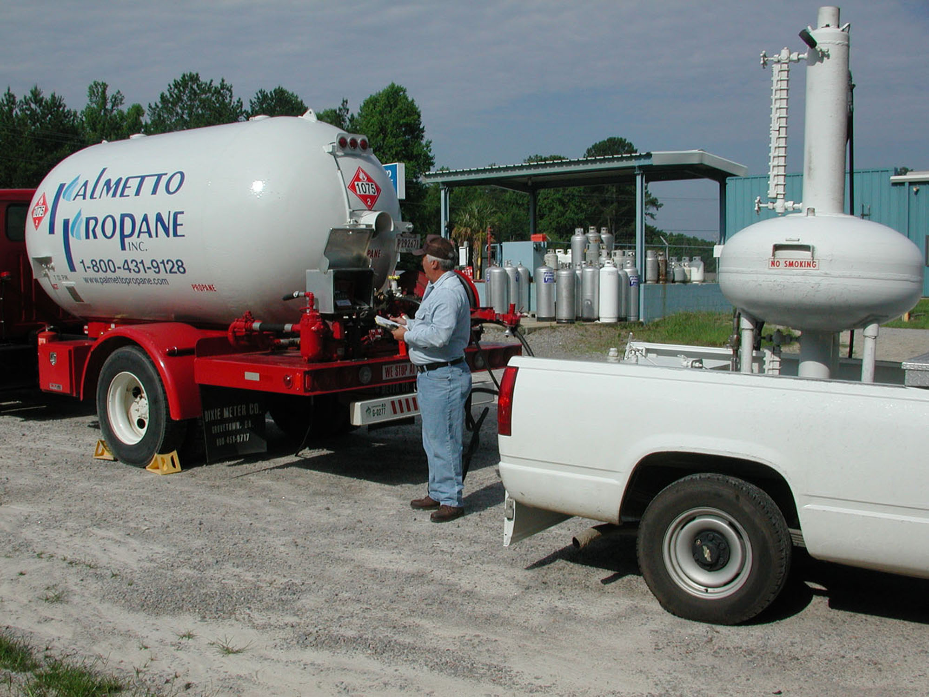
The Commissioner began informal quarterly sessions with staff at the agency’s various locations to gather feedback from employees and garner camaraderie within staff. The Commissioner’s most recent session included hosting a hot dog cookout.

5. 5. How do you maintain a safe and healthy work environment?

Safety is a high priority to the Department of Agriculture. The laboratories conduct regular safety meetings and training sessions. The agency also coordinated with Workers Compensation safety division to assist with safe work practices when collecting testing samples as well as when in processing plants.
As a result of the September 11, 2001 terrorist attack, the agency is also an active participant in the Bioterrorism Advisory Committee, and Agroterrorrism Subcommittee. The agency also participates in the evacuation plan spearheaded by the Budget and Control Board.


Information regarding health issues is distributed electronically on a regular basis to staff. Employees frequently participate in programs offered by Prevention Partners such as diabetes education and health screening.

5. 6. What activities are employees involved with that make a positive contribution to the community?

Staff participates in a number of fund-raising activities such as United Way,
Community Health Charities, and Red
Cross Blood Drives.

The agency also has a plethora of involvement in the community. The agency is filled with Sunday school teachers and leaders, coaches for youth sports, contributors for food drives, counselors, Board members, volunteers at the Town Theater, and many other organizations.

III Category 6 – Process Management

6. 1. What are your key processes that produce, create or add value for your customers and your organization, and how do they contribute to success?

As policies and procedures are developed, standardization and communication have become of utmost importance. Whenever possible, technology is an integral part in meeting the agency’s mission.

Customer requirements are evaluated to assist in determining policy changes, budget requests to maximize delivery of services.

6.2. How do you incorporate organizational knowledge, new technology, changing customer and mission-related requirements, cost controls, and other efficiency and effectiveness factors into process design and delivery?

When developing a process, problems are identified and solutions are weighed to identify the best solution. If necessary, a small test is conducted prior to putting the plan into action. Development as outlined, often takes place during meetings with senior leadership. When necessary a follow up evaluation is conducted to make adjustments.

6. 3. How does your day-to-day operation of these production/delivery processes ensure meeting key performance requirements?

Communication is essential to stay abreast of new developments and to ensure information needs are met. The agency is constantly seeking new and efficient approaches for daily operations.

6. 4. What are your key support processes, and how do you improve and update these processes to achieve better performance?

Key support processes include Administration, Information Technology, Human Resources, Procurement, Finance, Budget, Legislative Liaison Services, and Legal Counsel. These areas are designed to assist the agency’s major programs by providing a qualified work force, funding to support the mission, timely technology, and input regarding legislation and regulations.

With a shrinking work force, technology is a critical component in improving agency performance.

6. 5. How do you manage and support your key supplier/contractor/partner interactions and processes to improve performance?

The agency works collaboratively with producers and processors to help ensure consumers receive the best possible product. While regulatory requirements are designed to help protect the consumer, the agency works closely with agribusiness and other state and federal agencies not only to enhance partnerships, but also to maximize South Carolina quality products.

Alliances and partnerships with public and private organizations continue to be developed to utilize all available resources in a cooperative effort. These alliances have proven to be beneficial in performing services during the budget crisis.

III Category 7 – Business Results

7.1 What are your performance levels and trends for the key measures of customer satisfaction?

The SCDA is comprised of three major areas and one minor area of programs and services:

Program: Laboratory Services

The SCDA is charged with a broad range of consumer protection regulatory responsibilities regarding production, storage, handling, transport and sale of food for human consumption. Assurance of quality and safety of food products from process facilities to marketplace involves chemical, physical, and biological testing of products.

Responsibilities extend beyond food products, to include regulating animal feeds and seeds sold for agriculture and gardening, inspecting commercial weighing and measuring devices, and testing petroleum products sold for heating and automotive uses across the state. In addition, the SCDA administers product registration and conducts routine inspections for items such as animal and pet foods, antifreeze, frozen desserts, and cosmetic products. Permits are also issued for special services and businesses.

The objectives of Laboratory Division programs are:

Receive samples and analyze products from the public food supply to detect adulteration, confirm conformance to standards of identity and quality and assure consumers are protected from fraudulent or unsafe food products.

Sample commercial animal feed and pet foods from the state’s markets for analysis of nutritional and medicinal ingredients for conformance to label guarantees and standards of quality.

Provide seed analysis services to consumers, certifying agencies, seed companies, seed producers, and in support of regulatory surveillance and enforcement under the state’s Seed and Noxious Weed Law.

Receive samples of gasoline, diesel fuel, kerosene, and heating fuel from channels of commerce and test them for conformance to quality standards, label representations and safety.

Administer product registrations required by law including animal and pet foods, frozen desserts, gasoline, antifreeze, and to issue licenses and permits to certain special services and businesses. Licenses or permits are issued for frozen desserts, butterfat testers, samplers and weighers and salvagers.

Laboratory Services division includes:

- Seed Testing
- Pesticide Residue Testing
- Food Labeling Testing
- Feed Testing
- Petroleum Testing
- Seed Licensing
- Food & Safety Council
- Product Registration

Meeting the objectives represents a considerable volume of laboratory effort as is reflected in Tables I and II.

TABLE I. DIVISION WORKLOAD BY YEAR

99/00 00/01 01/02 02/03 03/04

Food Samples 3,644 3,526 3,654 4,143 3,129
Animal Feed Samples 1,406 1,694 1,953 1,993 1,674
Seed Samples 18,691 14,252 14,413 16,423 17,251
Petroleum Samples 2,137 1,518 2,918 2,854 2,407
Registration Transactions 3,096 2,765 3,654 2,681 2,641

TABLE II. NUMBER OF ANALYSES PERFORMED BY YEAR

99/00 00/01 01/02 02/03 03/04

Food Analyses 13,382 12,623 11,029 10,383 11,866
Feed Analyses 4,767 4,405 5,804 5,445 7,142
Seed Analyses 26,709 23,695 23,199 22,824 24,882
Petroleum Analyses 12,710 9,976 19,869 16,647 15,093

Year to year fluctuations in samples analyzed and numbers of analyses performed are more or less random for foods, feeds and seeds. Petroleum samples and analyses were again down slightly from a year earlier owing to temporary staff realignments dictated by the temporary loss of our petroleum chemist to military service in Iraq. Petroleum lab work was covered for more than half of the year by chemists shifted out of the Feed Lab into the Petroleum Lab. This shifting around of technical people produces a little distortion of productivity measures when compared year to year.

The efficiency of the Laboratory Division’s testing and analytical effort is reflected in the per sample and per analysis cost to produce work results. These costs have been computed for each section of the laboratory and are elaborated on below:

Registration Office
Registration Office transactions averaged a cost of $24.61 per transaction. This cost was up 5.9% over the prior year on a slight decrease in the total number of transactions for the year.

Food and Pesticide Residue Lab
Food sample testing costs were $111.56 per sample, up only slightly from the prior year. The cost per analysis was $28.54, down 8% from the prior year owing to an 8% increase in the number of analyses performed.
Feed Laboratory
Feed Lab sample work was performed in FY 04 at a cost of $126.92 per sample and $41.93 per analysis down 28% and 29% respectively. The decrease owed mostly to the decreased Feed Lab staffing because of the need to shift a Feed Lab person into the Petroleum Lab to cover the loss to military service of the Petroleum Lab chemist.

Seed Lab
Seed analyses were performed in FY 04 for a cost of $28.04 per sample and $19.44 per analysis. These figures were down from the previous year owing to loss of analyst which spread the work of the lab over a smaller workforce.

Petroleum Lab
Petroleum Lab work was performed for a cost of $55.62 per sample and $8.87 per analysis. This is an increase of 39% for sample testing cost and 43% on a per analysis basis. The increase is attributable to personnel realignments during the year necessitated by the calling of our regular petroleum chemist into active duty in the Army.

The outcome of the Laboratory Division’s work can be assessed by reviewing compliance records for each of the program areas. Table III affords such information in violation rates recorded by year.

TABLE III. VIOLATION RATES FOUND BY PROGRAM OVER 5 YEARS

PROGRAM FY 00 FY 01 FY 02 FY 03 FY 04

Food 12.0% 10.7% 5.2% 7.7% 7.36%
Pesticide Residue 1.6 2.4 3.2 1.2 2.47
Feed 21.0 20.8 10.8 15.3 19.50
Seed 13.6 7.9 4.5 6.0 6.30
Petroleum 6.2 5.2 2.5 1.9 3.15

The food program continues to show a compliance rate in the 6-8% range with excess fat in ground meats being the most frequent type of violation.

Pesticide residue violations are mostly technical in nature and do not represent a significant food safety threat. It is rare that these technical violations necessitate any enforcement action. The pattern of pesticide residue violations observed in our laboratory mirrors the pattern of violations found nationwide in USDA’s “Pesticide Data Program”.

Animal feed violations continue to occur in the range of 15 to 25% as they have over many years. This rate is typical for feed products both in our experience and that of other states.

Seed Lab violations observed remain around 6% again reflecting improved quality assurance by seed merchants compared to past years.

At 3%, petroleum violations continue to reflect the rates observed nationally where petroleum laws are in force. Based on these violation rates, South Carolina consumers can be confident that petroleum products they buy in the state meet ASTM standards and are fairly labeled.

Program: Consumer Services

Consumer Services Division includes:
- Weights and Measures
- Metrology Laboratory
- Food and Cosmetic
- Sample Collection for the Laboratory Testing function
- Licensing of State Warehouses for Storage of Cotton and Grain
- Licensing of Dealers and Handlers of Agricultural Products
- Licensing of Public Weighmasters
- Administration of Warehouse Guaranty Fund, Grain Producers Guaranty Fund, and Dealers and Handlers Guaranty Fund

Number of Firms and Devices Inspected under Weights and Measures Law
Number of Official Samples Drawn for Laboratory Division
Number of Standards Calibrated by Metrology Lab Per Fiscal Year
Percentage of Weighing and Measuring Devices Found Incorrect
Percentage of Packages Incorrectly Labeled as to Net Content
Per Fiscal Year

Number of Food Manufacturers and Food Warehouses Inspected
Number of Licensed Public Weighmasters

Per Fiscal Year

Number of Licensed Dealers and Handlers of Agricultural Products
Number of Licensed Warehouses for the Storage of Cotton or Grain
Number of Audits of Licensed Dealers, Handlers, Warehouses Per Fiscal Year

Program: Marketing and Promotions

The South Carolina Department of Agriculture is charged with the responsibility of maintaining and developing broad based marketing programs to increase consumer awareness and product demand for quality South Carolina agricultural commodities at local, national and international levels. The South Carolina Department of Agriculture also encourages expansion and development of existing industries that utilize South Carolina agricultural commodities, both fresh and processed, thereby increasing the marketability of locally grown products. In support of our marketing program, our inspection and market news programs provide quality grade standards and up-to-date firsthand market news through a cooperative status with USDA to the allied industry.

Marketing divisions include

- State Farmers Markets
- International & National Products
- Fruit & Vegetable
Grading &
Inspection
- Grain Grading &
Inspection
- Poultry & Egg Grading & Inspections
- SC Quality Program
- Commodity Board
- Roadside Markets
- Livestock Market News
- Fruit & Vegetable Market News
- Horticulture
- Aquaculture
- Equine

State Farmers Markets

The SCDA operates State Farmers Markets in Columbia, Greenville and Florence. The Markets provide facilities for farmers to conduct direct sales of fresh produce to both consumers and major food distributors. The Markets serve as food distribution hubs. In addition, produce is shipped directly to grocery chains, restaurants, and industrial food handlers. The service area of the Markets extends beyond the boundary of the state, supplying produce throughout the eastern United States and Canada.

A source of fresh, locally produced fruits and vegetables, the markets are also major venues for the sale and distribution of horticultural products that draw consumers from a broad geographic area. Spring and fall plant and flower festivals are a main draw for the markets, and help promote year-round business to the markets.

The Columbia and Greenville State Farmers Markets operate 24 hours a day for wholesale operations, closing only on Thanksgiving and Christmas days. The Columbia Market is the second largest Farmers Market in the Southeast in volume of produce, next only to Atlanta.

Columbia State Farmers Market:
The Columbia Market is the largest and most complex of the three markets. The market provides facilities for daily sales by farmers; monthly or seasonal leases to farmers, wholesalers and retailers; and long-term leases to farmers, wholesalers, retailers, restaurants, and food processors. Numerous private sector jobs are supplied at the facility, though many are seasonal in nature.

The Columbia Market is in need of significant repairs and improvement. Most of the buildings and sheds were constructed in the 1950’s, and are in need of repair. Major structural repairs are needed; however, the uncertainty of whether or not the market will be relocated makes it difficult to justify long-term investments.

Greenville State Farmers Market:
Wholesale operations are predominant at the Greenville Farmers Market. The facility provides the same services as the Columbia market, but on a smaller scale. A private poultry processing plant is located within the facility, but not on market property. Improvements to the market are needed to help ensure present day standards are being met by food handlers.

Pee Dee Farmers Market:
The Florence Market provides daily space for farmers and long-term leases to wholesale and retail operations. Harvest Hope Food Bank operates a regional distribution center from the market providing food products to people in need.
The market currently has a waiting list for additional rental space; however additional building space is necessary to meet demands.

Farmers Markets Revenue and Disbursement

 | Revenues | Disbursements
FY 00-01 | $1,285,667.12 | $1,406,868.98
FY 01-02 | $1,583,895.70 | $1,397,787.07
FY 02-03 | $1,609,293.92 | $1,562,276.30
FY 03-04 | $1,543,611.21 | $1,596,176.13

Market and Promotions

The performance level of the Marketing Division is controlled by factors far beyond the realm of our state. Weather conditions, volume harvest, supply and demand are just a sample of factors that influence the performance of this Division.

Services offered however are available in “bad” crop years as well as “good” crop years. Participation by the industry affects our ability to perform at a maximum level.

The Division suffered budget reductions last year thereby restricting activities in continuing consumer awareness campaigns regarding local products. Various joint cooperatives and brokers are utilized to maintain as much awareness of local products as possible.

Listed below are results for the agency’s major marketing programs.

- Utilization and orderly marketing of 410 million plus pounds of South Carolina’s major fresh fruit and vegetable crops.

- Maintained the level of awareness at consumer level in South Carolina retail and food service establishments.

- Maintained consumer confidence in food channels, supporting healthy nutritional diets while removing fear of contaminated products, thereby increasing fresh and processed product consumption.

- Continued exposure and high visibility of South Carolina specialty products, both fresh and processed, at all levels of retail and wholesale trade.

- Established and maintained South Carolina growers as number two in peach production, number two in flue-cured tobacco production, number seven in tomato production, number nine in watermelon production, number eight in turkey production, number eight in sweet potatoes, number nine in peanut production, number thirteen in cotton production, and number fourteen in pecan production.

- Worked to stabilize decreasing numbers in fresh fruit and vegetable production industry with cooperative cost effective marketing plans, programs, and promotions.

- International Market Development – Agricultural exports from South Carolina for 2002 estimated at 259.10 million dollars.

- Certified Roadside/Direct Marketing – Serving 115 plus markets and direct sales outlets.

- Domestic Market Development – Participated in seven National Exhibitions, various regional promotional exhibitions, contacted over 500 chain and food service buyer/establishments. Coordinated in-state visits for chain and food\service buyers with outlets numbering over 5,000.

- Specialty Products – Assisted the 60 plus specialty product manufacturers and distributors through South Carolina trade shows and supplying trade leads.

- Sheep, Goat, and Ratite Development and Expansion – Worked with individuals and groups to further develop and expand this industry to its maximum potential for South Carolina producers. Assisted with meetings that included producers, processors and food brokers to establish markets and market demand with profit potential.

- S. C. Quality Program – A program to increase overall awareness of South Carolina products, working with 70 plus members and most chain food stores operating in South Carolina.

- Equine Program – Served 50,000 owners with 100,000 plus animals that have an estimated economical impact on our economy of 400 million dollars. Also worked with the Horse Council’s membership of 500 plus.

- Aquaculture – Coordinated activities of aquaculture and striped bass association with membership of 60 plus. Worked closely with legislative issues and national associations.

- Home Economist/Nutritional Program – Worked with national 5 A Day Program, S. C. School Lunch Challenge, Farm City Week, DHEC and Harvest Hope Food Bank. Also through 125 plus television and radio spots promoted nutritional and healthy diet and lifestyles to all of South Carolina with over-laps into neighboring states.

- Ornamental Horticulture Program – Worked with 600 plus members of the Nurserymen’s Association, green house growers, landscape, and turf and sod producers. The green industry had sales listed at 1.4 billion dollars in their latest poll.

- Agribusiness Support Services – Assisted over 100 established agri-business firms with marketing and production assistance. Also with packaging, transportation, and other aspects of business for profit and expansion within South Carolina.

- Pecan Producers and Processors – Worked with three commercial processors and with South Carolina production estimated at 1 million lbs.

- S. C. Commodity Board Program – Assisted the present S. C. Commodity Boards with their collections, marketing, administrative, and other related duties to promote sales, usage and research for each.
Cotton Board: 326,000 bales on 218,000 harvested acres
Soybean Board: 11.8 million bushels harvested on 420,000 acres
Peanut Board: 58 million pounds harvested on 20,000 acres
Watermelon Board: 100+ million pounds harvested on 7,000 acres
Pork Board: 250,000 hogs and pigs
Cattle and Beef Board: 430,000 cattle and calves
Tobacco Board: 63 million pounds on 30,000 acres

- Major Agricultural Associations – Coordinated and worked closely with Chairmen and Association Boards with their administrative, marketing, financial guidance, and other related items.
S. C. Peach Council: Weather condition limited production to 100 million pounds on 16,000 harvested acres
S. C. Tomato Association: 10.2 million pounds on 3300 harvested acres
S. C. Watermelon Association: 100+ million pounds on 7000 harvested acres
S. C. Corn Growers Association: 22.5 million bushels on 215,000 harvest acres
S. C. Soybean Association: 11.8 million bushels harvested on 420,000 harvested acres
S. C. Horsemen’s Council: Worked with 500+ memberships and over 100,000 animals

Market Bulletin

The 91-year-old Market Bulletin is published twice a month for producers and consumers as a resource for buying and selling agricultural and agricultural-related items. The Market Bulletin includes information designed to encourage buying and selling of the state’s locally grown produce through the “South Carolina Quality Program” and hundreds of agricultural events. Each time all items in the ads are sold, millions of dollars are generated into the state’s economy.

In keeping with technology ads for the agency publication can be received electronically and an effort is underway to provide on-line subscription for those who would rather subscribe to the Market Bulletin via the internet.

Website

The website has become a valuable tool for all state agencies. Farmers and non-farmers have access to information such as a weekly Market News Report, SC Farm Report, daily Peach Reports, lists for packers, stockyards, auction markets, vet services, USDA information, and US grades for steers, cattle and meat goats. Links were established to external sites for easy access to frequent inquiries such as climatology, plant diseases, home and garden information, and boll weevil eradication.

An Emergency Preparedness section was included to provide information for livestock owners on evacuation sites, information on how to evacuate livestock, and links to the South Carolina Emergency Management Division.

Printing

A variety of brochures and publications are produced in-house throughout the year. Items such as the South Carolina Produce Shippers Guide was published and distributed to buyers and sellers to assist in marketing 850 million pounds of South Carolina produce. The guide lists over 165 South Carolina produce shippers.

Excluding print materials produced at printing companies, 76 print jobs were produced in-house. The total cost of printing copies in the agency’s print shop was produced at a substantially lower cost than a private printing company.

Public Information

As part of the media relations effort to support public awareness, promotion, and publicity of South Carolina agricultural products, pertinent news releases were sent during the fiscal year describing important food recalls, agricultural meetings, events, and other news.

A cooperative effort was developed with other individuals and organizations to provide videotape services as needed. Most recently a service station inspection video was produced and can be used for training new inspectors.

