STATE OF
SOUTH CAROLINA

DEPARTMENT OF INSURANCE

AGENCY ACCOUNTABILITY REPORT

FISCAL YEAR 2003-2004

TABLE OF CONTENTS

Section I -Executive Summary
Significant Achievements page 5

Section II- Business Overview
Employees and Operations page 8
Expenditures/Appropriations Chart page 8
Key Customers page 12
Key Suppliers page 12
Description of Products and Services page 12
Organizational Structure page 13

Section III- Elements of Malcolm Baldrige Award Criteria Category 1-Leadership page 14
Category 2-Strategic Planning page 15
Category 3-Customer Focus page 15
Category 4-Measurement, Analysis & Knowledge Management page 15
Category 5-Human Resource Focus page 16-17
Category 6-Process Management pages 18-38
Category 7-Business Results pages 18-38

EXECUTIVE SUMMARY

Mission and Values

The South Carolina Department of Insurance (Department) is charged with the protection of the insurance consumer, the public interest, and the insurance marketplace by ensuring the solvency of insurers; by enforcing and implementing the insurance laws of this State; and by regulating the insurance industry in an efficient, courteous, responsive, fair, and equitable manner. The Department accomplishes this mission through professional services, which include, but are not limited to, examinations and audits of insurance underwriters; consumer education, outreach and assistance; premium tax and fee collection on behalf of the State and its subdivisions; prior review and approval of certain insurance premium rates and insurance policy forms; and licensure of insurers and insurance-related individuals and entities. The Department was created by S.C. Code Ann. Section 38-3-10, et seq. (1976, as amended, and Supp. 1997). It is managed and operated by a director appointed by, and serving at the will of, the Governor upon the advice and consent of this State’s Senate. Our mission is accomplished through the administration of several areas. The Department has established a series of guiding principles and values, among these, the highest priority is given to the following: integrity, accountability, concern regarding the issues that affect our stakeholders, professionalism, customer service, leadership, employee growth and development, open lines of communication with all stakeholders, and ultimately, a quality performance, providing the best service possible to our stakeholders.

Strategic Goals

Guidance and direction for the Department is achieved through the development of a yearly strategic operating plan that incorporates the agency’s five-year vision plan. The Department continues to strive toward the five-year goal of being recognized internationally as a model agency providing quality service through efficient, effective and equitable regulation of the insurance industry. Furthermore, the Department will be an organization: with satisfied customers; that has dedicated, courteous, knowledgeable, and professional employees; that maximizes the use of available resources for the benefit of its customer base; and that is committed to promoting a competitive market that offers insurance consumers a choice of various insurance coverages provided by a number of insurers. This past year, the Department made tremendous strides toward the achievement of these goals.

Ongoing priorities for the Department include the effective regulation of the insurance industry through the assurance of company solvency and compliance with related state laws and regulations. Financial examinations and financial analysis audits to help reduce the number of insolvencies within the industry are also a priority. By implementing these activities, insurance costs are reduced and insurance products are available for South Carolinians. Consumer Services and Public Information remain priorities for the Department as these areas have the highest public profile of all our program areas. The Policy Forms and Rates Program area ensures that forms, rules and rates used by all lines of insurance meet the statutory requirements.

National Overview

The American economy seems to be emerging from a downturn and recently, we have seen a softening of the prices in the insurance market. It has been a year of review and change for insurance regulation. The debate over state versus federal regulatory oversight continues to take center stage as the most controversial topic on the horizon. A draft proposal from the House Financial Services Committee chaired by Congressman Oxley of Ohio, and its subcommittee on insurance chaired by Congressman Baker of Louisiana, has been developed and is currently under review.

The National Association of Insurance Commissioners (NAIC), of which the former South Carolina Director of Insurance, Ernst N. Csiszar, was President until his resignation August 18, 2004, has and continues to work with members of Congress and state legislators to expand state adoption of national regulatory standards. The standards will provide a streamlined system of effective regulation across the United States.

The NAIC has prepared a detailed framework covering 15 areas where national standards can be effectively implemented to include market conduct uniform standards, company licensing, agent licensing, life insurance, property/casualty commercial insurance, property/casualty personal lines, surplus lines, reinsurance, antifraud network, antitrust exemption and rate regulation, state-national insurance coordination partnership, viaticals, interstate compact for health insurance processes, financial surveillance enhancements and receivership. Several of these areas have already been reviewed and programs implemented by state departments of insurance to include South Carolina.

Department Activities

The South Carolina Department of Insurance continues to strive toward the utmost protection of the consumer as outlined in our mission statement. The staff utilizes a business-model approach to management, which is extremely effective in the insurance regulatory field. Because of these solid business practices, the insurance industry operates efficiently and effectively in South Carolina’s regulatory environment, thus helping to lower premium costs. Revenue that includes premium taxes, license fees, penalty fees, etc. is collected from insurance agents and agencies operating businesses in South Carolina. These funds are deposited into the State’s general fund. To date, for this fiscal year, an estimated $140 million has been collected.

The passage of Act No. 331 in 2000, referred to as South Carolina’s Captive Insurance Law, is another mechanism by which the State’s economy is strengthened. The Act enables the Department to aggressively develop the captive insurance industry in South Carolina. This emerging market is important because it not only provides alternative forms of insurance to South Carolina’s consumers, but it has also created an environment that has attracted captive companies to establish offices in South Carolina. This economic development approach to the regulation of the insurance industry is a boost to South Carolina’s economy. To date, 95 captive insurers have been licensed in South Carolina. The number of licensed captive insurers in South Carolina will exceed 100 by December 31, 2004. Conservative estimates reflect that the South Carolina captive insurance industry has had an approximate $5.5 million impact upon the South Carolina economy. During the 2004 legislative session, H.5002 passed, which provides for the creation of Special Purpose Financial Captives to achieve greater efficiencies in structuring and executing the securitization of risks for captive insurance companies. This legislation is yet another tool for expanding the presence of licensed captive insurance companies in South Carolina. The Department’s website, www.doi.state.sc.us provides extensive information regarding the development and management of captives organizations and the captives market within South Carolina.

Additionally, the Department has attempted to respond to market availability issues in South Carolina by attracting new carriers to the market. Where possible, the Department has reviewed and improved its regulatory processes and increased its efforts to recruit insurers writing health and other insurance products to the South Carolina insurance market place. Thus, South Carolina’s response to the hardened market is to attract industry thereby increasing competition. It has been successfully demonstrated that increased competition within a market directly benefits consumers by enhancing the choice of insurance products.

Current market pressures for uniformity in insurance regulation have required an intense review of the State’s current “prior approval” approach to the review of forms and rates, including endorsements. External pressures for a “speed to market” approach have been weighed against the agency’s responsibility to the public to ensure that each insurer continues to legally and ethically transact its business in South Carolina and its contractual obligation or “promise to pay” is met. This review has resulted in the development and passage of legislation toward file and use protocols with certification from insurers that their products comply with South Carolina laws. In accordance with NAIC efforts to advance uniformity and reciprocity in the regulatory environment, South Carolina has enacted “speed to market” initiatives. This electronic system allows a 23-day turnaround in the filing review cycle. To date, 1,300 companies are currently licensed to use this system and have utilized it for more than 50,389 filings. Emphasis continues to be placed upon the importance of continued market conduct review activities so as to ensure consumer confidence in the products entering South Carolina’s marketplace.

South Carolina continues to utilize the System for Electronic Rate and Form Filing (SERFF) along with 48 other states. State regulators and insurers alike understand the benefits offered in terms of cost efficiency, increased accuracy and more accurate status tracking. More than 76,000 filings were channeled through SERFF in 2003. As of August 31, 2004, over 93,000 filings had been submitted via SERFF for 2004. State insurance departments are also implementing the Uniform Product Coding (UPC) Matrix. This initiative will establish uniform product naming convention with SERFF. This is a key element of the state insurance department’s speed to market initiative. SERFF was essentially created to improve efficiency of the rate and form filing and approval processes and to reduce the time involved in making regulatory filings.

Without additional resources, the Department of Insurance has continued to implement process changes in compliance with federal mandates such as the Gramm-Leach-Bliley Act of 1999. In May of 2002, the Single Model Producer Licensing Law was approved by the House and Senate and subsequently signed into law. The Single Model Producer Licensing Law benefits consumer, agents and insurers by providing better protections and safeguards. Consumers may now quickly access information online and review information about a licensed insurance agent.

Licenses for individual nonresident producers are processed via an agreement with the National Insurance Producer Registry (NIPR) that was established following the implementation of the Single Model Producer Licensing Law. Insurance agents pay a one-time licensing fee, enabling agents to maintain a lifetime license. There is also a reciprocity component that allows resident insurance agents an opportunity to become licensed in other states as well. To date, 5000 non-resident producer licenses have been processed through the on-line system. Companies have used the online system to appoint 38,160 agents to represent them. More than 20,643 terminations were made utilizing this system. Companies utilizing this system made more than 20,643 appointment terminations.

The Department was accredited in 1990 by the National Association of Insurance Commissioners. Accreditation refers to a comprehensive set of standards designed to establish consistent and effective regulation of the financial condition of insurance companies. The goal of the program is to ensure that a state’s solvency regulation meets certain minimum requirements so that other jurisdictions can have a degree of confidence in the State’s oversight of its domestic industry. This promotes efficiency by allowing each state to focus its resources on its own domestic insurance industry. This process avoids duplicative analysis and examinations of insurers by non-domiciliary states. Achieving accreditation is an indication that the state has the procedures in place to protect policyholders through monitoring insurer solvency. Solvency monitoring is one of the Department’s greatest strengths. During the NAIC 2001 review, the South Carolina Department of Insurance ranked among the states with the highest accreditation scores for its solvency surveillance processes and procedures. The Department is scheduled to go through the fourth round of accreditation in 2006.

Significant Achievements

Personal Lines Rate Modernization Act, S.686

The passage of S.686, Personal Lines Rate Modernization Act, was the top priority of the Department’s 2004 legislative agenda. The goal of this legislation, to streamline the rate approval process, will attract more insurers to enter the market in South Carolina, thereby giving consumers more options when shopping for coverage. The bill allows for “flex rating” (using rating bands of +or-7%, currently used with respect to auto coverage). There are provisions within the Act that allow the Director to declare the market competitive; if this occurs, then “file and use” will replace the flex rating method.

Uniform Regulation Through Technology Award

In March of 2004, the Department received the Uniform Regulation Through Technology Award (URTT). The award was given for the Department’s successful implementation of 12 technology-based initiatives. These initiatives dramatically enhance communication and interaction between the nation’s insurer’s and insurance regulators, by emphasizing efficiencies in the areas of agent and broker licensing and continuing education, the licensing process for foreign insurers, the filing and approval process for rates and policy forms, and reporting of financial data used by insurance regulators. A total of 46 state insurance departments have completed these initiatives.

HRSA State Planning Grant Program

Following a review of the status of insurance within the small group market in 1999, the Department of Insurance applied for and received a State Planning Grant from the U.S. Department of Health and Human Services, Health Resources and Services Administration (HRSA). The primary focus of the grant project has been to formulate state policy initiatives to reduce the number of uninsured. This includes both expanding health insurance coverage for the uninsured and stabilizing the market for those who are currently insured so they do not lose their insurance coverage. Issues facing the uninsured and the small employer health insurance market were considered during the grant research. These included affordability, increased cost sharing for employees, decreased benefit plans, decreased competition, lack of knowledge of available public programs, lack of awareness of small group insurance laws and inappropriate use of the health care system. Because most people obtain insurance coverage through their employment, the State Planning Grant has focused on the small group health insurance market where problems of affordability and availability appear to be more acute. This twenty-four-month project included the development and formulation of a Health Insurance Policy Advisory Committee (HIPAC) to work with the Department grant team on data analysis and policy formulation. The project also involved the examination of existing data and the collection of state-specific health insurance data through interviews, focus groups and surveys.

In an effort to provide greater outreach opportunities, the Department hosted a series of five Small Business Health Benefit Fairs in Columbia, Greenville, Charleston, Hilton Head Island and Myrtle Beach this past June, July and August. These free events were made possible through the U.S. Department of Health and Human Services, Health Resources and Services Administration, State Planning Grant Program. The one-day fairs provided an opportunity for small employers and their employees to gain additional knowledge and a greater awareness of the health care options that are currently available.

Following the research and analysis phase of the state planning grant project, the Department with the assistance of the HIPAC, has formulated three policy recommendations to be reviewed and considered by the Governor and the General Assembly. The following recommendations are proposals and therefore subject to modification:
- Implement a Medicaid Expansion Program for working adults of small business. This program will provide a statewide employer coverage option that would cover all of the employees in a group plan, and will subsidize the premium for individuals/families who fall at or below 150% of the federal poverty level.
- Develop legislation allowing existing and new non-profit community-based health care programs to raise funds through prepayment fees. These fees will be used to expand programs, increase participant size and/or increase provider reimbursement. Since each program is community based, the plan design, fees and networks will be determined upon the community needs.
- Obtain funding to develop and implement educational programs focusing on preventive care and other measures to help South Carolinians become more informed health care consumers. Target audiences will include children, adults, employers and providers.
The next step is to develop specific models within the framework of the above referenced policy options. Pilot projects will likely be developed focusing on small employers. With the development during this past legislative session of the Commission on Healthcare Access, a mechanism is now in place to implement these policy initiatives.

Opportunities and Barriers

Tremendous change is occurring within the insurance industry. Historically, the regulation of the business of insurance has fallen within the province of the states. However, with the convergence of the capital markets upon the insurance industry, and the globalization of insurance, the number of proposals calling for a federal regulator of insurance is increasing. Along with the proposal as submitted by Congressmen Oxley and Baker, others continue to explore an optional federal charter for life and property and casualty insurers. Against this backdrop, states are attempting to preserve state regulation by streamlining processes and exploring ways to enter into cooperative interstate agreements governing certain aspects of insurance regulation.

The Department continues to work toward a more efficient and streamlined work process. The most significant barriers for the Department continue to be financial reductions in state appropriations and unfunded mandates. The reductions in funding and increases in responsibility continue to drain already strained resources. The Department is doing more with less and trying to devise creative ways to manage its budget shortfalls while providing customer service and staying abreast of all of the developments within the industry. In these economic times, it is critical for the Department to continue to further develop cost saving practices thereby increasing efficiency and effectiveness for our stakeholders.

EMPLOYEES AND OPERATIONS

The Department of Insurance operates three organizational Divisions: the Executive Division, the Administrative Services Division and the Financial Services/Office of General Counsel Division. During fiscal year 2003-04, the Department had eighty-five (85) classified employees, three (3) unclassified employees, five (5) temporary employees, and two (2) temporary grant funded employees.

The organization operates out of the facility located in the Fontaine Business Park, 300 Arbor Lake Drive, Suite 1200, Columbia, South Carolina, 29223 and 145 King Street, Suite 311, Charleston, South Carolina, 29401.

Base Budget Expenditures and Appropriations

 | 02-03 Actual Expenditures |  | 03-04 Actual Expenditures |  | 04-05 Appropriations Act
Major Budget Categories | Total Funds | General Funds | Total Funds | General Funds | Total Funds | General Funds
Personnel Services | $4,239,667 | $2,953,562 | $4,030,848 | $2,834,630 | $3,718,675 | $2,446,290
Other Operating | $2,181,322 | $510,952 | $2,609,536 | $251,731 | $2,594,096 | $351,601
Special Items | $0 | $0 | $0 | $0 | $0 | $0
Permanent Improvements | $0 | $0 | $0 | $0 | $0 | $0
Case Services | $0 | $0 | $0 | $0 | $0 | $0
Distributions  to Subdivisions | $48,700 | $0 | $96,773 | $0 | $496,000 | $0
Fringe Benefits | $1,118,565 | $817,646 | $1,090,870 | $752,828 | $977,905 | $656,705
Non-recurring | $0 | $0 | $0 | $0 | $0 | $0
Total | $7,588,254 | $4,282,160 | $7,828,027 | $3,839,189 | $7,786,676 | $3,454,596

Other Expenditures
Sources of Funds | 02-03 Actual Expenditures | 03-04 Actual Expenditures
Supplemental Bills | $71,071 | $52,788
Capital Reserve Funds | $0 | $0
Bonds | $0 | $0

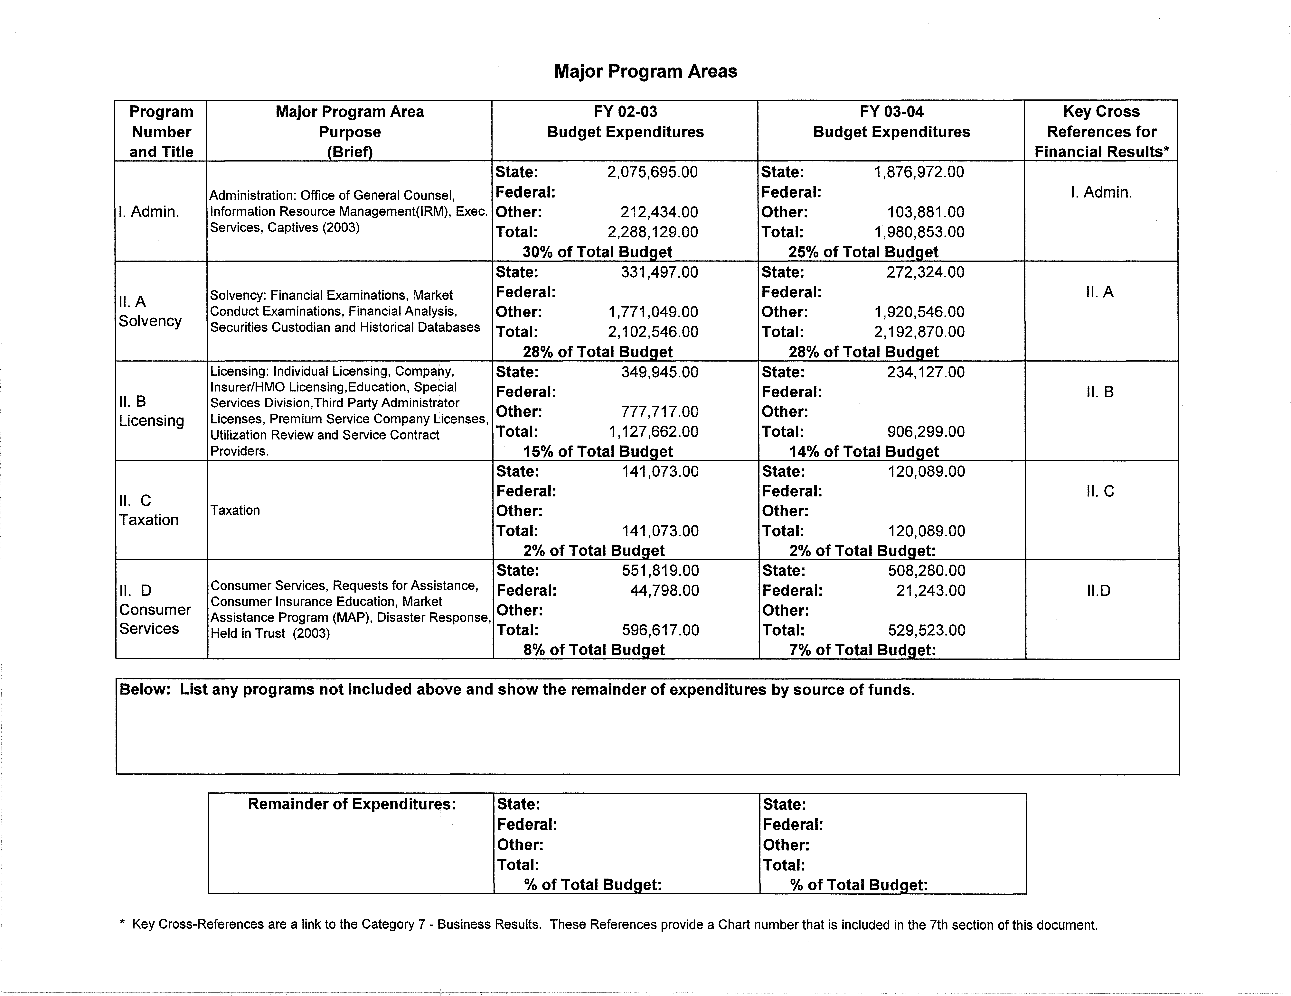

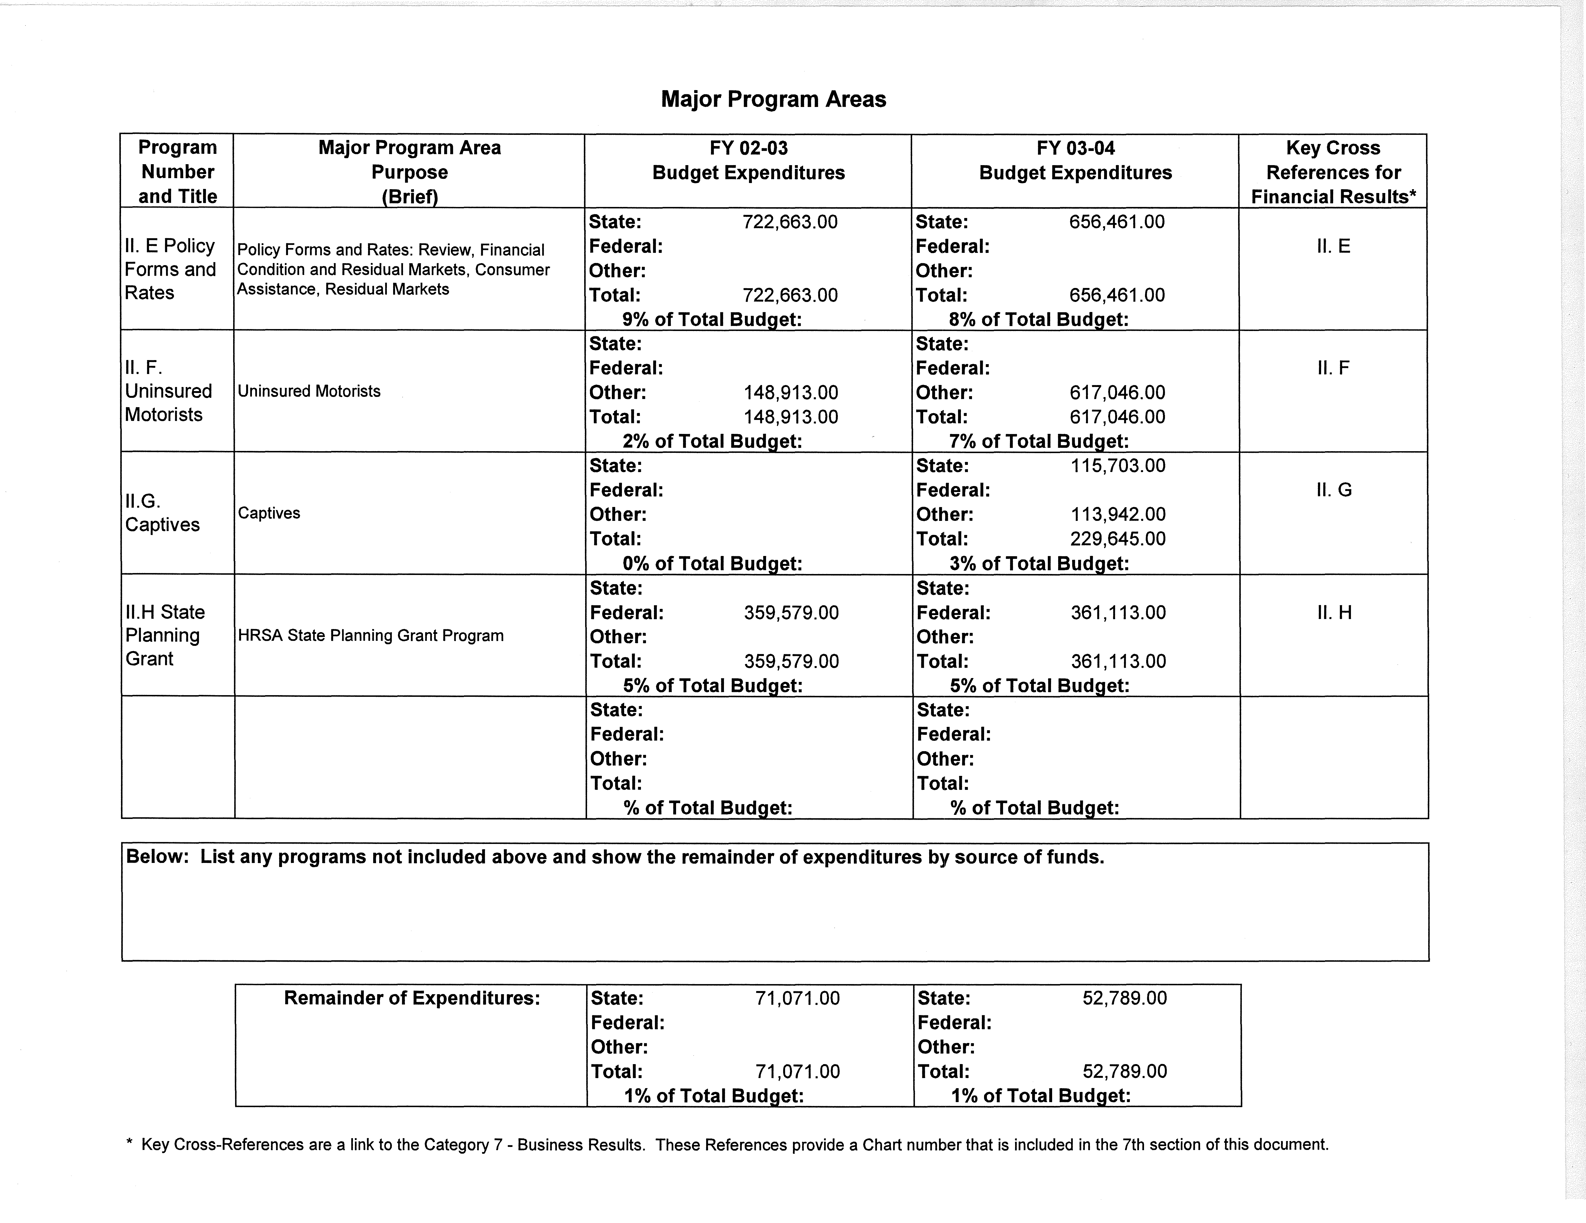

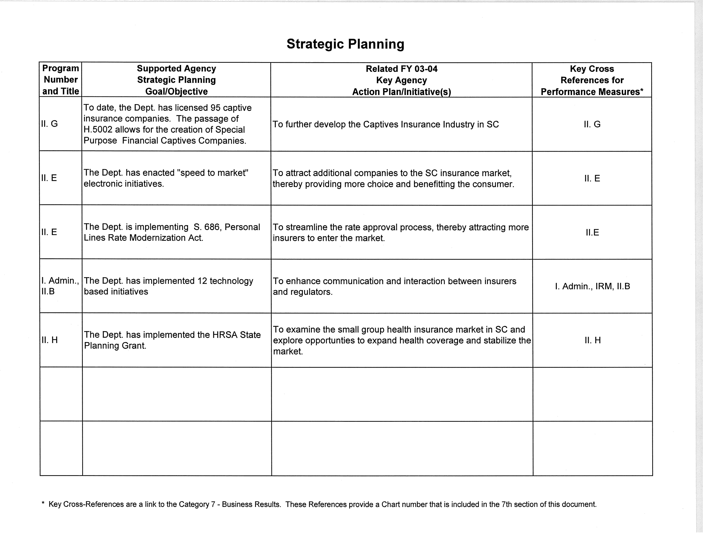

KEY CUSTOMERS AND KEY SERVICES PROVIDED

The Department’s key customers are the citizens of South Carolina, insurance consumers and the insurance marketplace.

The South Carolina Department of Insurance is a regulatory agency. Through the Administrative Division, the Office of Consumer Services provides assistance to consumers regarding insurance related issues, complaints and concerns. Also within the Administrative Division, the Office of Education reviews and approves sponsors, instructors and courses for both prelicensing and continuing education for insurers. The Department is responsible for the collection and deposit, into the State’s General Fund, of premium taxes collected from insurers and brokers. We administer licensing programs for agents, agency brokers, adjusters, appraisers, bail bondsmen, runners and surety bondsmen. The Department also issues Third Party Administrator Licenses, and Premium Service Company and Utilization Review Company Licenses.

Our Financial Services Division provides market conduct exams of insurers, monitors the financial condition and operations of insurers and health maintenance organizations conducting business in S.C. and acts as a securities custodian for S.C. policyholders, enrollees and creditors of insurers, eligible surplus lines insurers and health maintenance organizations. The Financial Services Division is also responsible for the review of all policy forms and rates for compliance with S.C. laws and regulations for all companies writing insurance in S.C. Within the Financial Services Division, the Office of General Counsel is charged with the review of summons and complaints served upon the Director of Insurance in his capacity as the agent for service of process for insurers transacting the business of insurance within S.C. and to accept service of pleadings that are served in accordance with S.C. law.

Through the Executive Division of the Department, assistance is provided to the legislative and executive branches of government regarding changes and additions to insurance legislation and the resolution of constituent matters.

KEY SUPPLIERS/VENDORS

The Department works with a number of suppliers and vendors. The following is a listing of the businesses and organizations that we conduct business with on a regular basis: The South Carolina Budget and Control Board, Office of Information Resources for technology infrastructure, Central Supply, The South Carolina Department of Corrections, Industries Division, Gateway Company, J.M. Grace Corporation, Kosi Office Systems, Minolta Corporation, Mac Paper Supply Company, General Services Print Shop, Dell Computer Corporation and Prestige Travel Services.

ORGANIZATIONAL STRUCTURE

The S.C. Department of Insurance’s organizational structure is outlined below.

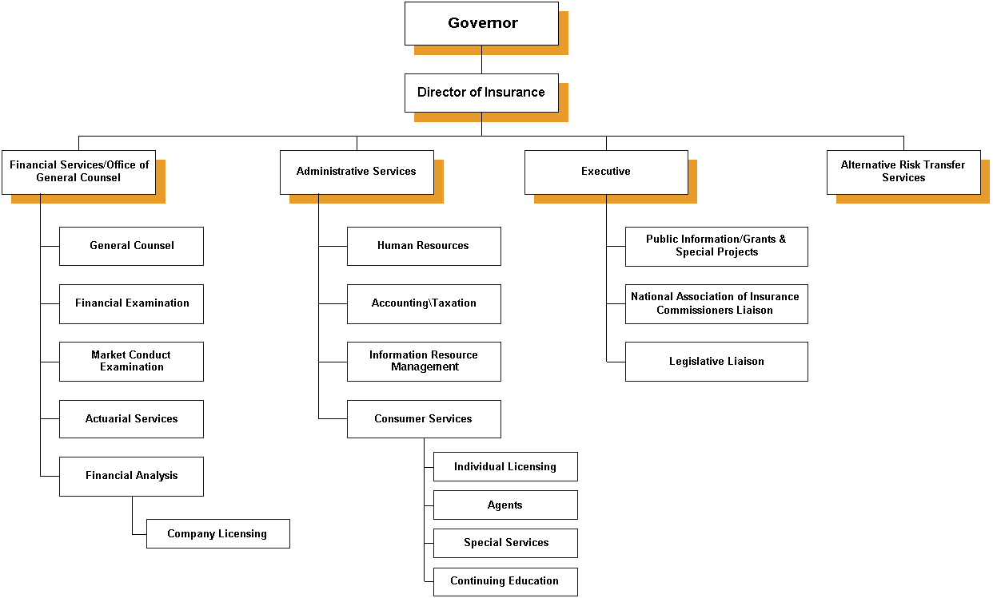

CATEGORY 1 - LEADERSHIP

The Department’s organizational structure includes the Executive Staff of which the senior management consists of the Director, the Deputy Director of Administrative Services and the Deputy Director of Financial Services and Office of General Counsel. The Executive Staff also includes three Executive Assistants to the Director, the Chief Life Actuary, the Senior Associate General Counsel and managers of each of the offices within the three organizational divisions. The senior management initiates an annual operating plan. The senior leadership works through the Office of Human Resources to encourage employee recognition and innovation. Continuing education and training is also encouraged through this office. The Department adheres to the State Government Ethics and Accountability Act regarding ethical behavior. We also utilize the services of the State Ethics Commission for filing Statements of Economic Interest and training opportunities.

Customer focus relates directly to the Department’s mission as mandated by S.C. law which charges us with the protection of the public interest and insurance consumers. Therefore, the senior leadership closely monitors the efficiency and accuracy of consumer and constituent inquiries and requests. Information detailing the numbers of consumer requests, etc. is reflected in Category 7. Periodic work sessions and staff meetings with the Executive Staff assist in the monitoring process. These meetings provide opportunities for suggestions and feedback from staff members.

There are several mechanisms used to address the current and potential impact on the public regarding products, programs and services. The most frequently used methods include news articles, interviews, press releases and public hearings that are closely monitored by the public information officer.

Organizational priorities for improvement are communicated through the Department’s strategic plan, meetings and discussions with the Director and legislative directives. Office managers discuss these priorities with staff and receive feedback and communication regarding the establishment of practices and processes necessary to meet these goals and priorities.

The Department, senior management and staff members actively support and strengthen the community. Priorities for community involvement are established by the Director, senior management and individual staff member participation. The following is a listing of the organizations and activities supported by the Department and staff members: S.C. Budget and Control Board Cost Containment Committee, the Governor’s Workers’ Compensation Advisory Task Force, the S.C. DHEC First Sounds Advisory Committee, the State Interagency Coordinating Council for BabyNet, a S.C. Early Intervention Program, the Governor’s Budget Working Group, the National Association of Insurance Commissioners (NAIC) International Securitization Committee, the NAIC International Insurance Relations Committee, the NAIC Small Face Amount Working Group, and the NAIC Suitability Committee.

CATEGORY 2 - STRATEGIC PLANNING

The Department began the strategic planning process in 1998 as a method for improving its programs and services. All employees participated in the planning process through survey and discussion. This information provided opportunities to analyze an employee’s individual duties and division responsibilities so as to efficiently streamline the Department’s delivery of services. It also enabled the Department to plan with the future in mind, to set benchmarks, and to develop a long-range strategy that reflects the changing economic environment.

The Director and Executive Staff continue the strategic planning process by incorporating the Malcolm Baldrige National Quality Award Criteria. Based on the present status of the state and national economy, the Department will continue to focus on strengthening and streamlining functions and procedures for a more efficient quality performance.

CATEGORY 3 - CUSTOMER FOCUS

The Department of Insurance is a Regulatory and Cabinet Agency. The key customers and stakeholders are South Carolinians, the insurance industry, the Office of the Governor, Legislators and State Government Agencies.

Our key customers are identified through the Department’s mission statement, which is derived from S.C. Code Ann. Section 38-3-10, et seq. (1976, as amended, and supp. 1997). As defined within the Division Offices Business Process Plans (see categories 6 and 7), timely and accurate service is priority in that it directly impacts the customer.

The Director and Executive Staff consider communication and feedback from the customer and stakeholder an important tool for improving the Department’s service capabilities. This is achieved through various mechanisms: public meetings, outreach events (when funding is available), advisory committees, public forums, customer surveys and updated websites.

CATEGORY 4 – Measurement, Analysis & Knowledge Management

Day-to-day processes are in support of the Department’s mission statement that is based on the statutory requirements found within S.C. Code Ann. Section 38-3-10, et. seq. (1976, as amended and supp. 1997). Due to the many different services provided by the Department, each Division develops a business process plan based on state and federal mandates for the services and products produced within the Division. The business process plan, which includes review, measurement and analysis components, is developed in concert with the Director, Deputy Directors and Office Managers. Each program area provides feedback to the Managers regarding the effectiveness of the processes. It is at this time that staff reviews for “best practices” and other successful activities.

The various Divisions within the Department maintain correspondence, data logs and monthly reports regarding response and follow-up as well as assignment completion times. The Finance Office within the Division of Administrative Services provides data reports for both the State Treasurer’s Office and the Comptroller General regarding the status of financial activities, including the collection of tax premiums.
The Office of General Counsel provides reports to the Deputy Director for Financial Services and the Director regarding the status of summons and complaints served upon the Department. The Office of Financial Examinations provides monthly reports regarding the financial status of companies writing insurance in S.C. as well as status reports regarding findings of market conduct examinations performed by Department financial examiners.

Ongoing analysis of the reports and information provided by the Department Divisions allows the Director and Executive Staff to monitor the status and health of the insurance market in S.C. This is a critical service for South Carolinians. The Market Assistance Program (MAP), within the Office of Consumer Services, collects data, which reveals the need to explore the status of the health insurance market and the importance of the Department’s efforts to attract additional companies, which will offer property and casualty insurance products to South Carolinians. To that end, the Department has undertaken several special projects focusing on health insurance, primarily the small group health insurance market, and property and casualty insurance with an emphasis on coastal property initiatives.

The Department is a longstanding member of the National Association of Insurance Commissioners (NAIC). The NAIC is a voluntary organization of the chief insurance regulatory officials of the fifty (50) states, the District of Columbia and four US territories. The NAIC’s mission is to protect consumers and help maintain the financial stability of the insurance industry. The collaboration and sharing of ideas between other state insurance departments and the NAIC provides opportunities to utilize comparative data and information.

CATEGORY 5 - HUMAN RESOURCE FOCUS

Employees of the Department of Insurance are provided opportunities to develop their skills and expertise through various programs and mechanisms. The standard Employee Performance Management System (EPMS) is utilized for a formal method of review. Standard processes involve the development of a planning stage for each employee with the involvement of the employee and the manager.

Employees are encouraged to take advantage of training opportunities offered through various federal, state and private organizations. These include the Governor’s Office, the State Budget and Control Board, the Federal Emergency Management Agency/National Flood Insurance Program, and the NAIC. The staff receives notification of these course offerings through the Department’s Division of Administrative Services.

Additional mechanisms for involving the employees in the activities of the organization include department-wide staff meetings, an intranet site for Department employees, as well as, e-mail postings regarding employee news and achievements. Employees receive a S.C. Department of Insurance Policies and Procedures Manual and orientation packet prior to their first day on the job.

The Department, through the Division of Administrative Services, administers the Recognition Achievement Program. This program recognizes an employee’s achievements. The Director has established an Employee Task Force consisting of representatives from each Division that meets to discuss and provide feedback regarding the staff’s well being. This Task Force is also responsible for the planning of staff-wide holiday dinners and activities. The Director also organizes an Employee Appreciation Day and provides lunch for Department employees.

The Department provides a safe and healthy environment for its employees. The Department is located in a facility that offers a clean and pleasant work environment in a park-like setting.

Employees are involved in numerous community activities, which include the Annual Good Health Appeal, Harvest Hope Food Bank, Families Helping Families, the United Way and the First Ladies Annual Walk for Life Campaign.

EXECUTIVE SERVICES
The Executive Division of the Department provides assistance to the legislative and executive branches of government regarding the creation of new statutes and regulations, the amending of existing statutes and regulations and the resolution of constituent matters.

CATEGORY 6 & 7 - PROCESS MANAGEMENT AND BUSINESS RESULTS

LEGISLATIVE

GOAL
The legislative liaison provides assistance to the legislative and executive branches of government regarding the creation of new statutes and regulations, the amending of existing statutes and regulations, and the resolution of constituent matters.

BUSINESS PROCESS
Technical assistance in the drafting of proposed legislation is provided. Such assistance is provided to the Director, legislators and to the legislative committee staff who have requested assistance from the Director and Department. In addition, assistance is provided upon request from legislators and legislative staff in the handling of constituent matters.

PROCESS MEASURES
Bills and regulations on the Department’s legislative agenda, which were enacted in legislative year 2004, include:

Bills Subject

S.686 Property and Casualty Insurance Personal Lines Modernization Act (Key provisions include: allows for “flex rating” via rating bands of + or – 7%; if market is declared competitive, “file and use” will replace flex rating.)

H.5002 Captives (Key provisions include: strengthen confidentiality requirements; allow non-profits to form captives; provide flexibility re specific capital and surplus requirements; and allow for creation of Special Purpose Financial Captives (SPFCs); also amended to include the DOI “Clean Up” bill which contains a variety of provisions—mostly related to requirements with respect to producer licensing and continuing education.)

Regulations Subject

69-50 Continuing Insurance Education

69-53 Credit for Reinsurance

From August 19, 2003 through September 8, 2004, two hundred and ninety-six (296) constituent matters have been reviewed and resolved.

DIVISION OF ADMINISTRATIVE SERVICES
The Division of Administrative Services provides assistance through the Consumer Services Section, Office of Education, the Taxation Section and the Special Services Section. These Sections are charged with the following responsibilities: to provide assistance to consumers regarding insurance related issues, complaints and concerns; the review and approval of sponsors, instructors and courses for both prelicensing and continuing education for insurers; the collection and deposit into the State’s General Fund of premium taxes due from insurers and brokers; the administration of licensing programs for agents, agency brokers, adjusters, appraisers, bail bondsmen, runners and surety bondsmen; and the licensing of Third Party Administrators, Premium Service Companies and Utilization Review Companies.

TAXATION
*II. C

GOAL
The program area annually collects and deposits into the State’s General Fund premium taxes due from insurers and brokers. A percentage of these funds are distributed to county governments.

BUSINESS PROCESS
Insurers’ premium taxes are collected on a quarterly basis and deposited in the General Fund. Each of the 1,615 premium tax returns is audited beginning March 1. The total premium taxes collected are balanced to the general ledger by June 30. Fire taxes are collected from insurance companies writing in South Carolina by the Department and are then distributed by the State Treasurer to the counties on an annual basis.

Brokers’ premium taxes are collected on a quarterly basis and deposited in the General Fund. Brokers report by January 30 a listing of premiums and taxes for the previous calendar year. The total premium taxes collected are balanced by June 30. Taxes collected in the amount of one (1%) percent of property premiums are then distributed by the State Treasurer to the counties on an annual basis.

PROCESS MEASURES
Premium taxes were collected and audits were completed from the four hundred and forty-seven (447) fire insurance companies, and a listing of taxes for distribution to the counties was compiled. All taxes were balanced to the general ledger by June 24, 2004.

Brokers’ premium taxes were collected and all Summaries of Transactions were reconciled by May 12, 2004 for the one hundred and seventy-nine (179) brokers doing business in the State.

On a gross basis, the Department collected in excess of one hundred thirty-six (136) million dollars in insurer and broker premium taxes. Of this amount, approximately ten point one (10.1) million dollars was distributed to county governments, six point four (6.4) million dollars was transferred to the Department of Labor, Licensing and Regulation and two point seven (2.7) million dollars was drawn to cover insolvent self-insured workers’ compensation claims. The remainder of these taxes was credited to the General Fund. Gross collections were up five (5) million dollars over the previous year and continued a trend of increases in collected insurance tax revenue.

CONSUMER SERVICES
*II. D

REQUESTS FOR ASSISTANCE

GOAL
Consumer Service representatives respond and resolve consumer complaints/inquiries within fifteen days of receipt.

BUSINESS PROCESS
Consumer Service representatives respond and resolve consumer requests relating to insurance issues to include unfair sales, false advertising, underwriting and claims handling practices.

PROCESS MEASURES
The Office of Consumer Services received two thousand, eight hundred sixty-eight (2,868) written complaints and sixty-five thousand, six hundred two (65,602) telephone complaints and requests for assistance for fiscal year 2003-2004. Compared to the previous year, written complaints are down by seven hundred and seventy-one (771); however, telephone requests for assistance were up significantly by twelve thousand, seventy-eight (12,078) or twenty-two point five percent (22.5%). Approximately fifty-five percent (55%) of telephone requests for assistance continued to be related to life, accident and health insurance issues while forty-five percent (45%) involved automobile and other property lines of insurance.

More than ninety-five percent (95%) of the written requests for assistance continue to be resolved within fifteen to twenty-one (15-21) days of receipt. Approximately ninety-eight percent (98%) of all telephone requests for assistance continue to be concluded within the same day of receipt. Electronic and telephonic capabilities have assisted the staff to resolve complaints quickly, thereby lowering the number of written complaints mailed to the Department.

CONSUMER INSURANCE EDUCATION
*II. D

GOAL
The Office of Consumer Services works to improve the consumers’ knowledge and understanding of insurance products marketed in South Carolina.

BUSINESS PROCESS
The Office of Consumer Services increases the public’s awareness through outreach activities that include speaking engagements and the distribution of educational brochures.

PROCESS MEASURES
During the 2003-2004 fiscal period, eight thousand seven hundred (8,700) brochures regarding automobile, life, health, flood, home, business insurance and catastrophe insurance were distributed to the public at public forums, agent conventions, and other public meetings. As a cost savings initiative, consumers are frequently referred to the Department’s website where brochures can be downloaded. In addition, the Office of Consumer Services also completed fifty-eight (58) speaking and outreach engagements, compared to forty-nine (49) during the previous fiscal period.

MARKET ASSISTANCE PROGRAM
*II. D

GOAL
The Market Assistance Program (MAP) was developed as a tool to assist consumers in locating hard-to-place coverage. Insurance providers that offer coverage for individuals with specific conditions and risks are listed in the MAP Directory, which is made available to the public through the Office of Consumer Services.

BUSINESS PROCESS
The Office of Consumer Services conducts an annual review of the available markets and updates the MAP Directory. In addition to this service, the Insurance Regulatory Analysts respond to requests for assistance in locating these providers.

PROCESS MEASURES
The Office of Consumer Services responded to five hundred twenty (520) requests for property and health insurance market assistance this fiscal period. The number of requests decreased by twenty-six point five percent (26.5%) from the 2002-2003 fiscal period. These results suggest that a market of availability exists, thus reducing the Department’s involvement in locating coverage.

TREND DATA

DISASTER RESPONSE
*II. D

GOAL
The Office of Consumer Services responds to consumer requests for assistance with insurance issues following a natural disaster.

BUSINESS PROCESS
The Department of Insurance has in place an Emergency Response Plan that is initiated by the Director and is facilitated through the Director’s Office. The Office of Consumer Services has a critical role in the plan. By providing constant telephone access for the public via local and toll-free numbers, the Office of Consumer Services is able to maintain communications with the insurance industry during a critical period.

PROCESS MEASURES
During this past fiscal period July 2003-July 2004, South Carolina was again spared major disasters and had relatively few storms and inland or coastal flooding requiring the Department’s assistance. The Department continued to review its emergency response procedures to improve its preparedness in the event our stakeholders require disaster assistance.
INDIVIDUAL LICENSING AND EDUCATION
*II. B

GOAL
The Division of Licensing is charged by statute with the responsibility of accurately and efficiently issuing producer, agency, broker, adjuster, public adjuster, and appraiser licenses.

BUSINESS PROCESS
The Division accurately and efficiently issues the aforementioned licenses within twenty-four to seventy-two (24-72) hours of receipt of properly completed licensing paperwork.

PROCESS MEASURES
Approximately ninety-eight percent (98%) of all properly completed producer license applications submitted to the Department were issued within 24-72 hours of receipt. As of June 30, 2004, five thousand, four hundred fifty (5,450) agency licenses were in force. This is a decrease of more than twenty percent (20%) from the 2002-2003 fiscal period. A total of four hundred six Thousand, Two Hundred Fifty-five (406,255) appointments for producers were in force as of June 30, 2004 compared to 376,941 in 2002-2003, a seven point eight percent (7.8%) increase. Additionally, twenty thousand, two hundred sixty-six (20,266) new producer, agency, adjuster, appraiser, public insurance adjuster and broker licenses were issued this fiscal year. Seventeen (17) applications submitted by producers, adjusters, appraisers and brokers were denied because of a crime committed that would not allow licensure. Seventy-nine thousand, three hundred sixty-seven (79,367) producers, sixteen thousand, nine hundred eighty-one (16,981) adjusters, seven hundred ninety-six (796) motor vehicle physical damage appraisers, one hundred fifty-two (152) public adjusters and one thousand, five hundred sixty-two (1,562) brokers held licenses to transact insurance business in South Carolina during the fiscal period.

During fiscal period 2003-2004, the Division received fifty-five thousand, three hundred and eighty (55,380) telephone calls, and two thousand, five hundred and sixty-three (2,563) walk-in visitors.

SPECIAL SERVICES DIVISION
*II. B

GOAL
The Division of Special Services is required to accurately and efficiently issue bail bondsmen, runners, and surety bondsmen licenses following a careful review of submitted applications. The Division is also required to process annual renewals of licenses and to collect appropriate fees.

BUSINESS PROCESS
The Division administers the licensing of professional bail bondsmen and runners in accordance with state statute and maintains licensing records. Licenses are issued within ten (10) days following individual clearance from state and federal authorities.

PROCESS MEASURES
During the 2003-2004 fiscal period, five hundred eighty-five (585) professional bail bondsmen, runners and surety bondsmen were licensed by the Department within ten (10) days of receipt of a properly completed application. License and renewal fees collected were sixty-five thousand, eight hundred fifty dollars ($65,850) for bail bondsmen and runners. This represents more than a two point five percent (2.5%) increase from the prior fiscal period.
THIRD PARTY ADMINISTRATOR LICENSES
*II. B

GOAL
The Division of Special Services issues via statute Third Party Administrator (TPA) Licenses.

BUSINESS PROCESS
The Division administers the licensing of TPAs in accordance with state statute. Licenses are issued within ten (10) days.

PROCESS MEASURES
During this fiscal period, two hundred forty-nine (249) TPAs were licensed. This represents approximately a six point four percent (6.4%) increase from the prior fiscal period. On average, these licenses were issued within the projected ten-day period.

PREMIUM SERVICE COMPANY LICENSES

GOAL
The Division of Special Services issues Premium Service Company Licenses and maintains records of the licenses as defined by statute.

BUSINESS PROCESS
The Division administers the licensing of Premium Service Companies in accordance with state statute. Licenses are issued after statutory requirements are met by the applicant and the forms are reviewed and approved by the office of Special Services Division.

PROCESS MEASURES
During the 2003-2004 fiscal period, eighty-three (83) Premium Service Companies were licensed representing a three point eight percent (3.8%) increase compared to the prior fiscal period of eighty (80) companies. On average, these licenses were issued within the thirty-day period established for licensing. License and renewal fees collected were forty-one thousand, five hundred dollars ($41,500).

UTILIZATION REVIEW COMPANIES
*II. B

GOAL
Private Review Agent (Utilization Review Companies) Licenses and biennial renewals are issued by the Division of Agents Licensing as defined by state statute.

BUSINESS PROCESS
The Division administers the licensing of Utilization Review Companies in accordance with state statute.

PROCESS MEASURES
During the 2003-2004 fiscal period, seventy-seven (77) utilization review companies were licensed. This represents an increase of eight point three (8.3%) in the number of companies licensed compared to the 2002-2003 fiscal period. License and renewal fees collected were sixty-one thousand, six hundred dollars ($61,600).

SERVICE CONTRACT PROVIDERS
*II. B

GOAL
The Division issues Service Contract Providers licenses following careful review of applications and qualifications and maintains records of those licenses. It also processes annual renewals of licenses and collects the appropriate fees.

BUSINESS PROCESS
The Division administers licensing of service contract providers in accordance with Chapter 78, of Title 38, of the South Carolina Code of Laws. Licenses are issued within fifteen days (15) after the applicant meets statutory requirements and the forms are reviewed and approved by the Special Services Division. Licensing records are accurately maintained for proper policing enforcement of the statute.

PERFORMANCE MEASURES
As of June 30, 2004, one hundred seventy-five (175) Service Contract Providers were licensed by the Department of Insurance representing an increase of six point seven percent (6.7%). License and renewal fees collected were thirty-five thousand dollars ($35,000).

EDUCATION
*II. B

GOAL
The Division accurately and efficiently reviews and approves sponsors, instructors and courses for prelicensing and continuing education. The Division also administers the South Carolina Department of Insurance examination process.

BUSINESS PROCESS
The Division with the assistance of a review board as outlined in Chapter 43, Title 38, Regulation 69-23 and 50 of the South Carolina Code of Laws administers the review and approval of sponsors, instructors and courses for continuing education. The Division is responsible for the continuing education program and ensuring that sponsors, instructors and proctors follow the requirements outlined in Chapter 43 and Regulation 69-50. The Division contracts with Experior Assessments to administer the Continuing Education Contract. The Division is responsible for over site of the contract.

The Department contracts with Experior Assessments to administer twenty-four (24) insurance examinations. The Division is responsible for the oversite of the state’s insurance examinations and the proctoring process. The Department oversees and sponsors an annual Examination Review Workshop with Drake University, Experior Assessments and members of the South Carolina insurance industry.

The Education Division sponsors a yearly education meeting for prelicensing sponsors and members of the South Carolina insurance industry to provide them with updates in the licensing examination process.

PROCESS MEASURES
During this fiscal period (2003-2004), one thousand two hundred twenty-one (1,221) continuing education courses were approved; seven hundred seventy-six (776) continuing education instructors, one hundred seventy-six (176) continuing education proctors, and forty-four (44) continuing education sponsors were also approved. In addition, a total of three (3) new pre-licensing courses were approved: one (1) for life, accident and health, one (1) for property and casualty and one (1) for broker.

Five thousand, seven hundred forty-seven (5,747) insurance examinations with an overall pass rate of fifty-six percent (56%) were administered this fiscal period, which represents a twenty-three percent (23%) decrease from the number of examinations administered during the prior fiscal period.

DIVISION OF FINANCIAL SERVICES

The Division of Financial Services is charged with the following responsibilities: monitoring the financial solvency and trade practices of insurers transacting business within the State of South Carolina, including the approval of some of the rates charged and products sold; licensing insurers and health maintenance organizations; and enforcing the laws of the State of South Carolina. The following discussion highlights some of the accomplishments of the Division during the past fiscal year by section. The Division of Financial Services consists of the Financial and Market Conduct Examination Sections, the Financial Analysis Section, the Life, Accident and Health and Property and Casualty Sections and the Office of the General Counsel.

FINANCIAL EXAMINATIONS
*II. A

GOAL
Monitoring the solvency and trade practices of insurers are primary regulatory responsibilities of an insurance department, as stated in the Department mission statement. These functions are performed through the Financial Examinations, Market Conduct Examinations and Financial Analysis Sections of the South Carolina Department of Insurance.

It is the goal of the Financial Examinations Section to perform financial examinations on each domestic insurer no less than once every five (5) years, and each domestic health maintenance organization no less than once every three (3) years in accordance with the requirements of South Carolina law. These examinations may be either Comprehensive Full Scope, Limited Scope or Targeted examinations. These examinations test internal controls, management issues and the financial condition of the company. Most examinations performed by this Department are comprehensive examinations. Target financial examinations may be conducted more frequently than comprehensive examinations and often focus on a specific issue of regulatory concern. Target examinations supplement the regularly scheduled comprehensive examination.

BUSINESS PROCESS
Financial examinations are conducted to detect as early as possible those insurers and health maintenance organizations which are considered to be financially troubled or which are in violation of state statutes or which are engaging in unlawful or improper marketing activities. Toward this end, the Financial Examinations Section works closely with the Financial Analysis and Market Conduct Examination Sections. Each Section reports any signs of potential financial trouble to the Deputy Director of Financial Services so that the appropriate financial examination and review may be determined.

PROCESS MEASURES
Financial examinations are scheduled based upon the financial performance of the company and the priority, which may be assigned by the Financial Analysis Section. Seventeen (17) financial examinations of insurers and HMOs were commenced during the period from July 1, 2003 to June 30, 2004 including 7 priority companies. Five (5) examinations were based on a one-year schedule, two (2) examinations were based on a 3-year schedule, one (1) examination was based on a four-year schedule and nine (9) examinations were based on a five-year schedule. In addition, one (1) organizational examination was completed during this period.
Information is reported within 60 days following the completion of an examination. This information includes the appropriate regulatory action that is necessary. A copy of the examination report is forwarded to the Director and Office of General Counsel for institution of the appropriate administrative disciplinary action.

With the exception of the one (1) priority company, the domestic insurers and health maintenance organizations examined were deemed to be in substantial compliance with South Carolina insurance or health maintenance organization’s statutes, financially sound, and able to meet their obligations to its South Carolina policyholders or enrollees.

MARKET CONDUCT EXAMINATIONS
*II. A

GOAL
The Market Conduct Examination Section audits the trade practices of insurers licensed to transact the business of insurance within the State of South Carolina. Market conduct examinations test the claims practices of the insurer or HMO and whether the insurer or HMO is utilizing approved rates and selling approved products. Moreover, this Section also checks for general compliance with the insurance laws of the State.

The Market Conduct Section follows a similar examination schedule as that followed by the Financial Examinations Section. The Department is required by statute to perform a comprehensive market conduct examination on each domestic insurer no less than once every five (5) years, and each domestic health maintenance organization no less than once every three (3) years. Examinations of premium finance companies, bail bondsmen, third party administrators, agencies, agents, and any other entity conducting the business of insurance in South Carolina are also the responsibility of this examination Section, if necessary.

Target examinations may be performed from time to time on a specific market issue on all companies licensed in this state (both domestic and non-domestic), as conditions dictate. The target examinations conducted during the past fiscal year audited race-based pricing practices, premium tax issues, claims practices and whether companies were complying with various provisions of South Carolina insurance laws.

BUSINESS PROCESS
Market Conduct Examinations are conducted to detect as early as possible those insurers, health maintenance organizations and other entities conducting the business of insurance, which may be in financial trouble, violation of state statutes, or engaged in improper marketing, claims, rating or other trade practices.

PROCESS MEASURES
Seventeen (17) market conduct examinations of insurers commenced during the period July 1, 2003 to June 30, 2004. Six (6) of these examinations were based on a five-year schedule and nine (9) were target examinations. Eight (8) examinations were completed during this time period.

Two (2) three-year exams commenced and two (2) were completed during this time period. Two (2) examinations of HMOs commenced and two were completed. Five (5) examinations are currently in progress.

TREND DATA

Insurance departments are relying more on target examinations to audit the trade practices of insurers. Target examinations allow a department to focus its resources on the specific issue upon which it is receiving complaints about the insurer. These examinations supplement the regular examinations conducted by this Department. Additionally, there is a trend within the market to conduct more multi-state or zone examinations. This trend appears to be based upon the concerns raised by industry over the cost of market conduct examinations.

FINANCIAL ANALYSIS
*II. A

GOAL

A primary objective of solvency monitoring is the assurance that companies, to include HMOs are in compliance with South Carolina insurance statutes and regulations and, if necessary, take regulatory action to protect policyholders and enrollees. Solvency monitoring involves financial examinations, and includes the detection of potentially troubled insurers and HMOs through regular financial analysis of their financial statements. Financial statements are required to be filed with the Department and with the NAIC by specified dates. South Carolina law requires annual statements to be filed by March 1 and quarterly statements to be filed by June 15, August 15, and November 15. Through the financial analysis function, the Department monitors indicators of excessive financial risk which may place an insurer or HMO in hazardous financial condition and may trigger regulatory action including, but not limited to, suspension or revocation of the insurer’s or HMO’s certificate of authority. They may also be placed under administrative supervision, rehabilitation, conservation or into liquidation.

South Carolina law requires this Department to monitor the financial condition and operations of insurers and HMOs licensed by and conducting business in this State. The Office of Financial Analysis monitors the solvency of insurers and HMOs through regular analysis of their financial statements and other available financial information. Their financial condition is monitored in order to detect, as early as possible, transactions involving significant financial risk, which may threaten their overall financial condition.

BUSINESS PROCESS
Within the guidelines of South Carolina insurance and HMO statutes, the Department analyzes financial and other available relevant information of all insurers and HMOs which have been licensed to conduct business in this State. These guidelines ensure that each will be able to meet its financial responsibilities and obligations to policyholders or enrollees.

The annual statements of all domestic insurers and HMOs are analyzed between March 1 and May 1 each year. Annual statement information of all foreign insurers and HMOs is analyzed by August 1 each year. Regulatory action may be taken based upon the results of these analyses. If the Office of Financial Analysis determines that an insurer or HMO has entered into a transaction that poses a significant financial risk to its solvency, it will alert the Office of Financial Examinations and other appropriate Sections of this Department to ensure that the necessary regulatory action is taken for the protection of its South Carolina policyholders or enrollees.

PROCESS MEASURES
Beginning March 1, 2004, the annual statements of fifty-seven (57) domestic insurers and HMOs were received. Reviews were completed by May 1, 2004. Annual statement information of one thousand, six hundred and eighty-nine (1,689) foreign insurers and HMOs was reviewed by August 1, 2004.

Between July 1, 2003 and June 30, 2004, two (2) insurers were required to place an additional deposit with this Department for the protection of South Carolina policyholders; two (2) insurers voluntarily agreed to cease writing new business in South Carolina; the certificates of authority of one (1) insurer was suspended by the Director; and the certificates of authority of fourteen (14) insurers were revoked by the Director.

TREND DATA

SECURITIES CUSTODIAN
*II. A

GOAL
Insurers and HMOs are required to place securities or other acceptable instruments on deposit with this Department for the protection of policyholders and enrollees. This Department is responsible for receiving, verifying, depositing, approving withdrawing of, and maintaining control of the securities.

BUSINESS PROCESS
This Department accurately maintains the deposits of insurers, HMOs, premium service companies, service contract providers, and third party administrators.

PROCESS MEASURES
Deposits totaling three hundred fifty-nine million, six hundred thirty-six thousand, five hundred fourteen ($359,636,514) dollars were held by the Director on behalf of one thousand, two hundred sixty-seven (1,267) licensed insurers, HMOs, premium service companies, service contract providers, and third party administrators as of June 30, 2004.

The type and market value of the securities placed on deposit were verified for compliance with South Carolina insurance statutes and regulations. Transactions to this Department’s Company Securities System during the period from July 1, 2003 to June 30, 2004 totaled nine hundred and sixty-nine (969), four hundred sixty-nine (469) deposits five hundred (500) withdrawals. Insurers with a net worth in excess of $10 million are not required to maintain a deposit in South Carolina, but, instead, may place securities on deposit with their domiciliary or another insurance department.

TREND DATA
INSURER AND HMO LICENSING
*II. B

GOAL
The Office of Financial Analysis is required to review financial and other pertinent information submitted by insurers and HMOs applying to conduct business in this State in order to determine their compliance with South Carolina insurance statutes and regulations. These reviews provide information to the Department’s Committee on Applications, which recommends to the Director if an insurer or HMO should be issued a certificate of authority to transact business in this State. The Director makes the final decision to license or not to license an insurer or HMO.

BUSINESS PROCESS
Through analysis, and within the guidelines of South Carolina insurance and HMO statutes, this Department reviews financial and other information submitted by insurers, and HMOs applying to conduct business in this State. This review ensures that each will be able to meet its financial responsibilities and obligations to policyholders or enrollees.

An insurer or HMO that submits a properly completed application and complies with South Carolina insurance or HMO statutes should be licensed within sixty (60) days from receipt of its application. The Office of Financial Analysis reviews the financial and other information contained within the application and prepares a memorandum to the Department’s Committee on Applications. The Committee on Applications considers the information in the memorandum and votes to recommend or not recommend licensure of the applicant to the Director, who makes the final decision.

PROCESS MEASURES
From July 1, 2003 to June 30, 2004, applications from fifty-nine (59) insurers and HMOs were received, reviewed, and analyzed. Forty-eight (48) of the applications were deemed to be in compliance with South Carolina insurance or HMO statutes.

These insurers or HMOs were licensed, on average, within sixty (60) days from receipt of their applications. As of June 30, 2004, eight (8) applications were pending while the Department awaits receipt of either additional information or their 2004 Annual Statement due to their failure to be in compliance with South Carolina insurance or HMO statutes. Three (3) applications were withdrawn.

TREND DATA

MAINTAINING AND RESPONDING TO INQUIRIES REGARDING THIS DEPARTMENT’S HISTORICAL DATABASES
*II. A

GOAL
The Office of Financial Analysis reviews transactions involving insurers, eligible surplus lines insurers, risk purchasing groups, HMOs, and other entities licensed by the Department so as to document those transactions on the Department’s Company Licensing System and respond to inquiries from the general public regarding historical information.

BUSINESS PROCESS
The Office accomplishes this process by requiring insurers, eligible surplus lines insurers, risk purchasing groups, HMOs, and other licensed entities to file appropriate documentation within thirty (30) days of the effective date of the transaction. The transaction is reviewed and recorded on the Company Licensing System within five (5) working days from date of receipt of the information.

PROCESS MEASURES
From July 1, 2003 to June 30, 2004, two hundred and ninety-eight (298) transactions were reviewed and recorded on this Department’s databases. Approximately twelve thousand (12,000) telephone inquiries (1,000/month) requesting information found on this Department’s Company Licensing System were answered during this period.

TREND DATA

ASSIGNED RISK PLAN OF SOUTH CAROLINA
*II. E

GOAL
The Assigned Risk Plan (AAIP) was established by state statute as a mechanism to provide automobile insurance for the State’s high-risk drivers. It replaced the South Carolina Associated Auto Insurance Plan as the residual market mechanism for auto insurance on March 1, 2003.

BUSINESS PROCESS
The Department is charged with the responsibility of monitoring the activities of the Assigned Risk Plan, its board and auxiliary services, in order to assure its actions comply with state statutes.

PROCESS MEASURES
This was the first full year of operation for the AAIP as the new automobile insurance residual market mechanism. To date less than one hundred (100) personal and commercial risks have been insured through this mechanism.

POLICY FORMS REVIEW
*II. E

GOAL
The Department is charged with protection of the insurance-buying public by ensuring that policy forms are in compliance with the laws and regulations of South Carolina. Forms regulation is an integral part of monitoring the market conduct of insurers.

BUSINESS PROCESS
These Sections review property, casualty, life, accident and health insurance policy forms to ensure that they are in compliance with the laws and regulations of South Carolina and that they do not contain provisions that are unfair, deceptive, ambiguous, misleading or unfairly discriminatory. Our objective is to perform accurate and thorough reviews and to complete these reviews within a reasonable review period. The length of time varies between thirty (30) and sixty (60) days depending on the type of policy form.

PROCESS MEASURES
There are several performance measures for the review of policy forms: number of policy forms received, the number of forms approved, the number of forms received for information only, the number of forms disapproved, the number of forms pending and the average date of the forms on which the analysts are currently working. The Department utilizes checklists to review compliance with South Carolina statutory requirements.

For the Life, Accident and Health division during fiscal year 2003-04, the Division received four thousand and thirty-seven (4,037) new filings. These forms were reviewed within an average of 30 days. At the end of fiscal year 2003-04, the policy forms analysts, on average, were reviewing forms within an average of thirty (30) days.

During fiscal year 2003-04, the Property and Casualty Division received a total of eight thousand, three hundred and sixteen (8,316) new form, rule and rate filings. These filings were completed within an average of thirty (30) days.

POLICY RATES REVIEW
*II. E

GOAL
This area within the Department is responsible for ensuring that benefits under Individual Accident and Health insurance policies are not unreasonable in relation to premiums charged and to ensure that rates for Property and Casualty insurance are neither excessive, inadequate nor unfairly discriminatory.

BUSINESS PROCESS
The area reviews individual accident and health insurance rates and individual health maintenance organization rates to ensure that benefits provided in the policies are not unreasonable in relation to the premiums charged. The objective is to perform accurate and thorough reviews and to complete these reviews within a reasonable period. The length of time varies between thirty (30) and ninety (90) days depending on the type of policy form. In addition to reviewing rates for new policy forms and requests for rate increases, several other duties are performed to ensure that benefits provided in the policies are not unreasonable in relation to the premium charged.

Within the Property and Casualty Section, a notice of filing is required when an insurer has written premium of two million (2,000,000) dollars, and an increase in a policyholder’s rate is requested. The notice of filing is published in five newspapers of general statewide circulation. This notice provides the public with an opportunity to request a public hearing on the rate change request. In accordance with South Carolina state regulation, a public hearing is held if requested.

PROCESS MEASURES
There are several performance measures for the review of policy rate form filings: total number of rate filings reviewed, the number rate filings reviewed for new policy forms, the number of rate filings reviewed for rate increases requests, average date of the rate filings for new policy forms on which the analysts are currently working and the average date of filings for rate increases on which the analysts are currently working.

During fiscal year 2003-04, the Life, Accident and Health Division reviewed three hundred and fifty-two (352) Accident & Health rate filings for existing products.

The measure for fiscal year 2003-04 indicates that a large number of reviews were performed in a timely fashion. This helps the consumer by ensuring that insurers are not charging rates that are unreasonable in relation to the benefits provided.

ASSISTANCE AND TRAINING
*II. E

GOAL
These Sections provide technical assistance and training on Property, Casualty, Life, Accident and Health insurance issues to the Director of Insurance, to other divisions of the Department, and to consumers.

BUSINESS PROCESS
These Sections train and assist volunteers in the I-Care program with respect to Medicare supplement insurance and other forms of health insurance, and provide general assistance to South Carolina consumers on issues that cannot be handled by the Consumer Services Section of the Department. In addition, the Property and Casualty and Life, Accident and Health Sections conduct forums, seminars and other programs designed to educate members of the insurance industry on changes to laws, regulations and bulletins that affect the insurance industry.

PROCESS MEASURES
Members of these Sections participated in or conducted the following presentations and workshops during the past fiscal year: I-Care presentations; the Disability Forum; 71st LHCA Meeting; SOGCA Meeting; Florence Association of Insurance and Financial Advisors; Clemson Association of Independent Agents; S.C. Low Country Independent Agents; Marsh Company, Greenville, S.C.; the Spartanburg Association of Independent Agents; the SERA Conference hosted by the Florida Department of Insurance; and the Drake Exam Review Workshop.

CONSUMER ASSISTANCE
*II. E

GOAL
The Division provides accurate, timely, courteous and professional assistance to consumers with respect to technical issues and supports our Office of Consumer Services with respect to rating issues.

BUSINESS PROCESS
The Life, Accident and Health Section maintains an accurate consumer guide for Medicare supplement insurance that contains premium rates for all standardized plans of all insurers approved for sale in South Carolina and updates this guide quarterly. The Life, Accident and Health Section, as well as, the Property and Casualty Section also assists with technical consumer complaints and problems with respect to life, accident and health and property and casualty insurance in a courteous and timely fashion.

PROCESS MEASURES
The Medicare Supplement Premium Comparison Guide was updated and published on November 1, 2001 and May 1, 2002. The Life, Accident and Health Division processed approximately one hundred and ten (110) consumer complaints involving rating issues while the Property and Casualty Division processed fifty-four (54) consumer complaints involving rating issues.

FINANCIAL CONDITION AND RESIDUAL MARKETS
*II. E

GOAL
The Property and Casualty Section also provides technical expertise regarding actuarial principles involved in measuring the financial condition of insurers.

BUSINESS PROCESS
The Property and Casualty Actuary assists in solvency monitoring by providing technical assistance on financial condition examinations through providing actuarial opinions on loss reserves, assessing company practices with regard to claims operations, and evaluating market conduct practices.

PROCESS MEASURES
Actuarial assistance was provided on the examinations of the following companies:

Consolidated American Insurance Company
South Carolina Insurance Company
Catawba Insurance Company
Direct General Insurance Company
South Carolina Insurance Reserve Fund

The time budgeted for the actuarial component of an examination may be constrained by the completion date scheduled for the examination. Effective financial condition examinations prevent insurer insolvency. The actuarial analysis is a critical part of this process.

RESIDUAL MARKETS
*II. E

GOAL
The Division represents the Department of Insurance on the boards of various mechanisms for residual markets in South Carolina and ensures their orderly operation.

BUSINESS PROCESS
The Department is charged with supervision of several residual market mechanisms in order to ensure their adequate performance and solvency. Residual market mechanisms include the following:
South Carolina Associated Auto Insurers
South Carolina Wind and Hail Underwriting Association
South Carolina Reinsurance Facility
South Carolina Medical Malpractice Joint Underwriting Association
South Carolina Property and Casualty Guaranty Association
South Carolina Life, Accident and Health Guaranty Association
South Carolina Health Insurance Pool
South Carolina Workers’ Compensation Assigned Risk Plan
South Carolina Small Employer Insurer Reinsurance Program

PROCESS MEASURES
The staff attends many of the meetings held and participates in committee work. Each residual market mechanism performed adequately with staff involvement in all phases of their activities.

GENERAL COUNSEL
*I. Admin.

The Office of General Counsel provides various forms of legal representation to the South Carolina Department of Insurance. These activities include, but are not limited to: acceptance of service of process; drafting legal documents including bulletins, Requests for Proposals, contracts and legislation; representing the Department in both state and federal courts; providing advice and counsel to the various divisions and sections of the Department through training and technical assistance programs; providing advisory opinions to members of the general public on the South Carolina insurance laws; and initiating enforcement or administrative disciplinary action against persons charged with violating the insurance laws of the State of South Carolina. Highlighted below are some of the more significant activities of this office during fiscal year 2003-04. The Office of General Counsel has experienced a forty (40%) percent reduction in staff as a result of state budget cuts.

ACCEPTANCE OF SERVICE OF PROCESS
*I. Admin.

GOAL
The Office of the General Counsel is charged with the review of summons and complaints served upon the Director of Insurance in his capacity as the agent for service of process for insurers transacting the business of insurance within the State of South Carolina and to accept service if pleadings are served in accordance with South Carolina law.

BUSINESS PROCESS
The Office accepts or rejects service of process on the same day the Office of General Counsel receives the summons and complaints.

PROCESS MEASURES
During fiscal year 2003-04, the Office of General Counsel received approximately three thousand, eight hundred and four (3,804) summons and complaints in civil actions to be served upon insurers transacting the business of insurance within the State of South Carolina. Additionally, the Office received and served three hundred and eighty-two (382) pleadings from the South Carolina Workers’ Compensation Commission. Seven hundred and forty (740) pleadings were initially returned to counsel for deficient service upon the Director of Insurance during fiscal year 2003-04. The number of returns decreased by five point five percent (5.5%) from seven hundred and fifty-three (753). Thirty-eight thousand, forty ($38,040) dollars was collected in service of process fees for this fiscal year. This Office collected one thousand, four hundred dollars ($1,400) in service of process fees for the Workers’ Compensation Commission during the 2003-04 fiscal year.
This service has a significant impact upon the resources of this Office. Approximately fifty percent (50%) of an employee’s time is spent processing the documents received and contacting attorneys who have not properly served the documents upon the Department. The additional time spent contacting attorneys who have not properly served the documents has contributed to the decrease in the number of returned pleadings.

TREND DATA

RESPONDING TO REQUESTS FOR INFORMATION
*I. Admin.

GOAL
The Office is required to respond to requests for information in accordance with the South Carolina Freedom of Information Act.

BUSINESS PROCESS
Staff responds to requests for information within fifteen (15) working days.

PROCESS MEASURES
During fiscal year 2003-04, it is estimated that the Office of General Counsel received at least one hundred seventy-two (172) requests for information under the Freedom of Information Act. The majority of these were requests for information regarding disciplinary actions taken against insurance agents. All indications are the amount of requests for information will increase. It is estimated that each attorney handled at least two or three such requests per month.

This figure does not include oral requests for information or requests that are easily handled over the telephone in accordance with the provisions of the South Carolina Freedom of Information Act.

There is one staff member who is primarily responsible for responding to such requests. The Office continues to work on the development of a system which will enable the Office of General Counsel to better track the number of such requests received and the number of hours spent compiling information in response to such requests.

PROVIDING INTERPRETATIONS OF SOUTH CAROLINA INSURANCE LAWS
*I. Admin.

GOAL
The Office of General Counsel provides interpretations of the South Carolina insurance laws to members of the Department, industry, general public and state government.

BUSINESS PROCESS
Staff responds to requests for interpretations of the South Carolina insurance laws within thirty days’ receipt of the request.

PROCESS MEASURES
The Office of General Counsel responded to two hundred and forty-nine (249) requests for interpretations of the South Carolina insurance laws. The great majority of these were requests by agents, agencies and insurers about whether a proposed action or business practice would constitute a violation of the South Carolina insurance laws. These interpretations are informal in nature and do not constitute legal advice. It is anticipated that providing this service may prevent some insurers and agents from engaging in conduct that may be in violation of the South Carolina insurance laws. Requests for such opinions and consultations with counsel are increasing. Therefore, the caller is asked to place such requests for assistance in writing to the Office of General Counsel.

PROVIDING ADVICE AND COUNSEL ON THE LEGAL IMPLICATIONS OF PROPOSED ACTION OR POLICY
*I. Admin.

GOAL
The Office of General Counsel provides advice and counsel to the supervisory staff of the South Carolina Department of Insurance on the legal implications of proposed action or policy.

BUSINESS PROCESS
The staff provides advice and counsel to the supervisory staff of the Department on matters such as policy development, license denials, appeals, insurer suspensions and market conduct examinations.

PROCESS MEASURES
The Office of General Counsel routinely receives requests for advice and opinions from the staff of the South Carolina Department of Insurance.

This service enables the Department to avoid some potential legal problems and ensures that the Department is operating in compliance with state and federal laws. The number of calls received by the Office of General Counsel appears to be on the rise.

ADMINISTRATIVE DISCIPLINARY PROCESS
*I. Admin.

GOAL
The Department is responsible for investigation of violations of the South Carolina insurance laws and to impose administrative disciplinary action where appropriate.

BUSINESS PROCESS
The Office of General Counsel staff investigates allegations that the South Carolina insurance laws have been violated and imposes administrative disciplinary action where appropriate.

PROCESS MEASURES
The Investigations Section of the Office of General Counsel opened three hundred and seventy-two (372) investigation files during the past fiscal year. It closed three hundred and thirty-one (331) investigation files. Ninety (90) of those actions resulted in administrative fines totaling two hundred eighteen thousand, nine hundred ninety-five ($218,995.56) dollars and fifty-six cents; and thirty (30) resulted in revocations. The Department did not issue any license suspensions this fiscal year. Eight (8) files were referred to the Insurance Fraud Division of the South Carolina Attorney General’s Office for criminal investigation and prosecution.
ADMINISTER RECEIVERSHIPS ON BEHALF OF THE STATE OF SOUTH CAROLINA
*I. Admin.

GOAL
The Office of General Counsel monitors the insurers placed under suspension, in receivership, or liquidation and distributes the assets in accordance with South Carolina law.

BUSINESS PROCESS
The staff was responsible for resolving six (6) pending receiverships held over from the previous fiscal year, three (3) were closed and four (4) are pending litigation. Also responsible for reviewing the financial holdings and open receiverships for all revoked companies with deposits as ancillary receiverships as necessary for the protection of South Carolina policyholders.

PROCESS MEASURES
The Department placed one (1) company in Ancillary Receivership during the fiscal year; the Director suspended the licenses of one (1) insurer, and revoked the licenses of fourteen (14) insurers for being in a hazardous financial condition.

The impact of the Office of General Counsel’s efforts in this area is that more funds were made available to the Guaranty Association to minimize the number and amount of assessments that had to be made against member insurers.

South Carolina differs from most other states in the manner in which it handles receiverships. Estates are disposed of in accordance with Chapter 27 of the South Carolina Insurance Code and the provisions of Chapter 9, which deal with statutory deposits. However, most states require special rather than statutory deposits. According to the NAIC, the requirement of “special deposits” versus “statutory deposits” makes the process a little more streamlined and less cumbersome. A statutory deposit can only be used to pay the claims of South Carolina policyholders. Special deposits are used to pay the claims of all policyholders. Forty-five (45) of the fifty (50) states require special deposits. These states have also adopted the 1994 NAIC Model Act in this area.

TREND DATA
REPRESENT THE SOUTH CAROLINA DEPARTMENT OF INSURANCE IN STATE AND FEDERAL PROCEEDINGS
*I. Admin.

GOAL
The Office of General Counsel is responsible for minimizing the Department’s exposure to liability through effective legal representation.

BUSINESS PROCESS
The staff provides effective representation to the South Carolina Department of Insurance in actions filed by, or against, the Department. Counsel handles the defense of all matters not covered by the Department’s tort liability policy.

PROCESS MEASURES
The bulk of the litigation handled by attorneys within the Office of General Counsel is before the Administrative Law Court (ALC). During the past fiscal year, attorneys in the Office of General Counsel represented the Department in six (6) matters before the ALC. In addition, the Office of General Counsel received seven (7) Administrative Disallowance of Subrogation by Insurer Petitions and two (2) Worker’s Compensation rate approval requests.

Additionally, during the past fiscal year, the Office of General Counsel lead or participated in the following special projects: 1) Department Study of the South Carolina Small Group Health Insurance Market; 2) Grant proposal to secure funding from the Health Resources Services Administration on “Expanding Health Insurance Coverage and Stabilizing Rates within the Small Group Market;” 3) Training sessions on South Carolina’s privacy regulation and the privacy provisions of the Gramm-Leach-Bliley Act, as well as, other legislation affecting the business of insurance; 4) Examinations of rating and underwriting practices; 5) National committees involved in insurance regulation; and 6) Insurance regulatory consulting services and training to the insurance supervisory authorities of Egypt and Malaysia. These international consulting activities were sponsored or funded by the Commercial Law Development Program of the United States Department of Commerce and the National Association of Insurance Commissioners.

