OFFICE OF
THE ADJUTANT GENERAL

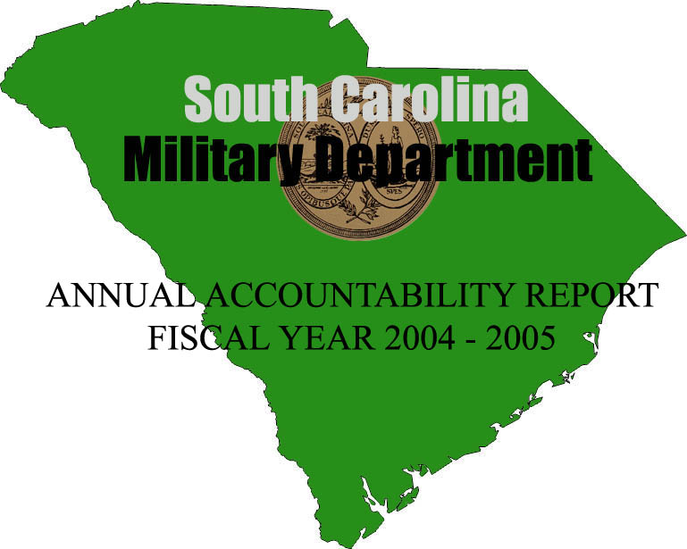

Mark Sanford, Governor
Stanhope S. Spears, The Adjutant General
TABLE OF CONTENTS

TRANSMITTAL FORM------------------------------------------------------1

EXECUTIVE SUMMARY---------------------------------------------------2

BUSINESS OVERVIEW------------------------------------------------------6

LEADERSHIP-----------------------------------------------------------------12

STRATEGIC PLANNING--------------------------------------------------15

CUSTOMER FOCUS AND SATISFACTION-------------------------18

MEASUREMENT, ANALYSIS AND KNOWLEDGE---------------21

HUMAN RESOURCES FOCUS-------------------------------------------23

PROCESS MANAGEMENT-----------------------------------------------26

KEY BUSINESS RESULTS------------------------------------------------29

Armory Operations-----------------------------------------------------------------------------------------------------29
South Carolina Emergency Management Division (SCEMD) Operations----------------------------------33
SCEMD – Plans, Training and Operations – I--------------------------------------------------------------------35
SCEMD - Plans, Training and Operations - II-------------------------------------------------------------------37
SCEMD - State Warning Point Operations--- --------------------------------------------------------------------40
SCEMD - Public Assistance Program------------------------------------------------------------------------------42
SCEMD - Citizen Corps and Community Emergency Response Team Training Grants---------------44
SCEMD - Individual Assistance Program for Tropical Storm Frances--- ---------------------------------45
SCEMD - HMGP Federal Disaster Assistance Program-------------------------------------------------------46
SCEMD - Pre-Disaster Mitigation Program (PDM)-------------------------------------------------------------48
SCEMD - Domestic Preparedness Program---- ------------------------------------------------------------------49
Youth ChalleNGe Academies-----------------------------------------------------------------------------------------50
Office of The Adjutant General--------------------------------------------------------------------------------------53
South Carolina State Guard------------------------------------------------------------------------------------------62
National Guard Pension Fund----------------------------------------------------------------------------------------64
STARBASE Swamp Fox-----------------------------------------------------------------------------------------------67
South Carolina AmeriCorps Defense Brigade--------------------------------------------------------------------69

TRANSMITTAL FORM

Agency Name…...…………………….………………….South Carolina Military Department

Date of Submission…………….…………….…...........................................September 15, 2005

Agency Director……………..………………....………….Stanhope S. Spears, Major General
SCARNG, The Adjutant General

Agency Contact Person……………...………………………………….Mr. W. Carson Raichle

Agency Contact’s Telephone Number….…………………………………………803-806-4445

EXECUTIVE SUMMARY

The South Carolina Military Department’s (SCMD) commitment to quality management lends itself to empowerment, innovation and entrepreneurship. It has promoted partnering with other State and Federal agencies and the private sector for mutual advantage. As this agency benchmarks against others for best practices, others benchmark against this agency.

This report is “a work in progress” providing a basis for future agency improvements that affect efficiency, productivity, accountability and customer satisfaction.

The events of September 11, 2001 did not change the mission of this agency. In fact, those events put in motion what this agency has been trained to do – and do exceptionally well:

Mission Statement

- Provide combat-ready units to the US Army and US Air Force.

- Provide planning, coordination and military capabilities in response to State emergencies.

- Add value to State and Nation with community-based organizations, soldiers and airmen.

Values

Values represent the foundation upon which an organization and its members base their decisions, actions and behaviors. Values establish the boundaries for the organization to measure its ethical and moral culture.

The SCMD is a values-based organization that has embraced the values adopted by the three entities: Army, Air and State Operations.

Army Air State Operations

Loyalty Integrity Communications
Duty Service Before Self Honesty
Respect Excellence Integrity
Selfless Service Competence
Honor Teamwork
Integrity Fairness
Personal Courage Family
Patriotism

In this summary, please note the collateral value this agency’s State dollars have in bringing Federal dollars to South Carolina.

Here are a few examples of Army Guard (SCARNG) and Air Guard (SCANG) achievements during Fiscal Year 04-05: (1) the largest deployment of SCARNG personnel since World War II continued with 162 Guard men and women actively deployed within the continental USA and 1,419 deployed overseas in Operation Iraqi Freedom – since September 11, 2001 over 7,000 members of the Army Guard have seen active duty; (2) continued with the successful feeding and billeting at McCrady Training Center for over 5,000 Individual Ready Reservists called to active duty; the Air Guard continued to provide homeland security and service in Kuwait and Iraq with personnel having specialties in critical military occupations; Army Air was authorized additional helicopters with a Chinook contingent and additional support personnel numbering over 200; the 169th Fighter Wing completed a major upgrade of its F-16’s weapons systems; while the 157th Fighter Squadron trained active-duty Air Force pilots from Misawa AB in Japan; several SCANG units assisted the state of Florida in the aftermath of hurricanes when its C-130 flew Governor Jeb Bush around his state to observe the devastation; the Air Guard’s 240th Combat Communications Squadron also sent specialists to support Florida’s recovery efforts; and finally the news that the Guard has eagerly awaited – the Base Realignment and Closure (BRAC) recommendations.

The Guard, in conjunction with the Governor’s Office, the Chamber of Commerce and the various city and county governments, lobbied long and hard to protect existing assets at what is now known as McEntire Joint National Guard Base. The upshot of the initial BRAC recommendation was to increase operations for the Air Guard at McEntire to include nine additional F-16 fighter jets and over 400 support-related Air Guard personnel. Implementation of these changes will include additional facilities and state jobs for civilians at the installation. The total benefit to South Carolina is estimated to be in the millions of dollars. This is a true success story resulting from the efforts of a dedicated task force.

State Operations (DSO), the third element of the South Carolina Military Department, continued with its own list of achievements during the fiscal year.

Foremost among these was the transfer of the South Carolina National Guard Pension Fund to the South Carolina Retirement System. This has been an initiative of the agency’s leadership for the past nine years. Lacking adequate funding, the pension fund was earmarked for an actuarial disaster beginning as early as the year 2013. Through the support of the Budget and Control Board and the General Assembly, the pension fund is now in a financially sound position and guarantees that funds will be available for those Army and Air Guard personnel presently retired and those who are “grandfathered” under the current provisions of the law.

The Environmental Section of the Construction and Facilities Maintenance Office (CFMO) has been consistently recognized by the National Guard Bureau for its lead role as one of the best consultation programs in ensuring cultural resources are adequately protected and goodwill developed within the Native American community. The agency has received awards from several of the tribal consultation partners and Tribal National flags to honor the agency’s commitment to their communities. The agency partners with twelve Native American tribes from throughout the nation.

The Youth ChalleNGe Program, one of the most cost-effective programs of its type, celebrated with its 1,792 graduate since inception in 1998. The program is now available to South Carolina’s at-risk youth at two campuses located in West Columbia and Aiken County.

South Carolina Emergency Management Division (SCEMD) has taken the lead in establishing the National Incident Management Systems (NIMS) throughout the state. NIMS will be the standard across the nation and will be a prerequisite for eligibility for future federal funds.

Weapons of Mass Destruction (WMD) training for more than 320 first responders was coordinated by SCEMD for Office of Domestic Preparedness (ODP) funded courses held in Anniston, AL. While this is a decrease from the previous year, it was offset by the presentation of 37 ODP-sponsored courses around the state and resulting in travel savings. 1,383 personnel attended these courses.

SCEMD managed three new major disaster declarations: Hurricane Charley, Hurricane Gaston and Tropical Storm Frances. Hurricanes Charley and Gaston were approved for federal public assistance (PA) and Hazard Mitigation Grant Programs (HMGP) with estimated assistance at $3.3 million and $20.8 million respectively. Tropical Storm Frances was approved for Individual Assistance and Hazard Mitigation Grant Programs at an estimated $7.7 million.

SCEMD conducted training for emergency management personnel at the state, county and municipal levels to enable effective preparation for and efficient response to emergencies and disasters. 335 training courses were presented for 8,902 personnel, an increase of 28% in number of courses and 25% in personnel trained.

SCEMD provided assistance to state and local officials on legal authorities and mutual aid agreement construction for response to terrorism/WMD incidents. Currently 46 counties, 175 municipalities and 121 others (special purpose tax districts, fire departments, etc.) are signatories to the statewide mutual aid agreement.

For the sixth straight year, SCEMD published and distributed more than 580,000 copies of the Official SC Hurricane Guide from Columbia to the coast. Also available in Spanish, this publication advises the public on actions to take before, during and after a hurricane. Partnerships with other agencies and the private sector helped defray the cost of printing and distribution.

SCEMD has in final testing and user-training a statewide system called REACH-SC to be used by state and local emergency officials for the blanketing of a local area with telephone calls providing critical information in a crisis, as well as notification of key officials and special response groups.

SCEMD served as focal point on coordinating assistance to Florida via the Emergency Management Assistance Compact (EMAC). Twelve requests for personnel and equipment were handled.

In March, SCEMD presented the 2005 State Hurricane/Terrorism/Emergency Management Workshop. Over 400 emergency managers, responders, planners and volunteers participated.

And, during the spring of 2005, SCEMD led a series of Hurricane Evacuation Shelter Strategy and Coordination meetings. The purpose was to review and update the state’s current shelter plans, update the statewide shelter list and coordinate each of the 240 shelters with supporting state agencies and counties.

The South Carolina Military Department, despite being one of the state’s largest holders of real property, continues as one of the most efficient agencies in the use of energy per square - $0.75 per square foot!

Barriers and Opportunities

SCEMD continues to be hampered by a lack of trained personnel necessary to accomplish its daily mission and emergency response operations. An independent study by the Governor’s Office of Homeland Security in 2002 remains accurate. It concluded that SCEMD is understaffed to meet the requirements of a post 9/11 environment.

Many armory facilities remain in a continuing state of disrepair for lack of a state match. As yearly maintenance falls farther and farther behind, deferred maintenance has amounted to a staggering $60,000,000! Not only do some of the armories fail federal standards for usability but pose serious safety, recruiting and retention issues as well.

Funding for a State Regional District Operations Program has been a priority of SCEMD for the past five years. This program would provide dedicated district coordinators and would enhance the overall emergency management homeland defense program throughout the state. This program would facilitate coordinated, consistent plans and effective training at state, county and municipal levels. This program has proven effective in other states to ensure program continuity from the state to the local levels.

State Operations (DSO) continues to make strides in the use of innovative technology to meet the needs of its customers. However, outdated equipment and the lack of adequate funds to upgrade and replace equipment seriously endanger support of vital federal and state missions.

In summation, the SCMD views the “Annual Accountability Report” process as an important management tool to be used in identifying the agency’s strengths, weaknesses, opportunities and threats. It provides the impetus to pursue excellence in government at all levels and is the ground for a continuous effort in process improvement for its customers, both external and internal.
BUSINESS OVERVIEW

Workforce. The Adjutant General’s staffing includes state employees (to include grant/agreement positions), federal employees (technicians), Active Guard Reserve (AGR) and the traditional Guard members who drill on weekends and participate in two week’s training each year.

State Employees: 350

Federal Employees: 960 (100% federally funded)

AGR: 765 (100% federally funded)

Traditional Guard: 9,927 (100% federally funded)

TOTAL: 11,992

Of the normal full-time workforce of 2,065 there are only 25 state employees who are 100% funded by the State or 1.2% of the workforce! Other state employees are a combination of State and Federal funds.

As in last year’s report, it is interesting to note that the agency’s budget is approximately $4.9 million.

The 100% federally funded staff assigned to the Military Department has an annual payroll of just over $76,000,000. Applying an average 7% state tax on this unadjusted federal payroll accounts for approximately $5,340,000 that is transferred directly to the State Department of Revenue. The state collections on these federal employees alone exceed the State’s annual appropriation to the agency.

Additionally, the payroll of the citizen-soldier, the m-day or traditional soldier, while not subject to state tax, brings over $68,000,000 into the economy.

It is the mission of the agency’s state employees to “support the South Carolina Military Department’s military operations and protect the lives and property of South Carolina’s citizens during times of emergency.” State agency employees and the citizen-soldiers of South Carolina have displayed a high degree of readiness to respond to the personnel and equipment demands following the events of September 11 and continuing deployments both at home and abroad.

Locations. The agency is headquartered at 1 National Guard Road in Columbia and maintains 71 armories throughout the State valued in excess of $300,000,000, two Army National Guard training installations and a McEntire Joint National Guard Base in Eastover for both Army and Air operations.

The State Guard is housed in the Olympia Armory on Granby Lane in Columbia in a WPA building that is listed in the National Historic Register. The Youth ChalleNGe program in West Columbia is housed at the Wil Lou Gray Opportunity School and the Youth ChalleNGe program in Aiken County is housed at Clemson’s Youth Learning Institute’s Camp Long.

Base Budget Expenditures and Appropriations

 | 03-04 Actual Expenditures |  | 04-05 Actual Expenditures |  | 05-06 Appropriations Act
Major Budget Categories | Total Funds | General Funds | Total Funds | General Funds | Total Funds | General Funds
Personal Service | $9,379,952 | $1,977,314 | $10,135,943 | $2,046,906 | $9,859,585 | $2,013,751
Other Operating | $16,652,203 | $2,160,007 | $16,311,592 | $2,297,174 | $15,252,987 | $2,149,295
Special Items | $223,492 | $95,889 | $301,366 | $101,708 | $439,914 | $150,210
Permanent Improvements | $3,012,154 | $0 | $6,818,492 | $0 | $0 | $0
Case Services | $0 | $0 | $0 | $0 | $0 | $0
Distributions  to Subdivisions | $5,086,100 | $17 | $3,181,914 | $0 | $2,534,725 | $0
Fringe Benefits | $4,591,226 | $2,559,871 | $2,552,674 | $544,700 | $2,896,319 | $648,292
National Guard  Pension | $0 | $0 | $2,021,581 | $1,996,581 | $0 | $0
Total | $38,945,127 | $6,793,098 | $41,323,562 | $6,496,839 | $30,983,530 | $4,961,548

Other Expenditures

Sources of Funds | 03-04 Actual Expenditures | 04-05 Actual Expenditures
Disaster Assistance (Non-Recurring):
Supplemental Bill: State Appropriations | $731,307 | $1,626,260
Total Funds | $8,290,177 | $16,054,459
Open Ended Appropriation –State Active Duty/EMAC | $26,810 | $230,019
* EMAC – Emergency Management Assistance Compact

Interim Budget Reductions
Total 03-04 Interim Budget Reduction | Total 04-05 Interim Budget Reduction
$49,229 | $36,116
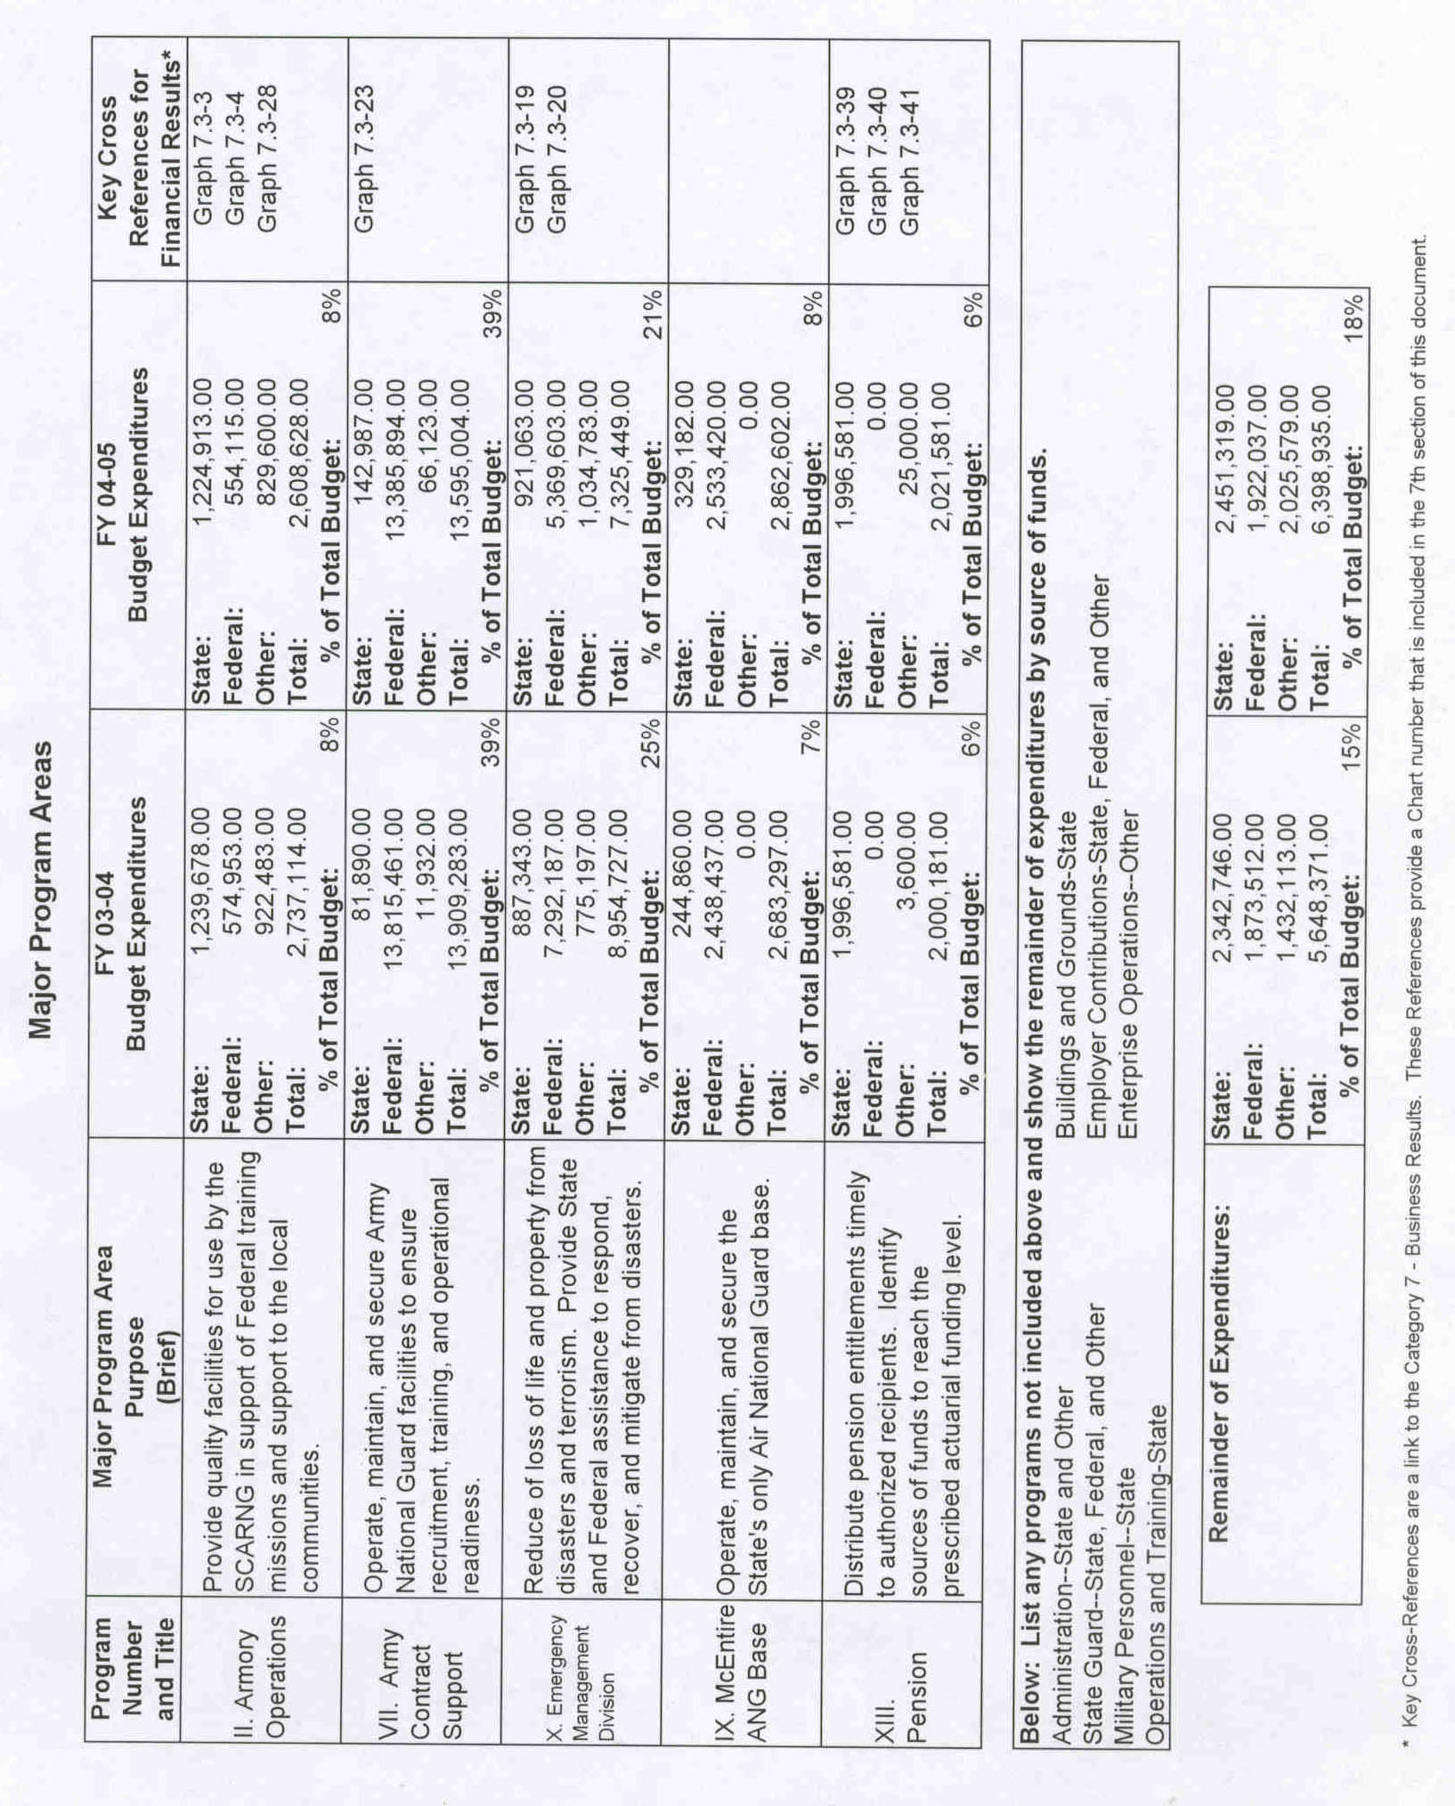

Key Customers. Identification of customers and their needs is crucial to the strategic planning process of this agency. However, the South Carolina Military Department’s operations are of such a diverse nature that a complete list of customers exceeds the demands of this report. A primary list of customers includes: the President of the United States; the Governor of South Carolina and the General Assembly; the citizens of this state; the Department of Defense; the U.S. Army and U.S. Air Force; the National Guard Bureau; the Office of Homeland Defense; the Federal Emergency Management Agency; the traditional National Guard men and women of our Army and Air components; parents/guardians of at-risk youth; the Universities of South Carolina and Clemson; South Carolina Departments of Juvenile Justice, Social Services, Health and Environmental Control, Public Safety and Transportation; the U.S. Drug Enforcement Administration; the U.S. Customs Service; the U.S. Marshals Service; the U.S. Attorney’s Office; the U.S. Postal Inspection Service; the State Law Enforcement Division; Greenville County’s Sheriff’s Office; the Port of Charleston; magistrates; county and municipal governments; the American Red Cross and, of course, the agency’s staff.

All of these customers provide input and feedback on the agency’s processes. A variety of methods is employed to determine their market requirements and expectations. Please refer to the section on “Customer Focus and Satisfaction” for details.

Key Suppliers. Among the key suppliers to the South Carolina Military Department are: U.S. Army and Air Force; the National Guard Bureau; the South Carolina General Assembly and the Governor’s Office; the Universities of South Carolina and Clemson; the Department of Vocational Rehabilitation; the South Carolina Departments of Corrections, Law Enforcement Division, Budget and Control Board, Comptroller General, Treasurer’s Office, Health and Environmental Control; Pratt and Whitney; Tyler Construction; the Piedmont Foundation; Hussey Gay Bell and DeYoung; Guy White and Associates; Law Gibb Engineering; Amana Corporation; SCANA/SCEGCO; Monteray Construction; Bonitz Flooring; Stern Two Notch Properties; John Deere; Danka Business; URS Mechanical Design; BES Incorporated; PYA/Monarch; McMillan Smith; and the municipalities and counties of South Carolina.

Major Products/Services. The agency’s mission statement correctly identifies those products and services provided by the South Carolina Military Department:

“Provide combat-ready units to the U.S. Army and U.S. Air Force…provide planning, coordination and military capabilities in response to State emergencies…add value to State and Nation with community-based organizations, soldiers and airmen.”

Organizational Chart

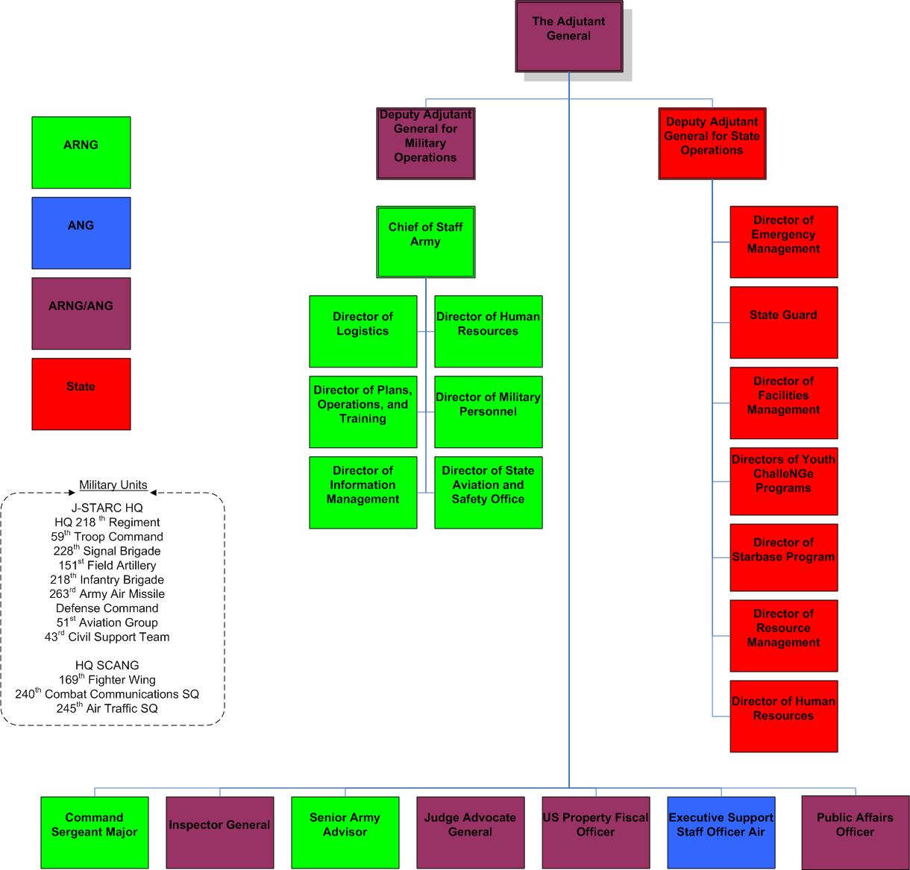

LEADERSHIP

Led by the Adjutant General, Major General Stanhope S. Spears, the senior leadership of the South Carolina Military Department through its Executive Council, the Air Guard and State Operations Quality Councils and the Army Readiness Council, is vitally involved in all aspects of the agency’s operations. These include guiding the agency’s long-range strategic planning, development of annual business plans, seeking innovative business-like practices, insuring that performance measures are monitored for excellence and serving as role models for all employees of the organization. It is the leadership’s responsibility to ensure that participation in these activities extends to all levels of the organization and is communicated throughout the organization. In turn, feedback from these organizational processes is used to improve the agency’s leadership.

Leading by example, the senior leadership provides the environment for innovation and improvement within the agency.

General Spears, the senior ranking Adjutant General in the United States, is a member of the prestigious Reserve Forces Policy Board. This board is the principal and independent policy advisor to the Secretary of Defense on matters relating to the reserve components. He serves on the Board of Visitors, The Citadel, and is a member of the Advisory Board for Communities-In-Schools in South Carolina. The senior leaders on the military side of the agency have been trained in management principles, team leadership and Malcolm Baldrige-type criteria, viz., Quality Air Force Assessment and Army Performance Improvement Criteria, all at federal expense. Leaders in State Operations receive Malcolm Baldrige training as an on-going project in addition to the courses available through the Budget and Control Board’s Human Office, especially the Executive Institute. Their leadership abilities are recognized at all levels of government. For example, the past director of the Emergency Management Division directed a Weapons of Mass Destruction Office at the U.S. Justice Department and returned to South Carolina to serve as executive assistant in charge of homeland security to SLED’s Chief Stewart. The current director is a member of the State Counter-Terrorism Coordination Committee and serves as chairman of the South Carolina Hurricane Task Force that focuses on improving communities’ survival from the effects of hurricanes. He also chairs the National Emergency Management Association (NEMA) Hurricane Sub-Committee. The Deputy Adjutant General for State Operations has just finished a term as chairman of the statewide Communities-In-Schools Board, an after-school program for at-risk youth.

Senior leadership has also ensured that all employees of the agency have an opportunity to receive training that will enhance their value to the agency. Training of this nature ensures that future leaders will have both the skills and experience to excel and continue a tradition of excellence in leadership. Of special note is the agency’s “Culture for Change” course, which not only serves to address the diversity of the agency, its mission and its customers, but is a valuable tool for employee feed-back and communication of the organization’s strategic plan and action plans.

The agency demonstrates its public responsibilities and practices in many ways. For the sixth consecutive year, the Emergency Management Division compiled, designed, published and distributed more than 580,000 copies of the “Official S.C. Hurricane Guide,” which advises the public regarding actions to take before, during and after hurricanes. For the fourth consecutive year the guide was produced in Spanish as well as English. Partnerships with other government agencies and the private sector were expanded to help defray the costs of printing and distribution. Both English and Spanish versions are available on the division’s web site. The Emergency Management Division has again partnered with Hispanic Outreach of South Carolina in an attempt to ensure that Spanish versions reach the appropriate audience.

Emergency Management personnel are members of the State and Regional Counter-Terrorism Coordination Committees, the State Agroterrorism Committee, the State Bioterrorism Committee, the State EMS Oversight Committee, the State Chemical, Ordnance, Biological, Radiological (COBRA) Oversight Committee and the Mass Casualty Planning Committee. These committees are essential to the successful execution of the state’s “Homeland Security Strategy.”

Information technology has a direct impact on the public. Since its adoption of a “.com” address, the agency has had successive years of exceptional growth in the number of web “hits.” This web site, which includes a link to the Emergency Management Division, provides the public with ready access to information on the agency, its history and mission; job openings; the State Guard; the AmeriCorps Defense Brigade; the StarBase program and the Youth ChalleNGe programs. The agency has also developed an online “Facility Work Request” program for its internal customers. It automatically generates work requests, tracks work requests, assigns work crew and tracks work order cost. This helps saves the extremely limited work time available and improves both accountability and customer feedback. This technology, called PRIDE, is provided 100% by the federal government.

Agency leadership is committed to education and the youth of South Carolina. This is evidenced by its highly successful Youth ChalleNGe and StarBase programs. The Youth ChalleNGe program in West Columbia is a partnership with the Wil Lou Gray Opportunity School and the program at Camp Long in Aiken is a new partnership with Clemson’s Youth Learning Institute. The combined data of the two campuses reflect a success rate in post-residential placement of between 70% and 80%. Nearly 1,800 of South Carolina’s young men and women have been graduated and are now leading productive lives as citizens and taxpayers. The StarBase program, now in its fourth year, exceeded its goal of 700 students per year instructing at-risk primary graders in science and math.

The Army Guard’s Governor’s Counterdrug Task Force (100% federally funded at nearly $2,000,000.00) addressed over 43,000 young people through July of this federal fiscal year (Oct-Sep) on the dangers of drug abuse and distributed information on drug demand reduction. Additionally, this same Task Force provided trained personnel to the Drug Enforcement Agency, the U.S. Attorney’s Office, the U.S. Postal Inspection Service, the State Law Enforcement Division, the U.S. Marshals Service and the FBI. It participated in the seizure of drugs, currency, weapons and vehicles in excess of $15,000,000.00.

The above are just a few examples of what leadership means to the South Carolina Military Department above and beyond its primary federal mission. Once more, it is worth restating that the Malcolm Baldrige Criteria include citizenship as a primary element of leadership. This agency is proof of that citizenship with 9,927 Army and Air Guard men and women selflessly and proudly serving their State and Nation. It is citizenship at its very best!

STRATEGIC PLANNING

The South Carolina Military Department’s strategic plan is the basis for both its long-range and short-term planning. The agency is now in its twelfth year of strategic planning as mandated by Presidential Executive Order. The original strategic plan began with an analysis of the agency’s strengths, weaknesses, opportunities and threats or SWOT. The process involved intense study of both internal and external customers. The internal scan covered opportunities for improvement in our culture, human resources, structure, systems, processes and technology. Covered externally were federal and state mandates that affect our vision and mission, demographic trends, technology trends and other relevant topics.

Using input from all sources, leadership formulated statements of mission, vision and values to reflect the agency’s strategic direction. Goals were developed that are key issues for the agency: Safety, Personnel Readiness, Training Readiness, Equipment Readiness, Quality of Life and Support of State and Federal Missions.

In doing business, the SCMD is committed to process improvement by: (1) strategic and annual business planning; (2) quality management; and (3) measurement of key performance indicators. All three of these components are “in line of sight” with the agency’s goals as expressed in the strategic plan.

The strategic plan sets the agency’s direction long-term, while the annual business/action plan represents short-term initiatives backed-up by measurable action plans. All major work groups participate in this important annual planning process. With the identification and tracking of key performance indicators, the agency is able to gauge its effectiveness and efficiency. When analyzed, these same key performance indicators give management the tools necessary to make sound and business-like decisions.

To accomplish the strategic plan, an Executive Council, comprised of senior leadership from the SCMD’s three major elements, was established. This council not only develops long-term policies based on the strategic plan but also serves as a catalyst for process improvement throughout the organization. This has resulted in the formation of Quality Councils for the Army National Guard (known as the Army Readiness Council), the Air National Guard and State Operations. These councils ensure that the strategic plan, goals and objectives are communicated to every employee through meetings, newsletters and employee courses, such as “Culture for Change.” The strategic plan is reviewed annually and updated as necessary in order to remain a viable plan of action for the agency. An understanding of the strategic plan’s linkage to the Malcolm Baldrige criteria is critical for the plans success. In October 2004, the Executive Council revisited the agency’s strategic plan and the agency’s goals.

The deployment of the strategic plan involves all employees of the South Carolina Military Department. The agency’s plan addresses improvement opportunities in each agency division and sets objectives and initiatives that are then formulated in the annual business plan. This allows alignment of employee efforts with the issues of most importance to the agency and helps leadership in monitoring programs and the wise use of resources. Progress updates are reported on a regularly scheduled basis throughout the year by the Quality Councils directly to the Executive Council.

Since the events of September 11, leadership of the agency’s three components has been meeting weekly. These SITREPS (Situation Reports) cover the latest available information from the White House, the Department of Defense, Departments of the Army and Air Force, the National Guard Bureau and the Governor’s Office. This intelligence is of the utmost importance in assisting the agency to achieve its state and federal mandates during these difficult times.

Performance measures are an important part of the strategic planning process and help the agency track and measure progress on issues directly tied to the goals of the strategic plan. These include: recruiting and retention, facility management and maintenance, response times to emergencies, error rates, cycle time reduction, customer satisfaction, employee expectations and needs, and employee and external customer training. The agency benchmarks with other states and like agencies to identify, translate and implement best practices.

Strategic planning, initiatives for quality improvement and key performance measure are the agency’s tools in determining how successful it is in achieving its goals and accomplishing the mission set forth in the strategic plan.

STRATEGIC PLANNING
Program Number and Title | Supported Agency  Strategic Planning  Goal/Objective | Related FY 04-05  Key Agency  Action Plan/Initiative(s) | Key Cross  References for  Performance Measures*
II. Armory Operations | Impacts four agency goals: Safety, Personnel Readiness, Training Readiness and Quality of Life | Request additional funding to support contractual agreement between State and Federal government/Initiate and implement self help and community support locally/Pursue proactive armory rental program | Graph 7.3-3  Graph 7.3-4  Chart 7.3-28
VII. Army Contract Support | Impacts four agency goals: Safety, Personnel Readiness, Training Readiness and Quality of Life | Support Army Guard initiatives in environmental, security, recruitment, training, telecommunications and youth programs | Graph 7.3-23
X. Emergency Management Division | Impacts five agency goals: Safety, Personnel Readiness, Training Readiness, Support of State and Federal Missions and Quality of Life | Increased funding for additional staff/Funding to provide State match to enhance the "Emergency Management Program"/Advance the need for a "State Regional District Operations Program" | Chart 7.2-10  Graph 7.1-18  Graph 7.3-19
IX. McEntire ANG Station | Impacts four agency goals: Safety, Personnel Readiness, Training Readiness and Quality of Life | Support Air Guard initiatives in environmental, security, recruitment, operations and maintenance, and youth programs | Graph 7.1-42
XIII. Pension | Impacts two agency goals: Quality of Life and Support of State and Federal Missions | Increased funding to support the actuarial needs of this state mandated pension | Graph 7.3-39  Graph 7.3-40  Chart 7.3-41
* Key Cross-References are a link to the Category 7 - Business Results. These References provide a Chart number that is included in the 7th section of this document.
CUSTOMER FOCUS AND SATISFACTION

Identification of customers and their needs is crucial to the agency’s strategic planning process. The very diversity of the South Carolina Military Department’s operations precludes a complete list of external customers. Primary external customers were provided earlier in this document in the section entitled: Business Review. Many of these customers are mandated by State and Federal law.

All of these customer groups provide input and feedback on the agency’s processes. A variety of methods is employed to determine their market requirements and expectations. These include but are not limited to:

- Workshops

- Command Climate Surveys (Army and Air National Guard)

- Recruiting and Retention Surveys (Army and Air National Guard)

- Participation in State and National Conferences

- After Action Reports and Debriefings

- In-process Reviews (IPRs)

- Vendor Surveys

- One-on-One Customer Surveys

- On-Site Surveys

- Exit Interviews (State Employees)

- Hurricane Season Assessment (EMD)

- Training Needs Assessment for Local and State Officials (EMD)

- Training Needs Assessment for State Employees

- Customer Satisfaction Surveys – Internal and External

- Town Hall Meetings – Employees of the Agency

- Weekly Meetings of the Senior Leadership

- Utilization of the Agency’s Web Site

- Quarterly State Employee Newsletter

Information gained from the above processes is analyzed and tracked in order for the agency to improve practices that enhance customer satisfaction. Recent assessments show that customer focus and satisfaction indicated an area of opportunity for the agency. In an effort to overcome this deficiency, several innovative programs have been established.

- Established a more secure, reliable and significantly faster server access for remote SABAR (state accounting system) customers. Many of these remote customers are federal employees of the agency who must access certain accounting information because of State/Federal programs.

- Developed a program that allows remote users to initiate work order requests, follow the status of the requests, assign work crews and track order costs, thereby saving on work time available and improving both accountability and customer feedback. The program is entitled PRIDE and supported by 100% federal dollars.

- Continuous improvement of the agency’s web site for the dissemination of information to customers and the general public. The goal of 20% increase in web traffic over the prior three years was exceeded. Conversion to a .com address greatly enhanced public accessibility.

- EMD continued to enhance its web site in order to reach the maximum number of people. It now provides first responders with course descriptions, a schedule of courses and application forms for each of the resident weapons of mass destruction sites managed by the Office of Homeland Defense.

- EMD has also provided awareness training to senior public officials throughout the state via the Municipal Association; published numerous brochures to inform the public on a variety of issues from disaster vulnerability to assistance programs; conducted many meetings with federal, state and local representatives to evaluate and schedule terrorism/weapons of mass destruction planning, training, equipment and exercise needs and requirements; and continues to maintain a “Public Information System” to provide hurricane related information to evacuating citizens.

- Site visits and customer needs assessments are tracked and reported through the facility management office’s “Installation Status Reporting System” (ISR). The ISR and “Service Base Costing” (SBC) automated programs are currently used to measure satisfaction and customer needs.

- The agency’s budget and finance section determined that vendors required a fast turnaround on invoice payments. A goal of six days was established in order to process payments in a timely fashion. This past year’s turnaround time was an average of 6.07 days to the Comptroller General’s Office and an average 6.56 days from the CG’s office to the agency. Both measurements indicate an area for improvement since the desired turnaround in both instances is 6 days. See Charts 7.2-31 and 7.2-32

- Two years ago, the Deputy Adjutant General for State Operations and the United States Property and Fiscal Officer (USPFO) initiated regularly scheduled meetings with Federal and State program managers to better serve customers, internal and external, on critical issues regarding budget and human resource issues. These meetings continue to provide a valuable conduit in communicating across State and Federal areas of responsibility.

- The agency’s human resources section established a universal evaluation date of July 1 for all state employees using a combined position description and employee performance form endorsed by the Budget and Control Board’s Human Resources Office.

- In support of the agency’s deployed military force, energetic and volunteer Family Supports have been formed throughout the state to keep spouses fully informed on benefits, news from the field and information on available resources. A newsletter, which has received national recognition from the Department of Defense, and an e-mail network (http://www.NGFamilyof One.org) were established to further communications.

The South Carolina Military Department is continually exploring ways to correct weaknesses in existing processes that hinder our progress in achieving operational excellence.

The agency must ensure that our customers’ needs and expectations are being met.

MEASUREMENT, ANALYSIS AND KNOWLEDGE

The agency’s divisions have developed performance measures to monitor system inputs, outputs and outcomes and improve these systems by eliminating special and common cause variations. These measurements reflect the information necessary for quality management to make data-based decisions that are wise, business-like and in the best interests of the customer. These measurements also ensure that the systems are operating properly to achieve the strategic plan’s goals in the delivery of products or services to the agency’s customers.

The agency’s strategic plan calls for action plans that are “in line of sight” with the goals of the South Carolina Military Department. Action plans are the direct result of collective input from senior leadership, directorates, staff and, of course, the customers. Action plans assign responsibility either to an individual or group. They have established deadlines and designated metrics for the measurement of progress. These measurements are analyzed and interpreted on a regular basis by senior leadership through staff meetings held weekly, monthly, quarterly or annually, e.g., Quality Council meetings for Army and Air Guard and State Operations, the Executive Council and the annual Strategic Conference. Since the action plans are “works in progress,” they are modified as deemed necessary by senior leadership in order to meet the needs of the State and Federal governments and other key customers.

Both Army and Air National Guard have in place measurable key performance indicators tied directly to the agency’s goals: Safety – regularly scheduled accident reports with appropriate follow-up action as necessary; Personnel Readiness – recruiting and retention reports that are briefed on a regular basis to commanders for their immediate action; Training Readiness – unit status reports reflect the readiness of Guard personnel in the event of Federal deployment or State emergencies; Equipment Readiness – regular and frequent equipment readiness reports in support of soldiers and airmen; Quality of Life – quarterly meetings of facility personnel to address maintenance, future needs and training requirements; and Support of State Missions – regularly scheduled meeting and daily liaison with the Emergency Management Division.

Similarly, State Operations has key performance indicators in “line of sight” with the agency’s goals. These key performance indicators are considered so important to the day-to-day operations of the agency that they are reported on and analyzed monthly as well as at quarterly meetings.

Here are some examples of activities within State Operations with respect to in formation gathering, measurement and analysis:

- Comparative data are gathered from like events such as hurricane to hurricane or winter storm to winter storm. This is necessary since the personnel and equipment mix is different each time. Logistical analysis is used to select the right mix and avoid over expenditure and waste.

- Youth ChalleNGe collects data from monthly reports to track performance levels of the residential and post-residential phases of this program for at-risk youth. These data are transferred for validation to the program’s contractor, the National Guard Bureau, and are benchmarked against other states’ programs.

- The facilities management office maintains historical data, reviewing results and lessons learned. It maintains an open dialogue for constructive criticism among employees, project managers and contractor such as architects and construction companies. Additionally, it maintains maximum information management standards while setting realistic priorities within human resource restraints.

- The human resources office maintains trend charts on state FTEs, number of vacancies, individual employee training, grant/agreement employees and temporary hires. HRO maintains open lines of communication through meetings, conferences and seminars with supervisors and program managers within the agency as well as the Office of Human Resources at the Budget and Control Board. Monitoring these key performance indicators is critical during this time of budget downsizing and personnel cutbacks.

- EMD develops an annual work plan that defines priorities, milestones and end products within 13 separate functions in order to apply for Emergency Management Performance Grant (EMPG) funding through FEMA. This funding allows South Carolina to structure programs based on identified needs and priorities in the event of emergencies.

- Additionally, EMD conducts a “Joint Assessment” with each county to review every aspect of their emergency management program. Information and customer feedback is collected in order to “fine tune” programs and establish priorities.

- The State’s EMD program is evaluated every three years using the “Capability Assessment for Readiness” instrument provided by FEMA. National results are published which allows EMD to benchmark against other programs across the country.

- In the accountability area, EMD and the contractor for SABAR developed a module to track disaster payments and balances in the SABAR accounting system that will save taxpayer dollars and speed up delivery of services and products.

These are just a few instances of how the South Carolina Military Department utilizes information gathering techniques and their analyses to become more accountable to the citizens of South Carolina and provide services in a timely and efficient manner.

HUMAN RESOURCE FOCUS

The Adjutant General’s staff consists of 1,715 federal technicians and Army Guard Reserve (AGR) personnel (100% federally funded with annual payroll in excess of $76,000,000) and 350 state employees who are FTEs or occupy grant/agreement positions (grant/agreement positions can be funded up to 100% federally). This staff operates from the Columbia headquarters on Bluff Road, 71 armories throughout the state, two Army National Guard training sites and one joint Army/Air National Guard training station. The South Carolina Military Department is committed to attract South Carolina’s best and brightest, retain them and develop them to their fullest potential. In order to succeed, employees are empowered to cross team and/or division lines to communicate issues and collaborate to optimize service delivery.

Leadership’s responsibility does not end with internal staffing but extends to 9,927 citizen-soldiers of the state’s Army and Air National Guard, one of the agency’s largest customer groups, which generates an annual payroll of over $68,000,000 in federal dollars. For the first time in nearly a decade, there is a significant upward trend in strength due in part to the patriotism following the September 11, 2001 terrorist attacks. Over four years ago, Dr. Hardy Merritt of the Budget and Control Board conducted a milestone survey of the Army and Air Guard and identified the influence of a civilian job as one of the major reasons people leave the Guard. Because of that finding, this agency has supported a stronger “Employer Support for Guard and Reserve” (ESGR) program and numerous Family Support Groups throughout the state to assist families of deployed spouses. A website has been developed for use by families of the deployed.

As traditional National Guard men and women, these customers come to us one weekend a month and two weeks a year for training. Part of customer satisfaction for the citizen-soldiers is receiving the quality training they expect in a timely and efficient manner. Thus, the agency’s responsibility extends not only to providing training of the highest caliber available but providing facilities that are mission specific, free of health and environmental hazards and generally pleasing in which to work. Personnel and facilities continue to be the driving force of this organization.

The events of September 11 and the period following were strong evidence of the agency’s ability to meet its Federal and State mandates. Calls from the President and the Governor to perform immediate service were answered swiftly and in a highly professional manner. The Guard continues to play an important and vital role in homeland security, duty overseas and meeting state emergencies.

State employment recruitment and retention face problems. Every effort is made to hire the best qualified people for the job, train them, provide them with the right tools and technology and provide a work environment that is safe, healthy and pleasing to work in. Processes are in place to reward exceptional performance with pay increases when possible and recognition through an awards program. In line with directives from the Governor’s Office, awards are presented annually on an “Employee Appreciation Day.” However, the budget downsizing of recent years has affected every employee of the agency. Recruitment efforts are hamstrung and key personnel leave for a more secure workplace at other agencies or in the private sector. Leadership will suffer a lack of continuity with the loss of experienced staffers.

Employees perform better when they are kept fully informed. The agency’s newsletter entitled “All About Us” keeps employees up-to-date on policy changes, upcoming agency seminars and courses, employee recognition and other pertinent data. Also a “Culture for Change” course is required for all new employees and for all those employees who have not received quality awareness training. The course offers an overview of the agency and its different components, tours of the Army and Air National Guard’s McEntire Joint National Guard Base, the Army National Guard’s McCrady Training Center and Emergency Management Division’s headquarters, a core of instruction on customer service and a briefing on the agency’s strategic planning process and business plan. At commencement, a member of the senior leadership addresses the class and answers questions. Courses of this type help employees gain the skills and knowledge to become future leaders of the agency.

A flexible work schedule also allows employees time to pursue undergraduate and post-graduate courses. While additional education contributes to the individual’s quality of life, it also enhances the individual’s value to the agency. The human resources section has a continuing program which determines individual needs, e.g., supervisory training, computer skills, accounting techniques and other relevant areas. Professional training of this nature is critical in preventing the loss of skilled personnel.

In this fiscal year, the agency established an alternate workweek schedule. A state employee has the option, with the consent of the supervisor and/or program manager, of (1) Eight hours per days, five days a week for two weeks; (2) eight hours per day, five days a week for the first week and 10 hours per day, four days a week for the second week; and (3) 10 hours per day for four days each week.

Information technology plays an important role in today’s marketplace by increasing the speed of internal processes and the faster delivery of services to the agency’s customers. The dramatic network speed upgrade from a 10MB/sec to a 100MB/sec network has greatly enhanced the agency’s ability to serve its customers and supply its employees with state-of-the-art technology. Unfortunately, a four-year program of workstation replacements to keep current technology has suffered because of recent budget shortfalls.

EMD, budget shortfall or no, still lacks adequate personnel, as noted earlier in the report generated by the Governor’s Office, to meet routine as well as other operational requirements in a post September 11 environment.

The agency has adopted measures to meet the state’s fiscal problems with a hiring freeze (exclusive of mission-critical personnel) effective three years ago. At the same time, an agency-wide 40-hour workweek was adopted to increase productivity and efficiency. This move gained the agency 16.25 workdays per year per employee who had worked a 37.5 hour week.

Seeing a preventive need in the area of sexual harassment education and appropriate follow-up disciplinary action, the agency’s human resource section established a mandatory course of instruction for all state employees. Additional courses include workplace violence and knowledge of the agency’s progressive discipline policies. The agency’s policies are now available on-line reflecting the most recent changes and updates for the information of supervisors and employees alike.

In Fiscal Year 2003-2004, a universal evaluation date of July 1 was established by the human resources section. This process has significantly reduced the amount of time for employee evaluation and employee planning documents to be filed with human resources and provides accurate job descriptions of what an employee does – and is expected to do. Accuracy in these records is especially important for grant/agreement employees governed by federal regulations and is important overall in the event of a staff reduction-in-force.

The agency’s human resources section has also created, tested and implemented an automated “Leave and Attendance” sheet that allows program managers/supervisors to save paperwork and also ensure the accuracy of an employee’s pay records.

Some of the tools used by human resources to measure areas of personnel concerns/issues include: Program managers’ meetings, “Town Hall” meetings, identification of training needs, customer satisfaction surveys – both external and external, employee exit interviews, utilization of the agency’s web site and regular communications through the state employee newsletter.

Employee well-being and satisfaction is a significant indicator of the agency’s return on investment.

PROCESS MANAGEMENT

A responsibility of quality management is the identification and monitoring of key organizational processes that affect customer needs and business results. These processes need to be under constant review for improvement, elimination and/or additions. These processes and their measurement are the key to the agency’s strategic plan in delivering quality products/services to its customers.

The South Carolina Military Army and Air National Guard have federal mandates that require regular reports on a number of mission-essential processes along with appropriate metrics. These include recruiting and retention, strength, training and equipment readiness. Additional requirements, but of high customer importance, are pay and leave records, officer and enlisted evaluations, promotions, benefits and retirement. All processes support the goals of the agency’s strategic plan.

Here are a few examples of process management and process improvement within State Operations of the SCMD:

For the fourth year, EMD, in addition to providing English and Spanish editions of the South Carolina Hurricane Guide, has partnered with Hispanic Outreach of South Carolina to ensure that Spanish editions reach the appropriate audience. Improvements have included distribution of the “Guide” in three Hispanic newspapers and an increase in the number of partners to share in the expense of printing and distribution of the brochure.

EMD’s strategic objectives to establish and equip an alternate emergency operations center (AEOC) and enhance the SEOC’s operational capabilities were improved by a Federal grant that supported the development of the AEOC. The state’s alternate emergency operations center has been established through the cooperation and assistance of the Department of Public Safety and the Department of Motor Vehicles. Operational work areas, communications and redundant automation capabilities are now in place at this critical alternate site for continuity of operations.

EMD’s strategic objective to improve the process for managing the delivery of state assistance to local communities has been strengthened through the development of a statewide disaster logistics support plan and local planning guidance for county distribution sites. The disaster logistics support plan was exercised in June and further modified.

A DHS grant was awarded to the EMD for GIS enhancements. This grant will assist the division in centralizing the data requirements from each application creating a centralized depository for data. This data will reside in a database with real time data reducing workloads for many state agencies during emergencies.

EMD continued to forge new partnerships in hurricane preparedness by working with the National Aeronautics and Space Administration (NASA) and the National Oceanic and Atmospheric Administration (NOAA) to analyze, refine, and incorporate laser derived county elevation data into storm surge computer models. The updates will provide more accurate storm surge mapping that will contribute to greatly enhanced evacuation planning.

EMD has integrated the functional areas and standards of the Emergency Management Accreditation Program into the county joint assessment instrument. This will assist counties in preparing for national accreditation in the future.

The latest addition to the EMD website is a refinement of the hurricane surge inundation feature, which allows coastal residents to better understand whether they will be affected by storm surge at various categories of a storm. It is designed to provide the public with valuable protective-action information during disasters and crises.

EMD researched and established a forward area-refueling plan in order to insure the most efficient use of air assets during disaster operations.

EMD successfully procured the services of a trucking company to provide transportation services and coordination during a major disaster on a contingency basis.

Other agency process improvements include:

The agency’s budget and finance section continues process improvements with quarterly meetings of the Army National Guard’s administrative officers to brief them on armory operations’ issues, and also attends, along with the human resources section, regularly scheduled meetings of federal and state program managers to discuss personnel and budget issues.

The budget and finance section is also providing on-going training to unit managers of each armory maintenance fund to ensure a strict accountability of receipts and expenditures. Budget and finance accountants attend numerous meetings in order to ensure compliance GASB 34 (a State mandated inventory report).

Historically, natural disasters have been fiscally open-ended events where “price is no object.” Price very much becomes an object after the event is over, for months and sometimes years to come. Close working ties with state operations, the Army and Air National Guard and EMD have established more accurate estimates and projections on the front-end when much sounder decisions can be made on application of troops and equipment during an emergency.

The human resources section, as noted earlier, was responsible for establishing a universal evaluation date for all state employees, thus streamlining a system that was bogged down in paperwork and staggered deadlines. The universal evaluation date and a new form incorporating job descriptions as well as employee planning have facilitated the process for both employee and supervisor.

Additionally, the establishment of a flexible workweek allows state employees, with their program managers/supervisors approval, to opt for (1) Eight hours per day, five days a week for two weeks; (2) Eight hours per day, five days per week for the first week and 10 hours per days, four days per week the second week, or (3) 10 hours per day, four days per week for each of the two weeks.

An energy section within the facilities management office is the driving force to reduce energy consumption. Monthly statistics are collected and analyzed for further action such as lighting retrofits, etc. Consumer suggestions, seminars, interviews and facility manager input on how to save energy are important to this process. As a result of this dialogue, an Internet was developed where callers can obtain exact information on how much energy was consumed by their particular facility and in what areas. This agency has been cited repeatedly by the Budget and Board Control Board for its energy conservation programs.

The agency’s information technology section is currently upgrading computer operating systems from Windows 2000 to Windows XP. The office productivity programs are being upgraded from Office 2000 to Office 2003 – the most current version. These upgrades will be completed by January 2006.

CFMO is using a new concept called “Planning Charrette” on all major construction projects. The program effectively connects subject matter experts in all engineering fields with the end-users of a proposed facility during the design phase. This is a tremendous asset in that all aspects of planning and coordination are initiated at the very beginning of a project. In short, this means that the customer – the end user- of the facility is involved in critical decisions.

It was clear from the agency’s Malcolm Baldrige-type assessment that process management is an area that requires constant attention and on-going review. This agency is dedicated to rigidly addressing information flow, follow-up actions when necessary, revisiting processes to correct weaknesses, develop better tracking and trending mechanisms, and, of course, improved measurements.

Our customers deserve no less!

KEY BUSINESS RESULTS

Name: Armory Operations

Cost: | $1,224,913 | State
 | $829,600 | Earmarked
 | $554,115 | Federal
 | $2,608,628 | Total

Goal: Manage facility programs in accordance with Section 25-1-1620, South Carolina Code of Laws, 1976, as amended. Provide quality facilities for use by the South Carolina Army National Guard in support of federal training missions as mandated by the United States Army and the National Guard Bureau and support to the local communities. Program considers adequacy of facility relative to providing needed space for meeting strength requirements and fielding military equipment.

Objectives:

- Conduct comprehensive inspections of all supported facilities to identify and prioritize maintenance/construction requirements.
- Develop long-range plans for maintenance, repair and construction of facilities to meet program goal.
- Improve the physical condition of the facilities and ensure that they provide a safe and clean environment for employees and the general public at the lowest possible cost.
- Safely and effectively manage hazardous materials, to protect and preserve natural and cultural resources, to protect endangered species, to manage erosion control, to manage land-disturbing activities, to manage the underground storage tank program and to facilitate the removal and disposal of asbestos containing materials at existing locations.
- Effectively and efficiently manage the military construction program.

- The current goal is to close armories that are outside their lifecycle and replace these facilities where appropriate and feasible, see Graph 7.2-1, Readiness Center Age. The Construction and Facilities Management Office (CMFO) intends to consolidate units to gain greater efficiencies in construction, and long-term maintenance and operational costs. The older facilities are typically energy inefficient, costly to maintain, and some do not meet current mission requirements. Consolidations and/or replacements are intended to address these issues, although this is certainly a long-term strategy due to funding constraints. While closings and consolidations have a positive fiscal impact, this reduces the presence of the National Guard in our communities. The result is decreased community relevance, recruiting, and much needed local support.
Graph 7.2-1

- Facility condition is charted below in graph Readiness Center Deficiency Status. Currently we are experiencing a significant numbers of deficiencies. The CFMO is ever cognizant of customer perceptions and the impact that ongoing maintenance deficiencies has upon employee morale. Because of a change in Department of Army inspection standards, the facilities now coded “green” are only marginally adequate for supporting assigned soldiers.
Graph 7.2-2
Minor deficiencies – Some effects to state or federal mission requirements

Moderate deficiencies -Impacts state missions including availability of staging areas for natural disasters

Major deficiencies – facilities do not meet minimum standards impairing both state and federal missions

- Although this office strives to improve customer and employee satisfaction, current funding levels make it very difficult to address customer concerns, much less assure their satisfaction. Since the resources are not available to address major deficiencies, the strategy is to address minor and moderate deficiencies to the greatest extent possible. This obviously leaves armory operations with a growing backlog of major deferred maintenance.

- During 2004-2005, the facilities management office worked on completing three major construction projects representing an investment of nearly $20 million with 100% federal funding.

These projects include:

Joint Force Headquarters, in design currently at 35%. – A facility to consolidate all Adjutant General Headquarters elements under one roof.
Citadel Range, approximately 75% complete in the construction phase – This is a joint funded collaborative effort with The Citadel.

Army Aviation Flight Facility (AASF), 100% complete – located at the McEntire Joint National Guard Base.
Graph 7.3-3

- State Appropriations for 2004-2005 Armory Operations totaled $1,224,913. Rental revenue and federal reimbursement provided the funds for the remaining $1,383,715 of cost. Utility costs, i.e., electricity, natural gas, water, propane, etc. totaled approximately $1,112,355. Maintenance and supply costs during this fiscal year totaled $1,496,273. The total annual operating cost for the year was $2,608,628.

Net Rental Income
Graph 7.3-4

- Funding shortfalls required to offset operating costs and make emergency repairs were derived from carry-forward funds from the previous year as an active rental program. Proceeds derived from the rental of armories, authorized through the annual Appropriations Act, totaled $271,087 net of expenses.

Name: South Carolina Emergency Management Division (SCEMD) Operations

Cost: State: $ 921,063
Federal: $ 5,369,603
Earmarked: $ 1,034,783
Total: $ 7,325,449

Goal: Prevent the loss of life and property attributable to disasters.

Objective: Reduce the risk of loss of life from hazards and improve the state's capability to respond to disasters.

Key Results:

- In 2005, we continued the consolidation and adjustment of the number and capacity of hurricane shelters to better meet the needs of coastal population growth and the resulting evacuation patterns. Since 2003, the total shelter capacity in the Northern Conglomerate increased by 9%.

Graph 7.2-5

- In the key Central Coastal Hurricane Conglomerate that includes the Charleston and Columbia metropolitan areas, the total shelter capacity increased by nearly 8% since 2003.
Graph 7.2-6

- In 2005, total shelter capacity in the Southern Coastal Hurricane Conglomerate also increased. Since 2003, total capacity grew by 5%.

Graph 7.2-7

- Traffic Control Points (TCP) at key intersections along hurricane evacuation routes greatly contribute to increased traffic control, which enables smoother and faster evacuation traffic flow. In 2005, the total number of TCPs (680) marked a 20 % increase compared to 2003. Since 1999, total numbers of TCPs have increased by nearly 78%.
Graph 7.2-8

Name: South Carolina Emergency Management Division (SCEMD) Plans, Training & Operations - I

Goal: Prevent the loss of life and property attributed to all disasters.

Objective: Reduce the risk of loss of life from hazards and improve the state’s capability to respond to disasters.

Key Results:

- The SC Emergency Operations Plan for disaster response and recovery was revised with input from numerous state agencies and volunteer organizations.

  - Seventeen established functional area workshops were conducted and two new functional areas were added to coincide with the new National Response Plan.

  - Sixteen of the 17 emergency support functions operating procedures were reviewed. Sixteen were certified during this reporting period, an increase of 1 over the last reporting period.

Graph 7.2-9
A joint emergency management assessment program began in 1997 to assist county officials in developing highly efficient and effective programs. One-third of the 46 counties are scheduled for review each year. A baseline was established in 2000. The chart below indicated the average score for each functional area for FY2000 through 2005. FY 2005 indicated improvement in all areas in comparison with FY 2004 results. Ratings in all areas remain above average.

Graph 7.2-10

1- Hazard analysis 11 - Warning
2 - Mitigation 12 - Emergency Operations Center
3 - Planning 13 - Direction and Control
4 - Resource Identification 14 - Disaster Declaration
5 - Training and Education 15 - Disaster Records and Documents
6 - Tests and Exercises 16 - Evacuation Strategies
7 - External Coordination 17 - Shelter Strategies
8 - Public Education and Awareness 18 - On-Site Management of Incidents
9 - Public Information 19 - Recovery
10 - Communications 20 - Post-Incident Activities

Name: South Carolina Emergency Management Division (SCEMD) Plans, Training and Operations - II

Goal: Reduce human suffering and enhance the state’s capability to recover from a disaster.

Objective: Provide state and federal assistance to respond and recover from disasters.

Key Results:

- The SCEMD provides numerous emergency management-training programs and conducts exercises to validate plans and to test the state’s capability to respond to emergencies. Although we had several emergencies to respond to this past year, the training and exercise programs continued to expand.

- For FY04, the goal was to maintain the number of courses presented and the personnel trained at or above the baseline of FY01. Courses offered were 419% above FY01 and 28% above last year. Personnel trained were 396% above the FY01 baseline and increased 25% over last year. The quality of training is as important as quantity. The goal was to maintain student ratings of courses above 4.0 on a scale of 1 to 5, with 5 being the highest. For FY04, the average course rating was 4.54.

- Three hundred-twenty first responders attended Weapons of Mass Destruction (WMD) training provided by the Office of Domestic Preparedness (ODP) at Anniston, Alabama, the Nevada Test Site, Socorro, New Mexico, Dugway Proving Ground, Utah, or Texas A&M. This was a decrease of 40% from the previous year. However, this decrease was partially offset by the presentation of 37 ODP-sponsored courses around the state resulting in significant travel fund savings. One thousand three hundred eighty-three personnel attended those courses. One thousand one hundred eighty-five personnel attended training sessions in preparation of the WMD exercises. Therefore, 3,888 students received WMD training. Although not included in these figures, the 15 WMD exercises also provided additional training to the 3,586 exercise participants.

Personnel Trained

Courses Conducted

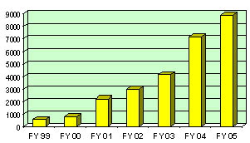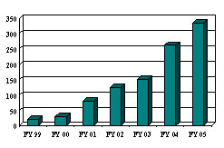
Graph 7.2-12
Graph 7.2-11

Graph 7.2-11
Weapons of Mass
Destruction Training

Course Ratings

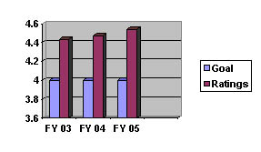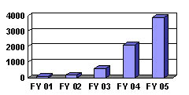
Graph 7.1-13
Graph 7.2-14

- The SCEMD developed, coordinated, and participated in 54 exercises during the past year.

- Three federally evaluated exercises involving a fixed nuclear facility were successfully completed without any deficiencies.

- The SCEMD developed and coordinated fifteen Weapons of Mass Destruction (WMD) exercises including a two-day state exercise that tested the state’s urban search and rescue capability for 36 consecutive hours. These WMD exercises were all requested by the State or Regional Counter-Terrorism Coordinating Committees and funded by the Federal government through a Homeland Security Grant.

- Three tabletop exercises were held for primary members of the State Emergency Response Team (SERT) to test their procedures when responding to an earthquake scenario.

- A tabletop exercise using a hurricane scenario was conducted for the entire SERT.

- Six federally evaluated exercises involving Federal Energy Commission regulated dams were successfully completed.

- One tabletop exercise and one functional exercise were conducted for other state agencies to validate their hurricane response plans.

- Three federally evaluated Medical Services drills involving local EMS and hospital emergency room response to a radiological accident were successfully completed without any deficiencies.

- Three tabletop exercises and one full-scale exercise were conducted jointly with the Department of Health and Environmental Control to test the Metropolitan Medical Response System and the Strategic National Stockpile.

- The SCEMD personnel assisted with and participated in ten tabletop exercises to test various Public Health District plans regarding response to a bio-terrorism incident.

- The SCEMD personnel participated in two National Disaster Medical System exercises and five other smaller exercises developed by other outside agencies.

Graph 7.2-15

- Fifteen WMD exercises were conducted during FY 05 funded by the federal government through a Homeland Security Grant.

Name: South Carolina Emergency Management Division, State Warning Point Operations

Goal: Minimize the loss of life and property attributed to all natural and technological disasters and acts of terrorism.

Objective: Reduce the risk of loss of life from all hazards and improve the state’s capability to respond to disasters.

Key Results: The State Warning Point receives and disseminates disaster/weather reports to insure local officials are aware of potential problems. The number of incidents/warnings received and sent out by operators totaled 1,376 actions for FY04, 5,342 actions for FY05, 405 river flood-warning actions in FY04, 898 actions for FY05, by the State Warning Point during the reporting period.
Graph 7.2-16
- The State Warning Point currently provides support to the DHEC Emergency Response section by answering all after business hours incoming calls. The calls are documented and immediately forwarded to the DHEC Duty Officers for appropriate action. This support assures a continuity of communications for the emergency response section and for all South Carolina citizens. The State Warning Point Operators documented 1,162 calls for FY04 compared with 1,537 calls for FY05.
Graph 7.1-17

Name: The Public Assistance Program (PA) is the federal assistance program, authorized by the Stafford Act, which provides financial assistance to aid state and local governments and certain private non-profit organizations with expenses related to the response to and recovery from a disaster. During 2004-2005, five ongoing disasters were managed. Capable management allows funds to be received by victims in an expedited manner, thus hastening the recovery process.

Costs: Funds Disbursed in state FY 2004

1299 1451 1509 1543 1543
Hurricane Winter Storm Winter Storm Hurricane Hurricane TOTALS
Floyd 2002 2004 Charley Gaston
1999 2004 2004
Federal $ 43,507.23 $105,152.64 $10,478,603.26 $939,979.22 $3,123,850.13 $14,694,092.48
State: $ 70,877.52 -0- $ 845,305.37 $ 55,278.10 $ 84,304.18 $ 1,055,908.63
Total: $114,384.75 $105,152.64 $11,323,908.63 $995,257.32 $3,211,154.31 $15,749,857.65

Goals: Improve the survivability of government infrastructure and privately owned businesses and homes.

Improve capability to coordinate the delivery of federal, interstate, and intrastate assistance in an efficient and effective manner.

Objectives: Develop a state capability to manage long-term recovery issues following a disaster.

Enhance contingency plans and procedures that address recovery activities in a post-disaster environment.

Key Results: Of the five disasters open in 2004-5, Hurricane Floyd Public Assistance was closed. Two new disasters, Hurricane Charley and Hurricane Gaston, received Presidential Declarations in the fall of 2004.

Hurricane Floyd--1999

- All funds are obligated and closed.

- Requested closure by FEMA May 2005.

Winter Storm--2002

- Ninety-nine percent (63 of 64) sub-grantees entirely paid and in closeout process.

- Ninety-nine percent ($3,939,939.78 paid of $3,949,761.15) of sub-grantee funding disbursed.

- Ninety-nine percent (63 of 64) of final inspections complete.

Winter Storm--2004

- Eighty-nine percent (126 of 141) sub-grantees paid in full and in the closeout process.
- Seventy-four percent ($15,613,955.59 paid of $21,352,889.38) eligible for federal and/or state reimbursements.

- Eighty-nine percent (126 of 141) of final inspections completed.

Hurricane Charley--2004

- Forty-eight percent (15 of 31) sub-grantees paid in full.

- Thirty percent, $983,036.71 paid of $ 3,287,005.87 eligible for federal and/or state reimbursements.

Hurricane Gaston-2004

- Forty-nine percent (17 of 35) sub-grantees paid in full.

- Twenty-two percent ($3,199,060.78 paid of 14,609,699.75) eligible for federal reimbursements.
Graph 7.1-18
Graph 7.3-19

Name: South Carolina Citizen Corps and Community Emergency Response Team (CERT) Grants

Costs: Program Costs for 2004-2005 (100% Federal)

Citizen Corps CERT
FY02 $17,013.02 $28,311.82
FY03 $0.00 $271,971.92
FY04 $147,259.33 $0.00
Total: $164,272.35 $300,283.74

Goal: Reduce human suffering and enhance the state’s capability to respond to and recover from all disasters.

Objective: Increase citizen disaster preparedness through education.

Key Results:

- Local Citizen Corps Councils have been established in 21 counties that are actively participating in the grant.

- Local Citizen Corps Councils are bringing first responders together with the local volunteer community in order to promote Citizen Corps programs.

- One hundred, twenty-four instructors have been trained in order to implement the CERT program.

- One thousand, four hundred, fifteen CERT members have been trained.

- CERT members are being used to staff shelters. Principals, assistant principals, and teachers from various school districts are being trained in CERT.

- CERT members have served as volunteers at several events in numerous counties.

- CERT members have served as a resource for FEMA for the response to the hurricanes of 2004.

Name: Manage the Individual Assistance Program for Tropical Storm Frances: The Individual Assistance Program is a federal assistance program that provides financial assistance to individuals and their households. Title 44, Code of Federal Regulations, mandates the Individuals and Households Program, in which housing assistance is provided along with Other Needs Assistance. Housing Assistance provides for temporary housing, repair assistance, and replacement assistance and is 100% federally funded. Other Needs Assistance provides assistance in the areas of medical, dental, funeral, disaster created needs, personal property, and transportation. There is a 75%/25% cost share between the federal and state government to fund this part of the program.

Costs: Program Costs for 2004-2005

Housing Assistance Other Needs Assistance
(100% Federal) (75%/25% Cost Share)

Federal Share: $5,770,529.19 $1,086,855.79
State Share: $0.00 $362,285.27
Total: $5,770,529.19 $1,449,141.05

Goal: Reduce human suffering and enhance the state’s capability to respond to and recover from all disasters.

Objective: Improve the capability to coordinate the delivery of federal, interstate, and intrastate assistance.

Key Results:

- During 2004, there was a Presidential Declaration for Tropical Storm Frances that was managed effectively. The incident period for Tropical Storm Frances encompassed Tropical Storms Ivan and Jeanne as well. Individuals who incurred damage from any of the three storms were eligible for Individual Assistance under the Presidential Declaration.

- Housing Assistance was provided in the amount of $5,770,529.19 to 3,986 individuals.

- Other Needs Assistance was provided in the amount of $1,449,141.05 to 1,141 individuals.

Name: Managed ongoing Hazard Mitigation Grant Program (HMG) disaster accounts. The HMGP is a federal disaster assistance program, authorized under Section 404 of the Stafford Act, as amended. This program provides financial assistance to state and local governments and certain private non-profit entities to implement corrective actions to reduce or eliminate long-term risk to people and property from natural hazards. These programs extend through multiple years until the applicants’ projects are completed.

Cost: Program Costs for 2004-2005

 | 1999  Hurricane Floyd | 2000  Winter Storm | 2003  Winter Storm | 2004  Winter Storm | 2004  Hurricane Charley | 2004  Hurricane Gaston | 2004  Tropical Storm Frances
Federal Share | $236,204.89 | $110,095.84 | $26,460.70 | $138,572.31 | $0* | $0* | $0*
Non-Federal Share | $78,734.98 | $36,698.70 | $8,662.50 | $46,192.87 | $0* | $0* | $0*
Total | $314,939.87 | $146,794.54 | $35,123.20 | $184,765.18 | $0* | $0* | $0*

*Hurricane Charley (2004), Hurricane Gaston (2004), and Tropical Storm Frances (2004). Twenty-two applications totaling $2,101,540 were received, and are currently under review.

Goal: Improve the operational survivability of essential government buildings, businesses, and homes.

Objectives: Promote mitigation as an integral part of the planning process for all new construction and retrofitting projects.

Work with partners to develop an incentive plan for taking steps that would mitigate disasters.

Key Results:

- Technical assistance was provided in identifying potential projects and completing project applications. Coordination was made for federal technical assistance when required.

- Hurricane Floyd (1999)–Twenty projects were approved at a cost of $8,777,829. Seventeen projects are complete, and the remaining 3 are ongoing. These projects include acquisition and elevation of homes, wind retrofits, and drainage improvements.

- 2000 Winter Storm–Sixteen projects were approved totaling $1,745,233. Fourteen projects are complete, and two are ongoing. These projects included wind retrofits and a county alert system.

- 2003 Winter Storm–Nine applications were forwarded to FEMA, and their approval is pending.

- 2004 Winter Storm–Eighteen applications totaling $4,354,754 were submitted to FEMA for approval, and are currently under review.
Graph 7.3-20

Name: Administer the Pre-Disaster Mitigation Program (PDM). The PDM is a federal mitigation program authorized under Section 203 of the Stafford Act, as amended. FY 2002 was the first year of this program. Additional funding was allocated in FY 2003. Also in FY 2003, a new nationally competitive program was developed to replace the previous non-competitive program. SCEMD provides pass through funds to local governments that successfully compete for the funds. The PDM provides funding to state and local governments for cost-effective projects that aim to reduce or eliminate the effects of hazards on people and property. Funding is provided on a 75% Federal, 25% non-federal cost-share basis.

Cost: Program Costs for 2004-2005
 | Non-competitive  FY 2002 Grant | Non-competitive  FY 2003 Grant | Competitive  FY2003 Grant
Federal Share | $132,379.59 | $44,906.06 | $24,447.00
Non-Federal Share | $ 44,126.53 | $14,998.69 | $ 8,147.00
Total | $176,506.12 | $59,904.75 | $32,594.00

Goal: Improve the operational survivability of essential government buildings, businesses, and homes.

Objectives: Promote mitigation as an integral part of the planning process for all new construction and retrofitting projects.

Work with partners to develop an incentive plan for taking steps that would mitigate disasters.

Key Results:

- Eligible applicants were notified of funding availability via mail and briefings, and technical assistance was provided in completing applications.

- In FY 2002, 18 applications were received totaling $835,144. Ten applications totaling $459,877 were submitted and approved. This funding was provided to the Councils of Governments to develop regional hazard mitigation plans. All funds were expended and the grant was closed out in 2004.

- In FY 2003, 13 applications were received totaling $408,943. Eleven applications totaling $372,913 were submitted and approved. This funding was used to purchase GIS software for the Councils of Governments for development of regional hazard mitigation plans, as well as provide mitigation planning funds to several local communities. These projects are on going.

- In FY 2003, three applications were approved by FEMA for competitive funds. One project was completed, and is pending closeout with FEMA, the remaining two are on going.

Name: South Carolina Domestic Preparedness Program

Goal: Develop a comprehensive program to enhance the state’s ability to effectively manage a Terrorism/Weapon of Mass Destruction (WMD) incident.

Objective: Develop plans, resources, and trained personnel to respond in a timely manner to make a significant impact on the containment and management of Terrorism/Weapon of Mass Destruction (WMD) incident.

Key Results:

- Resources:

Applied, coordinated the procurement, and managed Department of Homeland Security funding that will provide the following: Emergency response management software, SCEMD personnel, training for paramedics, terrorism response team equipment, decontamination systems for hospitals, local EOC enhancements, and the Citizen Corp program.

 | 2004 | 2005
New Funding | $1,102,000 | $1,306,000
Active Funding | $5,000,000 | $3,900,000
Applied Funding (State) | $4,248,698 | $1,252,000
Applied Funding (Local) | $5,814,557 | $3,840,000

- Chemical, Ordnance, Biological, Radiological (COBRA) First Response Program:

- Managed the COBRA program, resulting in first responders specially WMD trained HAZMAT technicians, paramedics, fire, and law enforcement personnel and responses.

 | 2004 | 2005
Participating Agencies | 200 | 217
First Responders | 850 | 900
Exercises | 28 | 50
Responses | 30 | 82

Name: Youth ChalleNGe Academies: (West Columbia & Aiken)

The South Carolina National Guard Youth ChalleNGe Program is a quasi-military program designed to assist at-risk youth ages 16-18 from all over South Carolina acquire the basic skills and education necessary to be successful in today’s society. The program is co-educational and is 17-months in duration. The youth spend five months in residence with a 12-month follow-up mentoring program using volunteers from their home communities.

Cost: Federal $3,780,000

Goal: Reach maximum enrollment each class at both programs. This means 100 students each class in Aiken and 105 students each class in West Columbia. Maintain 85% of enrolled students who complete the program and return successfully to the public school system, become gainfully employed, enter military service or pursue higher education.

Objectives:

- Graduate at least 50% of enrolled students with a GED.
- Secure or assist in securing positive placement for at least 100% of graduating students within the first month Post-Residential.
- Maintain at least 75% positive placement as of the 12th month Post-Residential.

Key Results:

- The South Carolina National Guard Youth ChalleNGe Program was in its seventh year of operation during State Fiscal Year 2004-2005. The second program that was relocated to Aiken in January of 2004 has increased its enrollment by just over 25% during its first year. A class is defined as participation in the full 17-month program. This report will incorporate data from both campuses.

- Chart 7.1-21 illustrates the continued growth of successful students and the number of GEDs that were earned at the two campuses during the last year. The enrollment for both sites has come from throughout the state, routinely from 25-30 counties are represented with each class.

- Chart 7.1-22 shows which counties are gaining the most benefit from the South Carolina Youth ChalleNGe Program. Additionally it shows where recruiting efforts have to be increased so that all at-risk youth in South Carolina are offered the opportunity for success. Since the program’s inception over 1,700 at-risk youths in South Carolina are now productive tax-paying citizens, some of which are serving in our military in harms way defending our way of life.

Graph 7.1-21
GEDs Earned During the Program

Graph 7.1-22

- Youth ChalleNGe is one of the most cost effective programs of its type. It is a cheaper alternative to other programs offered in the state. The chart below shows just how cost effective the program is to the taxpayers of our state and the nation.

Graph 7.3-23
- The graph below answers the question, “Are you effective?” To date, the two programs have a combined success rate that consistently stays between 70 and 80 percent

Graph 7.1-24
Name: Office of the Adjutant General

Cost: $1,405,996 State
544,700 State (Employer Contribution)
12,737 State (Military Personnel)
18,222 State (Military Operations)
142,897 State (Army Contract)
252,073 State (Air Contract)
___________
$2,376,625 Total

Goal: Manage the agency and the South Carolina National Guard in accordance with Section 25-1-350, South Carolina Code of Laws, 1976, as amended.

Objectives: Provide direct support of the organizational goals which enable the agency to achieve its mission and vision. The six goals of the South Carolina Military Department are:

#1 - Safety #5 - Quality of Life

#2 – Personnel Readiness #6 - Strengthen Support for
State and Federal Missions
#3 - Training Readiness

#4 - Equipment Readiness

Key Results:

In promoting the goals of “Quality of Life” and “Strengthen Support for State and Federal Missions”, the agency has developed a website to provide customers with information concerning the South Carolina Army and Air Guard, the Youth ChalleNGe Academies, the South Carolina State Guard, the Emergency Management Division, StarBase, the South Carolina AmeriCorps Defense Brigade and State Operations. The website also supplies valuable information on Family Readiness matters relating to the spouses of deployed military personnel. The tracking of the number of hits to this site is an indication of the effectiveness of this initiative. In Fiscal Year 04-05, the agency’s website, www.scguard.com, exceeded its goal by over 20% for the third consecutive year. Additionally, the agency has implemented a more secure, reliable and significantly faster server access for our remote customers. Up to 60% improvement in data access and reporting is now being realized.

In its role of supporting military activities, the state operations of this agency must be able to interface with its federal counterpart by way of the most advanced technology available. Failure to do results in costly delays that can, and indeed do, affect the security and safety of citizens both in South Carolina and the country at large.

The agency’s information technology section has suffered from the last several years of budget shortfalls and is falling farther and farther behind in its projected update of replacing equipment and programs every four years. Even in the face of such obstacles, the information technology section has established three very important metrics to ensure the collection and transmission of data affecting not only the military but matters relevant to emergency management, personnel and budget and finance.

The graphs below indicate three areas of extreme importance to operations: server on-line readiness, virus protection and server back-up.

Graph 7.2-25
In the above graph, the goal of server on-line readiness for FY 04-05 was 95%. The achieved result was over 99%.

Graph 7.2-26

In the above graph, the goal of virus protection updates was no more than two weeks for the fiscal year. The result achieved was less than two weeks.

Graph 7.2-27
In the above graph, the goal of server backups was no more than an average of 1.5 days old. The goal was achieved with a less than 1.5 days average.

The facilities management office continues to manage energy consumption and work towards overall reductions in this area. During Fiscal Year 04-05, the South Carolina Military Department ranked among state agencies with the lowest energy use per square foot.

Additionally, this agency ranked among state agencies with the lowest energy cost per square foot the same fiscal year.

Energy consumption dropped in Fiscal Year 04-05, see Chart 7.3-28, Energy Trends. This trend is attributable to the great number of soldiers mobilized and, therefore, not utilizing facilities in South Carolina. Federal mission expansion is bringing increased utilization of existing facilities and requirements for new facilities to accommodate air and ground simulators, computer battle exercises, aviation maintenance and operational aviation units. Although energy consumption may rise as a result of expanding operations, this agency will continue to make progress in energy reduction per square foot. This will be accomplished through continued education, energy efficient design and retrofit, analysis and effective management.
Chart 7.3-28

The budget and finance division of state operations charts and trends several key performance indicators. These include the number of vouchers processed against an average standard from previous years, the number of voucher errors against an average standard, the average process time to the Comptroller General’s office and the average process time from the Comptroller General’s office.

The division uses these indicators to monitor and maintain work flow at an acceptable level. The agency continues to recognize savings from reducing vouchers processed as a result of the procurement card program. The following charts are self-explanatory:
AS OF JUN 05
Vouchers FY 05
Chart 7.2-29
AS OF JUN 05
Voucher Errors FY 05
Chart 7.2-30
The charts are also a reminder that vendors are customers, too!
Avg Process Time To CG’s FY 05
AS OF JUN 05
Chart 7.2-31
AS OF JUN 05

Avg Process Time From CG’s FY 05
Days
Chart 7.2-32

Just as information management, energy conservation and the processing of vouchers are important, so, too, is the management of the agency’s workforce in light of reduced budgets and the possibility of a reduction in force.

The following charts track and monitor the agency’s State FTE allocation, State FTE vacancies, grant/agreement positions and the temporary workforce. The South Carolina Military Department has made every effort to keep state FTEs to a bare minimum and fully utilize wherever possible grant/agreement positions which are 100% federally funded.
State FTE Allocation
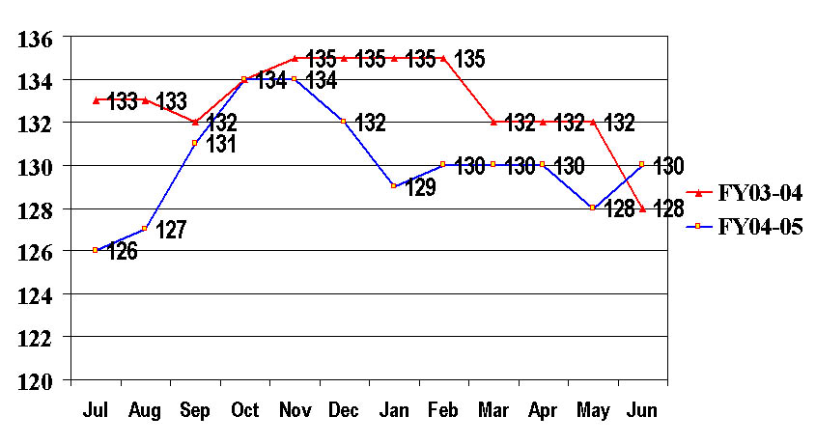
Chart 7.4-33

State FTE Vacancies
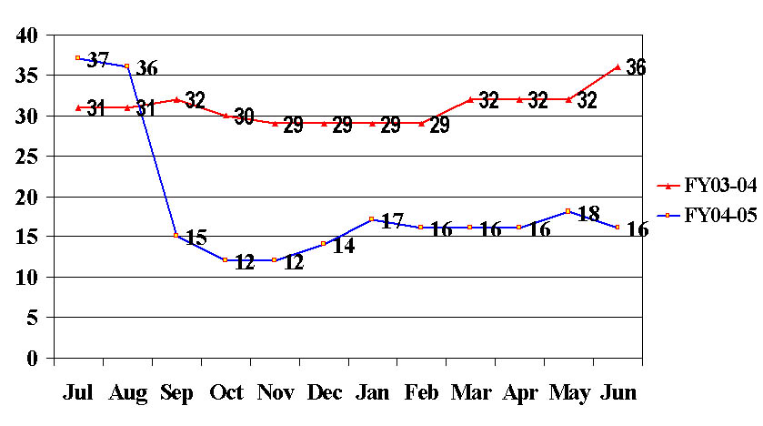
Chart 7.4-34

Grant/Agreement Positions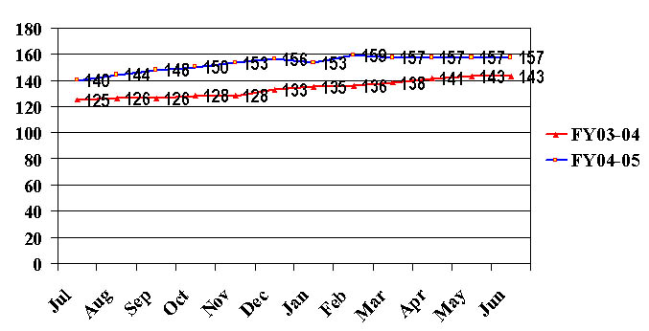
Chart 7.4-35

Temporary Workforce
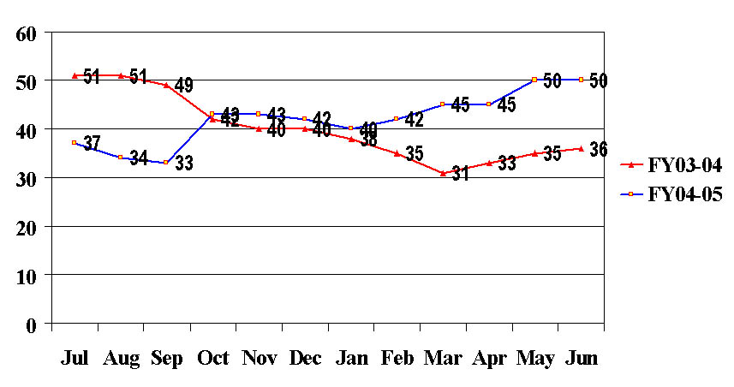
Chart 7.4-36
Chart 7.4-35
Name: The South Carolina State Guard

Cost: $114,283. State

$ 701. State (Funeral Flags)
________
$114,984.

Goal: Support the Military Department in state missions consisting of maintaining public safety, supporting local civil authorities to provide essential service, protecting local resources and services, assisting local law-enforcement agencies, supporting disaster assistance requests from the Red Cross and other humanitarian agencies, conducting state and community service projects at minimal cost to the state.

Objectives: Provide continuous support to the Budget and Control Board during contingency operations. Provide support to State/Local Law Enforcement Agencies. Provide chaplain support to the National Guard Youth ChalleNGe programs. Conduct honor guard for military funerals when requested. Conduct annual training in drill, ceremonies and continuing education.

Results:

- During FY 04-05, the South Carolina State Guard provided more than 60,000 hours of volunteer service to various State and local authorities and has maintained the same level of performance as the previous year. These volunteer hours represent more than $1,200,000 in savings to the taxpayers of South Carolina.

Volunteer Service Hours
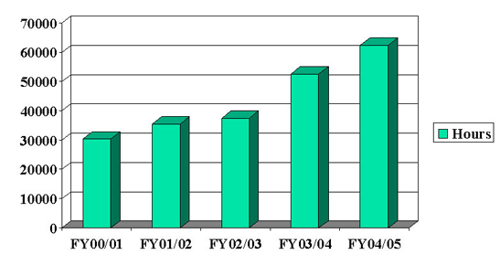
Graph 7.2-37

Volunteer Hours Savings

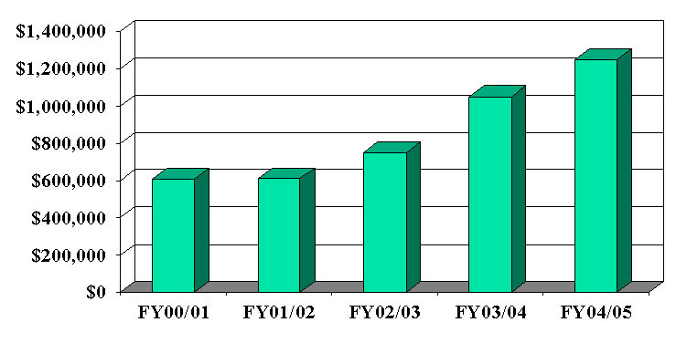
Chart 7.3-38

- Since 1977, the State Guard has shown remarkable growth from a force of 600 to a total of nearly 2,000 volunteer members serving in local communities throughout the state.

- Metrics are based on actual official State Guard orders, which tell: who, what, when, how and how many. This reliable data is upgradeable with a minimum effort and can be directly related to the strength of the State Guard – the more volunteers available, the more projects and services can be accomplished.
Name: National Guard Pension Fund

Cost $2,021,581 State

Goal: Program is managed in accordance with Sections 25-1-3210 through 25-1-3240 of the South Carolina Code of Laws, 1976 as amended.

Objectives: To accurately identify authorized recipients and distribute entitlements in a timely manner. To maintain the fund at the prescribed actuarial funding level.

Key Results: The National Guard soldier qualifies for the South Carolina state pension upon retirement with 20 years of services, with at least 15 years of this service in the South Carolina National Guard. During FY 04-05 Army and Air National Guard State Pension had an annual economic benefit to the South Carolina economy of $2,521,745.

SCARNG RETIREMENT STATE MILITARY PENSION
FISCAL YEAR 2004/2005
TOTAL $2,521,745
Graph 7.3-39

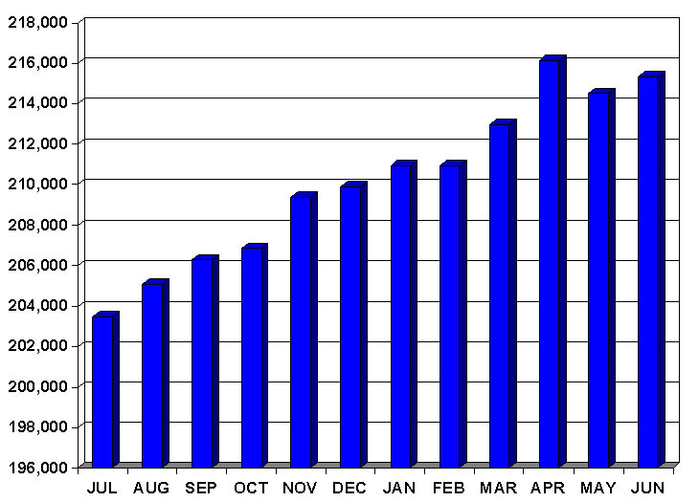

The South Carolina National Guard soldier also qualifies for a Federal Military Pension at age 60 with 20 years or more of service. During FY04-05, South Carolina National Guard Federal Pensions had an annual economic benefit to the state of $2,290,858.

FEDERAL MILITARY PENSION ECONOMIC BENEFIT TO SC FY 04-05
TOTAL $2,290,858
Graph 7.3-40
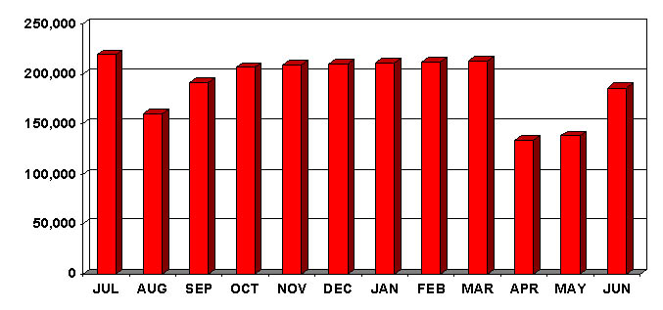

- Section 25-1-3235 requires the General Assembly to appropriate sums “sufficient over time to establish and maintain (National Guard Pension) fund on an actuarial basis” As depicted below, the fund begins declining in 2012, becomes insufficient to meet outlays in 2031, given the current appropriation status. There are presently 2,552 retired participants receiving benefits with a projected 7,388 additional eligible participants entitled to state pension benefits over the next 37 years.

Chart 7.3-41
Chart 7.3-41

NOTE: Beginning in January 1, 2006, the National Guard State Pension will become a part of the South Carolina Retirement System.

- In a continuing effort to keep the National Guard retiree abreast of activities, the Adjutant General schedules an Annual Retiree Update Briefing each year and has established www.scguard.com to assist retirees in obtaining information from numerous agencies that support the over 60 soldier.

Name: STARBASE Swamp Fox

Cost: $240,000 Federal

Goal: To provide STARBASE Academies to 700 students during the regular school year.

STARBASE Swamp Fox is a National Guard Youth program designed to boost the math science and technology skills of elementary and middle school students in a twenty to twenty five hour academy devoted to the study of flight. The program targets primarily fifth graders in South Carolina as the national curriculum for STARBASE correlates best in science and math to the skills required of our fifth grade. Working with the classroom teacher and his/her class, the program utilizes the resources and the personnel of the South Carolina National Guard to teach thirteen core topics of flight through specially designed hands on math and science activities.

Objectives:

Insure that STARBASE Swamp Fox is providing complementary instruction where needed by having 80% of academy students from the at risk population.

Have 70 percent of Academy students pass the national testing instrument

Continue the collaborations established in previous years and add partnerships that involve secondary students and at least one partnership related to teacher training. Also, one internal partnership within the DOD was a target.

Increase the reach of the STARBASE program by having at least 1000 students involved in programs beyond the normal academies.

Key Results:

- The critical measure of the STARBASE program, the academy contacts, has met and exceeded the required goal of 700 students in STARBASE academies with a total during the period of 825.
In addition we exceeded by a large margin the stated goal of at least 1000 students involved in STARBASE activities beyond the academies. During the report period we had 3200 students engaged in non academy activities. See Chart 7.1-42 on the next page.

Graph 7.1-42

- The makeup of our student population in the program continued the emphasis on low income and potentially at risk youth as 94 percent of academy students came from schools or classes from the designated population.

- The STARBASE program proposal called for the formation of partnerships and programs with secondary school students, at least one program involving teacher training and one partnership involving organizations internal to DOD. The first goal was met through a partnership with WJ Keenan High School in Columbia.

- The second goal involved a series of workshops with teachers utilizing a 16 week series of the Newspaper in Education program of the STATE newspaper.

- The third goal was attained in April 2004, when the DOD representatives to the President’s Science Summit endorsed the STARBASE Swamp Fox science enhancement proposal by encouraging adoption by other STARBASE units of the Swamp Fox student testing program.

Name: South Carolina AmeriCorps Defense Brigade

Cost: $297,476 Federal

Goal: Provide training to an all-volunteer force in South Carolina in the areas of emergency preparedness and public safety in order to relieve first-responders in the event of an emergency.

Objectives:

- Recruit 1,500 volunteers

- Train a cadre of 30 security specialists who are qualified law enforcement officers

- Check 50 child or adult care facilities

- Manage a statewide database of volunteers identified by professional specialty, talents and skills to serve as emergency responders

- Assist public safety by providing traffic or crowd control at 150 events

- Provide federally approved emergency preparedness training to volunteers

Key Results: The charts below reflect the effectiveness of the program.

Recruit 1,500 volunteers | Train 30 Security Specialists
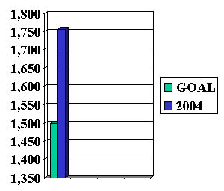  Graph 7.2-43 | 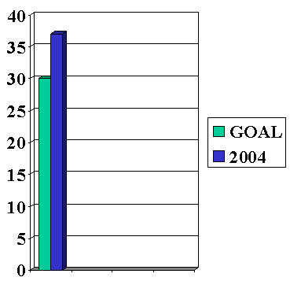  Graph 7.2-44

Check 50 Child or Adult Care Facilities | Manage Statewide Database
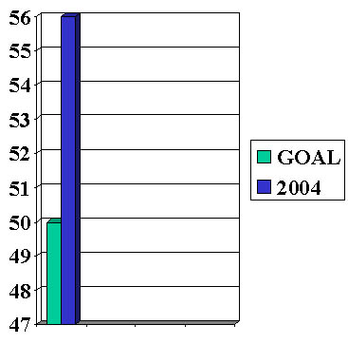  Graph 7.2-45 | 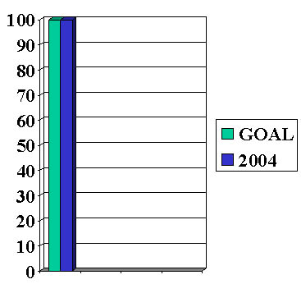  Graph 7.2-46
Traffic or Crowd Control | Emergency Preparedness Training
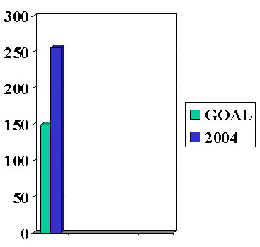  Graph 7.2-47 | 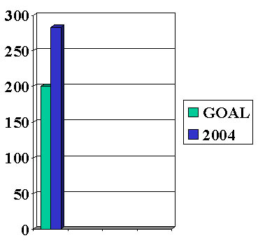  Graph 7.2-48

- Recruited over 1,750 volunteers to respond in times of emergency

- A cadre of volunteers has taken courses at the US Department of Homeland Security for Domestic Preparedness in the weapons of Mass Destruction, Law Enforcement Protective Measures and Incident Command. Six members were certified as trainers. Volunteers also completed a 40-hour Surveillance Detection Course, a 40-hour Executive Protection Specialist Course and an eight hour Refuse-to-be-a-Victim Course.

- 56 Child or Adult care facilities have been checked.

- Trained 37 security specialists who are qualified law enforcement officers.

- Assisted public safety in providing traffic or crowd control at over 250 events.

- A statewide data base is operational available to law enforcement and emergency preparedness offices in South Carolina. This is being expanded to include a web site that will make current information available to volunteers.

The AmeriCorps Brigade forms a brigade of the South Carolina State Guard. It is funded by the only federal grant of its kind to a state military department in the name of homeland defense.

