Department of Probation, Parole, and Pardon Services

Accountability Report
Fiscal Year 2004-2005

Section I – Executive Summary

The S.C. Department of Probation, Parole, and Pardon Services (DPPPS) provides a variety of essential services in support of the Department’s mission and related public safety initiatives. These include:
- Supervising and assisting offenders to successfully complete their court mandated periods of supervision; and, providing opportunities for their education and successful integration back into the community.
- Assisting victims of crime; including the management and oversight of restitution payments to crime victims.
- Supporting and conducting Parole Board Hearings
- Providing assistance to state law enforcement and emergency response organizations in support of homeland security, natural disaster response activities, and special events requiring law enforcement augmentation.

To provide these services the Department works in close collaboration and with the strong commitment of other officials and organizations, including the Governor and his staff, the General Assembly, cabinet and other agencies, state boards and commissions, as well as public, private, and non-profit organizations.

Mission
The mission of the South Carolina Department of Probation, Parole and Pardon Services is to:
- Prepare offenders under our supervision towards becoming productive members of the community;
- Provide assistance to the victims of crimes, the courts and the Parole Board; and to
- Protect public trust and safety

Vision
To be recognized as a leader in: Supporting public safety service initiatives to the citizens of South Carolina; creating a culture that values all employees; developing innovative programs to provide quality service to our customers; and, advancing the application of our information management system.

Values
- Integrity
- Fairness
- Teamwork
- Performance Excellence
- Accountability

Key Strategic Goals for Present and Future Years
- To effectively meet our public safety responsibilities
- To continuously improve our processes
- To deliver quality services to our customers
- To be fiscally responsible
- To provide for personal and organizational growth

Barriers and Opportunities
Funding allocations for 2005 and an increased emphasis on grant monies to support improvements in technology have begun to improve the Department’s ability to fill critical agent vacancies, replace and procure needed equipment, and as a result enhance public safety.
One area that the Department will continue to closely monitor is the turnover rate within the Agent career field. As Agents become C-1 certified, they automatically become eligible for additional employment opportunities in law enforcement organizations outside of the Department.

Major Achievements FY 2004 - 2005
The Department has assumed a lead role in several initiatives to help offenders successfully reenter their communities and the workplace through a system of integrated partnerships with service providers.
  - Learn and Earn Program and GED Referrals: This is a collaborative effort between SCDPPPS and the Department of Education (SCDOE) to support the attainment of a GED by qualifying offenders under probation/parole supervision. This initiative helps make offenders more employable and raises their earnings potential. It facilitates their ability to pay taxes, take care of their families, and contribute to their communities. As of June 30, 2005, a total of 539 offenders have either entered into the Learn and Earn Program, or have been referred to the GED program by the Department.
  - “On the Outside” Mentoring Pilot Program
This initiative was undertaken to work with sister state agencies and South Carolina churches as mentoring partners. The initiative links faith-community mentors with adult offenders who are reentering South Carolina’s communities from prison, parole, or from supervision. It specifically targets offenders who are seeking to make meaningful changes in their lives. A mentor’s positive influence and support can help offenders make significant changes to become crime-free, productive, and law-abiding citizens.
  - South Carolina Reentry Interagency Collaborative Team (SCRICT): The Department, in collaboration with other state agencies, formed the (SCRICT). This team, comprised of representatives from DPPPS, SCDC, DOE, HHS, DMH, DAODAS, DSS, ESC, DPS, and SCDVR, is developing recommendations for improvements to South Carolina’s offender reentry practices. They include methods for gathering and sharing information, enhancements to the utilization of resources, the integration of promising practices, and the identification of potential funding for each recommendation. The ultimate goal is to help break the cycle of crime thereby creating safer communities.
  - Parole Employment Program (PEP): The Department coordinated the establishment of the PEP in partnership with the SC Vocational Rehabilitation Department (SCVRD). This program is designed to provide vocational and rehabilitation services and employment placement assistance to all eligible inmates being paroled who have very limited prospects for employment. Approximately 60 inmates were paroled to PEP during FY2004 – FY2005.
  - Partnership with the Employment Security Commission (ESC): The Departments partnership with the ESC serves as a significant referral resource for linking unemployed offenders to jobs. More than 30% of offenders have less than an 11th grade education. In addition, young offenders exiting the Department of Corrections under youthful offender parole average a ninth grade education, with a seventh grade reading level. This is clearly an area of concern as related to an offender’s ability to find employment, assist their family, and contribute to the community. A strengthened partnership with the ESC and an increased focus on offender unemployment directly supports an offender’s successful integration back into the community.

In addition to helping released offenders integrate successfully into the community, the Department is also pursuing a variety of other initiatives designed to enhance overall operations and public safety.

  - Mobile Technology
This grant project will provide the Department’s agents immediate and up-to-date access to critical offender records and information while working in the field. It is expected that more than 66 mobile units will be in use by the end of the current calendar year, with full deployment, to all employees, scheduled by the end of the next calendar year.
  - Victim Videoconferencing Pilot Project
This grant project will provide staffing and services to victims attending parole and pardon hearings in at a remote video-conferencing site in Charleston County. Services will include required notifications, accompaniment, response to questions and explanations of the outcome of the hearing.
  - Sex Offender Management Team
The Department chartered a cross-functional team to review and research current sex offender management practices toward the goal of recommending uniform supervision strategies for this offender population. With the help of a technical assistance grant from the Center for Sex Offender Management (CSOM) a trained facilitator educated the team on national trends in managing this unique offender population. To date, and through GPS and mapping technology, the Department has superimposed sex offender residences on large-scale state county and city maps used by the Department. This process supports the Department’s electronic monitoring initiatives, supervision strategies, and the Agent workload determination process.
  - Global Positioning Satellite (GPS) Technology
This technology, financed through a federal grant and currently being implemented, allows the Department to monitor and track targeted offender populations, including sex offenders. Associated communications equipment including electronic monitoring equipment and beepers will provide certain victims groups advance warning of territorial violations by offenders under electronic monitoring while simultaneously notifying law enforcement entities (Active GPS). As of the end of FY 2004 – 2005, staff in 15 field offices have been trained on the use of this new technology. Note: Active GPS is limited to offenders who have committed a crime of violence against an adult female victim. In the Passive GPS program, the agent is notified of offender activities on the next business day following the occurrence. As of June 30, 2005, the Department was monitoring 30 offenders on Active GPS, and 35 offenders on Passive GPS.

  - Mapping
Over the past year, the Department began using mapping technology to visually depict key subpopulations of offenders under the Department’s jurisdiction, to manage and illustrate the geographic distribution of agent caseloads, to determine the distribution of categories of offenders (i.e. sex offenders, high risk offenders, etc.), and to help forecast Agent manpower needs. This technology uses the “911” addresses for active offenders under the Department’s supervision, and displays data on large format maps printed by special plotting equipment. To date, 10 counties have the ability to view this information on the local level, and more are planned. Future plans also include a project expansion that will allow the sharing of this and other databases with other law enforcement organizations.

The map below provides an example of the Department’s “Mapping Technology.” Dots within the image depict residence locations of Offenders in the City of Florence, SC.

Additional achievements:
- The Community Services Division is continuing an initiative to provide immediate access to live offender information databases through the use of laptop technology in the courtroom. As of June 30, 2005, all 46 counties were using a courtroom laptop. This initiative is expected to result in significant savings realized through more expedient courtroom proceedings and accelerated case resolutions.
- The Field Operations and Community Services Divisions are continuing to collect blood samples from which DNA can be derived, in support of the national DNA database initiative. As a result, more than 19,000 samples have been collected during FY 2004 – 2005. In conjunction with this initiative, new legislation enacted on July 1, 2004 significantly expands the type of offenses for which DNA sampling is required.
- During FY 2004-2005, offenders supervised by the Department contributed 316,742 hours of public service work at government and non-government agencies. Calculating these hours at minimum wage ($5.15) per hour, offenders contributed more than $1,631,221 of labor to organizations within our state.
- The Interstate Compact Section of the Community Services Division coordinated the processing 1,421 offender transfer requests from South Carolina to other states and the processing of 1,495 offender transfer requests from other states to South Carolina.
- The Field Operations and Community Services Divisions jointly coordinated five legislatively mandated special release programs to effect inmate release from incarceration to supervision. During the year 1268 inmates were released to Youthful Offender Act supervision; 1289 to parole supervision; 680 to the Community Supervision Program; 130 to the Supervised Furlough IIA program; and, 384 through the Shock Incarceration Program.
- The Special Operations Section of the Community Services Division and staff from the Community Services Division participated in eight exercises conducted by the SC Emergency Management Division. These included exercises in support of hurricane evacuation traffic management, post-hurricane security deployments, and shelter security. The Department expended $26,788 in support of these exercises during FY 2005.
- The Special Operations Section of the Community Services Division and staff from the Community Services Division augmented state law enforcement organizations to provide essential security in support of Martin Luther King Day at the Dome, and the Memorial Day Bike Festival at Myrtle Beach. The Department contributed a total of 76 Agents to these efforts (in excess of 3,000 work hours).
- The Special Operations Section of the Community Services Division designed and created code plugs for the Department’s 800 MHz radios and has reprogrammed all other existing Department radios. By developing our own in-house programming capability, the Department has realized over $20,000 in savings this past fiscal year. 800 MHz radios are required to provide common and secure communications capability between a variety of emergency response organizations, including SLED, DNR, local police departments, sheriff offices, fire departments, and our own Department.
- The Victim Services Section continued a process to e-mail parole notifications to solicitors and law enforcement officials. This change represents an annual cost savings of approximately $4,350 in actual savings with additional monies saved in “staff-time”.

How is the accountability report used to improve organizational performance:
The accountability report serves as an annual assessment and baseline for measuring organizational performance and setting of improvement initiatives. The primary vehicle for setting these initiatives is the Department’s strategic planning process and integrated quarterly performance review process.

Section II – Business Overview

SCDPPPS is the only Department in South Carolina providing supervision for approximately 49,000 adult offenders on probation, parole, community supervision, supervised furlough and adult offenders under youthful offender supervision. The Department is also charged with conducting investigations for offenders who are eligible for parole or those who make application for pardons. The Department stands as the first line of defense between the criminal offender population released to the community from institutional programs, or deemed suitable for community placement by the courts of General Session, the Board of Probation, Parole and Pardons, and the general citizenry of the state.

A major component of this unique mission is placing the needs of the victim’s community at the forefront. The capacity to place offenders in our residential facilities to ensure gainful employment produces significant returns by way of restitution payments and other monetary obligations. Additionally, the Department’s mandate to provide and administer court ordered restitution through the collection and disbursement of millions of dollars annually contributes directly to the well-being of our citizenry.

To support its mission, the SCDPPPS’ organizational structure consists of four divisions and the Office of the Chief of Staff. The Divisions comprise Field Operations, Community Services, Legal, and Administrative Services (Fig. A-2). Each section within these divisions is distinctively different, but all serve to support the mission of the Department.

Total Number of Employees (as of June 30, 2005)

 | Authorized | Filled (FY 2004) | Filled (FY 2005)
Classified | 814 | 662 | 700
Unclassified | 6 | 5 | 6
Total | 820 | 667 | 706

Operating Locations
The Department maintains the following operating locations to support its mission and service related requirements: 46 county offices; four county satellite offices (Beaufort, Berkley, Dorchester, and York counties); three Residential Services Centers (Columbia and Charleston Community Residential Centers, Spartanburg Restitution Center); and, a Headquarters facility in Columbia, SC.

Key Stakeholders
Key Stakeholders are defined as the citizens of South Carolina and other states that are not direct customers, but are affected by the products and services provided by the Department. These also include local, state and national professional associations in which employees of the Department actively participate by holding officer positions, conducting workshops, or providing other essential support.

Key Customers and Key Services
The primary customer products/services for all key customer segments are being formally defined as part of the Department’s strategic and office action planning process (see Cat. 2). Key service requirements for all customer transactions are: Safe Environment; Timely and Accurate Response; Flexible Access; Professionalism; and, Quality in Service and Products (PPP Strategic Plan). See Table A-1 below for a sample listing of key customer segments and key services.

Section Key Customers Key Services
Special Operations | Federal, state agencies and law enforcement organizations; | Special operations assistance; information requests/records; safety plans/equipment; special operations training
 | Offenders | Information; special assistance
 | General Public | Information; special assistance
Community Services | Offenders; Law Enforcement Organizations; General Public | Supervision Requirements; technology initiatives (GPS, Mapping); correspondence and other communications; training; preparation of offender related documentation
Field Operations | Offenders; Law Enforcement Organizations: Judiciary; General Public | Field supervision requirements; home visits; intervention; warrant service; residence verifications; collection of fees; correspondence
Victim Services | Victims | Correspondence and other communications; payment of restitution monies; documentation in support of parole hearings
Programs & Interstate Compact | Employees; SC Dept. of Corrections Employees | Correspondence; YOA residence verifications; YOA release cases: YOA revocation and termination orders; certificates; review violation documentation: presenting violations to hearing officers
 | Victims; Offenders | Response to correspondence and other communications
Legal Services | Employees | Training; Legal Advisement and Representation
 | Judiciary | Training; Detail Summaries; Court Presentations
 | General Public; Offenders | Respond to Case Inquiries and Correspondence
Hearing Section | Employees | Training; Orders of Continuation; Detailed Summaries
 | Parole Board | Training; Findings for Revocation Cases; Video Site Coverage
 | Judiciary | Training and Detailed Summaries
 | Offenders | Respond to Case Inquiries and Correspondence
 | SC Dept. of Corrections | Order of Revocations and Detailed Summaries
Parole Board Support Services | Board of Parole and Pardons (Members) | Detailed Summaries, Investigation Reports, Recommendation Request, and Training
 | Attorneys | Respond to Inquiries and Correspondence
 | Offenders | Provide Hearing Notification and Respond to Inquiries
 | General Public | Provide Information on Parole and Pardon matters, Respond to Inquiries and Correspondence
Human Resources | Employees | Job applicant screening; drug testing; classification and compensation; benefits counseling/services; EPMS management; disciplinary/grievance processing
 | General Public | Job applicant support processes; drug testing; classification and compensation info. benefits info.
 | SC State Office of Human Resources | HR data reporting; EPMS reporting; disciplinary/grievance reporting; EEO reporting
 | State Agencies | Job applicant services; database reporting
Quality Management | EMT, Employees | Strategic Planning; Office Action Planning; Performance/Business Improvement Systems Planning, and Implementation; Facilitation
 | Employees; Other State Agencies | Performance Improvement/ Business Excellence Consultation/Tng.
 | SC Quality Forum | State Baldrige Examiner Tng. Panel of Judges for Governor’s Quality Award
Table A.1

Key Suppliers:
The Department conducts business with a large variety of suppliers/vendors, non-profit organizations, and the faith-based community. Our top suppliers/vendors, in terms of business conducted, include the following: Varian (Drug Testing Supplies), BI Inc. (Electronic Monitoring Equipment and Services); iSECUREtrac Corp. (Global Positioning Systems and Services); Lenovo Inc. (Computers); DELL (Computer Rentals); HP (Computer Printers and Supplies); and, the State of South Carolina (examples include, the state telephone system, fleet, liability insurance, and rent). Additionally, non-profit organizations, the faith based community, and the Department’s many partners contribute significantly to the Department’s efforts in addressing offender needs through numerous relationships, referral services including faith-based services, clothing and incidentals, short term housing and life skills related training.

Expenditures/Appropriations Chart

Base Budget Expenditures and Appropriations

 | 03-04 Actual Expenditures |  | 04-05 Actual Expenditures |  | 05-06 Appropriations Act
Major Budget Categories | Total Funds | General Funds | Total Funds | General Funds | Total Funds | General Funds
Personal Service | 23,459,251.63 | 13,562,674.13 | 22,401,499.39 | 12,214,074.57 | 23,003,876.00 | 12,295,202.00
Other Operating | 7,276,455.77 | 511,021.00 | 7,254,755.27 | 352,574.48 | 8,551,856.00 | 248,678.00
Special Items | 0.00 | 0.00 | 0.00 | 0.00 | 0.00 | 0.00
Permanent Improvements | 0.00 | 0.00 | 36,369.08 | 0.00 | 0.00 | 0.00
Case Services | 71,592.59 | 56,809.38 | 98,985.93 | 53,262.00 | 105,288.00 | 19,424.00
Distributions to Subdivisions | 0.00 | 0.00 | 0.00 | 0.00 | 0.00 | 0.00
Fringe Benefits | 8,145,470.10 | 4,814,850.49 | 7,683,657.09 | 4,354,728.95 | 7,986,945 | 4,268,893.00
Non-recurring | 0.00 | 0.00 | 0.00 | 0.00 | 0.00 | 0.00
Totals | 38,952,770.09 | 18,945,355.00 | 37,475,266.76 | 16,974,640.00 | 39,647,965.00 | 16,832,197.00

Other Expenditures

Sources of Funds | 03-04 Actual Expenditures | 04-05 Actual Expenditures
Supplemental Bills | 0.00 | 0.00
Capital Reserve Funds | 0.00 | 0.00
Bonds | 0.00 | 0.00

Organizational Structure

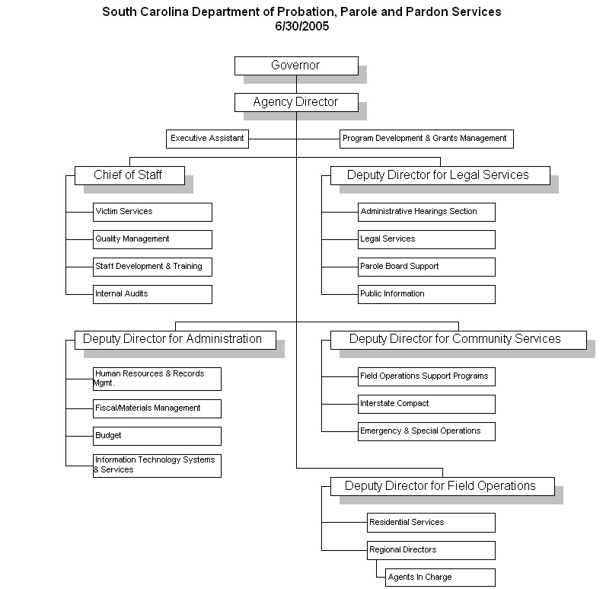

Category 1 Leadership

  - How do senior leaders set, deploy and communicate: (a) short and long term direction; (b) performance expectations; (c) organizational values; (d) empowerment and innovation; (e) organizational and employee learning; and (f) ethical behavior?

- Short and long term direction is set by the Governor. The Governor’s direction is communicated by the Department’s Director to members of the Executive Management Team, and in turn to division managers and other employees. Communication methods used include telephonic communications, e-mail, one-on-one’s, intra office discussions, staff meetings, and the Employee Performance Management System (EPMS). The agency’s strategic plan serves to communicate both, short and long term direction and, when completed during FY2005 – FY2006, will be linked to supporting Office Action Plans. It will further enhance the current foundation with a comprehensive management system that links office goals and performance measures to short and long term strategic goals.

To insure compliance, understanding, and effective communication, The Department’s Executive Management Team (EMT) uses a variety of approaches. These include Quarterly meetings between the EMT and all division managers, personal e-mails on important topics from the Department’s Director to all employees, regular scheduled intra-divisional management meetings and staff meetings with their respective office employees. These approaches provide for bi-directional communications between all levels of the organization and enable a quick response to issues or concerns of interest to the Department’s external and internal customers.

- Performance expectations are articulated by the Director and Deputy Directors and are reinforced through the EPMS process. Within each office, employees and their supervisors include specific work objectives and performance expectations in each employee’s Planning Stage for the coming year. Any incident of non-conformance is addressed verbally, in writing, or through prescribed state government HR regulations, as appropriate.

- Organizational values were developed by the Executive Management Team as part of the Department’s strategic planning process, and apply to all of the Department’s sections. Key values identified as important to the Department are “Integrity, Fairness, Teamwork, Performance Excellence, and Accountability.” Individual employee performance expectations towards modeling these values will be incorporated in the performance evaluation process beginning FY2005 – FY2006.

- Empowerment and innovation is encouraged and supported. At the managerial and supervisory level, division and office managers are given maximum flexibility to serve their customers quickly, effectively, and efficiently. Managers are expected to transfer empowerment to office staff so that they can work freely within broad guidelines appropriate to their function. Management training on supervisory skills and organizational development topics has been provided to the Department’s managers. Innovation is also encouraged within the Department. Any employee may suggest changes to policy, or new ways of doing business, directly to their supervisor, via an electronic template on a shared network drive, or via the cross-functional Agency Policy Review Committee. This process assures a comprehensive review of all submitted suggestions for potential implementation.

- Organizational and employee learning is strongly supported by senior management whether by participation in the Cabinet Agency Training Consortium, attendance at in-house training classes, through programs offered by the Budget & Control Board, the State Government Improvement Network, by attendance at conferences and seminars, by participating in writing this Baldrige-based accountability report, or through training procured through other methods. For example, to increase organizational learning and understanding of the Baldrige criteria each division manager participated in the development of their respective Divisional Accountability Report. This process, modeled by the division’s managers, significantly increased learning and organizational understanding of the performance excellence criteria and supporting methodologies.

- Ethical behavior and expectations are addressed as part of New Employee Orientation and specified in Policy 210. In addition, the State Government Ethics and Accountability Act provides clear procedures for investigating grievances and initiating disciplinary actions. The State Ethics Commission requires specified officials and public employees to file Statements of Economic Interest while the South Carolina Bar maintains ethics requirements for all practicing attorneys. In addition, the Department’s Director and Human Resources Office conduct Exit Interviews with departing employees with results analyzed for organizational improvement opportunities. These procedures and requirements help insure that ethical guidelines are followed.

  - How do senior leaders establish and promote a focus on customers and other stakeholders?
The goals and supporting strategies described in the Department’s Strategic Plan provide the primary emphasis and direction for each office’s focus on customer service. Key service requirements (Table A.1) are routinely reviewed at divisional manager meetings and also with local managers and supervisors. Examples for the Field Operations Division include: the accurate and timely collection of offender restitution payments (to enable victim payments), and the accurate and timely completion of Pre-Parole Investigations for the Board of Paroles and Pardons.

The Department Director’s close coordination with the Chief of Staff and EMT ensures that key customer needs and concerns are expeditiously addressed, whether pertaining to legislative, mission related, performance improvement, or quality of life issues. In addition, The Department’s Public Affairs Office, Internet web page, and published phone numbers for all office functions provide readily available customer access to the Department.
1.3 How do senior leaders maintain fiscal, legal, and regulatory accountability?
The Department uses a variety of approaches to insure fiscal, legal and regulatory accountability. These include a multiple stage review of proposed budgets, authorization for purchases, budget review at the divisional manager level, and routine communications by financial staff and legal staff with field staff and divisional managers. Financial information accuracy is validated through internal and external audits, including audits by the State Auditor’s Office, and crosschecks by the Comptroller General’s Office. Regulatory requirements and issues are reviewed by central office senior management, the Department’s legal staff, regional, and local managers during regular scheduled staff meetings, in special training sessions that include required legal training, and through electronic mail if necessary. Regulatory requirements that come under the purview of the Office of Occupational Safety and Health Administration (OSHA) have been met without any significant discrepancies noted.

1.4 What key performance measures are regularly reviewed by your senior leaders?
Key performance measures reviewed by senior leadership include program cost effectiveness, offender supervision results including home visits, NCIC Hits (timeliness of response), drug test results, pre-parole investigations, supervision fee collections, and warrant service status. Also, customer request for assistance and information, Minority Business Utilization statistics, victim restitution paid, bed space utilization for our restitution centers, employee turnover rates, and employee training completion and satisfaction data. Our Emergency and Special Operations function also reviews performance data related to the Department’s C-1 training initiative, emergency operations including special security deployments, and Special Operations Response Team activities including Homeland Security assistance. In addition, during FY2004–FY2005, each section linked their respective performance measures directly to the Department’s Strategic Plan (See Cat. 4.4). As part of the planned 2006 strategic plan review process, senior management will select a composite of key measures to establish the Department’s Balanced Scorecard.

1.5 How do senior leaders use organizational performance review findings and employee feedback to improve their own leadership effectiveness and the effectiveness of management throughout the organization?
The Employee Performance Management System (EPMS) process and corresponding dialogue between Senior and Division Managers provides the primary method for obtaining feedback on management effectiveness. Other methods include staff feedback obtained through routine one-on-one dialogue between managers and employees, through staff meetings, exit interview, and feedback obtained from discussions held at leadership related training classes. Division retreats within the Administrative Services Division provide an additional method for sharing and communicating organizational performance reviews.

1.6 How does the organization address the current and potential impact on the public of its products, programs, services, facilities and operations, including associated risks?
Our Department interfaces with numerous entities on a daily basis including but not limited to the judiciary, state and local law enforcement, victims, partners, and the general public. Our ability to effectively supervise offenders under our jurisdiction, respond to the needs of crime victims, and our many other customers can and does have a direct impact on the well being of South Carolina’s citizens. Our ability to address issues of offender accountability is first and foremost and is reflected in our results related to mission accomplishment (Cat. 7.2). Our supporting Offender Information System (OIS) serves as a repository of data from federal, state, and local law enforcement which is kept up to date with the most current offender information, and protected through the use of physical and technological security systems. Access to this data has been enhanced through the implementation of the GPS Monitoring process, and the Department’s initiatives related to courtroom technology (laptops).
Additional methods for obtaining information on program impact and risk factors include information obtained through our Internal Auditing Section, through partnerships and collaboration with other law enforcement and government entities, service providers, and during meetings with customers and the general public. Partnerships supporting our law enforcement responsibilities and multiple offender life enhancement initiatives (see Achievements section) are carefully managed through our Office of Grants and Program Development. Issues related to the general public are tracked through press summaries of South Carolina newspapers and a compilation of issues and inquiries received by the Department’s Public Affairs Office. The Department also maintains contact with the public through its web site and the media. These methods provide information that is consumed by a wide range of individuals and entities, and serve as a front line tool to disseminate information in a timely manner.

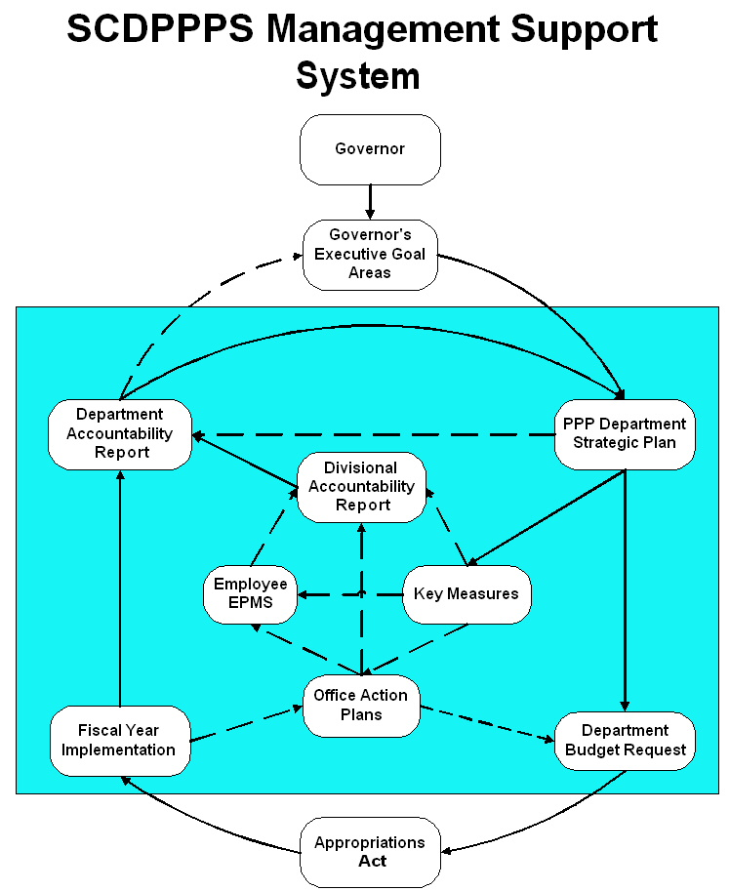
Fig. 1.6-1

1.7 How does senior leadership set and communicate key organizational priorities for improvement?
Improvement priorities for the Department are set and communicated through the Department’s Strategic Plan, legislative mandate, and through communication with the Office of the Governor. These priorities are communicated and reinforced within the Department through weekly EMT meetings, quarterly meetings with all Division Managers, and weekly, monthly, or quarterly staff meetings within each division and their respective sections. Reviews of the Department’s key measures during these meetings serve to compare desired to actual performance and also address any needed course adjustments.

1.8 How does senior leadership actively support and strengthen the community, and identify areas of emphasis?
Giving back to the community through joint-partnership initiatives and community volunteerism is strongly supported and encouraged by senior leadership. Joint partnerships with service providers initiated by the Department’s senior leadership help offenders successfully reenter their communities by creating opportunities for strengthened family relationships, education, and future employment. These initiatives include the South Carolina Reentry Interagency Collaborative Team, the Learn and Earn Program, the Parole Employment Program, as well as partnerships with DAODAS and the ESC (see Business Overview; Major Achievements). It is expected that in addition to enhancing successful offender supervision, that these initiatives will also help lower the state’s recidivism rate and improve offender unemployment rates.

In addition to the many joint-partnership initiatives, the Director, Chief of Staff, Deputy Directors and managers throughout the Department actively support the community, with priorities either set by the Governor, the Department’s EMT, or through self-initiated participation. The following examples indicate the extend of community support provided by the Department’s leadership team: Participation in the United Way Campaign, Community Health Charities, Families Helping Families, Mobile Meals programs, Red Cross blood drives, the Court Appointed Special Advocates (CASA) for abused and neglected children, law enforcement explorer programs, the local school mentoring program, the Lunch Buddy program, and Sistercare. The Department’s managers also actively participate in the American Probation and Parole Association, the South Carolina Probation and Parole Association, the National Association of Blacks in Criminal Justice, the South Carolina Correctional Association, the South Carolina Law Enforcement Officers Association, the Fraternal Order of Police, Leadership South Carolina, the South Carolina Victim Assistance Network, the South Carolina Quality Forum, and the South Carolina State Government Improvement Network. Additionally, the Chief of Staff serves on the National Board of Directors for the American Probation and Parole Association.

Category 2 Strategic Planning

  - What is your Strategic Planning process, including participants, and how does it account for: (a) customer needs and expectations; (b) financial, regulatory, societal and other potential risks; (c) human resource capabilities and needs; (d) operational capabilities and needs; (e) supplier/contractor/partner capabilities and needs?
(a-e) The Department’s EMT developed its Strategic Plan using a wide variety of information inputs. These included the Governor’s Strategic Initiatives, the Governor’s Cabinet, enabling legislation, key legislative and customer service requirements, and from feedback provided by the Department’s employees (Fig. 2.1). Following an EMT Strategic Planning Retreat the draft plan was forwarded for review to a cross-functional team of employees, all division managers and all Agents in Charge (AIC’s) of county offices. All were asked to share the draft plan with their respective employees for information and improvement ideas. Improvement recommendations were considered and incorporated, as appropriate during a subsequent review by the EMT.

The Department is planning to update its current strategic plan during FY2005 – FY2006. Once updated, quarterly EMT reviews of the Department’s progress towards achieving its strategic goals and objectives, and related reviews of key measures, will ensure plan alignment with mission requirements, customer needs, financial and human resource needs, risk management, and partnership needs and initiatives. In addition, routine reporting of action plan results to the EMT and division managers will provide opportunities for mid-stream adjustments, and will serve as a valuable input for annual full-scale reviews of the Department’s Strategic Plan.

2.2 What are your key strategic objectives?
DPPPS Goals (see Strategic Planning Chart for linkages to Action Plans)
- Goal #1: To effectively meet our public safety responsibilities
- Goal #2: To continuously improve our processes
- Goal #3: To deliver quality service to our customers
- Goal #4: To be fiscally responsible
- Goal #5: To provide for personal and organizational growth

  - What are your key action plans/initiatives?
Samples of current action plans for the Department’s initiatives and for our Administrative Division are listed below. Action plans will be more formally created as part of the Department’s planned annual Strategic Planning update during winter FY2005 – FY2006.
- Strengthen the Learn and Earn Program and GED Referral Process
- Expand the “Mentoring”, “GPS”, and “Mapping” initiatives (see “Major Achievements)
- Expand the sex offender supervision initiative
- Implement a pilot digital fingerprint scanning program in 14 field offices (this program will allow the electronic distribution of several thousand fingerprint records to SLED each year)
- Develop and implement an advanced Arrest Scenario training program
- Reduce offender drug involvement by 75% through our continued partnership with DAODAS; enhance standardization in referrals and progress reporting
- Increase Vocational Rehabilitation Assessment and Referral Service by 100% through the Parole Employment Program

Administrative Division: Sample of Key Action plans/initiatives

Human Resources | Meet all legal and regulatory requirements  To be responsive to the customers needs in a timely manner.  Maintain, recruit, and retain a trained workforce
Information Technology | Maintain 99% system uptime; develop and maintain a robust scalable network infrastructure; optimum system functionality; determination of optimum operating capacity based on customer requirements; research and develop comprehensive system for security and controls. Measured by industry standards and periodic review of customer needs.
Offender Information Services | Provide enhancements to the OIS database to provide customers data accuracy and efficient use of the information
Procurement; Materials and Records Management | Monitor and update contracts grid quarterly, process procurement requests within five days of receipt; streamline the collection, organization, and presentation of parole related information; and respond to other research and documentation requests effectively and efficiently.
Fiscal Management | Ensure compliance with internal and external requirements, processing of payables within fifteen days of receipt, distribution of victims restitution within twenty-five days of receipt, and providing a 99% accuracy rate of projections for EMT.
Fig. 2.2

  - How do you develop and track action plans that address your key strategic objectives?
Planned actions for FY 2005 – FY2006 include the deployment of the updated strategic plan to all of the Department’s offices, the development of supporting office action plans, a review, and updates, as necessary, of all existing key measures, and a direct link to each employee’s EPMS planning stage. Office action plans will be routinely reviewed at the office, division, and Department level, with financial resources allocated on a prioritized basis, based on the availability of funding. Human resource requirements will be addressed in the same manner. Action Plan timelines and results will be tracked through monthly and quarterly management reviews of key performance measures, and through the use of a “Project Queue” process within the Administrative Services Division.

2.5 How do you communicate and deploy your strategic objectives, action plans and performance measures?
Upon completion of the annual review process, the Department’s Strategic Plan will be cascaded in a series of briefings from the EMT to divisional managers, and in turn, to office managers and individual employees. The strategic plan, office action plans, and key related performance measures will be made available and maintained on the Department’s Intranet web-site during FY2005 – FY2006. At present, our Field Operations Division has in place key measures related to offender supervision that directly support our strategic goals and county office plans. These measures provide accountability from Agent, to county, to region, and to the statewide level. The Department’s first-line managers and leadership have electronic access to this information and related performance measures between the hours of 6:00 a.m. and 12:00 a.m. each work day.

2.6 If the agency’s strategic plan is available to the public through the agency’s internet homepage, please provide an address for that plan on the website.
The updated DPPPS Strategic Plan will be available at www.dppps.sc.state.us during FY2005 – FY2006.

Category 3 - Customer Focus

3.1 How do you determine who your customers are and what their key requirements are?
Key customers are identified through legislation that defines The Department’s mission, as well as the Governor and his Cabinet, the General Assembly, and our own Policy and Procedures. Key customers include, Offenders, Victims, Criminal Justice Agencies, the Parole Board, partner organizations, other State Government Agencies including Emergency Response Agencies, and citizens who are direct recipients of the Department’s services. For example, the Section of Special Operations’ customer segments consist of the following: Municipal Law Enforcement, State Law Enforcement, Federal Law Enforcement, Salvation Army, Red Cross, Out of State Agencies, SORT-Special Operations Response Team, Emergency Operations Agents (Shelter duty), Emergency Operations Centers, General Public, and other State Agencies. These customers require our assistance in the areas of training, manpower, general and emergency operations management, intelligence sharing and investigatory services. Customer and stakeholder requirements are identified through legislative mandates, direct communications, surveys, focus groups, interviews, direct customer feedback via the Internet, participation in forums, monitoring of legislative activity, court proceedings, Parole Board proceedings, workshops, conferences, and observation. Customers for the Department are more precisely segmented as related to the type of services provided by each section (Table A.1).

3.2 How do you keep your listening and learning methods current with changing customer/business needs?
The Department’s Senior Leadership strongly supports and encourages employees at all levels to take advantage of every contact with constituent groups to understand their concerns and expectations, and to either address those concerns or, if outside of their span of control, to forward them to the Department’s Senior Leadership. Mission accomplishment, including key customer expectations, and an analysis of strengths and areas for improvement are addressed through the Department’s assessment and improvement planning processes. For example, the Office of Victim Services uses several approaches to obtain information from victims to improve services. In addition to attending parole hearings and listening to victim’s concerns, victims may also submit letters, e-mails, a videotape, or petitions on their behalf. A “Suggestions/Comments” box has also been placed in the victims waiting area to provide an additional source for obtaining customer information.

The Department’s multiple partnerships with law enforcement and service provider organizations, and the newly designed website provide further listening and learning opportunities. Additional methods for listening and learning are described in Table 3.2-1, with customer access methods described in Table 3.2-2.

To effectively address complaints, the Department maintains a comprehensive complaint and investigation process to enhance responsiveness and to maintain proper protocol. The Community Services Division maintains primary responsibility in this area.

Listening & Learning
Agency Web Site
Regional Conferences
Solicitor’s Association
General Sessions Court Judges
Summary Court Judges
Municipal Association
Association of Counties
Victims Association
General Assembly
Faith Community
Senior Management & Line Staff
Direct Calls
Complaints

Approach & Processes
Internal Investigations
Focus Groups
Surveys
Suggestion Process
Policy & Procedures Review Process

Table 3.2-1

  - How do you use information from customers/stakeholders to keep services or programs relevant and provide for continuous improvement?
The Department’s offices use a variety of approaches to improve services to existing programs and to develop new services. These include formal process improvement committees and panels, and informal methodologies that may be addressed by simple process changes within an office. In addition to our strategic planning and review process, formal process changes suggested through customer input are first forwarded to our Department’s cross-functional Policy and Procedures Committee and the primary process owner for review and comment. Once the initial review is completed the proposed change recommendation is forwarded by e-mail to all employees, providing an opportunity to comment on suggested changes before the committee finalizes their recommendation to our Department’s Senior Managers. An annual policy review process, managed by this committee, uses this same method to ensure policy currency. Another example is the Staff Development and Training Office’s use of end of course evaluations and cross-functional Design a Curriculum (DACUM) panels to modify existing or to create new lesson designs. These panels are comprised of customers, instructors, curriculum design experts, and supervisors/managers. Informal input from customers may also be used to improve services such as suggested modifications to automated information or scheduling of classes.

3.4 How do you measure customer/stakeholder satisfaction?
The Department measures customer satisfaction and mission accomplishment using a variety of methods. These include post exercise/emergency response evaluations, focus groups, training evaluations, and through daily communications with customers. For example, the Special Operations Section measures customer satisfaction through discussions and post-emergency response or exercise evaluations with agencies following joint operations. A general staff review of overall agency performance and lessons learned is also added. The Office of Victim Services measures customer satisfaction from victims following their attendance at parole hearings. Informal methods used by individual sections within the Department include the analysis of e-mail messages, voice mail, and written correspondence.

3.5 How do you build positive relationships with customers and stakeholders? Indicate any key distinctions between different customer groups.
Each office views its customer base somewhat differently based on the type of services provided (Fig. A-1). In the Field Operations Division great care is given to ensure solid and productive partnerships with local law enforcement entities and service providers. Regular meetings are held within the respective county operations to maintain and improve lines of communication and briefings to allow us to understand local law enforcement needs, and also to share with them an understanding of our constantly evolving operations. Senior staff members meet with Sheriffs and Chiefs to facilitate cooperative relationships. Special Operations serves a similar function in relation to federal law enforcement to ensure good lines of communication, coordination of effort and execution of plans, especially concerning the apprehension of fugitives in our state and throughout the United States, as well as security operations related to Homeland Defense.
Additional examples are provided by the Office of Victim Services’ Victims Advisory Council and the Office of Residential Services. The Council, which meets on a quarterly basis, consists of 20 victims and victim advocates from across the state who provide feedback on how the Department can enhance its services to victims. The Office of Residential Services builds relationships through meetings with victims, offenders, and family members, in addition to e-mail, telephone communications and written correspondence. Relationship building is further reinforced, in all offices, through participation in cross-agency committees, participation in professional associations, by assisting individual offenders, or by assisting other agencies in the support of their mission, training activities, or the state’s initiatives related to Public Safety and Homeland Security.
Category 4 - Information and Analysis

4.1 How do you decide which operations, processes and systems to measure for tracking financial and operational performance?
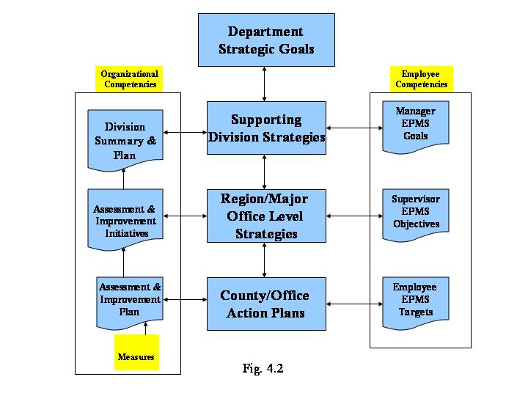
At the Department level, key measures are determined by the Director in consultation with senior leaders. These include measures related to key mission requirements, special operations, financial performance, customer service, and employee workload distribution. At the division and section levels measures are based on performance tracking requirements, and include those levied by the agency’s senior leadership, published Departmental policies and procedures, laws and regulations including the S.C. Code of Laws, and the published procedures and practices of the Board of Paroles and Pardons. Key measures related to offender supervision, financial, and HR related performance, supported by real time database information and Department wide access provide essential information at all organizational levels to support fact-based decision making (see Cat. 4.3).
As a new initiative during FY2004 - FY2005, each of the Department’s sections reassessed and updated their key performance measures, as necessary. An internally developed measurements template (Fig. 4.1-1) addresses linkages between the Department’s key measures, the specific goals of the strategic plan, the Baldrige process, and the annual accountability report. The template, standardized throughout the Department, also provides a specific description of each measure and the related mathematical calculation, measurement frequencies and targets, as well as specific process owners for each measure.
The Department’s measurements system will be further strengthened by the planned development of a Balanced Scorecard for key Department level measures, and Office Action Plans and their related measures to support all organizational levels and the Department’s strategic plan (Fig. 4.2).
  - What are your key measures?
In addition to key financial measures, the Department selected seven core mission related measures that best determine productivity and effectiveness in the supervision of offenders. These include Home Visits, Drug Testing Response, Pre-Parole Investigations, Offender Financial Obligations (Restitution, Fines, and Fees), and Process Service (new process and absconder actions). Other key measures include residential program activity, the timeliness of responding to offender interstate transfer requests, total number of legal cases heard and outcomes, victim restitution payments, and employee turnover rates. Fig. 4.1-1 depicts an example one of the Department’s key measures “Home Visits/High Level Supervision.” It also demonstrates the linkages between the Department’s measurements and strategic planning process.

South Carolina Department of Probation, Parole and Pardon Services
Field Operations/as of June 30, 2005
Home Visits/High Level Supervision
GOAL # 1: To Effectively Meet Our Public Safety Responsibilities

Strategy | Activities/Initiatives | Target Start Date | Target End  Date | Person Responsible
1.1 To establish effective community supervision strategies which result in accountable offender supervision.  1.5 To develop and utilize methods for providing accurate offender information. | To track the timely completion of Home Visits on offenders assigned to the “Intensive” level of supervision. Contacts required equals the number of offenders who have been at the Intensive level for one full month and any offenders that were at the Intensive level for less than a full month who had a Home Visit (HV) or Home Visit/Progress Report (HV/PR) completed in that month, excluding offenders with one or more cases in Active Warrant and Pending Warrant status as of the date the report is run. | In Progress | Indefinite | Renee Barrett - data report collections  David Stagg - data base (OIS)
Baldrige/Accountability Report Integration
6.1 Value Created Processes
7.2 Product and Service Results
Key Performance Measures |  | Target for Measure | Frequency of Measure | Data Source
The percentage of contacts completed will be calculated by dividing the number of contacts completed by the number of contacts required within the specified 30 day time period. |  | 90% on time completion | Monthly | Offender Information System (OIS)

Fig. 4.1-1

4.3 How do you ensure data quality, reliability, completeness and availability for decision making?
Each office within the Department performs unique and complimentary tasks. All are interrelated in support of the Department’s mission and public safety related initiatives. To support mission accomplishment the Department created and maintains an integrated computer network that incorporates multiple, linked databases. The state-wide computer network, supported by a variety of servers, provides daily access and current information for decision making via databases including the Offender Information System (OIS), Parole Information Center (PIC), Agency Information Management System (AIMS), and the State Agency Budgeting, Accounting, and Reporting (SABAR) system, a comprehensive and integrated financial management system. The OIS, with information on over 306,500 offenders, of which approximately 50,00 are currently active, and PIC with over 111,800 records on current or former inmates, share certain data elements on offenders between our Department’s offices and the Department of Corrections. The AIMS database provides immediate access to our Department’s employees on information including leave balances, salary and withholding data, emergency notification information, and training records. This system was further expanded to include a database and application for the tracking of the Department’s weapons, armored vests, and radios. AIMS also supports the online ordering of supplies through the Procurement Section, and the tracking of mileage and maintenance records for the Department’s fleet of vehicles. Accuracy and completeness for all of the Department’s databases is determined through daily, weekly, and monthly data reports that are reviewed by management, supervisors, and data users.

Data integrity and availability is ensured through a variety of methods. These include computer tape back-ups, remote storage of data files and fireproof boxes in the Department’s county office locations, back-up power supplies for all computers, mirrored files on servers, and a three–tier virus detection process including the workstation, server, and firewalls. Additional security is provided by personal passwords, and location security measures at the Department’s Central Office, county offices, and remote data storage locations.

4.4 How do you use data/information analysis to provide effective support for decision making?
A majority of the data and information used to support daily decision making is made available through the Department’s integrated computer databases. These include the Offender Information System (OIS), Parole Information Center (PIC), the State Agency Budgeting, Accounting, and Reporting (SABAR) system, and the Agency Information Management System (AIMS). The Department also maintains data and information linkages with the national crime network information systems such as the National Crime Information System (NCIC), and the National Law Enforcement Telecommunications System (NLETS). Access is based on a need-to-know basis and controlled by individual employee computer linkages and passwords.

To support organization wide data and information needs related to offender supervision, the Division of Field Operations developed key performance measures and targets for Home Visits, Warrant Service, Absconded Offenders, Pre-Parole Investigations, Financial Collections, and Drug Testing. These measures are further segmented into 12 specific performance indicators (Figs. 7.2-1 through 7.2-3, and 7.2-7). The primary supporting database OIS, contains real-time information that can be segmented by county size (based on offender population within a county), by individual counties, and by an Agent’s badge number. This information is made available to Agents, Supervisors, and Managers based on a need-to-know basis. Other automated systems such as the OIS and PIC system, the use of laptop technology in the courtroom, and the GPS system provide real-time information on offenders, directly supporting courtroom hearings, offender electronic tracking (for certain offender groups), and the Parole Board’s decision making processes.

The Department’s SABAR system is the primary data and information source for the Accounting and Finance, Budget, and Materials Management Offices. For these areas a combination of database (SABAR) analysis and manually created spreadsheets provide current information related to fiscal and materials management information needs.

Additional examples include the Special Operations Section that routinely reviews all of its operations, processes and systems. The office studies and measures services to make improvements, such as studies on radio system compatibility between our agency’s agents and the Sheriff’s Departments. The Office of Staff Development and Training uses information obtained from the CDS component of AIMS to determine training requirements and course completions. Using primarily manual methods, the Office of Residential Services determines methods of employment strategies that result in the highest levels of offender hiring, to help determine future strategies for our residential programs.
This combination of real-time offender database management, linkage to national information networks, in-house databases, and manual development of spreadsheets and other analyses methods provides an effective blend of data and information to support decision making at every level of the organization.

  - How do you select and use comparative data and information?
The Department and its divisions are an integral part of a variety of national networks in which they constantly work to identify performance measures that are common to its mission. Once these measurements begin to serve as standard benchmarks within the profession, it will better position the Department to identify best practices and improvements. Use of comparative data from other jurisdictions has been difficult. In many instances comparisons are difficult to achieve due to disparate mission requirements, jurisdictional authority and responsibility, and decentralized organizations. However, the Department does review a multitude of practices from other states including parole investigations, supervision violations, and the application of technology for supervision purposes. It also compares its law enforcement core training and operational procedures to the recommended standards used by the South Carolina Criminal Justice Academy and the South Carolina Highway Patrol. In another example, the Office of Residential Services compares its services to standards set by American Correctional Association (ACA), American Probation and Parole Association (APPA), and the National Institute of Corrections (NIC).

  - How do you manage organizational knowledge to accomplish the collection, transfer and maintenance of accumulated employee knowledge, and identification and sharing of best practices?
The Department uses a variety of methods to insure that valuable employee knowledge is shared, transferred, and maintained. Primary methods include on the job training, cross-training, peer mentors, succession planning and staff meetings. Within the Agent career field, Agents-In-Charge of county offices follow intensive on the job training policies and guidelines while also instituting cross-training initiatives. For example, select Agents are cross-trained to fill in as Cashiers within their county offices (to assist, as needed, with the collection of fines, fees, and restitution payments made by Offenders). In response to anticipated retirements during the next five years, each divisional manager within Field Operations was tasked with developing a succession plan for key roles within their respective areas of responsibility. Also, to insure that best practices are routinely shared, whether offender supervision related or administrative, the Field Operations Division routinely includes best practices as part of its monthly state-wide Agent-in-Charge (AIC) meetings. At these meetings AIC’s from throughout the state share work methods and supervision strategies from their own offices that they found to produce significantly improved results.

Category 5 - Human Resources
5.1 How do you and your managers/supervisors encourage and motivate employees (formally and/or informally) to develop and utilize their full potential?
Employees are provided opportunities to develop and utilize their full potential through both, formal and informal mechanisms. Each is intended to encourage learning, improve quality, customer and employee satisfaction, and performance levels.

The formal method for developing and motivating employees is through the Employee Performance Management System (EPMS) and the Department’s annual awards process. As part of the EPMS process, each employee and his/her supervisor jointly develop a Planning Stage that identifies key job tasks, responsibilities, and performance expectations. Additional formal methods include annual awards such as Employee of the Year, Manager of the Year, Administrative Staff Member of the Year, Agent of the Year, and Office of the Year. Other incentives include tuition reimbursement and pay increases for additional skills and knowledge (limited by funding availability), length of service recognitions, and flexible work hours based on job requirements.

Informal methods include scholarships for attending national conferences, attendance at external training courses offered by other state agencies and the State Training Consortium, workshops and seminars (limited by funding availability), recognition at staff and public meetings, luncheons, and encouraging and supporting employees to work on inter-divisional and inter-agency team projects. Special celebrations and recognition events held throughout the Department as part of national Probation and Parole Officer Week provide additional recognition opportunities.

5.2 How do you identify and address key development and training needs, including job skills training, performance excellence training, diversity training, management/ leadership development, new employee orientation and safety training?
The Department uses a variety of information sources to determine training needs. These include the EPMS process, C-1 police officer training requirements, safety training requirements for field office personnel, training requirements for Victims Coordinators, legal training and certification requirements, and training needs identified by management to support other job skills development, leadership development, and performance improvement initiatives.
As part of the EPMS process, training needs are assessed through individual interactions between supervisors and employees. Beginning FY2005 – FY2006, each employee’s Planning Stage will include a proposed formal training plan. These plans will be aggregated and analyzed by our Staff Development and Training Section to help determine and to prioritize the Department’s training offerings and initiatives. Follow-on EPMS review cycles and the Department’s existing integrated personal information database (AIMS), serve to track training accomplishments and each employee‘s professional development progress. For other categories of employees office managers and their employees together identify training needs. This includes temporary employees such as high school students that work for the Department in summer jobs in coordination with the Columbia Urban League; and, college students that work as interns.

5.3 How does your employee performance management system, including feedback to and from employees, support high performance?
The EPMS process and open-door policy provide an effective forum for ongoing feedback between supervisors and employees. Work related goals and objectives are included in the EPMS Planning Stage and the supervisor and/or office manager routinely works with the employee throughout the year to monitor progress toward those goals. An open-door policy throughout the Department allows each employee timely access to his/her supervisor to whom they can go immediately with questions or suggestions, allowing everyone to contribute to the overall work system.
5.4 What formal and/or informal assessment methods and measures do you use to determine employee well being, satisfaction, and motivation?
The EPMS process, internal surveys, and intra-office discussions, provide primary feedback on employee well being, satisfaction and motivation. For example, a state-wide satisfaction survey conducted within the Field Operations Division, during the fall of 2004, solicited input from all Field staff on Division work practices and policies, communications effectiveness, and other factors deemed important to employee motivation and satisfaction. Following the survey, a Field Operations Review Team along with the Department’s Quality Director consolidated, prioritized, and reported findings and recommendations to senior management. One immediate outcome resulted in improved communications with Field staff (i.e. regular updates on important legislative issues directly from the Director).

Routine work issues are discussed during normal staff meetings and as specific issues arise. These issues are addressed with care to foster a team environment and to assure that all team members’ perspectives are valued and considered. Additional information is obtained through the state grievance process, and exit interviews with departing employees. Products and services made available that promote and support employee well-being, satisfaction, and motivation are depicted in Fig. 5.4-1.

Products and Services made available to employees to enhance well-being, satisfaction, and motivation

- Law Enforcement safety equipment
- Tuition Assistance Program
- Medical Service for Agents
- Chaplaincy Program (SC LEAP)
- Employee Assistance Program
- Wellness Committee
- Employee/Volunteer Recognition
Source: SCDPPPS OHR
Fig. 5.4-1

5.5 How do you maintain a safe and healthy work place?
Maintaining workforce safety is a major area of focus for Executive Leadership. The Department maintains a dedicated Special Operations section that addresses safety concerns and initiatives as well as emergency operations and recovery throughout the various state-wide locations. Emergency plans for protecting employees during normal work and emergency operations, including building evacuations, have been developed and reviewed by all employees. Periodic reviews of emergency response plans and related exercises serve to validate these plans. Supporting county office safety plans and specially trained employees are in place to assist with any incidents as a result of interaction with offenders or in response to fires or hazardous weather conditions. The Department also maintains a designated Workplace Safety Officer, a Workplace Safety Committee, and has written Safety Policies.

Health in the workplace is promoted in a variety of ways (Fig. 5.5-1). Annual updates regarding communicable diseases are provided to all staff. Employee Health screenings are
frequently offered to employees throughout the state at a minimal cost including breast and
prostate cancer screenings, and flu shots. Free health workshops are available and health information is distributed from the Budget and Control Board’s sponsored Prevention Partners group. The Department, in addition, tests employees for HBV, TB and for illegal drug use. An annual Agent fitness assessment (Policy 135) and the expansion of fitness related programs for the Department’s Agents further enhance employee health. In addition, the use variable work schedules help employees balance personal and professional lives, reduce work related stress and contribute to emotional health and well-being.
Sample of Wellness Programs Made Available to the Department’s Employees
- Regional Health Screenings
- Spring Wellness Walk
- Digestive Problems Workshop
- Migraine & Headache Health Seminar
- Healthy Heart Workshops
- Women’s Reproductive Health Seminar
- Chronic Disease Management Workshops
- Weight Management Workshops
- Stroke Education Seminar
- Brown Bag Lunches on Health related issues
Fig. 5.5-1

5.6 What activities are employees involved with that make a positive contribution to the community?
The Department’s employees participate in wide variety of community support activities. These include: professional association memberships, speakers at criminal justice classes in surrounding schools, at civic functions, participation in the United Way fund drive, the March of Dimes’ “Buck a Cup” campaign, Red Cross blood drives, Families Helping Families, providing direct assistance to Sistercare, the Epworth Children’s Home, summer camps for children at risk, mentors for troubled children, the Lunch Buddy Program, Habitat for Humanity, the Salvation Army Bell Ringers Program, and many other programs designed to improve our communities and quality of life for the citizens of our state.

Category 6 – Process Management

6.1 What are your key processes that produce, create, or add value for your customers and your organization, and how do they contribute to success.
The Department’s key business processes are aligned with our core mission requirements and special operations support needs (see mission statement in Executive Summary). Using a structured and systematic approach, a cross-functional Policy and Procedures Team, that includes representation from every Division including management and staff, reviews all recommendations for new as well as changes to existing policies. Prior to finalization, draft policies are forwarded to all employees for review and input. This input is considered as well as budgetary, human resource, technology requirement, and the goals of the Department’s Strategic Plan. Once finalized, responsibility and accountability for each policy is ensured through the assignment of a senior manager as the process owner. Process owners are responsible for defining process purpose; identifying customers; understanding customer requirements; documenting the process; developing the appropriate measures and controls as well as assuring that the controls are properly used. They are also responsible for forming and prioritizing process improvement teams, as needed, to effect further improvements.

Field Operations and Community Services
Core Mission Processes and Requirements
Mission Process | Process Requirements
Offender Home Visits | Conduct offender home visits to verify residence and to assist in the monitoring and enforcing of offender’s compliance with general and special conditions.
Pre-Parole Investigations | Prepare investigations to prepare case summaries for consideration by the SC Board of Paroles and Pardons
Restitution | Monitor, track, and enforce payments
Fines | Monitor, track, and enforce payments
Fees | Monitor, track, and enforce payments
Offender Drug Testing | Monitor offender drug usage and respond to positive tests
Warrant Service | Attempt to serve warrants within 30 days of issuance. Total warrants served
Interstate Compact | Respond to transfer requests, and violation reports on South Carolina offenders being supervised in other states within required time frames
DNA Collections | Collect 1,500 DNA samples (target) from offenders per month until completed for all current offenders; then maintain currency
Electronic Monitoring | Deploy required electronic monitoring/GPS units as required
Parole Release | Effect the release of inmates granted Conditional parole to the Department’s supervision with 10 calendar days
Agent Safety | Successfully qualify/certify Agents in firearms, PPCT, and physical requirements
NCIC Hits Response | Respond to all “HITS” inquiries within the required time frames (10 minutes for immediate; 24 hours for routine)
Fig. 6.1-1

Communication on policy changes is accomplished through staff meetings and e-mail notifications. In addition, a mandatory annual policy review process ensures process reviews and currency/validity checks for all existing policies.

The use of cross-functional committees, performance improvement teams, and a systematic and structured approach ensures that the Department’s key processes are aligned with its strategic plan, and includes reviews of all applicable statutory and legal requirements, and existing policy and procedures.

Continuous improvement methods and initiatives, including the use of the annual accountability report to identify and prioritize organizational improvement opportunities, provide additional approaches for enhancing departmental effectiveness and efficiencies.

6.2 How do you incorporate organizational knowledge, new technology, changing customer and mission related requirements, cost controls, and other efficiency and effectiveness factors into process design and delivery?
The Department is intrinsically linked to the process of incorporating organizational knowledge and new technology with customer requirements. Initiatives in place include: the use of videoconferencing to conduct parole revocation hearings and to support the Youthful Offender Violations process; and, employee staff meetings at which evolving customer needs are discussed and acted upon (see achievements section: GED’s for offenders, laptops in courtrooms, etc.). The Department also conducted a Field Operations survey to obtain employee ideas on how to further improve effectiveness, efficiency and cost savings. Survey results were forwarded to Department’s EMT for consideration and integration into the Department’s strategic planning process. A special team has been assigned to provide recommendations addressing key survey results.

6.3 How does your day-to-day operation of key production/delivery processes ensure meeting key performance requirements?
Although day-to-day production and delivery processes vary by office, instant access to a variety of databases, including OIS, PIC, and AIMS are used by managers and staff to review up-to-date information on the Department’s key processes. Information provided by these databases is supplemented by a variety of weekly and monthly reports including those that are used to track financial expenditures, offender information, bed space utilization at our Restitution Centers, the timeliness of victim notifications, and training completion and recertification requirements. The Department’s Operations Command Center, provides instantaneous status reports and communications via telephones, hand held radios, and e-mail regarding SORT operations during exercises, and during routine and emergency operations.

6.4 What are your key support processes, and how do you improve these processes to achieve better performance?
Key support processes are an integral part of the Department and vital to mission success. The primary support processes are housed in the Administrative Division, Office of the Chief of Staff, and Legals Division. Key support processes for the Administrative Division (Fig. 6.4-1) include financial management and services, database management, IT network support, procurement services, fleet management, records management services, recruiting and hiring services, and benefits counseling and services.
Customer requirements for support processes, as defined in the Department’s Strategic Plan, are to provide a Safe Environment, Timely and Accurate Response, Flexible Access,
Professionalism, and Quality in Services and Products. Service related processes are improved through the Department’s formal design and delivery process methodology (see Question 6.1), or through informal methods within each section or office. The Department does not distinguish between support requirements for its external and internal customers.

6.5 How do you manage and support your key supplier/contractor/partner interactions and processes to improve performance?
The Department manages relationships with its suppliers and vendors by providing timely documentation, expectations, and feedback on vendor performance. Vendor selection is based on the South Carolina State Procurement Code, with special emphasis placed on minority and women owned businesses achieved approximately 300% of the Department’s goal. Bids for large projects are evaluated for cost effectiveness and performance requirements and standards.
Vendors are held to the standard required for the specific contract. Any disputes are first addressed by the Procurement Office, and if unable to resolve, elevated to the Budget and Control Board’s Materials Management Office. Routine interactions and constructive two-way feedback between vendors and the Procurement Office helps build relationships and contributes to performance improvements.
The Department also values its partnerships with a wide variety of organizations. These include state and national criminal justice agencies, including the Departments of Public Safety, Corrections, Social Services, Juvenile Justice, and other state agencies, as well as the South Carolina Victim Assistance Network, and the South Carolina State Government Improvement Network. National partnerships include the National Institute of Corrections, the American Probation and Parole Association, and the American Correctional Association. Relationships are nurtured and monitored as our Department participates in partnerships designed to improve the future of current offenders, participates in joint emergency operations and homeland defense activities, participates in information sharing activities on best practices, and participates in joint training events on both, the state and national level.

Fig.6.5-1 depicts a sample of the Department’s various partnerships with government, non-government, and volunteer organizations.

Community
Service and Faith Based Organizations

Dept. of Vocational Rehabilitation
Employment Security Commission
Alcohol and Drug Abuse Services
Local, State,
and National Law Enforcement Organizations
Dept. of Disabilities and Special Needs

Dept. of Social Services

Dept. of Education
DPPPS
Information/Data
Sharing
Partnerships
Fig. 6.5-1

Category 7 - Results

7.1 What are your performance levels and trends for the key measures of customer satisfaction?
While the Department provides services to a variety of customer segments, Offenders under the Department’s jurisdiction, and crime victims, constitute two of the largest groups. Other segments include Attorneys, Judges, law enforcement organizations, and state government agencies. Customers from the various segments routinely correspond with the Department to seek information or request assistance. Fig. 7.1 depicts the number of contacts from several key customer groups serviced by the Legals Division.

Fig. 7.1-1

Fig. 7.1-2 depicts the number and type of hearings conducted by the Department’s Hearing Section.

Fig. 7.1-2
The Victims Services Section’s primary customers are the victims of crime. During FY 2004-FY2005, this section provided information, assistance, and emotional support to over 1,800 victims, their family members and friends as they were attending Parole Board Hearings. The Victim’s Services Section, in addition, responded to over 3,600 phone calls within 24 hours of initial contact, and notified, in writing, over 17,600 Victims (and other related parties) of upcoming Parole Board Hearings to provide them the opportunity to attend these sessions.

Victim Services Survey Results
(Partial Sample of Questions Asked)

1. Received notification letter 4.9
2. Received helpful directions 4.9
3. Was greeted promptly and courteously 5.0
4. Hearing process was explained to me 5.0
5. Questions were answered by staff 5.0
6. Waited longer than expected (see note) 2.5
7. Treated courteously and professionally 4.9
8. Given chance to speak to Parole Board 4.9

Based on 5 point Likert Scale
1 = Strongly Disagree, 2 = Disagree, 3 = Neutral, 4 = Agree, 5 = Strongly Agree
Note: Question number 6 “Waited longer than expected for my case to be heard”; for this question the most favorable response would be a “1” on the Likert scale, as opposed to a “5.” This question is a control question on the survey to provide feedback on whether respondents carefully read and responded to each question.

7.2 What are your performance levels and trends for key measures of mission accomplishment?
The Department’s balanced performance measures yield an effective and comprehensive view of the impact of offender supervision across the state and down to the county and Agent level. These measures include: Offender supervision (Figs. 7.2-1 through 7.2-10); Special Operations Operational Participation/Results (Fig. 7.2-11), Residential Services results (Figs. 7.2-12 through 7.2-13), and Victim Services results (Figs. 7.2-14 through 7.2-15).
Fig. 7.2-1 represents the cumulative totals for all 12 measures and all county offices (see “explanation of codes” for specific measures). The horizontal blocks on Figs. 7.2-1 and 7.2-2 represent 100% increments; the highest attainable score for each measure. This type segmentation supports the analysis of data between county offices, for each county office, as well as to the Agent level.
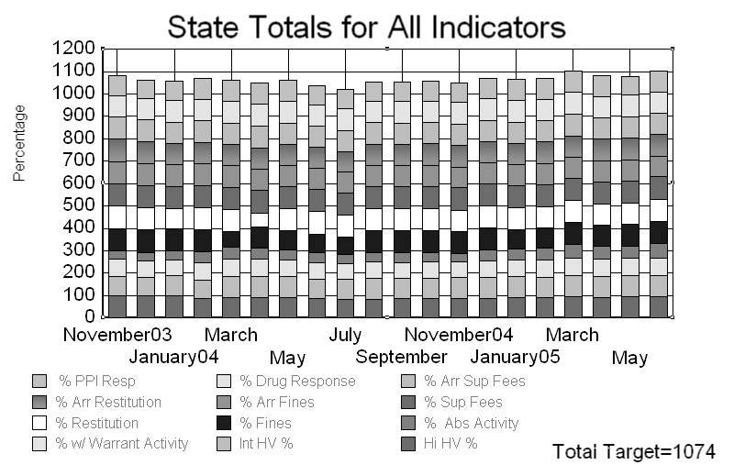
Fig. 7.2-1

% PPI Resp B Percentage of pre-parole investigations completed within the 60 day required time frame
% Arr Restitution - Percentage of restitution accounts less than six payments in arrears out of the total accounts in arrears
% Restitution - Percentage of the initial restitution that is satisfied versus that which has not been satisfied at the time the of a successful case closure
% w/Warrant Activity B Percentage of Warrants issued during the month versus those with a qualifying resolution activity within 30 days of issuance
% Drug Resp B Percentage of positive tests or confessions which are responded to by the Agent
% Arr Fines - Percentage of fine accounts less than six payments in arrears out of the total accounts in arrears
% Fines - Percentage of the initial fine that is satisfied versus that which has not been satisfied at the time of a successful case closure
Int HV % - Percentage of scheduled Intensive Supervision Home Visits completed monthly
% Arr Sup Fees - Percentage of supervision fee accounts less than six payments in arrears out of the total accounts in arrears
% Sup Fees - Percentage of the initial supervision fee that is satisfied versus that which has not been satisfied at the time of a successful case closure
% Abs Activity - Percentage of activity on cases in absconded level for the month
Hi HV % - Percentage of High Supervision Home Visits Completed (quarterly)

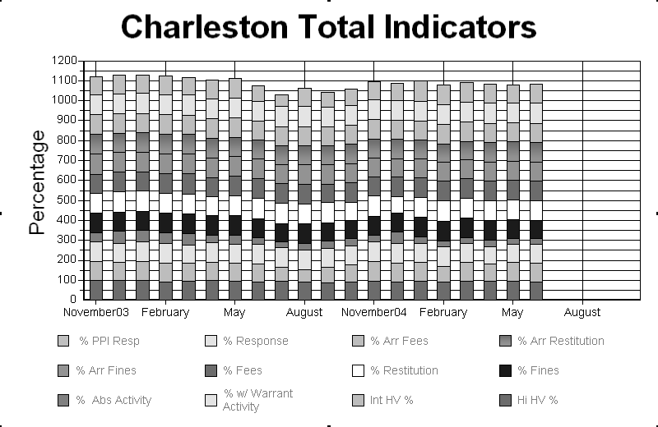
Fig. 7.2-2

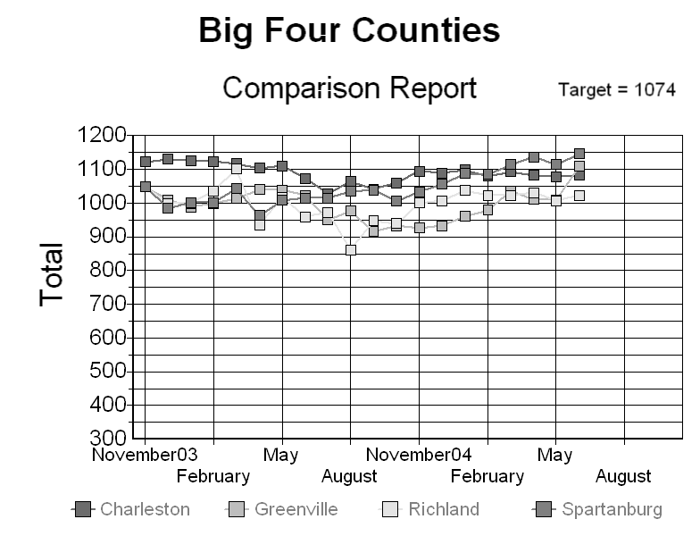
Fig. 7.2-3

Fig. 7.2-2 represents the cumulative totals for all 12 measures segmented for a sample county. Fig. 7.2-3 depicts a comparison of all measures between similar size counties (size based on offender population).

Fig. 7.2-4 depicts a slight downward trend in the offender population since 1998. The spike in the Department’s Agents during 2000 is due to an organizational realignment that added Hearing Officers and Parole Examiners as a resource to Field Operations. The increase for 2005 is due to the additional hiring of Agents into previously unfilled positions left vacant due to prior year budget reductions.

Fig. 7.2-5 shows a relatively unchanged seven year trend for Admissions and Successful Closures.

The Agent caseload comparison against 12 other states (Fig. 7.2-6) is based on a National Institute of Corrections survey that was completed in 2003 at the request of this Department. The 12 states used for comparative information were the states that responded to the survey. South Carolina’s caseload data comparison is as of June 30, 2005.

Fig. 7.2-6

During FY2002, the Department adjusted its programmatic requirements governing drug testing, resulting in the decline FYs 2002 through 2005 (Fig. 7.2-7). The Department initiated a change from testing 100% of offenders to testing only high risk offenders and those identified with a predictable or prior history of drug use.

Fig. 7.2-7

Fig. 7.2-8 reflects the Department’s aggressive pursuit of intermediate sanctions as opposed to granting full revocations. These include: home detention, public service employment, or assignment to a restitution center or residential center.

Benchmark research yielded one state with a standard addressing full revocation. A full revocation means that the offender violated the conditions of probation resulting in the judicial imposition of the suspended sentence

Fig. 7.2-8

A generally more challenging “hardened” offender base, prior year budget reductions, a resulting loss of professional staff, and an increase in the unemployment rate all contributed to the slight decline in the average success rate between 2001 and 2005 (Fig. 7.2-9).

Fig. 7.2-9

In order to better understand the workload requirements of the county offices of the Department, a task force composed of Agent staff members was asked to develop a list of activities that were performed to accomplish the responsibilities of each office. This list was developed into a survey that was sent to a random sample of Agents across the Department. The survey’s purpose was to validate the list of activities and to develop times associated with each activity. The model is being used to balance Agent workload between counties. Fig. 7.2-10 represents the distribution of duties for an Agent, and the average percent time spent on each of these duties. This chart does not include leave time (annual, sick, family, military, etc.) and holidays.

State Level Workload Model
FY05
Fig. 7.2-10

OSEPR: Operational Participation/Results
Special Operations | Participation Level/Results
Martin Luther King Day (Security) | 27 Agents, 189 Agent Hours
Memorial Day Bike Festival (Security) | 49 Agents, 2741 Agent Hours
Emergency Operations | Participation Level/Results
Traffic Evacuation Drill | Key Special Operations Staff
Hurricane Response Table Top Exercise | Key Special Operations Staff
Earthquake Response Table Top Exercise | Key Special Operations Staff
DPS Functional Hurricane Response Exercise | Key Special Operations Staff, Limited Agent Staff
Homeland Security | Participation Level/Results
Weapons of Mass Destruction Workshop (x2) | All Special Operations Key Staff
Fig. 7.2-11

The decline in admissions (Fig. 7.2-12) between FY02 and FY03 reflects the closure of a restitution center. The declining trend in successful completions through FY03 was primarily due to the declining economy with reduced opportunities for offender employment. The increase in admissions and successful completions between FY03 and FY05 was primarily due to the opening of a new residential center in Columbia, and an increase in accelerated payments of fines, fees, and restitution by residents. The accelerated payments in turn, resulted in a higher turnover, and consequently a higher “admissions” total.

Fig. 7.2-12

Fig. 7.2-13 depicts a slight drop in bed day utilization during FY04 – FY05. This decrease is primarily attributable due to some bed space being held open to accommodate the transition of female offenders to the new Columbia Residential Center.

Fig. 7.2-13

The decrease in requests for assistance and information by victims between FY2001 and FY2005 (Fig. 7.2-14) is primarily due to the Truth-in-Sentencing bill which disqualifies many for parole considerations, increased coordination with county solicitors, and increased public education on the parole process by the Office of Victim Services through written materials and public presentations.

Fig. 7.2-14

The significant increase in the number of victim impact statements/notification requests received (Fig. 7.2-15) is primarily due to the Office of Victim Services’ initiative to improve the coordination process with county solicitors.

Fig. 7.2-15

Fig. 7.2-16 depicts the impact of victim opposition on parole rejections.
Note: The Parole Board conducted 58 panel hearings during FY2004 and over
6, 600 supporting investigations.

Fig. 7.2-16

Fig. 7.2-17 represents the percentage of Paroles granted compared to the national average.

Fig. 7.2-17

7.3 What are your current levels and trends of financial performance?
The Department has very finite resources to bring to bear on the challenges it faces in conducting its mission critical activities. Financial data is continuously reviewed especially in consideration of ever shrinking budget capacities and cuts exceeding 44.36% since June 30, 2001 (includes FY 2004-05 Base Reduction).
Figure 7.3-1 shows the total dollar amount of restitution payments collected and disbursed to victims. Also see Fig. 7.3-2.

The Restitution Center program emphasizes victim restoration through offender paid restitution. Offenders must maintain employment and perform unpaid public service, with individual assessments completed against each offender.

Fig. 7.3-2
Fig. 7.3-3 depicts offender fees collected as a result of administrative violation hearings. These fees and fines were paid by offenders as an alternate option to incarceration. The FY02-03 to FY03-04 increase in Restitution payments and decrease in Fines is due to increased awareness within the offender population of non-payment consequences. The increase in Supervision Fee collections is due to a $15.00 increase in monthly supervision fees.

Fig. 7.3-3

Fig. 7.3-4
The Department has very finite resources to bring to bear on the challenges it faces in conducting its mission critical activities. Financial data is continuously reviewed especially in light ever shrinking budget capacities and cuts of 44.36%. Total costs by program area, total cost by type, cost of supervision by program area, and disbursement activity for Department administered restitution accounts is critical.

Fig. 7.3-5 compares the cost of supervision from FY 2001-02 through FY 2004-05.

Cost of Supervision
 | FY 2001-02 | FY 2002-03 | FY 2003-04 | FY 2004-05
Regular Supervision Costs | $2.67 | $2.68 | $2.61 | $2.44
Cost Per Day – All Levels | $3.42 | $3.15 | $3.07 | $2.97
Intensive Supervision Costs | $11.74 | $9.85 | $9.49 | $10.92
Home Detention without Electronic Monitoring | $15.61 | $13.10 | $12.62 | $14.52
Home Detention with Electronic Monitoring | $18.80 | $16.78 | $16.47 | $18.37
Residential Services Per Bed Day Costs | $36.30 | $33.78 | $36.89 | $35.94
Source: SCDPPPS Cost of Supervision
SCDC Total Fund Inmate Cost Per Day | $41.03 | $38.25 | $37.13 | Not Available
Source: Inmate Cost Per Day from SCDC

Fig. 7.3-6 illustrates the number of disbursement checks issued during the fiscal year by the Department.

Fig. 7.3-6

7.4 What are your performance levels and trends for the key measures of employee satisfaction, involvement, and development?
The Department considers employee turnover as an important measure of employee satisfaction (Fig. 7.4-1). Specific measures reviewed include employee turnover by class (administrative and Agent), Agent turnover by classification, Agent turnover by reason, administrative staff turnover by reason.

Fig. 7.4-1

Fig.7.4-2

Figure 7.4-3 represents the effects of prior year budget cuts. Improved funding during
FY2004 allowed us to fill some of the Department’s prior unfilled positions; particularly in the Agent career field.

Fig.7.4-3

Employee Training Results:
This past year, the primary focus for SDT continued to be on the completion of the Class-1 Law Enforcement certification for all targeted staff and ensuring that certified staff maintained their certification. Currently, 438 agents (97%) are C-1 certified. Additionally, SDT ensured that all certified staff maintained their certification by providing the mandated training for re-certification.

The Department provided training on forty one (41) courses. Sixteen (16) were evaluated using “End of Course” surveys. Survey responses on training effectiveness were received from 1,281 participants. From these, 87% of the respondents rated the courses as either “Excellent,” or “Above Average;” 99% either “Strongly Agreed,” or “Agreed” that the teaching methods used in class facilitation improved their learning, and 99% “Strongly Agreed,” or “Agreed” that the courses helped to increase their knowledge on the subject matter, 98% of respondents stated that they would recommend these courses to others.

7.4 What are your performance levels and trends for the key measures of supplier/contractor/partner performance?
Additional Department level measures to be developed during FY2005 – FY2006.

7.5 What are your performance levels and trends for the key measures of regulatory/legal compliance and citizenship?
The Department did not have any regulatory violations or significant findings by external auditors during the fiscal year. In the area of Equal Employment Opportunity, the Department achieved a rating of 90.4%, placing it near the top one third out of 61 state agencies.

Major Program Areas

Program Number and Title | Major Program Area  Purpose  (Brief) | FY 03-04  Budget Expenditures | FY 04-05  Budget Expenditures | Key Cross References for Financial Results*
15050000 | Offender Supervision: To supervise offenders under the Department’s jurisdiction. | State: 16,439,776.23  Federal: 431,446.12  Other: 15,863,798.63  Total: 32,735,020.98  % of Total Budget 84.04% | State: 15,059,245.22  Federal: 297,807.74  Other: 16,326,041.88  Total: 31,683,094.84  % of Total Budget 84.54% | Fig. 7.3-3  Fig. 7.3-4  Fig. 7.3-5
15150500  15152000  &  15153000 | Residential Services: To provide life skill training and employment for high risk offenders under a highly structured residential setting. | State: 0.00  Federal: 0.00  Other: 1,829,706.36  Total: 1,829,706.36  % of Total Budget 4.70% | State: 0.00  Federal: 0.00  Other: 1,947,396.39  Total: 1,947,396.39  % of Total Budget 5.20% | Fig. 7.3-2
15200000 | Parole Board: The Board has the sole responsibility for granting or denying paroles and pardons, revoking, modifying, or rehearing paroles and making recommendations on petitions for reprieves and commutations referred by the Governor. | State: 403,130.98  Federal: 0.00  Other: 79,202.73  Total: 482,333.71  % of Total Budget 1.24% | State: 647,042.92  Federal: 0.00  Other: 457,686.85  Total: 1,104,729.77  % of Total Budget 2.95% | Fig. 7.2-16 Note
15050000 | Victim Services: To provide crime victims with information and notification concerning offenders on probation, parole and appearing before the Parole Board. | State: 0.00  Federal: 0.00  Other: 196,080.05  Total: 196,080.05  % of Total Budget 0.50% | State: 0.00  Federal: 0.00  Other: 198,174.71  Total: 198,174.71  % of Total Budget 0.53% | Fig. 7.3-1  Fig. 7.3-4  Fig. 7.3-6

Below: List any programs not included above and show the remainder of expenditures by source of funds.
Legal, Records, Administration, Staff Development and Training, Research, Public Information

Remainder of Expenditures: | State: 2,102,447.79  Federal: 29,075.28  Other: 1,578,105.92  Total: 3,709,628.99  % of Total Budget 9.52% | State: 1,268,351.86  Federal: 0.00  Other: 1,273,519.19  Total: 2,541,871.04  % of Total Budget 6.78%
* Key Cross-References are a link to the Category 7 – Business Results. These References provide a Chart number that is included in the 7th section of this document.
Strategic Planning

Budget Program Number and Title  (Appropriations Act) | Supporting Agency Strategic Planning Goals/Objectives** | Related FY 04-05 Key Agency Action Plan/Initiative(s) | Key Cross References for Performance Measures*
15050000  Offender Supervision | Goals #1 - 5 | --Maintain performance at target for key Field Operations indicators  --Fully implement the Learn and Earn Program initiative  --Achieve equitable distribution of agent caseloads  --Increase Successful Closure Rate; supervision success rate  --Administer drug tests for all high risk offenders  -- Support the state’s special operations initiatives  --Collect current/delinquent restitution, supervision fees and fines | Figs. 7.2-1 through 7.2-3  Fig. TBD  Figs. 7.2-6, 7.2-10  Figs. 7.2-5, 7.2-9  Fig. 7.2-7  Fig. 7.2-11  Fig. 7.3-3
15150500; 15152000 & 15153000 Residential Services | Goals #1 - 5 | --Assist offenders in gaining employment  --Maintain 95% occupancy level (Restitution Centers)  --Collect offender restitution payments and fines  --Assist offenders towards successful program completion | Fig. TBD  Fig. 7.2-13  Fig. 7.3-2  Fig. 7.2-12
15200000  Parole Board | Goals #1 - 5 | --Provide case summaries and pardon materials two weeks prior to each scheduled hearing  --Address victim opposition  --Conduct Parole Board meetings | Fig. TBD  Fig. 7.2-16  See Fig. 7.2-16 Note
15050000  Victim Services | Goals #1 - 5 | --Provide victims 30 days written notice of Parole Board Hearings; respond timely to telephonic and written inquiries  --Disburse restitution payments to victims  --Maintain victim satisfaction with services provided by the Department. Service satisfaction to be maintained at 4 points or higher on a 5 point Likert scale (Victim Satisfaction Survey) | Fig. 7.2-14  Figs. 7.3-1, 7.3-6  See Ref. Cat. 7.1
*Charts, graphs, and tables referenced in the “Key Cross References for Performance Measures” column are located in Category 7 of this Annual Accountability Report.
**Strategic Planning Goals (2003 DPPPS Strategic Plan):
Goal #1: To effectively meet our public safety responsibilities
Goal #2: To continuously improve our processes
Goal #3: To deliver quality services to our customers
Goal #4: To be fiscally responsible
Goal #5: To provide for personal and organizational growth
Note: Goals # 1-5 support every Major Program Area

Note: As a new initiative, the Department has identified and segmented its projected FY 04 – FY05 budget components based on an Activity Based Cost Accounting methodology. Activities have been segmented as follows: Community Supervision—Regular; Community Supervision—Intensive; Victim Services; Residential Programs; Statewide Emergency Operations Support; Parole Board Support; Parole Board; Core Administration

Glossary

ACA American Correctional Association
AIMS Agency Information Management System
APPA American Probation and Parole Association
CASA Court Appointed Special Advocates
CDS Career Development System
CSOM Center for Sex Offender Management
DACUM Design a Curriculum
DAODAS Department of Alcohol and Other Drug Abuse Services
DMH Department of Mental Health
DOE Department of Education
DPS Department of Public Safety
DSS Department of Social Services
EMT Executive Management Team
EPMS Employee Performance Management System
ESC Employment Security Commission
GED General Equivalency Degree
HBV Hepatitis B Virus
HR Human Resources
HRS Human Resources System
HHS Health and Human Services
ISC Interstate Compact
IT Information Technology
NCIC National Crime Information Center
NIC National Institute of Corrections
NLTES National Law Enforcement Telecommunications System
PIC Parole Information System
SABAR State Agency Budgeting, Accounting, and Reporting System
SCDPPPS South Carolina Department of Probation, Parole, and Pardon Services
SCDC South Carolina Department of Corrections
SCDVR South Carolina Department of Vocational Rehabilitation
SCHP South Carolina Highway Patrol
SLED State Law Enforcement Division
SORT Special Operations Response Team
OIS Offender Information System
OSEPR Office of Safety, Enforcement, and Special Operations
OSHA Occupation, Safety, and Health Administration
TB Tuberculosis
YOA Youthful Offender Act

