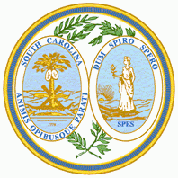

SOUTH CAROLINA PLANNING EDUCATION ADVISORY COMMITTEE

AGENDA
Friday, December 3, 2010
CONFERENCE CALL MEETING
10:00 a.m.

- CALL TO ORDER
- FREEDOM OF INFORMATION ACT COMPLIANCE
Public notification of this meeting has been published, posted, and mailed in compliance with the Freedom of Information Act

- APPROVAL OF MINUTES
a. Regular meeting of October 25, 2010

- NEW BUSINESS
  - Consideration of an application by the City of Conway to receive 3 hours of continuing education credits. Program will consist of a viewing of the film “Mr. Smith Goes to Washington” followed by a question and answer period using a prepared question guide.

- ADJOURNMENT
PUBLIC NOTICE:
INTERESTED PARTIES WHO WISH TO PARTICIPATE IN
THIS MEETING MAY DO SO IN ONE OF TWO WAYS:

- ATTEND IN PERSON AT THE OFFICE OF THE CHAIRMAN, TOWN OF HILTON HEAD ISLAND, CONFERENCE ROOM #1, ONE TOWN CENTER COURT, HILTON HEAD ISLAND, SC.

2. PARTICIPATE BY TELEPHONE. CONTACT VICKI PFANNENSCHMIDT AT 843-341-4701 FOR CONFERENCE CALL INSTRUCTIONS

