AGY: Building Codes Council - Labor, Licensing and Regulation
FII: 5
FIV: 29
PRD: 20040827
EFD: 20050527
EXD: 20050511
REG: 2918
PRI: 8
PRV: 28
COM: Labor, Commerce and Industry Committee 12 SLCI
Labor, Commerce and Industry Committee 26 HLCI
RES: 495
STA: Final
AUT: 6-9-40
SUB: International Residential Codes, 2003 edition

HST: 2918

BY DATE ACTION DESCRIPTION COM VOL/ISSUE EXP DATE R. NUM
___ ________ __________________________ _______ ___________ __________ _______
- 20040827 Proposed Reg Published in SR 28/8
- 20050111 Received by Lt. Gov & Speaker 20050511
H 20050111 Referred to Committee HLCI 26
S 20050113 Referred to Committee SLCI 12
S 20050215 Resolution Intro to Approv SLCI 12 S495
- 20050511 Approved by: Expiration Date 29/5

TXT:

Document No. 2918
DEPARTMENT OF LABOR, LICENSING AND REGULATION

BUILDING CODES COUNCIL
CHAPTER 8
Statutory Authority: 1976 Code Section 6-9-40

Synopsis:

The South Carolina Building Codes Council will update the International Residential Code, 2000 Edition, to the International Residential Code, 2003 Edition, in accordance with the statutory amendments to acts governing the Building Codes Council, including proposed modifications. These provisions will be established in regulations designated under Article 4—International Residential Code

Instructions:

Add new Article 4—International Residential Code.

Text:

Article 4—International Residential Code.
Regulation 8-400. International Residential Code.

NOTE—This article is identical to the International Residential Code, 2003 Edition, in accordance with the statutory amendments to acts governing the Building Codes Council, except for the modifications referenced below.

Regulation 8-401. Modifications.
Section R202
Story - That portion of a building included between the upper surface of a floor and the upper surface of the floor or roof next above. For the purpose of determining the appropriate code to be used, when the first story is built in the flood plain, a ‘Story’ must be ‘Habitable Space.’

Section R301.2(2)
The most recent seismic design map includes a new seismic zone designated as D₀ (D sub zero) that is not included in the 2003 edition of the International Residential Code, but will be included in the 2006 edition. The D₀ zone reduces the area of the existing D₁ zone in South Carolina and provides for less restrictive, and thus less costly construction requirements. The Building Codes Council determined that since the latest map is conclusive and available now, it should be used.

Section R301.2.2
Sections R301 design criteria, R403 footings, R404 foundation walls, R602 wood wall framing, R606 general masonry construction, R611 insulating concrete form wall construction, R703 exterior covering section and R1003 masonry fireplaces were revised to incorporate the design provisions for the new Seismic Design Category D₀ (D sub zero). The D₀ design category is not included in the 2003 edition of the International Residential Code, but will be included in the 2006 edition. This modification establishes the design criteria for the new D₀ seismic zone created by the modification to Section R301.2(2).

A moratorium was placed on enforcement of the D₀ (D sub zero) seismic design requirements for those areas in South Carolina designated as D₀, until adoption of the 2006 International Residential Code. The design requirements for the seismic zone C will be in effect for those areas in South Carolina designated as D₀.

Section R311.4.3
The floor or landing at the interior side of the exit door required by Section R311.4.1 shall not be more than 1.5 inches (38 mm) lower than the top of the threshold. The floor or landing at exterior doors other than the exit door required by Section R311.4.12 shall not be required to comply with this requirement but shall have a rise no greater than that permitted in Section R311.5.3.
Exception: The landing at an exterior/exit doorway shall not be more than 7 ¾ inches (196 mm) below the top of the threshold, provided the door, other than an exterior storm or screen door does not swing over the landing.

Section R311.5.3
When risers are closed, all treads may have a uniform projection not to exceed 1 ½ inches. The greatest riser height within any flight of stairs shall not exceed the smallest by more than 3/8 inch. The greatest tread run within any flight of stairs shall not exceed the smallest by more than 3/8 inch. Stairways shall not be less than 3 feet in clear width, and the headroom, rise and run shall conform to Figure R-213.1. Handrails may project from each side of a stairway a distance of 3 ½ inches into the required width.

Section R311.5.6.1
Handrail height, measured vertically from the sloped plane adjoining the tread nosing, or finished surface of ramp slope, shall be not less than 30 inches and not more than 38 inches (965 mm).

Table R402.2

MINIMUM SPECIFIED COMPRESSIVE STRENGTH OF CONCRETE
Porches, carport slabs and steps exposed to the weather 2,500 (PSI).

Section R403.1.4.2
In seismic design categories D₁ and D₂, interior footings supporting bearing or bracing walls and cast monolithically with a slab on grade shall extend to a depth of not less than 12 inches (305 mm) below the top of slab.

Section R403.1.6
When braced wall panels are supported directly on continuous foundations, the wall wood sill plate or cold-formed steel bottom track shall be anchored to the foundation in accordance with this section. The wood sole plate at exterior walls on monolithic slabs and wood sill plate shall be anchored to the foundation with anchor bolts spaced a maximum of 6 feet (1829 mm) on center. There shall be a minimum of two bolts per plate section with one bolt located not more than 12 inches (305 mm) or less than seven bolt diameters from each end of the plate section. In Seismic Design Categories D₁ and D₂, anchor bolts shall also be spaced at 6 feet (1829 mm) on center and located within 12 inches (305 mm) from the ends of each plate section at interior braced wall lines when required by Section R602.10.9 to be supported on a continuous foundation. Bolts shall be at least 1/2 inch (12.7 mm) in diameter and shall extend a minimum of 7 inches (178 mm) into masonry or concrete. Interior bearing wall sole plates on monolithic slab foundations shall be positively anchored with approved fasteners. A nut and washer shall be tightened on each bolt to the plate. Sills and sole plates shall be protected against decay and termites where required by Sections R318 and R319. Cold-formed steel framing systems shall be fastened to the wood sill plates or anchored directly to the foundation as required in Section R505.3.1 or R603.1.1.
Exception: Foundation anchor straps, spaced as required to provide equivalent anchorage to 1/2-inch-diameter (12.7 mm) anchor bolts.
Exception 2. Walls 24” total length or shorter connecting offset braced wall panels shall be anchored to the foundation with a minimum of one anchor bolt located in the center third of the plate section and shall be attached to adjacent braced wall panels per Figure R602.10.5 at corners.
Exception 3. Walls 12” total length or shorter connecting offset braced wall panels shall be permitted to be connected to the foundation without anchor bolts. The wall shall be attached to adjacent braced wall panels per Figure R602.10.5 at corners.

Section R403.1.7
Sections R403.1.7 (Footings on or Adjacent to Slopes); R402.1.7.1 (Building Clearances from Ascending Slopes); R403.1.7.2 (Footing Setback from Descending Slope Surfaces); R403.1.7.3 (Foundation Elevation); R403.1.7.4 (Alternate Setback and Clearances); figure R403.1.7.1 (Foundation Clearance from Slopes) were deleted. The sections referenced establish limitations for sites with varying topography that may be more appropriate in local zoning ordinances.

Table R502.5(1)
An additional table (identified as Table R502.5(1)A) was included with the existing table, which will allow for the use of standard lumber as an alternative to engineered wood for the fabrication of headers over 6 feet in length.

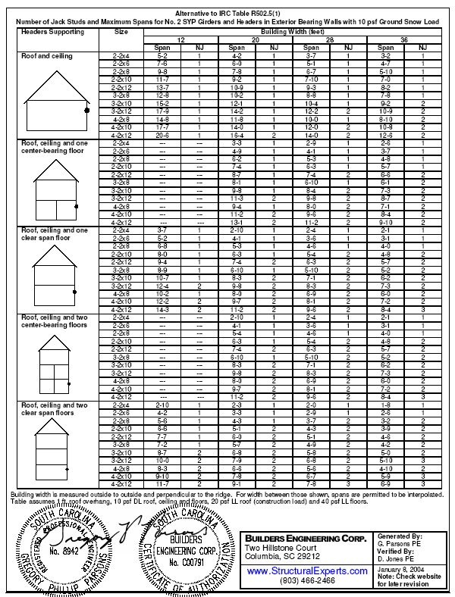

Section R502.11.4
Truss design drawings, prepared in compliance with Section R502.11.1, shall be provided to the building official at the time of inspection. Truss design drawings shall be provided with the shipment of trusses delivered to the job site. Truss design drawings shall include at a minimum the information specified below:

Section R602.10.5
When continuous wood structural panel sheathing is provided in accordance with Method 3 of R602.10.3 on all sheathable areas of all exterior walls, and interior braced wall lines, where required, including areas above and below openings, braced wall panel lengths shall be in accordance with Table R602.10.5. Wood structural panel sheathing shall be installed at corners in accordance with Figure R602.10.5. The bracing amounts in Table R602.10.1 for Method 3 shall be permitted to be multiplied by a factor of 0.9 for walls with a maximum opening height that does not exceed 85 percent of the wall height or a factor of 0.8 for walls with a maximum opening height that does not exceed 67 percent of the wall height.
Exception: Vertical wall segments in the first of one or first of two story buildings next to garage openings shall be permitted to have a 6:1 height-to-width ratio (with height being measured from top of header to sill plate) when constructed in accordance with the following provisions. Each panel shall have a length of not less than 16 inches (406 mm) and a height of not more tan 10 feet (3048 mm). Each panel shall be sheathed on one face with a single layer of 3/8-inch minimum-thickness (9.5 mm) wood structural panel sheathing nailed with 8d common or galvanized box nails in accordance with Figure R602.10.5(2). The wood structural panel sheathing shall extend up over the solid sawn or glued-laminated header and shall be nailed in accordance with Figure R602.10.5(2). The header shall extend between the inside faces of the first full-length outer studs of each panel. The clear span of the header between the inner studs of each panel shall be not less than six feet (1829 mm) and not more than 18 feet (5486 mm) in length. A strap with an uplift capacity of not less than 1000 pounds (454 kg) shall fasten the header to the side of the inner studs opposite the sheathing. Two anchor bolts shall be installed in accordance with Section R403.1.6, and flat washers shall be a minimum of 2 inches by 2 inches by 3/1 inch (51 mm by 51 mm by 4.8 mm) thick and shall be used on each bolt. This exception is only permitted in Seismic Design Categories A-C.

Section R802.10.1
Truss design drawings, prepared in compliance with Section R802.10.1, shall be provided to the building official at the time of inspection. Truss design drawings shall be provided with the shipment of trusses delivered to the job site. Truss design drawings shall include at a minimum the information specified below:

Chapter 11
The State of South Carolina has specific energy standards in statutory form (Re: Title 6, Chapter 9, Building Codes and Title 6, Chapter 10, Building Energy Efficiency Standard Act.). To eliminate any possible conflicts concerning the insulation requirements for single and two family residential buildings between the International Residential Code and state law, Chapter 11 was deleted.

Section M1411.4
M1411.4 Insulation of refrigerant piping. Piping and fittings for refrigerant vapor (suction) lines shall be insulated with insulation have a thermal resistivity of at least R-2.5 hr. ft 2 F/Btu and having external surface permeance not exceeding 0.05 perms [2.87 ng/(s m2 Pa)] when tested in accordance with ASTM E 96.

Figure R307.2
The minimum fixture clearance for a water closet had been 12 inches from the center of the bowl to the sidewall or bathtub for many years. The dimension was changed to 15 inches in the 2000 International Residential Code without a convincing reason for doing so. The minimum clearance, therefore, was changed back to 12 inches. Figure R.307.2 is a graphic. The modification changes the dimension on the graphic from 15 inches to 12 inches.

NOTE—This article is identical to the International Residential Code, 2003 Edition, in accordance with the statutory amendments to acts governing the Building Codes Council, except for modifications.

Statement of Rationale:

There was no scientific or technical basis relied upon in the development of these regulations.

Fiscal Impact Statement:

There will be no cost incurred by the State or any of its political subdivisions.

