NO. 18

JOURNAL

of the

HOUSE OF REPRESENTATIVES

of the

STATE OF SOUTH CAROLINA

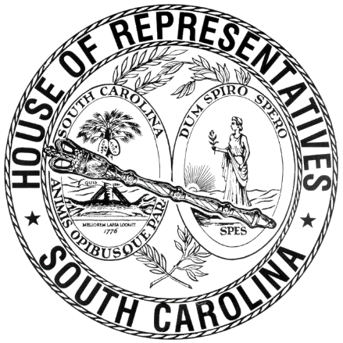

REGULAR SESSION BEGINNING TUESDAY, JANUARY 10, 2017
________

FRIDAY, FEBRUARY 9, 2018
(LOCAL SESSION)

Indicates Matter Stricken
Indicates New Matter

The House assembled at 10:00 a.m.
Deliberations were opened with prayer by Rev. Charles E. Seastrunk, Jr., as follows:

Our thought for today is from Psalm 111:2: “Great are your works, O Lord, pondered by all who delight in them.”
Let us pray. Almighty God, we give thanks with our whole heart, that you have blessed and protected us during this week. Give these women and men the rest and relaxation during the weekend. Bless our Nation, President, State, Governor, Speaker, staff, and all who give of their time and labor for this State. Bless and Protect our defenders of freedom and first responders as they protect us. Heal the wounds, those seen and those hidden, of our brave warriors who suffer and sacrifice for our freedom. Lord, in Your mercy, hear our prayers. Amen.

After corrections to the Journal of the proceedings of yesterday, the SPEAKER ordered it confirmed.

SENT TO THE SENATE
The following Bills were taken up, read the third time, and ordered sent to the Senate:

H. 4868 -- Rep. G. M. Smith: A BILL TO AMEND SECTION 9-4-40, AS AMENDED, CODE OF LAWS OF SOUTH CAROLINA, 1976, RELATING TO THE AUDIT OF THE PUBLIC EMPLOYEE BENEFIT AUTHORITY, SO AS TO CHANGE THE DATE THE AUDIT MUST BE COMPLETED.

H. 4869 -- Rep. G. M. Smith: A BILL TO AMEND SECTIONS 9-1-1650, 9-9-70, 9-9-100, 9-11-110, ALL AS AMENDED, AND 9-11-170, CODE OF LAWS OF SOUTH CAROLINA, 1976, RELATING TO CERTAIN AMOUNTS TO BE PAID UPON TERMINATION OF EMPLOYMENT, OPTIONAL FORMS OF ALLOWANCE, CERTAIN PAYMENTS ON DEATH OF A MEMBER OR BENEFICIARY, CERTAIN LUMP PAYMENTS TO BE PAID IN THE EVENT OF DEATH, AND THE SUPPLEMENTAL ALLOWANCE PROGRAM, RESPECTIVELY, SO AS TO REMOVE CERTAIN NOTARIZATION REQUIREMENTS.

H. 4870 -- Reps. B. Newton, Norrell, Yow and Lucas: A BILL TO AMEND SECTION 7-7-350, AS AMENDED, CODE OF LAWS OF SOUTH CAROLINA, 1976, RELATING TO THE DESIGNATION OF VOTING PRECINCTS IN LANCASTER COUNTY, SO AS TO ADD ONE PRECINCT, AND REDESIGNATE THE MAP NUMBER ON WHICH THE NAMES OF THESE PRECINCTS MAY BE FOUND AND MAINTAINED BY THE REVENUE AND FISCAL AFFAIRS OFFICE.

ADJOURNMENT
At 10:23 a.m. the House, in accordance with the ruling of the SPEAKER, adjourned to meet at 12:00 noon, Tuesday, February 13.
***

H. 4868 1
H. 4869 1
H. 4870 2

