NO. 57

JOURNAL

of the

HOUSE OF REPRESENTATIVES

of the

STATE OF SOUTH CAROLINA

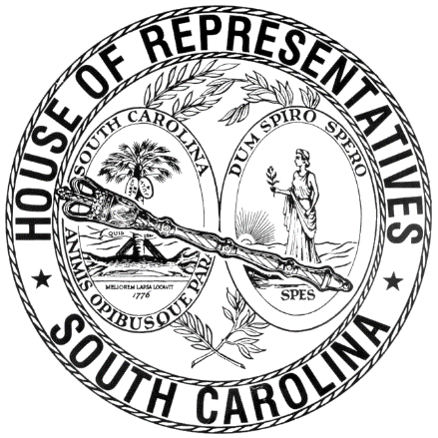

REGULAR SESSION BEGINNING TUESDAY, JANUARY 8, 2019
________

FRIDAY, APRIL 12, 2019
(LOCAL SESSION)

Indicates Matter Stricken
Indicates New Matter

The House assembled at 10:00 a.m.
Deliberations were opened with prayer by Rev. Charles E. Seastrunk, Jr., as follows:

Our thought for today is from Deuteronomy 26:18: “Today the Lord has obtained your agreement: To be his treasured people.”
Let us pray. To You, O Lord, I lift up my soul. My God, I put my trust in You. Provide for each of these Representatives and staff Your saving mercy. Lead us to the trust which comes from You, O merciful Lord. Bless and keep these people who You have called to this service. Keep them safe and give them rest, relaxation, and a good weekend. Bless our Nation, President, State, Governor, Speaker, staff, and all who serve in these Halls of Government. Protect them from all harm. We pray for our defenders of freedom and first responders who care for and protect us. Heal the wounds, those seen and those hidden, of our brave warriors who suffer and sacrifice for our freedom. Lord, in Your mercy, hear our prayers. Amen.

After corrections to the Journal of the proceedings of yesterday, the SPEAKER ordered it confirmed.

SENT TO THE SENATE
The following Bill was taken up, read the third time, and ordered sent to the Senate:

H. 3403 -- Reps. Collins, Allison, Felder, Govan, Taylor, Bradley, West, Erickson, Stringer, Young and Bannister: A BILL TO AMEND THE CODE OF LAWS OF SOUTH CAROLINA, 1976, BY ADDING SECTION 59-19-360 SO AS TO PROVIDE A PROCESS FOR THE EXEMPTION OF COMPETENCY-BASED SCHOOLS FROM CERTAIN APPLICABLE LAWS AND REGULATIONS, AND PROVIDE RELATED REQUIREMENTS FOR COMPETENCY-BASED SCHOOLS, THE STATE DEPARTMENT OF EDUCATION, AND THE COMMISSION ON HIGHER EDUCATION.

ADJOURNMENT
At 10:20 a.m. the House, in accordance with the ruling of the SPEAKER, adjourned to meet at 12:00 noon, Tuesday, April 23.
***

H. 3403 1

