NO. 38

JOURNAL

of the

HOUSE OF REPRESENTATIVES

of the

STATE OF SOUTH CAROLINA

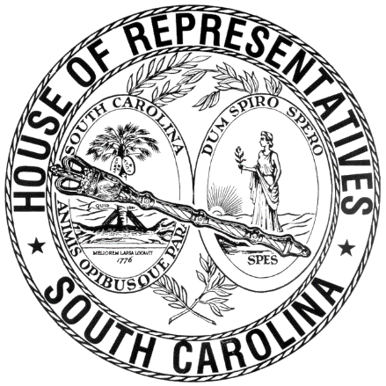

REGULAR SESSION BEGINNING TUESDAY, JANUARY 12, 2021
________

FRIDAY, MARCH 19, 2021
(LOCAL SESSION)

Indicates Matter Stricken
Indicates New Matter

The House assembled at 10:00 a.m.
Deliberations were opened with prayer by Rev. Charles E. Seastrunk, Jr., as follows:

Our thought for today is from Matthew 6:25: “Therefore, I tell you, do not worry about your life, what you will eat or what you will drink, or about your body, what you wear. Life is more than this.”
Let us pray. Gracious and loving Heavenly Father, we give You thanks and praise for giving us the freedom to live in this place and enjoy what You have made for us. Give us Your continued blessings as we assemble here and rest for the weekend as we serve. Bless our defenders of freedom and first responders. Bless our World, Nation, President, State, Governor, Speaker, staff, and all who give of their time and talents to this great cause. Heal the wounds, those seen and those hidden, of our brave men and women who suffer and sacrifice for our freedom. Lord, in Your Mercy, hear our prayers. Amen.

After corrections to the Journal of the proceedings of yesterday, the SPEAKER ordered it confirmed.

RETURNED TO THE SENATE WITH AMENDMENTS
The following Bill was taken up, read the third time, and ordered returned to the Senate with amendments:

H. 3991 -- Reps. Rutherford, Wooten, Caskey, Thigpen, B. Cox, Elliott, Erickson, S. Williams and Rivers: A BILL TO AMEND SECTION 16-17-680, CODE OF LAWS OF SOUTH CAROLINA, 1976, RELATING TO PERMITS TO PURCHASE NONFERROUS METALS, TRANSPORTATION AND SALE OF NONFERROUS METALS, AND VARIOUS OFFENSES ASSOCIATED WITH NONFERROUS METALS, SO AS TO INCLUDE IN THE PURVIEW OF THE STATUTE PROCEDURES FOR THE LAWFUL PURCHASE, SALE, AND POSSESSION OF USED, DETACHED CATALYTIC CONVERTERS OR ANY NONFERROUS PART OF ONE UNLESS PURCHASED, SOLD, OR POSSESSED UNDER CERTAIN DELINEATED CIRCUMSTANCES.

ADJOURNMENT
At 10:30 a.m. the House, in accordance with the ruling of the SPEAKER, adjourned to meet at 1:00 p.m., Monday, March 22.
***

H. 3991 1

