NO. 45

JOURNAL

of the

HOUSE OF REPRESENTATIVES

of the

STATE OF SOUTH CAROLINA

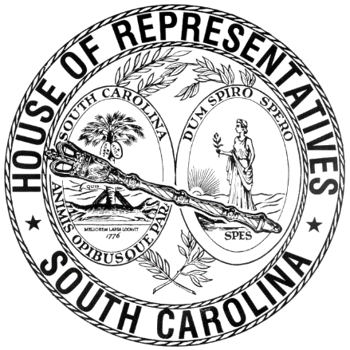

REGULAR SESSION BEGINNING TUESDAY, JANUARY 12, 2021
________

FRIDAY, APRIL 8, 2022
(LOCAL SESSION)

Indicates Matter Stricken
Indicates New Matter

The House assembled at 10:00 a.m.
Deliberations were opened with prayer by Rev. Charles E. Seastrunk, Jr., as follows:

Our thought for today is from Jeremiah 31:21: “Set up road markers for yourself, make yourself guidepost.”
Let us pray. Almighty God, You have called these Representatives and Staff to provide many avenues to fulfill the good things of life in their work. Bless and keep them in Your care. Bless our defenders of freedom and first responders as they care for us. Heavenly father, be our guest in everything we do for this State. Look in favor on our World, Nation, President, State, Governor, Speaker, Staff, and all who labor in this vineyard. Bestow Your blessings on the people of Ukraine. Bring them peace. Bless our men and women who serve our country and keep them safe. Lord, in Your mercy, hear our prayers. Amen.

After corrections to the Journal of the proceedings of yesterday, the SPEAKER ordered it confirmed.

ORDERED ENROLLED FOR RATIFICATION
The following Joint Resolution was read the third time, passed and, having received three readings in both Houses, it was ordered that the title of each be changed to that of an Act, and that they be enrolled for ratification:

S. 1132 -- Medical Affairs Committee: A JOINT RESOLUTION TO APPROVE REGULATIONS OF THE DEPARTMENT OF HEALTH AND ENVIRONMENTAL CONTROL, RELATING TO ONSITE WASTEWATER SYSTEMS, DESIGNATED AS REGULATION DOCUMENT NUMBER 5103, PURSUANT TO THE PROVISIONS OF ARTICLE 1, CHAPTER 23, TITLE 1 OF THE 1976 CODE.

SENT TO THE SENATE
The following Bill was taken up, read the third time, and ordered sent to the Senate:

H. 5097 -- Reps. Kirby, Jordan and Lowe: A BILL TO AMEND SECTION 4-11-290, CODE OF LAWS OF SOUTH CAROLINA, 1976, RELATING TO THE DISSOLUTION OF SPECIAL PURPOSE DISTRICTS, SO AS TO ALLOW A HOSPITAL DISTRICT THAT IS UNDERGOING DISSOLUTION TO TRANSFER ITS ASSETS TO AN AFFILIATED ORGANIZATION THAT IS EXEMPT FROM TAX UNDER SECTION 501(C)(3) OR (4) OF THE INTERNAL REVENUE CODE OF 1986.

ADJOURNMENT
At 10:20 a.m. the House, in accordance with the ruling of the SPEAKER, adjourned to meet at 12:00 noon, Tuesday, April 19.
***

H. 5097 2

S. 1132 1

