NO. 46

JOURNAL

of the

HOUSE OF REPRESENTATIVES

of the

STATE OF SOUTH CAROLINA

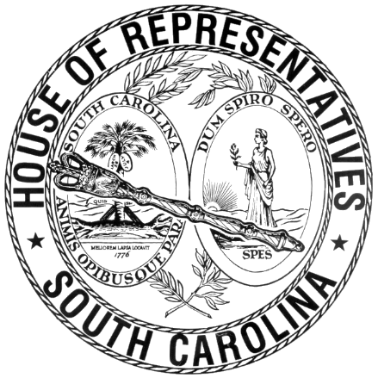

REGULAR SESSION BEGINNING TUESDAY, JANUARY 14, 2025

**________**

FRIDAY, APRIL 11, 2025

(LOCAL SESSION)

~~Indicates Matter Stricken~~

Indicates New Matter

The House assembled at 10:00 a.m.

Deliberations were opened with prayer by Rev. Charles E. Seastrunk Jr. as follows:

Our thought for today is from 1 Peter 5:4: “And when the Chief Shepherd appears, you will receive the unfading crown of glory.”

Let us pray. Love, power and glory are ours as we receive such wonderful things from our Lord who loves us and grants us everything we need. Bless and keep our defenders of freedom and first responders safe as they care for us. Be our guide for life as we receive your love for us. Look in favor on our World, Nation, President, State, Governor Speaker, Staff, and all who labor in this vineyard. Bless and keep safe our Armed Forces and those who suffer wounds and hidden wounds. Lord, in Your mercy, hear our prayers. Amen.

After corrections to the Journal of the proceedings of yesterday, the SPEAKER ordered it confirmed.

**SENT TO THE SENATE**

The following Bill was taken up, read the third time, and ordered sent to the Senate:

H. 4187 -- Reps. Caskey, Ballentine, Calhoon, Forrest, Govan, Kilmartin, May, McCabe, Taylor, White and Wooten: A BILL TO EXTEND THE ONE PERCENT SALES TAX IMPOSED BY ACT 378 OF 2004, AS AMENDED, THE LEXINGTON COUNTY SCHOOL DISTRICT PROPERTY TAX RELIEF ACT, FOR AN ADDITIONAL SEVEN YEARS.

**RETURNED TO THE SENATE WITH AMENDMENTS**

The following Bill was taken up, read the third time, and ordered returned to the Senate with amendments:

S. 164 -- Senator Campsen: A BILL TO AMEND THE SOUTH CAROLINA CODE OF LAWS BY AMENDING SECTION 1-23-120, RELATING TO THE REQUIREMENTS AND PROCEDURES FOR REGULATIONS, SO AS TO TOLL THE PERIOD OF LEGISLATIVE REVIEW FROM THE SECOND FRIDAY IN MAY THROUGH THE SECOND MONDAY IN JANUARY; AND TO ADD A PROVISION REVISING THE PERIOD OF LEGISLATIVE REVIEW FOR REGULATIONS FILED ON JANUARY 14, 2025, TO ONE HUNDRED THIRTEEN DAYS.

**ORDERED ENROLLED FOR RATIFICATION**

The following Joint Resolutions were read the third time, passed and, having received three readings in both Houses, it was ordered that the title of each be changed to that of an Act, and that they be enrolled for ratification:

S. 388 -- Education Committee: A JOINT RESOLUTION TO APPROVE REGULATIONS OF THE STATE COMMISSION ON HIGHER EDUCATION, RELATING TO PALMETTO FELLOWS SCHOLARSHIP PROGRAM, DESIGNATED AS REGULATION DOCUMENT NUMBER 5322, PURSUANT TO THE PROVISIONS OF ARTICLE 1, CHAPTER 23, TITLE 1 OF THE SOUTH CAROLINA CODE OF LAWS.

S. 389 -- Education Committee: A JOINT RESOLUTION TO APPROVE REGULATIONS OF THE STATE COMMISSION ON HIGHER EDUCATION, RELATING TO LIFE SCHOLARSHIP AND SCHOLARSHIP ENHANCEMENT, DESIGNATED AS REGULATION DOCUMENT NUMBER 5321, PURSUANT TO THE PROVISIONS OF ARTICLE 1, CHAPTER 23, TITLE 1 OF THE SOUTH CAROLINA CODE OF LAWS.

**ADJOURNMENT**

At 10:30 a.m. the House, in accordance with the ruling of the SPEAKER, adjourned to meet at 12:00 noon, Tuesday, April 22.

***

H. 4187 1

S. 164 1

S. 388 2

S. 389 2