NO. 4

JOURNAL

of the

HOUSE OF REPRESENTATIVES

of the

STATE OF SOUTH CAROLINA

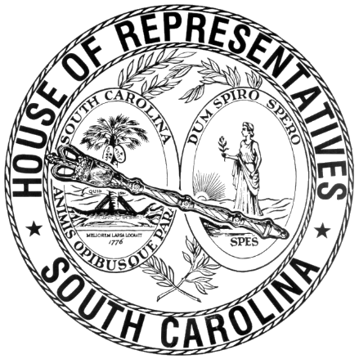

REGULAR SESSION BEGINNING TUESDAY, JANUARY 14, 2025
________

FRIDAY, JANUARY 16, 2026
(LOCAL SESSION)

Indicates Matter Stricken
Indicates New Matter

The House assembled at 10:00 a.m.
Deliberations were opened with prayer by the SPEAKER as follows:

Our thought for today is from Jeremiah 31:33: “Lord, please pace your teachings on my mind and in my heart, so that I live as one of your people.”
Let us pray. Almighty God, source of everything we have, place on our hearts and minds the will to carry out the responsibilities given to us. May we do our job with joy and gladness, knowing we are doing this for the people of this State. Grant us peace and understanding in working with each other. Bless those who lead us, give them wisdom and courage. Protect our defenders of freedom. Heal the wounds of our warriors, those seen and those unseen. Hear us, O Lord, as we pray. Amen.

After corrections to the Journal of the proceedings of yesterday, the SPEAKER ordered it confirmed.

SENT TO THE SENATE
The following Bills and Joint Resolutions were taken up, read the third time, and ordered sent to the Senate:

H. 4902 -- Reps. Hiott, G. M. Smith, Bannister, Rutherford, Brittain, Guest, Stavrinakis, Erickson, Caskey, Pope, Collins, B. Newton, Davis, Herbkersman, Hixon, Willis, Reese and Gilliard: A BILL TO AMEND THE SOUTH CAROLINA CODE OF LAWS BY AMENDING SECTION 59-158-50, RELATING TO AN EXEMPTION OF AN INTERCOLLEGIATE ATHLETE'S NAME, IMAGE, AND LIKENESS COMPENSATION CONTRACT DOCUMENTATION MAINTAINED BY PUBLIC INSTITUTIONS OF HIGHER LEARNING FROM PUBLIC DISCLOSURE UNDER THE SOUTH CAROLINA FREEDOM OF INFORMATION ACT, SO AS TO REMOVE AN EXCEPTION TO THE EXEMPTION, AND TO PROVIDE THAT RECORDS OF AGGREGATE REVENUE FUNDS EXPENDED FOR INTERCOLLEGIATE ATHLETICS REVENUE-SHARING PROGRAMS BY A PUBLIC INSTITUTION OF HIGHER LEARNING EACH FISCAL YEAR ARE SUBJECT TO THE SOUTH CAROLINA FREEDOM OF INFORMATION ACT SUBJECT TO EXCEPTIONS FROM SUCH DISCLOSURE FOR INDIVIDUAL ATHLETE PAYMENTS, SPORT-SPECIFIC ALLOCATIONS, AND NEGOTIATION RECORDS.

ADJOURNMENT
At 10:20 a.m. the House, in accordance with the ruling of the SPEAKER, adjourned to meet at 12:00 noon, Tuesday, January 20.
***

H. 4902 1

