NO. 24

JOURNAL

of the

HOUSE OF REPRESENTATIVES

of the

STATE OF SOUTH CAROLINA

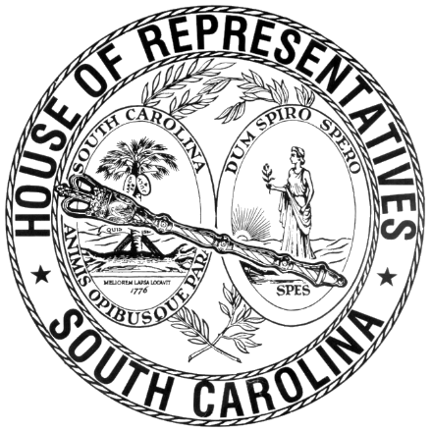

REGULAR SESSION BEGINNING TUESDAY, JANUARY 14, 2025
________

FRIDAY, FEBRUARY 20, 2026
(LOCAL SESSION)

Indicates Matter Stricken
Indicates New Matter

The House assembled at 10:00 a.m.
Deliberations were opened with prayer by Rev. Jeff Lingerfelt as follows:

Our thought for today is from Psalm 34:9: “O fear the Lord, you His saints; For to those who fear Him there is no want.”
Let us pray: O Lord our Father, thank you for providing your servants guidance in all we do today. Your goodness has been shed deeply into our hearts, so that we lack no good thing from your providential hand. Help us as we administer Your goodness to those under our care in this state. We pray for your provision, Your common grace, to us in our daily lives. Keep your eyes on us so that there is no lack in our daily provisions. We pray these things in the name of your beloved Son. Amen.

Pursuant to Rule 6.3, the House of Representatives was led in the Pledge of Allegiance to the Flag of the United States of America by the SPEAKER.

After corrections to the Journal of the proceedings of yesterday, the SPEAKER ordered it confirmed.

SENT TO THE SENATE
The following Bills were taken up, read the third time, and ordered sent to the Senate:

H. 5096 -- Reps. Haddon, Yow, Burns, Brewer, Rankin, Chumley, Morgan, Pedalino, J. E. Johnson, Guffey, Chapman, Lastinger, Robbins, Holman, Calhoon, Davis, Cox, Brittain, Forrest, Gagnon, Hixon, Ligon, Atkinson, Cromer and Gilreath: A BILL TO AMEND THE SOUTH CAROLINA CODE OF LAWS BY AMENDING ARTICLE 5 OF CHAPTER 17, TITLE 47, RELATING TO MISREPRESENTING PRODUCTS THAT ARE CELL-CULTURED MEAT, SO AS TO PROVIDE IT IS UNLAWFUL TO MANUFACTURE, SELL, OR DISTRIBUTE ARTIFICIAL OR CELL-CULTIVATED FOOD PRODUCTS IN THIS STATE, TO MAKE A TECHNICAL CHANGE, TO PROVIDE ADDITIONAL PENALTIES FOR VIOLATIONS OF THIS ARTICLE, AND TO PROVIDE THE DEPARTMENT OF AGRICULTURE MAY PROMULGATE REGULATIONS TO IMPLEMENT THE PROVISIONS OF THIS ARTICLE.

H. 5097 -- Reps. Haddon, Yow, Ligon, Holman, Rankin, Pedalino, Forrest, Hixon, Cromer and Gilreath: A BILL TO AMEND THE SOUTH CAROLINA CODE OF LAWS BY ADDING SECTION 6-1-145 SO AS TO PROVIDE THAT CERTAIN ROADSIDE MARKETS OPERATED BY FARMERS ARE NOT CONSIDERED COMMERCIAL OPERATIONS FOR LOCAL ZONING PURPOSES AND ARE EXEMPT FROM CERTAIN LOCAL AND STATE REGULATORY REQUIREMENTS, AND TO DEFINE NECESSARY TERMS, AMONG OTHER THINGS.

ORDERED ENROLLED FOR RATIFICATION
The following Bill was read the third time, passed and, having received three readings in both Houses, it was ordered that the title be changed to that of an Act, and be enrolled for ratification:

S. 383 -- Senators Davis, Goldfinch, Graham, Zell and Rankin: A BILL TO AMEND THE SOUTH CAROLINA CODE OF LAWS BY ENACTING THE "PROTHONOTARY WARBLER RECOGNITION ACT" BY ADDING SECTION 1-1-613 SO AS TO DESIGNATE THE PROTHONOTARY WARBLER (PROTONOTARIA CITREA) AS THE OFFICIAL STATE MIGRATORY BIRD OF SOUTH CAROLINA.

ADJOURNMENT
At 10:30 a.m. the House, in accordance with the ruling of the SPEAKER, adjourned to meet at 12:00 noon, Tuesday, February 24.
***

H. 5096 1
H. 5097 2

S. 383 2

