NO. 28

JOURNAL

of the

HOUSE OF REPRESENTATIVES

of the

STATE OF SOUTH CAROLINA

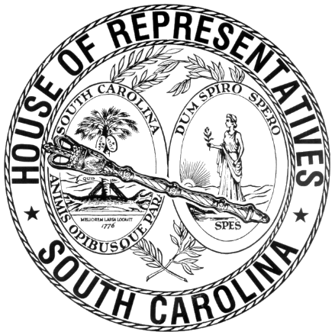

REGULAR SESSION BEGINNING TUESDAY, JANUARY 14, 2025
________

FRIDAY, FEBRUARY 27, 2026
(LOCAL SESSION)

Indicates Matter Stricken
Indicates New Matter

The House assembled at 10:00 a.m.
Deliberations were opened with prayer by Rev. Jeff Lingerfelt as follows:

Our thought for today is from Psalm 34:13: “Keep your tongue from evil and your lips from speaking deceit.”
Let us pray: Our Father and our God, oftentimes, our mouths speak but our hearts are far from you. We need your help! Please, align our words and ways to be pleasing in your sight. Keep our tongues from speaking evil and deceit. May all our words be wholesome and minister to the need of the moment. You remind us that out of the abundance of the heart, the mouth speaks, revealing what is within us. O Lord may our words be pleasing to you, so that we may bring praise and glory to our great God, our Savior! Amen.

After corrections to the Journal of the proceedings of yesterday, the SPEAKER ordered it confirmed.

SENT TO THE SENATE
The following Joint Resolution was taken up, read the third time, and ordered sent to the Senate:

H. 5261 -- Rep. W. Newton: A JOINT RESOLUTION TO EXTEND THE DEADLINE FOR RECEIVING ALCOHOL SERVER TRAINING AS PROVIDED FOR IN CHAPTER 3, TITLE 61 TO MAY 1, 2026.

ADJOURNMENT
At 10:20 a.m. the House, in accordance with the ruling of the SPEAKER, adjourned to meet at 12:00 noon, Tuesday, March 3.
***

H. 5261 1

