NO. 47

JOURNAL

of the

HOUSE OF REPRESENTATIVES

of the

STATE OF SOUTH CAROLINA

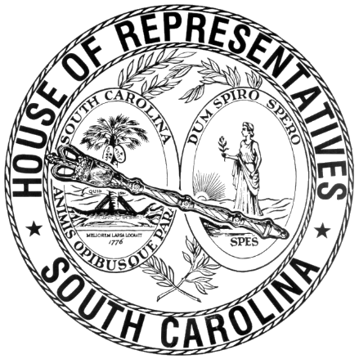

REGULAR SESSION BEGINNING TUESDAY, JANUARY 14, 2025
________

FRIDAY, APRIL 17, 2026
(LOCAL SESSION)

Indicates Matter Stricken
Indicates New Matter

The House assembled at 10:00 a.m.
Deliberations were opened with prayer by Rev. Jeff Lingerfelt as follows:

Our thought for today is from Job 19:25: “Yet as for me, I know that my Redeemer lives, and at the last, He will take His stand on the earth.”
Let us pray: O Lord our Father our citizenship is in heaven, and we eagerly await a Savior from there, the Lord—The Messiah, who, by the power that enables Him to subject all things to Himself, will transform our lowly bodies to be like His glorious body. O Lord until that day keep us Your servants faithful and steadfast, always abounding in the work of the Lord. Guide us this day and forever, that we might be Your servants in the realm of government; doing Your will for the betterment of this State. Now to Him who is able to make You stand before Him—Faultless! Always abounding in the work of the Lord. Amen.

After corrections to the Journal of the proceedings of yesterday, the SPEAKER ordered it confirmed.

RETURNED TO THE SENATE WITH AMENDMENTS
The following Bill was taken up, read the third time, and ordered returned to the Senate with amendments:

S. 585 -- Senators Tedder, Adams, Devine, Zell and Sutton: A BILL TO AMEND THE SOUTH CAROLINA CODE OF LAWS BY ENACTING THE "SAFEGUARDING AMERICAN FAMILIES EVERYWHERE (SAFE) ACT" AND BY ADDING SECTION 56-3-125 SO AS TO PROVIDE APPLICATIONS FOR MOTOR VEHICLE REGISTRATIONS MUST INCLUDE LANGUAGE ALLOWING APPLICANTS TO VOLUNTARILY INDICATE THEY OR THEIR FAMILY MEMBERS HAVE BEEN DIAGNOSED WITH CERTAIN DISABILITIES OR DISORDERS, AND TO REQUIRE THE DEPARTMENT OF MOTOR VEHICLES TO INCLUDE THE DESIGNATION "SAFE" IN THE MOTOR VEHICLE'S RECORDS.

SENT TO THE SENATE
The following Bill was taken up, read the third time, and ordered sent to the Senate:

H. 5401 -- Rep. Robbins: A BILL TO AMEND THE SOUTH CAROLINA CODE OF LAWS BY AMENDING SECTION 17-15-37, RELATING TO ELECTRONIC MONITORING BY THE SOUTH CAROLINA LAW ENFORCEMENT DIVISION, SO AS TO ESTABLISH NEW OFFENSES AND PROVIDE PENALTIES; AND BY AMENDING SECTION 38-53-84, RELATING TO NOTIFICATION OF ELECTRONIC MONITORING VIOLATIONS, SO AS TO PROHIBIT BONDSMEN FROM KNOWINGLY CONTRACTING WITH, REFERRING, OR OTHERWISE UTILIZING THE SERVICES OF AN UNCERTIFIED ELECTRONIC MONITORING COMPANY.

ADJOURNMENT
At 10:20 a.m. the House, in accordance with the ruling of the SPEAKER, adjourned to meet at 12:00 noon, Tuesday, April 21.
***

H. 5401 2

S. 585 1

