SENATE TO MEET AT 11:00 A.M. TODAY

NO. 5

CALENDAR

OF THE

SENATE

OF THE

STATE OF SOUTH CAROLINA

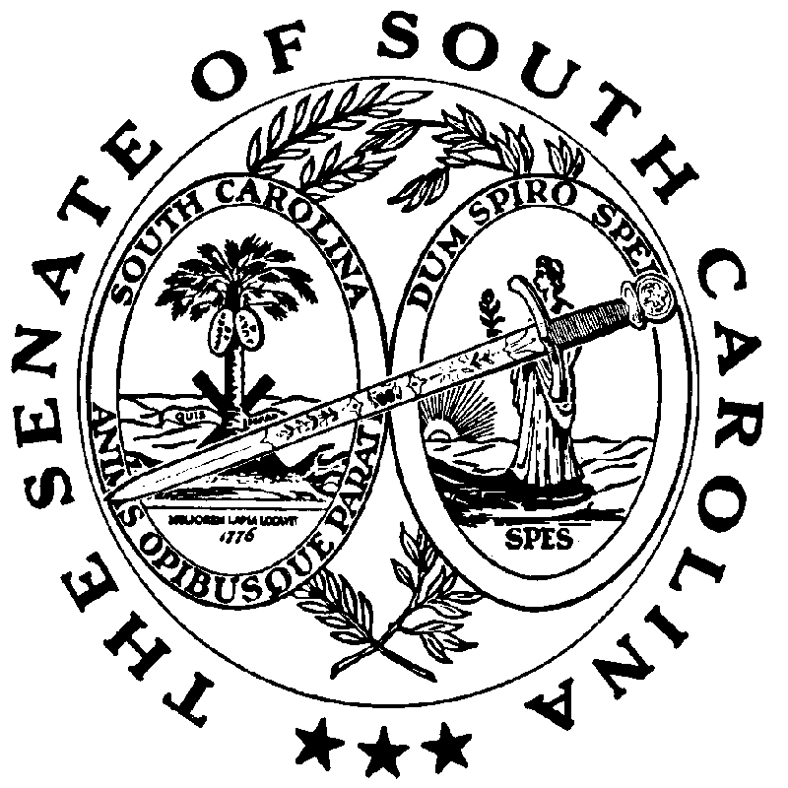

REGULAR SESSION BEGINNING TUESDAY, JANUARY 14, 2025

_______________

WEDNESDAY, JANUARY 22, 2025

Wednesday, January 22, 2025

JOINT ASSEMBLY

(Wednesday, January 29, 2025 at 7:00 P.M.)
H. 3660--Rep. G.M. Smith: A CONCURRENT RESOLUTION INVITING HIS EXCELLENCY, HENRY DARGAN MCMASTER, GOVERNOR OF THE STATE OF SOUTH CAROLINA, TO ADDRESS THE GENERAL ASSEMBLY IN JOINT SESSION AT 7:00 P.M. ON WEDNESDAY, JANUARY 29, 2025, IN THE CHAMBER OF THE SOUTH CAROLINA HOUSE OF REPRESENTATIVES.
(Adopted--January 15, 2025)

INVITATIONS

Tuesday, January 28, 2025 – 9:00 - 10:00 a.m.
Members, Breakfast, South Carolina Chamber of Commerce Office, 1301 Gervais Street, hosted by the SOUTH CAROLINA CHAMBER OF COMMERCE
(Accepted-January 13, 2025)

Tuesday, January 28, 2025 – 5:00 - 7:00 p.m.
Members and Staff, Reception, Capital Center Lobby, 1201 Main Street, hosted by the CITY OF COLUMBIA
(Accepted-January 13, 2025)

Tuesday, January 28, 2025 – 5:30 - 8:00 p.m.
Members and Staff, Reception, Bourbon, 1214 Main Street, hosted by the CONSERVATION VOTERS OF SOUTH CAROLINA
(Accepted-January 13, 2025)

Tuesday, January 28, 2025 – 6:00 - 8:00 p.m.
Members and Staff, Reception, Burr Forman Law Firm, 1221 Main Street, hosted by the PALMETTO BROADBAND COALITION
(Accepted-January 13, 2025)

Wednesday, January 29, 2025 – 8:00 - 10:00 a.m.
Members, Breakfast, 112 Blatt Building, hosted by AMIKIDS
(Accepted-January 13, 2025)

Wednesday, January 29, 2025 – 11:30 a.m. - 2:00 p.m.
Members, Luncheon, 112 Blatt Building, hosted by the SC ASSOCIATION FOR COMMUNITY ECONOMIC DEVELOPMENT
(Accepted-January 13, 2025)

Wednesday, January 29, 2025 – 12:00 a.m. - 2:00 p.m.
Members, Luncheon, The Palmetto Club, hosted by the SOUTH CAROLINA ASSOCIATION OF TECHNICAL COLLEGE COMMISSIONERS
(Accepted-January 17, 2025)

Wednesday, January 29, 2025 – 5:00 - 7:00 p.m.
Members and Staff, Reception, Capital Center Atrium, 1201 Main Street, hosted by the SOUTH CAROLINA BAR ASSOCIATION
(Accepted-January 13, 2025)

Thursday, January 30, 2025 – 8:00 - 10:00 a.m.
Members and Staff, Breakfast, 112 Blatt Building, hosted by the SOUTH CAROLINA FRATERNAL ORDER OF THE POLICE
(Accepted-January 13, 2025)

UNCONTESTED LOCAL
SECOND READING BILL

S. 213--Senator Turner: A BILL TO AMEND ACT 919 OF 1928, AS AMENDED, RELATING TO THE POWERS AND DUTIES OF THE GREENVILLE AIRPORT COMMISSION, SO AS TO INCREASE THE AUTHORIZED TOTAL INDEBTEDNESS TO TWENTY MILLION DOLLARS.
(Without reference--January 15, 2025)

MOTION PERIOD

STATEWIDE SECOND READING BILL

S. 62--Senators Hembree, Rice and Grooms: A BILL TO AMEND THE SOUTH CAROLINA CODE OF LAWS BY AMENDING SECTION 59-8-110, RELATING TO DEFINITIONS, SO AS TO DEFINE NECESSARY TERMS; BY AMENDING SECTION 59-8-115, RELATING TO THE STANDARD APPLICATION PROCESS, SO AS TO PROVIDE REQUIREMENTS FOR STUDENTS AND SCHOOLS SEEKING TO PARTICIPATE IN THE PROGRAM; BY AMENDING SECTION 59-8-120, RELATING TO ADMINISTRATION OF FUND, SO AS TO PROVIDE FOR THE ADMINISTRATION OF THE K-12 EDUCATION LOTTERY SCHOLARSHIP; BY AMENDING SECTION 59-8-125, RELATING TO FUNDS TO CREATE, OVERSEE, AND THE ADMINISTER PROGRAM, SUSPENSION OF ACCOUNTS, UNUSED FUNDS, AND TERMINATION OF SCHOLARSHIPS, SO AS TO APPROPRIATE FUNDS FOR THE SCHOLARSHIP PROGRAM FROM THE SOUTH CAROLINA EDUCATION LOTTERY ACCOUNT; BY AMENDING SECTION 59-8-130, RELATING TO TERMINATION OF SCHOLARSHIP STUDENT’S PROGRAM; NOTIFICATION, SO AS TO MAKE CONFORMING CHANGES; BY AMENDING SECTION 59-8-135, RELATING TO LIMITATIONS ON SCHOLARSHIPS, SO AS TO PROVIDE LIMITATIONS ON THE NUMBER OF SCHOLARSHIPS THAT MAY BE AWARDED; BY AMENDING SECTION 59-8-140, RELATING TO THE APPLICATION APPROVAL PROCESS FOR EDUCATION SERVICE PROVIDERS, SO AS TO PROVIDE THAT AN EDUCATION SERVICE PROVIDER MUST CERTIFY ANNUALLY TO THE DEPARTMENT THAT IT MEETS ALL PROGRAM REQUIREMENTS; BY AMENDING SECTION 59-8-145, RELATING TO PROCEDURES TO INFORM STUDENTS AND THEIR PARENTS OF ELIGIBILITY AND APPROVED EDUCATION SERVICE PROVIDERS, SO AS TO MAKE CONFORMING CHANGES; BY AMENDING SECTION 59-8-150, RELATING TO REQUIREMENTS FOR EDUCATION SERVICE PROVIDERS, DEPARTMENT, AND EDUCATION OVERSIGHT COMMITTEE, SO AS TO PROVIDE THAT THE SURETY BOND IS REQUIRED OF EDUCATION SERVICE PROVIDERS WHO EXCEED FIFTY THOUSAND DOLLARS IN QUALIFYING EXPENSES AND TO MAKE CONFORMING CHANGES; BY AMENDING SECTION 59-8-160, RELATING TO THE K-12 EDUCATION LOTTERY SCHOLARSHIP REVIEW PANEL, SO AS TO PROVIDE FOR ITS COMPOSITION AND PURPOSES; BY AMENDING SECTION 59-8-165, RELATING TO STUDENT TRANSFER POLICY, SO AS TO CLARIFY STUDENT TRANSFER REQUIREMENTS; BY AMENDING SECTION 59-8-170, RELATING TO IMMEDIATE PARTICIPATION IN A SPORT BY A TRANSFER SCHOLARSHIP STUDENT, SO AS TO MAKE CONFORMING CHANGES ; AND BY AMENDING SECTION 59-150-350, RELATING TO THE EDUCATION LOTTERY ACCOUNT MANAGEMENT, SO AS TO MAKE CONFORMING CHANGES.
(Read the first time--January 14, 2025)
(Polled by Committee on Education--January 14, 2025)
(Favorable)
(Amended--January 16, 2025)

CONCURRENT RESOLUTION

S. 237 -- Senators Rankin, Sabb and Garrett: A CONCURRENT RESOLUTION TO FIX NOON ON WEDNESDAY, FEBRUARY 5, 2025, AS THE TIME TO ELECT CERTAIN JUDGES TO THE COURT OF APPEALS, CIRCUIT COURT, FAMILY COURT, AND THE ADMINISTRATIVE LAW COURT. (abbreviated title)
(Without reference--January 16, 2025)
(Contested by Senator Climer)

SENATE CALENDAR INDEX

S. 62 3
S. 213 3
S. 237 5

H. 3660 1

