**NO. 61**

**JOURNAL**

**OF THE**

**SENATE**

**OF THE**

**STATE OF SOUTH CAROLINA**

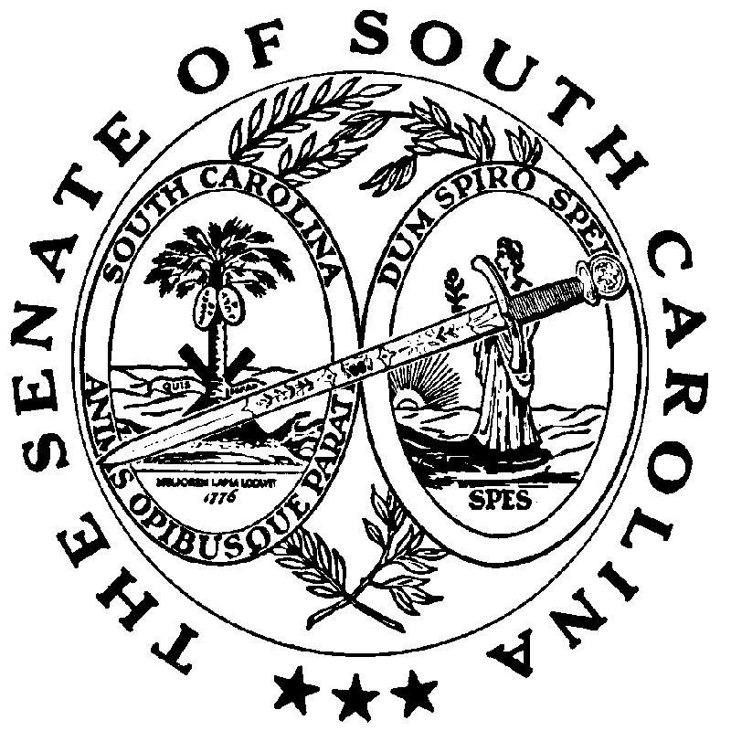

**REGULAR SESSION BEGINNING TUESDAY, JANUARY 14, 2025**

**_________**

**FRIDAY, APRIL 25, 2025**

Friday, April 25, 2025

(Local Session)

~~Indicates Matter Stricken~~

Indicates New Matter

The Senate assembled at 11:00 A.M., the hour to which it stood adjourned, and was called to order by the ACTING PRESIDENT, Senator KENNEDY.

**READ THE THIRD TIME**

**SENT TO THE HOUSE**

The following Bill was read the third time and ordered sent to the House:

S. 221 -- Senators Ott and Alexander: A BILL TO AMEND THE SOUTH CAROLINA CODE OF LAWS BY ENACTING THE “SOUTH CAROLINA KRATOM CONSUMER PROTECTION ACT” BY ADDING ARTICLE 20 TO CHAPTER 53, TITLE 44 SO AS TO PROVIDE FOR THE REGULATION OF THE SALE OF KRATOM PRODUCTS BY RETAILERS AND PROCESSORS AND TO CREATE PENALTIES FOR VIOLATION OF THE PROVISIONS OF THE ARTICLE.

On motion of Senator OTT.

REMARKS

**Remarks by Senator SABB**

Thank you, Mr. PRESIDENT and members. I will not oppose the amendment put forth by Senator MASSEY. I do believe that it gives us a basis to move forward.

And so, what I’d like to do Mr. PRESIDENT, if it's okay, is take a couple of moments to just acknowledge something. I stated last week that one of the things I regretted most was our inability to predict what was going to happen on the next day and we had a member who, in spite of the health challenges that he had, based upon his commitment to the people of South Carolina, and the people of his district -- he came, day after day after day. And so, I agonize over the fact that he came, and we really didn't do anything that we needed him for. I actually tried to dissuade him once or twice. But I think he had to be true to himself and so Mr. PRESIDENT, Senator MASSEY recognized him earlier. We all gave him a standing ovation; I got some texts about how great it was to see him here and smiling. And I want to share one more thing, and then I'll have a unanimous consent request, and then I'll take my seat.

So, when I received a phone call from Senator HUTTO, telling me he would not be here for a period of time, and what he expected of me in his absence -- obviously, I had some hesitations because of the admiration that I have for the manner in which he goes about his senatorial duties and leading our caucus. But one of the things he asked me to consider was occupying his desk, and that was not an easy thing for me to embrace. And so, I got counselled from some members of this Body, because one of the things that I’ve grown to admire about this Senate is a lot of its traditions. Traditions not for the sake of just having a tradition, but ones that are grounded in some fundamental principles that many of us try to live by. Mr. PRESIDENT, I’m thankful to every member of this Body for not opposing that unanimous consent request because of my thinking that, in light of my conversation with Senator HUTTO, and some of what I was experiencing, I concluded that it was something I felt compelled to do for reasons I won't necessarily disclose. But it was an honor for me to occupy desk number twenty-five. That's a part of my senatorial history, having sat where Senator HUTTO has earned the right to sit. And so, my sitting was not earned. And please, I want everybody to know that's exactly how I felt. And so, Mr. PRESIDENT, I would like to make a unanimous consent request. My request would be that I be allowed to return to desk number thirty-seven, and that Senator HUTTO be allowed to reoccupy desk number twenty-five.

On motion of Senator MARTIN, with unanimous consent, the remarks of Senator SABB were ordered printed in the Journal.

ADJOURNMENT

At 11:04 A.M., on motion of Senator MASSEY , the Senate adjourned to meet next Tuesday, April 29, 2025, at 12:00 P.M.

* * *

SENATE JOURNAL INDEX

S. 221 **1**