**NO. 65**

**JOURNAL**

**OF THE**

**SENATE**

**OF THE**

**STATE OF SOUTH CAROLINA**

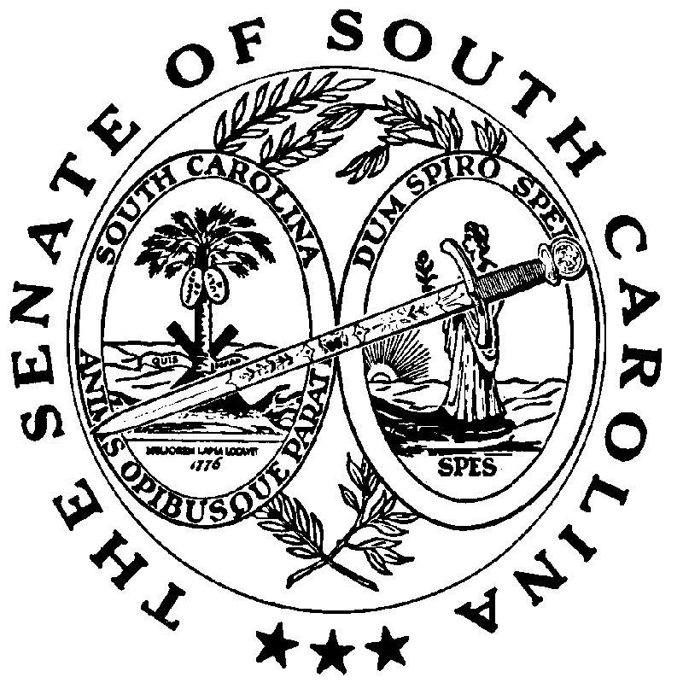

**REGULAR SESSION BEGINNING TUESDAY, JANUARY 14, 2025**

**_________**

**FRIDAY, MAY 2, 2025**

Friday, May 2, 2025

(Local Session)

~~Indicates Matter Stricken~~

Indicates New Matter

The Senate assembled at 11:00 A.M., the hour to which it stood adjourned, and was called to order by the ACTING PRESIDENT, Senator MASSEY.

**REMARKS**

**Remarks by Senator OTT**

Thank you, Mr. PRESIDENT and members of the Senate. From time to time, we must come to this podium and talk about things we certainly don't want to talk about. Today is definitely one of those days.

By now all of you are aware of the tragic accident that happened last Thursday on I-77 when a group of middle school students were returning from a field trip in Charlotte, N.C. One of the buses had a tire blow out which then caused an accident and the bus to overturn. Thirty-five students were injured, and tragically one of those students, Jose Marie Gonzalez-Linares, unfortunately passed away. Jose was a thirteen-year-old boy. From the different stories that I have heard from his friends, from parents of other students and from teachers -- they all highlight him in so many ways. He was a great kid, full of life and a very bright future that was certainly cut far too short. This is such a tragedy.

I just wanted to come today and tell each of you about him. I ask that we all remember him, remember his family and remember all the other students that were impacted.

Several students had to be airlifted that day to local hospitals, and it is now my understanding that they have all been released from the hospital. Regardless of whether it was physical injuries or emotional injuries, this is an event that will stay with all of them for quite some time.

We all come from different backgrounds, we all come from different places in life; but, at the end of the day the one thing that transcends all of that is the unexpected loss of a child. I think that probably most all of us can at least relate to what that must feel like, and no one should ever have to go through that.

I ask that you keep that family, Pine Ridge Middle School and the entire community, which is in my Senate district, in your prayers.

I would also like to acknowledge how proud I am of this Body, of the first responders, of the local law enforcement and of everyone who has been with this community over the last week. Senator STUBBS, who represents the area of South Carolina where the accident occurred, was one of the first ones who called me. He dropped everything to make sure that every resource was available and to make sure care was given to the best of their ability. The response from your community, sir, was outstanding. You should be commended, and on behalf of all of Lexington County, I express sincere gratitude and appreciation for everything that was done. Across the board -- from the Senate PRESIDENT to so many of you, from the concern related and the coordination of efforts on the local level to law enforcement, to the State Department of Transportation -- everyone that was involved has truly come together and has shown the greatness of the State of South Carolina in the face of tragedy.

Thank you all for allowing me to give everyone a brief update. I am extremely grateful for the response, and I ask that everyone continue to keep the family and the community in your prayers during this very hard time. Thank you very much.

On motion of Senator GARRETT, with unanimous consent, the remarks of Senator OTT were ordered printed in the Journal.

**Remarks by Senator LEBER**

Thank you, Mr. PRESIDENT. The oath to the Constitution is important. We have all taken this oath numerous times and we all take it very, very seriously. We have many veterans here. We have many who have taken the oath throughout their lives; throughout young adulthood; all the way into later years. My fellow Senator from Charleston, Senator SUTTON, he's been in the military and he's been in combat. Do you know, Mr. PRESIDENT, that he flew for thirty-two hours straight evicting refugees from Afghanistan on a C-17? I tell my kids that Senator SUTTON is a hero and I mean it. Senator GOLDFINCH has been deployed often throughout the world. He probably has plenty of stories, and I haven't heard all of them, but I’m anxious to hear them. I know there are many veterans here.

The oath to the Constitution -- poll workers take that oath -- all the way up to the President of the United States and everyone in between and it shouldn't be a political thing. It shouldn't be a moment of contention; it's what unites us in America. It spells out the rules, and it spells out the law for us. When you are willing to take that oath, you are basically putting your hand up and saying, “I will play by the rules, and I will follow the laws.” Not only will I uphold the laws, but I will also fight for them. I’ll do everything I can to fight for equal rights. Equal protection under the law cannot be corrupt, and that is true throughout the world.

Nations that do not have a constitution nor do they respect their constitution have corruption. They have wars. I found it out personally in 1996 as a young U.S. Paratrooper I was deployed to Boz Florida and to Bosnia. For that conflict, they did not honor their constitution. That is a contract for you, and for us with the people. There was nothing but hardship in nations that do not have a constitution and a strict rule of law that they follow. Regardless of what party, that is simply the standard that we set and say this is where we draw the line.

This is what we support, and Mr. PRESIDENT, I sadly must report that it is not being honored in Charleston County right now. There are boards and there are commissions in Charleston County that refuse to swear an oath for the Constitution. I don't know what is going on with that. I do not know what their potential story is. I could say I am angry about it but I am mostly sad about it. I think that is the bare minimum that you must do when you are appointed or elected to an office -- is to complete the citizens of that area of your jurisdiction, the region, and the folks you are going to serve to let them know you support the Constitution of the United States and the Constitution of South Carolina.

On our library board right now, eight of eleven members will not swear an oath to the Constitution because they refuse. I asked the Attorney General to make sure I was clear within the bounds of the law, understanding the situation clearly, so I asked him to give me an opinion. I waited a couple of weeks for the opinion to come and when it came, it was exactly as I expected. He stated it was clear in the law that anybody appointed and/or any elected official must swear an oath to the Constitution, but Mr. PRESIDENT, it is worse than that. Not only will they not swear an oath to the Constitution, but they have also made up their own pledge. They have made up their own oath. What could go wrong there? I thought for a second and I wanted to find some comedy in this. Elon Musk said he found some people two hundred, three hundred years old still receiving Social Security. I wish that wasn’t the case, Mr. PRESIDENT. They have been given four or five different opportunities to swear an oath to the Constitution and they still refuse. Rob, the chairman of the library board, says this opinion of the Attorney General doesn't have my name on it so I don't have to swear an oath. I don't know -- I have received many letters from the Attorney General with my name on them, but I swore an oath. This doesn't apply to us; this is just a piece of paper. I guess that's what he thinks of the Constitution, too; it's just a piece of paper, but our Founding Fathers made that piece of paper a key to our republic because they did not trust humans; they did not trust human nature. They knew that we needed to be bound by a document that spelled out what we believe in -- what we will follow -- and what we will fight for. That is not how it works, but if you won’t swear an oath to the Constitution, you just cannot be in charge of the taxpayers' money. This board has a 45-million-dollar budget, so no one is going to come to your house and make you swear an oath to the Constitution, ever? You don't have to be on the library board either or whatever board. I’ve called around the State -- your county library board -- and they have sworn an oath to the Constitution of South Carolina and the United States. Those Senators from York County, congratulations, but I think the rest of us probably need to be checking with our boards and commissions to see if any of them have made up their own pledges. I hate to think that this, you know, the communist manifesto is what they pledge to, who knows, but the constitution is what binds us together as Americans as well as those who are elected.

It is our deep respect for the Constitution and our pledge to uphold it, before we go and act on behalf of the public; before we go and act for citizens; before we sign contracts with outsiders and use the citizens' money to satisfy those contracts; before we set a policy. We need to let the citizens know we have a standard, and that is the Constitution. I’ve written a letter, and I’ve worked closely with Senator GROOMS on this to make sure that I did not get over my head on a lot of this because it is a complicated issue at times. I have written a letter to my county council and I have asked them to remind all those members that I do not want them to have another chance to put their fingers behind their back and swear the oath. I am counting on county council to give me eight people who will raise their hand and show their respect to the Constitution of the United States and the Constitution of South Carolina. It is not a partisan thing for me; it is very important to me. I have not met anybody with common sense who is against me on this -- who thinks I am wrong, no one. So, I am asking the Senate to back me up and support me on this issue. I encourage you to check on your boards and commissions throughout the State because we have got to have a standard and our Constitution is our record; it is our standard. It is where we start before we begin a day of governing. The Constitution is where we start. Thank you.

On motion of Senator CLIMER, with unanimous consent, the remarks of Senator LEBER were ordered printed in the Journal.

ADJOURNMENT

At 11:04 A.M., on motion of Senator OTT, the Senate adjourned to meet next Tuesday, May 6, 2025, at 12:00 Noon.

* * *