NO. 15

JOURNAL

OF THE

SENATE

OF THE

STATE OF SOUTH CAROLINA

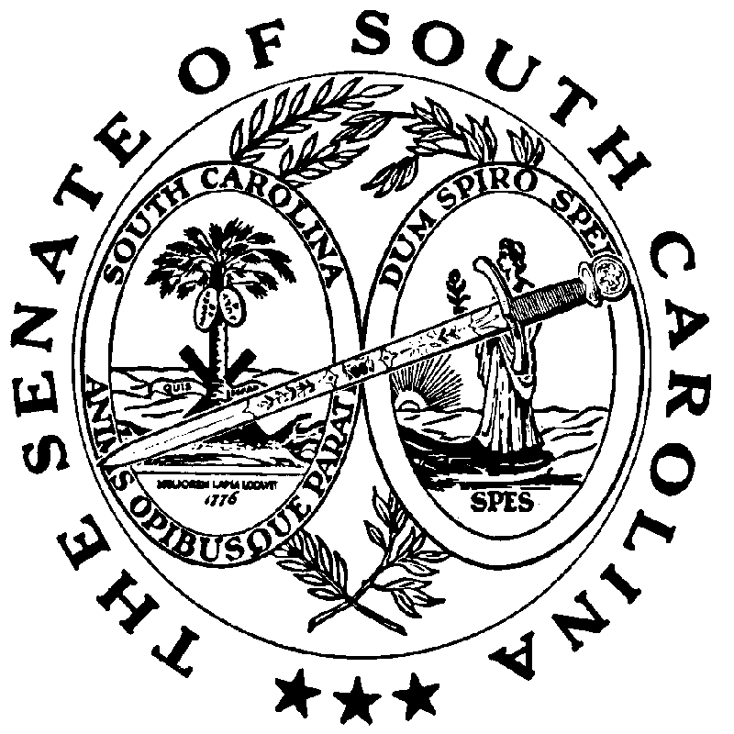

REGULAR SESSION BEGINNING TUESDAY, JANUARY 14, 2025

_________

FRIDAY, FEBRUARY 6, 2026

Friday, February 6, 2026

(Local Session)

Indicates Matter Stricken

Indicates New Matter

The Senate assembled at 11:00 A.M., the hour to which it stood adjourned, and was called to order by the ACTING PRESIDENT, Senator JACKSON.

READ THE THIRD TIME
SENT TO THE HOUSE
The following Resolution was read the third time and ordered sent to the House:
S. 880 -- Senators Massey and Rankin: A JOINT RESOLUTION TO PROVIDE THAT IF A MEMBER OF THE GENERAL ASSEMBLY SUBMITS AN IRREVOCABLE RESIGNATION PURSUANT TO SECTION 8-1-145 ON OR BEFORE MARCH 1, 2026, THEN THE ELECTION TO FILL THE VACANCY SHALL BE CONDUCTED CONCURRENTLY WITH THE CANDIDACY FILING AND ELECTION SCHEDULE APPLICABLE TO THE 2026 ELECTION FOR MEMBERS OF THE HOUSE OF REPRESENTATIVES.
On motion of Senator MASSEY.

CO-SPONSOR ADDED

The following co-sponsor was added to the respective Bill:

S. 695 Sen. Sutton

ADDENDUM TO THE JOURNAL
The following remarks by Senator MASSEY were ordered printed in the Journal of January 13, 2026:

Remarks by Senator MASSEY
Thank you, Mr. PRESIDENT. First, Mr. PRESIDENT, just a road map so everybody understands what we are doing. We have some committees and subcommittees scheduled to meet tomorrow, so we will allow that to happen. When we come in tomorrow afternoon, it is our intention to bring up the constitutional amendment for the balanced budget amendment and the call for the constitutional convention.
Now, I want to change gears just for a second. When we adjourned here in May, none of us expected that when we met today Senator Roger Nutt would not be part of this Body. Senator Nutt himself did not anticipate that he would not be part of this Body when we adjourned. I am hopeful that he will be able to come back, so we can greet him and speak with him; but everybody has seen the public announcements of course. I have had a number of conversations with former Senator Nutt. I had hoped he might make it to Columbia today, but that didn't happen, so I’m hoping he is watching us. I wanted to take just a minute to thank Roger and his family for the service he has provided, not just to us here in the Senate, but also for his service in the House and his many years of service to the people of Spartanburg County. He has been a very dedicated public servant and I know that the folks from Spartanburg are far more familiar with his service than I am.
Roger is a very, very quiet and reserved gentleman who is always paying attention. He is one of those guys, as everybody would agree, that when he spoke, people listened because he did not speak a whole lot. I consider him a friend, and I am sorry that he is not with us here serving today. So, I wanted to take a minute just to recognize his service and all of the time that he has given to Spartanburg County and to South Carolina. And if I could, Mr. PRESIDENT, I would like to adjourn in honor and gratitude for the service that Roger Nutt has given to South Carolina, and to wish him health and prosperity into the future.
***

The following remarks by Senator MASSEY were ordered printed in the Journal of January 22, 2026:

Remarks by Senator MASSEY
Thank you, Mr. PRESIDENT. I thought about doing this yesterday but you may have seen earlier in the week that Senator CAMPSEN passed out something for us to read. It was an op-ed that was written about the Revolutionary War. And as you know, because of our new license plates, we have received some controversy. The folks in Virginia especially have not taken kindly to the claim that South Carolina is where the Revolutionary War was won.
There has been some dispute among the other original states regarding how important a role each of them played. I love the title of the article Senator CAMPSEN passed out, “Yes, Virginia, the Revolutionary War was Really Won in South Carolina.” I bring this up also because last Saturday was the 250th anniversary of the battle of Cowpens, which was a major defeat of the British. In January of 1776, or shortly thereafter, Cornwallis was still in South Carolina, but he began to pack up to leave. But when Tarleton loses, the British start moving out of South Carolina because they're beaten here. And as this author wrote, “South Carolina may not be where Cornwallis surrendered, but, South Carolina was definitely where Cornwallis was beaten.”
After Cowpens when the British start leaving, they meet George Washington’s army. There are a lot of good educational opportunities for us to attend during this 250th Anniversary, and some great programming on television. I encourage you to take part and listen to some of those things. What I am learning more and more is that South Carolina’s role is even more important than many of us understood it to be. South Carolina is where Cornwallis was beaten. We caused him to flee, and when he fled into George Washington's army, it was there that he surrendered.
South Carolina had some major battles here that directly led to our country’s independence. There are all kinds of things on C-Span and public television these days talking about South Carolina's role in the Revolutionary War. For instance, did you know that before the Boston Tea Party in the Port of Charleston, they seized tea as well? But the people in Charleston were smart. They just didn't dump the tea into the water. They seized it and then sold it to finance the fight against the British. That happened here in Charleston before it happened in Boston.
The history in South Carolina is incredible and the role that our ancestors played in that fight is truly remarkable as well. Mr. PRESIDENT, maybe we could have more of these opportunities to point out the events that occurred here in South Carolina in 1775 that led to running the British out and establishing our country in 1776.
***

ADJOURNMENT

At 11:05 A.M., on motion of Senator KENNEDY, the Senate adjourned to meet next Tuesday, February 10, 2026, at 12:00 Noon.

* * *

SENATE JOURNAL INDEX

S. 880 1

