NO. 47

JOURNAL

OF THE

SENATE

OF THE

STATE OF SOUTH CAROLINA

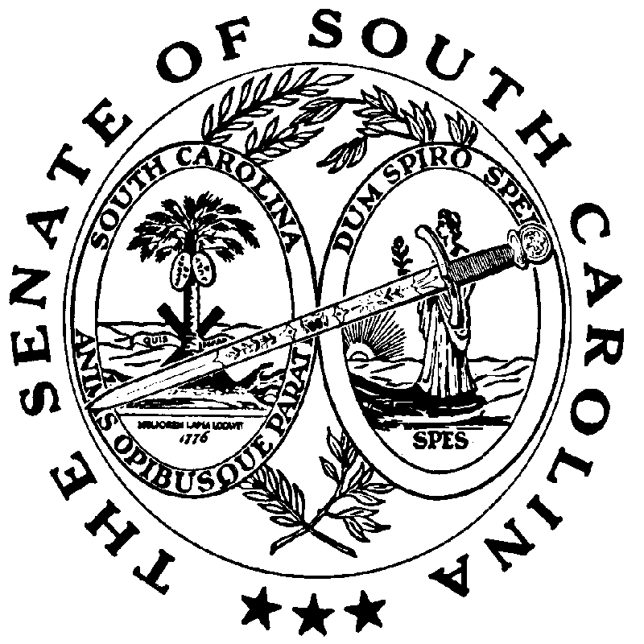

REGULAR SESSION BEGINNING TUESDAY, JANUARY 14, 2025

_________

MONDAY, APRIL 6, 2026

Monday, April 6, 2026
(Statewide Session)

Indicates Matter Stricken
Indicates New Matter

The Senate assembled at 11:00 A.M., the hour to which it stood adjourned, and was called to order by the ACTING PRESIDENT, Senator KENNEDY.

ADDENDUM TO THE JOURNAL
The following remarks by Senator ADAMS were ordered printed in the Journal of March 25, 2026:

Remarks by Senator ADAMS
Thank you, Mr. PRESIDENT. I’m up here to remind everybody as we have been here lately that our 250-year birthday is coming soon. I love our new phrase on our tags, which reads, “Where the Revolutionary War Was Won.” Whether Virginia likes it or not, it's not our fault that we forced Cornwallis out of our State.
I want to hit and touch a little bit on one of those battles that we had. On August 29, 1782, Francis Marion and his small Patriot force set an ambush on the settlement of Fairlawn along the Cooper River north of Charleston. British Major Thomas Fraser was leading about 200 British dragoons from Charleston on a forging mission and believed Marion was still operating near the Georgetown area. To lure the British into position, Marion sent Gavin Witherspoon with a reconnaissance party to locate Fraser and draw his force toward the ambush site. The plan succeeded and when Fraser’s dragoons entered a trap, Marion ordered his men to open fire. The surprise attack was initially very successful with Patriot rifleman killing about twenty of Fraser’s men in the first moments of the engagement. However, the British quickly regrouped and counterattacked, capturing one of Marion’s ammunition wagons. Losing the wagon provided the Patriots with much needed gunpowder and weapons at which time they withdrew into the Santee River area to avoid being overwhelmed. The skirmish illustrates the fluid and unpredictable nature of the war during the final months of conflict where the successful ambushes could quickly turn and surprise our enemies.
***

ADJOURNMENT
At 11:04 A.M., on motion of Senator MASSEY, the Senate adjourned to meet tomorrow at 11:00 A.M., under the provisions of Rule 1B.
* * *

